

|  |
| --- |
| CDIS Out-of-home care program process |
| Victorian Maternal and Child Health (MCH), Child Development Information System (CDIS) Published June 2020 – updated March 2023 |
|  |

Contents

On notification that a child has entered out of home care (OOHC) 1

Child information 1

Out of Home Care Program information 2

When Children are Re-united or No Longer in Out of Home Care Program 2

# On notification that a child has entered out of home care (OOHC)

## Child information

1. Search for child in CDIS
2. Go to the ‘Client Details’ tab and select ‘Update client details’
3. Under ‘Child Protection Status’, complete details including:

* Is the child under the care of Child Protection: Yes
* Child Protection worker’s name and email
* Department of Health and Human Services office
* Out of Home Care: Yes
* Type of care: select from drop down list

1. Select ‘Save’
2. Go to the ‘Client Details’ tab and select ‘Relationship’
3. Select the pencil icon to update the other relevant family members’ primary caregiver, caregiver,
4. contactable, and information sharing statuses. For example, if the birth mother is no longer the primary
5. care giver, un-tick primary caregiver, caregiver, information sharing and contactable checkboxes
6. Select ‘Save’
7. Select ‘Add relationship’ to add the new primary caregiver if known at the time or at a later stage
8. Go to ‘Clinical Activity’ and select ‘Referrals’
9. Under ‘Make a New Referral’, select ‘Internal’
10. Select ‘Program’ from look-up list and choose ‘Out of Home Care’
11. Select ‘Referral Reason’ from look-up list and choose OoHC
12. Select the green plus sign to add
13. Enter referral information (such as ‘Notified by letter from DDH of child moving into OoHC – letter attached’)
14. Select ‘Save’

## Out of Home Care Program information

1. Go to the home screen
2. Go to ‘General’ and select ‘Programs Active List’
3. Select ‘Program’ from look-up list and choose ‘Out of Home Care’
4. Under ‘Site’, choose ‘All’
5. Under ‘Action’, choose ‘Accept referral’
6. Select ‘Search’
7. Find the child in the list of search results and select the checkbox next to the ID number
8. Select ‘Accept referral’ (at bottom left of list)
9. Under ‘Action’, choose ‘View’ (this will show you the entire list of children in OoHC in your Council)
10. Find child ID
11. Use edit to add comments (such as ‘3.5 KAS due July 2019, ESK registered’). This comment will be visible on the client summary page under the ‘Programs’ heading as well as the OoHC program list.

# When Children are Re-united or No Longer in Out of Home Care Program

When children are reunited or no longer in OoHC are they removed/deactivated from the list.

To close a child from a program (same as EMCH or S&S programs),

1. On the child page go to clinical Activity
2. Select Programs
3. Edit button and close

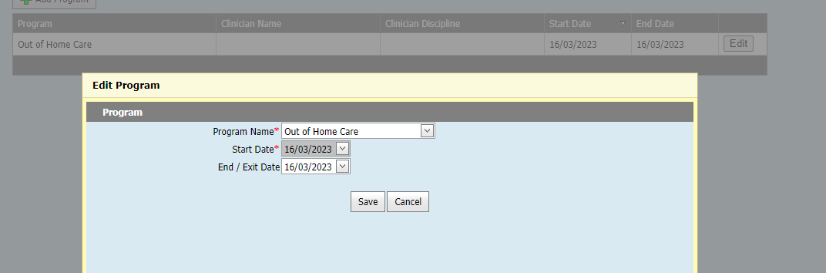

*Diagram 1 – Edit the Program to include an end date and Close the Program (un-enrol the client)*

|  |
| --- |
| To receive this publication in an accessible format phone 1300 650 172, using the National Relay Service 13 36 77 if required, or [email Commissioning Performance and Improvement Aged and Community Based Health Care and Cancer Services](mailto:mch@dhhs.vic.gov.au) <mch@dhhs.vic.gov.au>  Authorised and published by the Victorian Government, 1 Treasury Place, Melbourne.  © State of Victoria, Australia, Department of Health and Human Services June 2020.  ISBN 978-1-76096-027-8 (pdf/online/MS word)  Available at [health.vic – Child Development Information System](https://www2.health.vic.gov.au/primary-and-community-health/maternal-child-health/child-development-information-system) <https://www2.health.vic.gov.au/primary-and-community-health/maternal-child-health/child-development-information-system> |