Where should I inject vaccines?
• Accurately record site of administration, so vaccine brand can be quickly identified in the event of an AEFI.
• When injecting more than one vaccine into the same limb, separate by 2.5cm apart.
• Administer Bexsero in a separate limb from other vaccines due to injection site reactions.
• At 12 and 18 months of age, separate limbs (each deltoid and anterolateral thigh) may be used.
• Inject the least reactogenic vaccine into the anterolateral thigh.
• Annual influenza vaccine is recommended from 6 months of age.
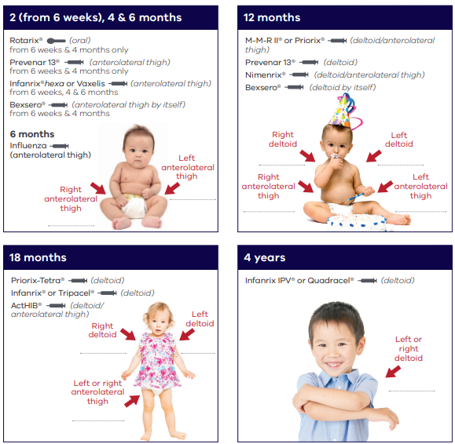
Refer to the current online edition of The Australian immunisation handbook for further details <immunisationhandbook.health.gov.au>
To receive this document in another format email <immunisation@health.vic.gov.au>
Authorised and published by the Victorian Government, 1 Treasury Place, Melbourne.
© State of Victoria, Australia, Department of Health, July 2023. (2306469)

