Place-focused consultation presentation
Alcohol and other drug residential development Mildura
OFFICIAL
Contents
Acknowledgements 2
Place-focused stakeholder consultation 2
Overview 2
A word about probity 2
The Victorian alcohol and drug treatment system 3
What to expect when accessing treatment 3
Project roadmap – stage 1 engagement timelines 5
Overview of session 6
Consultation activities – group based 7
Where to from here? 9
Appendix 1 10
Appendix 2 10

Acknowledgements
The Department of Health acknowledges the First People of the Millewa-Mallee, the Latji Latji and Ngintait peoples, as the traditional owners of the land in which this consultation focuses on. We pay our respect to Elders, past and present, and emerging leaders.
We acknowledge the rich diversity of culture and heritage of local Aboriginal Elders and communities from across Victoria and New South Wales, living and working in Mildura and the surrounding areas, who continue to lead the way and generously dedicate their lives to improving outcomes for community, by community.
We welcome the contribution of people with lived and living experience and extend our gratitude for working in partnership to achieve system transformation.

Place-focused stakeholder consultation

Overview
The following is a direct transcript of the presentation developed by the Mental Health and Wellbeing Division, Department of Health, for the place-focused consultations held in April and May 2023. Targeted consultation is part of the first stage in engaging with key stakeholders of the Mildura residential alcohol and drug service development.

A word about probity
- consultation and engagement activities are planned to meet probity obligations
- equal access to information in the planning and design stages ensures no service or entity has an actual or perceived advantage because of past activities and/or contributions made to community-based solutions leading up to stage 1 of the engagement process.
- Further information about Victorian Government procurement and probity obligations is available on the Buying for Victoria website <buyingfor.vic.gov.au/about-procurement>

The Victorian alcohol and drug treatment system
The Victorian funded Alcohol and other Drug (AOD) treatment system incorporates important functions and activities that enables the delivery of flexible, responsive and innovative treatment services.
The treatment system:
- intake function allows for clear points of access
- works from a ‘no wrong door’ approach
- acknowledges that assessment is an important part of building a therapeutic relationship and should be completed by the clinician as part of providing treatment
- a statewide approach aims to deliver faster and streamlined pathways

What to expect when accessing treatment

Alcohol and drug client charter
The Victorian alcohol and drug client charter outlines the basics of what to expect from a funded AOD service. That is:
- a safe environment,
- fair, honest and non-judgemental services,
- a service that is friendly and respectful,
- information on all treatment and services available to them,
- participate in all aspects of the service pathway,
- information that is kept confidential unless disclosure is otherwise authorised
- timely, effective and responsive services to individual needs
- make a complaint and have that complaint addressed efficiently
- culturally inclusive services that consider individual values and beliefs
More information on the Victorian alcohol and drug client charter is available on the Victorian AOD service standards and guidelines website <health.vic.gov.au/alcohol-and-drugs/alcohol-and-other-drug-service-standards-and-guidelines>.

Victorian AOD treatment principles
All Victorian funded AOD treatment providers are expected to:
- deliver services in accordance with the Victorian AOD client charter
- provide a friendly, welcoming and culturally safe environment for all, including Aboriginal people, people from culturally and linguistically diverse (CALD) backgrounds, and lesbian, gay, bisexual, trans and gender diverse, intersex and queer (LGBTIQ+) people and their families and friends
- ensure clients have the right to privacy and provide informed consent for any information regarding their care to be exchanged among workers within a treatment service or with other relevant agencies
- consider the needs of family and support people including, where necessary, the needs of any dependent children
More information on the Victorian alcohol and other drug treatment principles is available on the Victorian AOD service standards and guidelines website <health.vic.gov.au/alcohol-and-drugs/alcohol-and-other-drug-service-standards-and-guidelines>.

Project roadmap – stage 1 engagement timelines
The following diagram shows the indicative timelines and milestones expected for delivery from February to August 2023. Refer to Appendix 1 for further detail.
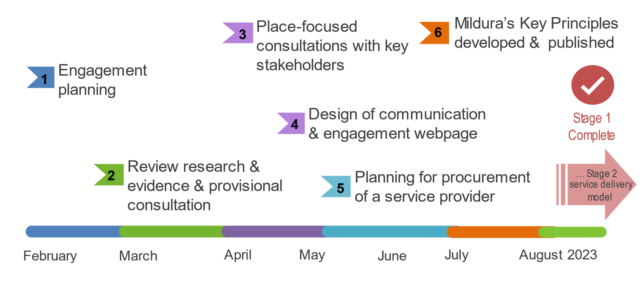

* Once developed, Mildura’s Key Principles will be available via the Department of Health website

Overview of session

Purpose of place-focused consultation
- A place-focused approach means the valued input from stakeholders is collected whilst preserving probity of procurement processes
- place-focused assists us to determine what is key to a new residential AOD service in Mildura
- the consultation is focused on aspirations for the future of the new statewide service to be built in Mildura - planning, design and future operation.
- aim is to collect valuable insights from those with lived and living experience and collate with those working in AOD treatment services, health and related services, with place-based linkages to Mildura.
- ‘Mildura’s Key Principles: guidance for planning, design and service delivery’ will be formulated from consultation and will be available online.
Further information on place-focused and place-based approaches is available on the Victorian Government Place-based approaches website <www.vic.gov.au/place-based-approaches>

Consultation activities – group based
The diagram below depicts a consumer’s treatment journey as a visual treatment pathway developed for the purpose of group activity. It provides examples of treatment type or ‘service stream’ to aid in the group activity discussion.
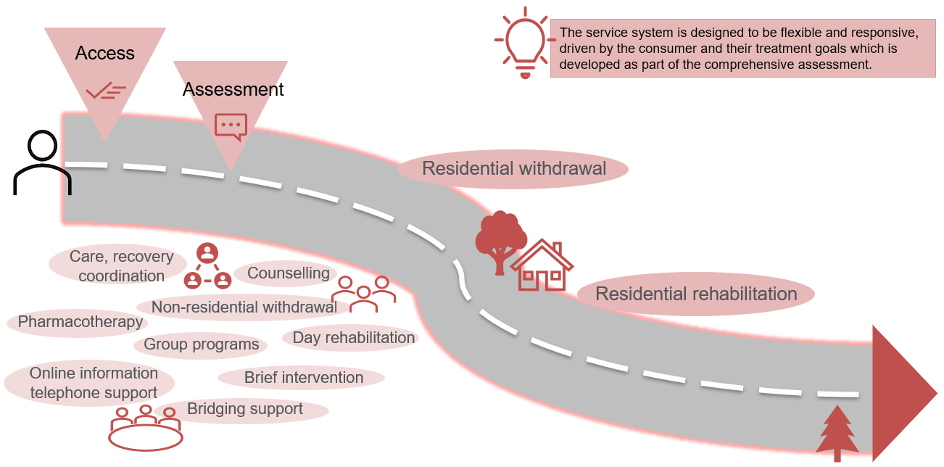

Group activity 1
- Thinking about your experience of residential treatment, what did you/do you need along the treatment pathway to achieve your treatment goals and improve outcomes?
- What do you think is important to enable and/or facilitate successful residential treatment?

Group activity 2
- Thinking about an inclusive residential treatment experience, what are the key environmental features of the facility that you must have to better meet your needs?
- Think about a service that is equitable and inclusive, how is a person’s individual needs met?

Where to from here?

Project roadmap – stage 2 timelines
The diagram below shows indicative timelines and milestones expected for delivery between June 2023 until completion. The Victorian Health Building Authority schedule of work is under development and independent of the below however will be delivered concurrently.
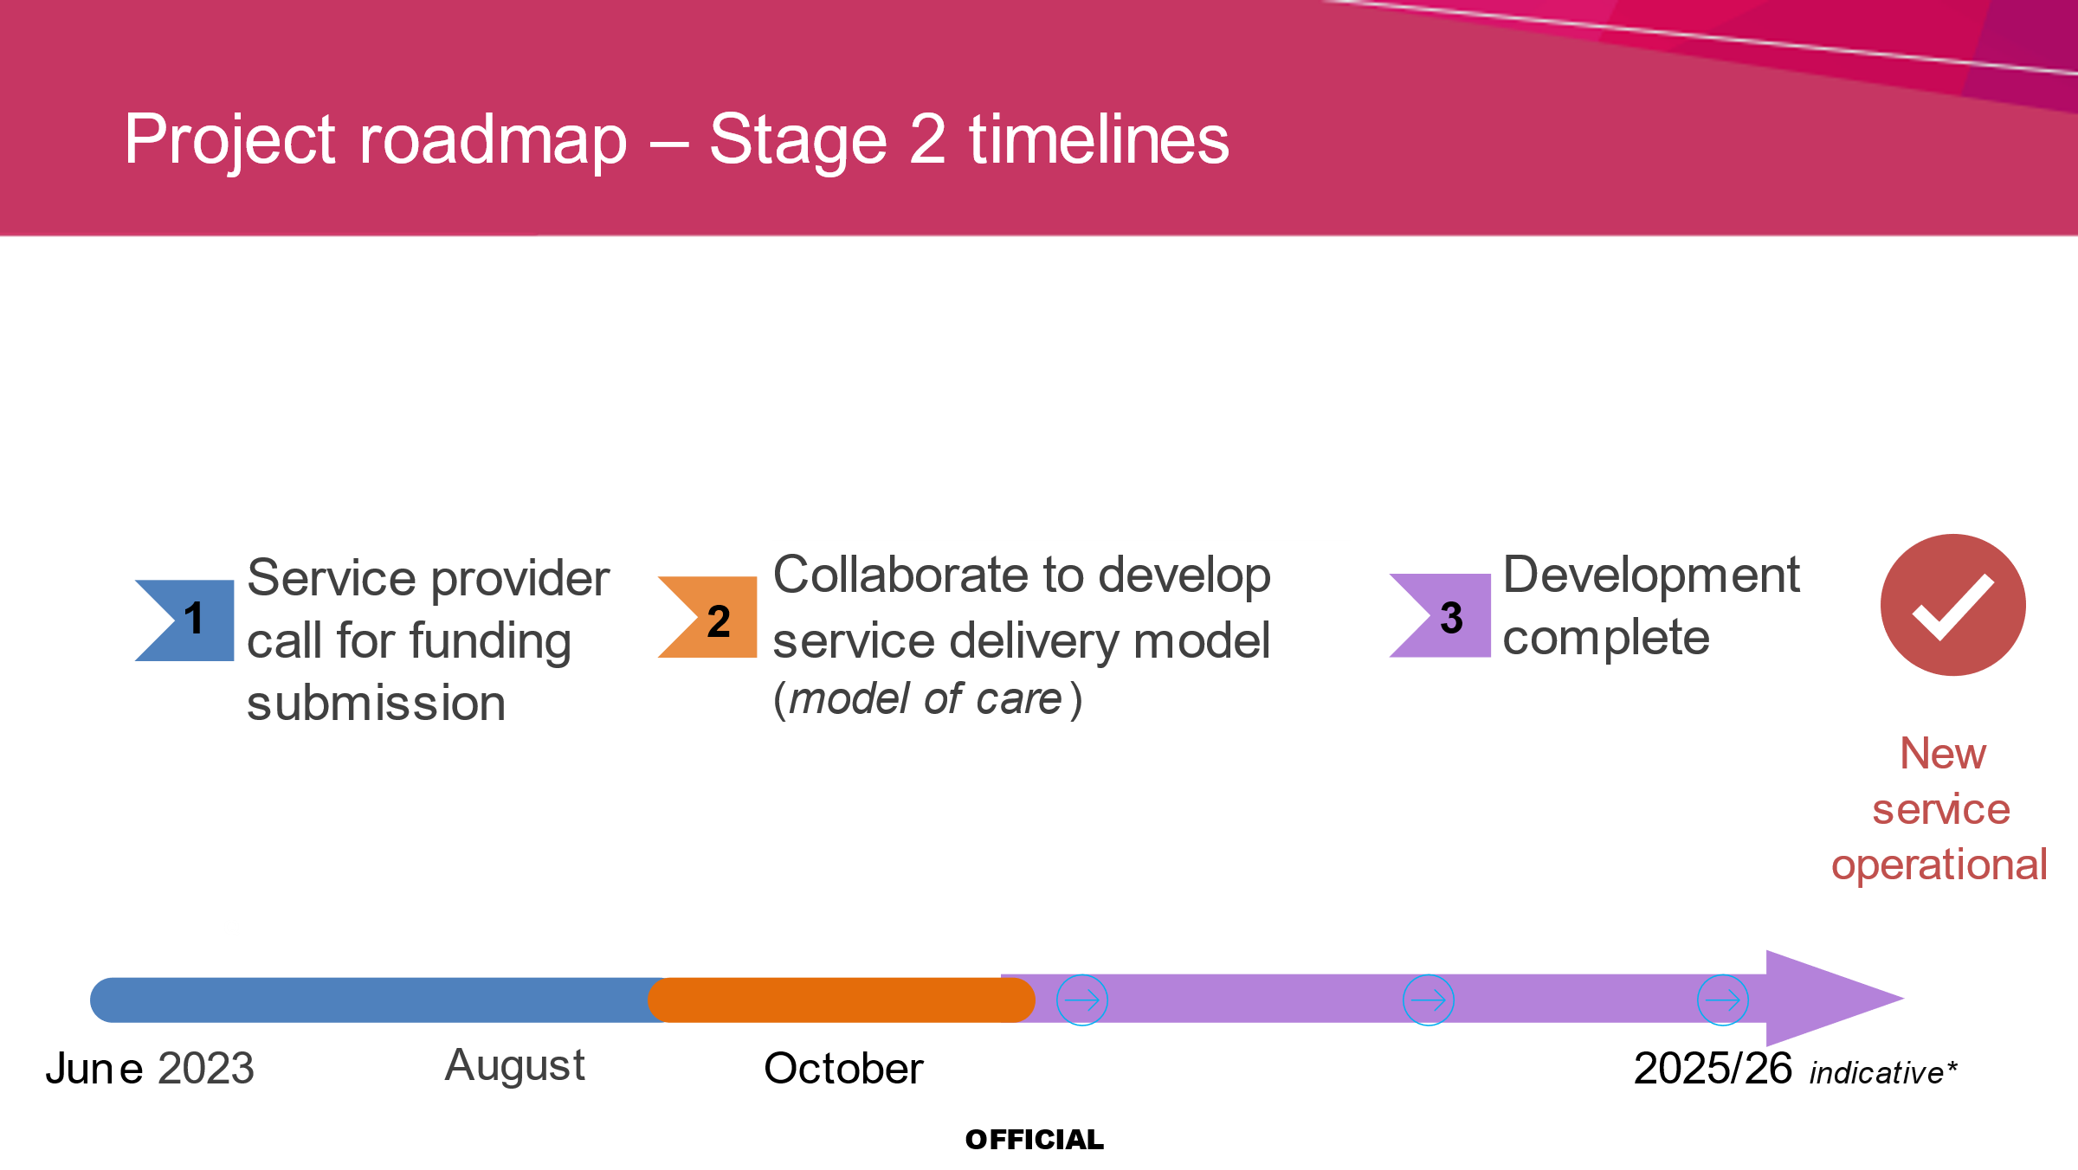

Appendix 1
February 2023 – Department of Health engagement planning commences
February – April 2023 – Review current research and existing evidence and engage in provisional consultation with identified stakeholders
April – May 2023 – undertake place-focused consultation with key stakeholders. Design and develop website for communication and engagement
May – June 2023 – planning for service provider procurement process
June – July 2023 – Mildura’s Key Principles developed from consultation themes and published via Department of Health website

Appendix 2
July – August 2023 – Call for Funding Submission procurement process and service provider appointed
September – December 2023 – Mildura’s Key Principles used as guidance by the appointed service provider to develop the service delivery model
2025 -2026 – development complete and new service operational
* Indicative timelines only.

To receive this document in another format, phone the National Relay Service 13 36 77 if required, or email AOD Enquiries, Mental Health and Wellbeing Division <aod.enquiries@health.vic.gov.au >.
Authorised and published by the Victorian Government, 1 Treasury Place, Melbourne.
© State of Victoria, Australia, Department of Health, June 2023.
Except where otherwise indicated, the images in this document show models and illustrative settings only, and do not necessarily depict actual services, facilities or recipients of services. This document may contain images of deceased Aboriginal and Torres Strait Islander peoples.
In this document, ‘Aboriginal’ refers to both Aboriginal and Torres Strait Islander people. ‘Indigenous’ or ‘Koori/Koorie’ is retained when part of the title of a report, program or quotation.
Available at Mildura statewide alcohol and drug residential treatment service
<https://www.health.vic.gov.au/aod-treatment-services/mildura-statewide-alcohol-and-drug-residential-treatment-service>

