Prostate cancer in Victoria
Optimal care pathway data summary report 2020
OFFICIAL

To receive this document in another format, phone (03) 9456 3332, using the National Relay Service 13 36 77 if required, or email the Cancer Support, Treatment and Research unit <cancerplanning@health.vic.gov.au>.
Authorised and published by the Victorian Government, 1 Treasury Place, Melbourne.
© State of Victoria, Australia, Department of Health, May 2023.
ISBN 978-1-76096-994-3 (pdf/online/MS word)

Available at the department’s cancer webpage <www.health.vic.gov.au/health-strategies/cancer-care>.

Foreword
This report summarises the data analyses prepared for the second Prostate Cancer Summit, which took place online on Friday 4 and Friday 11 December 2020.
The Victorian Tumour Summits are clinician-led forums to identify unwarranted variations in tumour-based clinical practice and cancer outcomes. We were honoured to co-chair the second Prostate Cancer Summit Working Group. The group has guided the analyses of statewide routine datasets to understand the current patterns of care for Victorians with prostate cancer. This work helped frame discussions about variations in care and has highlighted areas needing further investigation and action. This summit was also an opportunity to highlight progress made against issues raised at the first summit in 2016.
We thank the working group and participants of the summit for their time, effort, active contributions and support throughout the summit process. We also acknowledge Ella Stuart and Norah Finn, who undertook the analyses of the linked dataset, and Dr Nathan Papa for analyses of the Prostate Cancer Outcomes Registry dataset.
Through this summit series, we see the wealth of data accessible through both the linked departmental and Prostate Cancer Outcomes Registry datasets. Robust datasets, coupled with the expertise of data managers, means we can now measure and potentially manage variations in care more routinely. Prostate cancer incidence has been increasing in Victoria since 2014, although during COVID-19 the rates are lower than would be expected from recent trends. Diagnoses are increasingly by transperineal biopsy, especially in men at least socioeconomic disadvantage. This is also the group of men with higher incidence rates but more likely to be less aggressive.
Multidisciplinary discussion of men’s best options for management is less frequent than statewide targets, especially in regional areas. There is wide variation in the patterns of curative treatment across Victoria, but generally five-year relative survivals are very favourable. Also, when men are surveyed they generally have favourable perceptions of their care. Robot-assisted surgery is becoming increasingly common, especially in private services and in metro areas. Radiation therapy is increasingly image-guided and shorter courses. About a third of surgery is performed some distance from the men’s home, while generally well under a quarter of men having radiation therapy do not have it locally. In the most recent period the clear majority of men with low-risk disease are managed with what is now recognised to be appropriate ‘active surveillance’ rather than immediate attempts at radical cure.
Without this dataset and the work of biostatisticians, none of these patterns would be so clear and identified in such a timely manner. We strongly believe a smart-adapting well-designed system would find increased and sustained funding to support, bolster and enlarge these datasets. This would be a cost-effective investment in improving the health and quality of life of the thousands of Victorian men diagnosed each year with prostate cancer.

Professor Jeremy Millar
Co-chair, Prostate Cancer Summit
Professor Damien Bolton
Co-chair, Prostate Cancer Summit

Contents
Foreword 3
List of figures 5
List of tables 6
Acknowledgements 7
Introduction 8
More information 8
Data sources 9
Linked dataset 9
Other data sources 9
At a glance 11
Key findings 11
Key variations for action 12
Incidence, demographics and tumour characteristics 13
COVID-19-related effects 18
Diagnosis and treatment planning 20
Multidisciplinary team meeting 22
Treatment 23
Cumulative incidence and volume of prostatectomy 23
Radical prostatectomy and radiation therapy patient pathways 24
Variation in treatment 27
Recent treatment trends 33
Clinical commentary – recent treatment trends 35
Survival 36
Clinical commentary – survival 37
Supportive care and unmet needs 38
Victorian Healthcare Experience Survey 38
Survivors’ unmet needs survey 40
Abbreviations 43
Victorian Integrated Cancer Services 43
Glossary 44
Supplementary material 47
Codes 47

List of figures
Figure 1: Number of prostate cancer diagnoses from 2009 to 2018 and the contribution to the Prostate Cancer Outcomes Registry 16
Figure 2: Age-standardised incidence rate of prostate cancer by ICS of residence (N = 23,380) 16
Figure 3: Age-standardised incidence rate of prostate cancer by socioeconomic status (N = 23,391) 17
Figure 4: Relative difference (with 95 per cent confidence intervals) between observed and expected number of prostate cancer diagnoses in 2020 18
Figure 5: Relative difference (with 95 per cent confidence intervals) between observed and expected number of prostate cancer diagnoses in 2020, by ISUP stage group at diagnosis 19
Figure 6: Percentage of transperineal biopsies by SES quintile (2015 to 2018) 20
Figure 7: Percentage of transperineal biopsies by residence location (2015 to 2018) 21
Figure 8: Percentage of patients with documented evidence of an MDM by ICS campus (N = 139) 22
Figure 9: Annual prostatectomy hospital volume, by campus and hospital type (N = 2,316) 24
Figure 10: Initial treatment for stage 2–3 prostate cancer patients by ICS of residence (2016–2018) (N = 16,441) 28
Figure 11: Variation in surgery type (robotic/open prostatectomy) and hospital type (public/private) by ICS of residence (2018–2019) (N = 4,233) 29
Figure 12: Variation in surgery type (robotic/open prostatectomy), by hospital type and socioeconomic status (N = 4,233) 30
Figure 13: Number of prostatectomies for non-metastatic prostate cancer patients by socioeconomic status and ICS of treatment (N = 8,818) 31
Figure 14: Treatment by NCCN risk group 32
Figure 15: Proportion of patients treated with a long or short course of radiation therapy by NCCN risk group and time 33
Figure 16: Docetaxel-containing therapy utilisation for metastatic hormone-sensitive prostate cancer over time 34
Figure 17: Docetaxel-containing therapies for metastatic hormone-sensitive prostate cancer by age 34
Figure 18: Relative five-year survival for prostate cancer patients by ICS of residence 36
Figure 19: Proportion of patients with documented evidence of supportive care screening (N = 139) 38
Figure 20: Example of the Survey of Survivor Unmet Needs 41
Figure 21: Top unmet needs from the Survey of Survivor Unmet Needs for men with prostate cancer 41

List of tables
Table 1: Demographics and tumour characteristics in the VCR-VAED linked data, diagnosed 2014–2018, N = 23,395 14
Table 2: Demographics and tumour characteristics in the Prostate Cancer Outcomes Registry (PCOR) data, diagnosed 2008–2019, N = 25,981 15
Table 3: Distribution of ISUP grade groups by SES quintile 21
Table 4: Cumulative incidence of radical prostatectomy within one year of diagnosis, by year of diagnosis (N = 23,380) 23
Table 5: Patient flow for radical prostatectomies within one year of non-metastatic prostate cancer diagnosis from ICS of residence (across) to ICS treatment campus (down) (N = 8,040) 25
Table 6: Patient flow for radical radiation therapy within one year of non-metastatic prostate cancer diagnosis from ICS of residence (across) to ICS treatment campus (down) (N = 3,272) 26
Table 7: Percentage of prostatectomies undertaken in Victorian hospitals that were robotic, by ICS of residence (N = 4,233) 29
Table 8: Percentage of non-metastatic prostate cancer patients who had surgery, by socioeconomic status (N = 21,425) 31
Table 9: Proportion of prostate cancer patients in each ISUP group by ICS of residence 37
Table 10: Distribution of treatment types for patients surveyed for VHES 39
Table 11: Percentage of positive responses from patients surveyed for VHES, by treatment type 39
Table 12: Percentage of positive responses for indicators where prostate cancer patients rated highly compared with other cancer types 40
Supplementary Table 1: Prostate cancer diagnosis codes 47
Supplementary Table 2: Surgical procedures codes used to identify patients who underwent prostatectomy (robotic or open) 47
Supplementary Table 3: Diagnosis, procedure and diagnosis related group codes used to identify patients who received chemotherapy 47

Acknowledgements
The data, analysis and commentary provided in this report represent a joint effort by key contributors from the following groups.
Team | Membership
Prostate Cancer Summit Working Party | Ms Gay Corbett  Prof. Damien Bolton (co-chair)  Mr Adee Davidson  Prof. Ian Davis  Prof. Sue Evans  Mr Adam Landau  Mr Jonathan Lewin  Prof. Jeremy Millar (co-chair)  A/Prof. Paul Mitchell  Prof. Declan Murphy  Dr Nathan Papa  Dr David Pook  Dr Neetu Tejani
Data analysis | Ms Norah Finn (Department of Health)  Ms Ella Stuart (Department of Health)  Dr Nathan Papa (PCOR)
Victorian Tumour Summits Project Team | Ms Lori Cameron  Ms Paula Howell  Ms Rebecca Miller  Ms Janine Scott
We also gratefully acknowledge the providers of the Victorian Cancer Registry data, Victorian Admitted Episodes Dataset and the Victorian Radiotherapy Minimum Dataset, as well as the Centre for Victorian Data Linkage for performing the linkages between the Victorian Cancer Registry and administrative datasets.
To view the prostate summit data presentation and related documents, visit the Prostate Cancer Summit meeting webpage <https://www.tumoursummits.org.au/prostate/>.

Introduction
The data presented in this report summarises the analyses prepared for the 2020 Prostate Cancer Summit. The Prostate Cancer Summit is part of the Victorian Tumour Summits program, an initiative of the Victorian Integrated Cancer Services (ICS) delivered in collaboration with the Department of Health and Cancer Council Victoria. The summits support the broader program of work implementing the optimal care pathways (OCPs).
Following the first Prostate Cancer Summit in 2016, several activities were undertaken to address the recommended priorities from the summit and other variations identified. The Victorian ICS worked with the Primary Health Network to produce a range of resources for GPs, including education events and videos. Cancer Council Victoria worked with the University of Melbourne to provide e-learning modules for GPs and health professionals, highlighting recommendations about prevention, early detection, initial investigation and referral pathways. The ICS did work to improve the supportive care needs, including a program of sexual health education, support group involvement, and contributed to other projects such as TrueNTH and BroSupPORT. The TrueNTH project, run by the Victorian Prostate Cancer Outcomes Registry (PCOR-Vic), identified men who were having significant problems with prostate cancer side effects after treatment. It then linked them with a prostate cancer nurse care coordinator to provide access to additional supportive care supports. Men in the TrueNTH group were 60 per cent less likely to report moderate to major problems with their sexual function compared with men in the historical control group. The BroSupPORT project built on the experiences of the TrueNTH project to provide scalable measures of support through a web-based portal. The BroSupPORT program will be ongoing if resourcing permits.
The Prostate Cancer 2020 Summit was held online across two two-hour Zoom sessions held one week apart, on 4 and 11 December 2020. Eighty-four active participants attended. In this summit, data on cancer care and outcomes for prostate cancer patients diagnosed between 2014 and 2018 were presented. Clinical commentary discussing key variations from the summit are included in this report.

More information
- Find out more about the Prostate Cancer Summit from the Tumour Summits website <https://www.tumoursummits.org.au/prostate/>.
- The prostate cancer OCP can be viewed and downloaded from the Cancer Council Australia website <www.cancer.org.au/OCP>. Please note that the second edition of the OCP was released after the Prostate Cancer 2020 Summit was held.
- Find out more about BroSupPORT from the BroSupPORT website <https://programs.movember.com/brosupport/>.

Data sources

Linked dataset

Datasets
The Victorian Cancer Registry (VCR) is a population-based cancer registry that collects demographic and tumour details, including diagnosis date and region of residence, for all Victorian residents diagnosed with cancer. The department’s Centre for Victorian Data Linkage performs an annual data linkage between the VCR and administrative datasets including the Victorian Admitted Episodes Dataset (VAED), the Victorian Radiotherapy Minimum Data Set (VRMDS) and the Victorian Death Index. Linking the VCR to the VAED provides information captured within the inpatient setting in all Victorian public and private hospitals such as patient diagnoses (for example, comorbidities, distant metastases) and cancer treatment, including surgery and intravenous chemotherapy (excluding oral chemotherapy). Linking the VCR to the VRMDS provides information on admitted and non-admitted radical and palliative radiation therapy courses provided in Victorian public and private radiation therapy centres. Unless otherwise specified, the data source used for the report analyses was the linked dataset for patients diagnosed between 2014 and 2018.

Patient selection
Victorian residents aged 18 years or older with a primary diagnosis of prostate cancer (refer to Supplementary Table 1) between 2014 and 2018 were identified using the VCR. Patients whose cancer diagnosis was notified to the VCR by death certificate only (n = 315, refer to the glossary for definition) were excluded. When a person was diagnosed with two or more prostate cancers during the study period, the record of the earliest diagnosis was retained (three patients with more than one prostate cancer).

Data limitations
Victorians with cancer living in HRICS may receive treatment in New South Wales (Albury) hospitals, which is not captured in the VAED. Therefore, variables in this report that are derived using the VAED (comorbidity count, distant metastases, surgery and chemotherapy) are likely to be underestimated for Victorians living in HRICS. Table and figure footnote text highlight where this limitation may apply. This limitation does not affect the VCR or VRMDS data collections.

Other data sources
In addition to the linked dataset, this report includes data from the following sources:
- PCOR-Vic collects information about treatments and outcomes following a diagnosis of prostate cancer in Victoria, across participating Victorian hospitals. The percentage of men who take part in PCOR-Vic increased from approximately 66 per cent to 90 per cent between 2016 and 2019.

- The Cancer Services Performance Indicator (CSPI) medical record audit 2018 collected data such as multidisciplinary meeting (MDM) use and MDM timing (prospective or retrospective to starting treatment), from the medical records of a random sample of cancer patients treated across 43 Victorian hospitals. There were 139 prostate cancer patients audited.
- The Estimated Resident Population, Australian Bureau of Statistics (ABS) <https://explore.data.abs.gov.au/> website includes data on estimated resident population by Statistical Area 2 (SA2) and local government area.

At a glance

Key findings

Incidence of prostate cancer
- The Victorian average age-standardised incidence rate of prostate cancer was 91.4 per 100,000 for the period from 2014 to 2018.
- Age-standardised incidence rates increased with increasing socioeconomic status (SES), from 72.5 per 100,000 in the most disadvantaged quintile to 102.8 per 100,000 in the least disadvantaged quintile.
- In 2020, the number of prostate cancer diagnoses declined by 13 per cent from the expected number.

Diagnosis and treatment planning
- The proportion of transperineal biopsies increased over time, with higher uptake in major cities and in areas with lower socioeconomic disadvantage.
- From the 2018 CSPI medical record audit, 38 per cent had documented evidence of and MDM, with high variation among hospitals.

Treatment
- In the 2018–19 financial year, there were 2,316 prostatectomies; 1,625 prostatectomies (70 per cent) were performed in 20 private hospitals (median volume of 41.5, mean of 81), as compared with 691 prostatectomies in 19 public hospitals (median volume of 27, mean of 36).
- 57 per cent of patients had a prostatectomy at a campus within their ICS of residence, and 76 per cent of patients had radiation therapy at a centre within their ICS of residence.
- 64 per cent of prostatectomy was performed robotically. Surgery type (robotic/open) varies by hospital type (public/private), ICS of residence and SES.
- Patients of higher SES are more likely to receive radical prostatectomy (48 per cent of those in the highest SES quintile received surgery as compared with 32 per cent for those in the lowest SES quintile).

Recent treatment trends
- The proportion of patients receiving short-course radiation therapy versus long-course has increased since 2016, with 56 per cent of intermediate-risk patients and 20 per cent of high to very high risk patients having had a short course in the first half of 2019.
- The use of docetaxel-containing therapies for metastatic hormone-sensitive prostate cancer patients increased over time, from 29 per cent in 2014 to 42 per cent in 2018.

Survival
- The average relative five-year survival across Victoria was 94.4 per cent (95 per cent confidence interval (CI): 93.8 to 94.9) and was higher across metro ICS (ranging from 94.4 to 96.0 per cent) compared with regional ICS (ranging from 88.8 to 94.6 per cent).

Supportive care and unmet needs
- From the 2018 CSPI medical record audit, 19 per cent of men had documented evidence of supportive care screening, with high variation among hospitals.
- The 2019 Victorian Healthcare Experience Survey (VHES) of patients treated in 2018 in Victorian public hospitals showed that most patients (> 96 per cent) have overall positive experiences with prostate cancer treatment.
- The PCOR ‘Survey of Survival Unmet Needs’ administered 12 months after treatment showed that the high unmet needs in prostate cancer patients includes emotional, financial and fatigue management needs.

Key variations for action
- Variation in information and support at treatment planning.
- Prostatectomy utilisation differed by SES and region of residence, including variation in use of robotic versus open prostatectomy.
- Variation in identifying and addressing needs of men with prostate cancer (especially emotional, financial and fatigue management).
- The proportion of patients with evidence of an MDM varied by campus and overall was significantly below the statewide target.
- Some regional ICS had poorer survival and higher grade disease at diagnosis than men from metro ICS.
- Data limitation for patients from HRICS reduced our understanding of the complete picture across Victoria, and the discussion of local issues.

Incidence, demographics and tumour characteristics
- The demographics for men in the linked dataset (Table 1) are similar to those captured in PCOR-Vic (Table 2).
  - The median age at diagnosis was 68 years old and 66.8 years old for the linked data and PCOR-Vic respectively.
  - The proportion of cases categorised by SES was similar across the two datasets for the least disadvantaged SES quintile (24 and 27 per cent for linked data and PCOR-Vic respectively) and the most disadvantaged SES quintile (18 and 16 per cent for linked data and PCOR-Vic respectively).
- The coverage of PCOR increased since the 2016 summit, from 68 per cent in 2016 to 84 per cent in 2018 (Figure 1).
- Between 2014 and 2018, the statewide age-standardised average incidence rate of prostate cancer was 91.4 per 100,000 (Figure 2, Figure 3).
  - There is variation in incidence by ICS of residence but no association with metro ICS or regional ICS (Figure 2).
  - Age-standardised incidence rates increased with decreasing socioeconomic disadvantage, with an incidence of 76.5 (95 per cent CI: [74.1, 79.1]) per 100,000 in the most disadvantaged quintile as compared with 106.5 (95 per cent CI: [103.7, 109.4]) per 100,000 in the least disadvantaged quintile (Figure 3).
Table 1: Demographics and tumour characteristics in the VCR-VAED linked data, diagnosed 2014–2018, N = 23,395
Variable | Level, median [IQR] or N (%)
Age | Years, 68 [62–74]
SES (address at diagnosis) | Disadvantaged (Q1), 4,141 (18%)  Middle (Q2–Q4), 13,736 (59%)  Affluent (Q5), 5,514 (24%)
Stage at diagnosis | 1: VCR derived, 3,095 (13%)  2: VCR derived, 8,124 (35%)  3: VCR derived, 8,320 (36%)  4: VCR derived, 1,983 (8%)  Unknown – VCR derived, 1,873 (8%)
Grade | ISUP 1, 6,881 (29%)  ISUP 2, 6,288 (27%)  ISUP 3, 3,220 (14%)  ISUP 4, 1,713 (7%)  ISUP 5, 2,077 (9%)  (Metastatic), 1,917 (8%)  Unknown, 1,299 (6%)
‘Death certificate only’ patients excluded in the linked dataset (n = 315)
ISUP = International Society of Urological Pathology, refer to the glossary for further details
Table 2: Demographics and tumour characteristics in the Prostate Cancer Outcomes Registry (PCOR) data, diagnosed 2008–2019, N = 25,981
Variable | Level, median [IQR] or N (%)
Age | Years, 66.8 [60.9–72.5]
SES (address at diagnosis) | Disadvantaged (Q1), 16%  Middle (Q2–Q4), 57%  Affluent (Q5), 27%
Stage at diagnosis | NCCN Low risk, 19%  NCCN Int risk, 49%  NCCN High risk, 24%  Regional but no distant metastasis, 4%  Distant metastasis, 4%
Prostate-specific antigen (PSA) | ng/mL, 7 [4.9–11]
Grade | ISUP 1, 30%  ISUP 2, 31%  ISUP 3, 17%  ISUP 4, 10%  ISUP 5, 12%
'Death certificate only’ patients excluded in the linked dataset (n = 315)
NCCN = National Cancer Comprehensive Network, refer to the glossary for further details
ISUP = International Society of Urological Pathology, refer to the glossary for further details

Figure 1: Number of prostate cancer diagnoses from 2009 to 2018 and the contribution to the Prostate Cancer Outcomes Registry
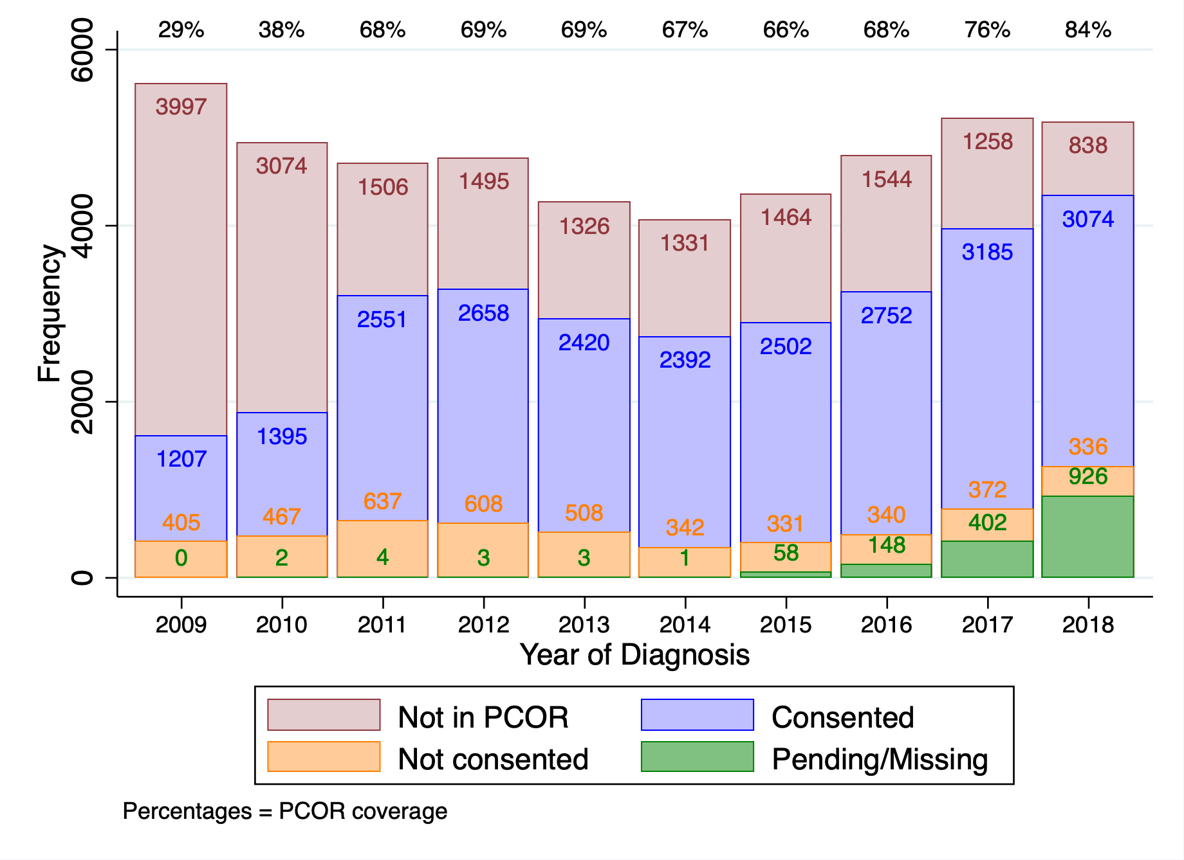
‘Pending/Missing’ are people whose details were not available.
Figure 2: Age-standardised incidence rate of prostate cancer by ICS of residence (N = 23,380)
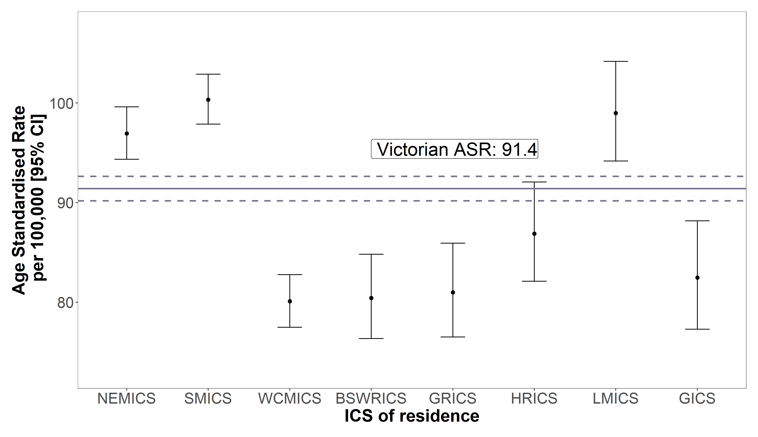
Data source: VCR; ABS population data
Standardised to the World Standard Population
Error bars represent 95 per cent confidence intervals.
Figure 3: Age-standardised incidence rate of prostate cancer by socioeconomic status (N = 23,391)
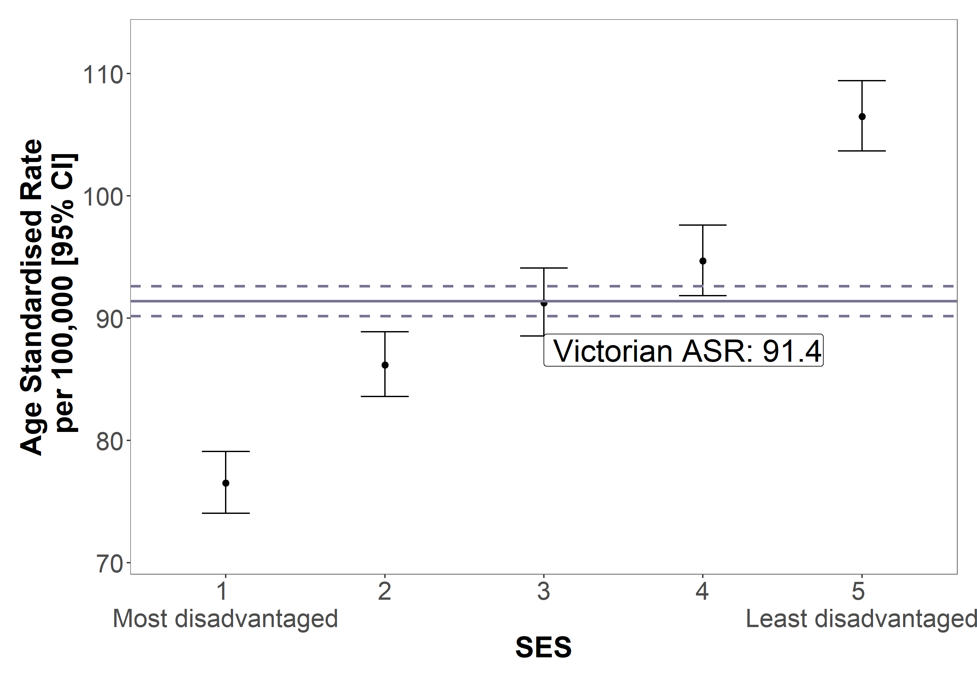
Data source: VCR; ABS population data
Standardised to the World Standard Population
SES based on Statistical Area 2 at diagnosis.
Error bars represent 95 per cent confidence intervals.

Clinical commentary – incidence, demographics and tumour characteristics
There are some differences between the VCR-VAED linked dataset and the PCOR-Vic dataset, including greater detail of staging of prostate cancer in PCOR-Vic, which includes data on PSA testing and clinical stage. The PCOR-Vic data also collects more granular information on management as well as information on men’s experiences and patient-reported side effects after management of prostate cancer. An outcome from the 2016 summit was to encourage all healthcare providers to contribute to the PCOR-Vic and for PCOR-Vic to share the findings from the registry with local clinical groups. We see the results of that in increasing coverage of all prostate cancer diagnoses in the PCOR-Vic data (84 per cent in 2018). It is regrettable that little progress was made to enable improved data accrual to the PCOR-Vic after barriers were highlighted at the first summit. The increasing incidence of men diagnosed with prostate cancer since 2014 probably reflects increasing use of PSA testing, as the rate of diagnosis is proportionate to the number of PSA blood tests done. Age-standardised incidence varies by ICS of residence and increases with increasing SES.

COVID-19-related effects
- The VCR annual statistics and trends report was released on 9 December 2021, with data published on cancer incidence in 2020. Overall, there were 819 fewer prostate cancer diagnoses than expected in 2020, a 13 per cent decline (Figure 4). There was a decline is diagnoses for all ISUP grade groups (Figure 5).
Figure 4: Relative difference (with 95 per cent confidence intervals) between observed and expected number of prostate cancer diagnoses in 2020
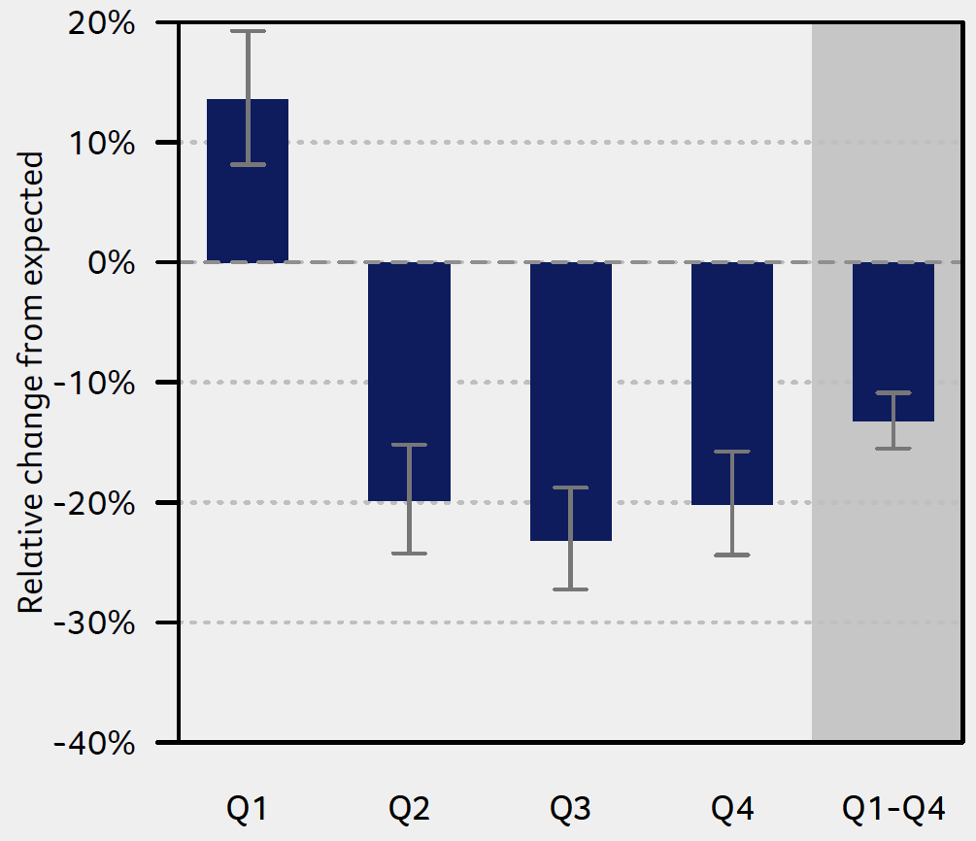
Data source: Cancer in Victoria 2020, Victorian Cancer Registry
Figure 5: Relative difference (with 95 per cent confidence intervals) between observed and expected number of prostate cancer diagnoses in 2020, by ISUP stage group at diagnosis
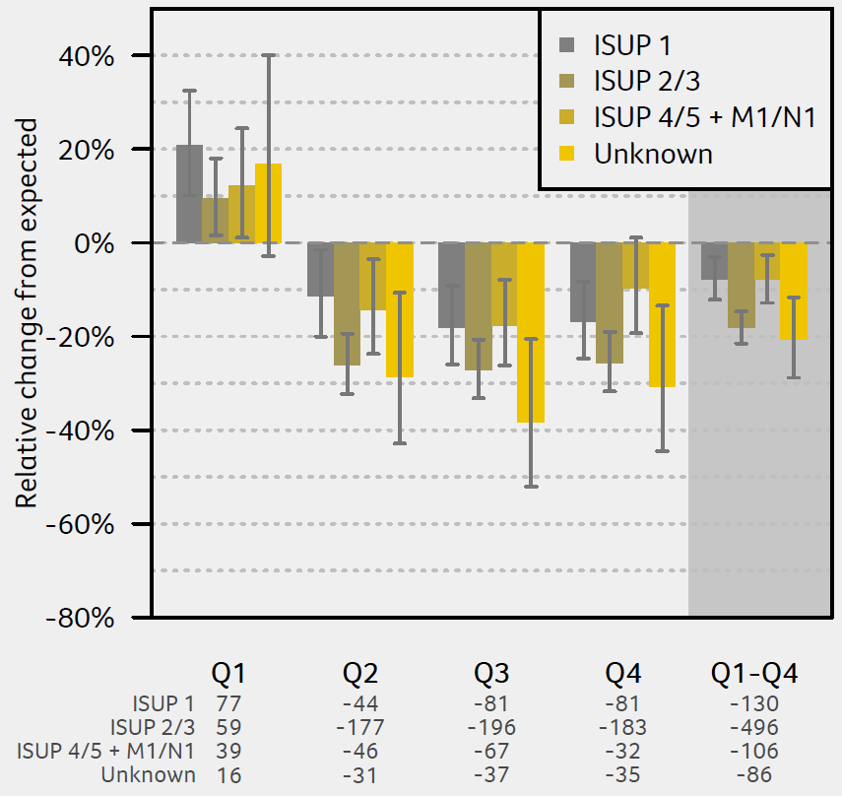
Data source: Cancer in Victoria 2020, Victorian Cancer Registry

Clinical commentary – COVID-19-related effects
In 2020, we saw the effects of the COVID-19 pandemic on decreasing overall rates of cancer diagnosis. Cancer pathology notifications declined following the first lockdown in Victoria that began on 30 March 2020. Across many cancers, the decrease in notifications was greater in males, but the decrease from expected in prostate cancer notifications are substantially larger (–25.7 per cent) than observed in other cancers in men. This translated to 819 few prostate cancer diagnoses in 2020 than was expected. The large decrease in diagnoses for prostate cancer may be due in part to a hesitancy to present to a doctor for diagnostic investigation of prostate cancer. As we emerge from the COVID-19 pandemic, it will be important to monitor whether these decreased notifications lead to delayed diagnoses and more advanced stage at diagnosis.

Diagnosis and treatment planning
- The percentage of patients who had a transperineal biopsy increased over time between 2015 and 2018 (Figure 6, Figure 7). This indicates a shift away from transrectal ultrasound (TRUS) biopsy.
  - The percentage of men who had transperineal biopsy increased for all SES quintiles. However, there was variation between quintiles, with a higher proportion of patients in more advantaged quintiles having this procedure (Figure 6).
  - The percentage of men who had a transperineal biopsy was highest for those living in a major city (Figure 7).
- Men in the most disadvantaged SES quintile had more aggressive cancers.
  - 21 per cent of men had ISUP 5 or metastatic disease in the most disadvantaged SES quintile, compared with 13 per cent in the least disadvantaged SES quintile (Table 3).
Figure 6: Percentage of transperineal biopsies by SES quintile (2015 to 2018)
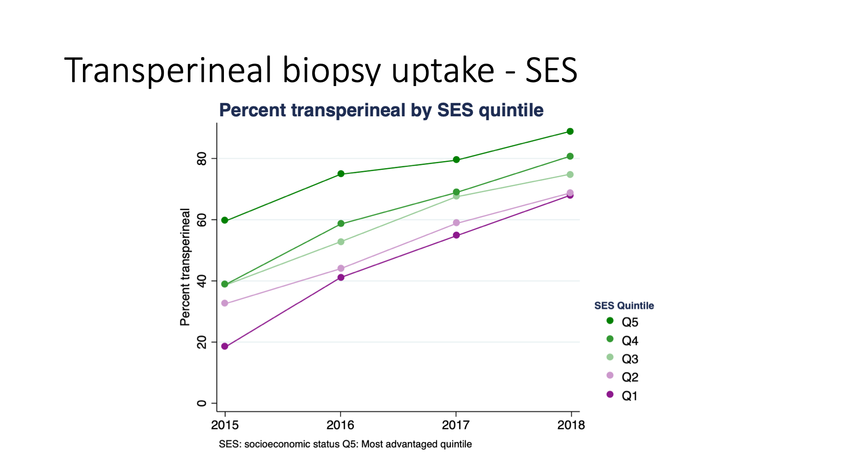
Data source: PCOR
Figure 7: Percentage of transperineal biopsies by residence location (2015 to 2018)
Data source: PCOR
Table 3: Distribution of ISUP grade groups by SES quintile
SES | ISUP 1 | ISUP 2 | ISUP 3 | ISUP 4 | ISUP 5 | Metastatic | Unknown
1: most disadvantaged (n = 4,141) | 27% | 23% | 14% | 9% | 11% | 10% | 6%
2 (n = 4,496) | 28% | 25% | 13% | 8% | 10% | 9% | 6%
3 (n = 4,543) | 28% | 26% | 15% | 8% | 9% | 8% | 6%
4 (n = 4,697) | 31% | 28% | 13% | 7% | 8% | 8% | 5%
5: least disadvantaged (n = 5,514) | 32% | 31% | 14% | 6% | 7% | 6% | 5%
Victoria (n = 23,391) | 29% | 27% | 14% | 7% | 9% | 8% | 6%

Clinical commentary – diagnosis and treatment planning
In the past three to five years, there has been movement of diagnostic technique away from the traditional TRUS biopsy to transperineal biopsy, which provides more information and is safer. While the use of transperineal biopsies has increased over time, there are still differences in uptake by SES and residence location, with greater uptake in least disadvantaged SES quintiles and metro areas.

Multidisciplinary team meeting
- The CSPI medical record audit 2018 audited 139 prostate cancer patients’ records from 21 public hospitals and four private hospitals. Of these, 38 per cent had documented evidence of an MDM (Figure 8).
Figure 8: Percentage of patients with documented evidence of an MDM by ICS campus (N = 139)
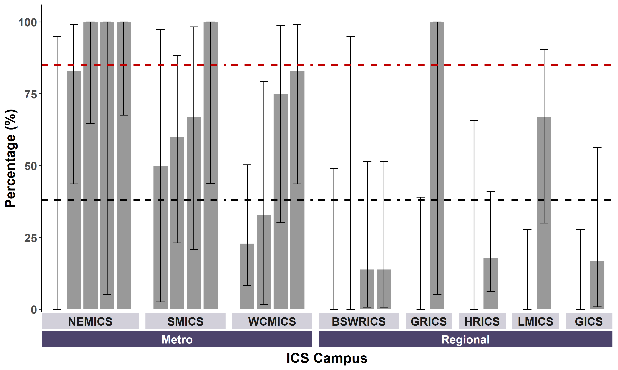
Target = 85%
Vic avg = 38%
Data source: CSPI medical record audit 2018
Bars represent 95 per cent confidence intervals.
Patients living in HRICS may have been treated in New South Wales and not captured in the audit population.

Clinical commentary – multidisciplinary team meeting
Multidisciplinary care improves patient outcomes. The OCP for prostate cancer outlines that patients with localised or locally advanced prostate cancer who are considering curative treatment should consult with a urologist to discuss surgical treatment options and be referred to a radiation oncologist to discuss radiation therapy treatment options. Those with metastatic disease should also be referred to a medical oncologist. A wide variety of specialist groups are involved, including nurses, medical oncologists, radiation oncologists, urologists, social workers and physiotherapists. Evidence of an MDM is 38 per cent across the state, well below the target of 85 per cent. Evidence of an MDM varies between ICS of treatment campus and perhaps across the health services within each ICS. However, although randomised the small sample sizes for individual campuses make the estimates imprecise.

Treatment

Cumulative incidence and volume of prostatectomy
- Cumulative incidence of radical prostatectomy varied over the 2014 to 2018 period, but there were no consistent time-varying patterns across ICS of residence (Table 4).
  - The highest was at 47 per cent in BSWRICS in 2017, and the lowest at 23 per cent in GICS in 2015.
- Annual prostatectomy volume in the 2018–19 financial year was higher in private hospitals (median of 41.5, mean of 81) compared with public hospitals (median of 27, mean of 36) (Figure 9).
  - Nineteen public hospitals and 20 private hospitals accounts for 30 per cent and 70 per cent of all radical prostatectomies respectively.
Table 4: Cumulative incidence of radical prostatectomy within one year of diagnosis, by year of diagnosis (N = 23,380)
ICS of residence | 2014 | 2015 | 2016 | 2017 | 2018 | Overall
NEMICS | 37% | 43% | 42% | 39% | 40% | 40%
SMICS | 36% | 36% | 37% | 35% | 32% | 35%
WCMICS | 37% | 41% | 36% | 34% | 34% | 36%
BSWRICS | 34% | 38% | 45% | 47% | 42% | 42%
GRICS | 35% | 32% | 32% | 41% | 37% | 36%
HRICS | 31% | 27% | 32% | 26% | 24% | 28%
LMICS | 31% | 33% | 29% | 34% | 34% | 32%
GICS | 28% | 23% | 32% | 32% | 24% | 28%
Victoria | 35% | 37% | 37% | 36% | 35% | 36%
Patients living in HRICS may have been treated in New South Wales.
Figure 9: Annual prostatectomy hospital volume, by campus and hospital type (N = 2,316)
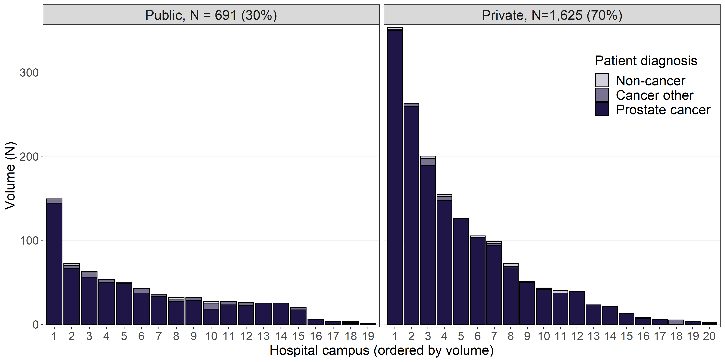
Data source: VAED 2018–19

Radical prostatectomy and radiation therapy patient pathways
- 57 per cent of patients received radical prostatectomy locally, ranging from 7 per cent in GRICS to 79 per cent in BSWRICS (Table 5).
- 76 per cent of patients received radiation therapy locally in their ICS of residence, ranging from 46 per cent in HRICS to 90 per cent in GICS (Table 6).
Table 5: Patient flow for radical prostatectomies within one year of non-metastatic prostate cancer diagnosis from ICS of residence (across) to ICS treatment campus (down) (N = 8,040)
ICS campus (down) / ICS of residence (across) | NEMICS | SMICS | WCMICS | BSWRICS | GRICS | HRICS | LMICS | GICS
NEMICS | 1,175  (53%) | 225  (10%) | 179  (14%) | 6  (1%) | 26  (6%) | 87  (24%) | 32  (6%) | 5  (2%)
SMICS | 196  (9%) | 1,426  (63%) | 65  (5%) | 8  (1%) | 191  (42%) | 22  (6%) | 12  (2%) | 5  (2%)
WCMICS | 850  (38%) | 595  (26%) | 1,016  (78%) | 89  (14%) | 208  (46%) | 196  (54%) | 252  (47%) | 42  (15%)
BSWRICS | 4  (0%) |  | 21  (2%) | 505  (79%) | 1  (0%) | 1  (0%) | 1  (0%) | 22  (8%)
GRICS |  |  |  |  | 31  (7%)
HRICS |  |  |  |  |  | 53  (15%)
LMICS |  |  | 1  (0%) | 1  (0%) |  | 1  (0%) | 197  (37%) | 1  (0%)
GICS |  | 1 (0%) | 18  (1%) | 32  (5%) |  |  | 41  (8%) | 200  (73%)
Total patients | 2,225 | 2,247 | 1,300 | 641 | 457 | 360 | 535 | 275
Patients living in HRICS may have been treated in New South Wales.
Table 6: Patient flow for radical radiation therapy within one year of non-metastatic prostate cancer diagnosis from ICS of residence (across) to ICS treatment campus (down) (N = 3,272)
ICS campus (down) / ICS of residence (across) | NEMICS | SMICS | WCMICS | BSWRICS | GRICS | HRICS | LMICS | GICS
NEMICS | 475  (72%) | 68  (7%) | 84  (15%) |  | 3  (1%) | 26  (15%) | 8  (2%) | 1  (0%)
SMICS | 40  (6%) | 778  (82%) | 7  (1%) | 2  (1%) | 31  (15%) | 2  (1%) | 2  (1%)
WCMICS | 144  (22%) | 99  (10%) | 422  (78%) | 12  (7%) | 10  (5%) | 19  (11%) | 60  (18%) | 9  (4%)
BSWRICS |  | 1  (0%) | 13  (2%) | 131  (78%) |  |  | 3  (1%) | 6  (3%)
GRICS | 1  (0%) | 4  (0%) |  |  | 167  (79%)
HRICS |  | 1  (0%) | 1  (0%) |  |  | 80  (46%)
LMICS |  |  |  |  |  | 48  (27%) | 235  (72%) | 7  (3%)
GICS |  |  | 17  (3%) | 23  (14%) |  |  | 17  (5%) | 215  (90%)
Total patients | 660 | 951 | 544 | 168 | 211 | 175 | 325 | 238

Clinical commentary – incidence and patient pathways
The cumulative incidence of radical prostatectomy serves as a surrogate for prostate cancer surgical treatment, and as an identification of people diagnosed at a point where curative treatment was possible. We see a fairly stable prostatectomy rate of 28 to 42 per cent between 2014 and 2018. There is substantial bias towards prostatectomy in the private hospitals as opposed to the public sector. The causes of this are multifactorial and interrelated – prostate cancer is more frequently diagnosed in private practice, in men who are least disadvantaged, and more likely to have insurance cover. Surgeons and patients may have a preference for a robotic approach which is more available in the private sector. The patient flow data supports this, where 38 per cent of patients living in NEMICS had radical prostatectomy at a campus in WCMICS where the greater technology prevalence is apparent. BSWRICS, which has access to robotics, has 78 per cent of surgery performed locally, while for LMICS, only 37 per cent were treated locally. For radiation therapy, both metro and regional ICS were well equipped, and we see a high percentage of patients getting radical radiation therapy locally.

Variation in treatment
- There was variation across ICS of residence in the initial treatment undertaken by patients diagnosed with stage 2–3 prostate cancer (Figure 10).
  - The proportion of patients who did not have a prostatectomy, radiation therapy or chemotherapy within one year of diagnosis was similar across ICS of residence, ranging from 37 to 41 per cent (excluding HRICS with 49 per cent where there is a data limitation).
  - The proportion of patients whose initial treatment was prostatectomy ranged from 35 per cent in GICS and HRICS (noting the data limitation for HRICS) up to 49 per cent in NEMICS and BSWRICS.
  - The proportion of patients whose initial treatment was radical radiation therapy ranged from 12 per cent in NEMICS and BSWRICS, up to 25 per cent in GRICS.
- Across Victoria, 64 per cent of prostatectomy was performed robotically (Table 7). Surgery type (robotic/open) varied by hospital type (public/private) and ICS of residence (Figure 11).
  - 74 per cent of surgery performed in private hospitals is robotic, while in public hospitals it is 38 per cent.
  - For patients living in BSWRICS, 90.5 per cent of surgery was performed robotically, compared with 27.4 per cent in GICS (Table 7).
- For every SES quintile, more men had surgery at a private campus, and a higher proportion of those treated at a private campus having robotic surgery compared with those treated at a public campus (Figure 12).
  - For men who had surgery at a public campus, most had an open surgery ranging from 56 per cent to 76 per cent for the least and most disadvantaged quintiles respectively (Figure 12).
  - For men who had surgery at a private campus, 54 per cent of SES quintile 2 (closer to the most disadvantaged quintile) had open surgery. However, the other quintiles had lower rates of open surgery compared with robotic, with the proportion as low as 19 per cent in SES quintile 3.
- Men with non-metastatic cancer from higher SES areas had a higher proportion of treatment in private hospitals, as well as a higher proportion having a radical prostatectomy (Figure 13).
  - 48 per cent of those in the least disadvantaged SES quintile received surgery as compared with 32 per cent for those in the most disadvantaged SES quintile (Table 8).
- Using the NCCN risk groupings in the PCOR, in low-risk men, there was an increase over time in the proportion of men who were treated with active surveillance, from 59 per cent in 2016 to 78 per cent in 2018 (Figure 14).
Figure 10: Initial treatment for stage 2–3 prostate cancer patients by ICS of residence (2016–2018) (N = 16,441)
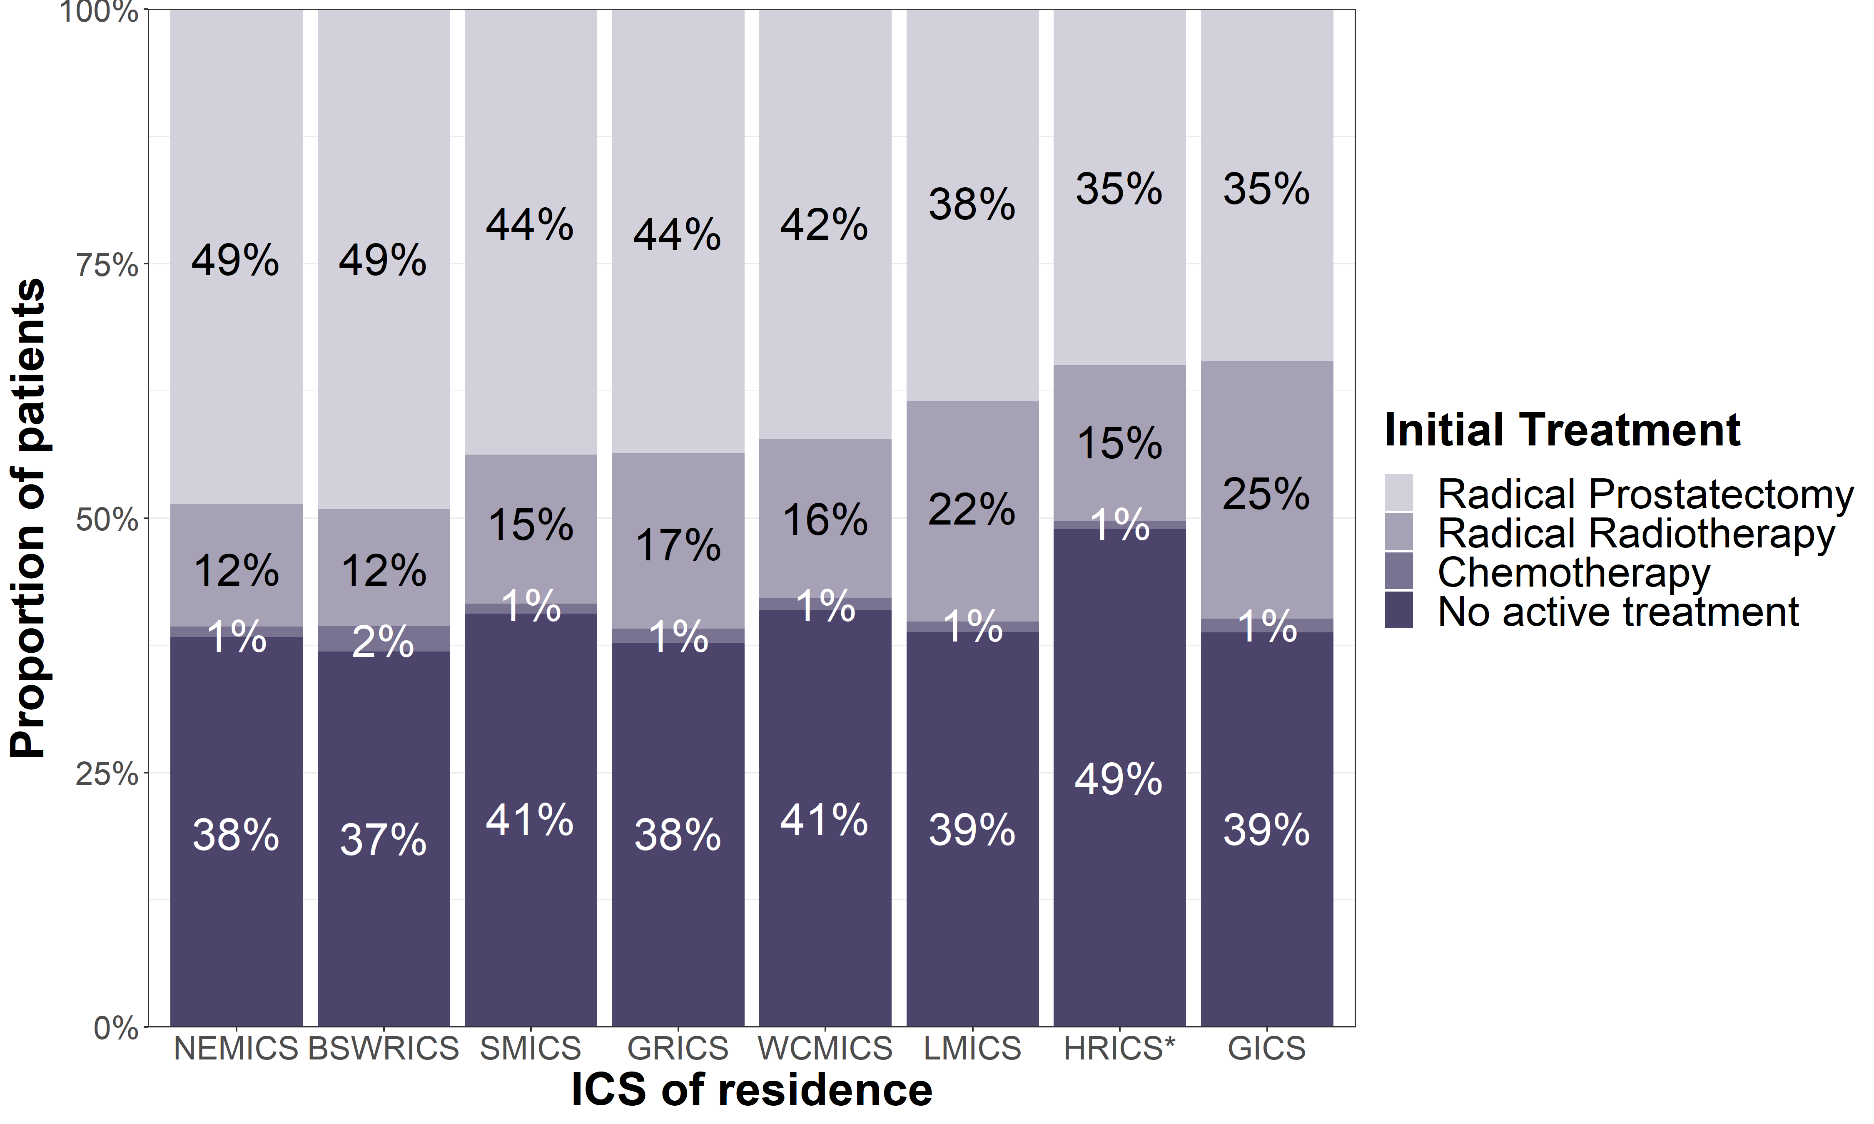
Patients living in HRICS may have been treated in New South Wales.
Figure 11: Variation in surgery type (robotic/open prostatectomy) and hospital type (public/private) by ICS of residence (2018–2019) (N = 4,233)
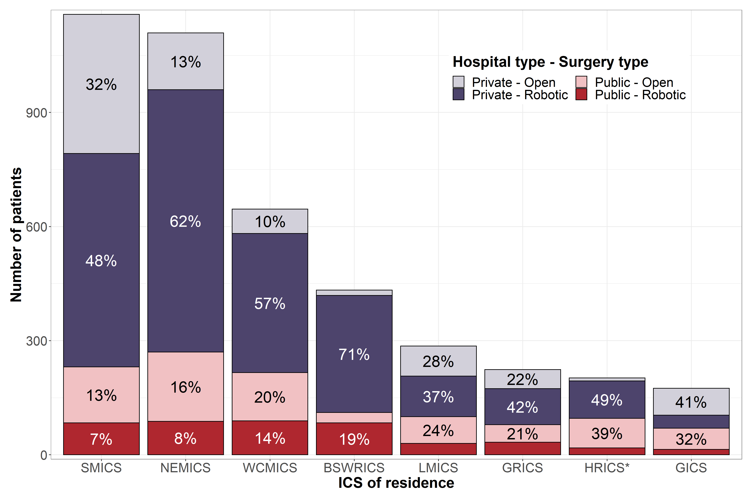
3%
4%
19%
8%
9%
15%
10%
6%
Data source: VAED 2018–2019 (calendar years)
ICS of residence based on postcode recorded in VAED admission. Non-Victorian patients excluded.
Patients living in HRICS may have been treated in New South Wales.
Table 7: Percentage of prostatectomies undertaken in Victorian hospitals that were robotic, by ICS of residence (N = 4,233)
ICS of residence | Number of patients who underwent surgery | Robotic surgery (% of total surgery)
BSWRICS | 433 | 392 (90.5%)
WCMICS | 646 | 455 (70.4%)
NEMICS | 1,109 | 778 (70.2%)
HRICS | 202 | 116 (57.4%)
GRICS | 224 | 128 (57.1%)
SMICS | 1,158 | 645 (55.7%)
LMICS | 286 | 137 (47.9%)
GICS | 175 | 48 (27.4%)
Victoria | 4,233 | 2,699 (64%)
Data source: VAED 2018–2019 (calendar years)
ICS of residence based on postcode recorded in VAED admission. Non-Victorian patients excluded.
Patients living in HRICS may have been treated in New South Wales.

Figure 12: Variation in surgery type (robotic/open prostatectomy), by hospital type and socioeconomic status (N = 4,233)
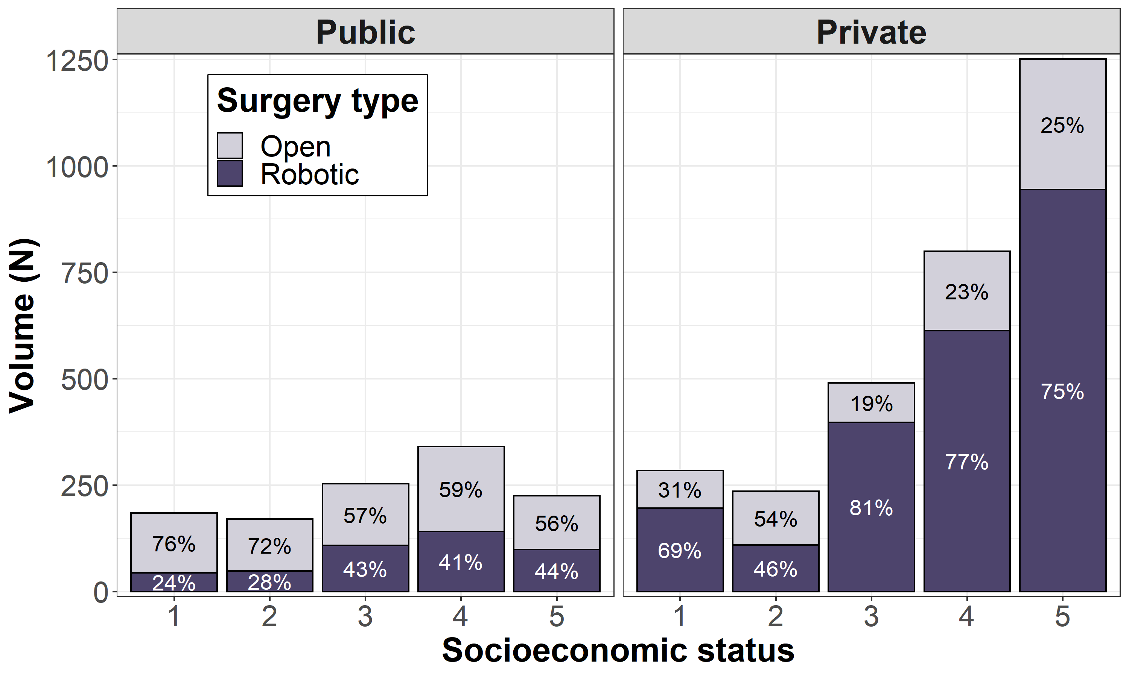
Most disadvantaged
Least disadvantaged
Data source: VAED 2018–2019 (calendar years)
SES based on local government area recorded in the VAED admission. Non-Victorian patients excluded.
Figure 13: Number of prostatectomies for non-metastatic prostate cancer patients by socioeconomic status and ICS of treatment (N = 8,818)
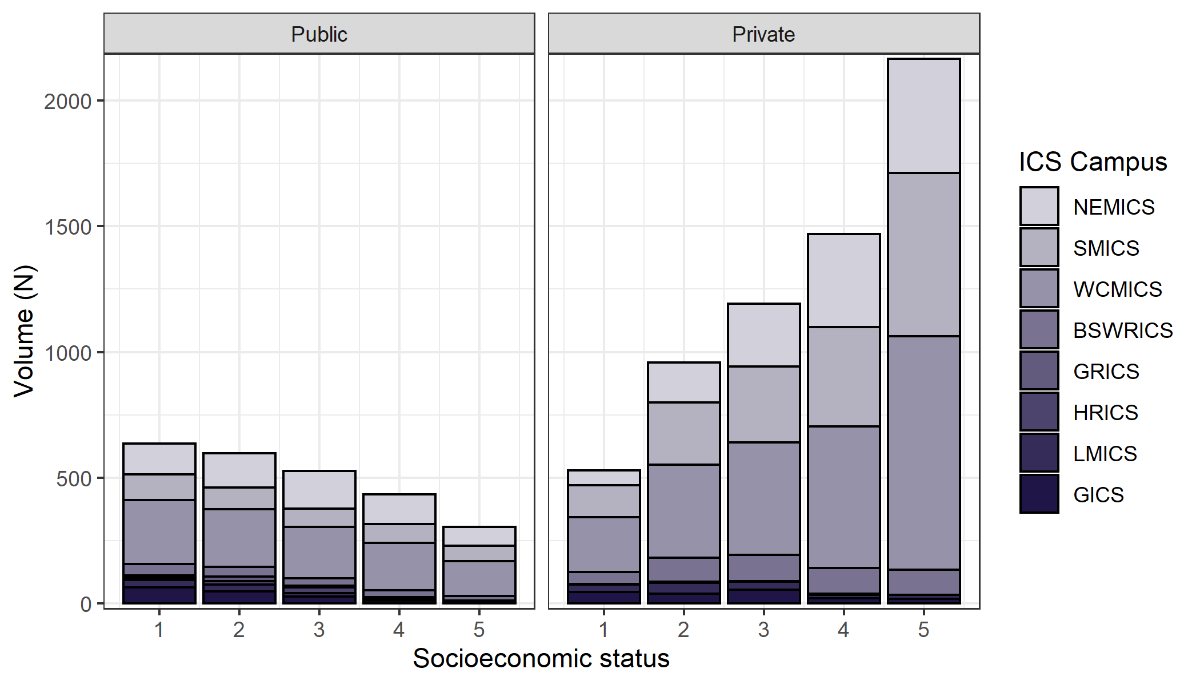
Most disadvantaged
Least disadvantaged
Table 8: Percentage of non-metastatic prostate cancer patients who had surgery, by socioeconomic status (N = 21,425)
SES quintile | Total patients | Surgical treatment within one year of diagnosis
1 (most disadvantaged) | 3,695 | 1,167 (32%)
2 | 4,075 | 1,557 (38%)
3 | 4,162 | 1,720 (41%)
4 | 4,334 | 1,905 (44%)
5 (least disadvantaged) | 5,159 | 2,469 (48%)
Overall | 21,425 | 8,818 (41%)
Figure 14: Treatment by NCCN risk group
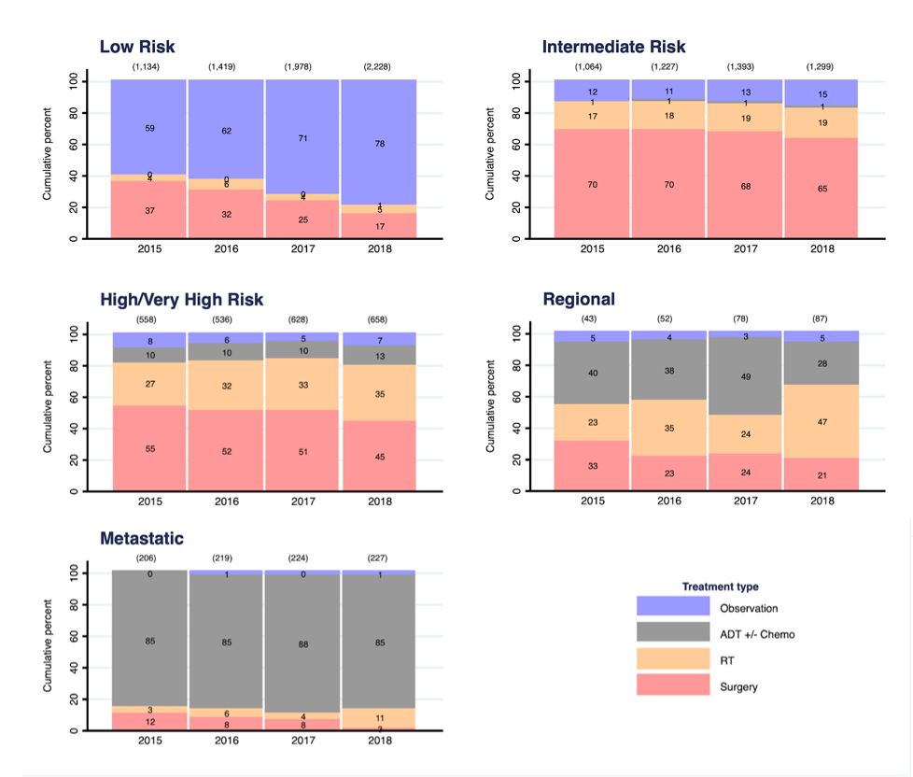
Data source: PCOR 2015–2018

Clinical commentary – variation in treatment
There is disparity in the use of equally effective treatment options (radical prostatectomy and radiation therapy) across ICS regions. There is very little local access to prostate brachytherapy across the state, particularly in public hospitals. Only 1–2 per cent of men with stage 2 or 3 prostate cancer had chemotherapy as their initial treatment. Associations between SES and surgery type and volume may reflect great ‘financial toxicity’ in the most disadvantaged SES. Variations in robotic prostatectomy rates, both by SES and geography, reflect the availability of robotic surgery. These more costly minimally invasive treatments may aid early return to work and reduce postoperative complications (not specifically examined).
Using the PCOR, we can see the change in treatment patterns over time by NCCN risk groupings – for example, that the proportion of low-risk patients treated with active surveillance increased over time.

Recent treatment trends
- The proportion of patients who had short course radiation therapy versus a long course has increased since 2016 (Figure 15).
  - 56 per cent of intermediate risk patients had a short course in the first half of 2019 compared with 20 per cent of men in the high to very high risk group.
- The use of docetaxel-containing therapies, as opposed to androgen deprivation therapy (ADT) alone, for metastatic hormone-sensitive prostate cancer patients increased over time, from 29 per cent in 2014 to 42 per cent in 2018 (Figure 16).
  - In 2018, for men under 70 years old, 70 per cent received docetaxel-containing therapies compared with 24 per cent for men 70 years or older (Figure 17).
Figure 15: Proportion of patients treated with a long or short course of radiation therapy by NCCN risk group and time
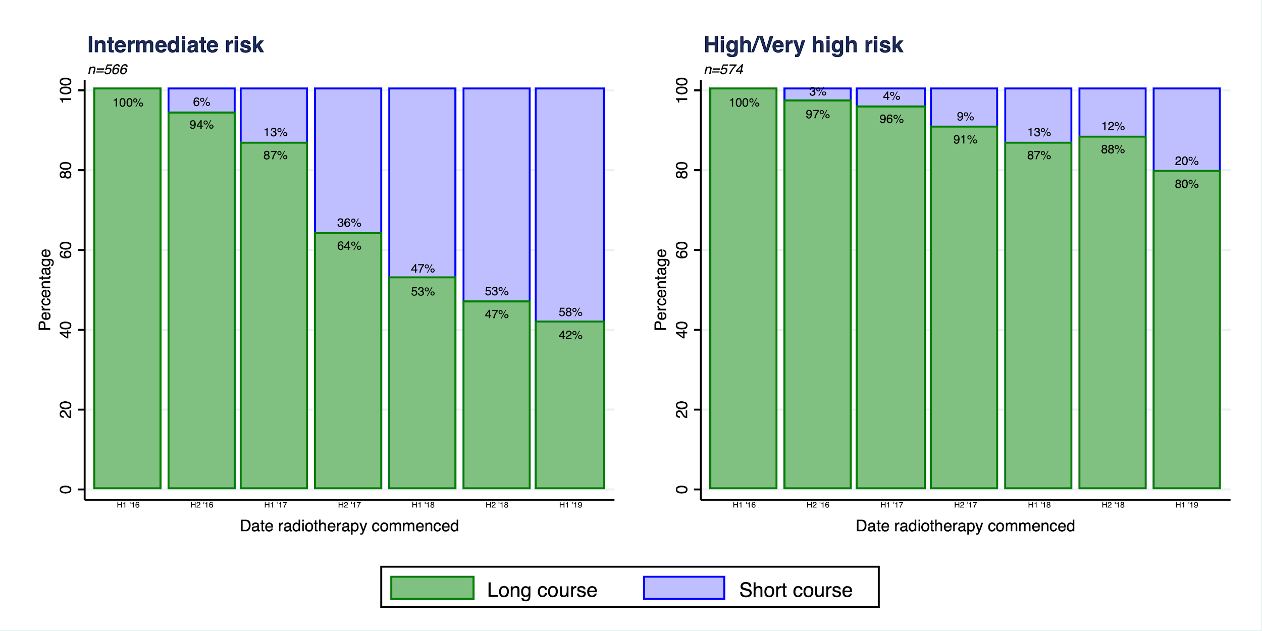
Data source: PCOR January 2016 to June 2019
Figure 16: Docetaxel-containing therapy utilisation for metastatic hormone-sensitive prostate cancer over time
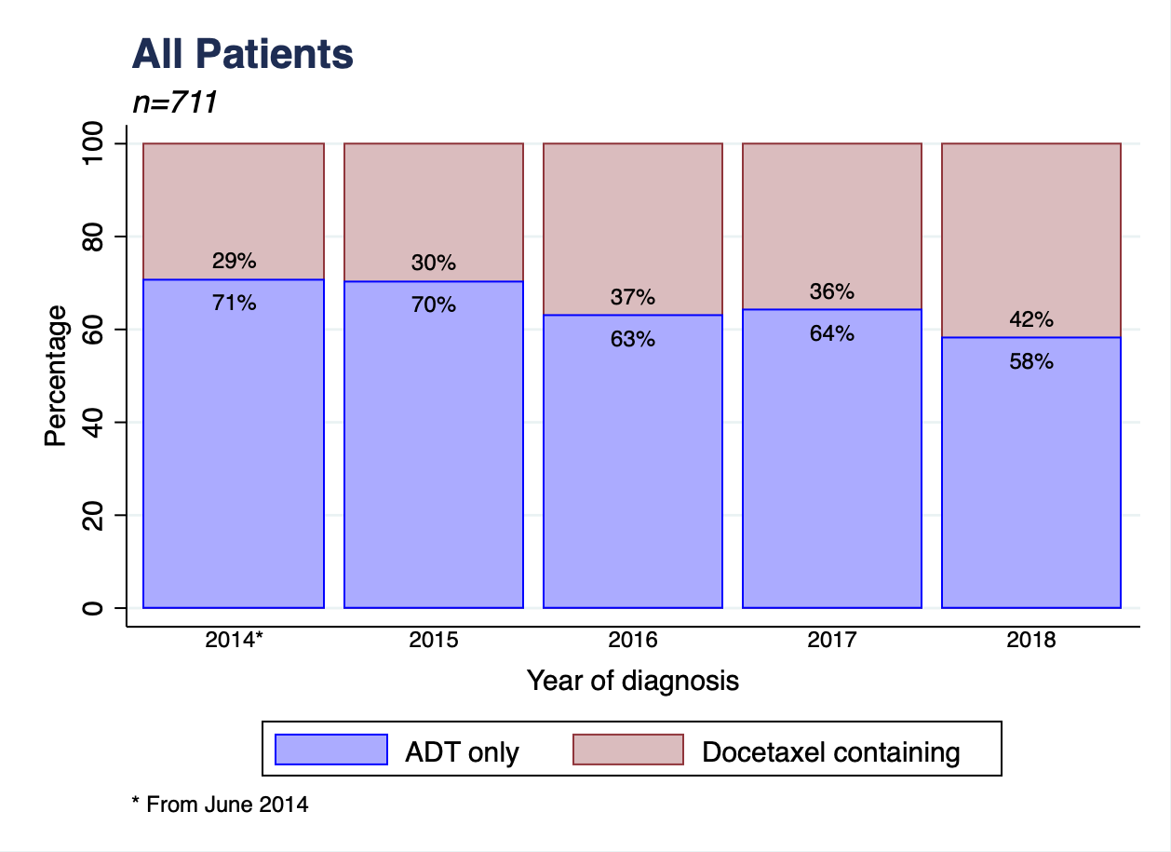
Data source: PCOR June 2014 to December 2018
Figure 17: Docetaxel-containing therapies for metastatic hormone-sensitive prostate cancer by age
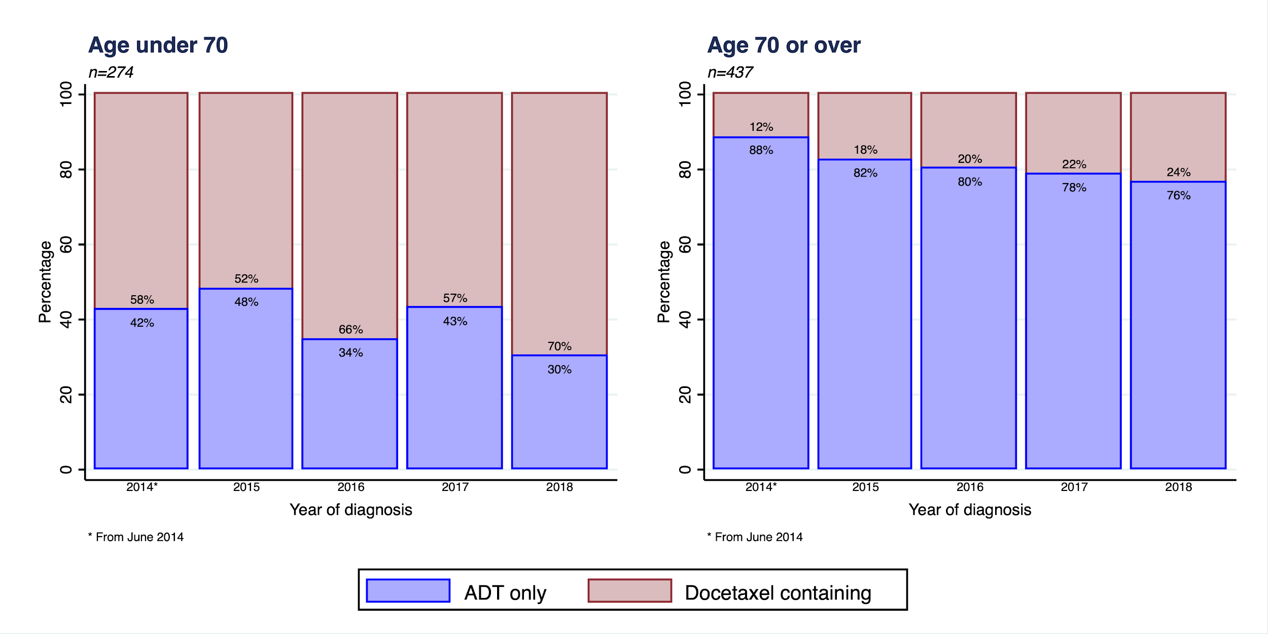
Data source: PCOR June 2014 to December 2018

Clinical commentary – recent treatment trends
The increase in short-course (versus long-course) radiation therapy and the increase in docetaxel-containing therapies (versus ADT alone), especially for men under 70 years of age, represents the influence and greater acceptance of evidence from studies that have emerged in recent years.

Survival
- The relative five-year survival varies by ICS of residence and is higher in metro ICS compared with regional ICS (Figure 18). This is consistent with overall cancer outcomes.
  - Five-year relative survival measures the likelihood of a person diagnosed with prostate cancer surviving for five years compared with similar men in the general population (for example, same age). Relative survival rates are determined by the outcomes of those diagnosed and the mix of cancer risk of progression in those diagnosed, and so difference between groups in relative survival may reflect management differences, or differences in the prognostic makeup of those diagnosed in the group.
  - There was statistically significant variation in relative survival by ICS of residence when compared to the statewide relative survival. The highest survival was observed in SMICS, with 96 per cent five-year survival (95 per cent CI: 95.0–97.0), while the lowest survival was observed in BSWRICS, with 88.8 per cent (95 per cent CI: 86.2–91.1). BSWRICS, GICS and GRICS all had significantly worse survival than the statewide relative survival, noting that the overall relative survival ranged from 88.8 to 96.0 per cent.
- The proportion of men with more aggressive cancer is higher in regional ICS compared with metro ICS (Table 9). If management of men was equally effective across the state, then the variation in aggressiveness alone might explain worse outcomes in certain areas.
Figure 18: Relative five-year survival for prostate cancer patients by ICS of residence
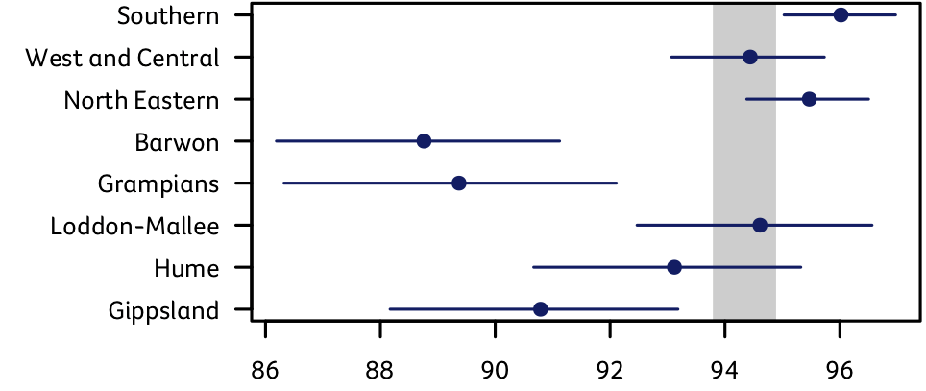
Five-year relative survival (%)
←Worse survival
Better survival→
Data source: VCR 2014–2018
Grey segment indicates the Victorian 95 per cent survival confidence intervals.
Error bars represent 95 per cent confidence intervals.
Table 9: Proportion of prostate cancer patients in each ISUP group by ICS of residence
ICS of residence | ISUP 1 | ISUP 2 | ISUP 3 | ISUP 4 | ISUP 5 | Metastatic | Unknown
NEMICS (n = 5,772) | 30% | 28% | 14% | 7% | 8% | 7% | 5%
SMICS (n = 6,761) | 32% | 29% | 13% | 6% | 7% | 7% | 4%
WCMICS (n = 3,748) | 31% | 26% | 13% | 7% | 8% | 9% | 6%
BSWRICS (n = 1,601) | 25% | 22% | 11% | 10% | 11% | 10% | 10%
GRICS (n = 1,360) | 24% | 26% | 14% | 8% | 11% | 10% | 7%
HRICS (n = 1,359) | 27% | 26% | 13% | 10% | 10% | 8% | 6%
LMICS (n = 1,756) | 29% | 24% | 15% | 7% | 11% | 9% | 5%
GICS (n = 1,023) | 21% | 19% | 18% | 9% | 15% | 11% | 6%
Total (n = 23,380) | 29% | 27% | 14% | 7% | 9% | 8% | 6%

Clinical commentary – survival
There are differences in five-year survival between ICS of residence, with metro ICS generally having higher survival rates than regional ICS. Whilst four ICS varied significantly from the statewide relative survival, it is worth noting that the magnitude of the difference between ICS is less than 10 per cent (range 88.8–96.0). The difference in survival could be attributable to more patients with advanced stage (ISUP group 5 or metastatic) in regional ICS.

Supportive care and unmet needs
Across the 21 public and four private hospitals audited, the overall documented evidence of supportive care screening is 19 per cent, with high variation between campuses (Figure 19).
Figure 19: Proportion of patients with documented evidence of supportive care screening (N = 139)
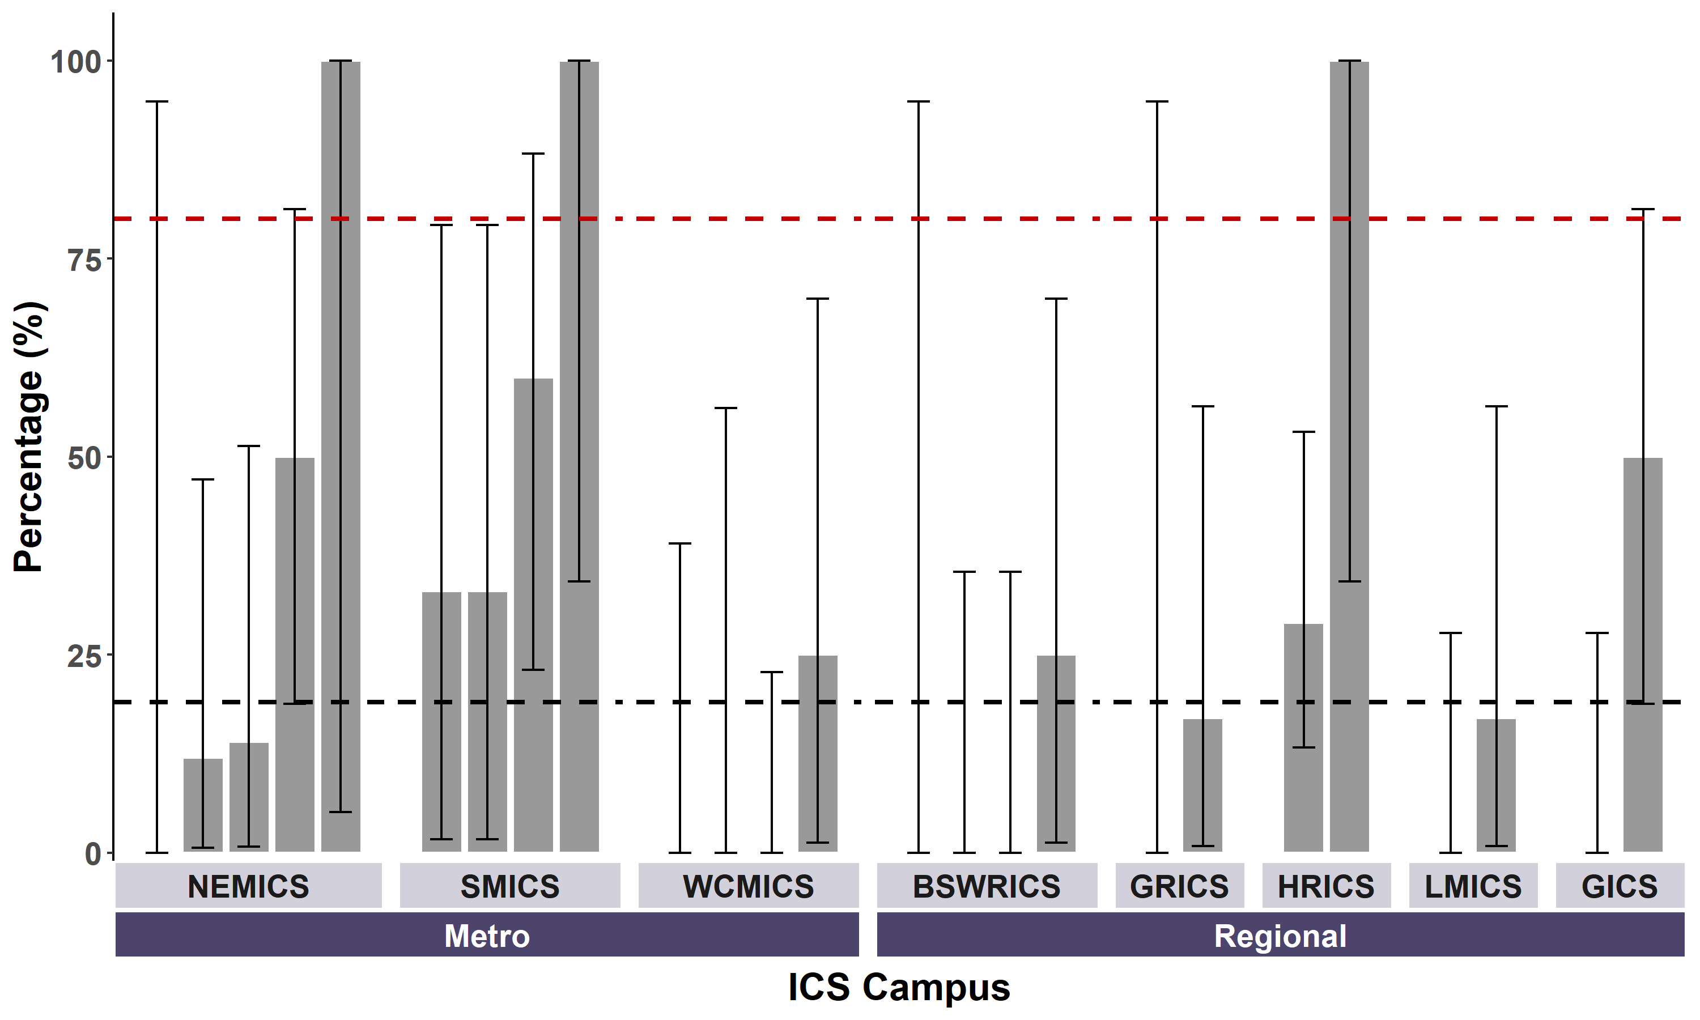
Target = 80%
Vic avg = 19%
Data source: CSPI medical record audit 2018
Bars represent 95 per cent confidence interval.
Patients living in HRICS may have been treated in New South Wales and not captured in the audit population.

Victorian Healthcare Experience Survey
- The 2019 VHES of patients treated in Victorian public hospitals in 2018 had 681 responses from prostate cancer patients (Table 10).
- Most patients (> 96 per cent) gave overall positive responses (Table 11).
- Areas that were rated more positively by men with prostate cancer compared with respondents with other types of cancer are listed in Table 12. However, there are also areas for improvement, including:
  - Respondents with prostate cancer were most likely to report that they had surgery-related bills to pay when compared with all other tumour types (19 per cent).
  - Depending on treatment type, between 10 and 15 per cent of men wanted information about financial support but did not receive it.
  - 50 per cent of men were not asked about support needs of family and friends.
Table 10: Distribution of treatment types for patients surveyed for VHES
Treatment type(s) received | Percentage of total respondents
Surgery | 39.8%
Radiation therapy | 24.3%
Chemotherapy or targeted therapies | 10.7%
Hormonal therapy | 25.3%
Total responses | 681
Data source: Victorian Healthcare Experience Survey
Acknowledgements: Victorian Agency for Health Information and Department of Health
Table 11: Percentage of positive responses from patients surveyed for VHES, by treatment type
Prostate cancer care | Percentage of positive responses | No. of responses
Surgery | 96.9% | 305
Radiation therapy | 98.5% | 183
Chemotherapy | 98.5% | 78
Overall care | 97.5% | 463
Data source: Victorian Healthcare Experience Survey
Acknowledgements: Victorian Agency for Health Information and Department of Health
Table 12: Percentage of positive responses for indicators where prostate cancer patients rated highly compared with other cancer types
Indicators | Percentage of positive responses
Informed about how to manage ongoing symptoms or side effects  after treatment | 81.3%
GP had a good understanding of follow-up care needs such as symptom management support | 81.3%
Communication with health professionals | 85.6%
Felt able to ask health professionals any questions | 86.6%
Informed about the impact of treatment on ability to perform work/other activities | 79.9%
Given information about things to do to stay healthy such as exercise, diet, stopping smoking | 77.9%
Data source: Victorian Healthcare Experience Survey
Acknowledgements: Victorian Agency for Health Information and Department of Health

Survivors’ unmet needs survey
As an outcome of the first Prostate Cancer Summit, the Victorian ICS funded the Unmet Need Project, which was run by PCOR-Vic. Its aim was to learn about the unmet needs of men diagnosed with prostate cancer 12 months after treatment. The ‘Survey of Survivor Unmet Needs’ was administered 12 months after treatment with data collected from March 2019 to December 2020. Figure 20 shows an example of the survey. The survey includes four domains of unmet needs:
- information needs
- work and financial needs
- access and continuity of care needs
- coping, sharing and emotional needs.
The items that showed high unmet needs in prostate cancer patients are shown in Figure 21.
Figure 20: Example of the Survey of Survivor Unmet Needs
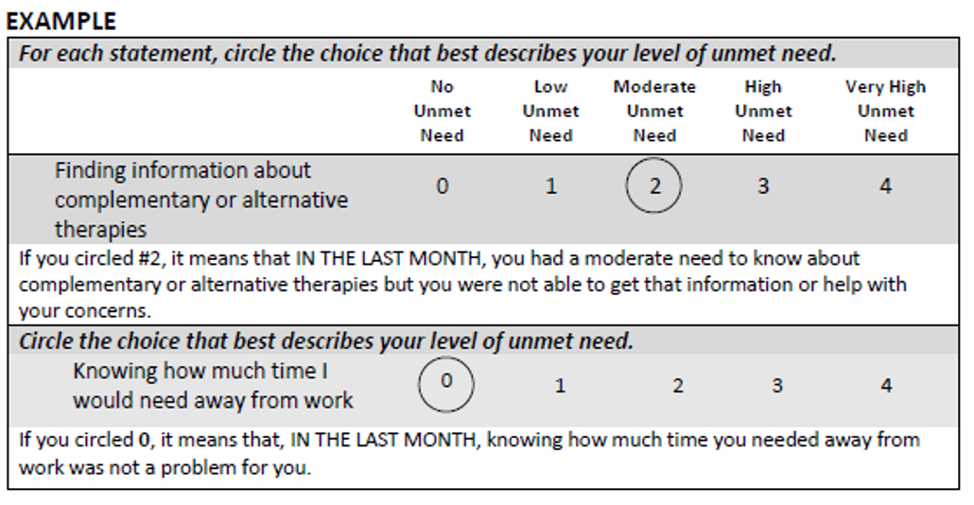
Figure 21: Top unmet needs from the Survey of Survivor Unmet Needs for men with prostate cancer
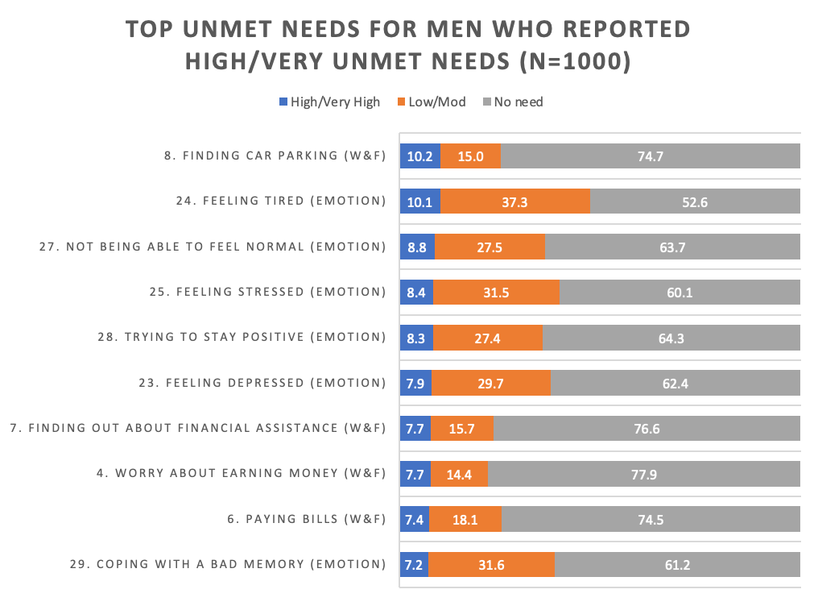

Clinical commentary – supportive care and unmet needs
Uptake of supportive care screening is low, with a statewide average of 19 per cent, well below the target of 50 per cent at the time of audit. This may be an underestimate of the actual amount of screening, since the 19 per cent figure is based on finding written evidence of the use of a validated supportive care screening tool; an inability to find documentation is counted as ‘not screened’. This reflects the policy intent of sharing information about supportive care needs across the treating team.
The VHES indicates that most patients are positive overall about their cancer care experience. Some areas for improvement include financial areas, lack of information for some men, and that some men were not asked about their support needs and the need for information.
The findings encourage an improvement in supportive care screening, to consider closer investigation of ‘financial toxicity’, and to identify other potential existing data (for example, the Expanded Prostate cancer Index Composite short form survey from PCOR) to identify areas of concern and address these with interventions.

Abbreviations
CI | confidence interval
CSPI | Cancer Services Performance Indicator
ICS | Integrated Cancer Service
ISUP | International Society of Urological Pathology
MDM | multidisciplinary meeting
NCCN | National Cancer Comprehensive Network
OCP | optimal care pathway
PCOR-Vic | Prostate Cancer Outcomes Registry – Victoria
SES | socioeconomic status
VAED | Victorian Admitted Episodes Dataset
VCR | Victorian Cancer Registry
VHES | Victorian Healthcare Experience Survey
VRMDS | Victorian Radiotherapy Minimum Data Set

Victorian Integrated Cancer Services
NEMICS | North Eastern Melbourne Integrated Cancer Service
SMICS | Southern Melbourne Integrated Cancer Service
WCMICS | Western and Central Melbourne Integrated Cancer Service
BSWRICS | Barwon South Western Regional Integrated Cancer Service
GRICS | Gippsland Regional Integrated Cancer Services
HRICS | Hume Regional Integrated Cancer Service
LMICS | Loddon Mallee Integrated Cancer Service
GICS | Grampians Integrated Cancer Service

Glossary
Chemotherapy | An admitted episode in the VAED where the admission date was between 30 days prior and one year after the patient’s prostate cancer diagnosis date and included a chemotherapy diagnosis, procedure or diagnosis related group code (Supplementary Table 3).
Comorbidity count | A count measuring the number of comorbid conditions a patient has at diagnosis, which may influence their prognosis. Data on patient comorbidities was extracted from diagnosis codes of admitted episodes in the VAED in the year prior to 30 days after the patient’s prostate cancer diagnosis date. Patients without admitted episodes were assumed to have no comorbidities. The comorbidity count was calculated for each patient according to Quan et al. (excluding cancer and metastases) and grouped into four categories (0, 1, 2 and 3+).  Diagnosis codes for comorbidities can only be assigned in the admitted episode when the comorbidities meet criteria for coding in line with the Australian Coding Standards. As a result, the identification of comorbidities is underestimated.  Conditions included in the comorbidity count:  - AIDS/HIV  - congestive heart failure  - chronic pulmonary disease  - dementia  - diabetes with chronic complications  - hemiplegia or paraplegia  - mild liver disease  - moderate/severe liver disease  - renal disease  - rheumatic disease.
Death certificate only | A method of cancer notification to the VCR whereby the death certificate provides the only notification of a person’s cancer to the registry.
Diagnosis date | The date of the pathology report or other investigative report where the diagnosis of prostate cancer was first confirmed to the VCR.
ISUP grade group | ISUP grade groups were based on the Gleason score. The two most common grades identified from samples of tissue are added together to calculate the Gleason Score.  - Grade group 1: Gleason Score ≤ 6  - Grade group 2: Gleason Score 7 (3 + 4)  - Grade group 3: Gleason Score 7 (4 + 3)  - Grade group 4: Gleason Score 8  - Grade group 5: Gleason Score 9 or 10  In the linked dataset, the ISUP grade group is categorised for patients with localised disease. Where patients were identified as metastatic, they are identified as such and their ISUP groups not broken out.
NCCN risk group | Metastatic disease in the PCOR dataset is any T, any N, M1.  Nodal disease in the PCOR dataset is any T, N1, M0.  High- or very high-risk disease is N0 and M0 and at least one of the following: PSA > 20 ng/mL, ISUP > 3, or cT > 2.  Low-risk disease is N0 and M0 and cT < T2b and PSA < 10 and ISUP < 2.  Intermediate-risk disease is N0 and M0 and neither high-risk nor low-risk disease.
Radiation therapy (radical) | Radiation therapy courses in the VRMDS where the start date was between 30 days prior and one year after the patient’s prostate cancer diagnosis date, the primary site was a prostate cancer code (ICD-10-AM C61), the target site was ‘prostate’, ‘prostate/lymph nodes’, or ‘pelvis’ and the treatment intent was radical.
Radiation therapy (palliative) | Radiation therapy courses in the VRMDS where the start date was between 30 days prior and one year after the patient’s prostate cancer diagnosis date, the primary site was a prostate cancer code (ICD-10-AM C61), the target site was any and the treatment intent was palliative.
Radiation therapy – long course | Radiation therapy administered over a ‘traditional’ or ‘conventional’ duration using radiation doses with each daily treatment (or ‘fraction’) of approximately 2 gray The treatment time is usually just under eight weeks.
Radiation therapy – short course | Refers to radical radiation therapy administered over a shorter duration than ‘traditional’ or ‘conventional’ in Australia, using higher radiation doses with each daily treatment (or ‘fraction’), typically 3 gray or more. The treatment time is usually four weeks or less.
Prostatectomy (open) | An admitted episode in the VAED where the admission date was between 30 days prior and one year after the patient’s prostate cancer diagnosis date and the episode included a prostate surgery procedure code (Supplementary Table 2, ‘Prostatectomy’ group).
Prostatectomy (robotic) | An admitted episode in the VAED where the admission date was between 30 days prior and one year after the patient’s prostate cancer diagnosis date and the episode included both a prostate surgery procedure code (Supplementary Table 2, ‘Prostatectomy’ group), as well as a robotic surgery code (Supplementary Table 2, ‘Robotic surgery’ group) within the same admission.
Socioeconomic status (SES) | A measure of a person’s economic and social position within society, which tends to be positively associated with better health. In this report SES is based on the Index of Relative Socio-Economic Disadvantage (IRSD) included in the Socio-Economic Index of Areas published by the Australian Bureau of Statistics. Victorians were assigned an IRSD score using their residential address at the time of their diagnosis. IRSD scores have been grouped into quintiles (from 1 – most disadvantaged, to 5 – least disadvantaged).

Supplementary material

Codes

Diagnosis
Supplementary Table 1: Prostate cancer diagnosis codes
ICD-10-AM | Description
C61 | Malignant neoplasm of prostate

Surgery
Supplementary Table 2: Surgical procedures codes used to identify patients who underwent prostatectomy (robotic or open)
Group | ICD-10-AM/ ACHI/ACS code | Description
Prostatectomy | 3720900 | Radical prostatectomy
Prostatectomy | 3720901 | Laparoscopic radical prostatectomy
Prostatectomy | 3721000 | Radical prostatectomy with bladder neck reconstruction
Prostatectomy | 3721001 | Laparoscopic radical prostatectomy with bladder neck reconstruction
Prostatectomy | 3721100 | Radical prostatectomy with bladder neck reconstruction and pelvic lymphadenectomy
Prostatectomy | 3721101 | Laparoscopic radical prostatectomy with bladder neck reconstruction and pelvic lymphadenectomy
Robotic surgery | 9623300 | Robotic assisted intervention

Chemotherapy
Supplementary Table 3: Diagnosis, procedure and diagnosis related group codes used to identify patients who received chemotherapy
Code group | Code | Description
Diagnosis | Z511 | Pharmacotherapy session for neoplasm
Procedure | 9619600 | Intra-arterial administration of pharmacological agent, antineoplastic agent
Procedure | 9619700 | Intramuscular administration of pharmacological agent, antineoplastic agent
Procedure | 9619800 | Intrathecal administration of pharmacological agent, antineoplastic agent
Procedure | 9619900 | Intravenous administration of pharmacological agent, antineoplastic agent
Procedure | 9620000 | Subcutaneous administration of pharmacological agent, antineoplastic agent
Procedure | 9620100 | Intracavitary administration of pharmacological agent, antineoplastic agent
Procedure | 9620200 | Enteral administration of pharmacological agent, antineoplastic agent
Procedure | 9620300 | Oral administration of pharmacological agent, antineoplastic agent
Procedure | 9620500 | Other administration of pharmacological agent, antineoplastic agent
Procedure | 9620600 | Unspecified administration of pharmacological agent, antineoplastic agent
Procedure | 9620900 | Loading of drug delivery device, antineoplastic agent
Diagnosis related group | R63Z | Chemotherapy

Refer to the ‘Abbreviations’ page for a list of Victoria’s Integrated Cancer Services.
Victorian Cancer Registry, Cancer in Victoria 2020, Cancer Council Victoria, Melbourne, viewed on 7 February 2022, <https://www.cancervic.org.au/research/vcr/fact-sheets-and-annual-reports>
Victorian Cancer Registry, Cancer in Victoria 2020, Cancer Council Victoria, Melbourne, viewed 7 February 2022, <https://www.cancervic.org.au/research/vcr/fact-sheets-and-annual-reports>
Victorian Cancer Registry, Cancer in Victoria 2020, Cancer Council Victoria, Melbourne, viewed on 7 February 2022, <https://www.cancervic.org.au/research/vcr/fact-sheets-and-annual-reports>
Quan H, Li B, Couris C, et al. 2011, ‘Updating and validating the Charlson comorbidity index and score for risk adjustment in hospital discharge abstracts using data from 6 countries’, American Journal of Epidemiology, vol. 173, no. 6, pp. 676–682.
Australian Coding Standard ACS 0002 Additional Diagnoses.

