Travelling overseas with subcutaneous immunoglobulin (SCIg) – medical/nurse coordinator considerations
More detailed information regarding “Supply of Blood and Blood Related Products for use by Australian Residents Temporarily Overseas” is available at the National Blood Authority (NBA) website: https://www.blood.gov.au/system/files/documents/overseas-use-factsheet.pdf
If required, contact Australian Red Cross Lifeblood (Lifeblood) at csradmintransfusionsupportaus@redcrossblood.org.au for assistance.

- Current authorisation for SCIg in BloodSTAR:
    - Consider an infusion of IVIg prior to travel and upon return to avoid the need to take any product overseas – depending on length of travel and clinical condition
    - The patient must have a current authorisation for SCIg in BloodSTAR
    - The authorisation must be valid for the full duration of intended travel
    - As Cuvitru must be transported and stored at 2-8˚ Celsius, patients who administer Cuvitru have the option to change to Hizentra prior to travel if they wish. They can remain on Hizentra on their return or revert back to Cuvitru. The treating doctor will need to request a change of product, for travel purposes, in BloodSTAR. (www.blood.gov.au). The NBA has a tipsheet to help with this. BloodSTAR - Requesting a product and dose change or an additional dose
    - Patients who do decide to travel with Cuvitru will be responsible for maintaining the product at 2-8˚ Celsius throughout the period of travel. Lifeblood shippers do not guarantee storage at 2-8˚ Celsius, therefore patients may need to supply and pack their own shipper which will maintain the required temperature.
- Documentation required:
    - Copy of the patient’s passport
    - Copy of the patient’s flight itinerary – (details for all flights are required)
    - Complete the form - Approval to Supply Blood Products to Australian Residents for Use Overseas
    - Email all documentation to csradmintransfusionsupportaus@redcrossblood.org.au as far in advance as possible and at least 4 weeks prior to departure date.
- Therapeutic Goods Administration (TGA) Export permit:
    - The documentation provided to Lifeblood will be forwarded to the TGA to obtain an Export permit for the product – this permit is required for the patient to travel with SCIg.
- Patient letter - prepare a letter for the patient including:
    - Treating doctor details
    - Diagnosis
    - Reason SCIg required
    - Dose and product

- Ordering the product:
    - You will need to inform the dispenser that a special order is required
    - The amount of product required for the journey will need to be requested via BloodNet “Please pack for travel” must be annotated in the comments field
    - It is advised that the product is collected as close to departure date as feasible – either the morning of travel (if time permitting), or the business day prior to departure
    - The product will be packed for travel, the shipper will be sealed and have a copy of the TGA Export permit attached to the outside
    - More than 1 shipper may be required depending on the amount of product required
    - The shipper must not be opened – if it appears to have been opened the airline may not permit the patient to board the aircraft with the product.

Travelling overseas with subcutaneous immunoglobulin (SCIg) – patient considerations

- Confirm travel details:
    - Duration of travel
    - Number of doses required for time away.
- As Cuvitru must be transported and stored at 2-8˚ Celsius, if you administer Cuvitru you have the option to change to Hizentra prior to travel if you wish. You can remain on Hizentra on your return or revert back to Cuvitru. Patients who decide to travel with Cuvitru will be responsible for maintaining the product at 2-8˚ Celsius throughout the period of travel. Lifeblood shippers do not guarantee storage at 2-8˚ Celsius, therefore patients may need to supply and pack their own shipper which will maintain the required temperature.
- Ensure you have enough consumables for the duration of travel.
- Letter to take with you from your treating doctor including:
    - Treating doctors’ details
    - Diagnosis
    - Reason SCIg required
    - Dose and product
- Contact the airline to ensure the shipper box can be taken as carry-on luggage and if there are any other conditions. (See below for shipper box dimensions)
- Check with Customs/Embassy of your destination (and all countries travelled through) to see if an Import Permit is required – Lifeblood is not able to assist with the acquisition of Import Permits.
- Make a plan with your treating specialist in case you become unwell overseas –The Department of Foreign Affairs and Trade (DFAT) encourage travellers to subscribe, via the travel tab on their website, to receive travel advice and alerts to the destinations you are travelling to and through. http://dfat.gov.au/pages/default.aspx
- Arrange collection of SCIg prior to travel. Generally, day of departure or 1 day prior, whichever is the most feasible based on time of flight, vicinity to hospital etc.
- IMPORTANT – DO NOT OPEN or tamper with the shipper box – it will be packaged for the flight and the airline may refuse to accept if there is any evidence that the shipper has been opened or tampered with. An Export permit will be attached to the outside of the shipper box for easy customs access.
Example of the shippers Lifeblood pack the product in:  Large: 26 x 35 x 38cm  Small: 24 x 19 x 25cm  The size and number of shippers required will depend on the amount of product requested.  Each shipper is sealed with a copy of the TGA export permit attached to the outside. |  | 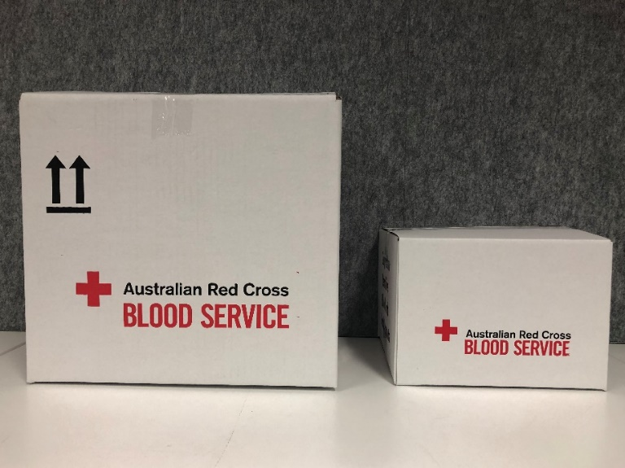

To receive this document in another format, phone 03 9694 0102, using the National Relay Service 13 36 77 if required, or email Blood Matters <bloodmatters@redcrossblood.org.au>.
Authorised and published by the Victorian Government, 1 Treasury Place, Melbourne.
© State of Victoria, Australia, Department of Health, July 2023.
ISBN 978-1-76131-191-8 (pdf/online/MS word)
Available at Blood Matters Program <https://www.health.vic.gov.au/patient-care/blood-matters-program>

