Brain cancer in Victoria
Optimal care pathway data summary report 2020
OFFICIAL

To receive this document in another format, phone (03) 9456 3332, using the National Relay Service 13 36 77 if required, or email the Cancer Support, Treatment and Research unit <cancerplanning@health.vic.gov.au>.
Authorised and published by the Victorian Government, 1 Treasury Place, Melbourne.
© State of Victoria, Australia, Department of Health, May 2023.
ISBN 978-1-76096-977-6 (pdf/online/MS word)
Available at the department’s cancer webpage <www.health.vic.gov.au/health-strategies/cancer-care>.

Foreword
This report summarises the data analyses prepared for the first Brain Cancer Summit, which took place online on 22 and 29 October 2020.
The Victorian Tumour Summits are clinician-led forums to identify unwarranted variations in tumour-based clinical practice and cancer outcomes. We were honoured to co-chair the Brain Cancer Summit Working Group. The group was convened to guide the analyses of statewide routine datasets to understand the current patterns of care for Victorians with brain cancer. This work helped frame discussions about variations in care and has highlighted areas needing further investigations and action.
We thank the working group and participants of the summit for their time, effort, active contributions and support throughout the summit process. We also acknowledge Ella Stuart and Norah Finn, who undertook the data analyses.
We look forward to ideas generated during the summit that inform ongoing measurable work so we can make meaningful improvements to brain cancer outcomes and patient experiences.

Professor Andrew Danks
Co-chair, Brain Cancer Summit

Professor Hui Gan
Co-chair, Brain Cancer Summit

Contents
Foreword 3
List of figures 5
List of tables 6
Acknowledgements 7
Introduction 8
More information 8
Data sources 9
Linked dataset 9
Other data sources 10
At a glance 11
Key findings 11
Key variations for action 12
Brain cancer demographics, incidence and mortality 13
Tumour characteristics 15
Surgery 16
Volume of all major brain surgeries 16
Mortality within 30 days of malignant brain tumour surgery 16
Length of stay after surgical/biopsy admissions 17
Multidisciplinary team meetings 20
Treatment 22
Treatment for brain cancer 22
Treatment for glioblastoma 25
Timeliness of treatment for glioblastoma 28
Treatment for oligodendroglioma 29
Treatment for astrocytoma (grades 2 and 3) 32
Survival 35
Palliative and supportive care 39
Abbreviations 42
Victorian Integrated Cancer Services 42
Glossary 43
Supplementary material 45
Codes 45

List of figures
Figure 1: Age-standardised incidence and mortality rate per 100,000 population, by sex, for Victorians with brain cancer (diagnosed 1982 to 2017) 14
Figure 2: Victorian hospital average annual major brain tumour surgery volume (July 2016 to June 2018) (N = 3,437) 16
Figure 3: Proportion of brain cancer patients who died within 30 days of first major brain surgery, by campus of surgery (diagnosed 2013 to 2017) (N = 1,507) 17
Figure 4: Percentage of acute brain surgical episodes with a length of stay greater than the median length of stay, by ICS of residence 18
Figure 5: Percentage of acute major brain surgical admissions with a length of stay greater than the median length of stay, by ICS of surgery campus 18
Figure 6: Percentage of acute biopsy admissions length of stay greater than the median length of stay, by ICS of surgery campus 19
Figure 7: Percentage of patients with documented evidence of a multidisciplinary team meeting in their central medical record (N = 148) 20
Figure 8: Percentage of patients with documented evidence of communication of their initial treatment plan to their GP (N = 148) 21
Figure 9: Proportion of glioblastoma patients with 20 or more fractions delivered in the first radiotherapy course (N = 954) 27
Figure 10: Proportion of glioblastoma patients who had radiotherapy within three months of major brain surgery (N = 1,012) 28
Figure 11: Timeliness of starting radiotherapy following brain surgery (major or biopsy) for glioblastoma patients by radiotherapy region and region of residence (N = 896) 29
Figure 12: Proportion of radiotherapy courses with low fractions (< 20 fractions) or high fractions (≥ 20 fractions), by astrocytoma grades (N = 179) 33
Figure 13: Survival by morphology group for brain cancer patients (N = 2,182) 35
Figure 14: Hazard ratios estimated by Cox proportional hazards models for the association between risk of death and morphology group adjusting for age, sex and Charlson Comorbidity count 36
Figure 15: Kaplan-Meier survival curves by ICS of residence for glioblastoma (N = 1,394) 36
Figure 16: Hazard ratios estimated by Cox proportional hazards models for the association between risk of death of glioblastoma patients and ICS of residence adjusting for age, sex and Charlson comorbidity count (N = 1,394) 37
Figure 17: Documented evidence of supportive care screening using a validated tool (2017) (N = 148) 39
Figure 18: Palliative care (inpatient and non-admitted) from 365 days prior until 30 days before death for brain cancer patients (N = 1, 516) 40

List of tables
Table 1: Demographic characteristics of brain cancer patients diagnosed between 2013 and 2017 13
Table 2: Tumour characteristics of brain cancer patients diagnosed between 2013 and 2017 15
Table 3: Treatment for brain cancer within one year of diagnosis by morphology group 23
Table 4: Brain cancer patient pathways from ICS of residence to ICS of surgery for major brain surgery (N = 1,507) 24
Table 5: Brain cancer patients pathways from ICS of residence to ICS of radiotherapy (N = 1,283) 24
Table 6: Treatment within one year of glioblastoma diagnosis by ICS of residence 26
Table 7: Treatment within one year of glioblastoma diagnosis by age at diagnosis 27
Table 8: Treatment within one year of diagnosis of oligodendroglioma by ICS of residence (N = 115) 30
Table 9: Treatment within one year of diagnosis of oligodendroglioma by morphology (N = 115) 30
Table 10:Treatment within one year of oligodendroglioma diagnosis by age at diagnosis (N = 115) 31
Table 11: Total number of oligodendroglioma patients by morphology and age at diagnosis (N = 115) 31
Table 12: Treatment within one year of diagnosis of astrocytoma diagnosis by ICS of residence (N = 304) 32
Table 13: Treatment within one year of astrocytoma diagnosis by morphology grade (N = 304) 33
Table 14:Treatment within one year of grade 2 astrocytoma diagnosis by risk status 34
Table 15: One- and two-year survival for glioblastoma by ICS of residence (N = 1,394) 37
Table 16: Acute hospital-based care in the last 30 days of life for brain cancer patients 40
Supplementary Table 1: Brain cancer diagnosis codes 45
Supplementary Table 2: Brain cancer morphology groups 45
Supplementary Table 3: Surgical procedures codes used to identify patients who underwent major brain tumour surgery 45
Supplementary Table 4: Surgical procedures codes used to identify patients who underwent brain tumour biopsy 46
Supplementary Table 5: Surgical procedures codes used to identify patients who underwent other brain tumour procedures 47
Supplementary Table 6: Diagnosis, procedure and diagnosis related group codes used to identify patients who received chemotherapy 47

Acknowledgements
The data, analysis and commentary provided in this report represent a joint effort by key contributors from the following groups.
Team | Membership
Brain Cancer Summit Working Party | Dr Vishal Boolell  Ms Rebecca Chapman  Dr Lawrence Cher  Dr Jonathan Clark  Dr Mike Dally  A/Prof. Andrew Danks (co-chair)  Mr Rana Dhillon  Dr Tony Dowling  Prof. Kate Drummond  Dr Ronnie Freilich  Prof. Hui Gan (co-chair)  A/Prof. Martin Hunn  Dr Craig MacLeod  A/Prof. Paul Mitchell  Prof. Jennifer Philip  Dr Claire Phillips  Dr Simone Reeves  Ms Emma Reiterer  Dr Ayesha Saqib  Dr Mori Wada
Data analysis | Ms Ella Stuart  Ms Norah Finn
Victorian Tumour Summits Project Team | Ms Lori Cameron  Ms Dianne Legge  Ms Rebecca Miller  Ms Janine Scott  Ms Kathy Simons
We also gratefully acknowledge the providers of the Victorian Cancer Registry data, Victorian Admitted Episodes Dataset and the Victorian Radiotherapy Minimum Dataset, as well as the Centre for Victorian Data Linkage for performing the linkages between the Victorian Cancer Registry and administrative datasets. The summit was only possible with the generous support of the Cancer Support, Treatment and Research unit in the Victorian Department of Health.
To view the Brain Cancer Summit data presentation and related documents, visit the Brain Cancer Summit meeting page <https://www.tumoursummits.org.au/brain>.

Introduction
The data presented in this report are a summary of the analyses prepared for the 2020 Brain Cancer Summit. The Brain Cancer Summit is part of the Victorian Tumour Summits program, an initiative of the Victorian Integrated Cancer Services (ICS) delivered in collaboration with the Department of Health and Cancer Council Victoria. The summits support the broader program of work implementing the optimal care pathways (OCPs).
The Brain Cancer Summit was held online across two two-hour Zoom sessions held one week apart, on 22 and 29 October 2020. Eighty active participants and 35 observers attended. In this summit, data on cancer care and outcomes for all brain cancer diagnoses between 2013 and 2017 were presented. Clinical commentary and recommendations from the summit are included in this report.

More information
- Find out more about the Brain Cancer Summit from the Victorian Tumour Summits website <https://www.tumoursummits.org.au/brain>.
- The high-grade glioma OCP can be viewed and downloaded from the Cancer Council Australia website <www.cancer.org.au/OCP>. Please note that the second edition of the OCP was released after the Brain Cancer Summit.

Data sources

Linked dataset

Datasets
The Victorian Cancer Registry (VCR) is a population-based cancer registry that collects demographic and tumour details, including diagnosis date and region of residence, for all Victorian residents who are diagnosed with cancer. The department’s Centre for Victorian Data Linkage performs an annual data linkage between the VCR and administrative datasets including the Victorian Admitted Episodes Dataset (VAED), the Victorian Radiotherapy Minimum Data Set (VRMDS) and the Victorian Death Index. Linking the VCR to the VAED provides information captured within inpatient settings in all Victorian public and private hospitals such as patient diagnoses (for example, comorbidities, distant metastases) and cancer treatment, including surgery and intravenous chemotherapy (excluding oral chemotherapy). Linking the VCR to the VRMDS provides information on admitted and non-admitted radical and palliative radiotherapy courses provided in Victorian public and private radiotherapy centres. Unless otherwise specified, the data source used for the report analyses was the linked dataset for patients diagnosed between 2013 and 2017.

Patient selection
Victorian residents aged 18 years or older with a primary diagnosis of brain cancer (refer to Supplementary Table 1) between 2013 and 2017 were identified using the VCR. Patients whose cancer diagnosis was notified to the VCR by death certificate only (2013–2017, n = 57, refer to glossary for definition) were excluded.
Using morphology codes, patients were grouped as having glioblastoma, oligodendroglioma or astrocytoma (grade 2 and 3) (refer to Supplementary Table 2). Patients who had a morphology code that didn’t align with any of the above groupings were classified as other/unknown morphology.

Data limitations
Victorians with cancer living in HRICS may receive treatment in hospitals located in New South Wales (Albury), which is not currently captured in the VAED. Therefore, variables in this report that are derived using the VAED (comorbidity count, chemotherapy) are likely to be underestimated for Victorians living in HRICS. However, because brain surgery was centralised to metropolitan Melbourne campuses, there is unlikely to be data limitations for surgical procedures for HRICS residents. There is no limitation in the reporting of radiotherapy treatments in Albury because these are included in the VRMDS. Table and figure footnote text highlight where this limitation may apply. The data does not identify consultations and does not include temozolomide treatment because it is not linked with federal Pharmaceutical Benefits Scheme data on community prescriptions.

Other data sources
In addition to the linked dataset, this report includes data from the following sources:
- Cancer Services Performance Indicator (CSPI) medical record audit 2017. This audit collected data such as multidisciplinary meeting (MDM) use and supportive care screening from the medical records of a random sample of cancer patients treated across 50 Victorian hospitals. There were 148 brain cancer patients audited.
- Victorian Cancer Statistics, Cancer Council Victoria <http://vcrdata.cancervic.org.au>. This website includes Victorian brain cancer incidence data from 1982 to 2017.

At a glance

Key findings

Brain cancer demographics, incidence and mortality
- Between 2013 and 2017, 2,182 Victorians were diagnosed with brain cancer.
- The median age at diagnosis was 62 years.
- 59 per cent of patients were male.
- 61 per cent of patients had no other comorbidity before diagnosis.
- There were a similar proportion of patients from areas classified as the least and most disadvantaged socioeconomic quintiles (21 per cent and 19 per cent respectively).
- In 2017 the age-standardised brain cancer incidence rates for Victorian males and females were 7.3 and 3.9 per 100,000 respectively.

Tumour morphology
- 64 per cent of brain cancer diagnoses between 2013 to 2017 were glioblastoma.

Treatment for brain cancer
- Within one year of diagnosis, 87 per cent of patients had surgery, 59 per cent had radiotherapy and 12 per cent had intravenous chemotherapy. 11 per cent received none of these treatments. Note, however, that data for oral chemotherapy (temozolomide) was not available.
- Almost all patients living in a regional ICS had major surgery at a metropolitan campus.
- 75 per cent of patients had radiotherapy in their local ICS.

Treatment for glioblastoma
- There was treatment variation within a year of glioblastoma diagnosis by ICS of residence.
  - For patients from LMICS, a higher proportion compared with the statewide average had major surgery (85 per cent compared with the average of 73 per cent), and a lower proportion had a biopsy (10 per cent compared with 21 per cent).
- The proportion of patients who had intravenous chemotherapy was higher in NEMICS (21 per cent) and lower in BSWRICS (8 per cent) and LMICS (6 per cent) compared with the statewide average (15 per cent). Oral chemotherapy is most commonly used in this patient group, but data about oral chemotherapy with temozolomide was not available. Glioblastoma patients from regional ICS had a slight delay in time between surgery and radiotherapy (if they received radiotherapy at a regional campus) compared with those who had radiotherapy at a metropolitan campus.
- The proportion of patients who had radiotherapy within three months of major brain surgery did not differ significantly by ICS of residence.

Treatment for oligodendroglioma and astrocytoma
- Patients with grade 3 oligodendroglioma and astrocytoma had high rates of surgery (91 and 95 per cent respectively) and radiotherapy (72 and 82 per cent respectively).
- 95 per cent of grade 2 oligodendrogliomas received surgery, with 30 per cent receiving radiotherapy.
- For grade 2 astrocytoma, there was significant variation between low- and high-risk groups in major surgery (94 and 47 per cent respectively) and slight variation in radiotherapy use (31 and 45 per cent respectively, not statistically significant).

Survival
- Compared with the average survival within the cohort, overall survival was poorer for brain cancer patients with glioblastoma and better for brain cancer patients with oligodendroglioma. Survival for patients with grades 2 and 3 astrocytoma did not vary from the average.

Multidisciplinary team meeting
- From the CSPI 2017 medical record audit:
  - The overall proportion of documented MDM discussions for brain cancer patients was 86 per cent, ranging from 70 to 89 per cent across metropolitan ICS.
  - The overall proportion of documented communication of initial treatment plan to a GP for brain cancer patients was 88 per cent, ranging from 75 to 100 per cent across metropolitan ICS.

Palliative and supportive care
- From the CSPI medical record audit 2017, the overall proportion with documented evidence of supportive care screening was 34 per cent, ranging from 0 to 56 per cent across metropolitan ICS.
- Across Victoria, among brain cancer patients who died, 51 per cent received palliative care (inpatient and non-admitted) from 365 days prior until 30 days before death, and 45 per cent received acute hospital-based care in the last 30 days of life. Note that community palliative care data is incomplete.

Key variations for action
- There is variation in length of stay among surgery campuses for major brain surgery and biopsy admissions.
- Among glioblastoma patients, there is variation in timeliness to radiotherapy by region of radiotherapy campus.
- Consumers identified coordination of care as an area for improvement, especially for patients with public/private and metro/regional service delivery mix. Systems better coordinated across the care journey and sectors could improve patient outcomes and experience.
- More data on grade 2 astrocytoma is needed to better understand the use of radical radiotherapy.
- Improvement is needed for access to early palliative care and use of services 30 days before death.

Brain cancer demographics, incidence and mortality
- Between 2013 and 2017, 2,182 Victorians were diagnosed with brain cancer (Table 1).
- The median age at diagnosis was 62 years old, with an interquartile range (IQR) of 49 to 73 years.
- More males (59 per cent) were diagnosed with brain cancer than females.
- There were a similar proportion of Victorians with brain cancer from areas classified as the least and most disadvantaged socioeconomic quintiles (21 per cent and 19 per cent respectively).
- 61 per cent of Victorians diagnosed with brain cancer had a Charlson comorbidity count of zero.
- Between 1982 and 2017, brain cancer incidence and mortality for males has increased slightly from 6.8 and 4.9 per 100,000 to 7.3 and 5.1 per 100,000 respectively (Figure 1).
- Between 1982 and 2017, brain cancer incidence and mortality for females has decreased slightly from 4.3 and 3.8 per 100,000 to 3.9 and 2.7 per 100,000 respectively.
Table 1: Demographic characteristics of brain cancer patients diagnosed between 2013 and 2017
Variable | Level | Diagnosed 2013–2017  Median [IQR] / N (%)
Age (years) | N/A | 62 [49–73]
Age (years) by morphology group | Glioblastoma | 65.5 [56–74]
Age (years) by morphology group | Oligodendroglioma | 43 [33–55]
Age (years) by morphology group | Astrocytoma | 47.5 [34.75–64]
Age (years) by morphology group | Other/unknown | 57 [37–75]
Sex | Female | 891 (41%)
Sex | Male | 1,291 (59%)
Socioeconomic status (derived from address at diagnosis) | Disadvantaged (Q1) | 407 (19%)
Socioeconomic status | Middle (Q2–Q4) | 1,310 (61%)
Socioeconomic status | Affluent (Q5) | 443 (21%)
Comorbidity count (VAED derived 1 year prior; 1 month after diagnosis; Quan 2011; excl. cancer) | 0 | 1,336 (61%)
Comorbidity count | 1 | 556 (25%)
Comorbidity count | 2+ | 290 (13%)
Figure 1: Age-standardised incidence and mortality rate per 100,000 population, by sex, for Victorians with brain cancer (diagnosed 1982 to 2017)
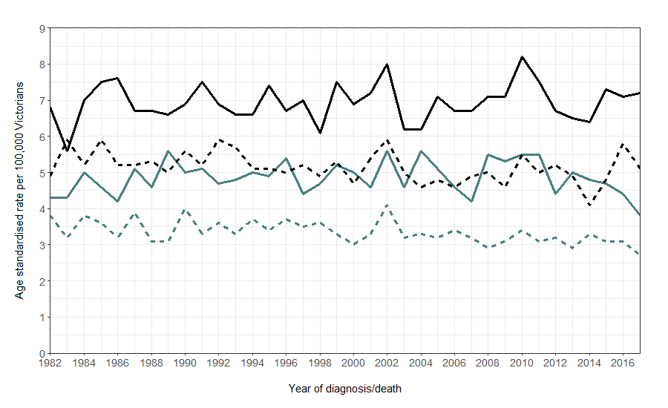
Male incidence
Female incidence
Female mortality
Male mortality
Source: Cancer Council Victoria <http://vcrdata.cancervic.org.au>

Tumour characteristics
- 96 per cent of all brain cancer patients had an ICD-10-AM primary diagnosis code of C71, malignant neoplasm of brain (Table 2).
- Based on morphology codes:
  - 64 per cent of brain cancer patients were diagnosed with glioblastoma.
  - 5 per cent were diagnosed with oligodendroglioma.
  - 14 per cent were diagnosed with astrocytoma.
  - 17 per cent did not align with the above three groupings and were classified as ‘other’ morphology group.
- 90 per cent of diagnoses were based on histology.
Table 2: Tumour characteristics of brain cancer patients diagnosed between 2013 and 2017
Variable | Level | Diagnosed 2013–2017  N (%)
ICD-10-AM Primary diagnosis | C70 Malignant neoplasm of meninges  C71 Malignant neoplasm of brain  C72 Malignant neoplasm of spinal cord, cranial nerves & other | 38 (2%)  2,094 (96%)  50 (2%)
Morphology group | Glioblastoma  Oligodendroglioma  Astrocytoma  Other/unknown | 1,394 (64%)  115 (5%)  304 (14%)  369 (17%)
Basis of diagnosis (VCR) | Clinical  Histology  Unknown | 200 (9%)  1,968 (90%)  14 (1%)

Surgery

Volume of all major brain surgeries
- From July 2016 to June 2018, the average yearly number of major brain surgical admissions in Victorian hospitals ranged from one to 317 (Figure 2).
- Nine of 14 (64 per cent) public hospitals and 18 of 25 (72 per cent) private hospitals performed fewer than 10 surgeries per year.
Figure 2: Victorian hospital average annual major brain tumour surgery volume (July 2016 to June 2018) (N = 3,437)
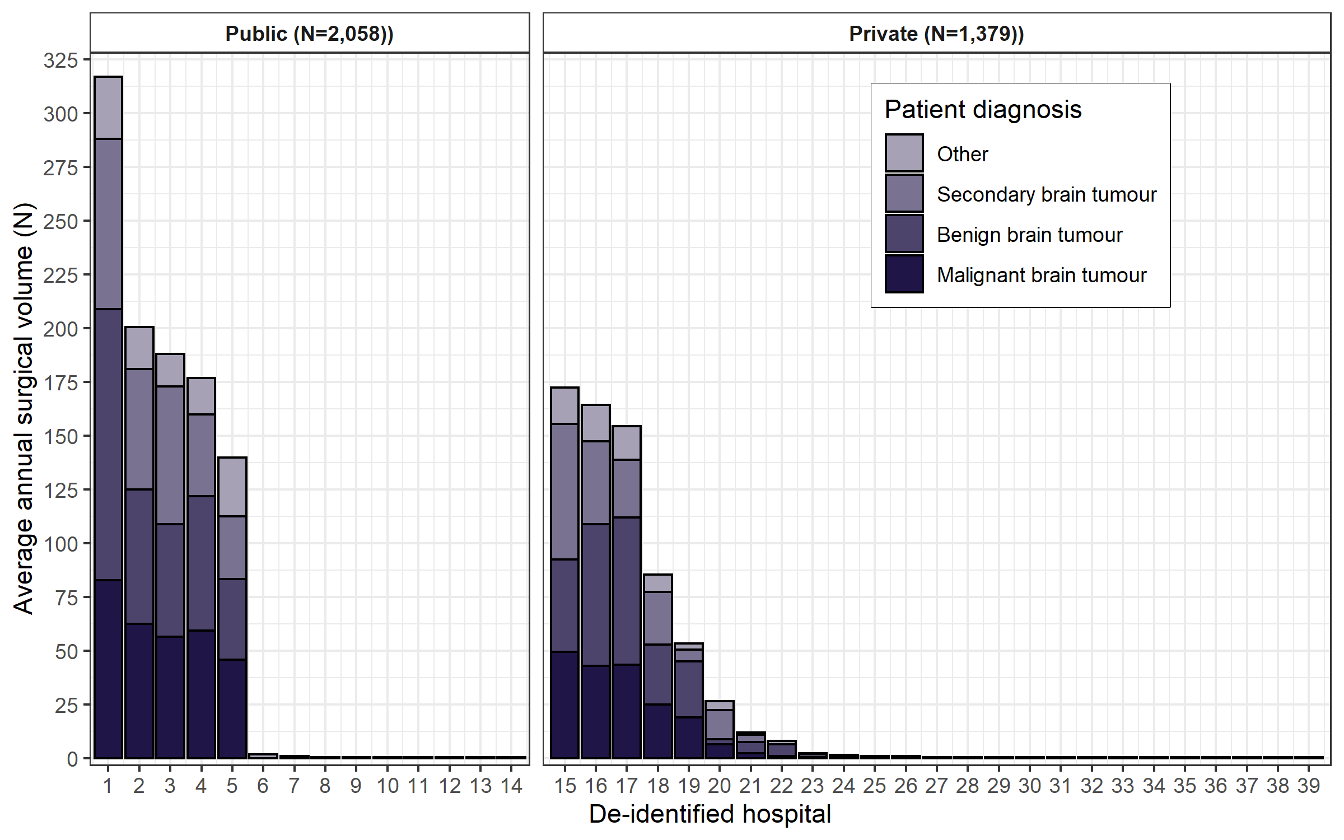
Source: VAED financial years 2016–17 and 2017-18 (unlinked)

Mortality within 30 days of malignant brain tumour surgery
- 1.7 per cent of Victorian brain cancer patients treated with major brain surgery died within 30 days of their first surgery (Figure 3).
- One hospital was flagged as having a significantly higher proportion of patients who died within 30 days of their first major brain surgery between 2015 and 2017. This outlier observation was investigated as per protocol by Safer Care Victoria. More recent data to April 2021 confirms this service’s recent mortality rates fall within accepted bounds.
Figure 3: Proportion of brain cancer patients who died within 30 days of first major brain surgery, by campus of surgery (diagnosed 2013 to 2017) (N = 1,507)
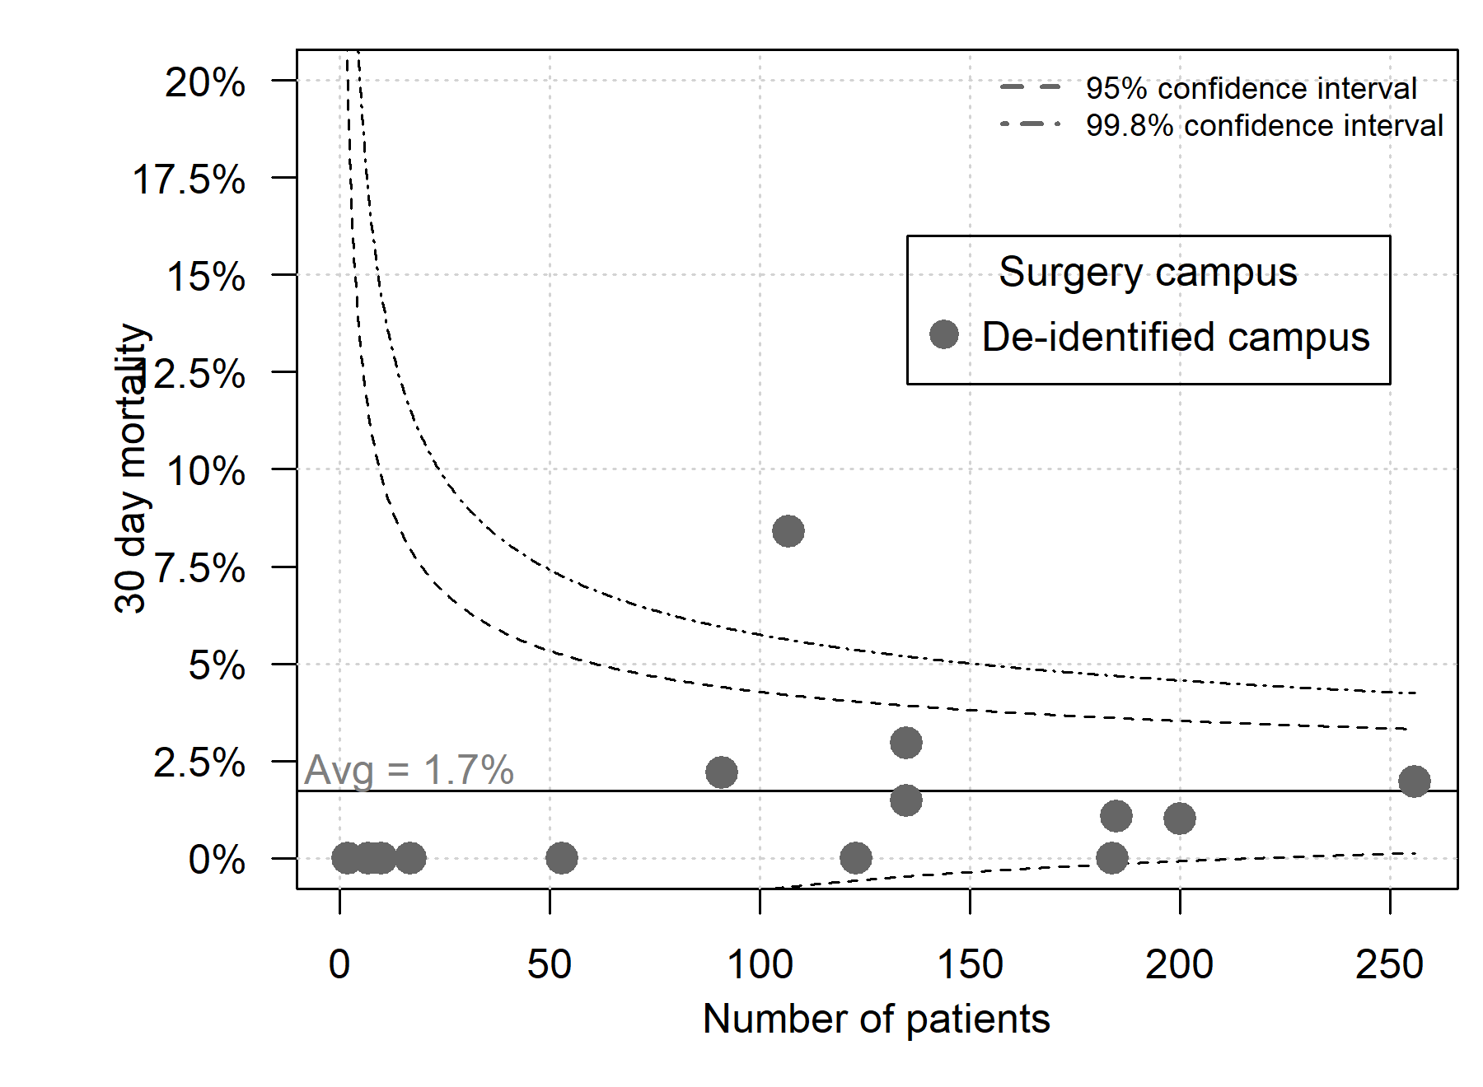

Length of stay after surgical/biopsy admissions
For Figures 4 to 6, the funnel plots show the percentage of patients in each ICS of residence or campus who had a length of stay above the median length of stay.
- Median length of stay for both major surgery and biopsy was seven days (Figure 4). The proportion of patients with a length of stay greater than the median varied significantly by ICS of residence:
  - A lower proportion of patients living in WCMICS and a higher proportion in GRICS had a length of stay of eight days or longer after major brain surgery, with the state average of 46 per cent.
  - A lower proportion of patients living in WCMICS and a higher proportion in GRICS had a length of stay of eight days or longer after brain biopsy, with the state average of 50 per cent.
- Median length of stay was nine days for emergency major surgery and six days for non-emergency major surgery (Figure 5). The proportion of patients with a length of stay greater than the median varied significantly by ICS of campus for both emergency and non-emergency major brain surgery, with several campuses having significantly lower and higher proportion of patients with a length of stay greater than the median.
- Median length of stay was 10 days for an emergency biopsy and five days for a non-emergency biopsy (Figure 6). There was some variation identified by ICS of campus:
  - There was one campus with a higher proportion of patients with a length of stay of 11 days or longer after emergency biopsy.
  - There were two campuses with a lower proportion of patients and one campus with a higher proportion of patients with a length of stay of six days or longer after non-emergency biopsy.
Figure 4: Percentage of acute brain surgical episodes with a length of stay greater than the median length of stay, by ICS of residence
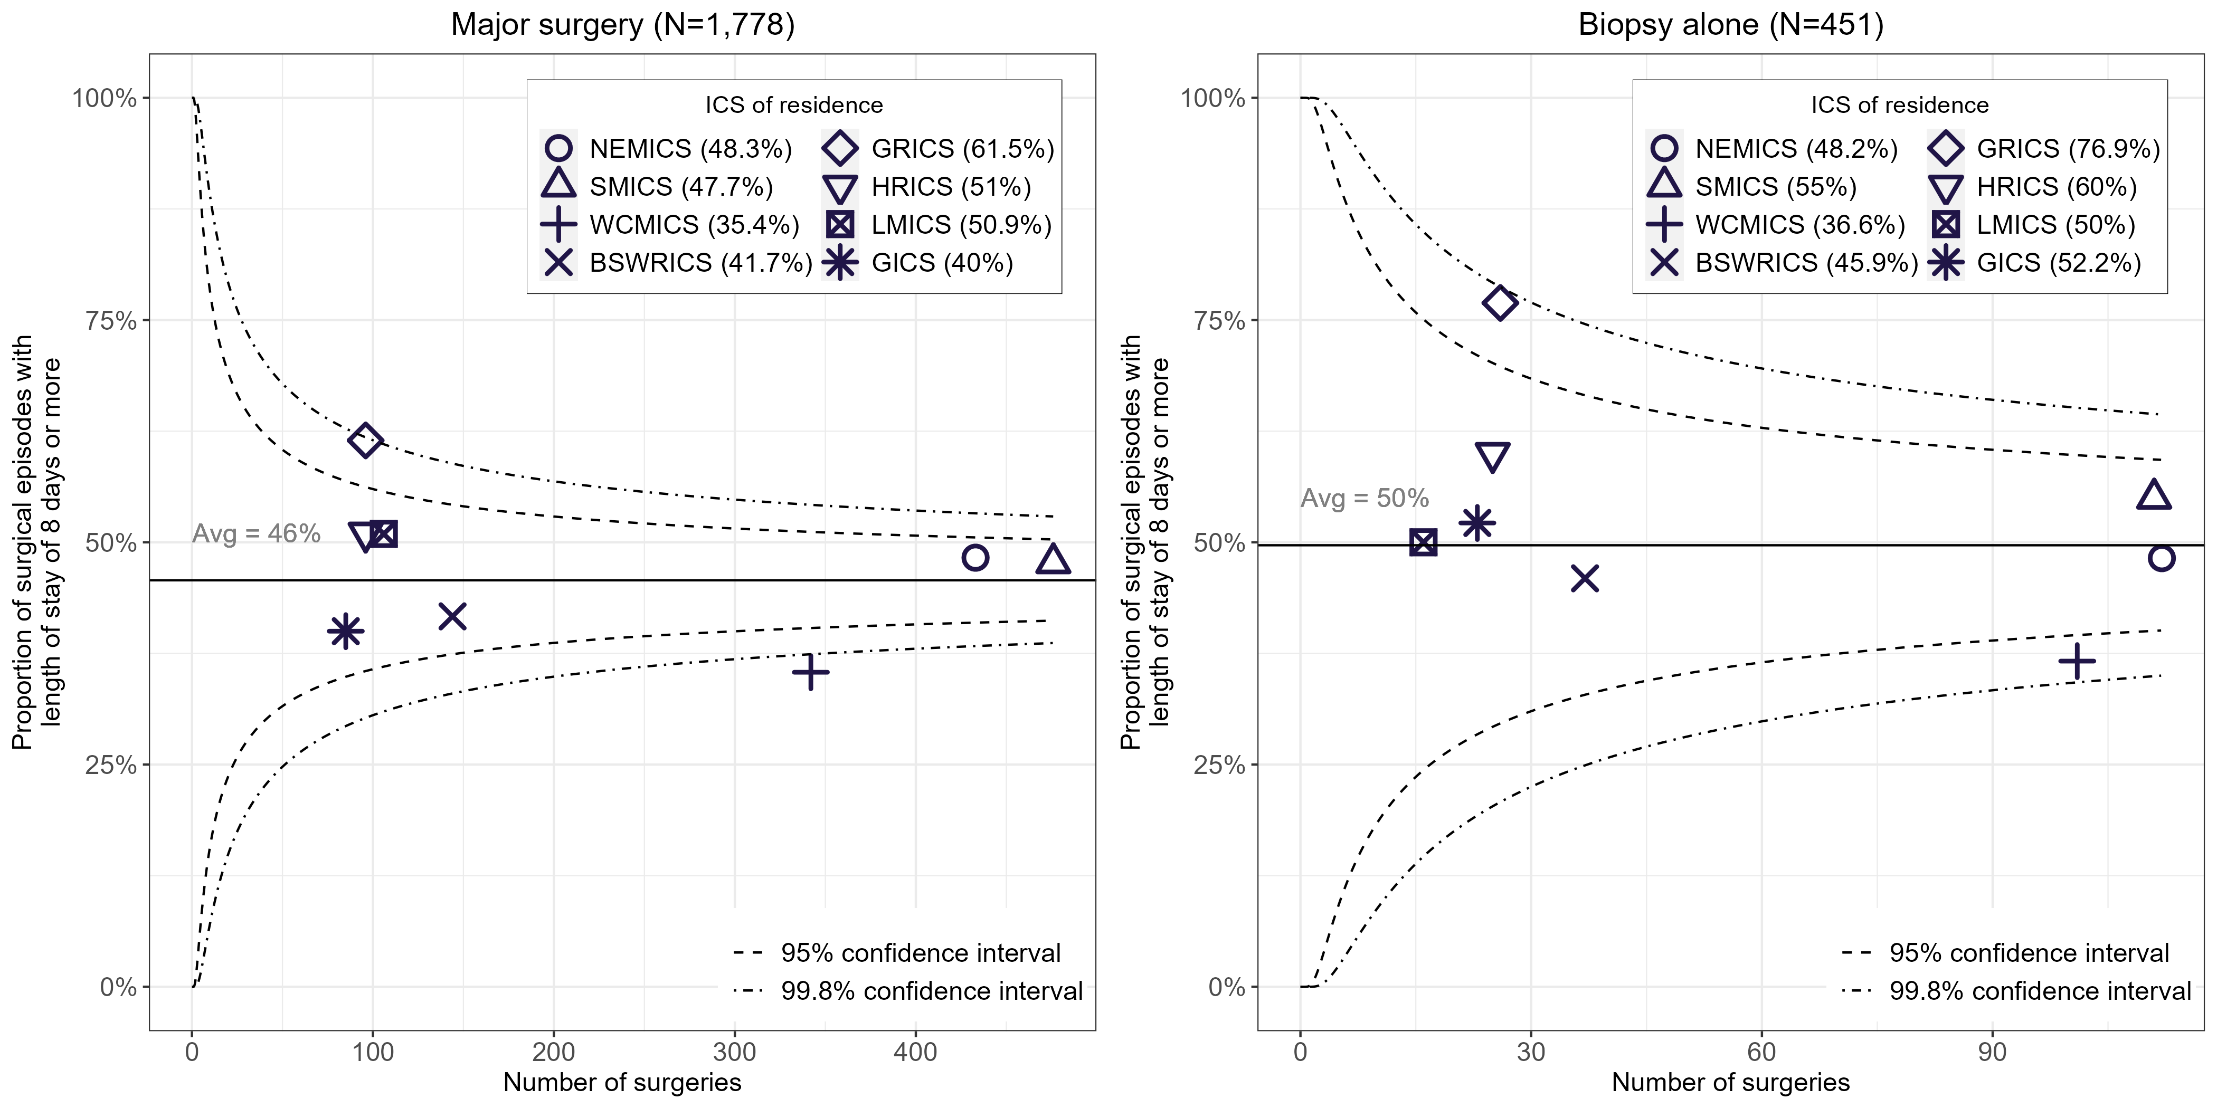
Patients living in HRICS may have been treated in New South Wales.
Includes all surgical admissions that occurred within one year after diagnosis.
For the biopsy alone cohort, any episodes that also included a major surgery were excluded.
Figure 5: Percentage of acute major brain surgical admissions with a length of stay greater than the median length of stay, by ICS of surgery campus
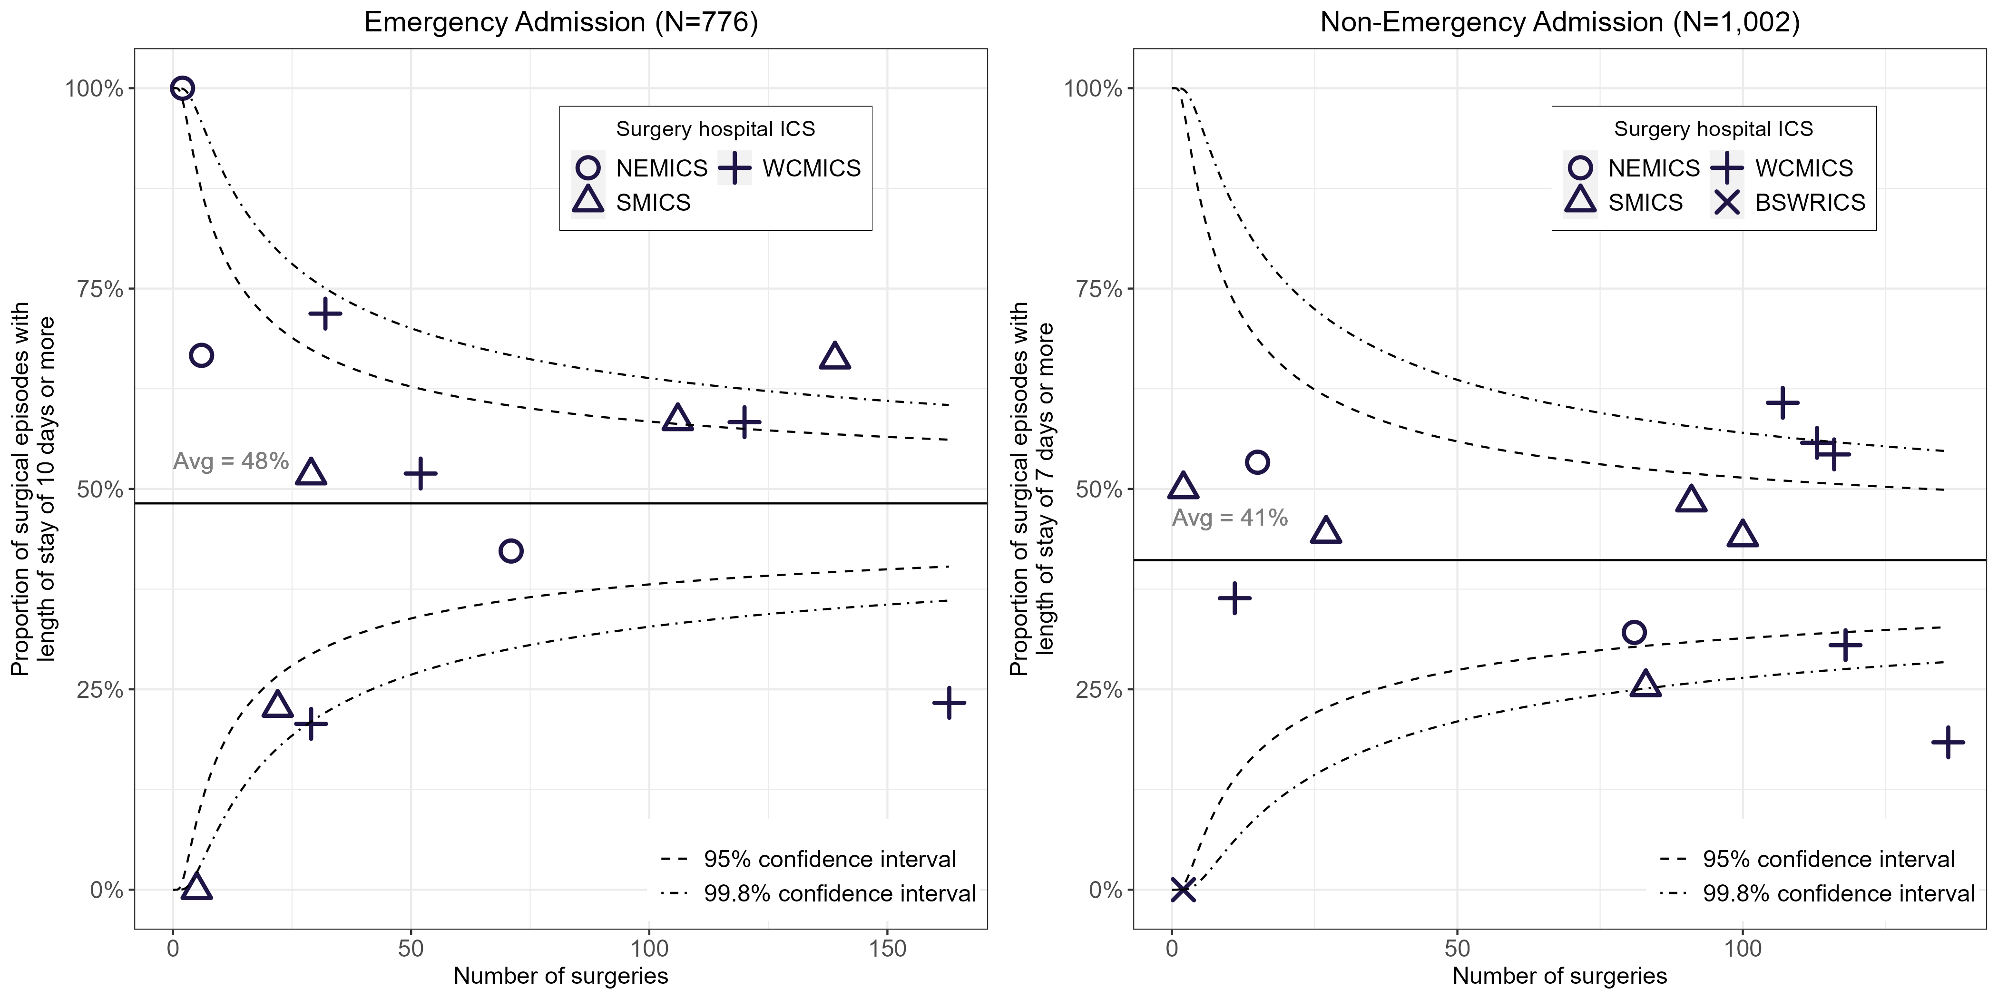
Includes all surgical admissions that occurred within one year after diagnosis.
Figure 6: Percentage of acute biopsy admissions length of stay greater than the median length of stay, by ICS of surgery campus
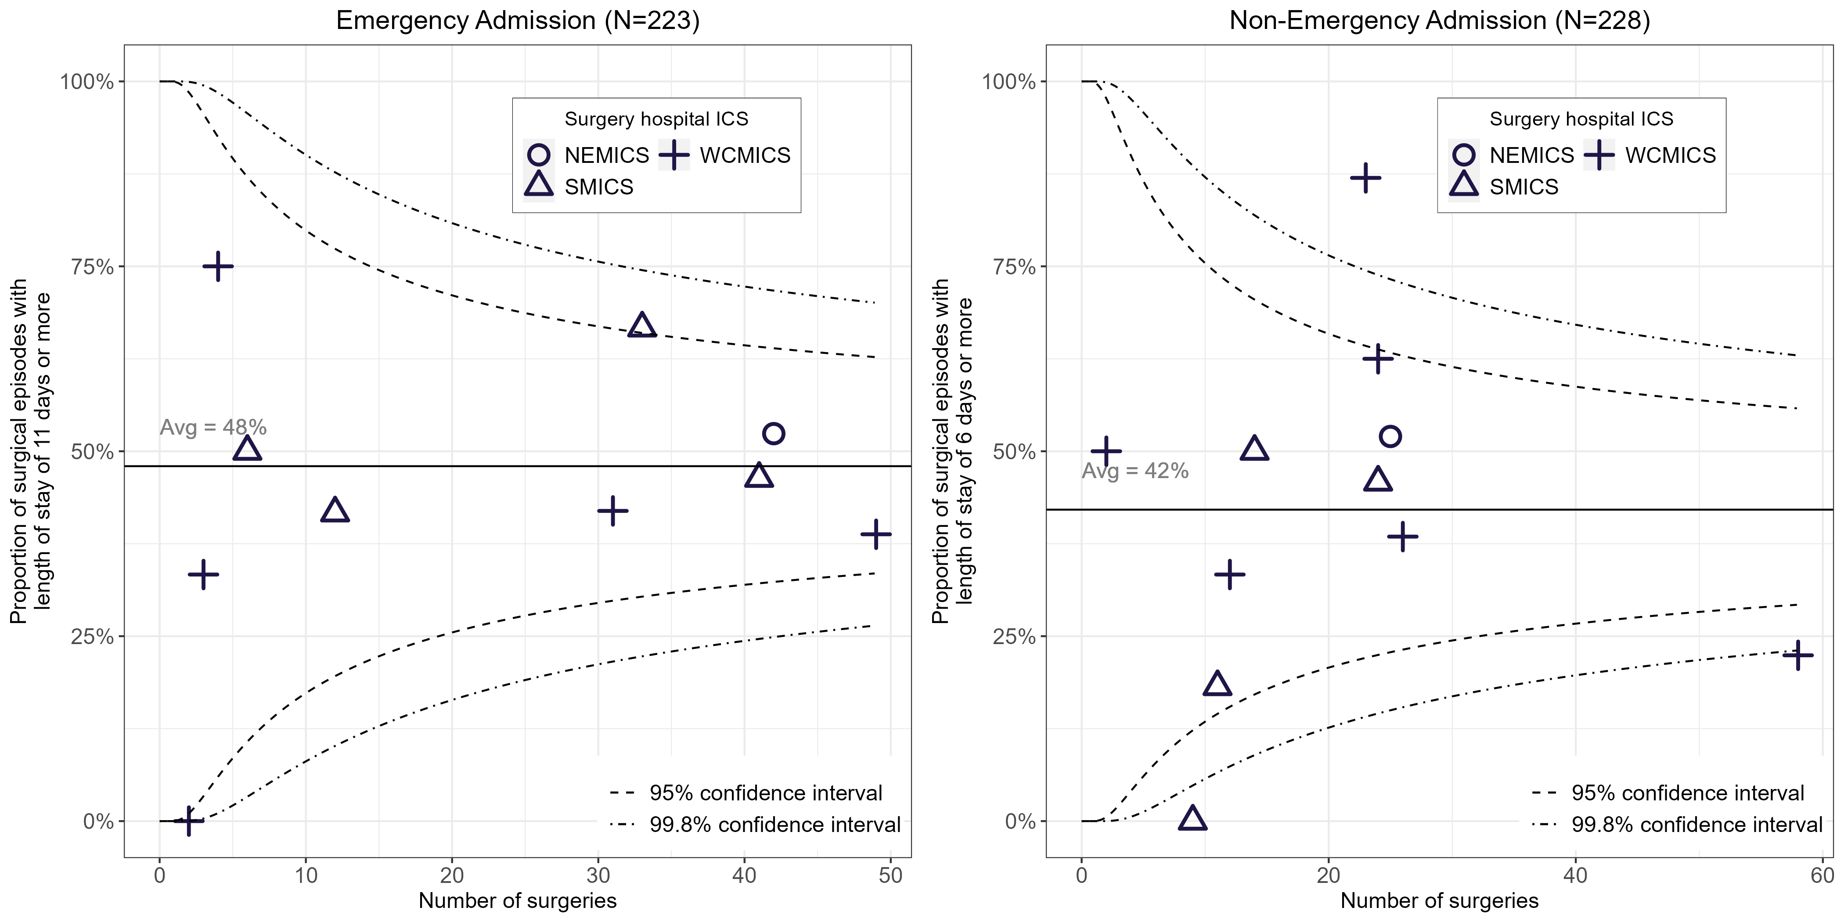
Includes all surgical admissions that occurred within one year after diagnosis.
For the biopsy alone cohort, any episodes that also included a major surgery were excluded.

Clinical commentary – surgery
The hospital volume data shows a long tail of hospitals conducting fewer than 10 major brain surgeries annually. For a surgical procedure as complicated as major brain surgery, the number of low-volume centres is concerning. However, it is reassuring that 30-day mortality post-surgery was overall low, even in low-volume centres. As expected, the median length of stay for emergency admissions was longer than that for non-emergency admissions, for both major brain surgeries and biopsies. The funnel plots show some variation in length of stay among campuses. Campuses that lie above the 99.8 per cent upper confidence limits could investigate whether there are any local efficiency or logistical issues, or local patient attributes impacting length of stay in their institution.

Multidisciplinary team meetings
There are currently no systems for routinely tracking the occurrence of MDMs. For this analysis, data from the 2017 CSPI audit was used, where a random sample of newly diagnosed brain cancer patients (who received inpatient treatment) were audited within each ICS of treatment. Documented evidence of MDM treatment recommendations in the patient’s medical record was used as a measure of whether an MDM had occurred. Patients were audited at the campus where they received this first treatment. Due to low numbers, regional ICS results were excluded from reporting.
- Across metropolitan ICS of treatment, the overall proportion of brain cancer patients with a documented MDM was 86 per cent (Figure 7).
  - This varied by ICS of treatment, with NEMICS and SMICS both above the target of 80 per cent (89 and 98 per cent respectively) and WCMICS below the target (70 per cent).
- Across metropolitan ICS of treatment, the overall proportion of patients with evidence of communication of initial treatment plan to a GP was 88 per cent (Figure 8).
  - This varied by ICS of treatment, with SMICS higher than the overall percentage (at 100 per cent) and NEMICS and WCMICS lower than the overall percentage (at 75 and 82 per cent respectively).
Figure 7: Percentage of patients with documented evidence of a multidisciplinary team meeting in their central medical record (N = 148)
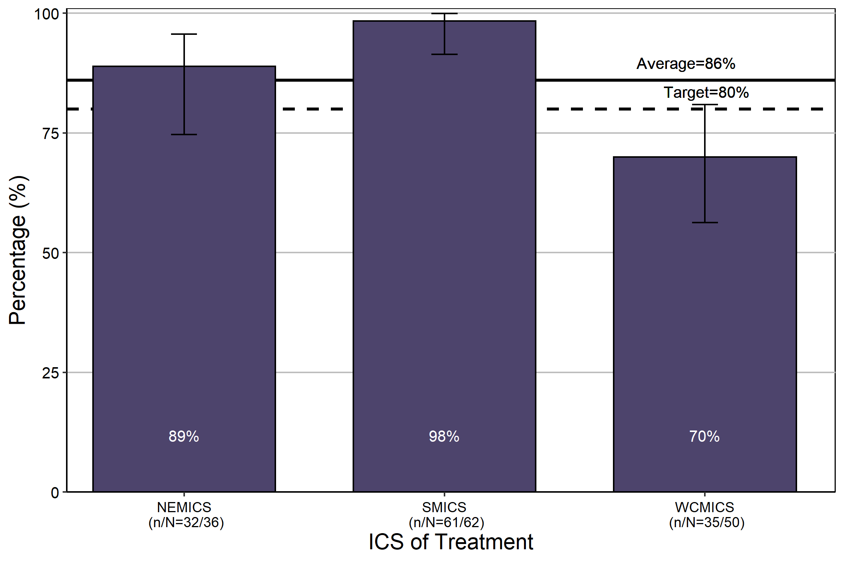
Source: CSPI medical record audit 2017, public hospital data only
Bars represent 95 per cent confidence interval.
Due to low numbers treated in regional ICS, only metropolitan ICS results are presented here.

Figure 8: Percentage of patients with documented evidence of communication of their initial treatment plan to their GP (N = 148)
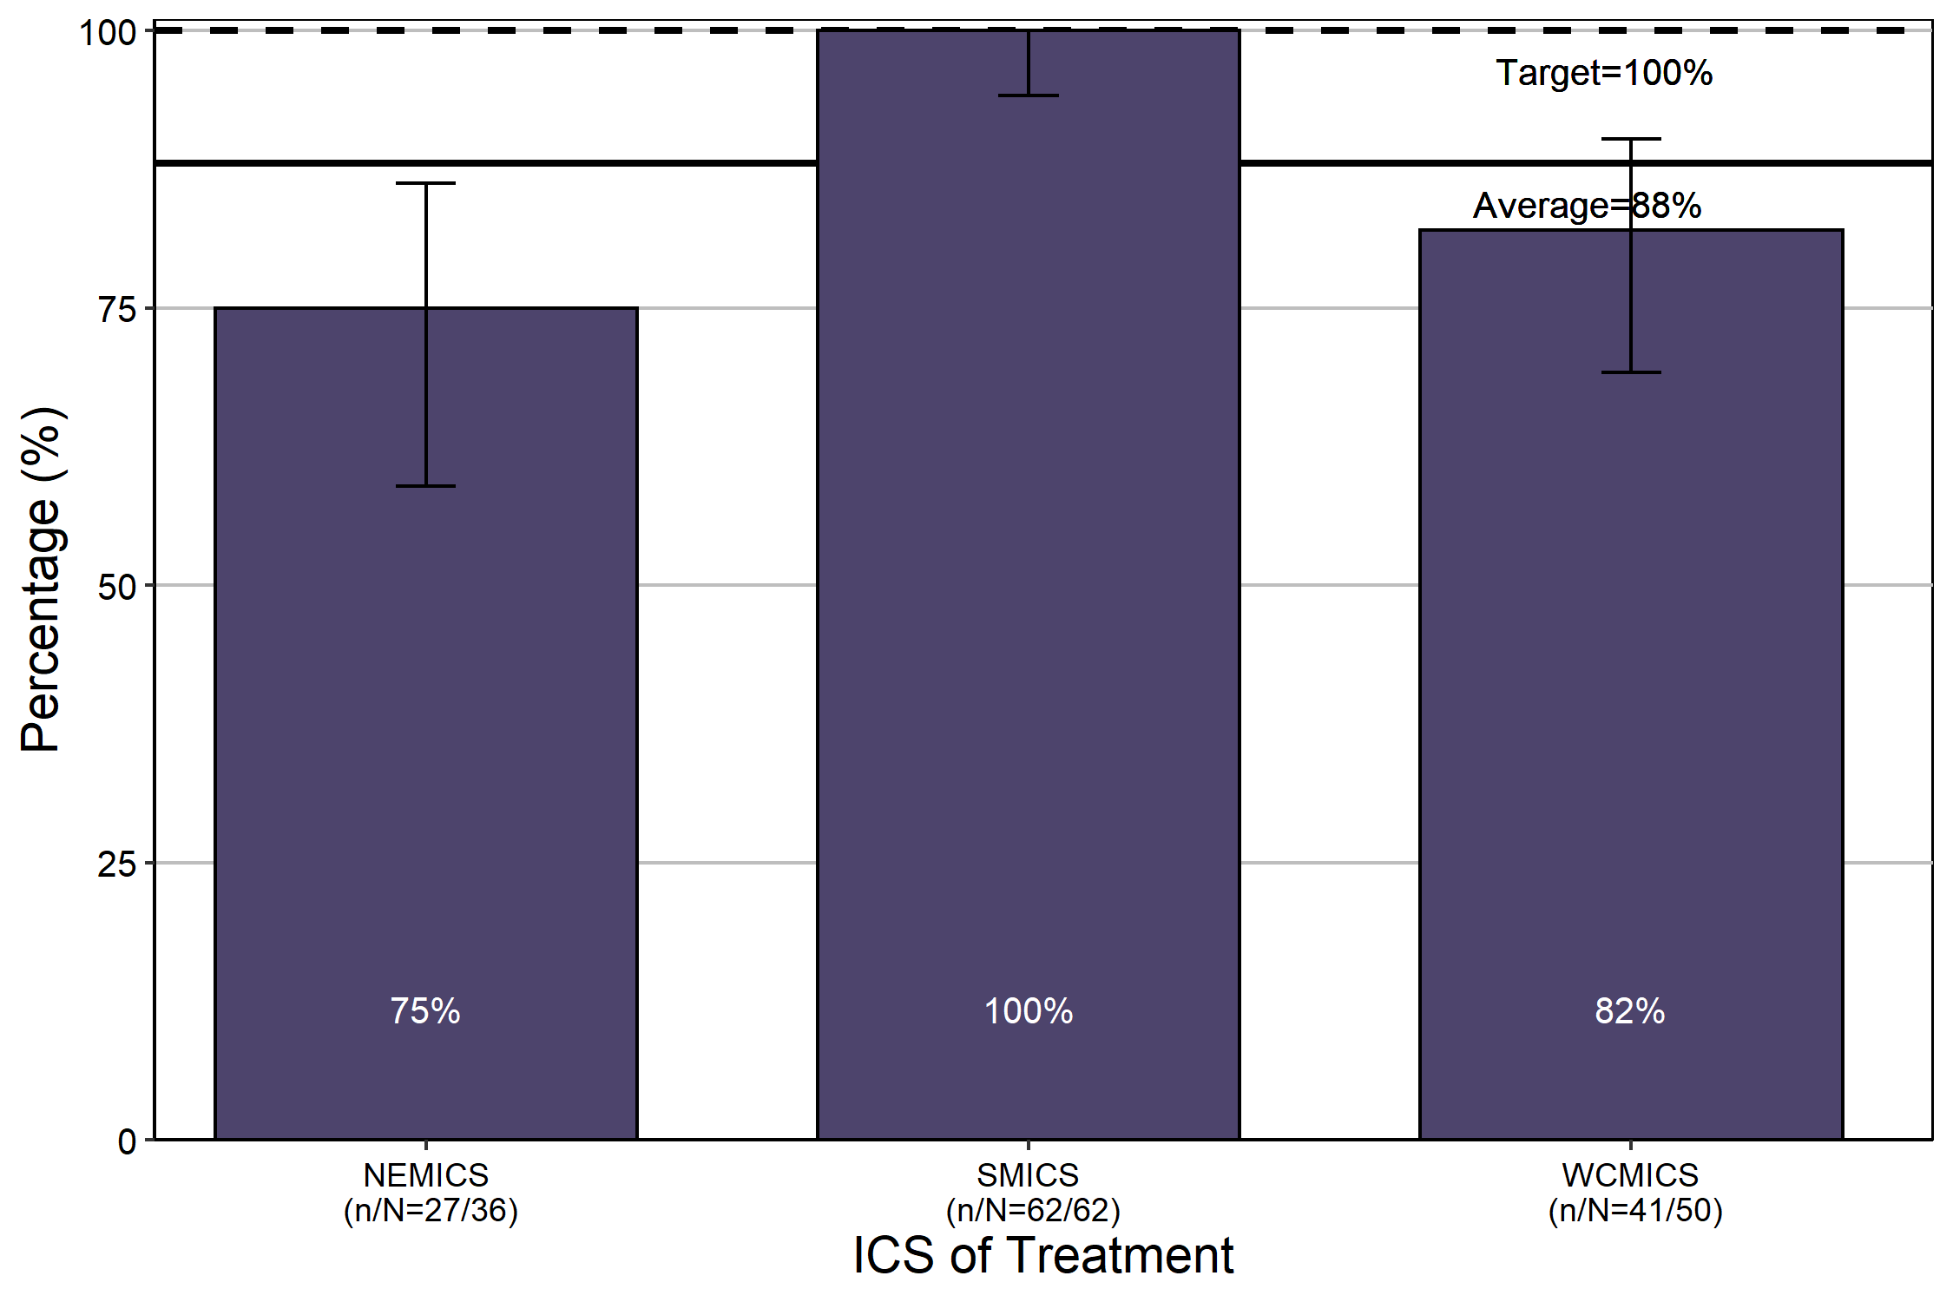
Source: CSPI medical record audit 2017, public hospital data only
Bars represent 95 per cent confidence interval.
Due to low numbers treated in regional ICS, only metropolitan ICS results are presented here.

Clinical commentary – multidisciplinary team meetings
MDMs are an important component of quality cancer care and should occur before treatment begins to ensure patients are given the most appropriate care. There was some variation across metropolitan ICS in the proportion of patients being presented at an MDM in 2017. The high-grade glioma OCP states that all newly diagnosed patients should be discussed at an MDM within two weeks of diagnosis. Initial communication with the patient’s GP about the diagnosis, treatment plan and recommendations from MDMs is crucial for patient experience. For ICS with a lower proportion of documented evidence of communication to their GP, there are improvements to be made, whether that is ensuring the communication is occurring (and occurring in the appropriate timeline) or ensuring the communication is recorded appropriately.

Treatment

Treatment for brain cancer
- Within one year of diagnosis:
  - Most patients had at least one type of surgical procedure (87 per cent), 69 per cent of all patients had major surgery (craniotomy and resection), 22 per cent had a biopsy, and 9 per cent had other brain cancer surgical procedures (Table 3; see Supplementary Table 3 to Supplementary Table 5 for definitions of surgical procedures).
  - Radiotherapy within one year of diagnosis was used in 59 per cent of the patients, with variation among the different morphology groups.
  - Intravenous chemotherapy within one year of diagnosis was used in 12 per cent of patients.
  - 11 per cent of patients did not receive surgery, radiotherapy or intravenous chemotherapy within one year of diagnosis. Of these 231 patients, 52 per cent died within 90 days of diagnosis.
- Overall, 44 per cent of patients had major surgery in their local ICS (Table 4). Almost all patients in regional ICS of residence had major surgery at a metropolitan campus.
- Overall, 75 per cent of patients had radiotherapy in their local ICS (Table 5).

Clinical commentary – treatment for brain cancer
Most patients had some form of surgery, with a number having a combination of major surgery, biopsy or other brain surgical procedure. A large proportion of patients also had radiotherapy, with there being a reasonable amount of variation between morphology groups. A small number of patients had intravenous chemotherapy, which is currently not the standard of care treatment in most gliomas, noting data for oral chemotherapy with temozolomide was not available. As such, chemotherapy usage was not analysed further. A palliative approach may be taken for some patients from the start of their treatment, or patients may opt to not receive active treatment. These patients will be captured in the 11 per cent who did not have surgery, radiotherapy or intravenous chemotherapy.
The centralisation of major brain surgery to Melbourne meant that nearly all patients from across Victoria needed to travel to Melbourne for major surgery. But for radiotherapy, 75 per cent of patients had treatment locally, including high rates among most regional ICS.

Table 3: Treatment for brain cancer within one year of diagnosis by morphology group
Treatment | Astrocytoma grade 2 | Astrocytoma grade 3 | Oligodendroglioma grade 2 | Oligodendroglioma grade 3 | Glioblastoma grade 4 | Other (multiple grades) | Total
Surgery – major, biopsy or other surgery | 159 (92%) | 125 (95%) | 79 (95%) | 29 (91%) | 1,261 (90%) | 247 (67%) | 1,900 (87%)
- Major surgery | 107 (62%) | 74 (56%) | 66 (80%) | 28 (88%) | 1016 (73%) | 217 (59%) | 1,508 (69%)
- Biopsy | 62 (36%) | 63 (48%) | 19 (23%) | 4 (12%) | 290 (21%) | 40 (11%) | 478 (22%)
- Other surgery | 18 (10%) | 10 (8%) | 3 (4%) | 2 (6%) | 123 (9%) | 35 (9%) | 191 (9%)
Radiotherapy – any | 71 (41%) | 108 (82%) | 27 (33%) | 23 (72%) | 954 (68%) | 105 (28%) | 1,288 (59%)
Chemotherapy (IV) | 16 (9%) | 11 (8%) | 1 (1%) | 7 (22%) | 210 (15%) | 26 (7%) | 271 (12%)
No surgery, radiotherapy or chemotherapy (IV) | 13 (8%) | 1 (1%) | 4 (5%) | 0 (0%) | 103 (7%) | 110 (30%) | 231 (11%)
Total patients | 173 | 131 | 83 | 32 | 1,394 | 369 | 2,182
Note – patients who had major surgery may have also had a biopsy and/or other surgery. Patients who had a biopsy may have also had other surgery.

Table 4: Brain cancer patient pathways from ICS of residence to ICS of surgery for major brain surgery (N = 1,507)
ICS of residence (down)/ ICS of surgery (across) | NEMICS | SMICS | WCMICS | BSWRICS | GRICS | HRICS | LMICS | GICS | Total
NEMICS | 100  (27%) | 83  (23%) | 183  (50%) |  |  |  |  |  | 366
SMICS | 3  (1%) | 321  (77%) | 92  (22%) |  |  |  |  |  | 416
WCMICS | 18  (6%) | 17  (6%) | 247  (88%) |  |  |  |  |  | 282
BSWRICS | 2  (2%) | 23  (19%) | 95  (78%) | 2  (2%) |  |  |  |  | 122
GRICS | 3  (4%) | 52  (61%) | 30  (35%) |  |  |  |  |  | 85
HRICS | 5  (6%) | 16  (20%) | 61  (74%) |  |  |  |  |  | 82
LMICS | 13  (15%) | 5  (6%) | 69  (79%) |  |  |  |  |  | 87
GICS | 10  (15%) | 3  (4%) | 54  (81%) |  |  |  |  |  | 67
Patients living in HRICS may have been treated in New South Wales.
Table 5: Brain cancer patients pathways from ICS of residence to ICS of radiotherapy (N = 1,283)
ICS of residence (down)/ICS of radiotherapy (across) | NEMICS | SMICS | WCMICS | BSWRICS | GRICS | HRICS | LMICS | GICS | Total
NEMICS | 203  (68%) | 40  (13%) | 55  (18%) |  |  |  | 1  (0%) |  | 299
SMICS | 14  (4%) | 297  (82%) | 42  (12%) |  | 9  (2%) |  |  |  | 362
WCMICS | 28  (12%) | 15  (6%) | 192  (80%) | 2  (1%) |  | 1  (0%) |  | 1  (0%) | 239
BSWRICS |  |  | 8  (8%) | 93  (90%) |  |  |  | 2  (2%) | 103
GRICS | 3  (4%) | 11  (14%) | 6  (8%) |  | 60  (75%) |  |  |  | 80
HRICS | 7  (10%) | 5  (7%) | 18  (26%) |  |  | 32  (46%) | 7  (10%) |  | 69
LMICS | 4  (5%) | 1  (1%) | 15  (21%) | 1  (1%) |  |  | 49 (67%) | 3  (4%) | 73
GICS | 1  (2%) |  | 9  (16%) | 4  (7%) |  |  | 2 (3%) | 42  (72%) | 58

Treatment for glioblastoma
- There was some variation in treatment by ICS of residence (Table 6).
  - For patients from LMICS, a higher proportion compared with the statewide average had major surgery (85 per cent compared with the average of 73 per cent) and a lower proportion had a biopsy (10 per cent compared with 21 per cent).
  - The proportion of patients who had intravenous chemotherapy was higher in NEMICS (21 per cent) and lower in BSWRICS (8 per cent) and LMICS (6 per cent) compared with the statewide average (15 per cent), noting the limitation of no oral chemotherapy data.
- Older patients (70 years or older) had less major surgery, radiotherapy and intravenous chemotherapy compared with the younger age group (Table 7).
- Among those who received radiotherapy, a lower proportion of older patients (70 years or older) received 20 or more fractions delivered in the first radiotherapy course (40.8 per cent on average) compared with the younger age group (87 per cent on average) (Figure 9).
- The proportion of patients who had radiotherapy within three months of major brain surgery was lower for older patients (70 years or older) at diagnosis compared with younger patients (82 per cent and 68 per cent respectively). It did not differ significantly among ICS of residence for either age group (Figure 10).

Table 6: Treatment within one year of glioblastoma diagnosis by ICS of residence
Treatment | NEMICS | SMICS | WCMICS | BSWRICS | GRICS | HRICS | LMICS | GICS | Victoria
Surgery – major, biopsy or other surgery | 306 (91%) | 353 (91%) | 216 (91%) | 97 (84%) | 81 (95%) | 74 (88%) | 73 (92%) | 61 (88%) | 1,261 (90%)
- Major surgery | 242 (72%) | 289 (75%) | 165 (70%) | 82 (71%) | 63 (74%) | 60 (71%) | 67 (85%) | 48 (70%) | 1,016 (73%)
- Biopsy | 71 (21%) | 78 (20%) | 62 (26%) | 20 (17%) | 21 (25%) | 15 (18%) | 8 (10%) | 15 (22%) | 290 (21%)
- Other surgery | 24 (7%) | 35 (9%) | 22 (9%) | 6 (5%) | 8 (9%) | 9 (11%) | 11 (14%) | 8 (12%) | 123 (9%)
Radiotherapy – any | 217 (64%) | 278 (72%) | 161 (68%) | 78 (68%) | 66 (78%) | 50 (60%) | 58 (73%) | 46 (67%) | 954 (68%)
Chemotherapy (IV) | 72 (21%) | 66 (17%) | 32 (14%) | 9 (8%) | 9 (11%) | 10 (12%) | 5 (6%) | 7 (10%) | 210 (15%)
No surgery, radiotherapy or chemotherapy (IV) | 26 (8%) | 25 (6%) | 16 (7%) | 13 (11%) | 2 (2%) | 8 (10%) | 6 (8%) | 7 (10%) | 103 (7%)
Total patients | 338 | 387 | 237 | 115 | 85 | 84 | 79 | 69 | 1,394
Patients living in HRICS may have had their chemotherapy (IV) and/or surgery in New South Wales.
All results are within the Victorian average except for:
- Chemotherapy (IV) utilisation in NEMICS, which is above (p < 0.05)
- Major surgery utilisation in LMICS, which is above (p < 0.05)
- Chemotherapy (IV) utilisation in BSWRICS and LMICS, which is below (p < 0.05)
- No surgery, radiotherapy, or chemotherapy (IV) in GRICS, which is below (p < 0.05)
- Biopsy utilisation in LMICS, which is below (p < 0.05)
Table 7: Treatment within one year of glioblastoma diagnosis by age at diagnosis
Treatment | Age younger than 70 | Age 70 years or older | Total | p-value for difference between age groups
Surgery – major, biopsy or other surgery | 805 (94%) | 456 (85%) | 1,261 (90%) | < 0.001
- Major surgery | 678 (79%) | 338 (63%) | 1,016 (73%) | < 0.001
- Biopsy | 162 (19%) | 128 (24%) | 290 (21%) | 0.035
- Other surgery | 92 (11%) | 31 (6%) | 123 (9%) | 0.002
Radiotherapy – any | 667 (78%) | 287 (53%) | 954 (68%) | < 0.001
Chemotherapy (IV) | 169 (20%) | 41 (8%) | 210 (15%) | < 0.001
No surgery, radiotherapy or chemotherapy (IV) | 31 (4%) | 72 (13%) | 103 (7%) | < 0.001
Total patients | 856 | 538 | 1,394
Statistically significant difference between age groups for all treatment types.
Figure 9: Proportion of glioblastoma patients with 20 or more fractions delivered in the first radiotherapy course (N = 954)
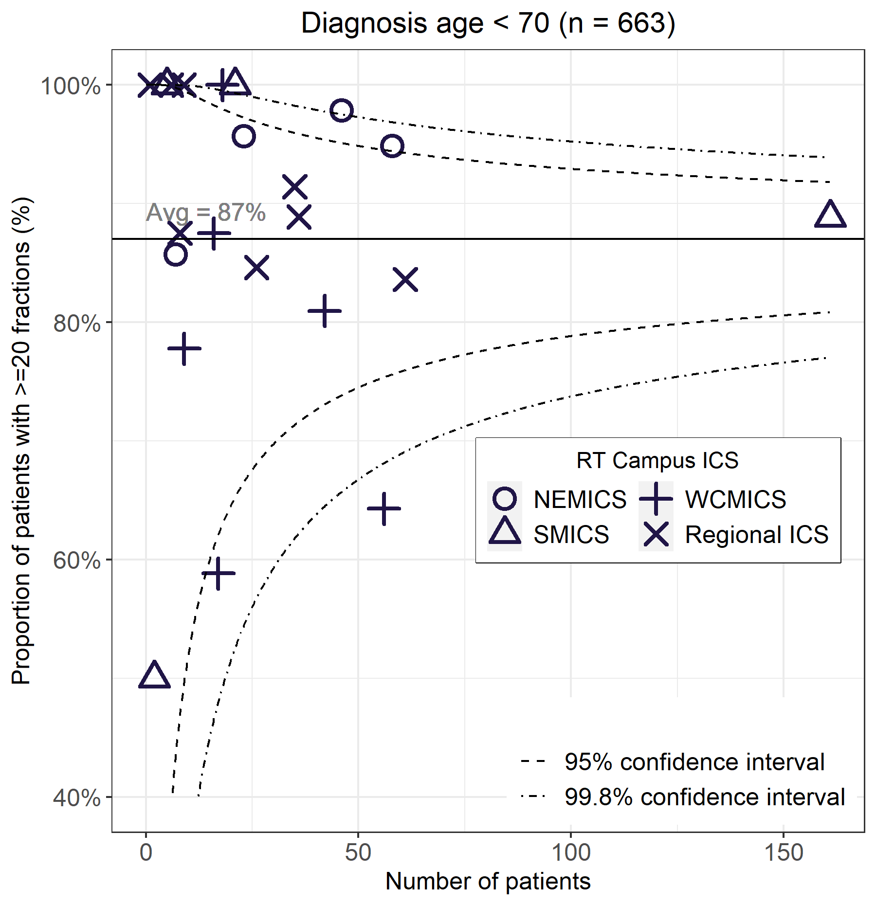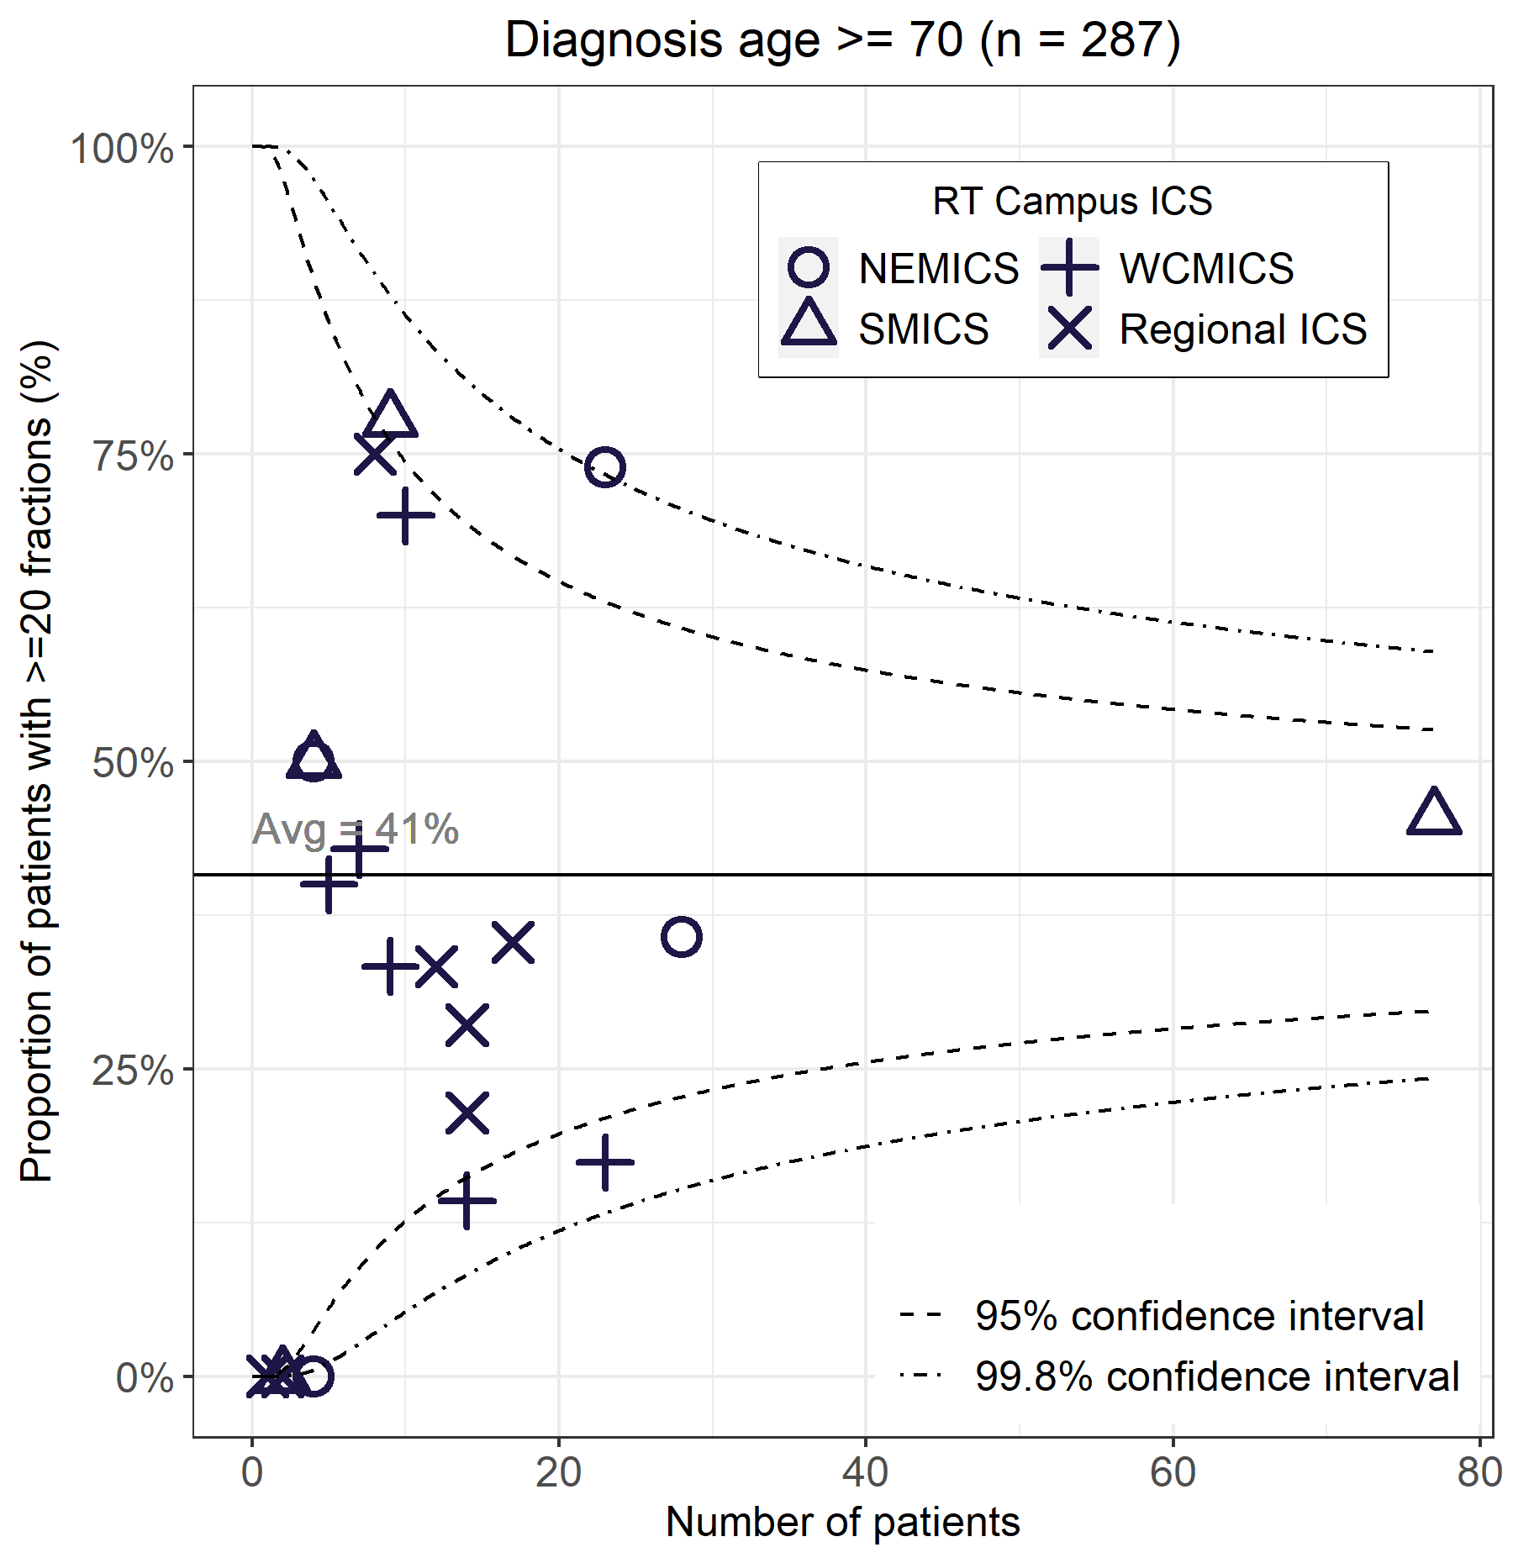
Figure 10: Proportion of glioblastoma patients who had radiotherapy within three months of major brain surgery (N = 1,012)
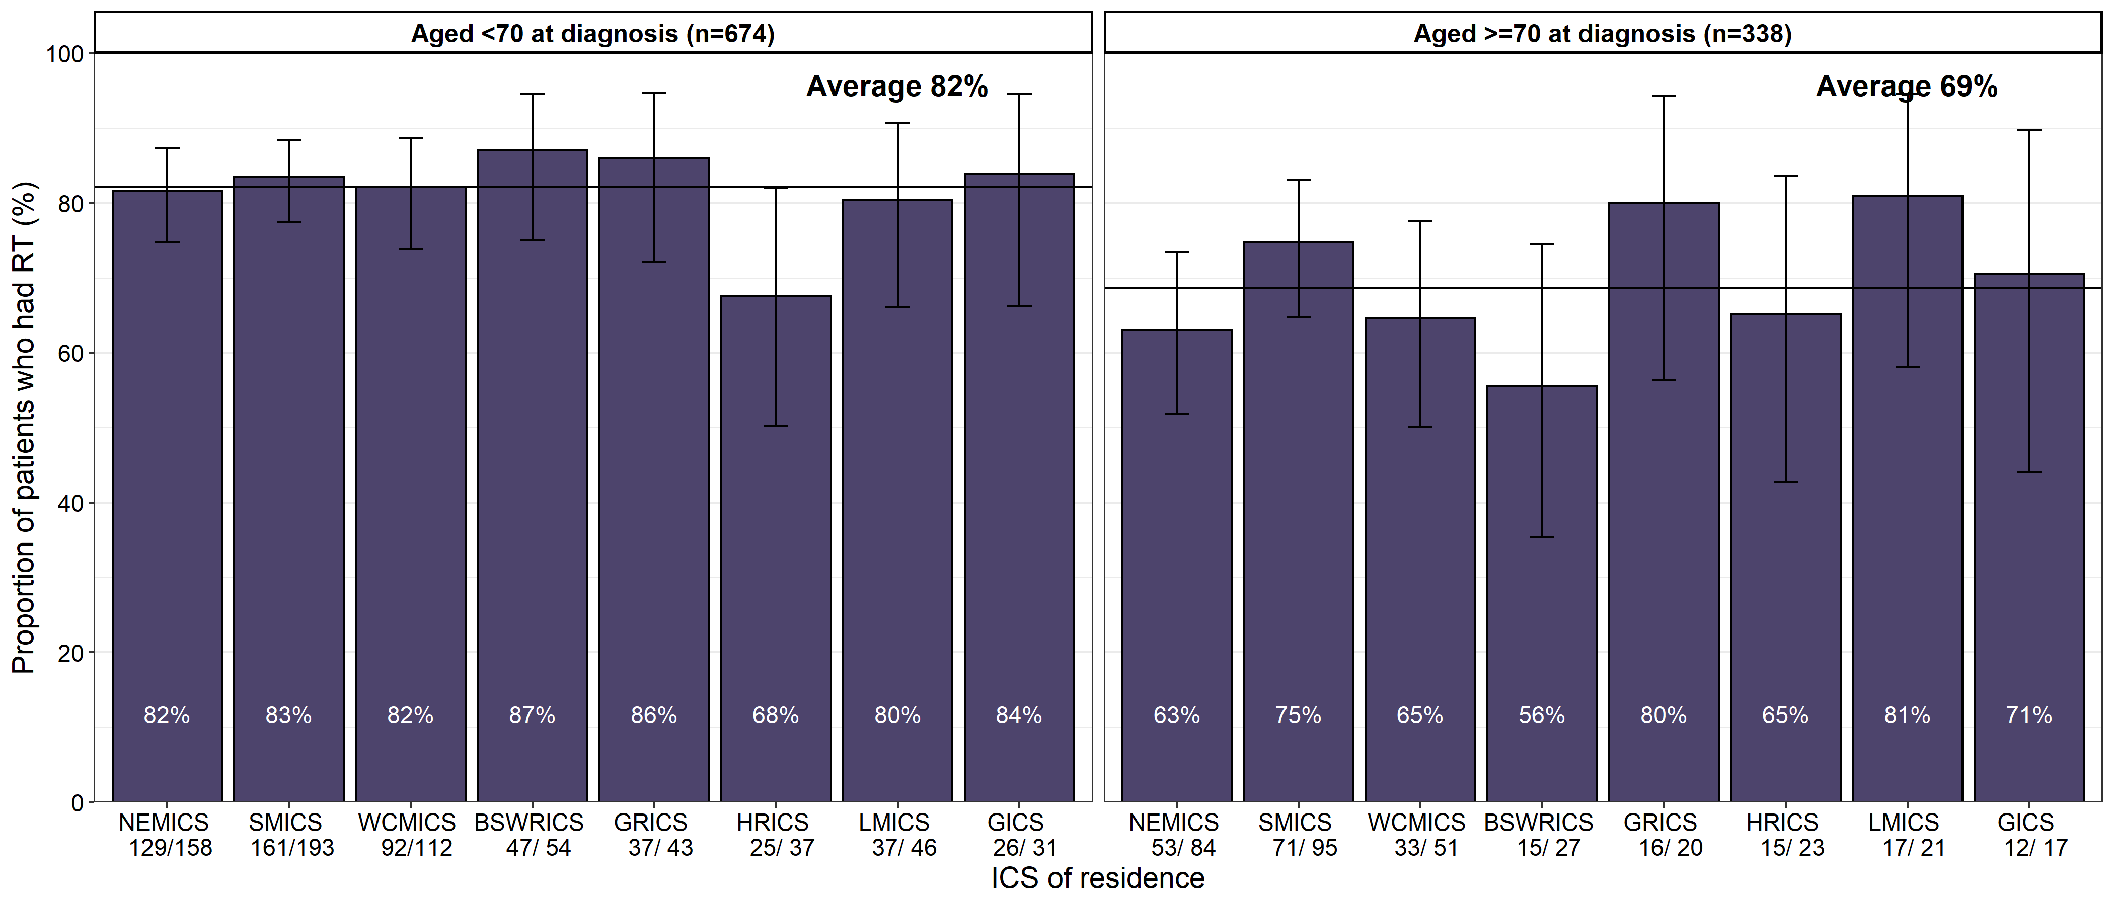
Patients living in HRICS may have had surgery in New South Wales.

Clinical commentary – treatment for glioblastoma
There are some statistically significant variations for treatment by ICS of residence, although variation in intravenous chemotherapy use may be due to data on the oral agent temozolomide not being available in this dataset. There are differences in treatment received when comparing by age groups. For those aged 70 or older, they received less surgery, radiotherapy and intravenous chemotherapy, indicating that treatment intensity was less for older patients.
Assessing whether patients had high fractions (≥ 20 fractions) for their radiotherapy course was used as a proxy for radical radiotherapy treatment. However, some patients may have received a higher dose in fewer fractions. A higher proportion of the younger cohort received higher fractions than the older cohort. There was some variation between campuses in the proportion of patients that had higher fractions, for both age groups. This might not indicate erroneous practices but rather highlights some variation in radiation delivery between different health services.
It was reassuring to see that, while there was some non-significant variation in the proportion of glioblastoma patients treated with radiotherapy within three months of major surgery, there was reasonable uniformity of practice across the state.

Timeliness of treatment for glioblastoma
- 32 per cent of glioblastoma patients who had radiotherapy following surgery began the course of treatment within four weeks, and 82 per cent within six weeks.
- There is variation in time from surgery by radiotherapy region (Figure 11).
  - Patients who both lived in and had radiotherapy at a campus in a metropolitan ICS had a median time to radiotherapy of 32 days (IQR 26–39 days).
  - Patients who had a regional ICS of residence but had radiotherapy at a campus in a metropolitan ICS had a median time to radiotherapy of 28 days (IQR 23–37 days). Patients from regional areas who had radiotherapy in regional Victoria had a median time to radiotherapy of 37 days (IQR 32–43 days).
Figure 11: Timeliness of starting radiotherapy following brain surgery (major or biopsy) for glioblastoma patients by radiotherapy region and region of residence (N = 896)
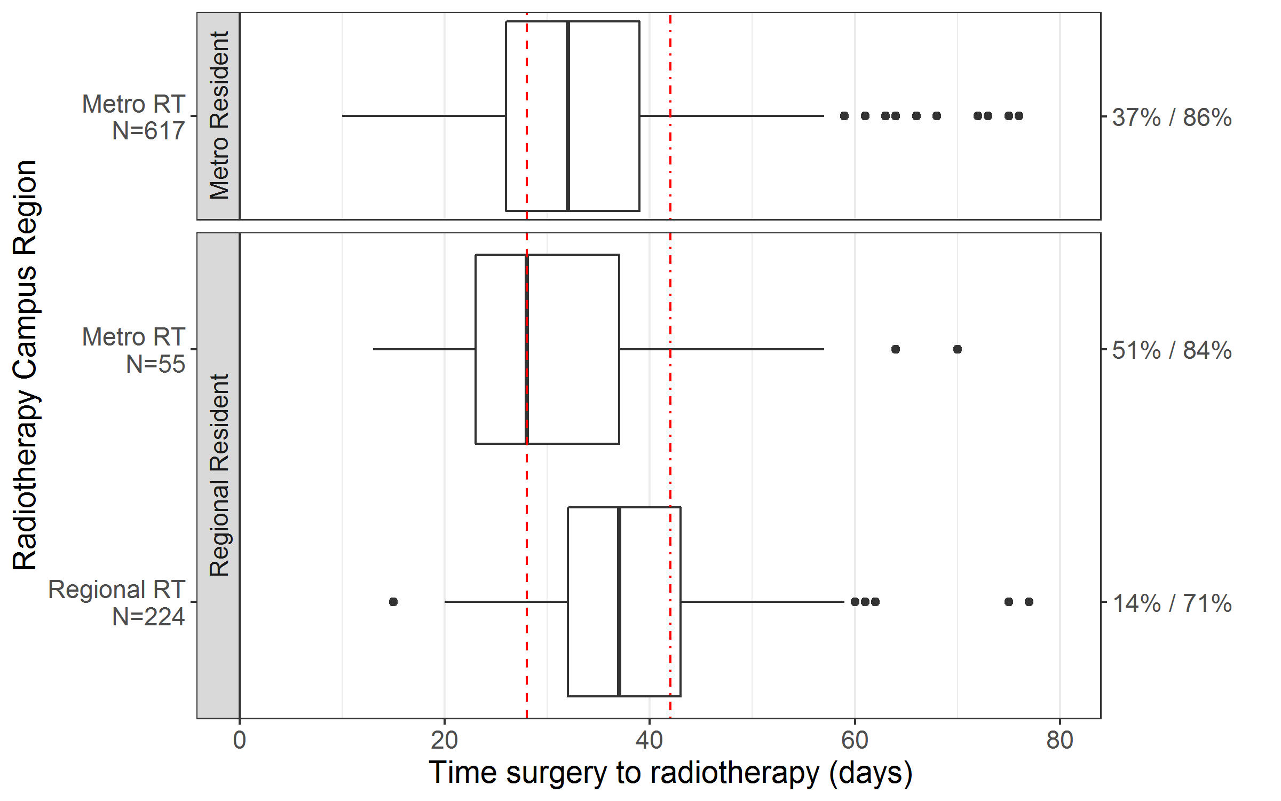
|---------4 weeks------|
≤ 4 weeks / ≤ 6 weeks
Pearson’s 𝛘²:
≤ 4 weeks: p-value < 0.01
≤ 6 weeks: p-value < 0.01
|---------6 weeks--------------------|

Clinical commentary – timeliness of treatment for glioblastoma
Regional patients who were referred to regional radiotherapy services following surgery saw delays in starting treatment compared with those who remained at a metropolitan campus for radiotherapy. However, with good communication and coordination of care with referral from metropolitan to regional health services, the time from surgery to radiotherapy for this cohort could be reduced. While other data doesn’t suggest a clinical advantage to stating treatment at four weeks compared with six weeks after surgery, the delay may be concerning to patients awaiting treatment. It is worth noting the tail out to the right, indicating delays of nearly 80 days. There are some patients who are not fit enough to start treatment immediately after surgery, and the delay is required to ensure the patient is well enough to start radiotherapy.

Treatment for oligodendroglioma
- Within one year of diagnosis, 94 per cent of oligodendroglioma patients had some form of surgery, 82 per cent had major resection, 43 per cent had radiotherapy, and 7 per cent had intravenous chemotherapy. There were no significant differences among ICS of residence (Table 8).
- Comparing anaplastic oligodendroglioma to not otherwise specified (NOS) oligodendroglioma (Table 9):
  - a higher proportion had radiotherapy (72 per cent compared with 33 per cent)
  - a higher proportion had intravenous chemotherapy (22 per cent compared with 1 per cent).
- Comparing patients aged 40 years or younger at diagnosis to those over 40 years (Table 10), there were no statistically significant differences, although the following numerical differences are noted:
  - a higher proportion had major surgery (90 per cent compared with 76 per cent)
  - fewer patients had radiotherapy (39 per cent compared with 47 per cent).
- The distribution of morphology type is similar between patients aged 40 years or younger at diagnosis to those over 40 years (Table 11). For those in the younger cohort, 27 per cent had anaplastic oligodendroglioma compared to 29 per cent in the older cohort.
Table 8: Treatment within one year of diagnosis of oligodendroglioma by ICS of residence (N = 115)
Treatment | NEMICS | SMICS | WCMICS | Regional ICS | Victoria
Surgery – major, biopsy or other surgery | 32 (94%) | 22 (96%) | 31 (94%) | 23 (92%) | 108 (94%)
- Major surgery | 29 (85%) | 21 (91%) | 26 (79%) | 18 (72%) | 94 (82%)
- Biopsy | 4 (12%) | 4 (17%) | 10 (30%) | 5 (20%) | 23 (20%)
- Other surgery | 1 (3%) | 1 (4%) | 1 (3%) | 2 (8%) | 5 (4%)
Radiotherapy – any | 15 (44%) | 9 (39%) | 15 (45%) | 11 (44%) | 50 (43%)
Chemotherapy (IV) | 3 (9%) | 1 (4%) | 3 (9%) | 1 (4%) | 8 (7%)
No surgery, radiotherapy or chemotherapy (IV) | 1 (3%) | 1 (4%) | 1 (3%) | 1 (4%) | 4 (3%)
Total patients | 34 | 23 | 33 | 25 | 115
Regional ICS have been grouped together due to low numbers.
All results are within the Victorian average
Table 9: Treatment within one year of diagnosis of oligodendroglioma by morphology (N = 115)
Treatment | NOS oligodendroglioma (grade 2) | Anaplastic oligodendroglioma (grade 3) | Total | p-value for difference between grades
Surgery – major, biopsy or other surgery | 79 (95%) | 29 (91%) | 108 (94%) | 0.631
- Major surgery | 66 (80%) | 28 (88%) | 94 (82%) | 0.469
- Biopsy | 19 (23%) | 4 (12%) | 23 (20%) | 0.323
- Other surgery | 3 (4%) | 2 (6%) | 5 (4%) | 0.912
Radiotherapy – any | 27 (33%) | 23 (72%) | 50 (43%) | < 0.001
Chemotherapy (IV) | 1 (1%) | 7 (22%) | 8 (7%) | < 0.001
No surgery, radiotherapy or chemotherapy (IV) | 4 (5%) | 0 (0%) | 4 (3%) | 0.486
Total patients | 83 | 32 | 115
Statistically significant difference between grades 2 and 3 oligodendroglioma for radiotherapy and intravenous chemotherapy use.
Table 10:Treatment within one year of oligodendroglioma diagnosis by age at diagnosis (N = 115)
Treatment | Age 40 years or younger | Age over 40 years | Total | p-value for difference between age groups
Surgery – major, biopsy or other surgery | 47 (96%) | 61 (92%) | 108 (94%) | 0.703
- Major surgery | 44 (90%) | 50 (76%) | 94 (82%) | 0.092
- Biopsy | 9 (18%) | 14 (21%) | 23 (20%) | 0.888
- Other surgery | 2 (4%) | 3 (5%) | 5 (4%) | 1
Radiotherapy – any | 19 (39%) | 31 (47%) | 50 (43%) | 0.492
Chemotherapy (IV) | 3 (6%) | 5 (8%) | 8 (7%) | 1
No surgery, radiotherapy or chemotherapy (IV) | 1 (2%) | 3 (5%) | 4 (3%) | 0.833
Total patients | 49 | 66 | 115
No statistically significant differences between age groups for any treatment types.
Table 11: Total number of oligodendroglioma patients by morphology and age at diagnosis (N = 115)
Morphology | Age 40 years or younger | Age over 40 years
Oligodendroglioma NOS (grade 2) | 36 (73%) | 47 (71%)
Oligodendroglioma, anaplastic (grade 3) | 13 (27%) | 19 (29%)

Clinical commentary – treatment for oligodendroglioma
Most oligodendroglioma patients have some form of surgery, with a large proportion having a major resection, regardless of where they live. Rates of radiotherapy were also very similar across the state, with approximately 43 per cent having some form of radiotherapy. Patterns of care seem to be very similar across the state.

Treatment for astrocytoma (grades 2 and 3)
- Within one year of diagnosis, 93 per cent of grades 2 and 3 astrocytoma patients had some form of surgery, 60 per cent had a major resection, 59 per cent had radiotherapy, and 9 per cent had intravenous chemotherapy. There were no significant differences among ICS of residence (Table 12).
  - A smaller proportion of regional ICS residents had major surgery compared with those in metropolitan ICS (49 per cent compared with 61–65 per cent).
- Comparing grade 2 astrocytoma patients with grade 3 astrocytoma patients (Table 13):
  - A higher proportion of patients had major surgery (62 per cent compared with 56 per cent).
  - A lower proportion had a biopsy (with or without major surgery) (36 per cent compared with 48 per cent).
  - A lower proportion had radiotherapy (41 per cent compared with 82 per cent).
- Among those who received radiotherapy within one year of diagnosis, 89 per cent of grade 2 and 82 per cent of grade 3 had courses with high fractions (≥ 20 fractions) (Figure 12).
- Among the high-risk astrocytoma patients, 47 per cent received major surgery, 45 per cent received radiotherapy and 13 per cent received intravenous chemotherapy. Among the low-risk patients, 94 per cent received major surgery, 45 per cent received radiotherapy and only 2 per cent received intravenous chemotherapy (Table 14).
Table 12: Treatment within one year of diagnosis of astrocytoma diagnosis by ICS of residence (N = 304)
Treatment | NEMICS | SMICS | WCMICS | Regional ICS | Victoria
Surgery – major, biopsy or other surgery | 74 (96%) | 77 (96%) | 63 (93%) | 70 (89%) | 284 (93%)
- Major surgery | 47 (61%) | 51 (64%) | 44 (65%) | 39 (49%) | 181 (60%)
- Biopsy | 34 (44%) | 31 (39%) | 26 (38%) | 34 (43%) | 125 (41%)
- Other surgery | 7 (9%) | 8 (10%) | 4 (6%) | 9 (11%) | 28 (9%)
Radiotherapy – any | 43 (56%) | 52 (65%) | 37 (54%) | 47 (59%) | 179 (59%)
Chemotherapy (IV) | 13 (17%) | 4 (5%) | 5 (7%) | 5 (6%) | 27 (9%)
No surgery, radiotherapy or chemotherapy (IV) | 2 (3%) | 2 (2%) | 4 (6%) | 6 (8%) | 14 (5%)
Total patients | 77 | 80 | 68 | 79 | 304
Regional ICS have been grouped together due to low numbers.
Table 13: Treatment within one year of astrocytoma diagnosis by morphology grade (N = 304)
Treatment | Grade 2 | Grade 3 | Total | p-value for difference between grades
Surgery – major, biopsy or other surgery | 159 (92%) | 125 (95%) | 284 (93%) | 0.322
- Major surgery | 107 (62%) | 74 (56%) | 181 (60%) | 0.409
- Biopsy | 62 (36%) | 63 (48%) | 125 (41%) | 0.042
- Other surgery | 18 (10%) | 10 (8%) | 28 (9%) | 0.531
Radiotherapy – any | 71 (41%) | 108 (82%) | 179 (59%) | < 0.001
Chemotherapy (IV) | 16 (9%) | 11 (8%) | 27 (9%) | 0.956
No surgery, radiotherapy or chemotherapy (IV) | 13 (8%) | 1 (1%) | 14 (5%) | 0.012
Total patients | 173 | 131 | 304
Statistically significant difference between grades for radiotherapy and biopsy use.
Figure 12: Proportion of radiotherapy courses with low fractions (< 20 fractions) or high fractions (≥ 20 fractions), by astrocytoma grades (N = 179)
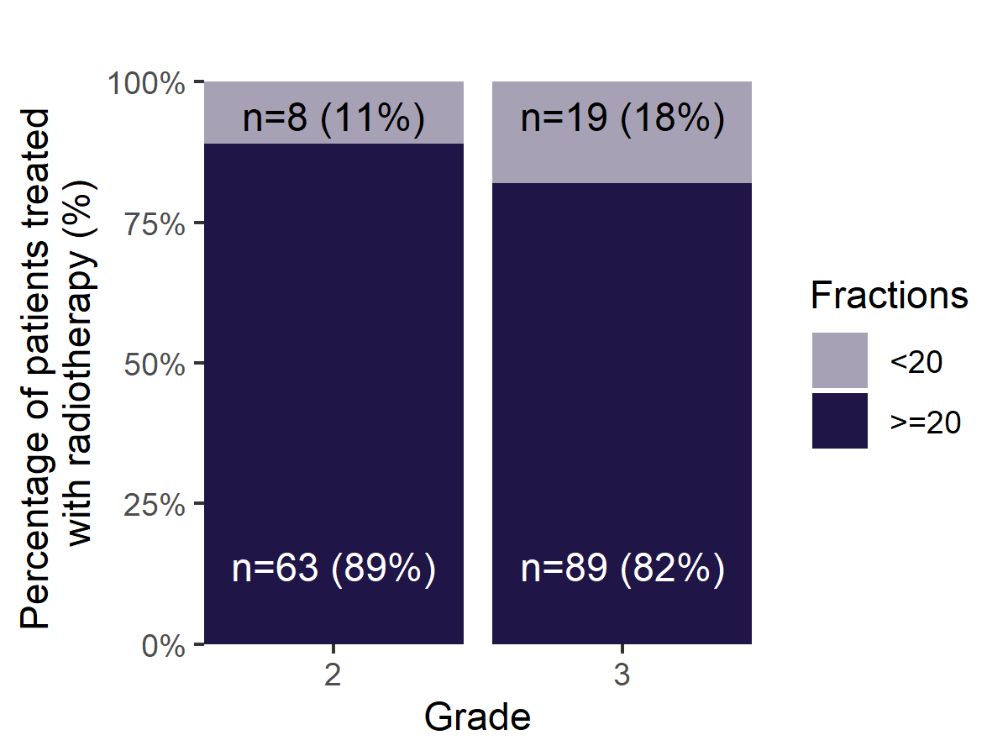
Table 14:Treatment within one year of grade 2 astrocytoma diagnosis by risk status
Treatment | Low risk | High risk | Total | p-value for difference between risk groups
Surgery – major, biopsy or other surgery | 51 (94%) | 107 (90%) | 159 (92%) | 0.491
- Major surgery | 51 (94%) | 56 (47%) | 107 (62%) | < 0.001
- Biopsy | – | 51 (43%) | 51 (29%) | –
Radiotherapy – any | 17 (31%) | 54 (45%) | 71 (41%) | 0.12
Chemotherapy (IV) | 1 (2%) | 15 (13%) | 16 (9%) | 0.048
No surgery, radiotherapy or chemotherapy (IV) | 3 (6%) | 11 (9%) | 13 (8%) | 0.0728
Total patients | 54 | 119 | 173
High risk was defined as: over 40 years of age, and/or biopsy is the only surgical treatment, and/or morphology code 9411 (gemistocytic astrocytoma).
Statistically significant difference between risk groups for major surgery and intravenous chemotherapy use.

Clinical commentary – treatment for astrocytoma (grades 2 and 3)
Treatment utilisation was similar across the state, with a slightly smaller proportion of regional patients having major surgery compared with the metropolitan ICS, although this was a non-significant difference. Reassuringly, 82 per cent of grade 3 diagnoses had radiotherapy. Utilisation for all treatment types was similar between grades, except for radiotherapy where the rate for grade 2 was half of the utilisation for grade 3. For those having radiotherapy, most had courses with high fractions, indicating a relatively aggressive radiotherapy schedule. The use of radiotherapy for grade 2 astrocytoma varies slightly between low- and high-risk groups. Other unexplored factors may influence ultilisation rates, with the variation likely representing appropriate risk adapted therapy. More data on risk stratification for grade 2 astrocytoma is needed to better understand the treatment utilisation.

Survival
- Unadjusted survival rates differed greatly by morphology groups, with glioblastoma having the poorest survival and oligodendroglioma having the highest survival (Figure 13).
- Adjusting for age, sex and comorbidity count, survival was significantly poorer for glioblastoma patients and significantly higher for oligodendroglioma patients compared with the Victorian average (Figure 14).
- There was some non-significant variation for one- and two-year survival of glioblastoma by ICS of residence (Figure 15, Table 15). One-year survival ranged from 39 per cent in GICS and 48–49 per cent in SMICS and NEMICS. Two-year survival ranged from 8 per cent in LMICS and 23 per cent in GICS and NEMICS.
- There was some non-significant variation for unadjusted survival for glioblastoma by ICS of residence (Figure 16).
Figure 13: Survival by morphology group for brain cancer patients (N = 2,182)
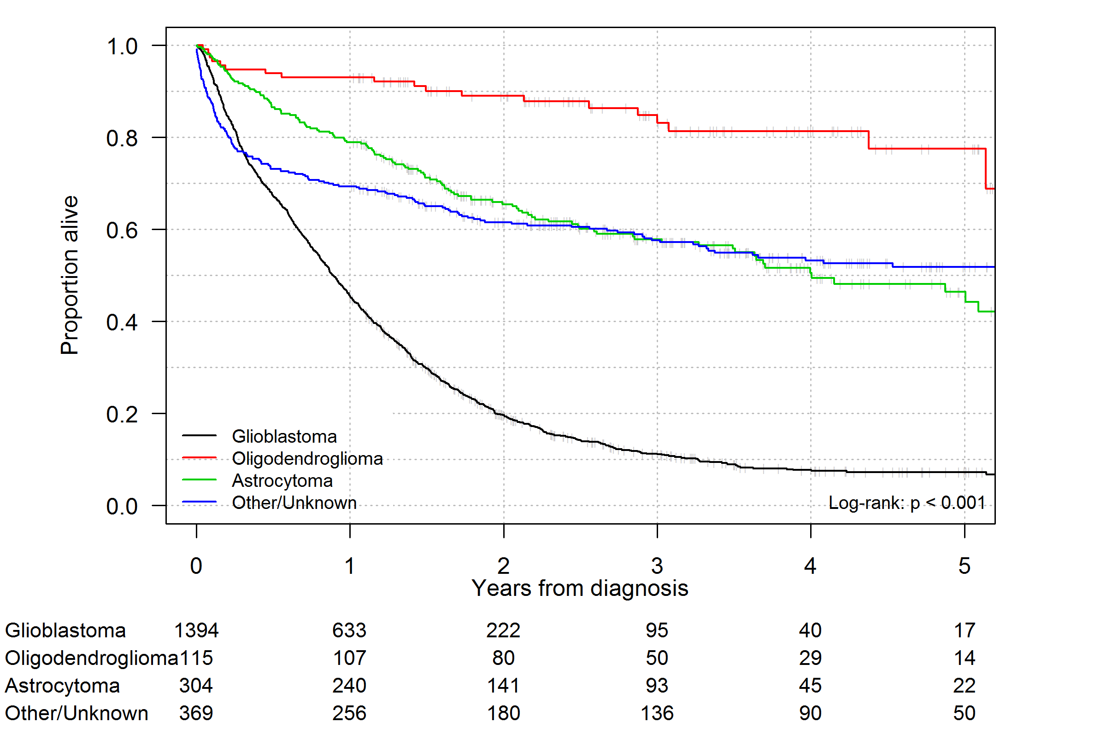
Figure 14: Hazard ratios estimated by Cox proportional hazards models for the association between risk of death and morphology group adjusting for age, sex and Charlson Comorbidity count
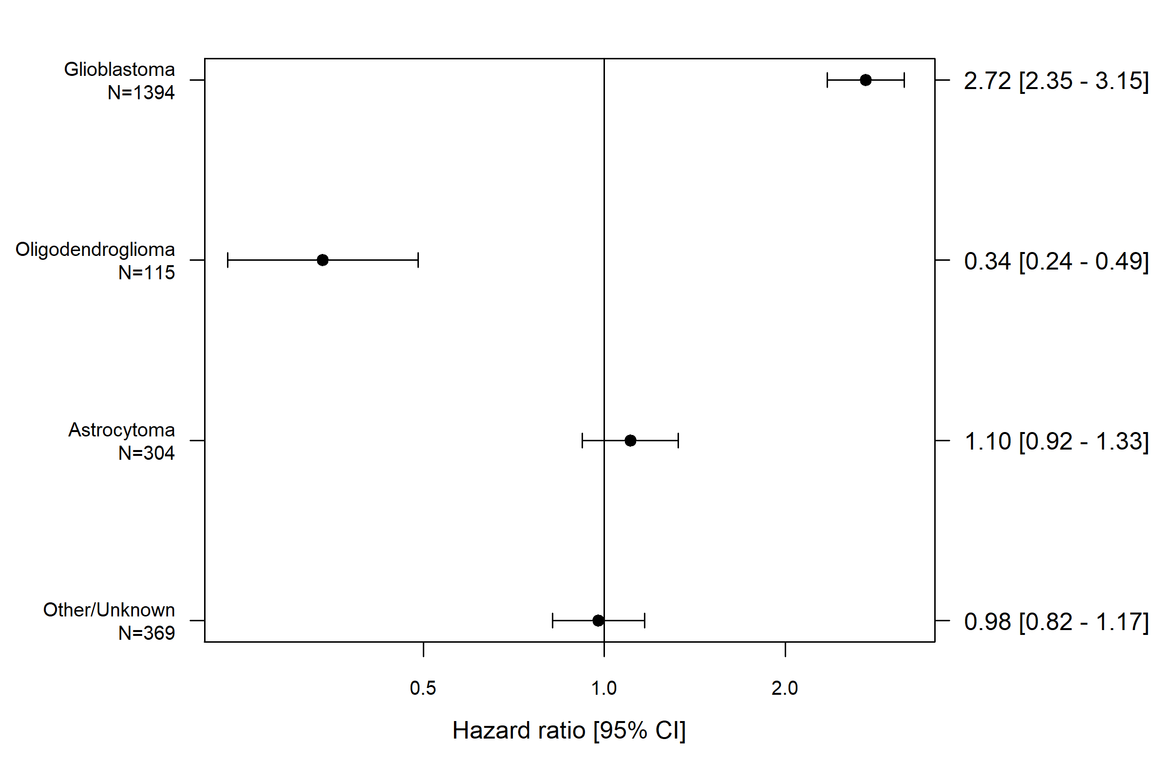
<---Better survival
Poorer survival--->
Hazard ratio
[95% CI]
Figure 15: Kaplan-Meier survival curves by ICS of residence for glioblastoma (N = 1,394)
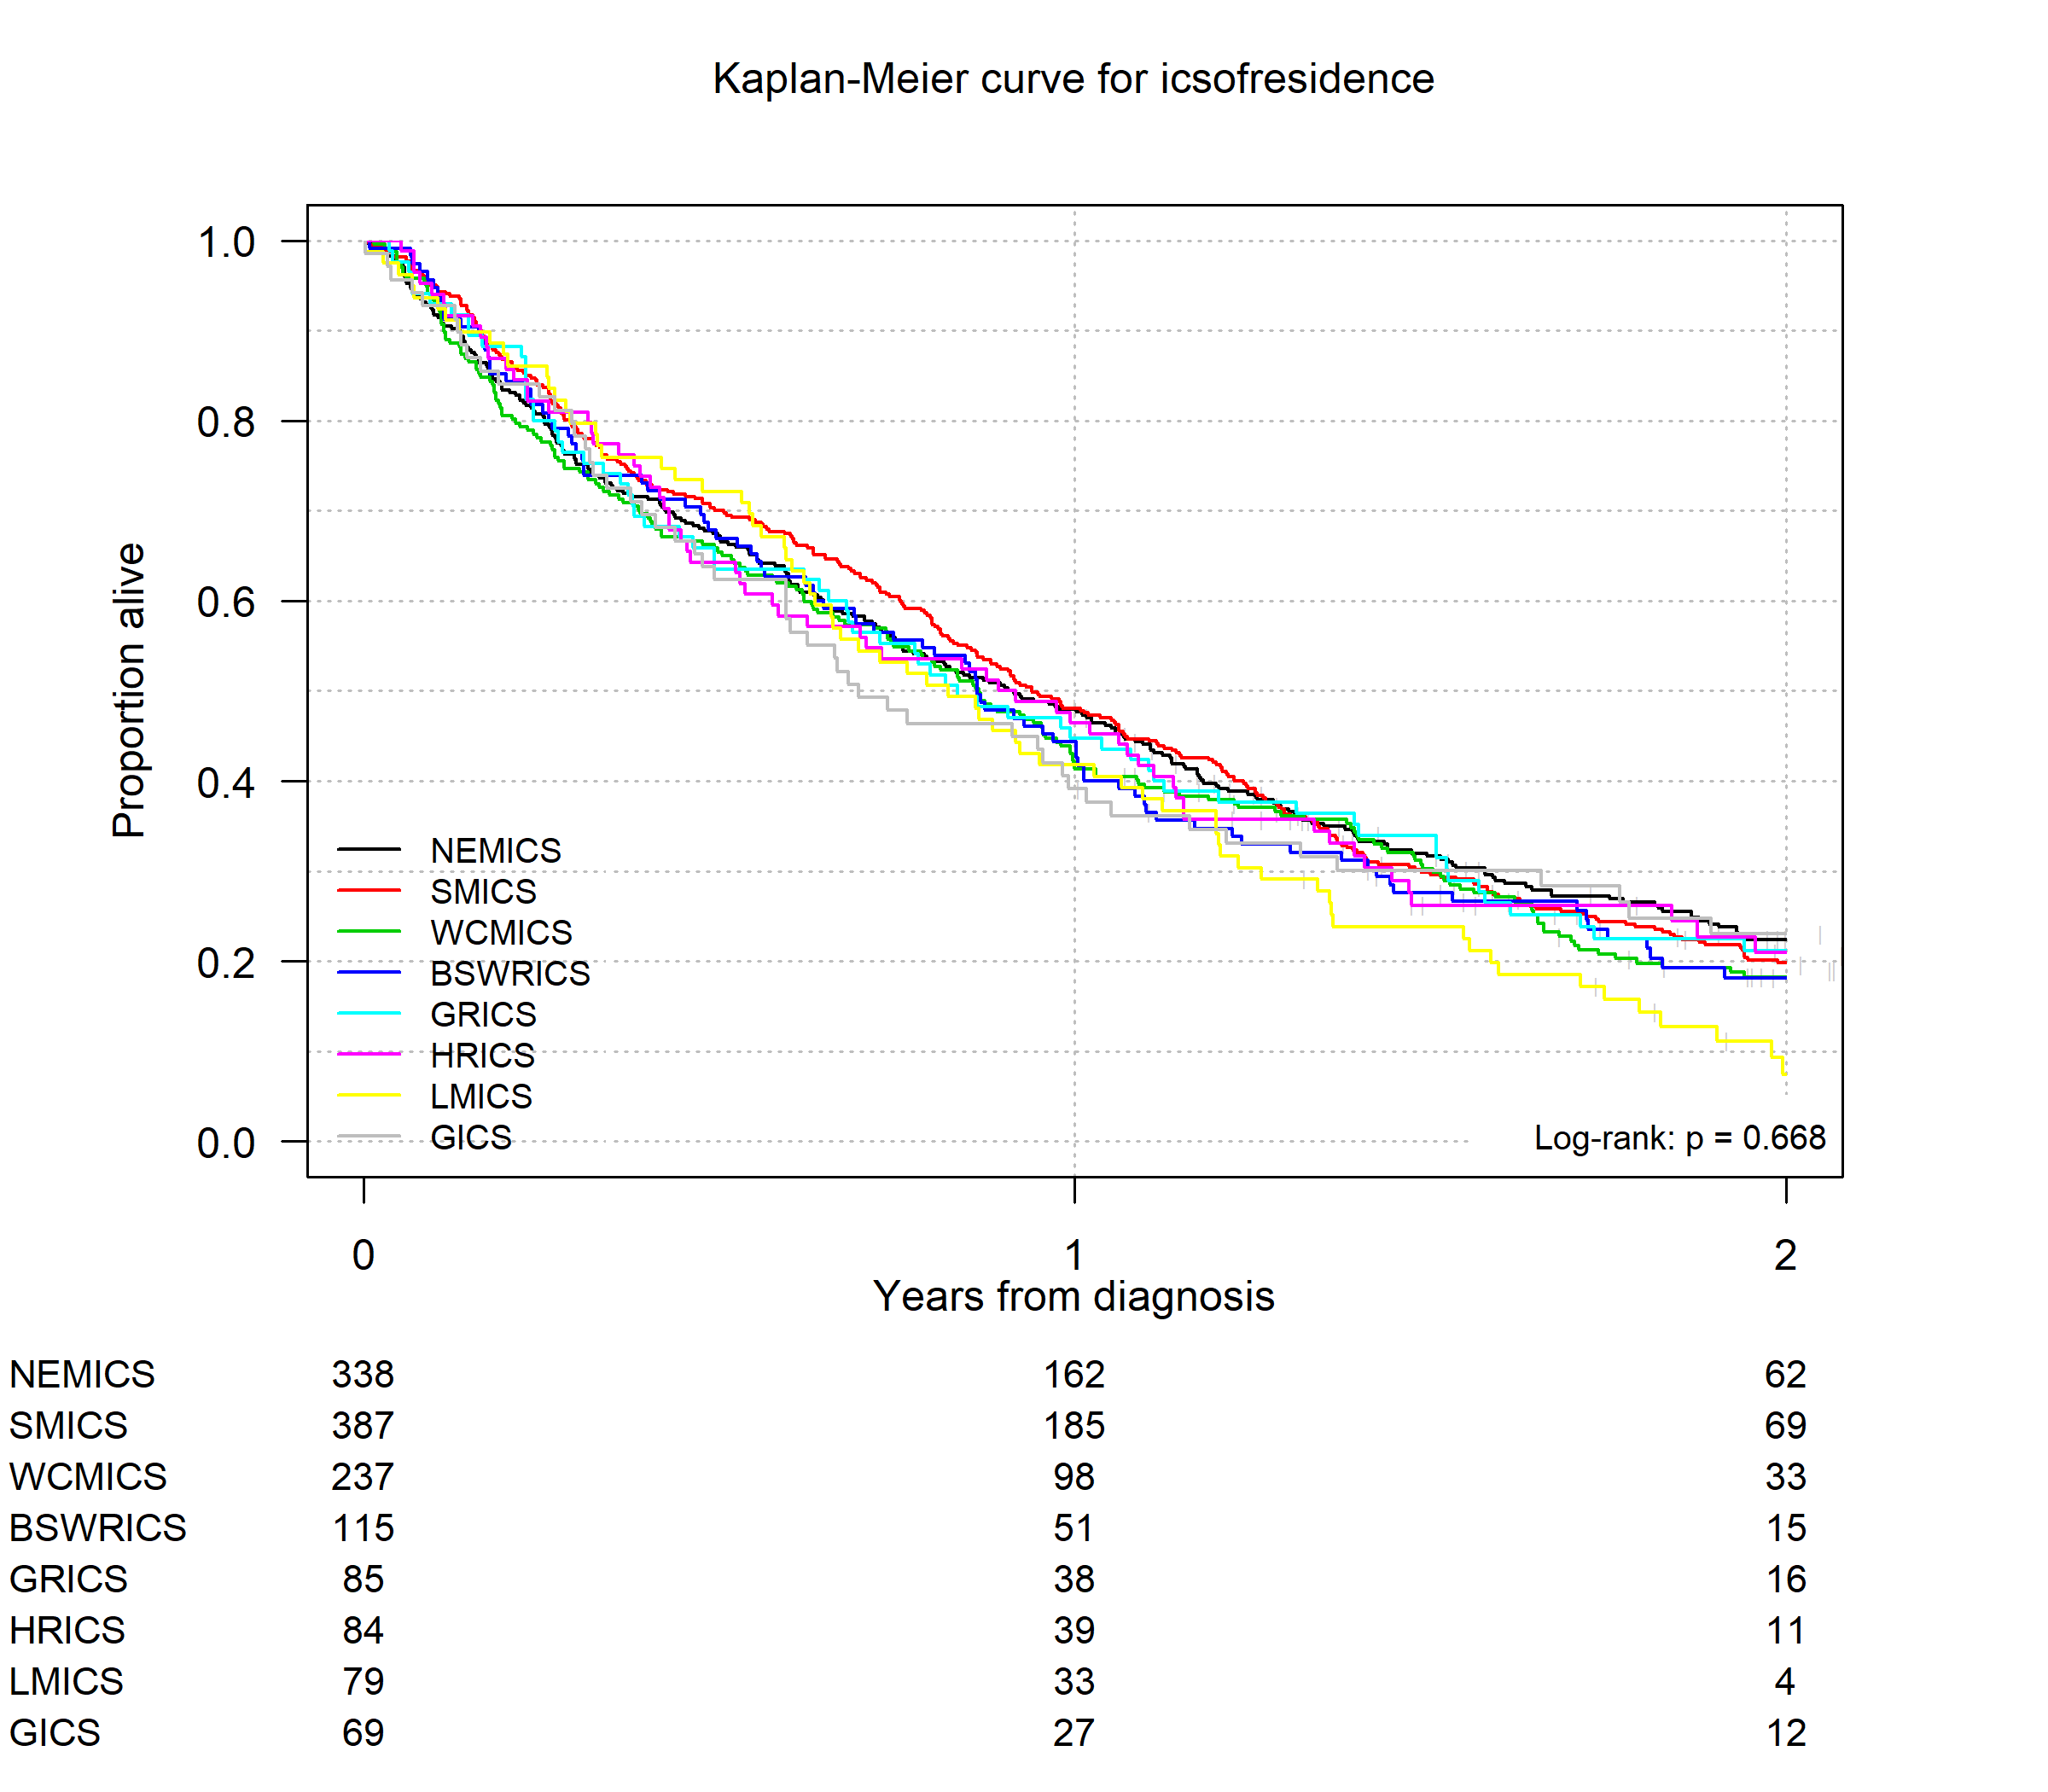
Table 15: One- and two-year survival for glioblastoma by ICS of residence (N = 1,394)
ICS of residence | One-year survival % (95% CI) | Two-year survival % (95% CI)
NEMICS | 48.41 (43.30–54.12) | 22.78 (18.54–28.00)
SMICS | 48.52 (43.74–53.82) | 20.12 (16.41–24.68)
WCMICS | 41.75 (35.88–48.58) | 18.56 (14.04–24.53)
BSWRICS | 44.76 (36.48–54.91) | 18.39 (12.30–27.48)
GRICS | 45.15 (35.72–57.08) | 21.46 (14.19–32.44)
HRICS | 47.00 (37.40–59.07) | 21.42 (13.81–33.21)
LMICS | 42.67 (32.99–55.18) | 7.68 (3.42–17.23)
GICS | 39.43 (29.48–52.73) | 23.37 (15.08–36.20)
All patients | 46.00 (43.40–48.70) | 19.90 (17.90–22.30)
Figure 16: Hazard ratios estimated by Cox proportional hazards models for the association between risk of death of glioblastoma patients and ICS of residence adjusting for age, sex and Charlson comorbidity count (N = 1,394)
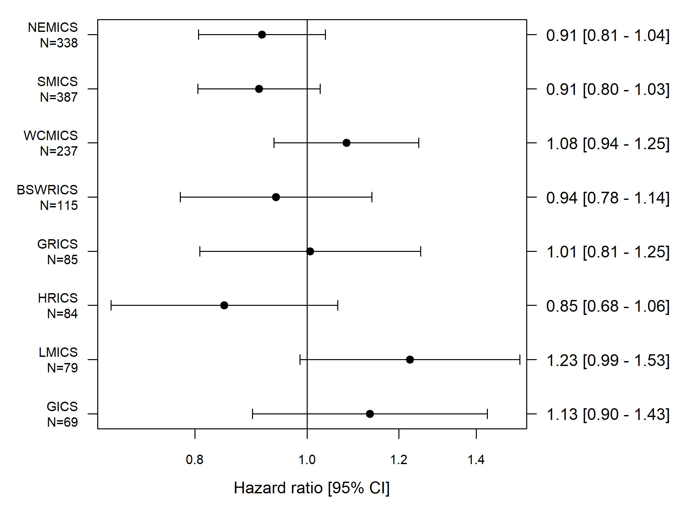
<---Better survival
Poorer survival--->
Hazard ratio
[95% CI]
Hazard ratio adjusted for age, sex and comorbidities.

Clinical commentary – survival
Glioblastoma had the poorest survival, which was expected. Oligodendroglioma had the best survival, which is likely due to this tumour type being very responsive to treatment, although it is worth keeping in mind that the cohort of patients is quite small. There is some non-significant variation in survival, although these are very small differences and whether they are truly different is unclear.

Palliative and supportive care
- Across Victoria, 34 per cent of brain cancer patients had documented evidence of supportive care screening in their medical record (Figure 17). This varied by ICS of treatment. There were patients with documented evidence of supportive care screening in WCMICS, although this may reflect a different approach used that does not involve the validated supportive care screening tools.
- Overall, 51 per cent of patients received inpatient, outpatient or community palliative care from 365 days prior until 30 days before death. The proportion of patients with palliative care varied significantly by ICS of residence:
  - A lower proportion of patients living in SMICS and a higher proportion in BSWRICS and LMICS had palliative care, with the state average being 51 per cent (Figure 18).
- Overall, 45 per cent of patients received acute hospital-based care in the last 30 days of life. There was some variation between ICS of residence for emergency admission, emergency department presentation and an acute stay of more than 14 days (Table 16).
Figure 17: Documented evidence of supportive care screening using a validated tool (2017) (N = 148)
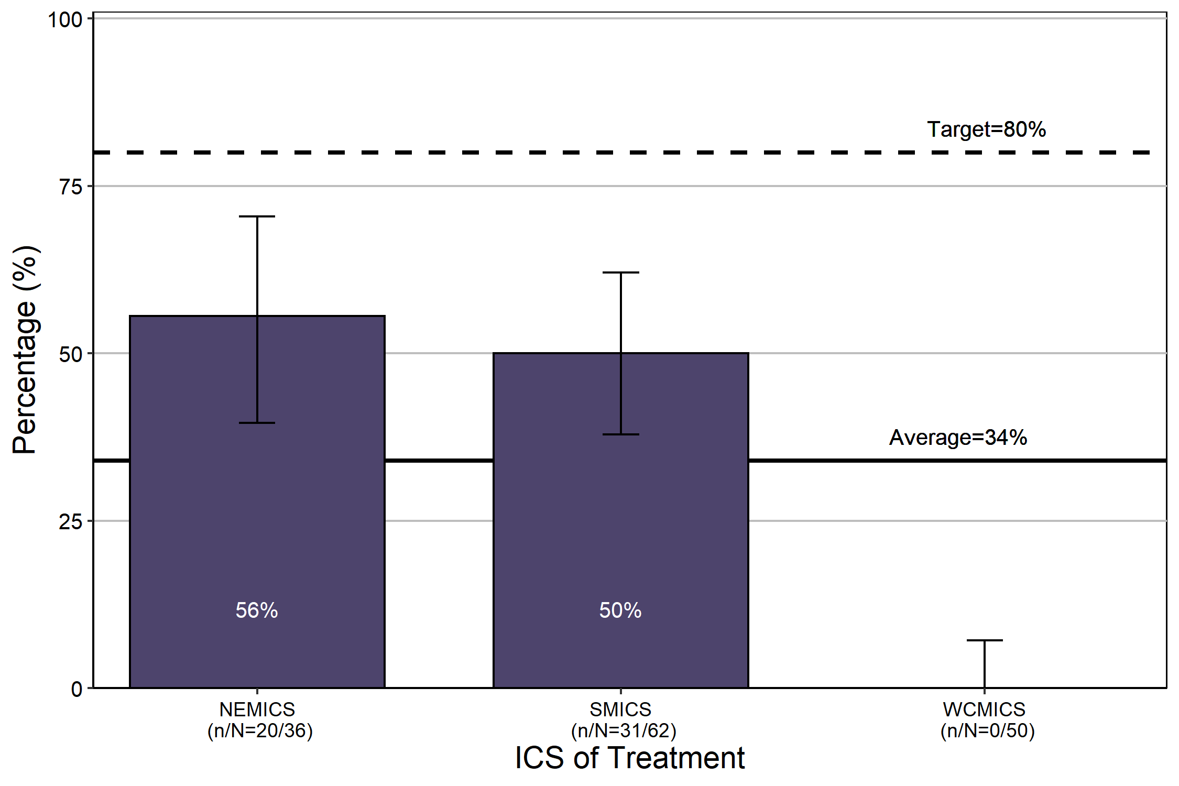
Source: CSPI medical record audit 2017
Bars represent 95 per cent confidence interval.
Patients with a C70–72 diagnosis, aged 18 and over at diagnosis.
Regional ICS excluded due to low numbers.
A validated supportive care screening tool must be used, such as the NCCN Distress thermometer and problem checklist, or Peter Mac Supportive Care Needs Tool.
Figure 18: Palliative care (inpatient and non-admitted) from 365 days prior until 30 days before death for brain cancer patients (N = 1, 516)
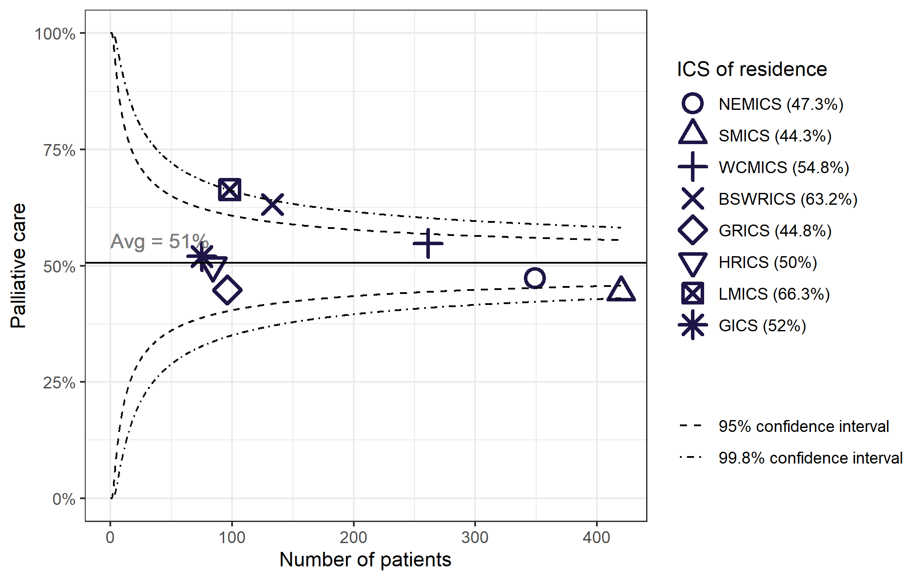
Community palliative care data is incomplete.
Patients living in HRICS may have received palliative care in New South Wales.
Table 16: Acute hospital-based care in the last 30 days of life for brain cancer patients
ICS of residence | Emergency admission | Emergency department presentation | > 14-day acute stay | ICU stay | Any acute hospital-based care | Total deaths
NEMICS | 101 (29%) | 86 (25%) | 58 (17%) | 14 (4%) | 145 (42%) | 349
SMICS | 148 (35%) | 116 (28%) | 60 (14%) | 33 (8%) | 181 (43%) | 420
WCMICS | 107 (41%) | 105 (40%) | 39 (15%) | 10 (4%) | 134 (51%) | 261
BSWRICS | 37 (28%) | 28 (21%) | 16 (12%) | 10 (8%) | 48 (36%) | 133
GRICS | 34 (35%) | 32 (33%) | 17 (18%) | 7 (7%) | 41 (43%) | 96
HRICS | 36 (43%) | 24 (29%) | 21 (25%) | 5 (6%) | 49 (58%) | 84
LMICS | 38 (39%) | 38 (39%) | 12 (12%) | 5 (5%) | 51 (52%) | 98
GICS | 26 (35%) | 16 (21%) | 21 (28%) | 7 (9%) | 39 (52%) | 75
Victoria | 527 (35%) | 445 (29%) | 244 (16%) | 91 (6%) | 688 (45%) | 1,516
Patients living in HRICS may have been treated in New South Wales.
Emergency admission, emergency department presentation, > 14-day acute stay and ICU stay are separate and non-mutually exclusive indicators (a patient may be counted in more than one indicator).
All results are within the Victorian average except for:
- Emergency department presentation in WCMICS, which is above (p<0.001)
- Emergency admission in WCMICS, which is above (p < 0.05)
- Greater than 14-day acute stay in GICS, which is above (p < 0.05)
- Any acute hospital-based care in HRICS, which is above (p < 0.05)
- Emergency admission in NEMICS, which is below (p < 0.05)
- Emergency department presentation in BSWRICS, which is below (p < 0.05)
- Any acute hospital-based care in BSWRICS, which is below (p < 0.05)

Clinical commentary – palliative and supportive care
Early referral to palliative care can improve quality of life. Only 51 per cent of patients had at least one episode of inpatient, outpatient, or community palliative care prior to the month before death. This is likely to be an underestimate due to incomplete capture of community palliative care.
Acute hospital care, such as emergency presentations and ICU stay, prior to death are indicators of quality of life. Forty-five per cent of patients had acute hospital care in the last 30 days of life. Interestingly, 16 per cent required prolonged admission and 6 per cent were admitted for an ICU stay.
Access to early palliative care planning (palliative care provided prior to the month before death) and reducing the use of acute hospital care within 30 days before death may be areas for improvement.
Supportive care deals with issues that emerge for patients, families and carers from the effects of diagnosis and treatment and is a vital part of any cancer treatment program. Documented evidence of supportive care screening across Victoria was less than the 2017 target of 50 per cent, with the target increased to 80 per cent in 2018. Other screening approaches may have been undertaken, but the audit measures the use of a validated supportive care screening tool because this is the recommended best practice for identifying unmet support needs for patients.

Abbreviations
CI | confidence interval
CSPI | Cancer Services Performance Indicator
HR | hazard ratio
ICS | Integrated Cancer Service
IQR | interquartile range
MDM | multidisciplinary meeting
NOS | not otherwise specified
OCP | optimal care pathway
VAED | Victorian Admitted Episodes Dataset
VCR | Victorian Cancer Registry
VRMDS | Victorian Radiotherapy Minimum Data Set

Victorian Integrated Cancer Services
NEMICS | North Eastern Melbourne Integrated Cancer Service
SMICS | Southern Melbourne Integrated Cancer Service
WCMICS | Western and Central Melbourne Integrated Cancer Service
BSWRICS | Barwon South Western Regional Integrated Cancer Service
GRICS | Gippsland Regional Integrated Cancer Services
HRICS | Hume Regional Integrated Cancer Service
LMICS | Loddon Mallee Integrated Cancer Service
GICS | Grampians Integrated Cancer Service

Glossary
Chemotherapy (intravenous) | An admitted episode in the VAED where the admission date was between 30 days prior and one year after the patient’s brain cancer diagnosis date and included a chemotherapy diagnosis, procedure or diagnosis related group code (Supplementary Table 6).
Comorbidity count | A count measuring the number of comorbid conditions a patient has at diagnosis, which may influence their prognosis. Data on patient comorbidities was extracted from diagnosis codes of admitted episodes in the VAED in the year prior to 30 days after the patient’s brain cancer diagnosis date. Patients without admitted episodes were assumed to have no comorbidities. The comorbidity count was calculated for each patient according to Quan et al. (excluding cancer and metastases) and grouped into four categories (0, 1, 2 and 3+).  Diagnosis codes for comorbidities can only be assigned in the admitted episode when the comorbidities meet criteria for coding in line with the Australian Coding Standards. As a result, the identification of comorbidities is underestimated.  Conditions included in the comorbidity count:  - AIDS/HIV  - congestive heart failure  - chronic pulmonary disease  - dementia  - diabetes with chronic complications  - hemiplegia or paraplegia  - mild liver disease  - moderate/severe liver disease  - renal disease  - rheumatic disease.
Death certificate only | A method of cancer notification to the VCR whereby the death certificate provides the only notification of a person’s cancer to the registry.
Diagnosis date | The date of the pathology report or other investigative report where the diagnosis of brain cancer was first confirmed to the VCR.
Palliative care | Person- and family-centred care provided for a person with an active, progressive, advanced disease who has little or no prospect of cure and who is expected to die, and for whom the primary goal is to optimise the quality of life.
Radiotherapy | Radiotherapy courses in the VRMDS where the start date was between 30 days prior and one year after the patient’s brain cancer diagnosis date, the primary site was a brain cancer code (ICD-10-AM C70, C71, C72) or a benign central nervous system code (D32, D33), and the target site was ‘brain’ or ‘skull’.
Socioeconomic status (SES) | A measure of a person’s economic and social position within society, which tends to be positively associated with better health. In this report SES is based on the Index of Relative Socio-Economic Disadvantage (IRSD) included in the Socio-Economic Index of Areas published by the Australian Bureau of Statistics. Victorians were assigned an IRSD score using their residential address at the time of their diagnosis. IRSD scores have been grouped into quintiles (from 1 – most disadvantaged, to 5 – least disadvantaged).
Surgery | An admitted episode in the VAED where the admission date was between 30 days prior and one year after the patient’s brain cancer diagnosis date and the episode included a brain surgery procedure code. Brain surgery was further categorised into major brain surgery (Supplementary Table 3), brain biopsy (Supplementary Table 4) or other brain surgical procedure (Supplementary Table 5).

Supplementary material

Codes

Diagnosis
Supplementary Table 1: Brain cancer diagnosis codes
ICD-10-AM | Description
C70 | Malignant neoplasm of meninges
C71 | Malignant neoplasm of brain
C72 | Malignant neoplasm of spinal cord, cranial nerves & other

Morphology groups
Supplementary Table 2: Brain cancer morphology groups
Group | ICD-10-AM | ICD-10-AM
Glioblastoma | 9440 | Glioblastoma NOS
Glioblastoma | 9441 | Giant cell glioblastoma
Glioblastoma | 9442 | Gliosarcoma
Glioblastoma | 9445 | Glioblastoma, IDH-mutant
Oligodendroglioma | 9450 | Oligodendroglioma NOS
Oligodendroglioma | 9451 | Oligodendroglioma, anaplastic
Astrocytoma – Grade 2 | 9400 | Astrocytoma NOS
Astrocytoma – Grade 2 | 9410 | Protoplasmic astrocytoma
Astrocytoma – Grade 2 | 9411 | Gemistocytic astrocytoma
Astrocytoma – Grade 2 | 9420 | Fibrillary astrocytoma
Astrocytoma – Grade 2 | 9425 | Pilomyxoid astrocytoma
Astrocytoma – Grade 3 | 9401 | Astrocytoma, anaplastic

Surgery
Supplementary Table 3: Surgical procedures codes used to identify patients who underwent major brain tumour surgery
ICD-10-AM/ ACHI/ACS code | Description
3970900 | Removal of lesion of cerebrum
3971204 | Removal of other intracranial lesion
3971200 | Removal of lesion of cerebral meninges
3970902 | Removal of lesion of cerebellum
3971203 | Removal of intraventricular lesion
9003200 | Removal of lesion involving posterior cranial fossa
3964000 | Removal of lesion involving anterior cranial fossa
3970901 | Removal of lesion of brain stem
3970000 | Excision of lesion of skull
4070302 | Partial lobectomy of brain
4157500 | Removal of lesion of cerebellopontine angle
3965000 | Removal of lesion involving middle cranial and infratemporal fossae
4031801 | Removal of spinal intramedullary lesion
4031200 | Removal of spinal intradural lesion
Supplementary Table 4: Surgical procedures codes used to identify patients who underwent brain tumour biopsy
ICD-10-AM/ ACHI/ACS code | Description
3970900 | Removal of lesion of cerebrum
3971204 | Removal of other intracranial lesion
3971200 | Removal of lesion of cerebral meninges
3970902 | Removal of lesion of cerebellum
3971203 | Removal of intraventricular lesion
9003200 | Removal of lesion involving posterior cranial fossa
3964000 | Removal of lesion involving anterior cranial fossa
3970901 | Removal of lesion of brain stem
3970000 | Excision of lesion of skull
4070302 | Partial lobectomy of brain
4157500 | Removal of lesion of cerebellopontine angle
3965000 | Removal of lesion involving middle cranial and infratemporal fossae
4031801 | Removal of spinal intramedullary lesion
4031200 | Removal of spinal intradural lesion
Supplementary Table 5: Surgical procedures codes used to identify patients who underwent other brain tumour procedures
ICD-10-AM/ ACHI/ACS code | Description
3960000 | Drainage of intracranial haemorrhage
3901500 | Insertion of external ventricular drain
3972100 | Postoperative re-opening of craniotomy or craniectomy site
4070300 | Corticectomy of brain
3970301 | Drainage of intracranial lesion or cyst
4060003 | Other cranioplasty
4001200 | Endoscopic third ventriculostomy
4060000 | Cranioplasty with insertion of skull plate
3901502 | Insertion of intracranial pressure [ICP] monitoring device, with monitoring
3961500 | Repair of dura of brain via craniotomy
3970601 | Decompression of intracranial tumour via osteoplastic craniotomy
3007500 | Biopsy of lymph node
3007501 | Biopsy of soft tissue
3007506 | Biopsy of pituitary gland, transsphenoidal approach
3007508 | Biopsy of pineal gland
3960301 | Removal of intracranial haematoma with craniectomy
3990300 | Removal of intracranial abscess

Chemotherapy
Supplementary Table 6: Diagnosis, procedure and diagnosis related group codes used to identify patients who received chemotherapy
Code group | Code | Description
Diagnosis | Z511 | Pharmacotherapy session for neoplasm
Procedure | 9619600 | Intra-arterial administration of pharmacological agent, antineoplastic agent
Procedure | 9619700 | Intramuscular administration of pharmacological agent, antineoplastic agent
Procedure | 9619800 | Intrathecal administration of pharmacological agent, antineoplastic agent
Procedure | 9619900 | Intravenous administration of pharmacological agent, antineoplastic agent
Procedure | 9620000 | Subcutaneous administration of pharmacological agent, antineoplastic agent
Procedure | 9620100 | Intracavitary administration of pharmacological agent, antineoplastic agent
Procedure | 9620200 | Enteral administration of pharmacological agent, antineoplastic agent
Procedure | 9620300 | Oral administration of pharmacological agent, antineoplastic agent
Procedure | 9620500 | Other administration of pharmacological agent, antineoplastic agent
Procedure | 9620600 | Unspecified administration of pharmacological agent, antineoplastic agent
Procedure | 9620900 | Loading of drug delivery device, antineoplastic agent
Diagnosis related group | R63Z | Chemotherapy

Refer to the ‘Abbreviations’ page for a list of Victoria’s Integrated Cancer Services.
Quan H, Li B, Couris C, et al. 2011, ‘Updating and validating the Charlson comorbidity index and score for risk adjustment in hospital discharge abstracts using data from 6 countries’, American Journal of Epidemiology, vol. 173, no. 6, pp. 676–682.
Quan H, Li B, Couris C, et al. 2011, ‘Updating and validating the Charlson comorbidity index and score for risk adjustment in hospital discharge abstracts using data from 6 countries’, American Journal of Epidemiology, vol. 173, no. 6, pp. 676–682.
Australian Coding Standard ACS 0002 Additional Diagnoses.
Palliative Care Australia 2019, What is palliative care? Available at: https://palliativecare.org.au/what-is-palliative-care. [Accessed 28 October 2019].

