Water fluoridation for healthy teeth
Community information
OFFICIAL

A message from Victoria’s Chief Health Officer
Fluoride is a repair kit for teeth. It reduces the risk of tooth decay. It can even reverse tooth decay in the early stages. Fluoride is added to drinking water in small amounts to help reduce tooth decay.
The Victorian Government recognises that oral health is important to a person’s overall health and wellbeing and is committed to improving the oral health of all Victorians. Significant improvements have been made over the past 30 years, however there is still evidence of poor oral health among many Victorians.
More than 97 per cent of Victorians drink water with either naturally occurring or added fluoride. Melbourne and some regional areas have enjoyed the benefits of fluoridated drinking water for more than 40 years.
The Victorian action plan to prevent oral disease 2020–30 focuses on reducing the gap in oral health for people who are at higher risk of oral disease.
The plan includes:
- providing water fluoridation to Victorian communities that do not currently have access to it
- funding public dental care for eligible people
- providing free annual oral health check-ups and follow-up care for children in government schools
- providing other oral health promotion and oral disease prevention programs.
Even with a fluoridated drinking water supply, it is important to keep looking after your teeth. The best way to do this is through healthy eating, brushing twice a day with an appropriate fluoride toothpaste and getting regular dental check-ups.
I encourage you to read the following information about water fluoridation and oral health.

Professor Cowie
Chief Health Officer

How oral health affects your general health
People need to have healthy teeth and a healthy mouth to be able to eat, speak and smile well.
Tooth decay can cause pain and have a negative effect on a person’s appearance, self-esteem, social interaction and the ability to eat, speak and chew, which can affect their general health.
The effects of tooth decay are costly in terms of time, money and personal pain and suffering.

Why tooth decay is a serious issue
Tooth decay is still a big problem in Victoria. Almost half of all children aged 5 to 10 years have signs of tooth decay and 90 per cent of adults are affected.,
Dental problems are the highest cause of all potentially preventable hospitalisations in children under ten. This is mostly because of tooth decay.
In Victoria in 2020–21, there were more than 4,800 children under the age of 10 who needed a general anaesthetic to treat their tooth decay.

About fluoride
Fluoride is a naturally occurring mineral found in rock, air, soil, plants and water. Both fresh water and sea water contains some fluoride. Many foods and drinks contain fluoride naturally.
It is also added to:
- drinking water, where fluoride is added to the local water supply
- fluoride toothpastes, gels and mouth rinses
- fluoride products painted on the teeth by health professionals.

About water fluoridation
Water fluoridation is the process of changing the amount of fluoride in drinking water to an optimal level to help reduce tooth decay. Around Australia and the world, health organisations recommend adding fluoride to drinking water. Extending water fluoridation is a key strategy in Australia’s national oral health plan, and is one of four goals in the Victorian action plan to prevent oral disease 2020–30.
In some parts of Victoria, the local water supply naturally contains enough fluoride to reduce tooth decay. However, most water supplies do not.
Adding fluoride does not alter the taste or smell of water.

The benefits of water fluoridation
Fluoride in drinking water is helpful because it:
- protects against tooth decay in people of all ages, regardless of education, income, or access to dental and health care
- helps repair the early stages of tooth decay caused by food and drinks
- can reduce the impacts of tooth decay, including discomfort, pain and the cost of dental treatment.

How fluoride protects against tooth decay
Tooth decay occurs when acid destroys the outer surface of the tooth.
Consuming food and drinks that contain sugar causes bacteria in the mouth to make this acid.
Fluoride works in a number of ways, it:
- helps to strengthen the mineral structure of developing teeth
- limits the amount of acid produced by bacteria
- repairs the early stages of tooth decay.

Continue to use fluoride toothpaste even if you drink fluoridated water
Drinking fluoridated water and using toothpaste with fluoride provide important benefits, especially when used together.
Fluoridated drinking water keeps low levels of fluoride in your saliva and in dental plaque all day.
By comparison, the amount of fluoride in children’s toothpaste is around 500 parts per million and in standard toothpaste is 1,000 to 1,500 parts per million. The much higher concentration of fluoride in toothpaste offers additional benefit.
Together, these two sources give you more protection than either one alone.

How fluoride is added to drinking water
Fluoride is added to the water at drinking water treatment plants that have been designed to add carefully controlled amounts.
The fluoride level in the water is continually monitored and equipment is designed to shut down if the fluoride level goes higher than it should at any point in the water treatment system. Samples of water are also taken from sites throughout the water supply network to check the fluoride concentration ‘at the tap’.

How much fluoride is in drinking water
Only a very small amount of fluoride is needed in drinking water to help protect against tooth decay.
In Victoria, the fluoride content of drinking water is adjusted to an optimal level of around 1 mg/L (also known as one part per million).

How we know water fluoridation is safe
Australia’s peak health body, the National Health and Medical Research Council (NHMRC), strongly recommends community water fluoridation as a safe, effective and ethical way to help reduce tooth decay across the population.
The NHMRC has specified the compounds that are acceptable to add to drinking water for this purpose. These are sodium fluoride, sodium fluorosilicate and fluorosilicic acid. The local water supplier chooses which compound to use. This is based on the fluoridation equipment at the water treatment plant.
Studies from the NHMRC and other health authorities around the world consistently find that water fluoridation does not have any harmful health effects.

Victorian communities with fluoridated water
About 97 percent of Victorians have access to fluoridated water. This is broken down into 99 per cent of communities in metropolitan Melbourne and 88 per cent in rural and regional areas (refer to Figure 1).

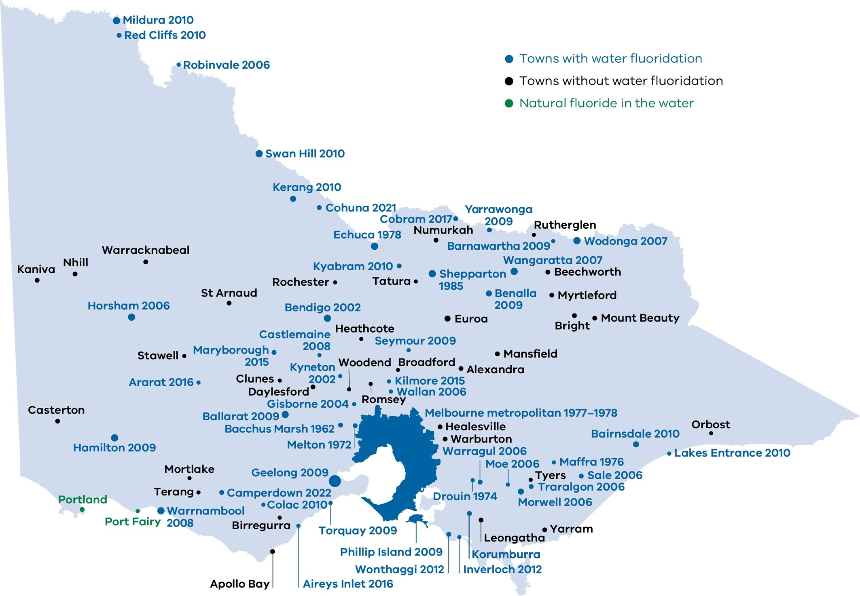
Figure 1: This map of Victoria shows locations with fluoridated drinking water in blue text, and towns with natural fluoride in the water in green text. Locations without water fluoridation are shown in black text.

Additional oral health advice

More ways to help protect your teeth
Even if your water is fluoridated, it is important to look after your teeth:
- eat a healthy diet. Limit high-sugar food and drinks (particularly added sugar)
- help your children brush their teeth. Do this until you are sure they can do it well by themselves
- brush your teeth and gums at least two times a day using a toothpaste with the appropriate level of fluoride in it:
  - do not use toothpaste for children aged up to 18 months old, unless recommended by your health professional
  - use a pea-sized amount of low-fluoride toothpaste for children aged between 18 months and six years old
  - use standard fluoride toothpaste for anyone over six years old.
- have regular dental check-ups.
Everyone has different oral health needs. Ask your dental professional how often you should have a dental check-up.
Children should have oral health checks starting when their first teeth appear. A dental professional, or another health professional such as your doctor, maternal and child health nurse or Aboriginal and Torres Strait Islander health practitioner may do this.
Find your nearest dental clinic:
- Visit the Dental Health Services Victoria website <https://www.dhsv.org.au/>. You can find your nearest community dental clinic. You can also find out if you are eligible for public dental care.
- Search online for a private dental practitioner.

Infant formula can be prepared with fluoridated water
Although breast milk is the best feeding choice for babies, infant formula also provides a baby with enough nutrition. If infant formula is used, it is safe to prepare it using fluoridated drinking water in Australia.

Fluoride tablets, drops and lozenges are not recommended
Do not use fluoride tablets, drops or lozenges, even if your water drinking water is not fluoridated. These products are no longer available in Australia. If anyone in your household has been using these products, it is important to stop. Dental professionals may still use and recommend fluoride varnishes and mouth rinses.

More information about water fluoridation
- Visit the Better Health Channel <https://www.betterhealth.vic.gov.au/health/conditionsandtreatments/dental-care-fluoride>.
- Visit the Department of Health’s website <https://www2.health.vic.gov.au/public-health/water/water-fluoridation>.
- Visit the NHMRC’s website <https://www.nhmrc.gov.au/health-advice/public-health/health-effects-water-fluoridation>.

More information about oral health and dental care
- Visit the Dental Health Services Victoria website <https://www.dhsv.org.au>.
- Visit the Better Health Channel <https://www.betterhealth.vic.gov.au/conditionsandtreatments/mouth-and-teeth>
- Visit the Department of Health’s website <https://www2.health.vic.gov.au/primary-and-community-health/dental-health>
- Talk to your dental professional, GP (doctor), pharmacist or maternal and child health nurse.

To receive this document in another format, phone 1300 761 874, using the National Relay Service 13 36 77 if required, or email the Water Unit <water@health.vic.gov.au>.
Authorised and published by the Victorian Government, 1 Treasury Place, Melbourne.
© State of Victoria, Australia, Department of Health, September 2023.
ISBN 978-1-76131-230-4 (pdf/online/MS word)
Available at the Department of Health’s Water fluoridation webpage <https://www2.health.vic.gov.au/public-health/water/water-fluoridation/fluoride-information>.

DH Ha, KF Roberts-Thomson, P Arrow, KG Peres and LG Do. ‘Chapter 5 Children’s oral health status in Australia, 2012-14’, p. 101. In: LG Do and AJ Spencer (Editors). Oral health of Australian children: National Child Oral Health Study 2012–14’, 2016. Adelaide: University of Adelaide, South Australia.
L. Do and L. Luzzi. ‘Chapter 4 Oral health Status’, p. 70. In: ARCPOH. Australia’s Oral Health: National Study of Adult Oral Health 2017–18. Adelaide: The University of Adelaide, South Australia.
Ambulatory Care Sensitive Conditions (ACSCs): Victorian Health Information Surveillance System (VHISS), Department of Health, Government of Victoria, Melbourne 2020-21.
Ambulatory Care Sensitive Conditions (ACSCs): Victorian Health Information Surveillance System (VHISS), Department of Health, Government of Victoria, Melbourne 2020-21.
COAG Health Council (2015) Healthy Mouths Healthy Lives: Australia’s national oral health plan 2015–2024. <https://www.health.gov.au/resources/publications/healthy-mouths-healthy-lives-australias-national-oral-health-plan-2015-2024?language=en>
Department of Health and Human Services (2020) Victorian action plan to prevent oral disease 2020–30 <https://www2.health.vic.gov.au/public-health/preventive-health/oral-health-promotion/oral-health-planning>
National Health and Medical Research Council (2011) Australian drinking water guidelines <https://www.nhmrc.gov.au/about-us/publications/australian-drinking-water-guidelines>
National Health and Medical Research Council (2021) Health effects of water fluoridation <https://www.nhmrc.gov.au/health-advice/public-health/health-effects-water-fluoridation>
For more information about which locations in Victoria have access to water fluoridation refer to the Department of Health’s website <https://www2.health.vic.gov.au/public-health/water/water-fluoridation/water-fluoridation-in-victoria>
In some cases a health professional may recommend using toothpaste with a different amount of fluoride that is right for you.

