Victorian guideline on Candida auris
For health services
Version 1.1
OFFICIAL

To receive this publication in an accessible format phone Communicable Disease Prevention and Control on 1300 651 160, using the National Relay Service 13 36 77 if required, or email Communicable Disease Prevention and Control <infectious.diseases@health.vic.gov.au>.
Authorised and published by the Victorian Government, 1 Treasury Place, Melbourne.
© State of Victoria, Department of Health October 2023.
Available on the Department of Health Infection Control Guidelines website <www.health.vic.gov.au/infection-control>.

Contents
Acknowledgments 4
Glossary 6
Section 1: Background 8
Candida auris (C. auris) 8
Scope of this guideline 9
Section 2: Governance 11
Roles and responsibilities of all agencies 11
Section 3: Laboratory methods and reporting requirements 15
Requirements for primary diagnostic laboratories to report cases 15
Other requirements for primary diagnostic laboratories 15
Yeast isolates that require speciation 15
Methods for detecting C. auris 16
Role of the reference laboratories 16
Environmental sample testing 17
Section 4: Screening, detection and investigation of C. auris 18
Surveillance strategy 18
Scope of screening and contact tracing requirements 18
Choice of screening samples for patients 18
Screening requirements for all facilities 19
Actions when a single case of C. auris is detected 20
Actions when local transmission of C. auris is identified 25
Environmental screening 28
Section 5: Management and control of C. auris 29
Infection control precautions 29
Acute healthcare setting 30
Subacute or rehabilitation healthcare setting 33
Ambulatory healthcare settings 34
Residential care facilities 35
Medical transport services 36
Hydrotherapy 37
Treatment of C. auris 38
Section 6: References 39
Section 7: Further reading 40
Appendix 1: Project governance 41

Acknowledgments
This guideline was developed by the Communicable Diseases Section of the Department of Health. Recommendations were derived from existing best practice documents, literature review and expert opinion.
We gratefully acknowledge the assistance of the Project Steering Committee, Laboratory Working Group and Infection Prevention and Control Working Group members (see Appendix 1) in developing the first version of this guideline. In addition, we also acknowledge those organisations that provided feedback on the guideline including health services, infectious diseases and health service infection prevention and control units and public health and diagnostic laboratories.
This guideline will remain open to continued review. The experience of health services in applying this guidance will be invaluable as we go forward.

Acronyms and abbreviations
ACSQHC Australian Commission on Safety and Quality in Health Care
AMR antimicrobial resistance
AMR IMT Antimicrobial Resistance Incident Management Team
ARTG Australian Register of Therapeutic Goods
CDS calibrated dichotomous sensitivity test
CLSI Clinical Laboratory Standards Institute
EUCAST European Committee on Antimicrobial Susceptibility Testing
HSIMT health service incident management team
ICU intensive care unit
IPC infection prevention and control
MALDI-TOF MS Matrix-assisted laser desorption ionisation time-of-flight mass spectrometry
MDU PHL Microbiological Diagnostic Unit Public Health Laboratory
MIC minimal inhibitory concentration
NATA National Association of Testing Authorities, Australia
NSQHS Standards National Safety and Quality Health Service Standards
PCR polymerase chain reaction
PPE personal protective equipment
PPS point prevalence survey
PRIS patients requiring pre-emptive isolation and screening
RCF residential care facility
TGA Therapeutic Goods Administration
the department Department of Health
TRA transmission risk area
VASRU Victorian AMR Surveillance and Response Unit
VICNISS Victorian Healthcare Associated Infection Surveillance System
VIDRL Victorian Infectious Diseases Reference Laboratory
WGS whole genome sequencing

Glossary
Case | Suspected case  A suspected case requires a non-Candida albicans Candida species to be isolated from a diagnostic or screening specimen (as designated in Box 1: Yeast isolates that require speciation).  Confirmed case  A confirmed case requires Candida auris (C. auris) to be isolated from a diagnostic or screening specimen irrespective of phenotypic susceptibility.  This definition intends for the term ‘confirmed case’ to refer to a person who is colonised or infected with a C. auris.
Clearance | In this guideline clearance is a term that refers to applying criteria to determine that an individual no longer requires infection control precautions in relation to a risk of transmission of C. auris. Further details are in Section 4.
Contact | An individual who is exposed to either a person (a case) colonised or infected with C. auris in a manner that might allow transmission to occur, or an individual who is exposed to a C. auris-contaminated environment where there is an increased risk of acquisition of C. auris. There are two categories of contact – a room contact, and a ward contact.  Room contact  A room contact is a person who resided for ≥24 hours in a health service in a shared room with a confirmed case during the case’s period of transmission risk.  Ward contact  A ward contact is any person who has been on a ward for ≥24 hours in the time period that the ward has been designated as a transmission risk area (TRA) (see TRA definition below).
Frequently touched surfaces | As per national guidelines (NHMRC 2019), surfaces can be divided into two groups – those with minimal hand contact (for example, floors and ceilings) and those with frequent hand contact (‘frequently touched’ or ‘high-risk’ surfaces). Frequently touched surfaces include doorknobs, bedrails, over-bed tables, light switches, tabletops and wall areas around the toilet in the patient’s bathroom/ensuite.
Local transmission / outbreak | Local transmission is defined as either:  - two or more confirmed cases of genetically closely related C. auris, or  - an isolate from an environmental source and a closely related isolate from a confirmed C. auris case suggestive of acquisition from the environment,  with a plausible epidemiological link and without an alternative explanation. The definition is deliberately inclusive.
Residential care facility | The term residential care facility (RCF) refers to any public or private aged care, disability services or other congruent accommodation setting where residents are provided with personal care or healthcare by facility staff.
Period of transmission risk | The period of transmission risk is the time when a C. auris case could potentially transmit C. auris to another patient. The period is from the date of likely acquisition (as determined by the Antimicrobial Resistance Incident Management Team (AMR IMT)) until the time that the case is placed into contact precautions (or discharged or transferred). The period of transmission risk is used for determining room contacts only.
Point prevalence screen (PPS) | Point prevalence screening is when a census point in time is chosen to screen a cohort of patients (for example all patients on a ward on a particular date) at risk of being infected or colonised with C. auris.
Transmission risk area | A transmission risk area (TRA) is an area (a distinct geographical area or ward) in which local transmission has been determined by the AMR IMT to have occurred. The timeframe for the TRA is the period when transmission may have occurred plus either four consecutive weeks of negative point prevalence screens or a single negative PPS four weeks after the final patient involved in the transmission was discharged. The timeframe for the TRA is different from the period of transmission risk. These concepts are explained further in Section 4.

Section 1: Background

Candida auris (C. auris)
C. auris is an uncommon Candida species that has been isolated from a range of body sites, including the skin, gastrointestinal tract, urogenital tract and respiratory tract and has been identified as the cause of a range of invasive fungal infections similar to other Candida species. Unlike other fungal pathogens, C. auris has shown a propensity to be transmitted between patients and been associated with a number of healthcare-associated outbreaks internationally. Candida auris is considered an emerging multi-drug resistant organism that is a significant public health threat to Victorian health services and Victorians.

Epidemiology
C. auris is an emerging fungal pathogen that was first described in 2009 after isolation from the ear discharge of a hospitalised patient in Japan (Satoh et al 2009). The first cases of bloodstream infection were reported in South Korea in 2011 (Lee et al 2011). One of these reported cases was found through a retrospective review of unidentified yeasts isolated in 1996, indicating the difficulty with identification of this organism without advanced molecular technologies. Since these early reports, C. auris cases have been reported in many countries worldwide.
To date there have been a number of cases of C. auris identified in Australia; the first in Western Australia in 2015. Victoria had four cases detected in late 2018. Local transmission occurred in one instance.
Another unusual feature of the emergence of C. auris globally is that, unlike most emerging pathogens which spread outward from one regional epicentre to other geographical regions, whole genome sequencing analysis of C. auris isolates from different global regions suggests that there has been independent clonal emergence and local spread within those regions. Four distinct clades that cluster geographically have been identified: South Asia (India/Pakistan), East Asia (Korea/Japan), South Africa and South America (Lockhart et al 2017).

Clinical presentation
C. auris can cause a similar range of infections as caused by other Candida species and can affect paediatric and adult populations. Bloodstream, urinary tract, pulmonary and surgical wound infections, meningitis and osteomyelitis have all been reported. The risk factors for development of invasive infection are also similar to those associated with other Candida species infections, and include 1) prolonged hospital stay, 2) serious underlying medical conditions including haematological malignancies and other conditions which result in immunosuppression, 3) prior antibiotic or antifungal treatment, 4) presence of central venous catheters and 6) recent surgery.
Although attributable mortality is unknown, some reports have indicated 30-60% of patients with C. auris infection have died (Lockhart et al 2017).

Public health significance
There are three factors which distinguish C. auris as a serious public health concern.
- C. auris is frequently resistant to multiple antifungal agents commonly used to treat Candida infections. Isolates resistant to all three major classes of antifungal therapy (azoles, amphotericin and echinocandins) have been reported.
- C. auris is difficult to identify with standard laboratory methods. It phenotypically resembles other yeasts, and traditional biochemical methods can misidentify C. auris as a wide range of Candida species and other genera, most commonly Candida haemulonii, Candida lusitaniae, Candida famata, Saccharomyces cerevisiae and Rhodotorula glutinis. Molecular methods such as matrix-assisted laser desorption ionisation time-of-flight mass spectrometry (MALDI-TOF MS) are required for identification.
- C. auris, unlike other Candida species, has caused numerous healthcare-associated outbreaks that have been difficult to control despite the implementation of enhanced control measures.
In Victoria, C. auris is an ‘urgent’ notifiable condition. Upon initial diagnosis (suspected or confirmed), pathology services must immediately (24/7) notify the department by telephone on 1300 651 160. Pathology services must follow up with written notification within 5 days. This is a Victorian statutory requirement.
Pathology services must refer all isolates of suspected or confirmed C. auris to the Victorian Infectious Diseases Reference Laboratory (VIDRL) for further confirmatory or susceptibility testing.

Mode of transmission
C. auris is spread via contact transmission. C. auris may spread person-to-person through contact with someone who is infected or colonised, via equipment that has been shared between patients or from the environment.
C. auris has been demonstrated to survive on surfaces for lengthy periods (Welsh et al 2017) and has been cultured from multiple locations in patients’ rooms and the healthcare environment and from shared patient equipment, such as temperature probes, pulse oxymeters and ECG leads (Adams et al 2018, Biswal et al 2017, Eyre et al 2018, Schelenz et al 2016). Some routinely used disinfectants, for example quaternary ammonium compounds (Cadnum et al 2017), may not be effective against C. auris and the use of disinfectants that are effective against Clostridioides difficile (C. difficile) spores is recommended (CDC 2019).

Scope of this guideline

Victorian health services
This guideline applies to all paediatric and adult health services in Victoria. For the purpose of this guideline, the term ‘health service’ refers to public and private hospitals that admit patients overnight. Where there are multiple campuses within a health service, each campus is referred to as a healthcare facility.
The guidance also applies to all satellite haemodialysis units and day oncology units, due to the nature of the patients treated and the risk of transmission of serious infections. Surgical day procedure centres are not within the scope of this guideline. If a known C. auris case is admitted to a surgical day procedure centre, appropriate standard and transmission-based infection control precautions should be implemented.
Recommendations in this guideline supersede all other state and national infection control guidelines related to the management of C. auris. They are relevant for all health professionals, including general practitioners, medical specialists and other hospital-based clinicians, allied health staff, and microbiology laboratory staff.
Any isolation of a suspected or confirmed C. auris isolate (as defined in the Glossary of this guideline) from clinical, screening or environmental samples is in scope. This means that all C. auris isolates, regardless of where they are isolated from, must be reported to the department and actions as outlined in this guideline are to be undertaken.

Victorian residential care facilities (RCFs)
Although Victorian RCFs, are not within the scope of this guideline, infection prevention and control (IPC) advice is provided in Section 5: Management and control of C. auris if a known C. auris case is admitted.

Microbiological scope
This guideline provides recommendations around the detection and response to C. auris. The scope of this guideline does NOT extend to other multi-resistant Candida or fungal species.

Section 2: Governance

Roles and responsibilities of all agencies

Department of Health (the department)
The department is the lead agency for the statewide response to C. auris. The department engages with VIDRL, the Microbiological Diagnostic Unit Public Health Laboratory (MDU PHL) and Local Public Health Units (LPHUs) to assist with the surveillance and response to CPO in Victoria.
The department will be the first point of contact for reporting suspected or confirmed C. auris cases and will maintain the database for all information collected during the investigation of cases.
The relevant roles for the department include:
- maintaining a notifiable conditions surveillance and response capability and capacity
- providing oversight of quality and safety in Victorian health services
- activating and maintaining the AMR-IMT when required.

VIDRL and MDU PHL
VIDRL and MDU PHL will assist the department in assessing and responding to C. auris in Victoria.
All isolates of suspected and confirmed C. auris are to be sent to VIDRL. VIDRL will perform further tests to confirm and characterise C. auris isolates, including antifungal susceptibility testing. Whole genome sequencing and bioinformatics is undertaken by MDU PHL and used to determine how closely related certain isolates are to one another.
Data and intelligence from VIDRL and MDU PHL will be used to establish whether local C. auris transmission has occurred and supports the AMR IMT in their response to transmissions.

LPHUs
LPHUs are responsible for managing data collection and implementing local C. auris prevention and control measures. LPHUs will liaise with IPC teams and/or clinicians (for example, general practitioners) to ensure C. auris surveillance forms are completed in a timely manner and provide assistance with implementation of control measures when required.

Victorian AMR Response and Surveillance Unit (VASRU)
VASRU is a surveillance collaboration of the department, MDU PHL, VIDRL and LPHUs focussing or prevention and, where identified, timely elimination of local C. auris transmission.

Antimicrobial Resistance Incident Management Team (AMR IMT)
The role of the AMR-IMT is to support and oversee the public health and health service response to C. auris. The AMR-IMT is activated at the discretion of the department in response to the identification of possible or confirmed local transmission of C. auris within Victoria and will remain activated as long as coordination of risk assessment and management is required.
The AMR IMT reports to the Victorian Chief Health Officer and will provide advice and guidance on required control measures based on the authority of the Public Health and Wellbeing Act 2008. Members of the AMR IMT have expertise in:
- public health medicine
- microbiology
- infectious diseases
- epidemiology
- infection prevention and control
- communications.
Appointment to these roles is at the discretion of the Chief Health Officer or delegate and may comprise internal and/or external participants.
A member from a health service incident management team (see below) will be invited to join the AMR IMT. The AMR IMT will be supported in its functions by MDU PHL, VIDRL, LPHUs and other agencies, who will perform roles such as assisting in collection of information and provision of advice and guidance.
The AMR IMT will oversee a range of actions, including coordinating a risk assessment, undertaking an epidemiological and microbiological investigation, determining the requirement for control measures and coordinating risk communication activities.
The key decisions that the AMR IMT has the authority to make on behalf of the Chief Health Officer and in recommendation to the Chief Health Officer include:
- determining the date of likely acquisition in order to determine the period of transmission risk (see Glossary)
- determining if transmission has occurred within a health service
- determining and communicating actions required of the health service to address any transmission
- determining any other investigation, control action or communication required
- audits of IPC measures and compliance with these measures by the affected health service.
The need for a coordinated response to the threat of C. auris means that on occasion, there may be different views formed by individual professionals, healthcare facilities, a health service’s incident management team or the department relating to the C. auris control actions and risk communication. The AMR IMT will retain the responsibility via the Chair for final decisions on any matter of assessment, control or communication when there is not unanimous agreement as to the required approach.
Outcomes and recommendations of AMR IMT meetings and decisions will be communicated directly to the affected health services. This communication will only be emailed to the:
- health service chief executive
- medical lead for IPC (if none, director of medicine)
- nursing manager or lead for IPC.
At the direction of the department, the Victorian Healthcare Associated Infection Surveillance System (VICNISS) will notify all other unaffected public and private health services via an email alert directing them to refer to the restricted VICNISS website for status updates on Victorian TRAs. On behalf of the department, VICNISS maintains an up-to-date list of all active TRAs (carbapenemase-producing organisms and C. auris) within a secure online portal. TRA information will remain listed within the portal until 12 months has lapsed since the end of the TRA timeframe.
Access to this information is restricted to relevant health professionals from Victorian public and private health services and RCFs. Portal access can be granted to relevant staff required to view TRA information such as quality managers, infectious diseases clinicians, infection control practitioners and chief executives but not to the public. Login access to the restricted area is at the discretion of the IPC coordinator or equivalent at each facility and/or VICNISS. For any enquiries regarding access/registration phone VICNISS on 9342 9333 or email VICNISS <vicniss@mh.org.au>.

Health services
Health services must implement this guideline, which contains a number of specific roles and responsibilities for health services as outlined within each chapter.

Management plan for C. auris
All health services should develop a plan for the prevention, detection and management of C. auris.
This guideline is intended to provide a template to assist health services in the development of individual management plans.
Health services should be aware that not all diagnostic laboratories are equipped to confirm C. auris. Laboratories that do not have a MALDI-TOF MS for identifying C. auris or a PCR test that detects C. auris need to submit non-Candida albicans Candida species from specimens described in Section 3: Laboratory Methods and reporting requirements to a laboratory that does have the capabilities to identify C. auris. This may increase the time to confirmation or exclusion of a C. auris case and in some circumstances increases the time a patient will be in isolation. The health service management plan should include how suspected cases will be managed in these instances.
Any health service staff member managing a suspected or confirmed case of C. auris should be familiar with the required actions, how to check that these are in place, and know who to contact for assistance. Non-laboratory clinicians are not required to report suspected of confirmed cases to the department. Reporting is a laboratory requirement only.
The following areas should be covered in any health service management plan for C. auris:
- governance and communication
- awareness and prevention of C. auris
- screening and detection of C. auris
- IPC measures.

Health Service Incident Management Team (HSIMT)
An HSIMT is an approach that provides best practice governance for a response to transmission of C. auris within a healthcare facility. An HSIMT should be established when there is confirmation of local transmission of C. auris.
An HSIMT will be activated at the discretion of the relevant lead at a health service. Membership could include representatives from:
- the health service executive
- the affected ward/unit – for example nurse unit manager, medical lead
- infectious diseases
- IPC
- microbiology
- environmental services
- communications/media.
The HSIMT should ensure that:
- there is timely notification of suspected cases
- all required data is collected and provided to the AMR IMT
- all control measures recommended in this guideline or by the AMR IMT are implemented
- any media and risk communication are undertaken in agreement with the department.

Staff communication and education
All health services should provide education to staff covering issues of high-risk patient identification and isolation, screening and transmission-based precautions. This education can be included in regular hand hygiene or personal protective equipment education sessions.
When a single (sporadic) case or local transmission is identified, staff from the affected ward or unit should receive further education. This should include all staff who may provide care to the affected patients, and who may be involved in the environmental response (that is cleaning and disinfection).

Compliance with national standards and guidelines
All health services should comply with the Australian national standards and guidelines around infection prevention and control and ensure that compliance is monitored in accordance with the current iteration of the National Safety and Quality Health Service (NSQHS) Standards. Access the NSQHS Standards here <https://www.safetyandquality.gov.au/our-work/assessment-to-the-nsqhs-standards/>.
Local audits of C. auris management are not required to be submitted to the department. In some circumstances, the department may initiate an audit of healthcare facility preparedness and response arrangements. This will be communicated in writing should it be required.

Diagnostic microbiology laboratories
The role of diagnostic laboratories is to identify suspected or confirmed C. auris, and upon initial diagnosis to notify the department immediately (24/7) by telephone on 1300 651 160. Pathology services must follow up with written notification within 5 days.
Where a laboratory is part of a commercial entity that can do MALDI-TOF MS, it is expected that suspected isolates will be sent to the ‘parent’ laboratory for identification.
All diagnostic, screening and environmental isolates must be sent to VIDRL for characterisation.
The diagnostic laboratory should notify the healthcare facility infection control lead of all confirmed C. auris isolates.

Section 3: Laboratory methods and reporting requirements

Requirements for primary diagnostic laboratories to report cases
All suspected and confirmed isolates of C. auris from diagnostic, screening and environmental samples must be reported to the department immediately (24/7) by telephone on 1300 651 160.
Results should be reported regardless of whether these have arisen from a sporadic case or as part of a recognised local outbreak.

Other requirements for primary diagnostic laboratories
IPC staff (or after hours, management staff) and treating clinicians should be notified of suspected or confirmed C. auris so that appropriate precautions and necessary alerts can be implemented.
All isolates (clinical, screening or environmental) of suspected or confirmed C. auris are to be referred to the VIDRL. All isolates will be stored at VIDRL. Isolates are to be accompanied by a completed laboratory C. auris isolate referral form. Forms for human isolates or environmental isolates can be found on the department’s website <https://www.health.vic.gov.au/infectious-diseases/victorian-guideline-on-candida-auris-for-health-services>. The form has provision for including the names of any infectious disease or clinical microbiology personnel that require a copy of the report.

Yeast isolates that require speciation
Candida species are common gastrointestinal or skin commensals and can be isolated from several sites, including the bloodstream, gastrointestinal, respiratory and urinary tracts. Often laboratories do not identify Candida beyond Candida albicans/ non-albicans Candida spp. from non-sterile specimens. As such, many laboratories may not have the internal capacity to further speciate all non-albicans Candida spp. isolates. While it is not suggested that primary laboratories change their regular protocols for reporting yeasts to clinicians it is recommended that the clinical isolates as listed in Box 1 below be fully speciated to ensure any potential C auris are detected.
Box 1: Yeast isolates that require speciation
- All yeast isolates from sterile sites such as blood cultures and CSFs
- Any culture that has a predominant growth of a yeast (except from genito-urinary samples)
- Where the laboratory has relevant information to identify isolates from:
  - patients who have been in an overseas hospital within the previous 12 months (screening and clinical samples)
  - significantly immunosuppressed patients (for example, haematology/oncology patients)
  - patients admitted to an intensive care unit (ICU) and other potentially high-risk wards/units such as those where patients have broad spectrum antifungal exposures as determined by the healthcare facility
  - screening samples from known contact/s of a C. auris case
  - samples from patients in or transferred from a transmission risk area (TRA).
When a new C. auris case is identified it is recommended to:
- speciate all Candida isolates from the same ward/unit for at least the following four weeks
- conduct a lookback for the four weeks prior to detection in the index case to see if there was an increase in detection of Candida spp. in the same ward/unit that may represent unrecognised transmission. Where possible, these Candida spp. isolates should be fully speciated.

Methods for detecting C. auris
While C. auris grows on routine laboratory media and mycological media such as Sabouraud’s dextrose agar, it may take up to 10 days to call a negative result. The Diagnosis, management and prevention of Candida auris in hospitals: Position statement of the Australasian Society for Infectious Diseases (Ong et al 2019) recommends that laboratories increase culture sensitivity by using broth enrichment methods for both clinical and screening isolates.
There are no phenotypic characteristics that can definitively distinguish C. auris from other Candida species. Most automated phenotypic identification methods will misidentify C. auris as a number of different yeasts. C. auris is most often misidentified as Candida haemulonii but misidentifications are specific to each yeast identification method.
Expert opinion is that confirmatory testing of C. auris requires one or both of MALDI-TOF MS or DNA sequencing. For C. auris detection the MALDI-TOF MS must have an appropriate spectral database that includes representative isolates from the four C. auris clades; South Asia, South Africa, South America and East Asia. Further information on speciation of C. auris is available in the ASID Statement (Ong et al 2019).
Further advice and recommendations for primary laboratories:
- Isolates of C. auris from clinically indicated samples should undergo routine antifungal susceptibility testing (AFST) using the usual method undertaken by the laboratory (if performed). These results should be reported to VIDRL via the C. auris referral form.
- All isolates will undergo AFST (‘Sensititre’) at VIDRL.

Laboratories that do not have the capability to identify C. auris
Some laboratories will not have the required technologies to enable identification of C. auris. These isolates, as per the recommendations for yeast isolates that require speciation noted above, should be sent to VIDRL for identification. If your laboratory has a parent laboratory that does have the required technology to identify C. auris the isolate should be sent to that laboratory in the first instance.
Isolates sent to VIDRL are to be accompanied by a completed laboratory C. auris isolate referral form. Forms for human isolates can be found on the department’s website <https://www.health.vic.gov.au/infectious-diseases/victorian-guideline-on-candida-auris-for-health-services>.

Role of the reference laboratories
All suspected and confirmed C. auris isolates are to be referred to VIDRL for further testing. This testing includes:
- molecular identification testing
- antifungal susceptibility testing.
VIDRL will refer all confirmed C. auris isolates to MDU PHL for:
- molecular and genomic characterisation
- phylogenetic analysis and assessment of genetic relatedness.

Environmental sample testing
Environmental screening in non-outbreak situations is generally not required. When there is evidence of local transmission, environmental screening may be undertaken to identify any environmental reservoir of C. auris.
If you require assistance with environmental sampling contact VIDRL.

Section 4: Screening, detection and investigation of C. auris

Surveillance strategy
The objective of surveillance for C. auris in Victoria is to detect all cases of C. auris in order to understand the extent of the problem and to minimise and prevent transmission in the health service setting and in the community. A precautionary approach is warranted.
The guideline outlines an approach to achieving this objective that is focused on screening by health services. The guideline outlines minimum requirements for who must be screened, how contact tracing should take place and in what circumstances, and details required infection prevention and control precautions for patients who have not yet been determined to be negative on screening.

Scope of screening and contact tracing requirements
As outlined in scope of this guideline, the requirements detailed in this section apply to all paediatric and adult health services in Victoria.
A healthcare facility may choose to undertake more extensive screening and contact tracing than outlined here, based on a local risk assessment. This should be undertaken or overseen by an infection control professional or equivalent.

Choice of screening samples for patients
International guidelines outline a range of suggested screening sites based on the preference of C. auris to colonise skin and mucosal surfaces.
Each set of screening specimens, as a minimum, should include:
- bilateral axilla AND groin (may be combined, for example, two separate swabs placed into one container).
In addition, the following sites or samples should also be considered:
- nose and throat
- urine (catheterised patients)
- wound swab
- endotracheal secretions
- drain fluid
- indwelling medical device entry site(s).
In all cases, follow appropriate referenced collection methods for the sample type(s) taken.

Screening requirements for all facilities
The inpatient admission process should include relevant questions to identify patients requiring screening for C. auris. The following patients are at risk of being infected or colonised with C. auris:
- room contacts of a confirmed case of C. auris
- patients who are transferred directly from an overseas hospital
- people admitted to an overseas hospital facility in the previous 12 months
- ward contacts of a C. auris TRA.
It is strongly recommended that all patients at risk of being infected or colonised with C. auris, as listed above, require pre-emptive isolation and contact precautions until clearance criteria have been achieved. See Clearance criteria for those who require screening for C. auris, for clearance criteria for these patients.
To date, there have been no clearly identified patient risk factors for acquiring C. auris. As such, these guidelines do not recommend routine screening of patients on particular types of wards or inpatient units.
Flowchart 1: C. auris screening requirements for all healthcare facilities
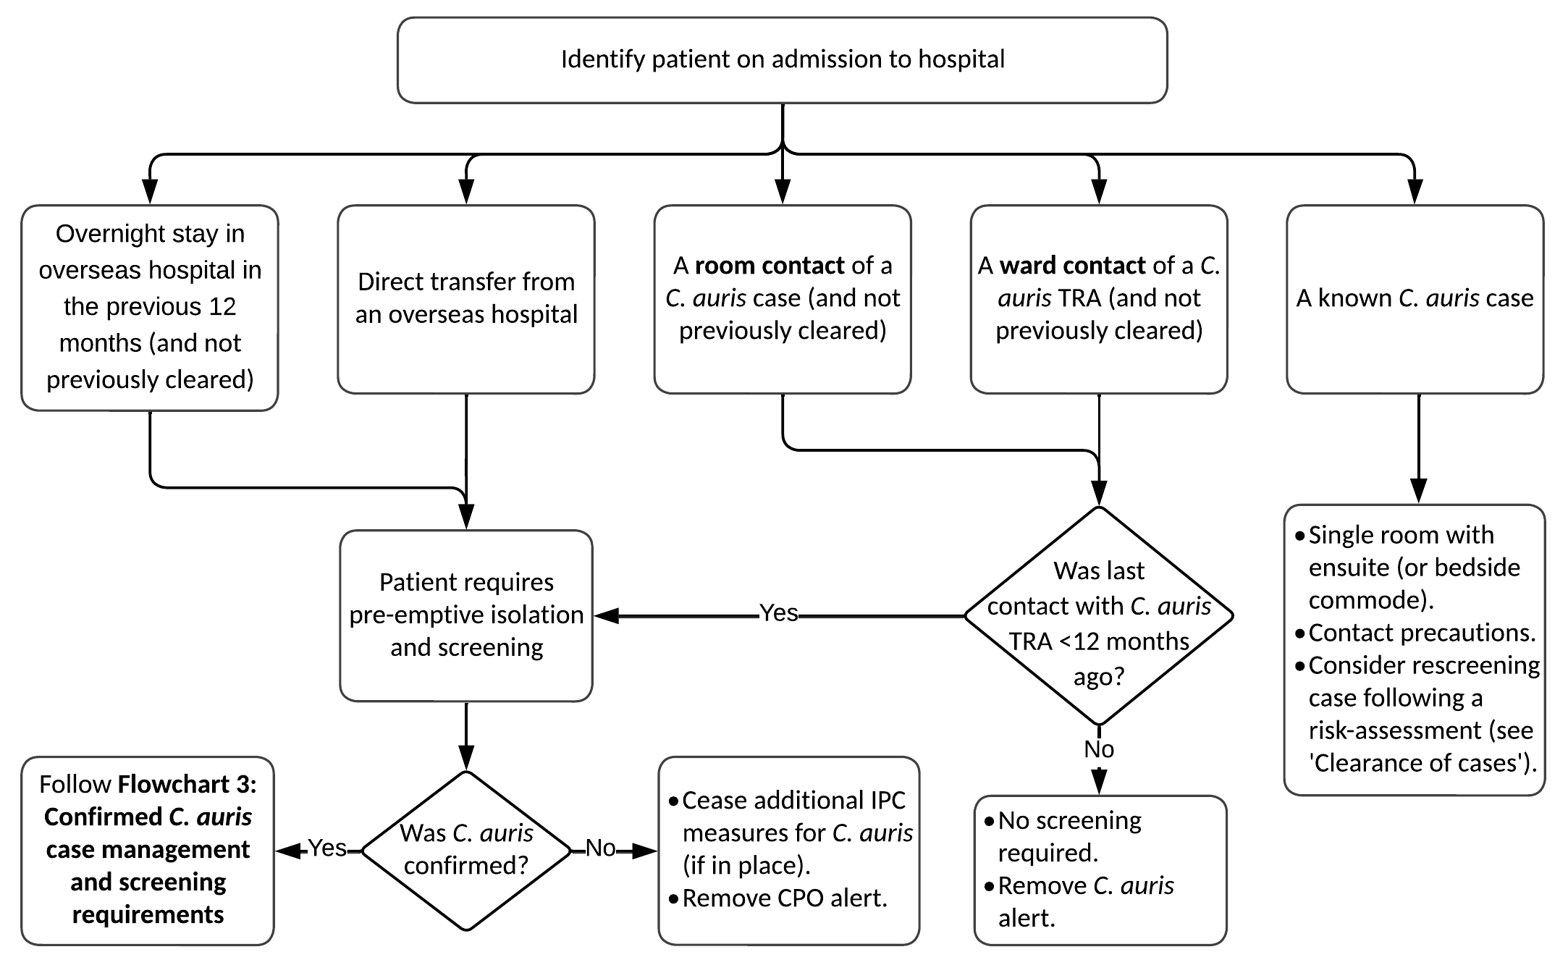

Length of time of exposure to C. auris to require screening
These requirements for screening reflect a precautionary approach to what constitutes sufficient time-based exposure to warrant screening. It is unknown whether there is a minimum period of exposure required to a known C. auris case or contaminated environment for transmission to occur although one study noted as little as four hours of exposure to a known case or contaminated environment for colonisation (Schelenz et al 2016). The department recommends that screening occurs after a minimum of 24 hours exposure (see Glossary for definitions of room and ward contacts). A health service may elect to screen after shorter periods of exposure.

When to commence screening
There is no evidence regarding the minimum time interval, following exposure to C. auris, after which a patient will become ‘detectable’ as colonised for C. auris. As such, no recommendation can be made to wait a certain period following cessation of exposure to C. auris before clearance screening should commence. Therefore, screening can be undertaken immediately, following cessation of the exposure to C. auris, for any person requiring screening.

Clearance criteria for those who require screening for C. auris
The following are the minimum requirements for the number of ‘rounds’ or ‘sets’ of screening specimens for each category or group of people required to be screened. See Choice of screening samples for patients, for the minimum screening samples required.
- Two sets of screening specimens taken, separated by at least 24 hours:
  - room contacts
  - those directly transferred from an overseas healthcare facility
- One set of screening specimens:
  - people admitted overnight to an overseas health service facility in the previous 12 months (and are not a direct transfer)
  - ward contacts of a C. auris TRA

Actions when a single case of C. auris is detected

Management of the case
As noted above, all suspected and confirmed cases must be notified immediately (24/7) to the department by telephone on 1300 651 160. See Section 3: Laboratory methods and reporting requirements.

Suspected C. auris cases
For healthcare facilities that refer isolates to diagnostic laboratories that are unable to confirm the detection of C. auris a risk-based approach should be taken. An infection control practitioner should establish if the suspected case also meets any criterion for screening as per Screening requirements for all facilities and, if so, initiate the steps below.
- Implement immediate IPC measures as per Section 5: Management and control of C. auris.
- Ensure the isolate is referred immediately to the ‘parent’ laboratory for identification. If there is no ‘parent’ laboratory or the ‘parent’ laboratory does not have the capability to identify C. auris, refer the isolate to VIDRL. Use the VIDRL C. auris isolate referral form which can be download from the department’s website <https://www.health.vic.gov.au/infectious-diseases/victorian-guideline-on-candida-auris-for-health-services>.
- If a suspected case is rejected by VIDRL infection control precautions for the management of C. auris may be ceased.
Flowchart 2: Suspected C. auris case reporting and management requirements
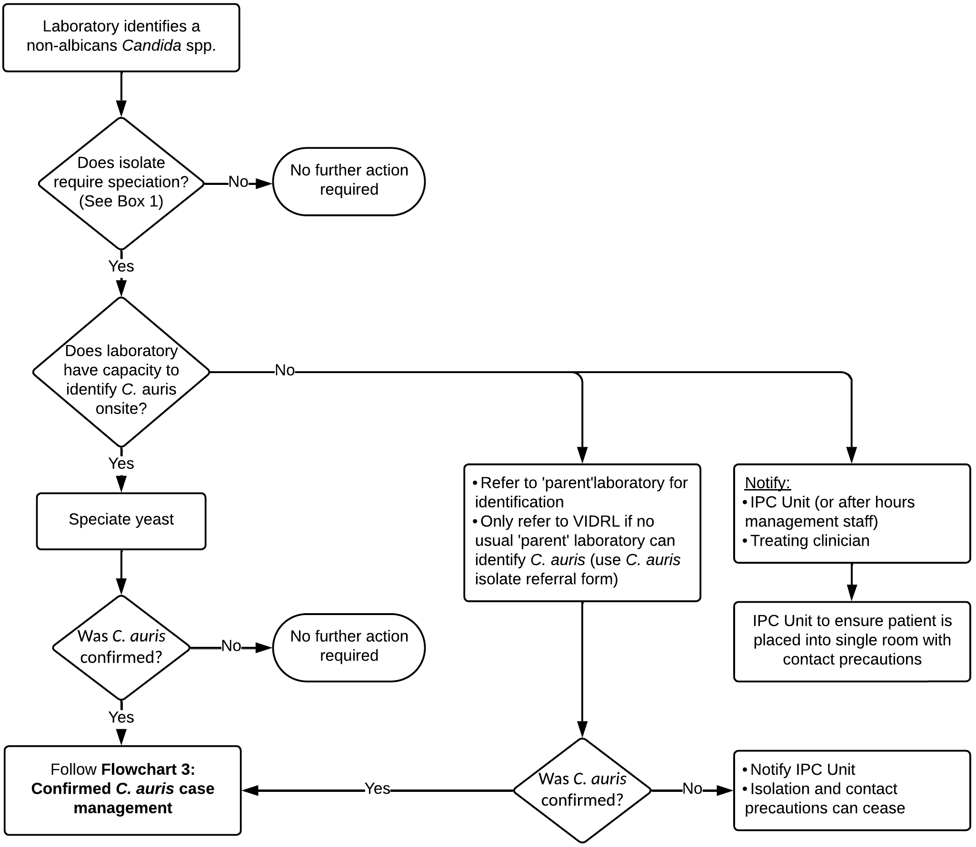

Confirmed C. auris cases
- Implement immediate IPC measures (if not already in place) as per Section 5: Management and control of C. auris.
- Ensure the patient, and/or their carer is notified and counselled appropriately regarding the diagnosis. An information sheet for patients with C. auris can be found on the department’s website <https://www.health.vic.gov.au/infectious-diseases/victorian-guideline-on-candida-auris-for-health-services>.
- Ensure the patient’s local doctor is informed of the case confirmation upon discharge. An example template letter and information sheet for clinicians can be found on the department’s website <https://www.health.vic.gov.au/infectious-diseases/victorian-guideline-on-candida-auris-for-health-services>.
- Ensure other healthcare providers are alerted to the patient’s C. auris status, and the requirement for a single room and contact precautions should they be transferred to another healthcare facility or RCF.
- Complete the C. auris surveillance form. Fax the form to the department within two business days (fax number: 1300 651 170). The form can be found on the department’s website <https://www.health.vic.gov.au/infectious-diseases/victorian-guideline-on-candida-auris-for-health-services>.
- Place an alert in the hard-copy and/or electronic patient records.
- Identify (where possible) and document the date of likely acquisition and period of transmission risk. This is required to determine which patients are room contacts of the case.
  - The date of likely acquisition depends on epidemiological factors, such as when contact first occurred with a known case with the same strain, or an overseas hospital admission in the absence of local risks. The final determination will be made by the AMR IMT.
  - The period of transmission risk is from the date of likely acquisition until the time that the case is placed in contact precautions (or discharged or transferred whichever is earlier).
  - If the date of likely acquisition is unable to be determined, the period of transmission risk is generally considered to be one month prior to the date of C. auris isolation (the date the screen or test was taken) or when the case was admitted to the ward or facility, whichever is greater, until the time that the case is placed in contact precautions or discharged or transferred, whichever is earlier.
Flowchart 3: Confirmed C. auris case management
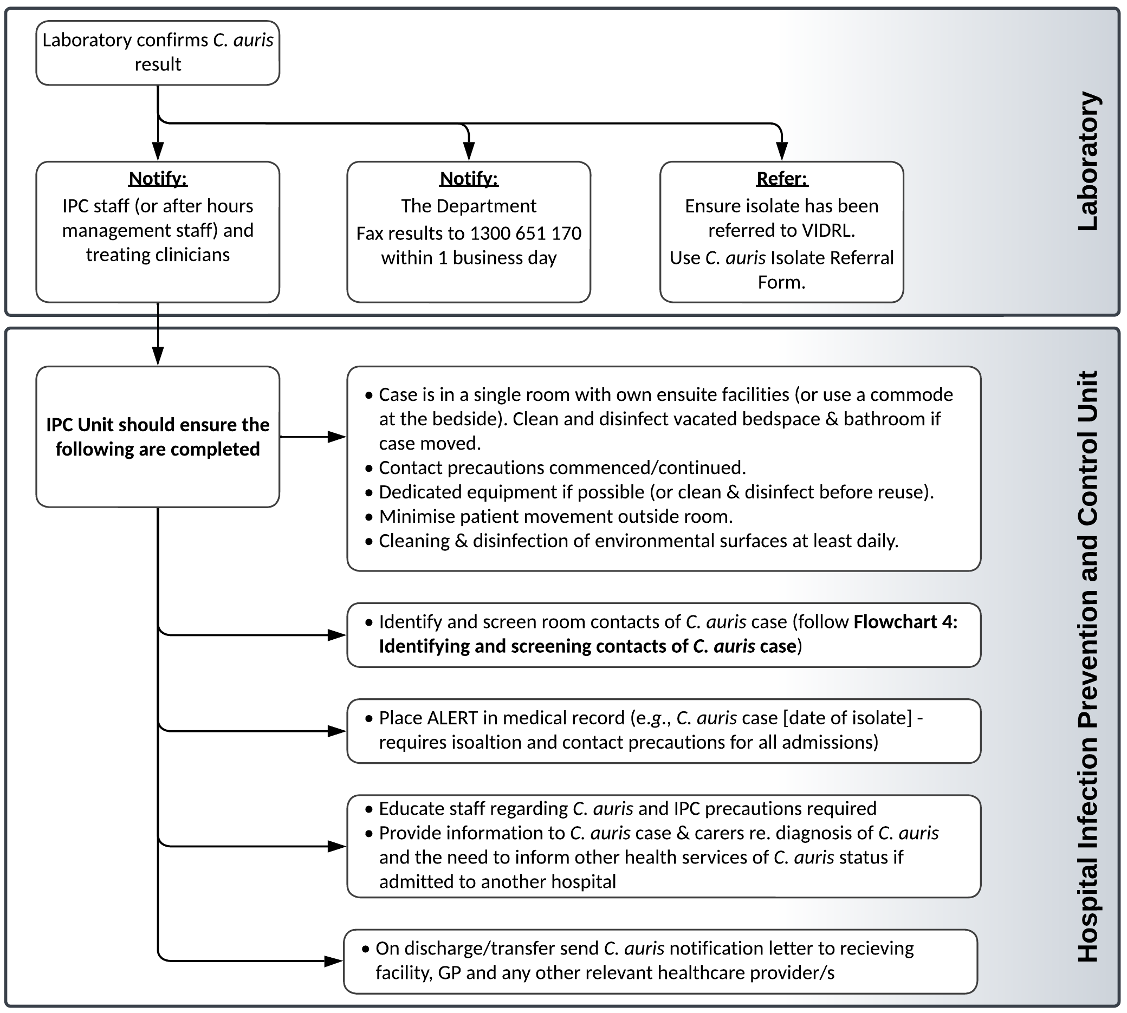

Clearance of cases
Once a person is identified as a case of C. auris, they are considered potentially infectious indefinitely. This is the position for all Victorian healthcare facilities until sufficient evidence can be identified to inform the development of clearance criteria.
This means that there are no clearance criteria for confirmed cases, and infection control precautions as outlined in the guideline must always be implemented upon readmission of a case to a healthcare facility.

Management of contacts

Purpose of contact tracing
The purpose of contact tracing is to identify potentially infected or colonised patients and to manage risk of onwards transmission from these patients. This occurs by identifying which patients should be screened and over what period of time this should occur and may also involve providing information or placing patients in pre-emptive isolation until a person is cleared.
No contact tracing is required until the case has been confirmed.

Room contacts
A room contact is any person who shared a room for ≥24 hours in a health service during the case’s period of transmission risk. Patients discharged prior to the case being diagnosed, but who meet the room contact criteria are included in the required actions.
Room contacts should have infection control precautions and other recommendations applied until clearance criteria are met.
On confirmation of a case of C. auris, the following actions must be taken for all room contacts:
- Room contacts who are still inpatients:
  - pre-emptively isolate and screen for C. auris (may be cohorted)
  - implement contact precautions until clearance criteria (see below) have been met.
- Room contacts who have been discharged prior to diagnosis and/or who have not met clearance criteria prior to discharge:
  - Give or send the room contact written advice of their room contact status. An example room contact letter can be found on the department’s website <https://www.health.vic.gov.au/infectious-diseases/victorian-guideline-on-candida-auris-for-health-services>.
  - Place an alert on their hard-copy and/or electronic hospital records so that they are placed into a single room with contact precautions and screened if readmitted before clearance criteria are met in the 12 months following last contact with the C. auris case. This includes room contacts who have refused to be screened. Alerts in hospital records may be removed after 12 months if screening has not occurred.

Clearance criteria for room contacts
A room contact is considered cleared when two consecutive sets of screening swabs/specimens taken at least 24 hours apart are negative for C. auris.

Further screening following confirmation of case of C. auris
A ward contact, as previously defined, is any person who has been on a ward for ≥24 hours in the time period that the ward has been designated as a TRA. Therefore, when there has been no local transmission, there are no ward contacts for the purposes of this guideline. Further actions are required if transmission is identified – see Actions when local transmission of C. auris is identified.
Some cases, however, may be considered a high-risk for spreading C. auris or have been admitted to a ward with particularly vulnerable patients, for example, a haematology ward. Health services may conduct their own risk assessment regarding these patients and consider performing further screening on some or all of the other patients on that ward. Further advice can be sought from the LPHU (in which the health service is located) or the department (phone: 1300 651 160) if a health service requires guidance or assistance in responding to complex cases.
Flowchart 4: Identifying and screening contacts of C. auris case
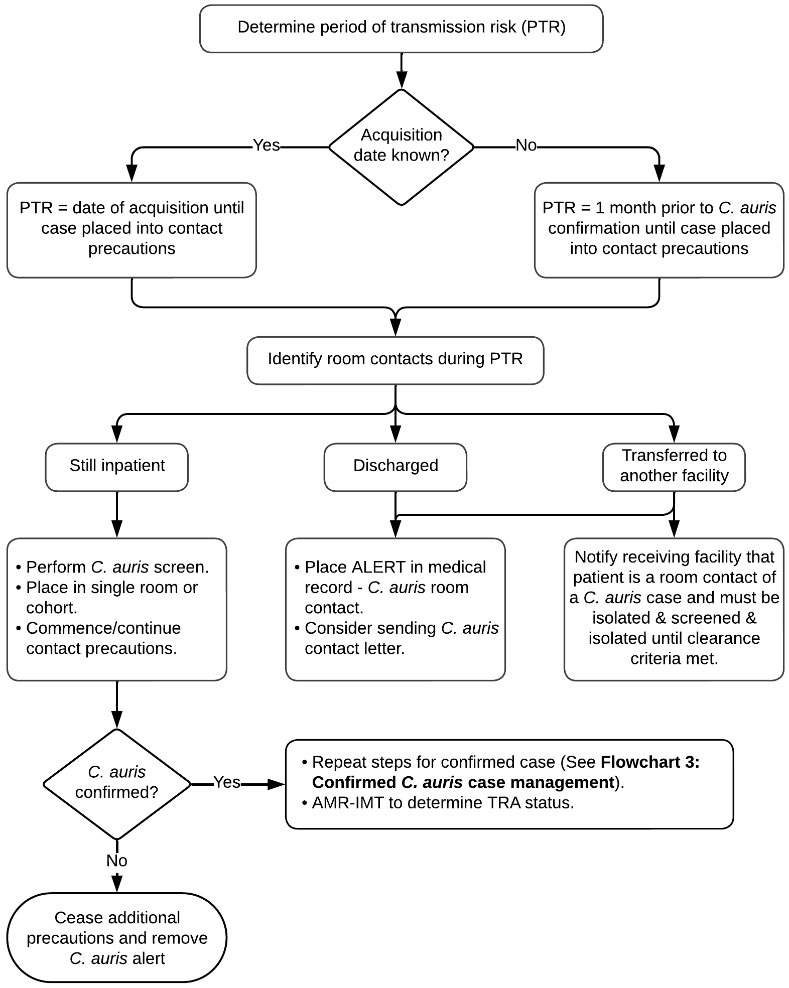

Healthcare workers, household and casual contacts
Healthcare workers who care for and manage a case of C. auris are not recommended to be screened.
Household and community contacts do not require contact tracing or screening.
Screening of healthcare workers or household contacts may be undertaken at the discretion of the AMR IMT, however given the lack of current evidence regarding the risk for transmission this is unlikely to be a common recommendation following C. auris transmission in a healthcare facility.

Actions when local transmission of C. auris is identified
When transmission of C. auris is suspected, the department’s AMR Unit will prepare a risk assessment for the AMR IMT. The AMR IMT will review the information and determine if transmission has occurred. If transmission has occurred, the ward (or a specified geographical area in the health service) will be designated as a transmission risk area (TRA). It is not necessary to delay the commencement of contact screening and other actions while awaiting formal recommendations from the AMR IMT.

Transmission risk area – overview
A TRA is an area (a distinct geographical area or ward) in which local transmission has been determined by the AMR IMT to have occurred. The following criteria are used by the AMR IMT:
- two or more confirmed cases of genetically related C. auris as determined by MDU PHL and
- at least one case is a locally acquired case and
- there is a plausible epidemiological connection between the two cases, either through geographic proximity or shared staff, equipment or other exposures in the healthcare setting as determined by the AMR IMT
OR
- where acquisition from an environmental source is suspected.
If the AMR IMT cannot reach a consensus regarding a TRA, the Chief Health Officer will make the final determination.

Health facility actions
- Make a preliminary determination of the timeframe for the TRA and document this
This will be done formally by the AMR IMT. The facility should also make a preliminary determination at the time a transmission is identified in order to commence contact tracing activities without delay. Note that the TRA timeframe is different from the period of transmission risk (see Glossary and Confirmed C. auris cases).
  - If one or more of the patients remains an inpatient or was discharged within the past four weeks: generally, the TRA will apply from the day that the first C. auris positive patient involved in the transmission was admitted, until there have been four consecutive weeks of negative ward screens.
  - If all of the patients involved in the transmission (that is, the confirmed C. auris cases involved in the transmission) have been discharged for longer than four weeks; generally, the TRA will apply from the time that the first patient involved in the transmission was admitted to four weeks after the final patient involved in the transmission was discharged.
  - When an environmental source is suspected, the timeframe will apply as for category b. Re-establishment or extension of the TRA timeframe will occur if there is evidence of further clustering of cases.
- Identify, notify and place alerts on room contacts as previously described.
- Commence screening programs
  - If one or more of the patients remains an inpatient, or were discharged within the past four weeks, perform a weekly point prevalence screen (PPS) for C. auris on ward patients until there have been four consecutive weeks of negative screens.
  - If all of the patients involved in the transmission have been discharged for longer than four weeks, perform a single PPS on the ward.
  - Where an environmental source is implicated in the TRA, the AMR IMT may recommend environmental screening in addition to patient screening requirements outlined above.
- Identify ward contacts
A ward contact is any patient who has been on a ward for four or more hours during the time period that the ward has been designated as a TRA. Actions that must be undertaken in relation to ward contacts include the following.
  - Alerts placed on their medical record if discharged before clearance criteria are met (see below for further information on clearance criteria) to ensure they are placed into contact precautions and screened if readmitted within 12 months of their last contact with the TRA. Alerts in hospital records may be removed after 12 months if screening has not occurred.
  - Notify any healthcare or RCFs where TRA ward contacts have been transferred prior to clearance, to enable the receiving facility to place alerts and consider further action (for example, screening) if required.
Actions that may be considered in relation to ward contacts include the following.
  - Notify all ward contacts discharged before clearance criteria are met. An example ward contact letter can be found on the department’s website <https://www.health.vic.gov.au/infectious-diseases/victorian-guideline-on-candida-auris-for-health-services>.
- Enact patient transfer procedures for ward contacts (if the TRA is active)
When transferring patients from a TRA to another ward or healthcare facility:
  - Ensure that all ward contacts are screened at the time of discharge or within the 24 hours prior to transfer to another ward or healthcare facility.
  - Inform the receiving ward or facility in writing that the patient is a ward contact.
When transferring patients to RCF:
  - Ensure that all ward contacts are screened on discharge or within the 24 hours prior to transfer.
  - If the result will be available within 24 hours, then it is ideal to wait for the result prior to transferring the patient.
  - RCFs should not refuse transfer of a patient awaiting a screening result.
  - RCFs should manage any cases of C. auris as per these guidelines (see Residential care facilities).

Clearance criteria for ward contacts
A ward contact is considered cleared when:
- A suitable set of specimens is negative for C. auris at any time after discharge or transfer out of the TRA
OR
- A suitable set of specimens taken within 24 hours of discharge or transfer out of the TRA is negative for C. auris.
If a patient remains in contact with a TRA, they should be screened weekly as per the TRA requirements.
Flowchart 5: Local transmission/outbreak response requirements
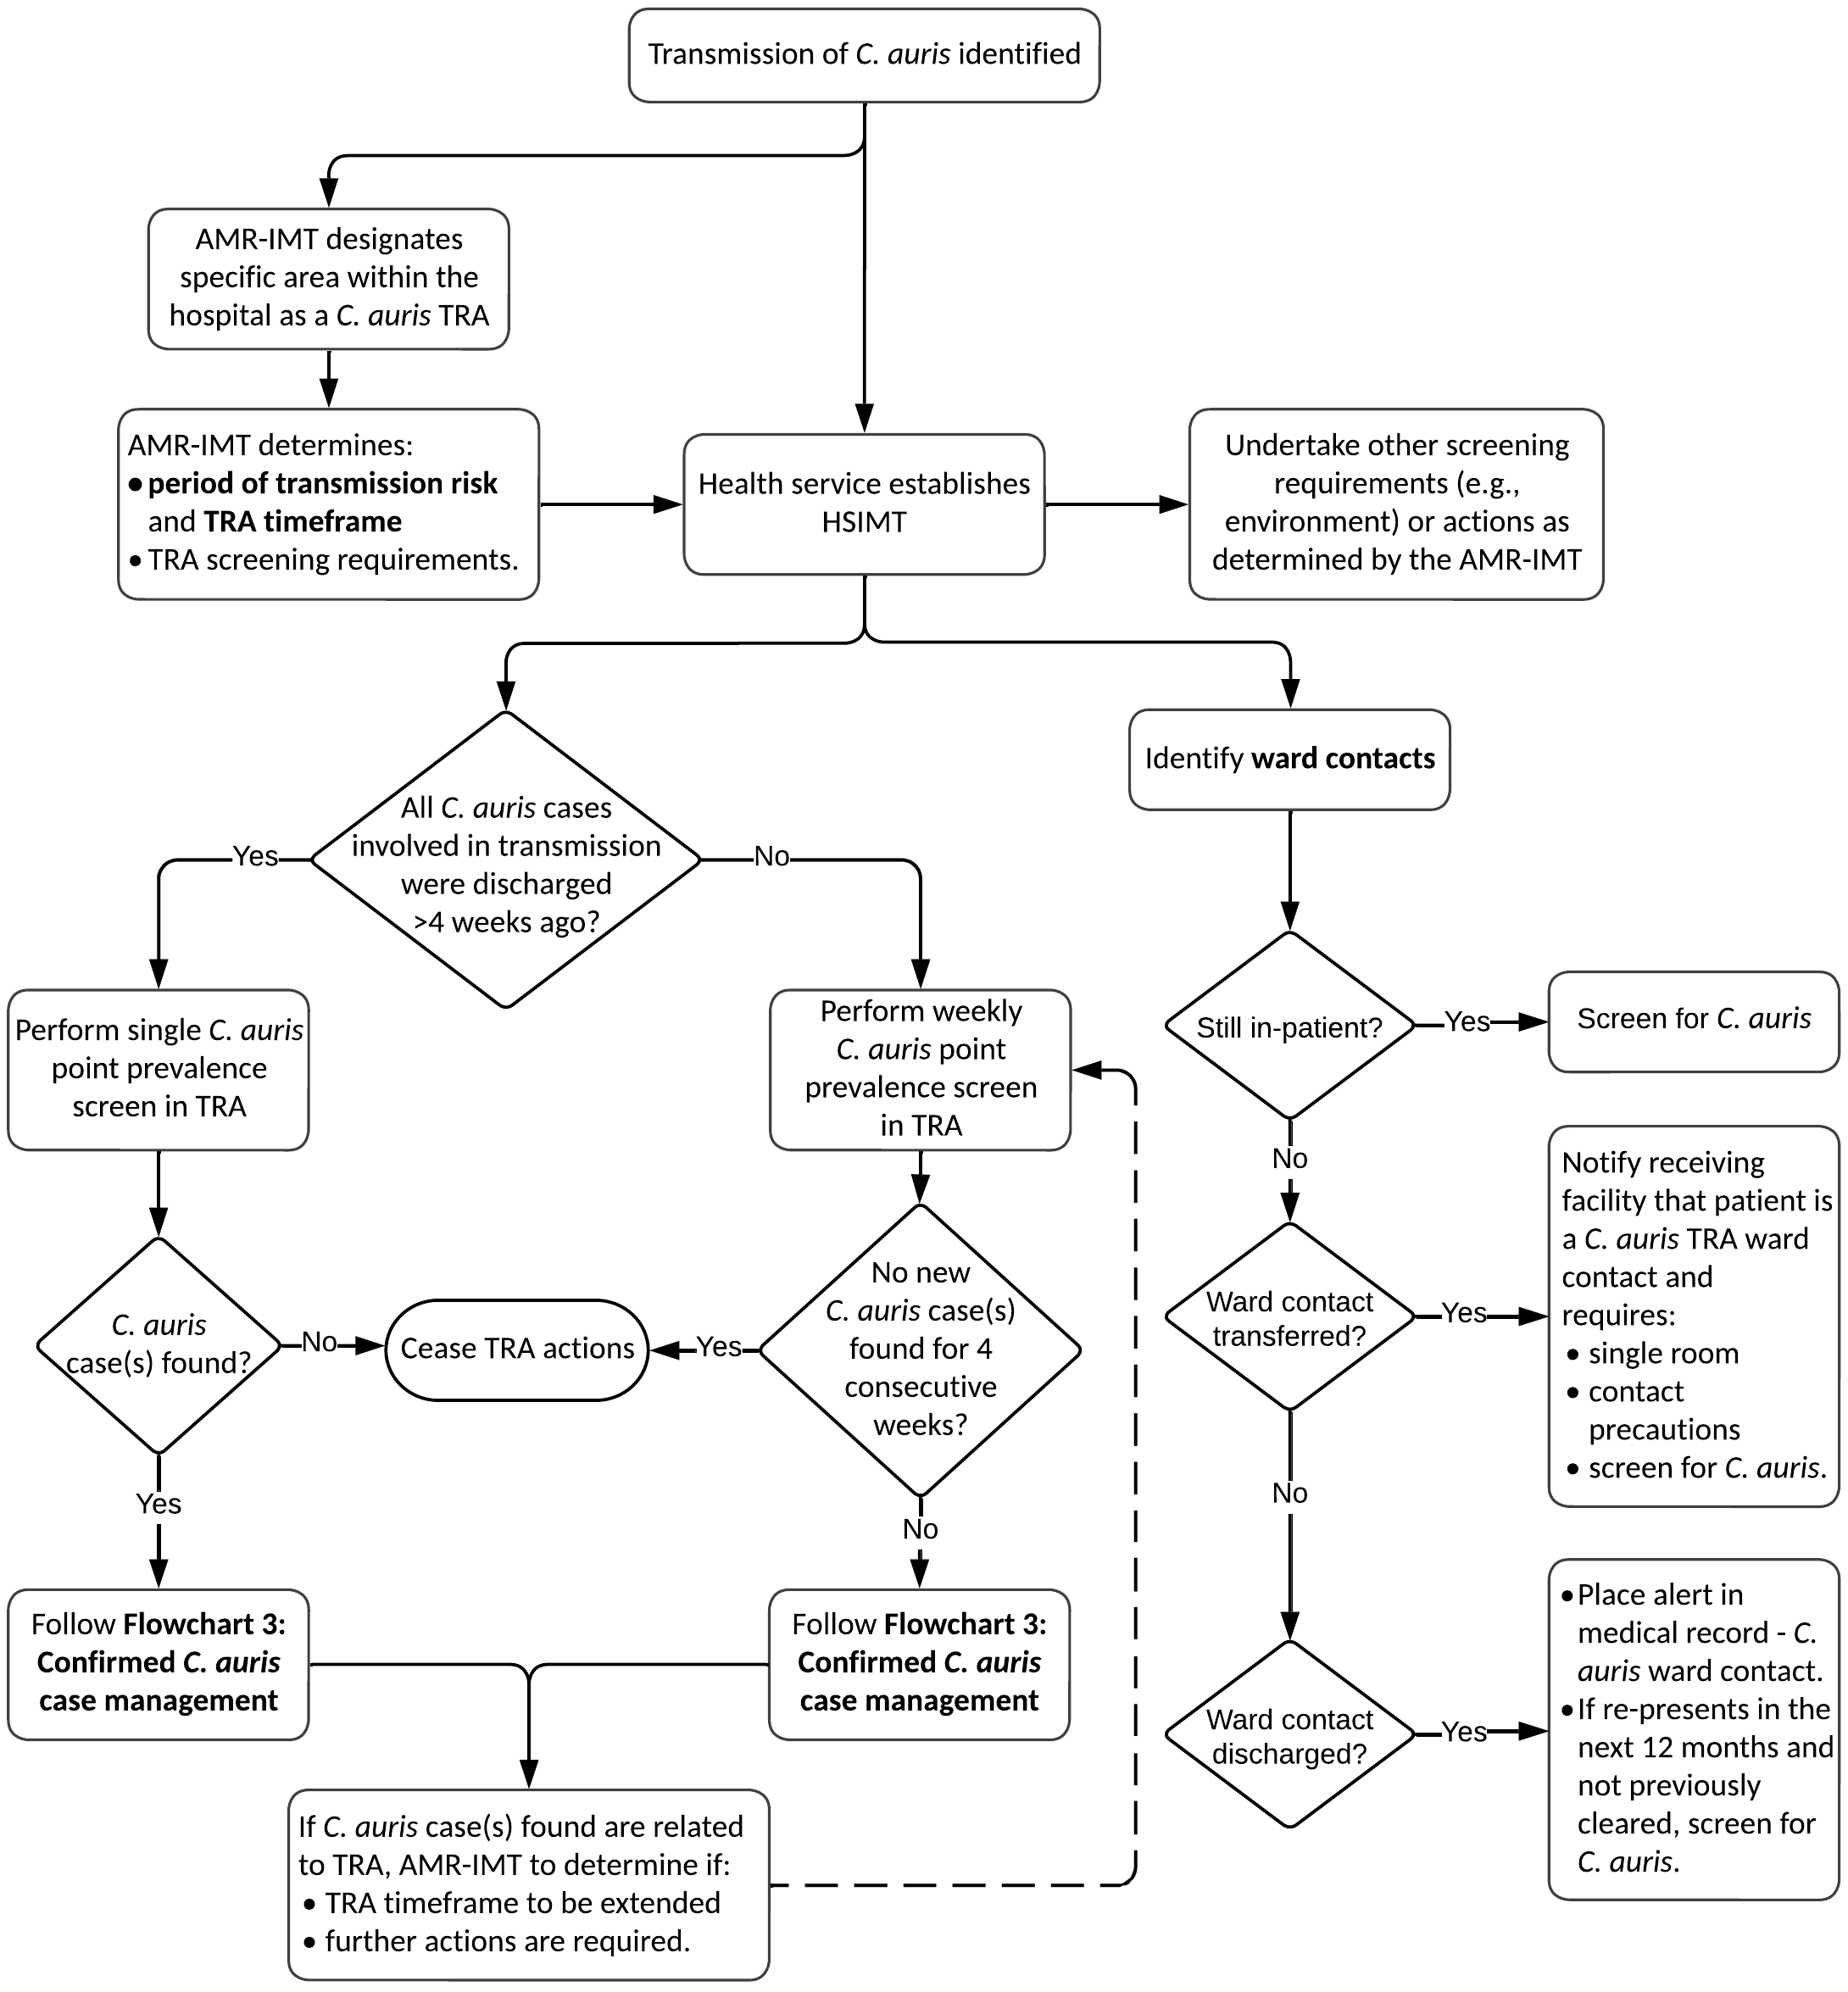

Environmental screening
Environmental screening in non-outbreak situations is not routinely recommended.
When there is evidence of local transmission, environmental screening may be undertaken to identify any environmental reservoir of C. auris. Screening taken before comprehensive cleaning can be a valuable part of an investigation to determine the source of persistent cases of C. auris in a healthcare setting. Screening undertaken after comprehensive cleaning can enable a healthcare facility to target problem areas effectively.
C. auris has been shown to survive in the environment for extended periods (up to 14 days on moist and dry surfaces) and has been isolated from a number of environmental sites in an outbreak setting. In particular shared patient equipment, such as axillary temperature probes and pulse oximeters, has been implicated in outbreaks of C. auris. Consideration could be given to sampling this type of equipment and other environmental sites in situations of ongoing transmission. Advice from the AMR IMT may be sought for methodology.
The AMR IMT may direct a health service to undertake environmental screening as part of the required responses for managing a TRA. Choice and number of sampling sites will be determined in consultation with the AMR IMT.

Section 5: Management and control of C. auris
Spread of C. auris in healthcare settings reflects the mode of transmission being through contact. The environment and contaminated fomites may be particularly important for C. auris transmission in health services. For example, shared patient equipment such as axillary thermometers have been associated with outbreaks. Hence, the interventions to control transmission of C. auris are focused on these transmission pathways.
Health services should ensure that their routine admission processes reliably identify patients who may be at risk of being infected or colonised with C. auris (see Screening requirements for all facilities). Each patient should be assessed on re/admission or transfer to the healthcare facility.

Infection control precautions
C. auris requires targeted interventions to prevent ongoing transmission in health services. The standard and transmission-based infection control precautions required for C. auris are outlined below.

Standard precautions
The use of standard precautions is an essential infection control strategy for the successful minimisation of transmission of infectious agents, including multi-resistant organisms. All healthcare facilities must ensure compliance with standard precautions as outlined in the current version of the Australian Guidelines for the Prevention and Control of Infection in Healthcare. Compliance should be monitored in accordance with the current iteration of National Safety and Quality Health Service (NSQHS) Standards.
Access the Australian Guidelines for the Prevention and Control of Infection in Healthcare here <https://www.nhmrc.gov.au/about-us/publications/australian-guidelines-prevention-and-control-infection-healthcare-2019>.
Access the NSQHS Standards here <https://www.safetyandquality.gov.au/our-work/assessment-to-the-nsqhs-standards/>
Standard precautions must be applied at all times and include:
- Hand hygiene, in accordance with the National Hand Hygiene Initiative. Alcohol-based hand rubs are sufficient for use with patients with C. auris unless hands are visibly soiled.
Note: Patients should also be strongly encouraged to perform hand hygiene after toileting, before eating and prior to leaving their room. If a patient’s cognitive state is impaired, staff caring for them must be responsible for helping with this activity.
- Use of personal protective equipment
- Safe use and disposal of sharps
- Routine environmental cleaning
- Reprocessing of reusable medical equipment and instruments
- Respiratory hygiene and cough etiquette
- Aseptic technique
- Appropriate waste management
- Appropriate handling of linen.

Transmission-based precautions
Transmission-based precautions are infection control practices used in addition to standard precautions to prevent the spread of certain infectious organisms. C. auris is transmitted by contact transmission. See Screening requirements for all facilities for which patients require a single-room and contact precautions.
The following precautions apply to all healthcare settings except lower acuity settings including subacute, rehabilitation, ambulatory care and RCFs.
No special precautions are required for linen management, dishes and cutlery, beyond those covered by standard precautions.

Acute healthcare setting

Patient placement
Patients who require contact precautions must be placed in a single room preferably with their own ensuite. If a single room with own ensuite is not available, then a single room with a dedicated commode or toilet facilities may be used until a single room with own ensuite is available.

Bed management and flow
To reduce the risk of transmission, bed movements for C. auris cases must be kept to a minimum.

Signage
Clear signage should be visible to alert healthcare workers of required precautions before entering the room.
Standardised transmission-based precautions signage has been developed by the Australian Commission on Safety and Quality in Health Care (ACSQHC) and are available their website <https://www.safetyandquality.gov.au/our-work/infection-prevention-and-control/standard-and-transmission-based-precaution-posters>.

Cohorting of patients and/or staff
If there are significant difficulties in ensuring compliance with infection prevention and control precautions, then there should be strong consideration of providing one-to-one nursing care.
The preference is always for patients with C. auris to be placed into single rooms. Cohorting is only recommended in the setting of an outbreak. A risk assessment by the HSIMT should consider the value of staff and patient cohorting. If staff cohorting is enacted, priority should be given to cohorting nursing staff, allied health professionals and patient care attendants.
Room contacts may be cohorted until clearance criteria have been met.

Personal Protective Equipment (PPE)
A long-sleeved gown and gloves must be worn whenever entering the patient’s room. Always remove gown and gloves before exiting the patient’s room. Perform hand hygiene before and after all glove use. Gloves must be changed, and hand hygiene performed during patient care in accordance with the National Hand Hygiene Initiative.
Visitors are not required to wear a gown and gloves unless assisting with patient care, for example showering or toileting. Visitors must perform hand hygiene before and after all visits. Visitors should be discouraged from visiting other patients within the health service immediately after visiting a patient with C. auris.

Movement of patients
A person who is a case of C. auris should be strongly encouraged to stay within their room at all times. If it is necessary to attend other clinical areas for diagnostic tests or procedures contact precautions must be maintained. Clinical areas receiving patients for procedures or investigations should be advised well in advance of patient arrival to enable adequate preparation to manage a C. auris case, for example to allow enough time to perform environmental cleaning and disinfection before the next patient.
Cases should avoid using toilets outside their room however, if necessary, staff should ensure cleaning and disinfection occurs after toilet use or that a commode is used where possible which must also be cleaned and disinfected afterwards.

Equipment and instruments/devices
It is strongly recommended that single patient use equipment be used where possible (for example, tourniquet, blood pressure cuff and thermometer). Outbreaks of C. auris have been associated with the use of shared patient equipment.
Where this is not possible, equipment should be dedicated to the use of one patient (for example, a commode) for the duration of their stay. If equipment must be shared between patients (for example, a lifting machine), ensure the equipment has been thoroughly cleaned and disinfected before use on another patient (see below for information regarding cleaning and disinfection).
Equipment and consumables kept in a case’s room should be kept to an absolute minimum. This will facilitate and enhance daily cleaning and disinfection procedures and reduce waste of stock on discharge as such stock cannot be returned to sterile and clean store areas.

Environment and equipment cleaning
C. auris has been isolated from environmental surfaces in healthcare facilities and been demonstrated to survive on surfaces for at least 14 days (Welsh et al 2017). Currently, there are limited studies regarding the most effective products and methods for environmental disinfection for C. auris. As such, environmental cleaning recommendations are based on the best available evidence, outbreak reports and other jurisdictional recommendations.
All cleaning of cases’ rooms and associated equipment must take place with a detergent and disinfectant. The disinfectant must be used at a concentration that is known to be sporicidal, for example at least 1000 parts per million (ppm) hypochlorite (CDC 2019, PHE 2017). There are also newer products that have sporicidal activity, such as peracetic acid and accelerated hydrogen peroxide containing agents, which may also be suitable.
Quaternary ammoniums compounds (also known as Quats or QACs) are not a suitable disinfectant for C. auris as they may not be effective (Cadnum et al 2017). A number of commonly used disinfectant wipes contain Quats. It is preferable that wipes are not used for routine environmental cleaning and disinfection of rooms of C. auris cases but reserved for cleaning single pieces of equipment and small frequently touched surfaces. If they are to be used, they should be a detergent-disinfectant wipe and contain an appropriate disinfectant as outlined above.
Products should be selected in accordance with the Therapeutics Goods Administration (TGA) regulation of disinfectants. Hospital grade disinfectants are exempt from having to be listed on the Australian Register of Therapeutic Goods (ARTG) unless they make specific claims. More information about the regulation of disinfectants can be found on the TGA website <https://www.tga.gov.au/resources/resource/guidance/disinfectants-sterilants-and-sanitary-products>.
Routine cleaning should be intensified. A case’s room and bathroom should be cleaned and disinfected at least daily. In addition, frequently touched surfaces (for example bedrails, IV pump, overbed table) should be cleaned and disinfected twice daily.
It is essential that the manufacturer’s instructions for the selected disinfectant are followed, especially with respect to contact times to ensure the disinfectant has sufficient time to kill C. auris. Long contacts times (that is, the time the surface needs to remain wet) are not practical and may present a safety hazard.
Discharge cleaning and disinfection should take place on patient discharge according to the recommendations above. Ensure curtains are changed upon discharge.
No-touch methods of surface disinfection (for example, ultraviolet [UV-C] light or hydrogen peroxide vapour) may be a useful adjunct for discharge disinfection, although there is limited evidence regarding their ability to reduce C. auris infections. Some studies have suggested that longer cycle times, such as those used for Clostridioides difficile (C. difficile), should be used for UV-C light to ensure C. auris is killed (Cadnum et al 2018). No-touch technologies may be used as an adjunct to but do not replace adequate cleaning and disinfection with a sporicidal disinfectant.
C. auris is known to persist in the environment for extended periods. When a C. auris case is confirmed, consideration may be given to cleaning and disinfecting rooms previously occupied by the case, particularly where a sporicidal product is not usually used for discharge cleaning and disinfection.

Audit of infection control processes
Health services are encouraged to routinely audit infection control practices; for example, PPE use and environmental cleaning, in accordance with the current iteration of the NSQHS Standards. Such audits are particularly important in outbreak settings to ensure compliance with additional measures that have been implemented.
Observational audits for environmental cleaning should be supplemented with objective methods of assessing cleaning, such as fluorescent markers or ATP bioluminescence.
In the event of local transmission, the AMR IMT may request evidence that relevant auditing has taken place. The department may perform external audits of patient management and the infection prevention and other measures which are in place. The frequency of these external audits may increase if local transmission continues for an extended period of time.

Limiting ward activity and ward closure
If there is ongoing transmission at a healthcare facility despite initial control measures (for example, ongoing transmission despite screening, contact precautions and cleaning and disinfection), the AMR IMT may consider requiring closure of an affected ward to new admissions.
If transmission involves a surgical ward, consideration of cancelling elective surgery may be required.

Further recommendations in the setting of ongoing transmission
Chlorhexidine impregnated wash cloths or body washes have been used in outbreak situations. While patients may remain colonised, the use of a skin antiseptic such as chlorhexidine may help reduce the bioburden of C. auris on the skin and hence reduce environmental contamination and HCW hand contamination, thereby reducing the risk of spread to other patients.
The intensity and frequency of cleaning will also need to be increased when there is ongoing transmission.
Environmental screening may also be considered. The AMR IMT will be able to provide further advice regarding sites and methods for screening the environment for C. auris.

Subacute or rehabilitation healthcare setting
Patient care activities in the subacute or rehabilitation healthcare setting are different from those in the acute healthcare setting. Patients are generally more ambulant and frequently participate in group activities or attend communal areas such as gymnasiums. In this lower acuity setting, the application of some of the precautions outlined above can be modified to allow C. auris cases to participate in rehabilitation activities as indicated below.

PPE
Staff should use a long-sleeved gown and gloves when attending to a patient’s personal care, such as showering and toileting, and when performing procedures such as wound care, care of indwelling urinary catheters and other invasive device management. Other occasions when PPE may be required to protect staff clothing may include when assisting with mobility such as when standing or transferring, suctioning of sputum or tracheotomies or massage.
Each facility should conduct their own risk assessment to determine if they require staff to always wear a gown and gloves whenever entering the patient’s room. The risk assessment should be based on the following factors:
- acuity of the patients within the facility
- location of the ward or facility (for example, stand-alone rehabilitation facility vs rehabilitation ward co-located with acute care wards)
- individual patient risk factors such as incontinence or oozing wounds.
When there is ongoing local transmission, a long-sleeved gown and gloves must be worn by staff whenever entering the patient’s room.
Visitors are not required to wear a gown and gloves unless assisting with patient care for example showering, toileting. After exiting the room, visitors should be discouraged from visiting other patients in the health service. Visitors must also be encouraged to perform hand hygiene before entering and after leaving the room.

Use of PPE during activities outside the patient’s room
Staff conducting group activities or one-to-one sessions (for example physiotherapist) where minimal physical contact occurs do not need to wear PPE. If they are providing close personal care, such as toileting, where clothes may become contaminated, gowns and gloves should be worn.
Staff must of course continue to practice hand hygiene according to the National Hand Hygiene Initiative and ensure they clean and disinfect all shared equipment (with a sporicidal product).

Movement of patients/participation in group activities
Unless a patient is unwell (for example, has diarrhoea) or they have wounds with uncontainable ooze, they may freely attend shared areas such as the dining room, and group activities. Patients need to be continent (or have contained incontinence) and cooperative to be able to participate in group activities. If it is deemed that a patient is unable to attend group activities, they may attend the gymnasium alone with the therapist or alternatively have rehabilitation in their room.
Patients should be educated to perform hand hygiene whenever they leave their room and when entering a communal area. If patient ability to perform hand hygiene is in doubt staff should assist. Patients’ personal hygiene should be maintained, and clean clothes worn when outside their room. Ensure wounds are covered with a dressing that contains any ooze.
Avoid using toilets outside the patient’s room however if it is necessary, ensure cleaning and disinfection with a sporicidal product (see Environment and equipment cleaning) occurs after toilet use or use a commode where possible which must also be cleaned and disinfected afterwards.

Equipment and instruments/devices
Single patient use equipment should be used where possible. Where this is not possible, equipment should be dedicated to the one patient. If equipment must be shared between patients, ensure the equipment has been thoroughly cleaned and disinfected using a sporicidal product before use on another patient.
Usual cleaning of equipment used in group activities (for example gymnasium equipment, weights) should continue at the end of any gym session with the addition of a sporicidal disinfectant after use by a patient with C. auris.

Environment and equipment cleaning
When patients with suspected or known C. auris are present, routine cleaning should be intensified. The patient’s room and bathroom, including frequently touched surfaces (for example, bed rails, overbed table, commode, toilet surfaces in resident bathrooms, doorknobs) should be cleaned and disinfected daily using a sporicidal product.
Environmental cleaning and disinfection of communal areas, such as gymnasiums, should also be increased when there is ongoing local transmission.

Ambulatory healthcare settings
For this guideline, ambulatory healthcare settings do not include outpatient clinics. Haemodialysis and day oncology units are in scope and have a number of differences compared to the acute healthcare setting. Patients are generally only admitted for a few hours and access to single rooms is often limited. In this setting, the application of some of the above precautions may be difficult and require modification.

Patient placement
The principles outlined above should be applied wherever possible, that is, preferably patients should be placed in a single room with own ensuite for the duration of their day admission. If none of these options are available, then patients with C. auris should be placed away from other patients (for example, at the end of the row) and a toilet or commode should be dedicated to the patient for the duration of their day admission where possible.

PPE
A long-sleeved gown or apron and gloves should be worn when undertaking procedures (for example IV cannula insertion) or assisting a patient to toilet. Staff should remember to always remove the gown/apron and gloves before exiting the immediate patient care area. Gloves must be changed during patient care in accordance with the National Hand Hygiene Initiative.

Movement of patients
Patients should be restricted to their rooms or chairs. Patients should be educated to attend to their hand hygiene as previously described or be assisted by staff if required. Wounds should be covered with a dressing that contains any ooze.

Equipment and instruments/devices
In addition to the above, some items (for example blood pressure cuff, tourniquet) can be solely dedicated for the one patient’s use for all subsequent admissions. Such items should be appropriately cleaned, disinfected and stored dry in a dust-proof container between admissions. These items must be labelled with the patient’s details.

Environment and equipment cleaning
The patient’s immediate environment and surrounds (for example chair and surrounds) must be thoroughly cleaned and disinfected on discharge. The disinfectant used must be sporicidal (see Environment and equipment cleaning).

Residential care facilities
Where possible, residents with C. auris should have a single room with own ensuite. If sharing a room is unavoidable, consider the following.
- Resident/s who shares a room with a C. auris case should not have indwelling medical devices or open wounds.
- If a roommate is transferred to a healthcare facility, notify the facility that the resident shares a room with a C. auris case in order for the receiving facility to be able to undertake clearance screening.

PPE
Use a gown or apron and gloves when attending to a resident’s personal care, such as showering and toileting, when clothing is at greatest risk of becoming contaminated. PPE does not need to be used for other ‘casual’ contact by staff. Remember to always remove gown/apron and gloves before exiting the resident’s room and perform hand hygiene before and after all glove use.
Visitors do not need to use gowns/aprons and gloves when visiting a resident in contact precautions unless they will be participating in personal care such as showering or toileting. Visitors must also be encouraged to perform hand hygiene before entering and after leaving the room.

Participation in group activities and attending communal areas
It is extremely important to maintain a resident’s ability to socialise and have access to rehabilitation opportunities. Residents with C. auris can continue to participate in group activities unless they are unwell (for example, have diarrhoea). Any wounds should be covered with a dressing that contains the wound ooze.
Avoid use of toilets outside of their room. It is always best to toilet residents in their own toilet to minimise potential contamination outside their room. If the toileting of a resident does need to occur outside their own room the toilet must be cleaned and disinfected immediately after its use or use a commode and ensure it is cleaned and disinfected as well.
Ensure strict hand hygiene by the resident if using equipment as part of a group session, and clean and disinfect equipment after use. Staff may need to assist residents with their hand hygiene.
Residents can attend a shared dining area and other common communal areas.

Equipment and instruments/devices
Use disposable equipment where possible or dedicate use of non-disposable equipment to any residents with C. auris (for example, commode). If equipment must be shared (for example, lifting machine) for multiple residents, ensure the equipment has been cleaned and disinfected (with a sporicidal product) before use on another resident.
No special precautions are required for linen management, dishes and cutlery, beyond those covered by standard precautions.

Environment and equipment cleaning
Routine cleaning should be intensified when there is a resident/s with C. auris. Rooms of residents with C. auris should be prioritized with a weekly full clean. Daily cleaning and disinfection of the C. auris case’s bathroom, frequently touched surfaces (for example, bed rails, overbed table, commode, toilet surfaces in resident bathrooms, doorknobs) and equipment in the immediate vicinity of the resident should be instituted.
If there is evidence of local transmission, environmental cleaning and disinfection of communal areas, such as gymnasiums, should also be increased.

Medical transport services
It is essential that medical transport services are advised of a patient’s infectious status at the time of booking in order for medical transport staff to ensure appropriate standard and transmission-based precautions are maintained. When transporting a patient with C. auris, contact precautions must be maintained.
Patients should not be transported with another patient unless they also have C. auris.
The vehicle must be cleaned and disinfected (with a sporicidal product) after transporting a patient with C. auris (see Environment and equipment cleaning).
When a C. auris case is confirmed and it is identified in retrospect that the patient has used a patient transport service, consideration may be given to cleaning and disinfecting the vehicle and patient trolley with a sporicidal product.

Hydrotherapy
Patients with C. auris may be required to access hydrotherapy pools as part of their rehabilitation program. A patient with C. auris should be permitted to attend a hydrotherapy pool and not be excluded merely because they are colonised or infected with C. auris. A risk assessment of the patient should be conducted prior to their use of the hydrotherapy pool. At times, a patient’s access to the pool may need to be deferred, for example, when they are incontinent of faeces or have wounds with ooze that is not containable.
Hydrotherapy pools are regulated under the Public Health and Wellbeing Act 2008 and the Public Health and Wellbeing Regulations 2019. The regulations outline registration requirements, general duties of aquatic facility operators, the minimum water quality requirements for aquatic facilities, response procedures for non-compliant water quality, requirements for aquatic facilities suspected or implicated as a source of infection and record-keeping. Download further information about aquatic facility requirements from the department’s Aquatic facilities website <https://www.health.vic.gov.au/water/aquatic-facilities>.
Further information about infection control precautions for hydrotherapy pools and management of patients can be found in the Australian Physiotherapy Association Australian guidelines for aquatic physiotherapists working in and/or managing hydrotherapy pools, second edition, 2015. Download this document from the APA website <https://australian.physio/sites/default/files/tools/Aquatic_Physiotherapy_Guidelines.pdf>.

PPE
In general, staff will not need to wear PPE unless providing close personal care, such as toileting, where staff clothing may become contaminated. PPE may also be required with mobility assistance, such as if transferring patients in and out of the pool.

Equipment and instruments/devices
Where possible, dedicate the use of equipment to one patient. If equipment must be shared between patients, ensure the equipment has been cleaned and disinfected with a sporicidal product before use on another patient. If a sling is used to transfer the patient in and out of the pool, the sling should preferably be dedicated to the use of that patient for the duration of their rehabilitation. Following use, the sling will need to be laundered prior to use on another patient.

Management and risk assessment of patients
- A risk assessment of all patients should be undertaken prior to hydrotherapy to determine their suitability. A risk assessment should include, but not be limited to, whether the patient is continent of urine or faeces, has an active infection or is colonised and if they have any wounds present.
- All patients must shower (washing with soap and water) immediately before entering the pool.
- Patients with uncontrolled faecal incontinence should be deferred from using the pool until this has either ceased or can be managed with appropriate devices (for example, continence aids).
- Patients should inform the facility if they have had loose bowel motions, have open wounds or been unwell. Hydrotherapy may need to be deferred for a period (for example, a period of two weeks after diarrhoea ceases).

Wounds
Patients with a wound may be able to participate in hydrotherapy. All wounds should have an occlusive dressing that will keep the wound covered and prevent exudate from leaking from the wound. Patients with heavily discharging wounds that are not able to be adequately contained within a dressing should not enter the pool.

Stomas
Patients with a healed stoma may participate in hydrotherapy with the following recommendations.
- Empty bags prior to entering the pool.
- Ensure the stoma bag is well adhered and closed.
- Secure the bag to the patient’s body with Tubigrip® (or equivalent) or strapping.

Treatment of C. auris

Medical therapy
An infectious disease specialist should advise on treatment options for C. auris infections. C. auris is often resistant to azole antifungals and oral treatment options are limited, therefore treatment should be guided by susceptibility testing.
For colonised patients, an infectious diseases physician should be consulted to provide advice on the use of antifungals in situations such as when a patient is unwell with sepsis or is significantly immunosuppressed.
Currently, there are no known proven therapies or methods for decolonisation.

Antimicrobial stewardship
Antimicrobial stewardship is a crucial aspect of the prevention of all multi-resistant organisms. Australia’s National Antimicrobial Resistance Strategy – 2020 & Beyond published in March 2020 outlines priority areas for action. This document is available on the Australian Government’s website <www.amr.gov.au/resources/australias-national-antimicrobial-resistance-strategy-2020-and-beyond>.
All healthcare facilities must have an antimicrobial stewardship program that is appropriately monitored.

Section 6: References
Adams E, Quinn M, Tsay S, Poirot E, Chaturvedi S, Southwick K, Greenko J, Fernandez R, Kallen A, Vallabhaneni S, Haley V, Hutton B, Blog D, Lutterloh E, Zucker H, Candia auris Investigation Workgroup (2018). Candida auris in healthcare facilities. New York, USA, 2013-2017, Emerging Infectious Diseases, 24(10): 1816-1824. DOI: https://doi.org/10.3201/eid2410.180649
Biswal M, Rudramurthy SM, Jain N, Shamanth AS, Sharma D, Jain K, Yaddanapudi LN, Chakrabarti A (2017). Controlling a possible outbreak of Candida auris infection: lessons learnt from multiple interventions, Journal of Hospital infection, 97(4): 363-370. DOI: https://doi.org/10.1016/j.jhin.2017.09.009
Cadnum JL, Shaikh AA, Piedrahita CT, Sankar T, Jencson AL, Larkin EL, Ghannoum MA, Donskey CJ (2017). Effectiveness of disinfectants against Candida auris and other Candida species, Infection Control & Hospital Epidemiology, 38(10):1240-3. DOI: 10.1017/ice.2017.162
Cadnum JL, Shaikh AA, Piedrahita CT, Jencson AL, Larkin EL, Ghannoum MA, Donskey CJ (2018). Relative resistance of the emerging fungal pathogen Candida auris and other Candida species to killing by ultraviolet light, Infection Control & Hospital Epidemiology, 39(1):94-6. DOI: 10.1017/ice.2017.239
Centers for Disease Control and Prevention (CDC) (last updated 26 September 2023). Candida auris, United States Department of Health and Human Services, Atlanta, viewed 20 October 2023, <https://www.cdc.gov/fungal/candida-auris/index.html>
Eyre DW, Sheppard, AE, Madder H, Moir I, Moroney R, Quan TP, Griffiths D, George S, Butcher L, Morgan M, Newnham R, Sunderland M, Clarke T, Foster D, Hoffman P, Borman AM, Johnson EM, Moore G, Brown CS, Walker AS, Peto TEA, Crook DW, Jeffery KJM (2018). A Candida auris outbreak and its control in an intensive care setting, The New England Journal of Medicine, 379(14): 1322-1331. DOI: 10.1056/NEJMoa1714373
Ku TSN, Walraven CJ, Lee SA (2018). Candida auris: Disinfectants and implications for infection control, Frontiers in Microbiology, 9:726. DOI: 10.3389/fmicb.2018.00726
Lee WG, Shin JH, Uh Y, Kang MG, Kim SH, Park KH, Jang HC (2011). First three reported cases of nosocomial fungemia caused by Candida auris, Journal of Clinical Microbiology, 49(9):3139-42. doi:10.1128/JCM.00319-11
Lockhart SR, Etienne KA, Vallabhaneni S, Farooqi J, Chowdhary A, Govender NP, Lopes Colombo A, Calvo B, Cuomo CA, Desjardins CA, Berkow EL, Castanheira M, Magobo RE, Jabeen K, Asghar RJ, Meis JF, Jackson B, Chiller T, Litvintsena (2017). Simultaneous emergence of multidrug-resistant Candia auris on 3 continents confirmed by whole-genome sequencing and epidemiological analyses, Clinical Infectious Diseases 64(2):134-40. DOI: 10.1093/cid/ciw691
National Health and Medical Research Council (2019), Australian Guidelines for the preventions and control of infection in healthcare, Australian Government, Canberra <https://www.nhmrc.gov.au/about-us/publications/australian-guidelines-prevention-and-control-infection-healthcare-2019>
Ong CW, Chen SC, Clark JE, Halliday CL, Kidd SE, Marriott DJ, Marshall CL, Morris AJ, Morrissey CO, Roy R, Slavin MA, Stewardson AJ, Worth LJ, Heath CH, on behalf of the Australian and New Zealand Mycoses Interest Group (ANZMIG), and the Hospital Infection Special Interest Group (HICSIG), both of the Australasian Society for Infectious Diseases (ASID) (2019). Diagnosis, management and prevention of Candida auris in hospitals: Position statement of the ASID, Internal Medicine Journal 49(10):1229-43. doi: https://doi.org/10.1111/imj.14612
Public Health England (2017). Guidance for the laboratory investigation, management and infection prevention and control for cases of Candida auris v2.0, Public Health England, London, <https://www.gov.uk/government/collections/candida-auris>
Satoh K, Makimura K, Hasumi Y, Nishiyama Y, Uchida K, Yamaguchi H (2009). Candida auris sp. nov, a novel ascomycetous yeast isolated from the external ear canal of an inpatient in a Japanese hospital, Microbiology and Immunology, 53:41. doi:10.1111/j.1348-0421.2008.00083.x
Schelenz S, Hagen F, Rhodes JL, Abdolrasouli A, Chowdhary A, Hall A, Ryan L, Shackleton J, Trimlett R, Meis JF, Armstrong-James D, Fisher MC (2016). First hospital outbreak of the globally emerging Candida auris in a European hospital, Antimicrobial Resistance and Infection Control 5(35) DOI 10.1186/s13756-016-0132-5
Welsh RM, Bentz ML, Shams A, Houston H, Lyons A, Rose LJ, Litvintseva (2017). Survival, persistence, and isolation of the emerging multidrug-resistant yeast Candida auris on plastic health care surface, Journal of Clinical Microbiology, 55:2996-3005. https://doi.org/10.1128/JCM.00921-17

Section 7: Further reading
European Centre for Disease Prevention and Control (ECDC) (2018). Candida auris in Healthcare settings – Europe – first update, ECDC, Stockholm, <https://ecdc.europa.eu/en/publications-data/rapid-risk-assessment-candida-auris-healthcare-settings-europe>
Jeffery-Smith A, Taori SK, Schelenz A, Jeffery K, Johnson EM, Borman A, Candia auris Incident Management Team, Manuel R, Brown CS (2018). Candida auris: a review of the literature, Clinical Microbiology Reviews, 31(1): e00029-17. DOI: https://doi.org/10.1128/CMR.00029-17
Lamoth F, Kontoyiannis D (2018). The Candida auris alert: Facts and perspectives, The Journal of Infectious Diseases, 217(4): 516-520. DOI: https://doi.org/10.1093/infdis/jix597
Osei Sekyere J (2018) Candida auris: A systematic review and met-analysis of current updates on an emerging multidrug-resistant pathogen, MicrobiologyOpen, 7(4):e00578. DOI: 10.1002/mbo3.578
Ontario Agency for Health Protection and Promotion (Public Health Ontario), Provincial Diseases Advisory Committee (2019). Interim guide for infection prevention and control of Candia auris. Toronto, Ontario: Queen’s Printer for Ontario, <https://www.publichealthontario.ca/en/health-topics/infection-prevention-control>
Spivak ES, Hanson KE (2018). Candida auris: an emerging fungal pathogen, Journal of Clinical Microbiology, 56(2): e01588-17. DOI: 10.1128/JCM.01588-17
Tsay S, Kallen A, Jackson BR, Chiller TM, Vallabhaneni S (2018). Approach to the investigation and management of patients with Candida auris, an emerging multi-drug-resistant yeast, Clinical Infectious Diseases, 66(2): 306-311.

Appendix 1: Project governance
The following groups assisted with the development of the first version of this guideline in 2019.
Project Steering Committee
Name | Affiliation
Dr Finn Romanes (Chair) | Public Health Physician, Communicable Disease Section, Department of Health and Human Services
Ms Marion Easton | Principal Epidemiologist, Antimicrobial Resistance & Genomic Sequencing, Communicable Disease Section, Department of Health and Human Services
Ms Donna Cameron | Infection Control Consultant, Communicable Disease Section, Department of Health and Human Services  Microbiological Diagnostic Unit Public Health Laboratory, The Peter Doherty Institute for Infection and Immunity
Dr Jason Kwong | Infectious Diseases Physician, Director of Infection Control, Austin Health
Professor Allen Cheng | Infectious Diseases Physician and Director, Infection Prevention and Healthcare Epidemiology Unit, Alfred Health
Associate Professor Leon Worth | Infectious Diseases Physician, Acting Director VICNISS Co-ordinating Centre, The Peter Doherty Institute for Infection and Immunity
Dr Tara Smith | Public Health Medicine Registrar, NSW Health
Dr Morgan Rose | Infectious Diseases Registrar, Communicable Disease Section, Department of Health and Human Services
Ms Kay Martin | Private Hospitals, Department of Health and Human Services
Laboratory working group
Name | Affiliation
Ms Marion Easton (Chair) | Principal Epidemiologist, Antimicrobial Resistance & Genomic Sequencing, Communicable Disease Section, Department of Health and Human Services
Dr Deborah Williamson | Deputy Director, Microbiological Diagnostic Unit Public Health Laboratory, The Peter Doherty Institute for Infection and Immunity
Dr Sharon Chen | Director, Centre for Infectious Diseases and Microbiology Laboratory Services, NSW Health Pathology
Dr Lynette Waring | Director, Microbiology Department and Director Immunoserology, Melbourne Pathology
Dr Caroline Reed | Medical Microbiologist, Peter MacCallum Cancer Centre
Ms Francesca Azzato | Senior Scientist, Antimicrobial Resistance and Healthcare Associated Infections, Victorian Infectious Diseases Reference Laboratory
Ms Amanda Dennison | Principal Scientist, Microbiology, Alfred Health
Infection prevention and Control working group
Name | Affiliation
Ms Donna Cameron (Chair) | Infection Control Consultant, Communicable Disease Section, Department of Health and Human Services  Microbiological Diagnostic Unit Public Health Laboratory, The University of Melbourne
Associate Professor Caroline Marshall | Infectious Diseases Physician, Victorian Infectious Diseases Service, Melbourne Health
Ms Jennifer Breen | Infection Control Consultant, Peter MacCallum Cancer Centre
Ms Elizabeth Orr | Infection Control Consultant, Melbourne Health
Ms Pauline Bass | Infection Control Consultant, Alfred Health
Ms Joanne Bendall | Infection Control Consultant, Clinical Excellence Commission, NSW Government
Ms Kathy Dempsey | Infection Control Consultant, Clinical Excellence Commission, NSW Government

