n

Allied health assistant role grade flow chart
OFFICIAL
Contents
Introduction 1
Grading flow chart 2
Assessment process 3

Introduction
Use this flow chart to determine grade level to target when you want to recruit an allied health assistant.
The questions can be adapted to suit your workplace.
The terminology used in the flow chart reflects the description of grades in current relevant enterprise agreements. You can adapt the words to suit your workplace needs.
The flow chart has been adapted with permission from SouthWest Healthcare (SWH).
The Allied health assistant classification decision making framework was developed by SWH as an internal decision making tool to assist managers when they were developing allied health assistant roles across the organisation. The tool further defines SouthWest Healthcare interpretation of the Allied health assistant supervision and delegation framework into a practical workplace resource.
– Allied health worker

Grading flow chart
Figure 1: Allied health assistant grading flow chart
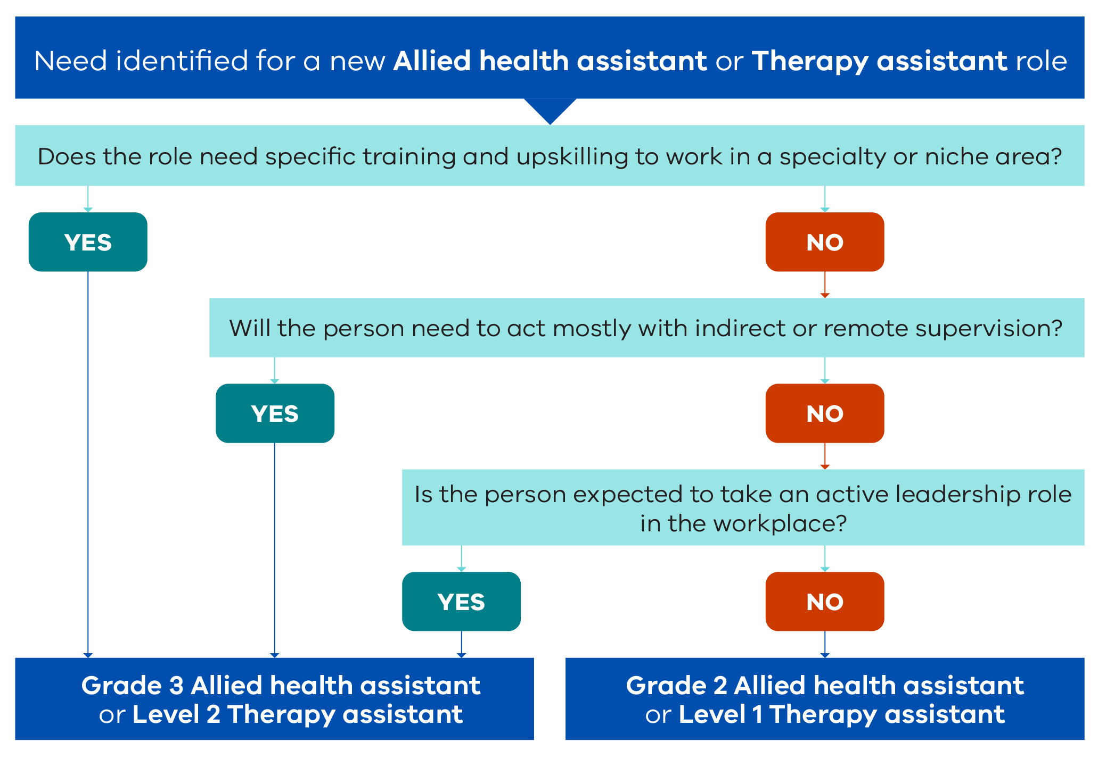

Assessment process
Need identified for a new allied health assistant or therapy assistant role.
Question 1: Does the role need specific training and upskilling to work in a specialty or niche area?
- Yes: Grade 3 Allied Health Assistant or Level 2 Therapy Assistant.
- No: Continue to next question.
Question 2: Will the person need to act mostly with indirect or remote supervision?
- Yes: Grade 3 Allied Health Assistant or Level 2 Therapy Assistant.
- No: Continue to next question.
Question 3: Is the person expected to take an active leadership role in the workplace?
- Yes: Grade 3 Allied Health Assistant or Level 2 Therapy Assistant.
- No: Grade 2 Allied Health Assistant or Level 1 Therapy Assistant.

To receive this document in another format, email Allied Health Workforce <alliedhealthworkforce@health.vic.gov.au>.
Authorised and published by the Victorian Government, 1 Treasury Place, Melbourne.
© State of Victoria, Australia, Department of Health, November 2023.
Available at Victorian Allied Health Assistant Workforce Recommendation and Resources <https://www.health.vic.gov.au/allied-health-workforce/victorian-allied-health-assistant-workforce-recommendations-resources>

