Fee justification model user guide
Guidance for Class B cemetery trusts
OFFICIAL

To receive this document in another format, phone 1800 034 280, using the National Relay Service 13 36 77 if required, or email the department <cemeteries@health.vic.gov.au>.
Authorised and published by the Victorian Government, 1 Treasury Place, Melbourne.
© State of Victoria, Australia, Department of Health, December 2023.
ISBN 978-1-76096-349-1 (pdf/online/MS word)
Available at Class B cemetery trust fee setting <https://www.health.vic.gov.au/cemeteries-and-crematoria/class-b-cemetery-trust-fee-setting>

Contents
Introduction 4
Fee justification model overview 4
Tab 1 – Fee Justification Sheet 5
A: Indirect costs 5
B: Trust signature block 6
C: Interactive fee schedule 6
Tab 2 – Trust Costs 8
Tab 3 – Fee Breakdown 9
Tab 4 – Fee Description List 10
Contact 10

Introduction
The department’s Fee justification model (the model) has been designed to help trusts determine fees for the cemetery services they provide <https://www.health.vic.gov.au/cemeteries-and-crematoria/class-b-cemetery-trust-fee-setting>. The model should be used to add new fees or increase existing fees outside of the annual CPI process.
The user guide has been developed in conjunction with the ‘Cemetery trust fees’ and ‘Fee applications - Class B cemetery trusts’ topics in the Manual for Victorian Class B cemetery trusts (the manual) <https://www.health.vic.gov.au/publications/manual-for-victorian-class-b-cemetery-trusts>. Before completing the model, trusts should read and become familiar with the concepts and terms used in the manual.
Please note the following general points:
- The model must be completed electronically in Microsoft Excel.
- The model requires trusts to enter information into the grey shaded cells only. Cells not shaded are automatically populated.
- There is space for 20 fees on the worksheet. If more than 20 fees are being submitted, please complete additional worksheets as necessary. If multiple models are being submitted, each model must be signed and dated.
- A signed copy of the model must be provided to the department. The completed Excel spreadsheet must also be emailed the department at cemeteries@health.vic.gov.au.
- The department has developed recommended memorial permit fees. If the trust wishes to charge the recommended amount or a lower fee, it can submit a Recommended Memorial Permit Fee Application Form instead of using the model. The form is available on the department's website at <https://www.health.vic.gov.au/ cemeteries-and-crematoria/class-b-cemetery-trust-fee-setting>. If the trust wishes to charge a memorial permit fee that is higher than the recommended amount, the fee must be included in the model.
For assistance with completing the model, please contact the department on 1800 034 280.

Fee justification model overview
The model contains simple instructions and four tabs:
- The first tab is the Fee Justification Sheet. This requires the trust to enter specific data into the worksheet to assist them to determine fees for products and services.
- The second tab is for Trust Costs. This can be used to assist trusts to identify costs associated with a fee. Entering data in this tab is optional.
- The third tab is the Fee Breakdown. This tab is populated automatically and lists the individual cost components of each fee. Trusts do not need to enter data onto this worksheet, it is for reference only (for example, finding the dollar amount allocated to GST or perpetual maintenance).
- The fourth tab is the Fee Description List. This tab includes all current standardised fee descriptions and fee codes. Trusts do not need to enter any data in this tab, it is for reference only.

Figure 1 – Fee justification model tabs
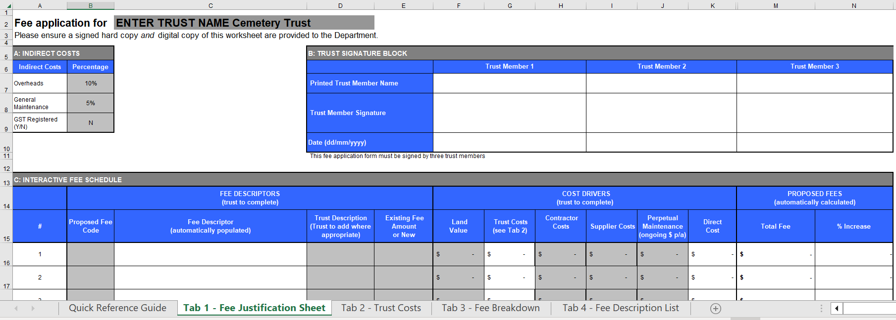

Tab 1 – Fee Justification Sheet
The Fee Justification Sheet is separated into three sections:
A: Indirect costs
B: Trust signature block
C: Interactive fee schedule
Each section is discussed separately below.

A: Indirect costs
The three items in indirect costs are overheads (default 10%), general maintenance (default 5%), and GST (default ‘N’). The trust’s choices in this section will be incorporated across all fees included in the model. Follow the instructions in the following table to complete the Indirect costs section.
Overheads | These include superannuation, insurances (including WorkCover), taxes, depreciation, repairs, marketing activities and, where appropriate, corporate services costs and information technology.  The default percentage of 10% is recommended. If the trust elects to change the default amount, it must justify (with calculations) the proposed percentage in the cover letter submitted with the model.
General maintenance | Includes activities such as mowing, watering, site specific maintenance needs for lawn and garden sections, ensuring pathways and roads are safe, maintaining fencing, servicing of cemetery equipment and basic upkeep of structures.  The default percentage of 5% is recommended. If the trust elects to change the default amount, it must justify (with calculations) the proposed percentage in the cover letter submitted with the model.
GST  Registered | If your trust is not registered for GST, please ensure that ‘N’ is typed in this box.  If your trust is registered for GST, please type Y. The worksheet will automatically determine which fees in the model incur GST and add the appropriate amount to those fees only. Certain fee categories are exempt from GST such as Right of interment fees and the model will automatically exclude these from its calculation of GST.

B: Trust signature block
Trusts can type in the name of three trust members in section B. Once tab 1 has been completed, it must be signed by three trust members (either by inserting digital signatures or printing out a copy to be signed in person).

C: Interactive fee schedule
Follow the instructions below to add fee descriptions and cost drivers to the model. Adding cost drivers will automatically calculate the Proposed Total Fee (column M).

1: Fee codes and descriptions
In this section the trust should enter a fee code corresponding to the appropriate fee description. A list of all fee codes is on the fourth tab of the model. Select the fee item from the list and enter its fee code into the Proposed Fee Code column (column B). The Fee Description field will automatically update; repeat for each fee item to be adjusted or added.
Trusts can enter their own fee name or site-specific identifiers in the Trust Description column (column D). For example, a trust may choose to distinguish right of interment fees by naming one ‘Lawn section’, and another ‘Monumental section’.

2: Existing fees
If the fee is an existing gazetted trust fee, add the current amount to the Existing Fee Amount column (column E). If the fee is new, type ‘new’.

3: Cost drivers
There are several columns under this heading in the worksheet, each identifying different cost drivers making up the fee. Each fee can have one or more cost drivers depending on the nature of the fee. For example, a right of interment fee may have figures added to the Land Value, Trust Costs, and Perpetual Maintenance columns whereas a memorial permit fee may only have a Trust Costs component.
Land Value
Land value is the estimated cost of the place of interment. This cost driver is applicable to right of interment fees only (for bodily and cremated remains) as the land is removed from the marketplace when the right of interment is sold.
When determining the cost or value of the interment site, trusts should consider the cost of developing the site for sale. For example, the cost of installing lawn beams or other foundations and any landscaping required to prepare the plots for sale, divided by the number of plots. The land value for niche wall right of interment fees would be the cost of constructing the niche wall divided by the number of available spaces.
Trusts can include infrastructure costs such as establishing paths, fences, or rotundas. Infrastructure costs could be distributed among all rights of interment or weighted to particular areas.
Trusts can also incorporate the replacement value of the land. Replacement value is the cost of replacing the land at the current land value within the local area. Land values can be obtained by looking at local sales for undeveloped land (that is, land without improvements such as buildings) or using the Guide to Property Values published by the Department of Energy, Environment and Climate Action <https://www.land.vic.gov.au/valuations/resources-and-reports/property-sales-statistics>.
To obtain the land value of a single site, add the replacement and development costs together, then divide by the number of interment sites.
For example, if a hectare of land in the local area has a conservative value of $10,000, development costs are estimated to be $15,000 and 50 interment sites can be provided, the land value per interment site works out to be (10,000 + 15,000) ÷ 50 = $500.
The trust’s calculations for the land value figures used in the model must be provided with its application.
The department has developed an optional Cemetery land development costing model to assist trusts to cost a development project. The outputs from this model can be entered into the Land Value section of the fee justification model. The Cemetery land development costing model is available on the department's website at <https://www.health.vic.gov.au/publications /cemetery-land-development-costing-model>.

Trust Costs
Trusts should list the internal costs associated with the provision of a product or service. For example, the administrative costs associated with processing a right of interment, record-keeping expenses and any costs associated with preparing information for trust meetings. The Trust Costs tab can assist trusts to work out these costs (see heading Tab 2 – Trust Costs below).
Trust Costs should include any labour costs (and on-costs) such as base wages/salaries, payroll tax, superannuation, training costs, and other costs such as materials/consumable supplies, equipment, and utilities that can be specifically linked to the fee. If providing the product/service requires trust members or staff to travel to and from the cemetery, for example, to assist a family to choose a place of interment, average travel time can be included here.

Contractor Costs
Contractor Costs are all costs associated with a contractor providing that service. For example, grave digging or additional equipment hire. If the trust wishes to charge a fee based on a percentage of the contractor’s cost, this should be typed into the Trust Description column (column D), for example ‘cost plus 20%’. If a fee will be ‘cost plus’ rather than a fixed price, the cost driver columns for that fee should be left blank.

Supplier Costs
Supplier Costs are all costs associated with the supply of third-party products. For example, memorials or backfill.
If the trust wishes to charge a fee based on a percentage of the supplier’s cost, this should be typed into the Trust Description column (column D), for example, ‘cost plus 20%’. If a fee will be ‘cost plus’ rather than a fixed price, the cost driver columns for that fee should be left blank.

Perpetual Maintenance
Enter an annual dollar contribution to perpetual maintenance or (for right of interment fees) an average dollar cost for maintaining a plot or area within the cemetery.
When setting fees trusts must consider the costs of operating and managing the cemetery and the need to provide for maintenance of buildings and structures, roads and paths, utilities, gardens and other vegetation contained within the cemetery in perpetuity. A perpetual maintenance component cannot be charged as a separate fee.
When entering a figure in the Perpetual Maintenance column, trusts are to enter a dollar figure representing the estimated annual cost of providing maintenance for that individual product or service.
A nominal amount up to $2 can be entered for all fee items (if an appropriate figure cannot be easily calculated or justified).
A simple method of calculating the perpetual maintenance figure for right of interment fees is to estimate the average annual cost of maintaining the cemetery (or specific area within the cemetery) and divide this by the number of plots in the cemetery (or specific area). Historical plots where no contribution to perpetual maintenance was collected can be removed from this calculation.
The model calculates a perpetual maintenance lump sum over a period of 100 years. If $10 is entered, the model will calculate the amount of money required up-front to enable the trust to spend $10 a year for 100 years to maintain the place of interment, factoring in interest rates and inflation.
In this example, the model will identify that the trust needs to collect $455 and will add this amount to the total proposed fee. When sales of this product/service occur, the trust should set aside the $455 for perpetual maintenance.
The trust’s calculations for the perpetual maintenance figures used in the model must be provided with its application unless the trust has applied only a nominal amount up to $2.

Direct Costs
Trusts do not need to enter information here. This field automatically provides a total for Direct Costs associated with the provision of the products and services listed; it does not show perpetual maintenance or GST (where applicable) or indirect costs.

4: Proposed fees
Trusts do not need to enter information into this section as figures are automatically calculated.
The Total Fee column (column M) displays the proposed price generated by the model for a product or service. This total incorporates the cost drivers, perpetual maintenance, GST (where applicable) and indirect costs. Trusts can elect to charge a lower amount by indicating this in the cover letter submitted to the department.
The Percentage Increase column (column N) will show the increase between the proposed and current fee as a percentage. Trusts should be aware that the department may require the trust to ‘stagger’ the proposed increase of its fees over several years if the increase is significant.

Tab 2 – Trust Costs
The Trust Costs tab (tab 2) can be used to determine the costs of providing a particular service. The figure generated in tab 2 can then be used in the Trust Costs column in tab 1.
Trusts only need to enter figures into the light-grey shaded areas highlighted below. There are 20 numbered sections corresponding to the 20 rows available in tab 1.
The Trust Costs tab is optional and can assist trusts to calculate the cost of providing a product or service. If a trust chooses not to use the Trust Costs tab to generate trust cost figures, the department may require the trust show how the figures were calculated.
Figure 2 – Trust costs tab
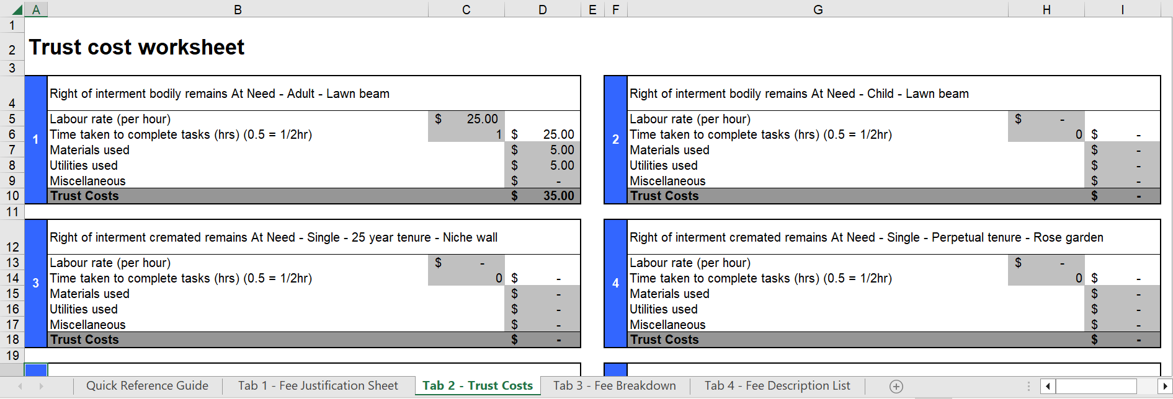
Follow these five steps to calculate Trust Costs for each fee (repeat the five steps for each separate fee listed in tab 1):
- Enter the cost of labour (per hour) for each fee. If the work is being undertaken by a paid employee, their hourly rate can be used.
    - If the work is being undertaken by a volunteer (unpaid) trust member, the value of a trust member’s time and effort can be quantified. The department suggests trusts consult the Cemetery Industry Award, available on the Fair Work Ombudsman's website at <https://www.fairwork.gov.au/employment-conditions/awards/list-of-awards#a-z> to find an appropriate classification for the work being done. ‘Funeral Supervisor’ or ‘Cemetery Employee Class 4’ (in Schedule A of the Cemetery Industry Award) might be an appropriate classification for the duties of a trust secretary (such as assisting with the purchase of graves and memorials, keeping appropriate records, supervising the funeral). The minimum wage for each classification is available on the Fair Work Ombudsman’s website (link above).
    - Trusts are required to note the source of the selected labour rate in the cover letter accompanying the fee application.
- Indicate, in hours, how long it takes to complete the task. For instance, if it takes one hour and 45 minutes to complete a task, the trust should enter 1.75.
- The next two cells allow the trust to enter costs associated with materials and utilities (such as postage, paper, electricity, and phone calls). Estimated costs are acceptable.
- The Miscellaneous section allows the trust to enter costs that are not covered in the previous categories. If the trust adds figures here, the department may ask the trust to describe the costs it has included.
- Once all costs have been entered, the final trust costs figure calculated in tab 2 will be displayed in the corresponding Trust Costs column in tab 1.

Tab 3 – Fee Breakdown
The Fee Breakdown tab is for information only. It does not require the user to enter any data. All figures for the proposed fees are drawn from the previous tabs.
The information contained here may be of use to trusts as it identifies how much indirect cost, perpetual maintenance and GST are applicable for each fee.
Figure 3 –The fee breakdown tab
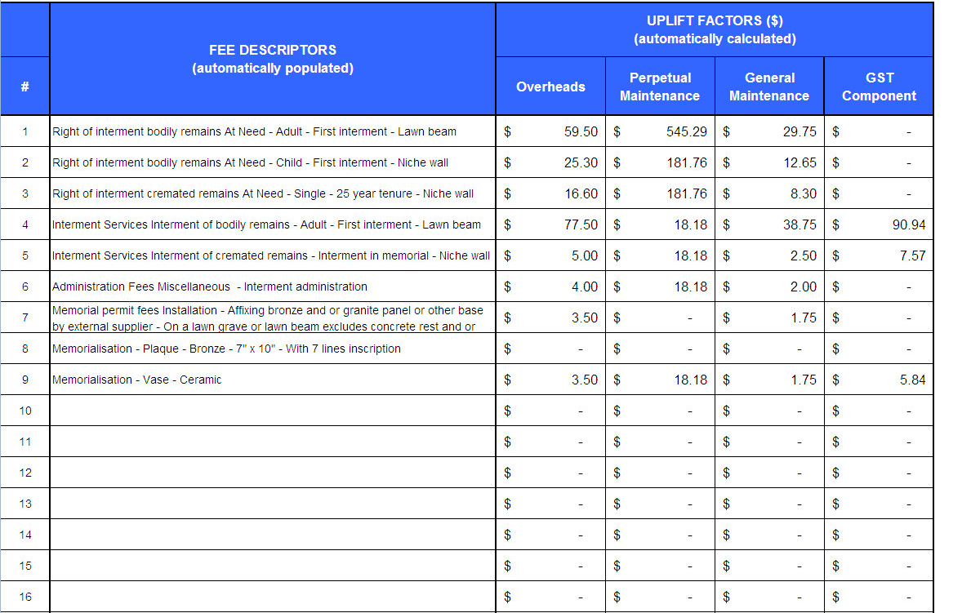

Tab 4 – Fee Description List
The Fee Description List tab lists all current fee codes and their standardised fee names.
The list is also available in the manual available on the department's website at <https://www.health.vic.gov.au/publications/manual-for-victorian-class-b-cemetery-trusts>.
All cemetery trust products and services are contained in these standardised descriptions. Definitions and suggestions about the fee categories are provided in the Manual. If the trust has difficulty selecting a fee description, please contact the department.
The fee codes are used in Column B on tab 1 as the first step in completing the model.

Contact
For assistance, please contact the department on 1800 034 280 or email cemeteries@health.vic.gov.au.

