Choking
Standardised care process
Contents
Objective 2
Why the response to choking is important 2
Definitions 2
Team 2
Acknowledgement 2
Brief standardised care process 3
Recognition and assessment 3
Interventions 3
Referral 3
Evaluation and reassessment 3
Resident involvement 3
Staff knowledge and education 3
Full standardised care process 5
Recognition 5
Assessment 5
Interventions 5
Referral 7
Evaluation and reassessment 7
Resident involvement 7
Staff knowledge and education 7
Flow chart: Immediate response to a choking episode 8
Evidence base 9
Further reading 9

Objective
To promote evidence-based practice in the management of choking for older people who live in residential care settings, and to provide responsive approaches to choking to reduce negative outcomes.

Why the response to choking is important
Normal age-related changes place older people at risk of experiencing swallowing problems. The risk is increased by pathological changes such as dementia, stroke, functional decline and the use of medicines. Choking is a medical emergency and can lead to death. Staff initiating appropriate responses to choking can improve outcomes for residents.

Definitions
Back thrust: a blow to the centre of the back between the shoulder blades using the heel of the hand.
Chest thrust: a thrust that uses the same compression point as for CPR but delivers the thrust at a sharper and slower rate (ANZCOR 2016).
Choking: complete or partial obstruction of the airway by inhalation of a foreign body.
Cyanosis: a bluish discolouration of the skin due to lack of oxygen.
Dysphagia: difficulty with swallowing.
Mendelsohn manoeuvre: a voluntary prolongation of hyolaryngeal elevation at the peak of the swallow that has been used to treat patients with pharyngeal dysphagia.
Stridor: abnormal, high-pitched, musical breathing sound caused by blockage.

Team
Manager, registered nurses (RNs), enrolled nurses (ENs), personal care attendants (PCAs), leisure and lifestyle staff, general practitioner (GP), allied health professionals (such as a physiotherapist, occupational therapist, exercise physiologist, speech pathologist and dietitian), residents and/or family/carers.

Acknowledgement
This standardised care process (SCP) has been developed for public sector residential aged care services (PSRACS) by the Australian Centre for Evidence Based Care (ACEBAC) at La Trobe University through the Department of Health and Human Services Strengthening Care Outcomes for Residents with Evidence (SCORE) initiatives. This SCP is one of a series of priority risk areas reviewed based on the best available evidence in 2023.

Brief standardised care process

Recognition and assessment
- Establish the resident’s choking risk.
- Recognise the presence of an acute airway obstruction.
- Assess the severity of an airway obstruction.
- Determine if the resident can cough effectively or if the cough is not effective.
- Conduct a post-episode assessment.

Interventions
- Inform the RN.
- Respond immediately to the choking episode as per the flow chart.
- Refer to a GP and speech pathologist for assessment.
- Implement an individualised risk reduction and prevention plan.
- Communicate changes.

Referral
- Ambulance services
- GP
- Speech pathologist
- Dietitian
- Physiotherapist
- Occupational therapist
- Residential Medication Management Review (RMMR)
- Oral hygienist/dentist

Evaluation and reassessment
- Monitor the resident’s:
  - swallowing status
  - adequacy of food and fluid intake
  - chest for signs of chest infection.
- Evaluate choking risk every six months.

Resident involvement
- Educate the resident about risk factors
- Discuss modified diets and safe swallowing methods
- Discuss advance care planning

Staff knowledge and education
- Recognition and response to a choking incident
- Identification of residents at risk of choking
- Identification and reporting of swallowing difficulties
- Interventions to reduce the risk of choking once swallowing difficulties have been identified
- Food and fluid texture modification
- Supervision, safe feeding assistance and positioning techniques at mealtimes or whenever swallowing

Full standardised care process

Recognition
Establish choking risk for residents who have:
- a swallowing disorder
- a history of choking
- impulsive behaviours.
Identify residents who present with an acute airway obstruction. Symptoms in conscious residents include:
- extreme anxiety
- agitation
- gasping sounds
- coughing
- loss of voice
- clutching the neck.
Implement an individualised risk reduction and prevention plan, including modification of food and fluids.

Assessment
Residents identified with a choking risk are referred for specialist assessment (for example, a speech pathologist, dietitian and dentist).
Assessment findings and recommendations should be documented, communicated across the care team and implemented.
When a resident presents with an acute airway obstruction:
- assess the severity of the airway obstruction – the obstruction may be partial or complete and the resident may be conscious or unconscious
- determine if the resident can cough effectively or if the cough is not effective
- partial obstruction is indicated if:
  - breathing is laboured
  - breathing is noisy (stridor)
  - air can be felt from the mouth.
The resident should be continually observed because the airway obstruction may progress to complete obstruction within a few seconds.
Complete obstruction is indicated if:
- the resident is attempting to breathe
- there is no sound of breathing
- no air can be felt coming from the mouth or nose
- there is cyanosis due to lack of oxygen.

Interventions
Respond immediately to the choking episode (see Figure 1) and inform the nurse in charge.
If the resident is coughing (effective cough):
- encourage the resident to keep coughing to force out the foreign body
- provide reassurance.
If the obstruction is not relieved, call triple zero (000) and request an emergency ambulance.
If the resident is not coughing and is conscious:
- call triple zero (000) and request an emergency ambulance
- position the resident in a sitting or standing position
- give up to five blows in the centre of the back, between the shoulder blades, using the heel of the hand
- after each blow, check whether the obstruction has been relieved
- if back blows are not effective, identify the CPR cardiac compression point and give up to five chest thrusts (chest thrusts are like cardiac compressions but sharper and delivered at a slower rate)
- after each chest thrust, check whether the obstruction has been relieved
- if the obstruction is not relieved and the resident remains conscious, continue to alternate back blows and chest thrusts until the ambulance arrives
- if chest thrusts cannot be applied, continue with back blows.
Important: The use of abdominal thrusts to dislodge the obstruction are no longer recommended (ANZCOR 2016).
If the resident is unconscious or falls into an unconscious state:
- call triple zero (000) and request an emergency ambulance
- if the object is not visible or the resident does not start breathing, lay the resident on their back on a hard surface and begin CPR.

Following a choking incident
- Inform the resident’s GP.
- Inform the resident’s family/carers.
- Identify the possible cause and maintain a high awareness of the signs and symptoms of dysphagia.
- Refer to a speech pathologist, if available, for a swallowing assessment and recommendations.
- For residents on modified diet and fluids, monitor food and fluid intake to check whether these are adequate (refer to a dietitian if intake is not adequate).
Implement an individualised risk reduction and prevention plan, including modification of food and fluids.
Risk minimisation strategies for residents at risk of choking may include:
- Systems to ensure at-risk residents are clearly identified to staff involved in food preparation, serving, feeding or supervision during mealtimes, drink rounds, medication rounds, or whenever swallowing.
- Systems to ensure the right food reaches the right resident.
  - A modified textured diet includes avoiding mixed-texture foods (for example, solid and liquid foods together such as vegetable soups, food with seeds, sticky foods and dry, crumbly foods)
- Supervision when eating and drinking:
  - modify the way assistance with meals is provided (for example, encourage coughing after swallowing, allow adequate time for chewing and swallowing, ensure swallowing has occurred before offering more food and drink, alternate mouthfuls of food with fluid, check the mouth for residual food after each meal)
  - modify seating to help the resident maintain an upright position
  - postural adjustments and positioning – the resident should be seated upright with their chin tucked or turned to facilitate safe and efficient swallowing
  - swallow manoeuvre (such as supraglottic and super supraglottic swallow, effortful swallow, Mendelsohn manoeuvre)
  - introduce eating and feeding aids, such as adapted cups, shallow spoons, non-slip table mats, angled utensils
  - modify the environment to minimise distractions
  - regularly attend to dental hygiene and provide oral hygiene before and after each meal.
- Medication review to identify:
  - drugs that can impair the cough reflex and swallowing
  - drugs that dry up oral secretions
  - alternative forms of preparations and routes of administration.
Communicate changes related to:
- choking risk
- eating plans
- dietary and fluid requirements.

Referral
- Ambulance services for emergency assistance
- GP for post-episode assessment and recommendations
- Speech pathologist for post-episode swallowing assessment and recommendations
- Physiotherapist and/or occupational therapist for seating modification
- Dietitian
- Residential Medication Management Review if indicated
- Oral hygienist or dental review if professional oral care is indicated

Evaluation and reassessment
Continue to monitor the resident for:
- swallowing difficulties
- adequacy of food and fluid intake
- signs of chest infection.
Evaluate choking risk every six months.

Resident involvement
- Educate the resident about risk factors
- Discuss modified diets and safe swallowing methods
- Advance care planning.

Staff knowledge and education
- Recognition and response to a choking incident
- Identification of residents at risk of choking
- Identification and reporting of swallowing difficulties
- Interventions to reduce the risk of choking once swallowing difficulties have been identified (swallowing strategies)
- Food and fluid texture modification
- Supervision and safe feeding assistance and positioning techniques at mealtimes, drink rounds, medication rounds, or whenever swallowing.

Figure 1: Immediate response to a choking episode
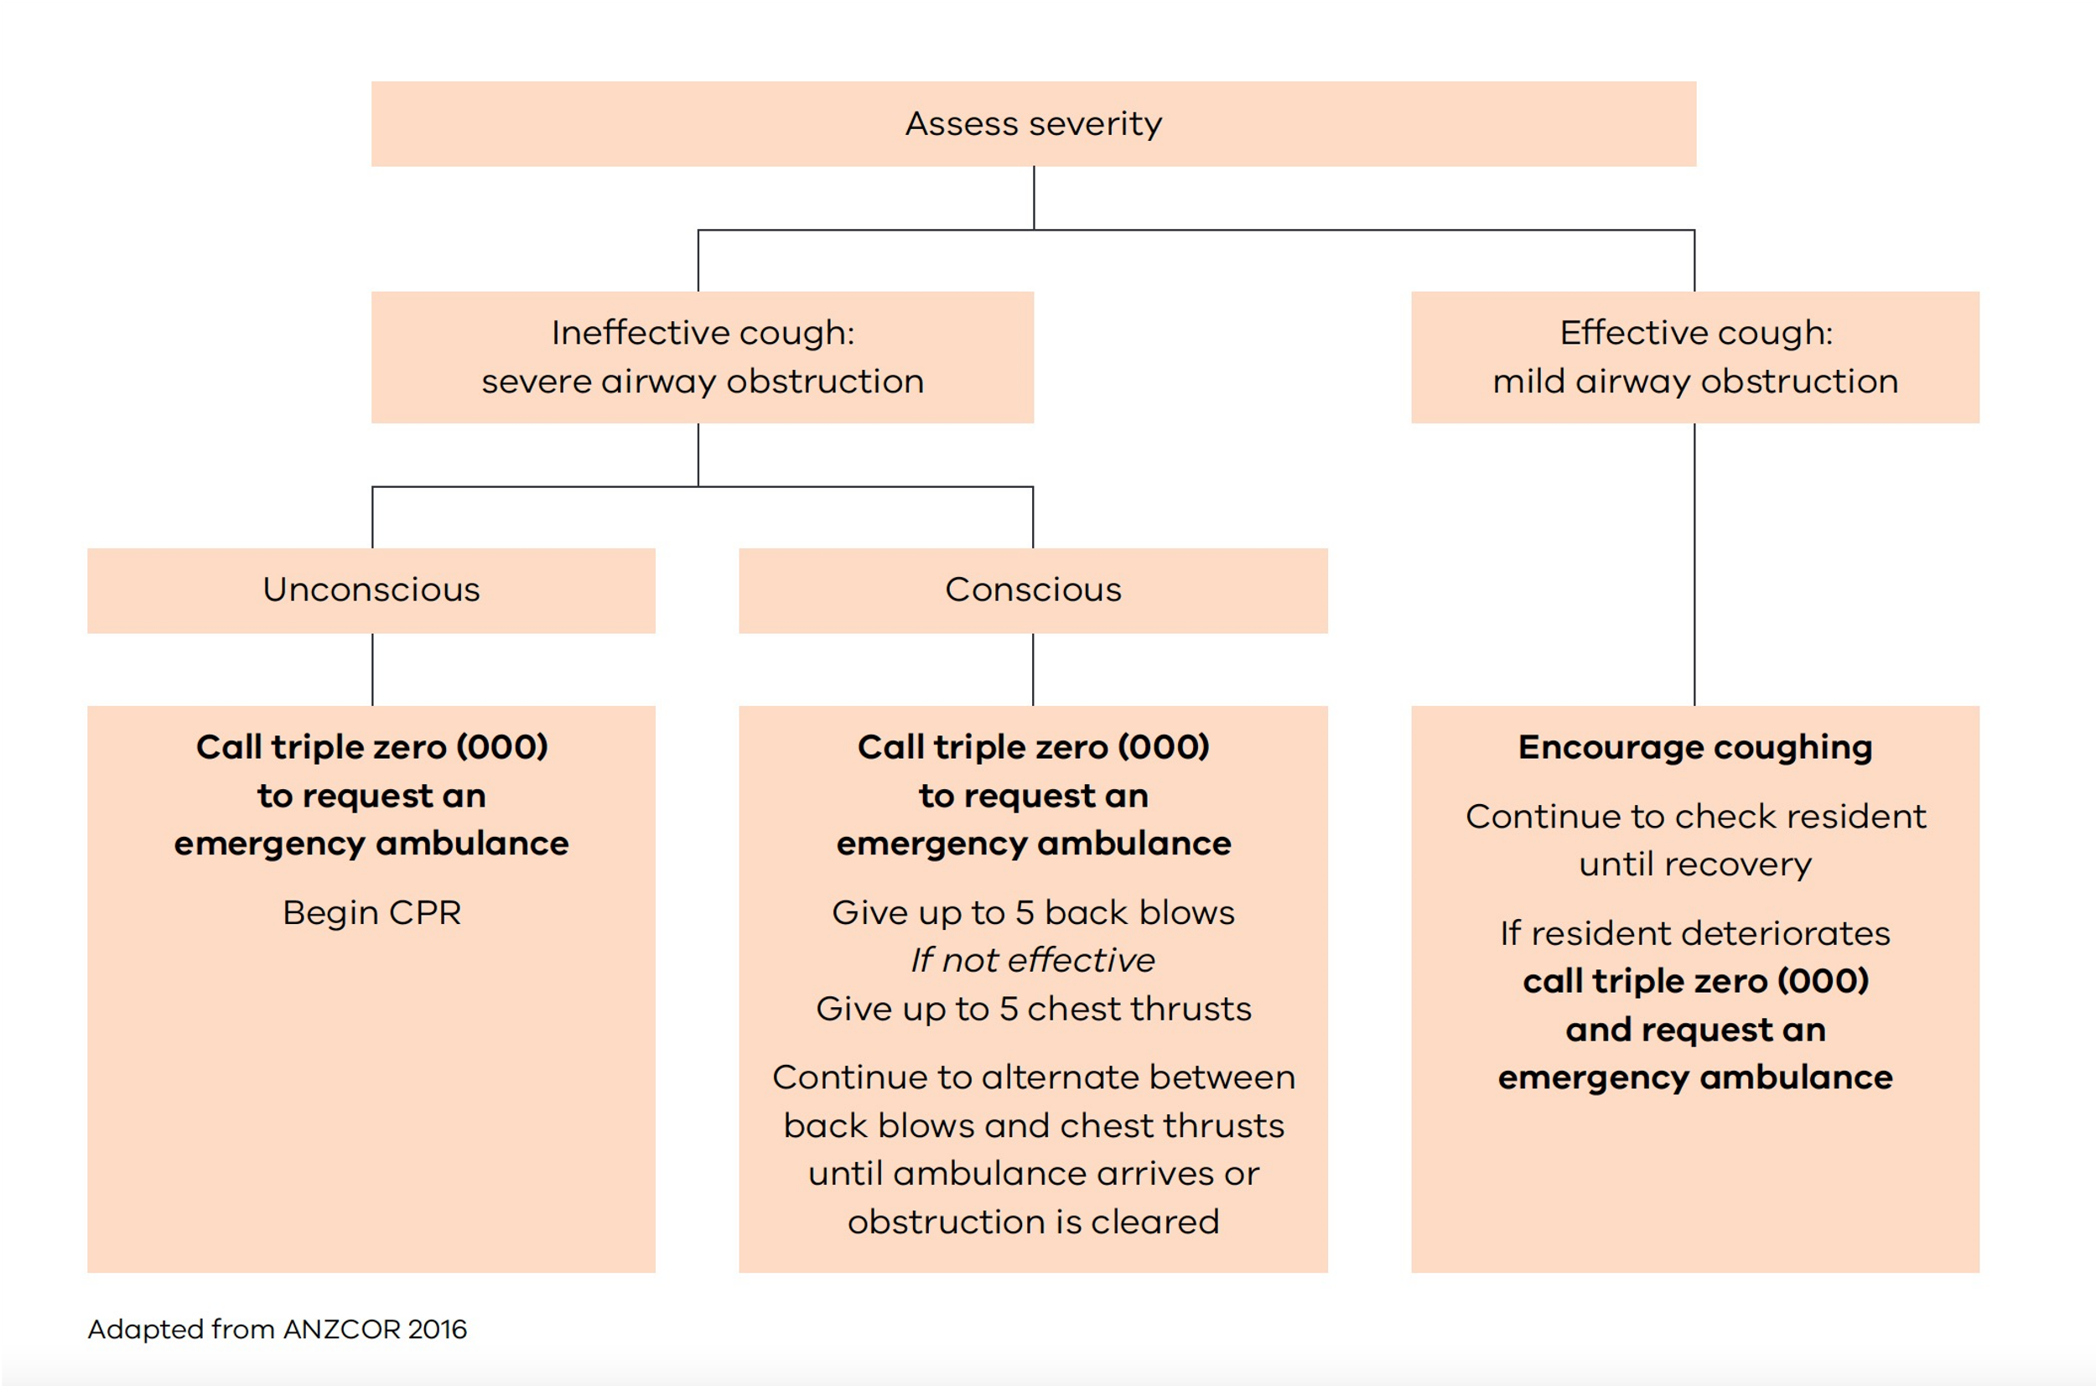

Flowchart of Immediate response to a choking episode, as described under heading Interventions.

Evidence base
Australian and New Zealand Committee on Resuscitation (ANZCOR) 2016, ANZCOR Guideline 4 – Airway, ANZCOR.
Australian and New Zealand Society for Geriatric Medicine 2019, ‘Position statement abstract: – dysphagia and aspiration in older people’, Australasian Journal of Ageing, DOI: 10.1111/ajag.12700.
Department of Health 2012, Strengthening care outcomes for residents with evidence (SCORE), Ageing and Aged Care Branch, State Government of Victoria, Melbourne.
Ibrahim, J 2017, Recommendations for prevention of injury – related deaths in residential aged care services, Monash University, Southbank.
Slade, S 2018, Evidence Summary. Dysphagia and the older person: Management, The Joanna Briggs Institute EBP Database, JBI@Ovid. JBI14521.

Further reading
Canham, M 2016, ‘Looking into oropharyngeal dysphagia in older adults’, Nursing 2016, pp. 37–42.
Murray, A, Mulkerrin, S & O’Keefe, S 2019, ‘The perils of ‘risk feeding’’, Age and Ageing, vol. 48, pp. 478–81.
Nawas, S & Tulunay-Ugar, O 2018, ‘Dysphagia in the older adult’, Otolaryngology Clinics of North America, vol. 51, pp. 769–77.
Sivapuram, M 2019, Evidence Summary. Dysphagia (Older people): Assessment, The Joanna Briggs EBP Database, JBI@Ovid. JBI13353.

Important note: This standardised care process (SCP) is a general resource only and should not be relied upon as an exhaustive or determinative clinical decision-making tool. It is just one element of good clinical care decision making, which also takes into account resident/patient preferences and values. All decisions in relation to resident/patient care should be made by appropriately qualified personnel in each case. To the extent allowed by law, the Department of Health and the State of Victoria disclaim all liability for any loss or damage that arises from any use of this SCP.

Authorised and published by the Victorian Government, 1 Treasury Place, Melbourne.
© State of Victoria, Department of Health, April 2023. (2308532)
ISBN 978-1-76096-810-6 (pdf/online/MS word)
Available from the department’s Standardised care processes webpage <https://www.health.vic.gov.au/residential-aged-care/standardised-care-processes>.

