

|  |
| --- |
| Blood Matters on the Bench and Beyond |
| Issue 16 – November 2023 |
|  |

Welcome to the Blood Matters newsletter for Scientists. It is distributed throughout the year to share information that may be helpful to you, and to let you know of upcoming activities which may be of interest.

## Blood Matters online events 2024

Blood Matters online events have become a regular fixture in our education calendar, continuing to support scientists and our multidisciplinary network of transfusion professionals.

RhD Ig Donor Program

#### Wednesday 13 March 2024

1.00pm – 2.00pm (AEDT)

Further information including registration details to follow.

## ‘STOP the waste’ festive campaign 2023-24

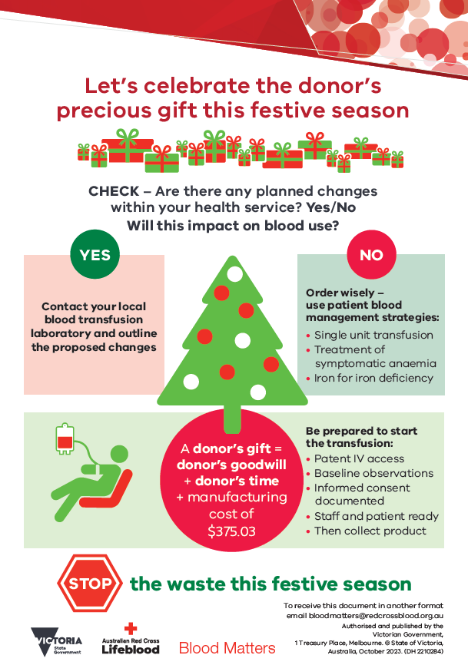The festive season is fast approaching, and once again it is time for us to consider how we can keep blood wastage to a minimum over this period.

Donated blood is a gift, and we all need to do our part to protect and manage this valuable resource.

**Let’s celebrate the donor’s precious gift this festive season.**

Are there anticipated changes to activity over the festive season which will impact blood use at your health service?

Adjust inventory accordingly and inform Lifeblood of any anticipated changes to your blood inventory and usage, to assist them to adjust donor collections as required. This will help to ensure sufficiency of the blood supply over the festive season.

Checklists are available for download from Blood Matters’ Blood component wastage webpage < https://www.health.vic.gov.au/patient-care/blood-component-wastage>.

**Your continued support of the ‘STOP the waste’ campaign is appreciated.**

## New Lifeblood courses to build your transfusion knowledge

Lifeblood’s Transfusion Policy and Education team have developed new courses to build your transfusion knowledge.

Each module is tailored to suit the needs of healthcare professionals in developing or improving knowledge in the transfusion setting.

While targeted to separate transfusion professional groups, both streams would provide value to holistic understanding of transfusion.

|  |  |
| --- | --- |
| Transfusion laboratory essentials | Transfusion practitioner microcredentials |
| Help new scientists and those returning to the workforce to feel safe and confident in their role in a transfusion laboratory.  Intended to complement your mandatory laboratory training programs. | Designed to build and support knowledge of safe transfusion practice and offer a certification of assessed learning.  These microcredentials are ideal if you’re new to transfusion and for existing health professionals who have identified gaps in their skills or knowledge. |
| **Available now:**  Module 1. The Australian transfusion community  Module 2. Pretransfusion testing | **Available now:**  Module 1. Transfusion practitioner role  Module 2. Blood physiology |
| **Coming soon:**  Module 3. Pretransfusion specimen labelling requirements  Module 4. Blood group systems (ABO, Rh and other)  Module 5. An introduction to ABO and Rh discrepancies  Module 6. Antibody investigations  *There will be 12 self-paced and interactive modules in total.* | **Coming soon:**  Module 3. Blood components  Module 4. Decision to transfuse and consent  Module 5. Blood administration  Module 6. Transfusion adverse events  *More modules to follow* |

More information at lifeblood.com.au/transfusion-courses

## National certification of the medical scientist profession

The Australian Council for Certification of the Medical Laboratory Scientific Workforce has simplified its acronym to CMLS. Join now at [www.cmls.org.au](http://www.cmls.org.au/).

Some changes to CMLS certification came into effect on 1st April 2023. Rather than the CMLS Board directly processing applications for certification or renewal, professional bodies operating CMLS approved CPD schemes will be able to issue certification on behalf of the Council for their members meeting the criteria.

The Council member organisations remain committed to the certification of the medical laboratory workforce and to the standards which they have established.  This change has been made to simplify the process and increase the participation in certification at minimal cost to the individual.

#### Why become certified?

* Recognition of our professional standing as part of Australia’s health service workforce.
* Certification will be the best benchmark available to assure competent professional practice.
* With a certified workforce there will be more obligation on the employer to ensure staff have professional development opportunities afforded to them.
* As a nationally certified medical scientist you can demonstrate your ongoing commitment to professional development and self-improvement and be recognised as passionate, progressive and pro-active.

[View a short video about the certification scheme](https://www.youtube.com/watch?v=6Zc4QQJEijs) <https://www.youtube.com/watch?v=6Zc4QQJEijs>

A Blood Matters education session was held in May 2021 which included information about the certification scheme. [View meeting recording](https://urldefense.com/v3/__https:/lifeblood.webex.com/recordingservice/sites/lifeblood/recording/3d6d869b9a801039b77f005056baad9d/playback__;!!FNSAje27EPQO!9z4B_6kTDzMvUPqe14jyDtZuJza4nzuaLDPUzZhE7LJH45b0vpBE8c-eKrkcEPPKP-NdJ8UR$)   
<https://lifeblood.webex.com/recordingservice/sites/lifeblood/recording/3d6d869b9a801039b77f005056baad9d/playback> (the certification presentation begins at time point 20:38).

Blood Matters is committed to providing support and education to assist in certification of the medical scientific workforce.

## How can Blood Matters help you?

The Blood Matters team are here to assist health services and laboratories through education and providing resources.

If you have suggestions for tools and resources that could assist in day to day activities and towards achieving accreditation please let Rae French or any of the Blood Matters team know by email [rfrench@redcrossblood.org.au](mailto:rfrench@redcrossblood.org.au) or [bloodmatters@redcrossblood.org.au](mailto:bloodmatters@redcrossblood.org.au) or phone 03 9694 3524.

|  |
| --- |
| To receive this document in another format, phone 03 9694 0102, using the National Relay Service 13 36 77 if required, or [email Blood Matters](mailto:bloodmatters@redcrossblood.org.au?subject=Accessible%20document) <bloodmatters@redcrossblood.org.au>.  Authorised and published by the Victorian Government, 1 Treasury Place, Melbourne.  © State of Victoria, Australia, Department of Health, November 2023.  **ISSN** 2652-7278 – **Online (pdf / word)**  Available at [Blood Matters](https://www.health.vic.gov.au/patient-care/transfusion-science-and-blood-stewardship) <https://www.health.vic.gov.au/patient-care/transfusion-science-and-blood-stewardship> |