Melanoma in Victoria
Optimal care pathway data summary report 2022
OFFICIAL

To receive this document in another format, phone (03) 9456 3332, using the National Relay Service 13 36 77 if required, or email the Cancer Support, Treatment and Research unit <cancerplanning@health.vic.gov.au>.
Authorised and published by the Victorian Government, 1 Treasury Place, Melbourne.
© State of Victoria, Australia, Department of Health, October 2023.
ISBN - 978-1-76131-476-6 (pdf/online/MS word)
Available at the department’s cancer webpage <https://www.health.vic.gov.au/health-strategies/cancer-care>.

Foreword
This report summarises the data analyses prepared for the Melanoma Summit, which took place in person on Friday 14 October 2022. There were approximately 83 people in attendance including consumers.
The Melanoma Summit is a newly activated tumour stream of the Victorian Tumour Summits, which are clinician-led forums to review analyses of routine datasets and identify unwarranted variations in tumour-based clinical practice and cancer outcomes. We were honoured to co-chair the Melanoma Summit Working Group, which was convened to guide the analyses of statewide routine datasets to understand the current patterns of care for Victorians with melanoma. The summit facilitates dialogue about quality of care and variations in clinical care, informs priority actions to address variations, and supports statewide, tumour-based clinician engagement and leadership.
We thank members of the working group and participants of the summit for their time, effort, active contributions and their support throughout the summit process. We also acknowledge Norah Finn and Ella Stuart who undertook the analyses of the linked dataset.

Professor Phillip Parente
Co-chair, Melanoma Summit

Associate Professor Victoria Mar
Co-chair, Melanoma Summit

Contents
List of figures 5
List of tables 6
Acknowledgements 7
Introduction 8
More information 8
Data sources 9
Linked dataset 9
Other data sources 9
At a glance 11
Key findings 11
Key variations for action 12
Incidence and mortality 14
Demographics 16
Tumour characteristics 18
Melanoma site 18
Stage at diagnosis 18
Melanoma thickness 20
Ulceration 21
Multidisciplinary meeting 23
Treatment 25
Utilisation 25
Timeliness of treatment 26
Patient flow 29
Sentinel lymph node biopsy (SLNB) volume 33
Supportive care 34
Survival 36
COVID-19 impacts 38
Abbreviations 40
Victorian Integrated Cancer Services 40
Glossary 41
Supplementary material 43
Codes 43

List of figures
Figure 1: Age-standardised incidence and mortality rate of melanoma in Victoria, 1982–2020 14
Figure 2: Disparities in melanoma incidence in Victoria, 2018–2020 15
Figure 3: Socioeconomic relative disadvantage of Victorians with melanoma, by ICS of residence 17
Figure 4: Stage at diagnosis by ICS of residence 19
Figure 5: Logistic regression model for stage IV disease by ICS of residence adjusted for age and sex 19
Figure 6: Percentage of melanoma patients with documented evidence of an MDM in their medical record, by ICS of health service 23
Figure 7: Percentage of melanoma patients presented at an MDM who had stage at diagnosis recorded in MDM documentation by ICS of health service 24
Figure 8: Odds of treatment within one year of diagnosis of a ≥ 1 mm melanoma adjusted for age, sex and comorbidities 26
Figure 9: Time from diagnosis to admitted surgery, by melanoma thickness and ICS of surgical hospital 28
Figure 10: Time from diagnosis to admitted surgery, by SLNB and ICS of treatment 28
Figure 11: Admitted surgery within eight weeks of stage I–III melanoma diagnosis, by hospital 29
Figure 12: Admitted surgery at local ICS for stage I–III melanoma patients by ICS of residence 31
Figure 13: SLNB at local ICS for stage I–III melanoma patients by ICS of residence 32
Figure 14: SLNB hospital volume in Victoria, 2020–2021 33
Figure 15: Proportion of melanoma patients with documented evidence of supportive care screening in their medical record, by ICS and campus of treatment, 2018 and 2020 34
Figure 16: Disparities in five-year relative survival for melanoma, 2015–2019 36
Figure 17: Survival by melanoma stage and ICS of residence adjusted for age, sex and comorbidities 37
Figure 18: Relative difference between observed and expected melanoma diagnoses in 2020, by sex and stage at diagnosis 38
Figure 19: COVID-19 impacts on admitted melanoma surgery trends, 2014–2022 39

List of tables
Table 1: Demographics of Victorians with melanoma 16
Table 2: Body site of melanoma by sex 18
Table 3: Melanoma stage at diagnosis by socioeconomic status (quintile of disadvantage) 19
Table 4: Thickness of melanoma for Victorians diagnosed with melanoma 20
Table 5: Melanoma thickness by remoteness 20
Table 6: Melanoma thickness by ICS of residence 20
Table 7: Melanoma thickness by socioeconomic status (quintile of disadvantage) 21
Table 8: Melanoma ulceration by demographic and tumour variables 21
Table 9: Admitted surgery within one year of diagnosis for melanomas < 1 mm thick, by ICS of residence 25
Table 10: Admitted surgery within four and eight weeks of stage I–III melanoma diagnosis, by hospital type 28
Table 11: Patient flow for stage I–III melanoma admitted surgery 30
Table 12: Patient flow for stage I–III melanoma SLNB 31
Supplementary Table 1: Melanoma diagnosis codes 43
Supplementary Table 2: Surgical procedure codes used to identify patients who undergo melanoma surgery (inpatient surgery) and sentinel lymph node biopsies 43
Supplementary Table 3: Diagnosis, procedure and diagnosis related group codes used to identify patients who receive intravenous anticancer therapy 44

Acknowledgements
The data, analysis and commentary provided in this report represent a joint effort by key contributors from the following groups.
Team | Membership
Melanoma Summit Working Party | Dr Margaret Chua  Dr Ian Devlin  Dr Tom Dewar  A/Prof. David Gyorki  A/Prof. Andrew Haydon  Dr Mahesh Iddawela  A/Prof. David Kok  Prof. Grant McArthur  A/Prof. Victoria Mar  A/Prof. Paul Mitchell  Prof. Phillip Parente  Dr George Pratt  Prof. Mark Shackleton  Dr Shelley Walder
Data analysis | Ms Ella Stuart  Ms Norah Finn
Victorian Tumour Summits Project Team | Ms Janine Scott  Ms Diana Fayle  Ms Sam Whitcher  Ms Rebecca Miller  Ms Allira Mitchell  Ms Lori Cameron
We also gratefully acknowledge the providers of the Victorian Cancer Registry data, Victorian Admitted Episodes Dataset and the Victorian Radiotherapy Minimum Dataset, as well as the Centre for Victorian Data Linkage for performing the linkages between the Victorian Cancer Registry and administrative datasets.
To view the Melanoma Summit data presentation and related documents, visit the Melanoma Summit meeting webpage <https://www.tumoursummits.org.au/melanoma>.

Introduction
The data presented in this report are a summary of the analyses prepared for the Melanoma 2022 Summit. The Melanoma Summit is part of the Victorian Tumour Summits program, an initiative of the Victorian Integrated Cancer Services (ICS) delivered in collaboration with the Department of Health and Cancer Council Victoria. The summits support the broader program of work of implementing the optimal care pathways (OCPs).
The Melanoma Summit was held in person on 14 October 2022. Eighty-three active participants attended. In this summit, data on cancer care and outcomes for Victorians diagnosed with melanoma between 2018 and 2019 were presented.

More information
- Find out more about the Melanoma Summit from the Victorian Tumour Summits website <https://www.tumoursummits.org.au/melanoma>.
- The melanoma OCP can be viewed and downloaded from the Cancer Council Australia website <www.cancer.org.au/OCP>.

Data sources

Linked dataset

Datasets
The Victorian Cancer Registry (VCR) is a population-based cancer registry that collects demographic and tumour details, including diagnosis date and region of residence, for all Victorian residents who are diagnosed with cancer. The Department of Health’s Centre for Victorian Data Linkage performs an annual data linkage between the VCR and administrative datasets including the Victorian Admitted Episodes Dataset (VAED), the Victorian Radiotherapy Minimum Data Set (VRMDS) and the Victorian Death Index. Linking the VCR to the VAED provides information from inpatient settings in all Victorian public and private hospitals such as patient diagnoses (for example, comorbidities, distant metastases) and cancer treatment, including surgery and intravenous anticancer therapy (excluding oral anticancer therapy). Linking the VCR to the VRMDS provides information on admitted and non-admitted radical and palliative radiotherapy courses delivered in Victorian public and private radiotherapy centres. Unless otherwise specified, the data source used for the report analyses was the linked dataset for melanoma patients diagnosed between 2018 and 2019.

Patient selection
The VCR was used to identify Victorian residents aged 18 years or older with a primary diagnosis of melanoma (refer to Supplementary Table 1) between 2018 and 2019. Patients whose cancer diagnosis was notified to the VCR by death certificate only (n = 8; refer to glossary for definition) were excluded. When a person was diagnosed with two or more incident melanomas during the study period, the record of the earliest diagnosis was retained. Using melanoma thickness (identified through the VCR), melanoma patients were grouped as having a < 1 mm thick or ≥ 1 mm thick melanoma.

Data limitations
Victorians with cancer living in HRICS may receive treatment in New South Wales (Albury) hospitals, which is not captured in the VAED. Therefore, variables in this report that are derived using the VAED (comorbidity count, distant metastases, surgery and sentinel lymph node biopsies) are likely to be underestimated for Victorians living in HRICS. Table and figure footnote text highlight where this limitation may apply. This limitation does not affect the VCR (including death notification from the Registry of Births, Deaths and Marriages) or the VRMDS data collections.
Stage IV disease recorded in the VCR data only reliably captures metastatic melanoma at diagnosis (de novo metastatic melanoma) and does not include data on all patients initially treated for earlier stage melanoma and who later progress or relapse.
This report does not include information about clinical trials, community-based health activity or oral anticancer therapies (immunotherapy or chemotherapy).

Other data sources
In addition to the linked dataset, this report includes data from the following sources:
- VCR Data explorer, Cancer Council Victoria <https://www.cancervic.org.au/research/vcr> includes Victorian melanoma incidence and mortality data from 1982 to 2020 and five-year relative survival data from 2015 to 2019.
- Victorian Cancer Registry. Cancer in Victoria 2020 <https://www.cancervic.org.au/downloads/cec/cancer-in-vic/Cancer-in-Victoria-statistics-and-trends-2020.pdf> is an annual statistical report on trends in cancer presentation, incidence, survival and mortality.
- The Cancer Services Performance Indicator (CSPI) <https://www.health.vic.gov.au/health-strategies/optimal-care-pathways> 2018 and 2020 medical record audits collected data such as multidisciplinary meetings (MDM) use, from the medical records of a random sample of cancer patients treated across multiple Victorian hospitals. The CSPI 2018 audit included 310 melanoma patients who received treatment across 33 campuses (28 public and five private) and the CSPI 2020 audit included 313 melanoma patients treated across 31 campuses (26 public and five private).

At a glance

Key findings

Incidence and mortality
- Melanoma incidence rates decreased between 2005 and 2020 (females – 29.4 per 100,000 to 19.5 per 100,000, males – 34.1 per 100,000 to 26.2 per 100,000).
- Melanoma mortality rates decreased between 2013 and 2020 (females – 2.0 per 100,000 to 1.0 per 100,000, males – 5.0 per 100,000 to 2.4 per 100,000).

Demographics
- There were 5,910 incident cases of invasive melanoma diagnosed in 2018 and 2019 in Victoria.
- The median age at diagnosis was 67 years; 57% were male and less than 1% identified as being Aboriginal.
- There was significant variation in socioeconomic status between ICS, where regional Victorians with melanoma had higher disadvantage.

Tumour characteristics
- 76% of Victorians with melanoma were diagnosed with stage I disease.
- After adjusting for age and sex and when compared with the Victorian average, the likelihood of being diagnosed with stage IV disease was significantly lower among SMICS residents, while it was significantly higher among GICS residents.
- Most Victorians (61%) were diagnosed with a melanoma < 1 mm thick.
- There was no significant association between melanoma thickness and ICS of residence.
- 12% of Victorians diagnosed with melanoma had ulceration present.
- There was no significant association between the presence of ulceration and ICS of residence.

Multidisciplinary meeting
- From the CSPI 2018 and 2020 medical record audits, 37% and 40% of patients with melanoma had documented evidence of case discussion at an MDM, respectively.
- There was large variation across metropolitan and regional health services in the rate of MDM documentation, ranging from 0% to 100%.

Treatment
- 47% of patients with a melanoma < 1 mm thick had excision surgery while admitted to a Victorian hospital, and there was a significant variation between ICS.
- 82%, 53% and 10% of patients with a melanoma ≥ 1 mm thick had excision surgery in hospital, a sentinel lymph node biopsy (SLNB) and received intravenous anticancer therapy respectively. There was a significant variation in treatment use among this patient cohort between ICS.
- 59% of patients with a melanoma < 1 mm thick and 51% of patients with a melanoma ≥ 1 mm thick had an admitted surgery within four weeks of their diagnosis date. There was a significant variation between ICS in the timeliness of admitted surgery for both melanoma groups.
- 65% of stage I–III melanoma patients had an admitted surgery within their local ICS. This ranged from 28% in GRICS to 82% in BSWRICS.
- 51% of stage I–III melanoma patients had an SLNB in their local ICS. This ranged from 15% in GRICS to 73% in BSWRICS.
- Between 2020 and 2021 there were 41 public and 40 private hospitals in Victoria performing SLNB. Annual volume ranged from one SLNB to 350 SLNBs.

Supportive care
- From the CSPI 2018 and CSPI 2020 medical record audits, 17% and 12% of patients with melanoma had documented evidence of supportive care screening, respectively.

Survival
- The statewide five-year relative survival for melanoma patients between 2015 and 2019 was 93%, with survival statistically better in SMICS (95%).
- After adjusting for age, sex and comorbidities, LMICS residents had poorer survival for stage I melanoma and HRICS residents had better survival for stage II melanoma compared with the Victorian average. There was no difference in survival between ICS for stage III and IV melanoma.

COVID-19 impacts
- In 2020 there was a 12% reduction in melanoma diagnoses.
- Between 2020 and 2021 there were 12% fewer melanoma surgical admissions.

Key variations for action
The key variations identified in small-group work discussions from the Melanoma Summit data presentation were: (1) Incidence and outcomes; (2) MDM discussion rate of 40%, which was below the 85% target; and (3) Supportive care screening documentation rate of 12%, which was below the 80% target. Two other key variations were identified based on the Melanoma 2022 Summit Consumer Recommendations Presentation <https://www.tumoursummits.org.au/melanoma>: (4) Consumer-identified variation in treatment, timeliness and local access; and (5) Improving patient and carer experience.
Potential actions and improvements are:
1. Incidence and outcomes
  - Scope local data to better understand patterns of melanoma diagnosis.
  - Review referral pathways to understand delayed presentation.
  - Campaign to increase public awareness of seeking early care.
2. MDM documentation rate of 40%, which was below the 85% target
  - Develop guidelines on selecting cases for discussion at MDMs including a risk stratification triage system to ensure patients with the greatest need were discussed first.
  - Establish combined regional MDMs supported by specialist skills and services from metropolitan hospitals as needed.
  - Refer complex cases to metropolitan MDMs and invite local specialist dermatologists/GPs to regional MDMs. Explore the possibility of regionwide MDMs.
  - Develop standard template to communicate results of MDMs to GPs.
3. Supportive care screening documentation rates of 12%, which was below the 80% target
  - Reconfigure MDM plans for consumer/GP use. Early-stage melanoma care plans made available to patients. Give more resources to patients at time of diagnosis, such as written handouts. Some resources may already be available from peak bodies.
  - Expand survivorship clinic to include melanoma surgery-only patients, and link these patients to CCV Access project.
  - Investigate current usage of supportive care screening tools and delivery of supportive care.

Incidence and mortality
- The age-standardised incidence rate of melanoma in 2020 was 19.5 per 100,000 for females and 26.2 per 100,000 for males (Figure 1).
  - Incidence has been steadily declining from 2005 when it peaked at 29.4 per 100,000 for females and 34.1 per 100,000 for males.
- The age-standardised mortality rate of melanoma in 2020 was 1.0 per 100,000 for females and 2.4 per 100,000 for males (Figure 1).
  - Mortality has been decreasing from 2013 where rates reached 2.0 per 100,000 for females and 5.0 per 100,000 for males.
- Between 2018 and 2020 there were geographical and demographical disparities in melanoma incidence in Victoria (Figure 2).
  - There was an increased likelihood of being diagnosed with melanoma for Victorians in the least disadvantaged socioeconomic quintile, those living outside major cities and those living in SMICS, BSWRICS, GRICS, GICS, HRICS and LMICS.
  - There was a decreased likelihood of being diagnosed with melanoma for Victorians with the most socioeconomic disadvantage in socioeconomic quintiles 1 and 2 and those living in NEMICS and WCMICS.
Figure 1: Age-standardised incidence and mortality rate of melanoma in Victoria, 1982–2020
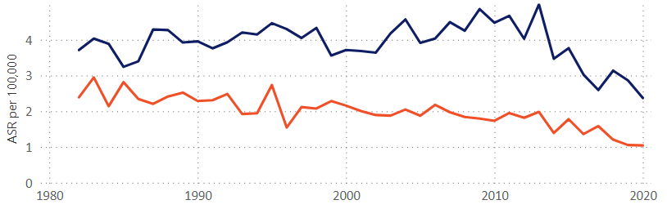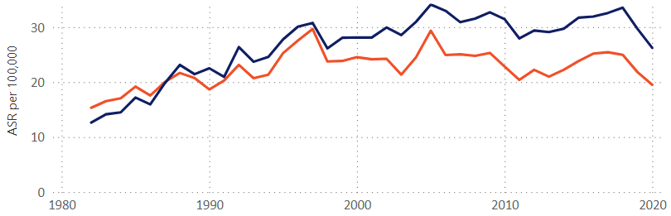
Incidence
Mortality
Source: VCR Data explorer <https://www.cancervic.org.au/research/vcr>
Figure 2: Disparities in melanoma incidence in Victoria, 2018–2020
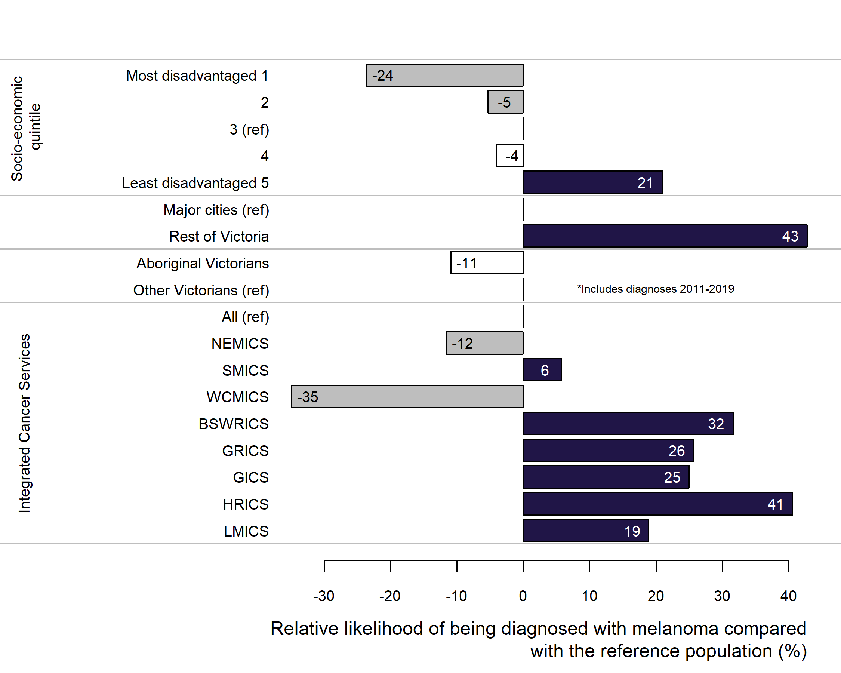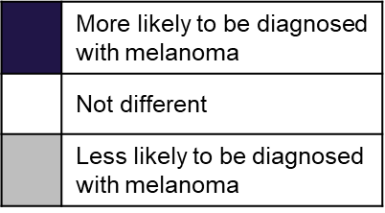
Source: VCR Data explorer <https://www.cancervic.org.au/research/vcr>

Clinical commentary – incidence and mortality
Incidence has been rising until the late 2000s where we’ve started to see a decline. This is likely a result of introducing SunSmart programs 20 to 30 years ago. Mortality has also seen a decline from 2010, which is also likely due to the SunSmart programs as well as advances in immunotherapy and targeted therapies for metastatic disease.
Southern Melbourne and regional areas in Victoria have a higher incidence of melanoma, whereas north-eastern Melbourne and West Central Melbourne have lower incidence. The drivers for this are unclear but contributing factors may include outdoor lifestyles and ethnicity.

Demographics
- From 2018 to 2019, there were 5,910 incident cases of invasive melanoma diagnosed across Victoria (Table 1).
  - The median age at diagnosis was 67 years; 57% were male and less than 1% identified as being Aboriginal.
  - 16% were in the most disadvantaged socioeconomic status (SES) quintile, and most cases (82%) did not have comorbidities.
- There was a significant variation in the SES of melanoma patients between ICS, with more patients in regional ICS belonging to more disadvantaged socioeconomic quintiles (Figure 3).
Table 1: Demographics of Victorians with melanoma
Variable | Level | Median [IQR] or  N (%)
Total | – | 5,910
Age | – | 67 [55–76]
Sex | Male | 3,390 (57%)
Aboriginal | Yes | 25 (< 1%)
Socioeconomic status | Most disadvantaged (Q1) | 963 (16%)
Socioeconomic status | Middle (Q2–Q4) | 3,476 (59%)
Socioeconomic status | Least disadvantaged (Q5) | 1,433 (24%)
Comorbidity count (VAED derived 1 year prior; 1 month after diagnosis; Quan 2011; excl. cancer) | 0 | 4,860 (82%)
Comorbidity count | 1 | 690 (12%)
Comorbidity count | 2+ | 360 (6%)
IQR – interquartile range
Figure 3: Socioeconomic relative disadvantage of Victorians with melanoma, by ICS of residence
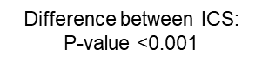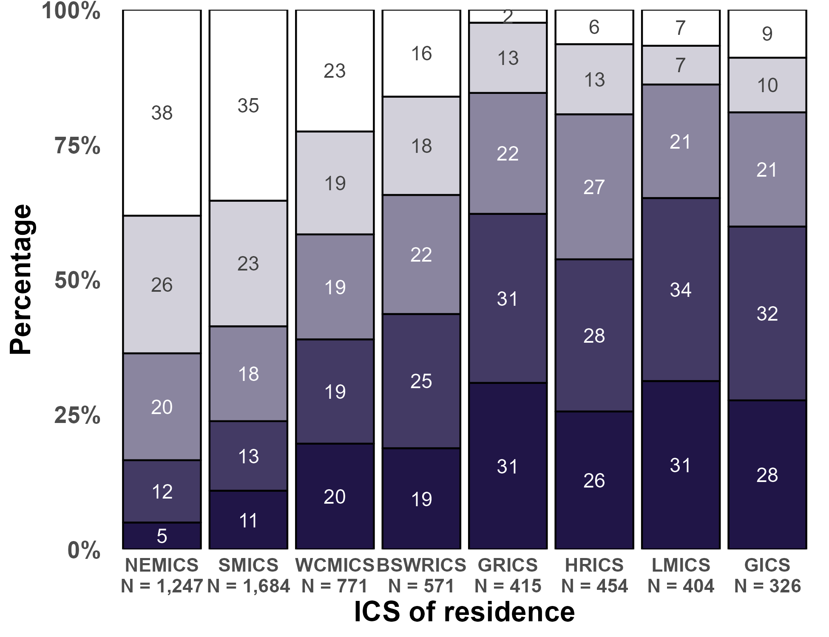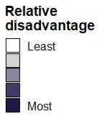
Patients with unknown socioeconomic quintile have been excluded (n = 38).

Clinical commentary – demographics
Melanoma primarily affects late middle-aged Victorians, and slightly more men than women.
There are poorer health outcomes for those from low socioeconomic groups, so it is important to understand where those Victorians are located. Regional areas in Victoria have a higher proportion of disadvantaged patients compared with metropolitan areas.

Tumour characteristics

Melanoma site
- The most common body sites for melanoma were the trunk, upper limb including shoulder and lower limb including hip (Table 2).
  - For females, the upper limb including shoulder was the most common site, whereas for males the trunk was the most common site.
Table 2: Body site of melanoma by sex
ICD-10-AM diagnosis code | Female, n (column %) | Male, n (column %) | Persons, n (column %)
C435: Trunk | 590 (23%) | 1,364 (40%) | 1,956 (33%)
C436: Upper limb, including shoulder | 797 (32%) | 710 (21%) | 1,507 (25%)
C437: Lower limb, including hip | 709 (28%) | 440 (13%) | 1,149 (19%)
C434: Scalp and neck | 125 (5%) | 358 (11%) | 483 (8%)
C433: Other and unspecified parts of face | 189 (8%) | 273 (8%) | 462 (8%)
C439: Skin, unspecified | 60 (2%) | 113 (3%) | 173 (3%)
C432: Ear and external auricular canal | 36 (1%) | 114 (3%) | 150 (3%)
C431: Eyelid, including canthus | 8 (< 1%) | 7 (< 1%) | 15 (< 1%)
C430: Lip | 3 (< 1%) | 8 (< 1%) | 11 (< 1%)
C438: Overlapping skin | 1 (< 1%) | 3 (< 1%) | 4 (< 1%)

Stage at diagnosis
- 76% of Victorians with melanoma were diagnosed with stage I melanoma (Figure 4).
  - A higher percentage of melanoma patients who lived in metropolitan ICS were diagnosed with stage I melanoma compared with those who lived in regional ICS (77–78% versus 72–75%).
- After adjusting for age and sex and when compared with the Victorian average, the likelihood of being diagnosed with stage IV melanoma was significantly lower for residents of SMICS, while it was significantly higher for residents of GICS (Figure 5).
- There was a statistically significant association (p < 0.001) between melanoma stage at diagnosis and SES, where those with greater socioeconomic disadvantage were more likely to be diagnosed with more advanced melanoma (Table 3).
Figure 4: Stage at diagnosis by ICS of residence
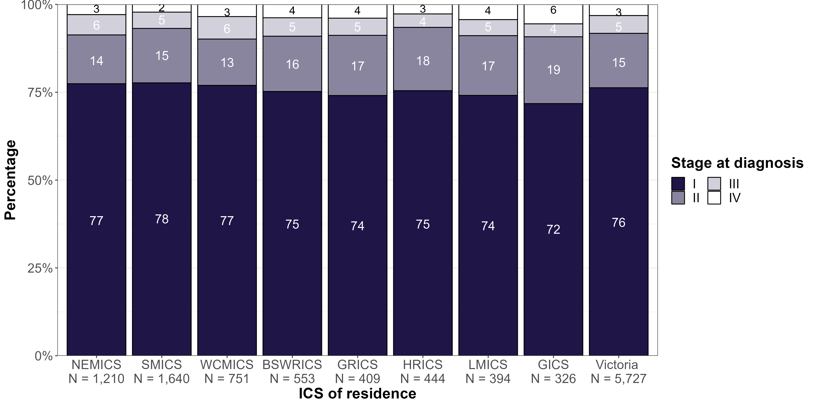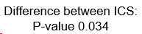
Patients with unknown stage at diagnosis (n = 183, 3%) are excluded.
Figure 5: Logistic regression model for stage IV disease by ICS of residence adjusted for age and sex
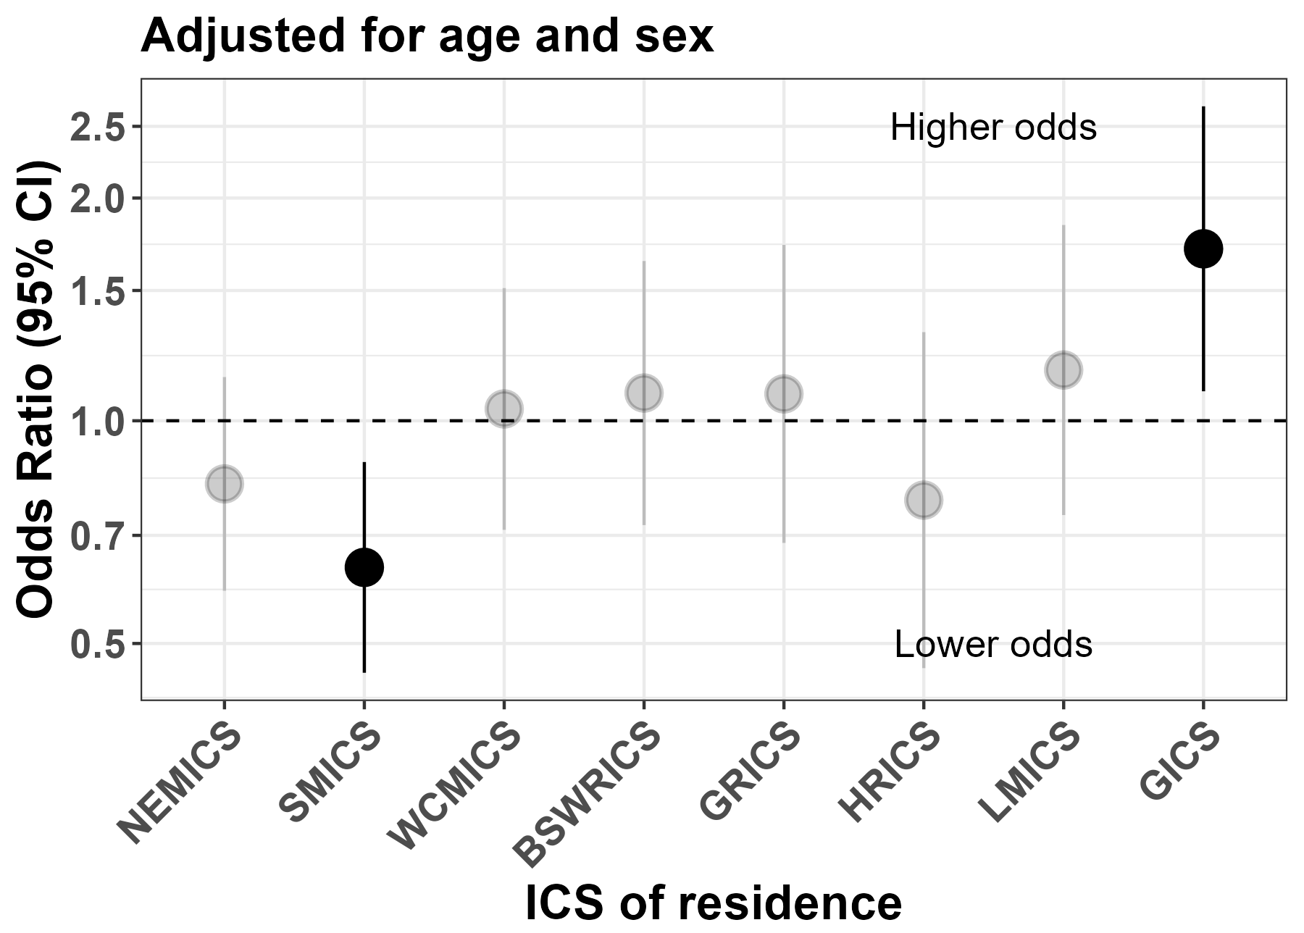
Victorian average = 1.0
Patients with unknown stage at diagnosis (n = 183, 3%) are excluded.
Table 3: Melanoma stage at diagnosis by socioeconomic status (quintile of disadvantage)
Stage at diagnosis | SES 1, N (column %) | SES 2, N (column %) | SES 3, N (column %) | SES 4, N (column %) | SES 5, N (column %)
1 | 632 (68%) | 848 (76%) | 868 (76%) | 888 (80%) | 1,110 (80%)
2 | 206 (22%) | 176 (16%) | 179 (16%) | 142 (13%) | 172 (12%)
3 | 53 (6%) | 61 (5%) | 57 (5%) | 48 (4%) | 69 (5%)
4 | 42 (5%) | 35 (3%) | 42 (4%) | 31 (3%) | 30 (2%)
Patients with unknown stage at diagnosis and unknown socioeconomic quintile are excluded (n = 221, 4%). SES 1 – most disadvantaged quintile, SES 5 – least disadvantaged quintile.

Melanoma thickness
- Most Victorians (53%) who were diagnosed with melanoma had a tumour thickness less than 0.8 mm (Table 4).
- Those living in outer regional and remote areas of Victoria had fewer cases of < 1 mm thick melanomas compared with those in major and inner regional areas (56% versus 61–62%) (Table 5).
- Residents of LMICS and GICS had the lowest percentage of melanomas < 1 mm thick (57%) (Table 6).
- There was a statistically significant association between melanoma thickness and SES where those with greater socioeconomic disadvantage were more likely to be diagnosed with a melanoma ≥ 1 mm thick (Table 7).
Table 4: Thickness of melanoma for Victorians diagnosed with melanoma
Melanoma thickness | N (%)
< 0.8 mm | 3,156 (53%)
≥ 0.8 mm and < 1 mm | 445 (8%)
≥ 1 mm and < 2 mm | 990 (17%)
≥ 2 mm and < 4 mm | 588 (10%)
≥ 4 mm | 420 (7%)
Unknown | 311 (5%)
Table 5: Melanoma thickness by remoteness
Remoteness | < 1 mm thick  n (row %) | ≥ 1 mm thick  n (row %) | Unknown  n (row %) | p-value
Major cities | 2,389 (62%) | 1,286 (33%) | 199 (5%) | 0.238
Inner regional | 992 (61%) | 556 (34%) | 87 (5%) | 0.238
Outer regional and remote | 208 (56%) | 142 (38%) | 24 (6%) | 0.238
Remoteness is defined by the Australian Bureau of Statistics.
Table 6: Melanoma thickness by ICS of residence
ICS of residence | < 1 mm thick  n (row %) | ≥ 1 mm thick  n (row %) | Unknown  n (row %) | p-value
NEMICS | 760 (61%) | 424 (34%) | 67 (5%) | 0.577
SMICS | 1,073 (63%) | 543 (32%) | 78 (5%) | 0.577
WCMICS | 482 (62%) | 251 (32%) | 42 (5%) | 0.577
BSWRICS | 337 (59%) | 204 (35%) | 34 (6%) | 0.577
GRICS | 252 (60%) | 144 (34%) | 23 (5%) | 0.577
HRICS | 279 (61%) | 156 (34%) | 24 (5%) | 0.577
LMICS | 230 (57%) | 152 (37%) | 24 (6%) | 0.577
GICS | 188 (57%) | 124 (37%) | 19 (6%) | 0.577

Table 7: Melanoma thickness by socioeconomic status (quintile of disadvantage)
Melanoma thickness | SES 1,  n (column %) | SES 2,  n (column %) | SES 3,  n (column %) | SES 4,  n (column %) | SES 5,  n (column %) | p-value
< 1 mm | 504 (52%) | 706 (61%) | 711 (60%) | 736 (65%) | 927 (65%) | < 0.001
≥ 1 mm | 403 (42%) | 390 (34%) | 408 (34%) | 345 (30%) | 432 (30%) | < 0.001
Unknown | 56 (6%) | 56 (5%) | 69 (6%) | 55 (5%) | 74 (5%) | < 0.001
Patients with unknown socioeconomic status are excluded (n = 38, < 1%).
SES 1 – most disadvantaged quintile, SES 5 – least disadvantaged quintile.

Ulceration
- 12% of Victorians diagnosed with melanoma had ulceration present (Table 8).
- There was significantly more ulceration for those with a melanoma ≥ 1 mm thick compared with those diagnosed with a melanoma < 1 mm thick (31% versus 2%).
- Approximately half of stage II, III and IV melanoma patients had ulceration present (52%, 43% and 51% respectively).
- There was no significant variation in the presence of ulceration between ICS.
Table 8: Melanoma ulceration by demographic and tumour variables
Variable | Level | Ulceration – absent  n (row %) | Ulceration – present  n (row %) | Ulceration – unknown  n (row %) | p-value
Melanoma thickness | < 1 mm | 3,321 (92%) | 75 (2%) | 204 (6%) | < 0.001
Melanoma thickness | ≥ 1 mm | 1,290 (66%) | 603 (31%) | 69 (4%) | <0.001
Stage at diagnosis | I | 4,045 (93%) | 83 (2%) | 241 (6%) | < 0.001
Stage at diagnosis | II | 408 (46%) | 461 (52%) | 18 (2%) | <0.001
Stage at diagnosis | III | 147 (54%) | 116 (43%) | 8 (3%) | <0.001
Stage at diagnosis | IV | 11 (31%) | 18 (51%) | 6 (17%) | <0.001
ICS of residence | NEMICS | 987 (84%) | 138 (12%) | 50 (4%) | 0.154
ICS of residence | SMICS | 1,340 (84%) | 179 (11%) | 84 (5%) | 0.154
ICS of residence | WCMICS | 605 (83%) | 101 (14%) | 24 (3%) | 0.154
ICS of residence | BSWRICS | 443 (83%) | 62 (12%) | 29 (5%) | 0.154
ICS of residence | GRICS | 314 (80%) | 58 (15%) | 22 (6%) | 0.154
ICS of residence | HRICS | 368 (85%) | 42 (10%) | 25 (6%) | 0.154
ICS of residence | LMICS | 307 (81%) | 51 (13%) | 22 (6%) | 0.154
ICS of residence | GICS | 247 (79%) | 47 (15%) | 17 (5%) | 0.154
Victoria | – | 4,611 (83%) | 678 (12%) | 273 (5%) | –
Unknown melanoma thickness and unknown stage excluded (n = 348)

Clinical commentary – tumour characteristics
In metropolitan areas melanoma patients are presenting with earlier stage disease. This may be related to better access to GPs, skin cancer clinics and dermatologists, and/or higher health literacy. During the Melanoma 2022 Summit, regional participants spoke of lengthy delays in accessing GPs and a lack of dermatologists in many regional areas.
Although not statistically significant, there were more Victorians living in major cities and inner regional areas diagnosed with melanomas < 1 mm thick compared with those living in outer regional and remote areas. Again, this may be related to access to health care and health literacy.
Victorians with higher socioeconomic disadvantage presented with higher stage disease and thicker melanomas. This is a significant unwarranted variation, and work is needed to reduce this variation.

Multidisciplinary meeting
- The CSPI 2018 and 2020 medical record audits showed 37% and 40% of patients audited had documented evidence of an MDM, respectively (Figure 6).
  - For both periods, there was large variation across metropolitan and regional health services, with rates ranging from 0% to 100%.
  - In the 2020 CSPI audit, melanoma MDM rates (40%) were lower than other tumour streams, including lung cancer (74%), breast cancer (85%) and colorectal cancer (76%) (refer to the 2020 CSPI report).
- The CSPI medical record audits showed a decrease in MDM documentation that recorded tumour stage at diagnosis from 83% in 2018 to 56% in 2020 (Figure 7).
  - In the 2020 CSPI audit, recording of tumour stage in MDM documentation for melanoma (56%) was lower than other tumour streams, including lung cancer (73%), breast cancer (83%) and colorectal cancer (80%) (refer to the 2020 CSPI report).
Figure 6: Percentage of melanoma patients with documented evidence of an MDM in their medical record, by ICS of health service
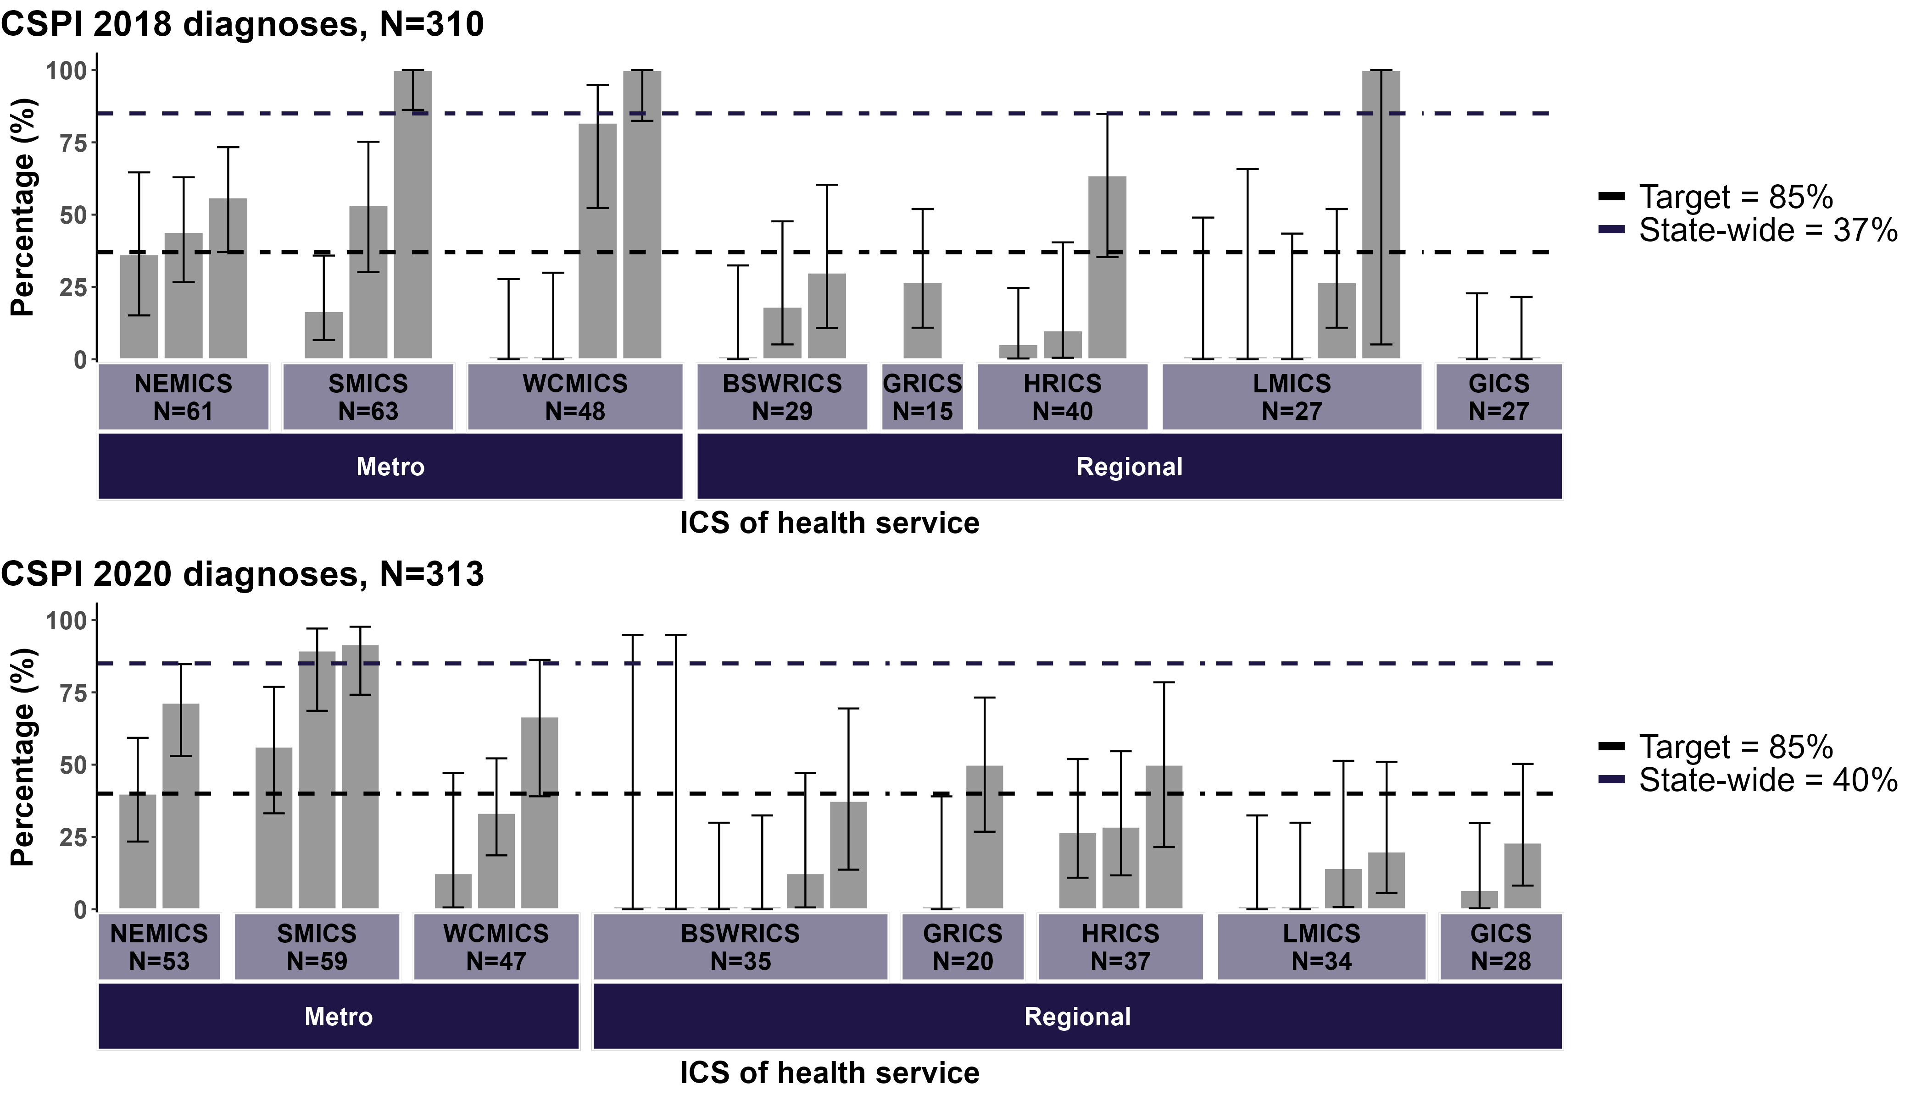
De-identified health service
Source: CSPI medical record audit 2018 and 2020
Bars represent 95% confidence interval (CI).
HRICS data limitation – missing data from Albury Wodonga Health – Albury campus
Figure 7: Percentage of melanoma patients presented at an MDM who had stage at diagnosis recorded in MDM documentation by ICS of health service
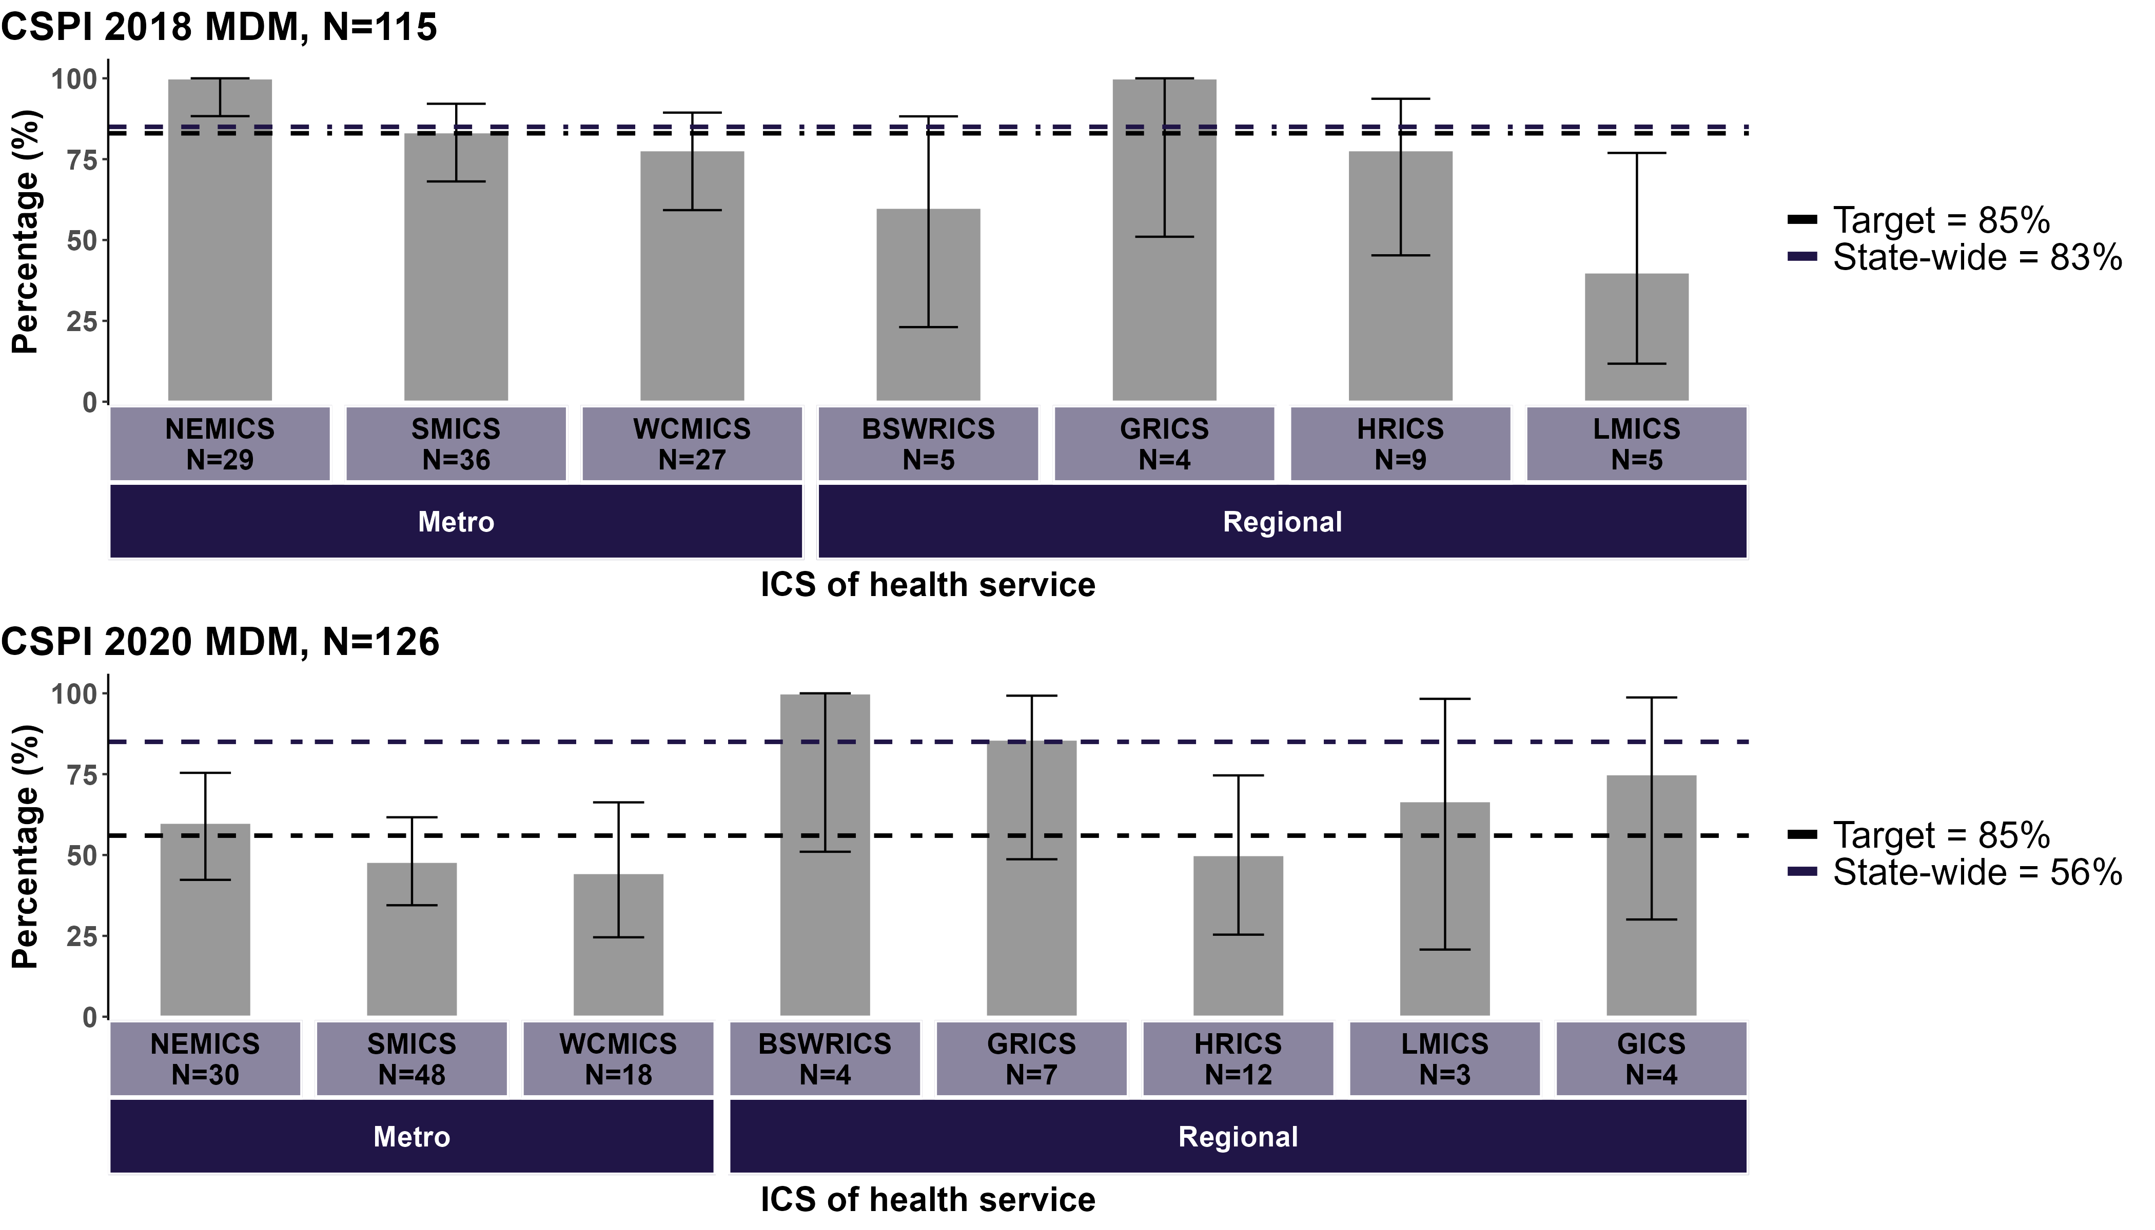
Multiple ICS health services
Source: CSPI medical record audit 2018 and 2020
Bars represent 95% CI.
HRICS data limitation – missing data from Albury Wodonga Health – Albury campus
Patients were classified as ‘presented at an MDM’ if there was MDM documentation in the patient’s health record.

Clinical commentary – multidisciplinary meeting
Documenting MDM recommendations in the medical record ensures this information is accessible to all members of the healthcare team. The target of 85% aims to drive quality improvement and equity of access to MDMs and applies to all tumour streams. This target needs to be discussed in the context of melanoma because it may be less appropriate or feasible to present 85% of thin, straightforward melanomas to MDMs.
For the MDM metric, melanoma has not performed as well as other tumour streams. There has been no improvement in rates between 2018 and 2020. Further, there has been a decrease in the recording of stage in MDM documentation between 2018 and 2020, possibly impacted by the COVID-19 pandemic increasing time pressures on health workers. Rates of recording stage were also much less for melanoma than for other tumour streams.
At the Melanoma 2022 Summit, consumers advocated for the outcomes of MDMs to be communicated to patients in the form of a written care plan. There should also be communication of MDM documentation back to GPs who are providing ongoing support to patients.
IT and digital platforms are a possible solution for the issues around poor documentation of MDMs. Care plans for patients and GPs could be automated and uploaded to the patient’s My Health Record.
At the Melanoma Summit, attendees spoke of partnerships between metropolitan and regional centres for melanoma MDMs. This is a great initiative to support and upskill regional teams. There were also suggestions of creating a forum where melanoma MDM chairs from across Victoria meet and discuss what information they are providing to patients and their GPs and share MDM templates so care is standardised across the state.

Treatment

Utilisation
- A total of 3,456 Victorians were diagnosed with a melanoma < 1 mm thick (excluding residents of HRICS Border East).
  - 47% of patients had an excision surgery while admitted to a Victorian hospital (Table 9).
  - Patients who lived in BSWRICS, GRICS and HRICS West had significantly less admitted excision surgeries than the Victorian average, whereas patients who lived in the GICS had significantly more admitted surgeries.
  - 5% of patients had an SLNB and there was no significant variation observed between ICS.
  - No treatment was identified in the linked dataset for 52% of patients. This percentage was significantly higher for patients living in BSWRICS, GRICS and HRICS West and significantly lower for patients living in GICS compared with the state average.
- A total of 1,854 Victorians were diagnosed with a melanoma ≥ 1 mm thick (excluding residents of HRICS Border East).
  - 82%, 53% and 10% of patients had an excision surgery while admitted to a Victorian hospital, an SLNB and received intravenous anticancer therapy respectively.
  - After adjusting for age, sex and comorbidities and when compared with the Victorian average, patients living in SMICS had significantly more admitted surgeries, patients living in LMICS had significantly fewer admitted surgeries and significantly less intravenous anticancer therapy. Patients living in WCMICS had significantly more SLNBs (Figure 8).
Table 9: Admitted surgery within one year of diagnosis for melanomas < 1 mm thick, by ICS of residence
ICS of residence | Total patients, N | Excision surgery in hospital, N (%) | SLNB, N (%) | No treatment identified in linked data, N (%)
NEMICS | 759 | 378 (50%) | 34 (4%) | 374 (49%)
SMICS | 1,072 | 498 (46%) | 47 (4%) | 569 (53%)
WCMICS | 482 | 247 (51%) | 26 (5%) | 233 (48%)
BSWRICS | 337 | 134 (40%)# | 19 (6%) | 198 (59%)^
GRICS | 252 | 101 (40%)# | 13 (5%) | 148 (59%)^
HRICS (West) | 136 | 51 (38%)# | 5 (4%) | 85 (62%)^
LMICS | 230 | 113 (49%) | 6 (3%) | 115 (50%)
GICS | 188 | 109 (58%)^ | 9 (5%) | 78 (41%)#
Victoria | 3,456 | 1,631 (47%) | 159 (5%) | 1,800 (52%)
HRICS data limitations – patients who live in HRICS (Border East) excluded due to missing treatment data (n = 143). ^ Above the Victorian average (p < 0.05) (shaded darker blue). # Below the Victorian average (p < 0.05) (shaded lighter blue).
Figure 8: Odds of treatment within one year of diagnosis of a ≥ 1 mm melanoma adjusted for age, sex and comorbidities
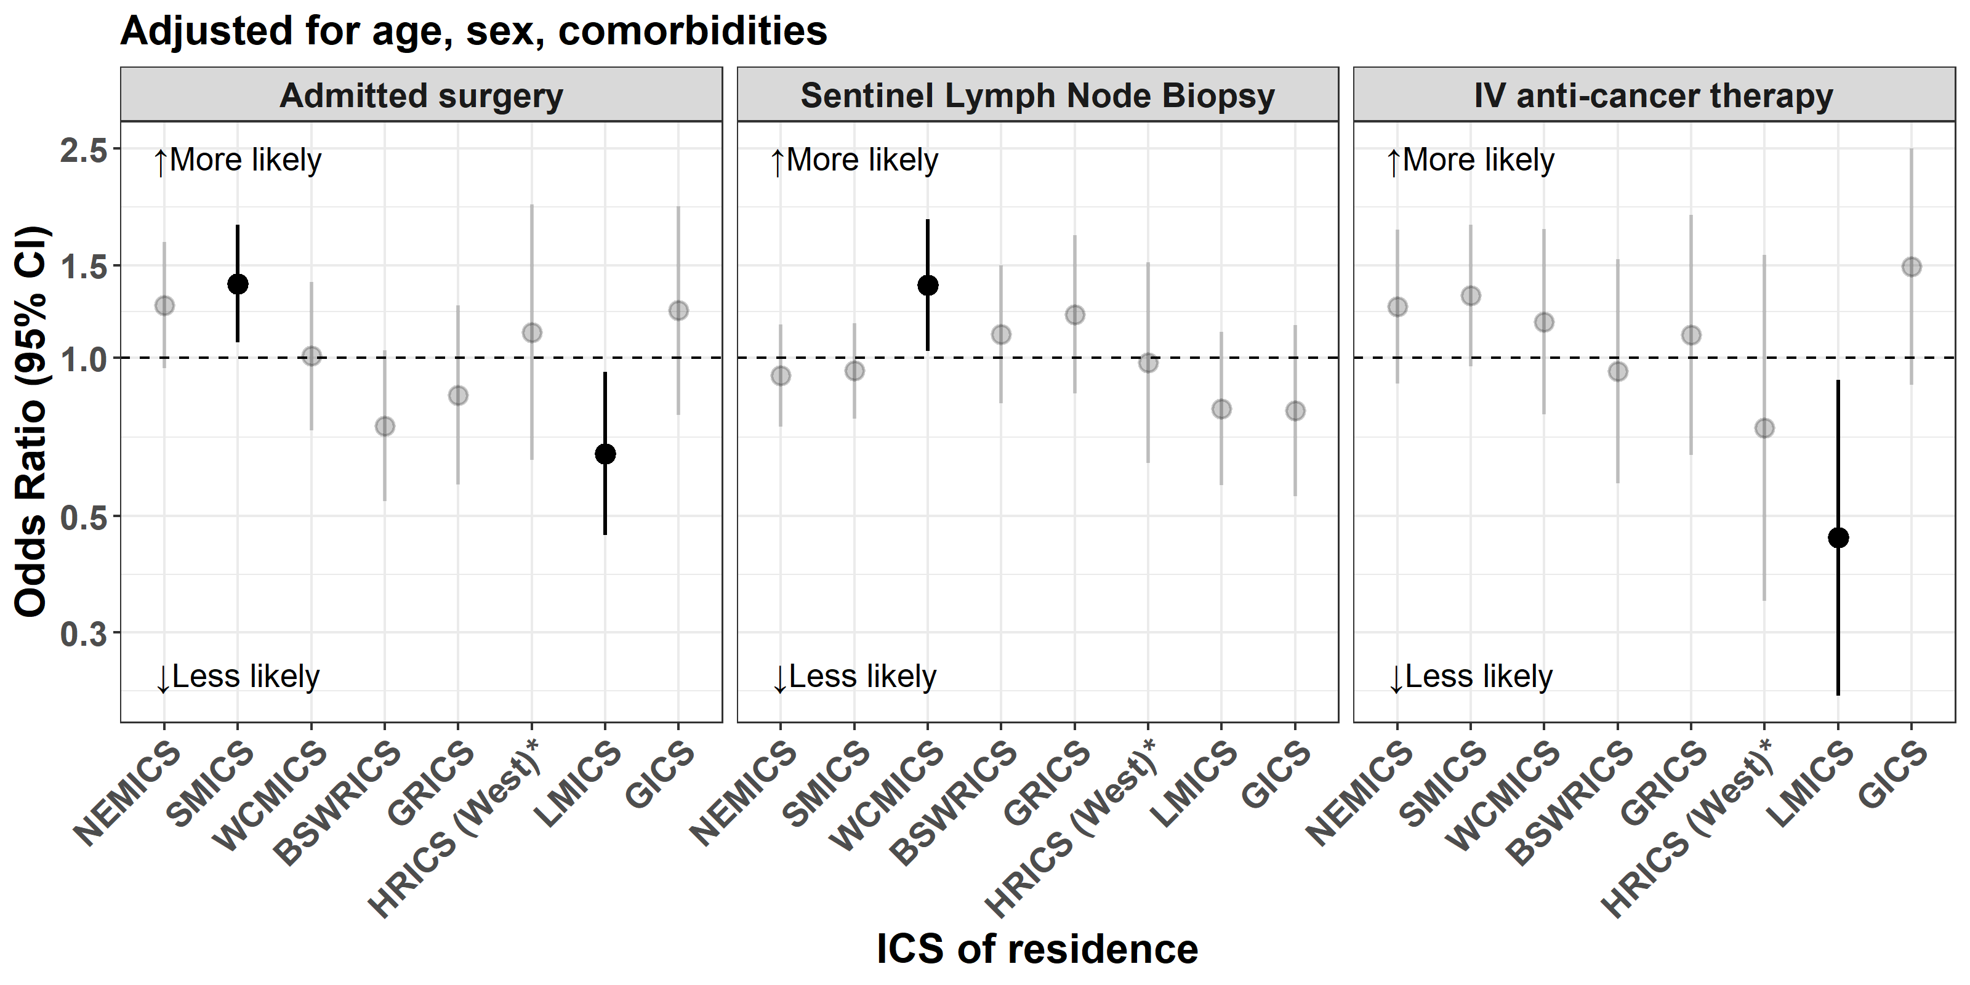
HRICS data limitations – patients who live in HRICS (Border East) excluded due to missing treatment data (n = 74).

Clinical commentary – utilisation
We expect most melanomas < 1 mm thick to be treated outside the hospital setting, which is what we see here. It is difficult to interpret the differences in admitted surgery rates between ICS without having access to linked GP data. It may be that those ICS with lower admitted surgical rates have more melanomas resected in primary care and that those with higher rates have fewer melanoma resected in primary care. Indeed, there is a pattern of less treatment identified overall for the ICS with lower admitted surgical rates, suggesting that a significant portion of patient care may occur outside of the acute setting captured in the current available datasets.
Similarly, we do not currently have complete access to anticancer therapy data, and differences seen between ICS may be due to differences in prescribing of oral anticancer therapies.
Interestingly, patients living in WCMICS were more likely to undergo an SLNB, but it is unclear why this may be.

Timeliness of treatment
- Of those diagnosed with a melanoma < 1 mm thick and who had an admitted surgery:
  - The median time between receiving a diagnosis and having surgery was 24 days.
  - 59% and 92% had an admitted surgery within four weeks (28 days) and eight weeks (56 days) of their diagnosis date respectively (Figure 9).
  - Those having surgery in NEMICS and SMICS were significantly more likely to have it within four weeks, as well as within eight weeks, of their diagnosis date compared with the Victorian average.
  - Patients having surgery in WCMICS and HRICS were significantly less likely to have it within four weeks of their diagnosis date compared with the Victorian average. Those having surgery in WCMICS were also significantly less likely to have it within eight weeks of their diagnosis date.
- Of those diagnosed with a melanoma ≥ 1 mm thick and who had an admitted surgery:
  - The median time between receiving a diagnosis and having surgery was 28 days.
  - 51% and 91% had an admitted surgery within four weeks (28 days) and eight weeks (56 days) of their diagnosis date respectively (Figure 9).
  - Those having surgery in NEMICS, BSWRICS and HRICS were significantly more likely to have it within four weeks of their diagnosis date compared with the Victorian average.
  - Those having surgery in WCMICS were significantly less likely to have it within four weeks, as well as eight weeks, of their diagnosis date compared with the Victorian average.
- For patients who had an admitted surgery and an SLNB:
  - The median time between receiving a diagnosis and having an admitted surgery was 31 days.
  - 44% and 91% had an admitted surgery within four weeks (28 days) and eight weeks (56 days) of their diagnosis date respectively (Figure 10).
  - Those having surgery in NEMICS, SMICS and BSWRICS were significantly more likely to have it within four weeks of their diagnosis date compared with the Victorian average.
  - Those having surgery in LMICS were significantly more likely to have it within eight weeks compared with the Victorian average.
  - Those having surgery in WCMICS were significantly less likely to have it within four weeks, as well as eight weeks of their diagnosis date, compared with the Victorian average.
- For patients who had an admitted surgery and did not have an SLNB:
  - The median time between receiving a diagnosis and having an admitted surgery was 23 days.
  - 60% and 92% had an admitted surgery within four weeks (28 days) and eight weeks (56 days) of their diagnosis date respectively (Figure 10).
  - Those having surgery in NEMICS and GICS were significantly more likely to have it within four weeks of their diagnosis date compared with the Victorian average.
  - Those having surgery at NEMICS and SMICS were significantly more likely to have it within eight weeks of their diagnosis date compared with the Victorian average.
  - Those having surgery at WCMICS were significantly less likely to have it within four weeks, as well as eight weeks, of their diagnosis date compared with the Victorian average.
- Patients who were treated at a public hospital were significantly less likely to have undergone surgery at four and eight weeks after their diagnosis date compared with the Victorian average. The opposite was observed for patients treated at a private hospital (Table 10).
- There was significant variation between surgical hospitals in the proportion of patients who had surgery within eight weeks of their diagnosis date (Figure 11). Sixty-five hospitals were significantly above the state average and three hospitals were significantly below the state average.
Figure 9: Time from diagnosis to admitted surgery, by melanoma thickness and ICS of surgical hospital
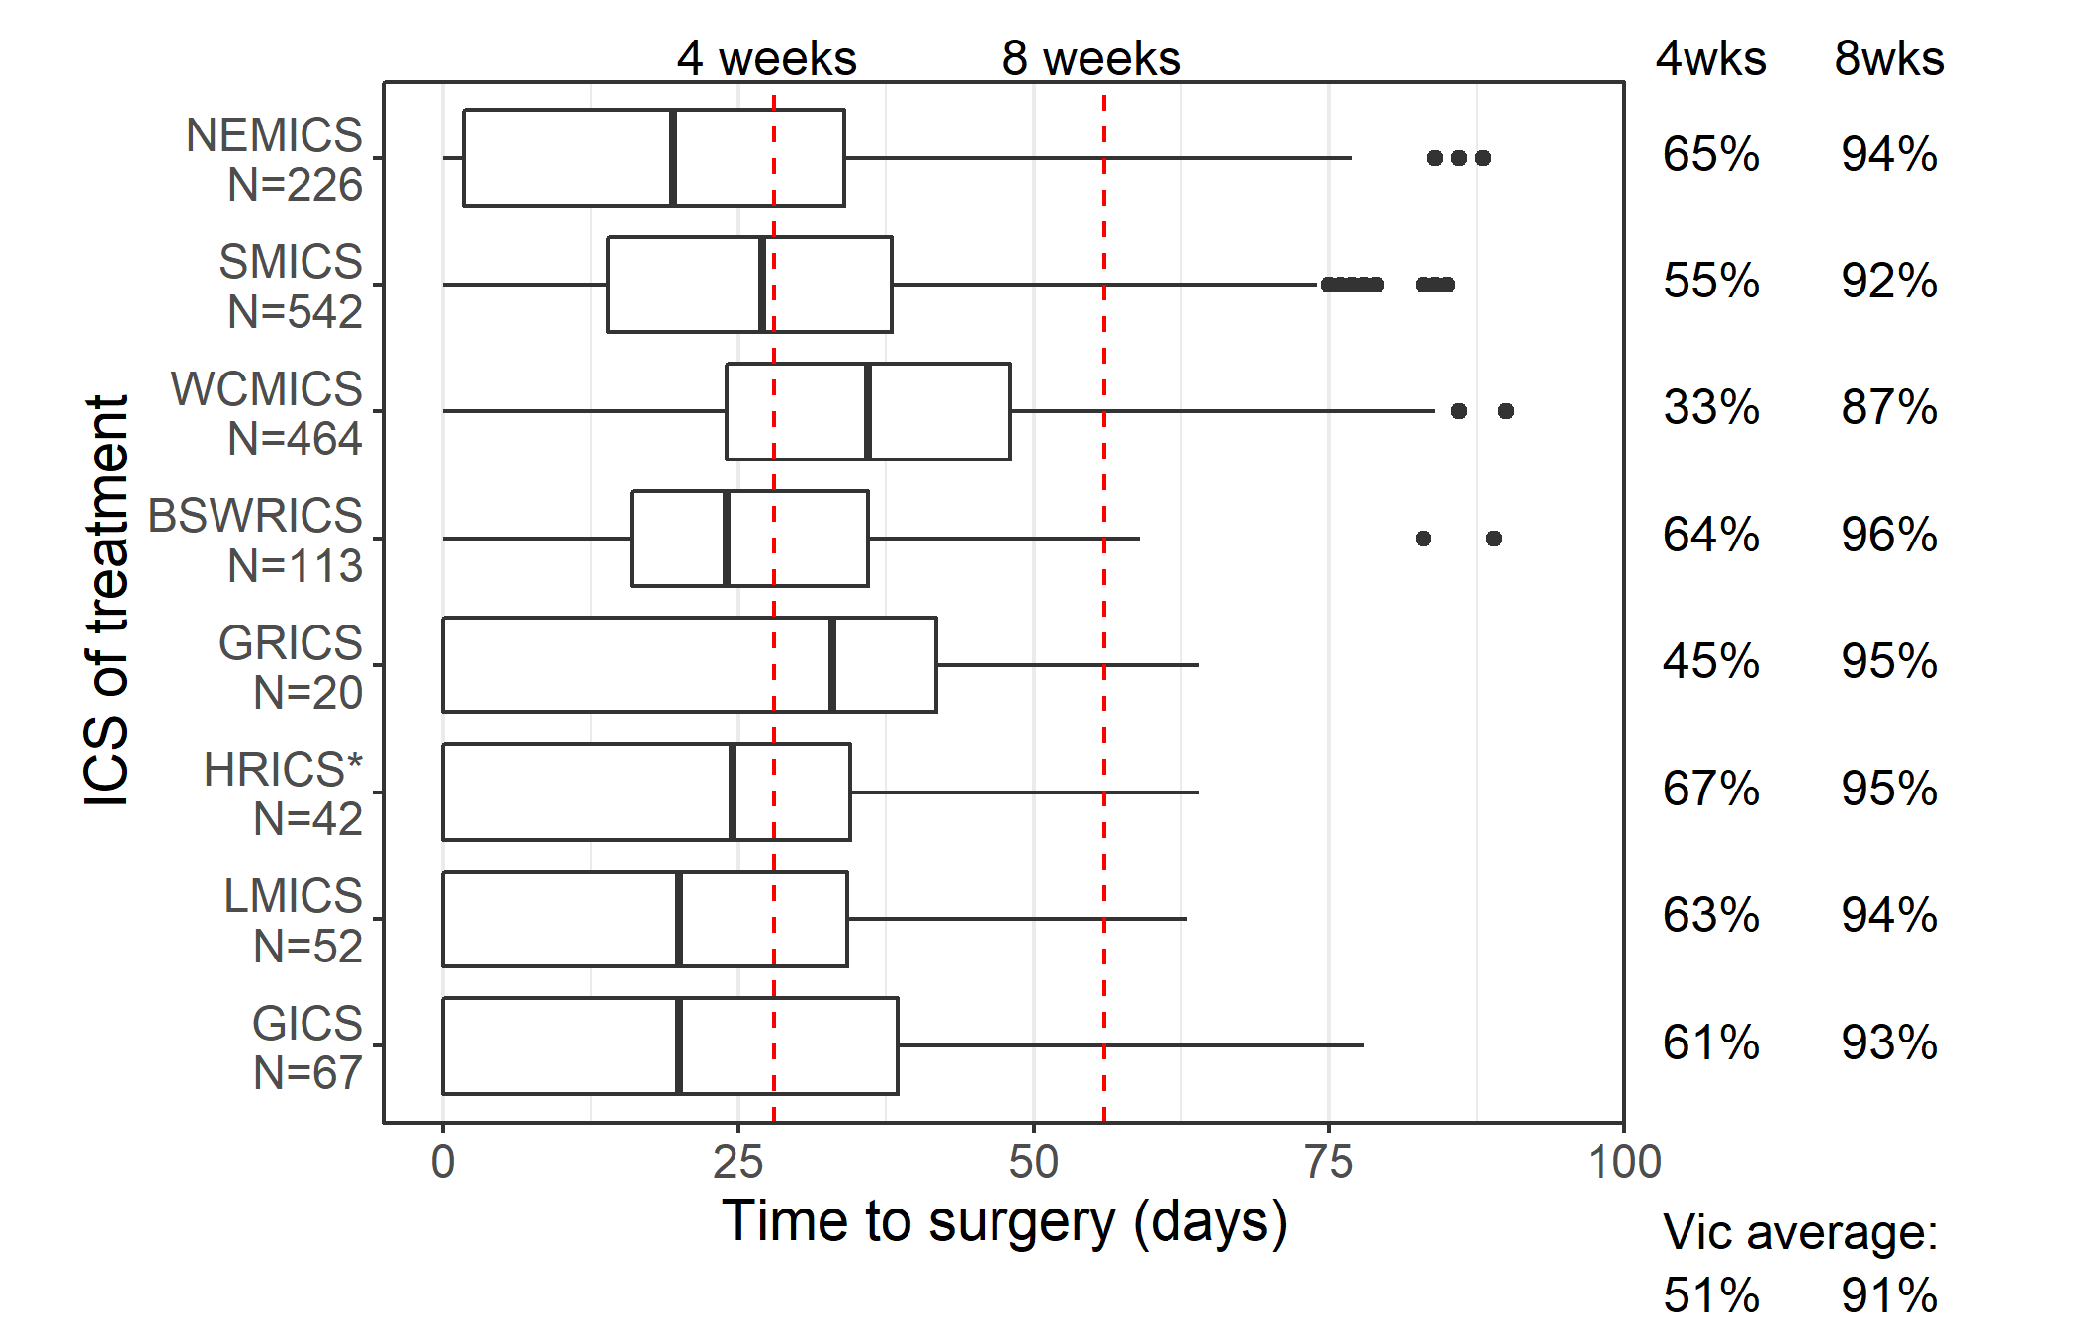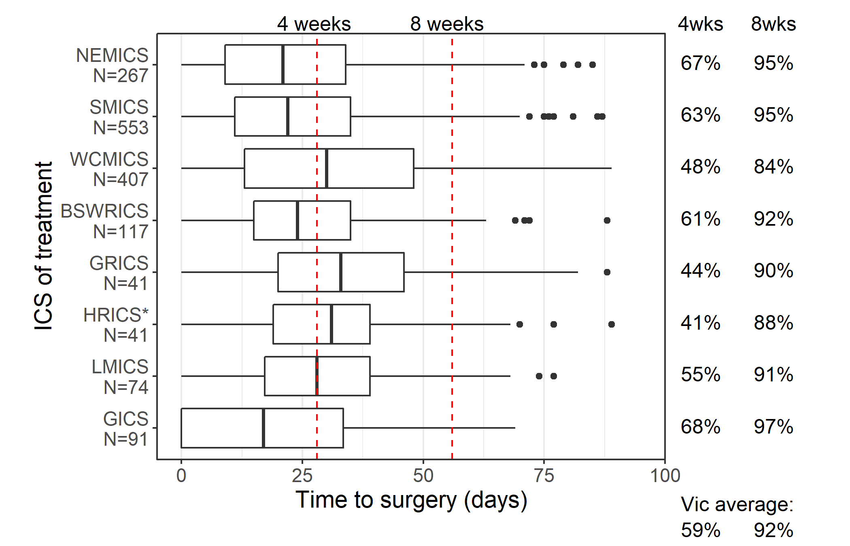
Above Victorian average p < 0.05
Below Victorian average p < 0.05
Restricted to surgery in hospital within 90 days of diagnosis and excluding stage IV melanomas.
HRICS data limitation – missing data from Albury Wodonga Health – Albury campus.
Figure 10: Time from diagnosis to admitted surgery, by SLNB and ICS of treatment
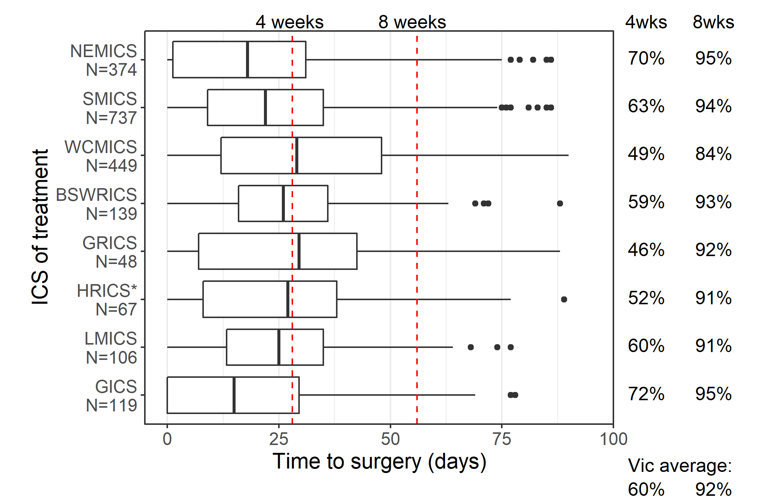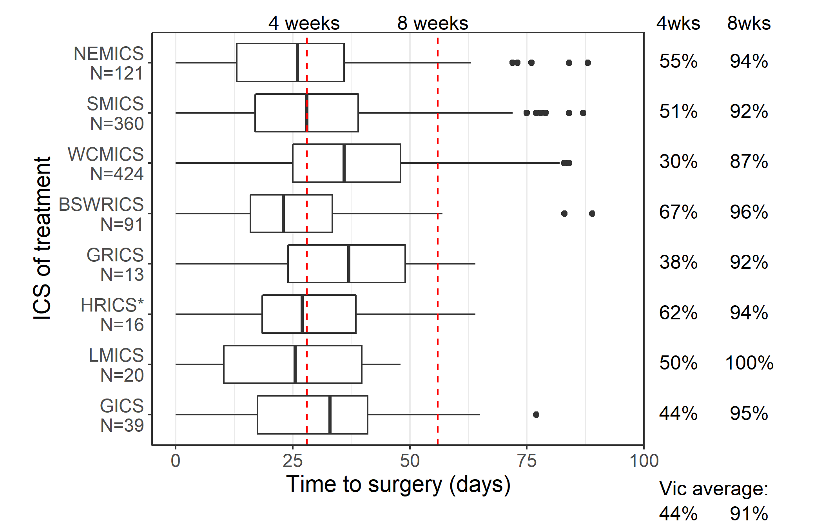
Above Victorian average p < 0.05
Below Victorian average p < 0.05
Restricted to surgery in hospital within 90 days of diagnosis and excluding stage IV melanomas.
HRICS data limitation – missing data from Albury Wodonga Health – Albury campus.
Table 10: Admitted surgery within four and eight weeks of stage I–III melanoma diagnosis, by hospital type
Hospital type | Admitted surgery within four weeks  n (%) | Admitted surgery within eight weeks  n (%)
Public, N = 1,488 | 476 (32%)# | 1,274 (86%)#
Private, N = 1,635 | 1,236 (76%)^ | 1,581 (97%)^
Victoria | 1,712 (55%) | 2,855 (91%)
Restricted to those treated with surgery in hospital within 90 days of diagnosis.
^ Above the Victorian average (p < 0.05) (shaded darker blue). # Below the Victorian average (p < 0.05) (shaded lighter blue).
Figure 11: Admitted surgery within eight weeks of stage I–III melanoma diagnosis, by hospital
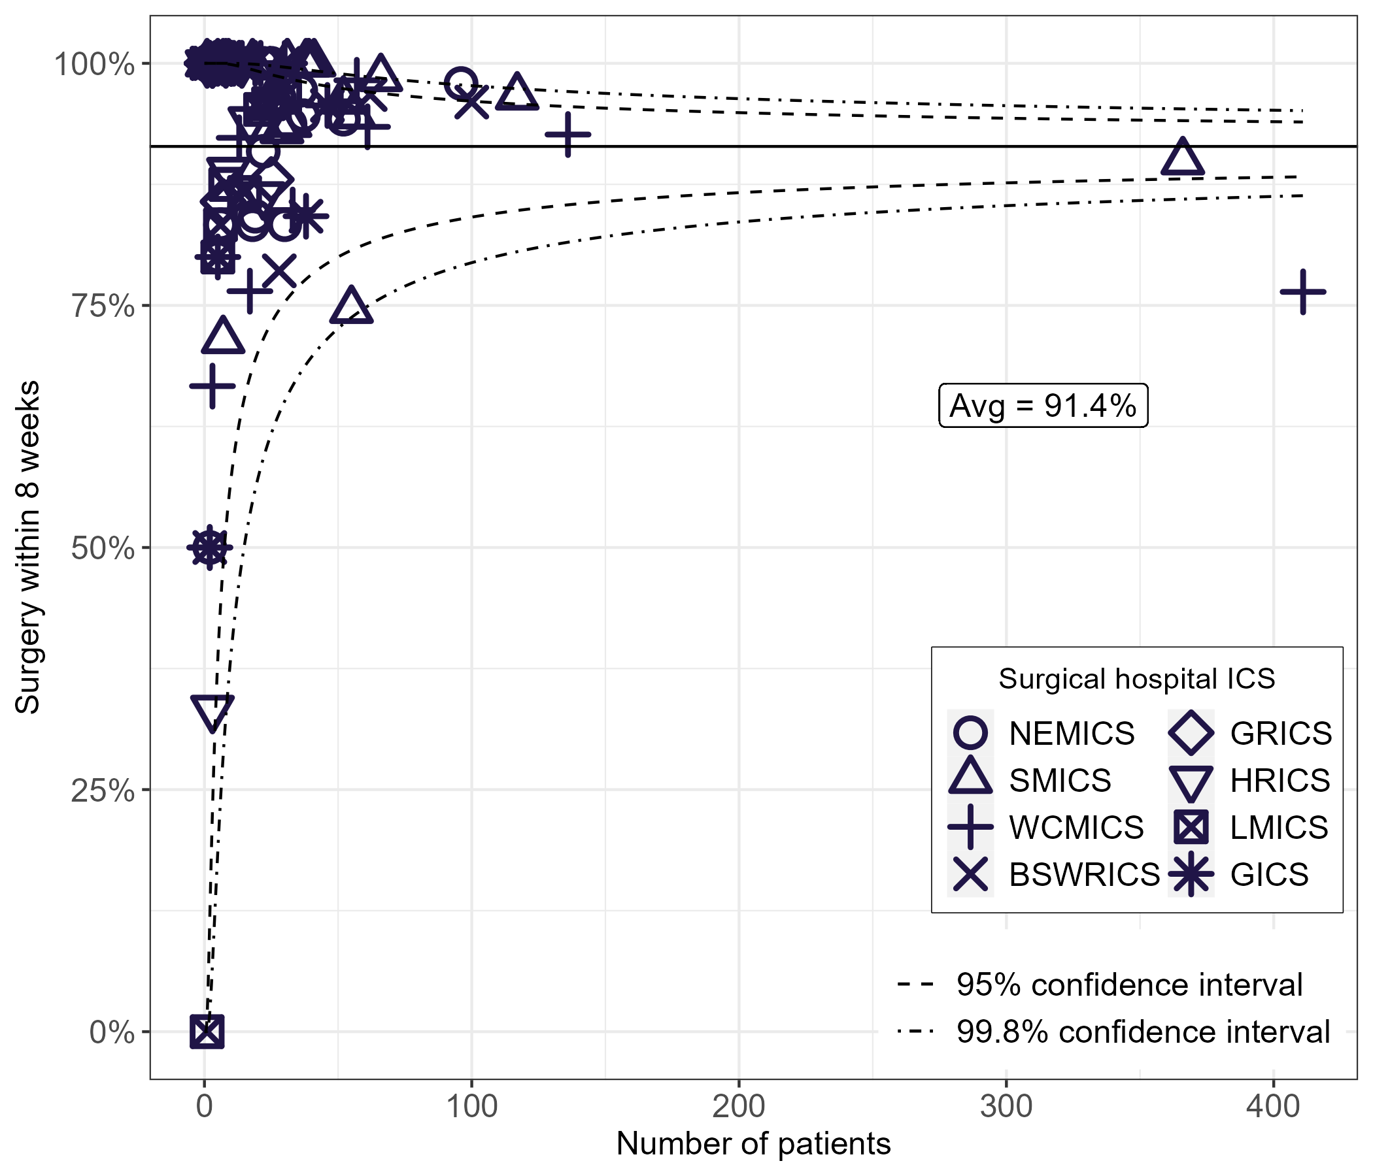
Restricted to those treated with surgery in hospital within 90 days of diagnosis
HRICS data limitation – missing data from Albury Wodonga Health – Albury campus

Clinical commentary – timeliness
The optimal care pathway for melanoma states that surgery in primary care should occur within two weeks of diagnosis. There is no recommendation for admitted surgery, so the working party deemed it appropriate to assess time to admitted surgery at four and eight weeks following diagnosis.
Private hospitals are treating patients with surgery more quickly than public hospitals. This is not surprising. However, further investigation is needed to determine why there are three hospitals that have significantly fewer patients undergoing surgery within eight weeks of their diagnosis compared with the rest of the state. Notably WCMICS is below the state average at four and eight weeks for both thickness groups and by those who did and didn’t have an SLNB.

Patient flow
- 65% of stage I–III melanoma patients received an admitted surgery within their local ICS. This ranged from 28% in GRICS to 82% in BSWRICS (Table 11).
- BSWRICS, SMICS, GICS had significantly more patients having an admitted surgery locally whereas NEMICS, LMICS, HRICS and GRICS had significantly fewer patients having an admitted surgery locally compared with the Victorian average (Figure 12).
- 51% of stage I–III melanoma patients received an SLNB within their local ICS. This ranged from 15% in GRICS to 73% in BSWRICS (Table 12).
- BSWRICS, SMICS and WCMICS had significantly more patients having an SLNB locally, whereas NEMICS, LMICS, HRICS and GRICS had significantly fewer patients having an SLNB locally compared with the Victorian average (Figure 13).
Table 11: Patient flow for stage I–III melanoma admitted surgery
ICS of treatment (down) / ICS of residence (across) | NEMICS | SMICS | WCMICS | BSWRICS | GRICS | HRICS | LMICS | GICS
NEMICS | 377  (54%) | 24  (3%) | 49  (12%) |  | 19  (9%) | 15  (8%)
SMICS | 129  (18%) | 741 (81%) | 75  (18%) | 26  (10%) | 57  (28%) | 31  (16%) | 25  (12%) | 13 (6%)
WCMICS | 191  (27%) | 152 (17%) | 292  (70%) | 19  (7%) | 73  (35%) | 64  (33%) | 54  (25%) | 28 (14%)
BSWRICS |  |  |  | 221  (82%)
GRICS |  |  |  |  | 58  (28%)
HRICS |  |  |  |  |  | 79  (41%)
LMICS |  |  |  |  |  |  | 119 (56%)
GICS |  |  |  |  |  |  |  | 150 (74%)
Victoria | 697 (100%) | 917 (100%) | 416 (100%) | 266 (100%) | 207 (100%) | 189 (100%) | 198 (100%) | 191 (100%)
HRICS data limitation – missing data from Albury Wodonga Health – Albury campus.
Cells with < 10 removed (n = 42).
Figure 12: Admitted surgery at local ICS for stage I–III melanoma patients by ICS of residence
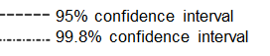
HRICS data limitation – missing data from Albury Wodonga Health – Albury campus.
Table 12: Patient flow for stage I–III melanoma SLNB
ICS of treatment (down) / ICS of residence (across) | NEMICS | SMICS | WCMICS | BSWRICS | GRICS | HRICS | LMICS | GICS
NEMICS | 86  (35%) |  | 12  (7%) |  |  | 8  (11%)
SMICS | 44  (18%) | 220  (69%) | 37  (22%) | 15  (12%) | 25  (27%) | 10  (14%) | 10  (13%) | 9  (13%)
WCMICS | 114  (47%) | 90  (28%) | 123  (72%) | 17  (13%) | 50  (53%) | 42  (57%) | 37  (49%) | 21  (31%)
BSWRICS |  |  |  | 93  (73%)
GRICS |  |  |  |  | 14  (15%)
HRICS |  |  |  |  |  | 12  (16%)
LMICS |  |  |  |  |  |  | 21  (28%)
GICS |  |  |  |  |  |  |  | 34  (50%)
Victoria | 244  (100%) | 310  (100%) | 172  (100%) | 125  (100%) | 89  (100%) | 72  (100%) | 68  (100%) | 64  (100%)
HRICS data limitation – missing data from Albury Wodonga Health – Albury campus.
Cells with < 10 removed (n = 42).
Figure 13: SLNB at local ICS for stage I–III melanoma patients by ICS of residence
HRICS data limitation – missing data from Albury Wodonga Health – Albury campus.

Clinical commentary – patient flow
Victorians with melanoma who live in SMICS, WCMICS and BSWRICS tend to have surgery and SLNBs locally, whereas those living in other ICS travel for their treatment. There are many patients flowing into WCMICS and, to a degree, SMICS for their treatment.
Interestingly when we compare melanoma SLNB patient flow with breast cancer SLNB patient flow (data not shown), there was a difference because most patients with breast cancer had an SLNB locally – both for regional and metropolitan ICS. Further investigations are needed to understand this difference.
Clear and streamlined referral pathways within each ICS could ensure patients are travelling less to appointments and for treatment. Many summit attendees commented on how important it is to have patients treated in their local areas, particularly for regional patients who may be unnecessarily sent to a metropolitan area for a procedure that may be relative straightforward and available locally. If patients receive treatment closer to home, they have an accessible local support network of family and friends. It is important for patients to have a well-known point of contact in regional settings.

Sentinel lymph node biopsy (SLNB) volume
- Between 2020 and 2021 there were 41 public hospitals and 40 private hospitals in Victoria performing SLNBs (Figure 14).
- The median annual number of SLNBs performed was 24 for public hospitals and 32 for private hospitals.
- The average annual hospital volume ranged from one SLNB to 350 SLNB.
- The number of hospitals in each ICS performing SLNB ranged from four hospitals in GICS to 18 hospitals in SMICS.
- Overall, 12% of SLNB performed in Victoria were for patients with a melanoma diagnosis, followed by 78% for other cancers and 9% for non-cancer diagnoses.
Figure 14: SLNB hospital volume in Victoria, 2020–2021
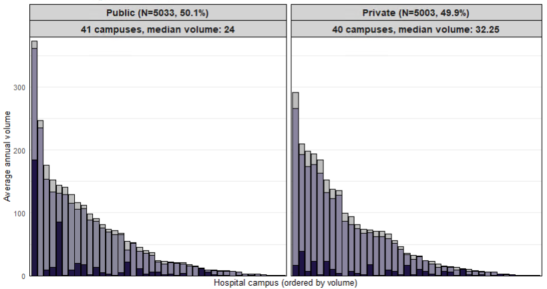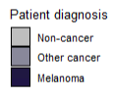
Source: VAED only
HRICS data limitation – missing data from Albury Wodonga Health – Albury campus.

Clinical commentary –SLNB volume
Hospitals that perform low volumes of surgery are concerning, though not necessarily reflecting a lack of facility or clinician expertise. It does raise issues of whether there are differential experiences in terms of where people are being treated.
We can see there are many hospitals in each ICS performing SLNB. This raises further questions as to why more melanoma patients are not receiving an SLNB locally if the capability exists.

Supportive care
- Across the 24 and 25 hospitals audited in 2018 and 2020 respectively, the overall percentage of patients with documented evidence of supportive care screening was 17% and 12%, with a significant variation observed between health services (Figure 15).
- In the 2020 CSPI audit, melanoma supportive care screening rates (12%) were lower than other tumour streams including lung cancer (50%), breast cancer (47%) and colorectal cancer (25%) (refer to the CSPI 2020 report).
Figure 15: Proportion of melanoma patients with documented evidence of supportive care screening in their medical record, by ICS and campus of treatment, 2018 and 2020
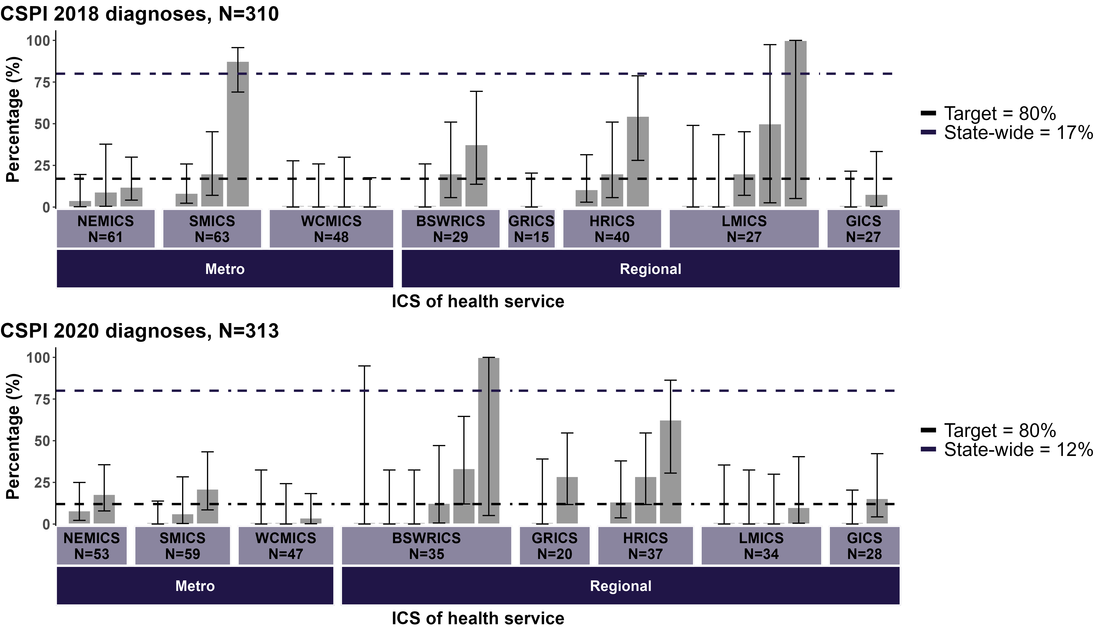
De-identified health service
Source: CSPI medical record audit 2018 and 2020
Bars represent 95% CI.
HRICS data limitation – missing data from Albury Wodonga Health – Albury campus.

Clinical commentary – supportive care
Supportive care addresses a wide range of needs across the continuum of care for those affected by cancer. Supportive care screening is an important part of comprehensive cancer care. The measure of documented evidence of screening for supportive care needs is set at 80% to drive quality improvement and equity of access to supportive care services. The target applies to all tumour streams.
Uptake of supportive care screening is low, with the 2020 statewide average of 12%, well below the target of 80%. This may be an underestimate of the actual amount of screening, since the 12% figure is based on finding written evidence of the use of a validated supportive care screening tool; an inability to find documentation is counted as ‘not screened’. Nevertheless, melanoma supportive care screening is well below many other tumour streams such as breast, lung and colorectal cancer.
One solution to low screening rates may be more care coordinators. Care coordinators are invaluable at supportive care screening, and an increase in these roles may improve screening rates across hospitals.
At the Melanoma 2022 Summit attendees from one metropolitan hospital reported providing information packs to melanoma patients following a diagnosis. If possible, this information pack should be presented to all patients, particularly regional patients, because it includes information about supportive care and how to access various services.

Survival
- The statewide five-year relative survival for melanoma was 93% (Figure 16).
- Those who were less socioeconomically disadvantaged, living in SMICS and were born overseas had better survival compared with the Victorian average.
- Those who were the most socioeconomically disadvantaged and born in Australia had poorer survival compared with the Victorian average.
- The survival of Aboriginal Victorians was 84%, 9% lower than the Victorian average.
- As shown in Figure 17, after adjusting for age, sex and comorbidities and when compared with the Victorian average, survival for:
  - stage I patients was significantly poorer in LMICS
  - stage II patients was significantly better in HRICS
  - stage III and stage IV patients was similar between ICS.
Figure 16: Disparities in five-year relative survival for melanoma, 2015–2019
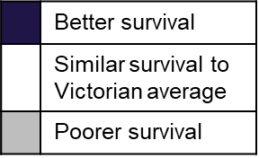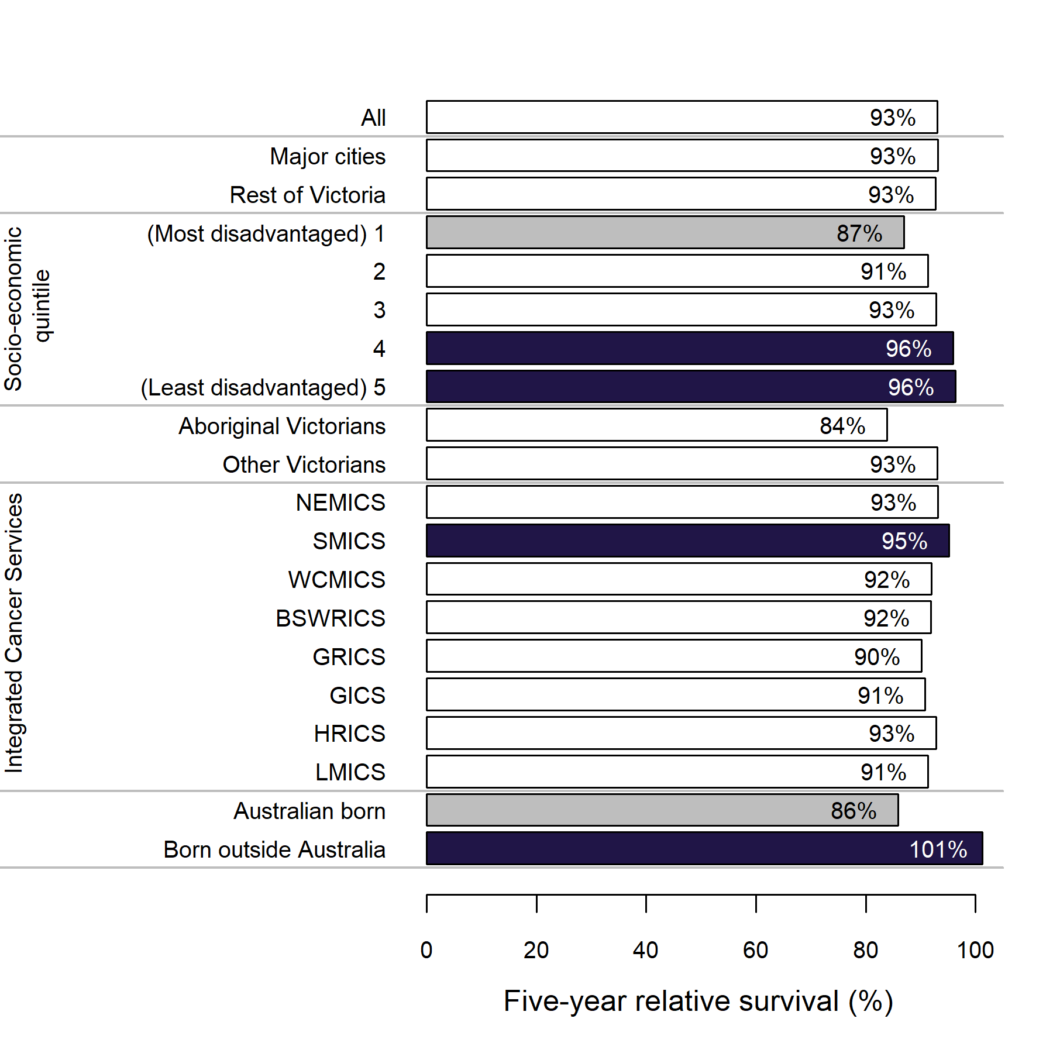
Source: VCR Data explorer <https://www.cancervic.org.au/research/vcr>
Figure 17: Survival by melanoma stage and ICS of residence adjusted for age, sex and comorbidities
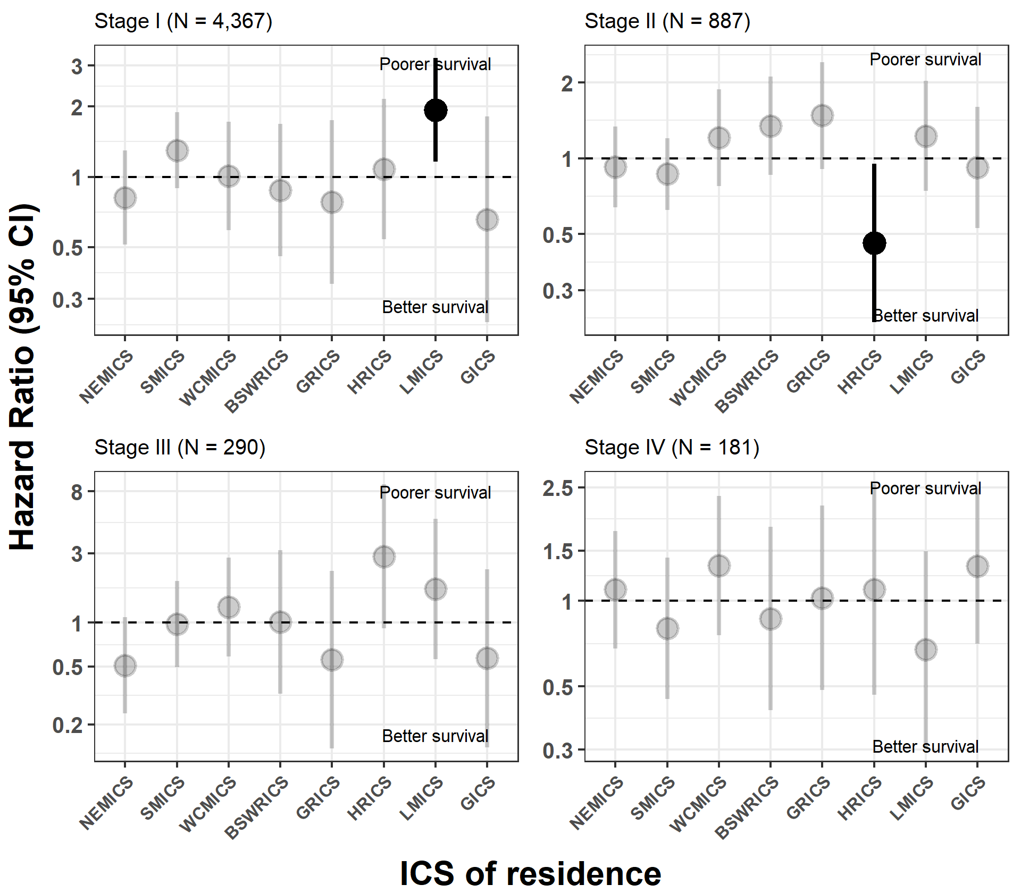

Clinical commentary – survival
The most disadvantaged patients have the poorest survival, and the least disadvantaged patients have better survival – this is not unexpected. Better survival is also seen for SMICS residents and those born outside of Australia, although it isn’t clear why.
When we drill down further into adjusted survival by stage, we see there is poorer stage II melanoma survival for LMICS and better stage III melanoma survival for HRICS. It is not clear what is driving these differences in survival between the regions.

COVID-19 impacts
- In 2020 there were 350 fewer melanoma diagnoses, a decrease of 12%, from the expected number of diagnoses based on incidence data of previous years (Figure 18).
  - The decline in diagnoses was evident in both males and females.
  - Most of the decline (83%) was for stage I disease. There was no significant decline observed for diagnoses of stage III and stage IV disease.
- Based on historical data, 5,488 melanoma surgery episodes in Victorian hospitals were expected between 2020 and 2022, but only 4,841 episodes were observed (Figure 19). This is a difference of 647 surgeries, accounting for a decrease of 12%.
Figure 18: Relative difference between observed and expected melanoma diagnoses in 2020, by sex and stage at diagnosis
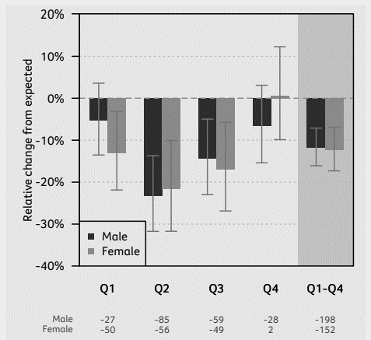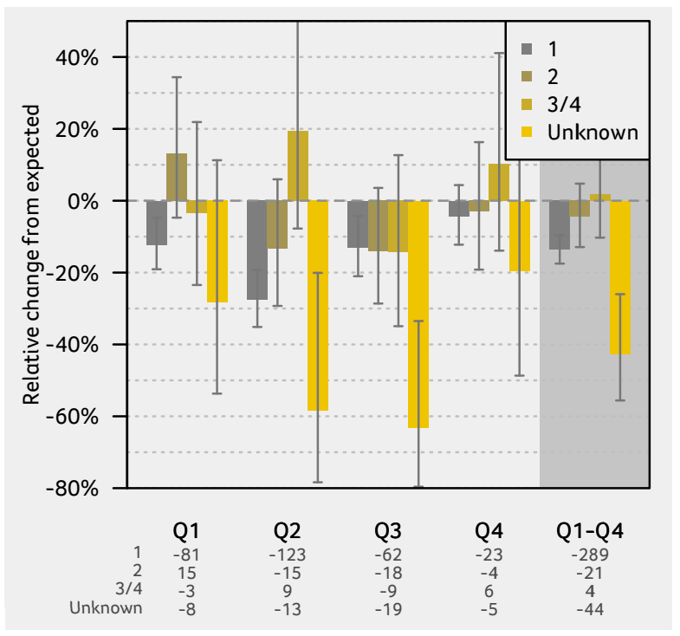
Source: Victorian Cancer Registry, Cancer in Victoria 2020. Cancer Council Victoria, Melbourne, Victoria. 2021.
Figure 19: COVID-19 impacts on admitted melanoma surgery trends, 2014–2022
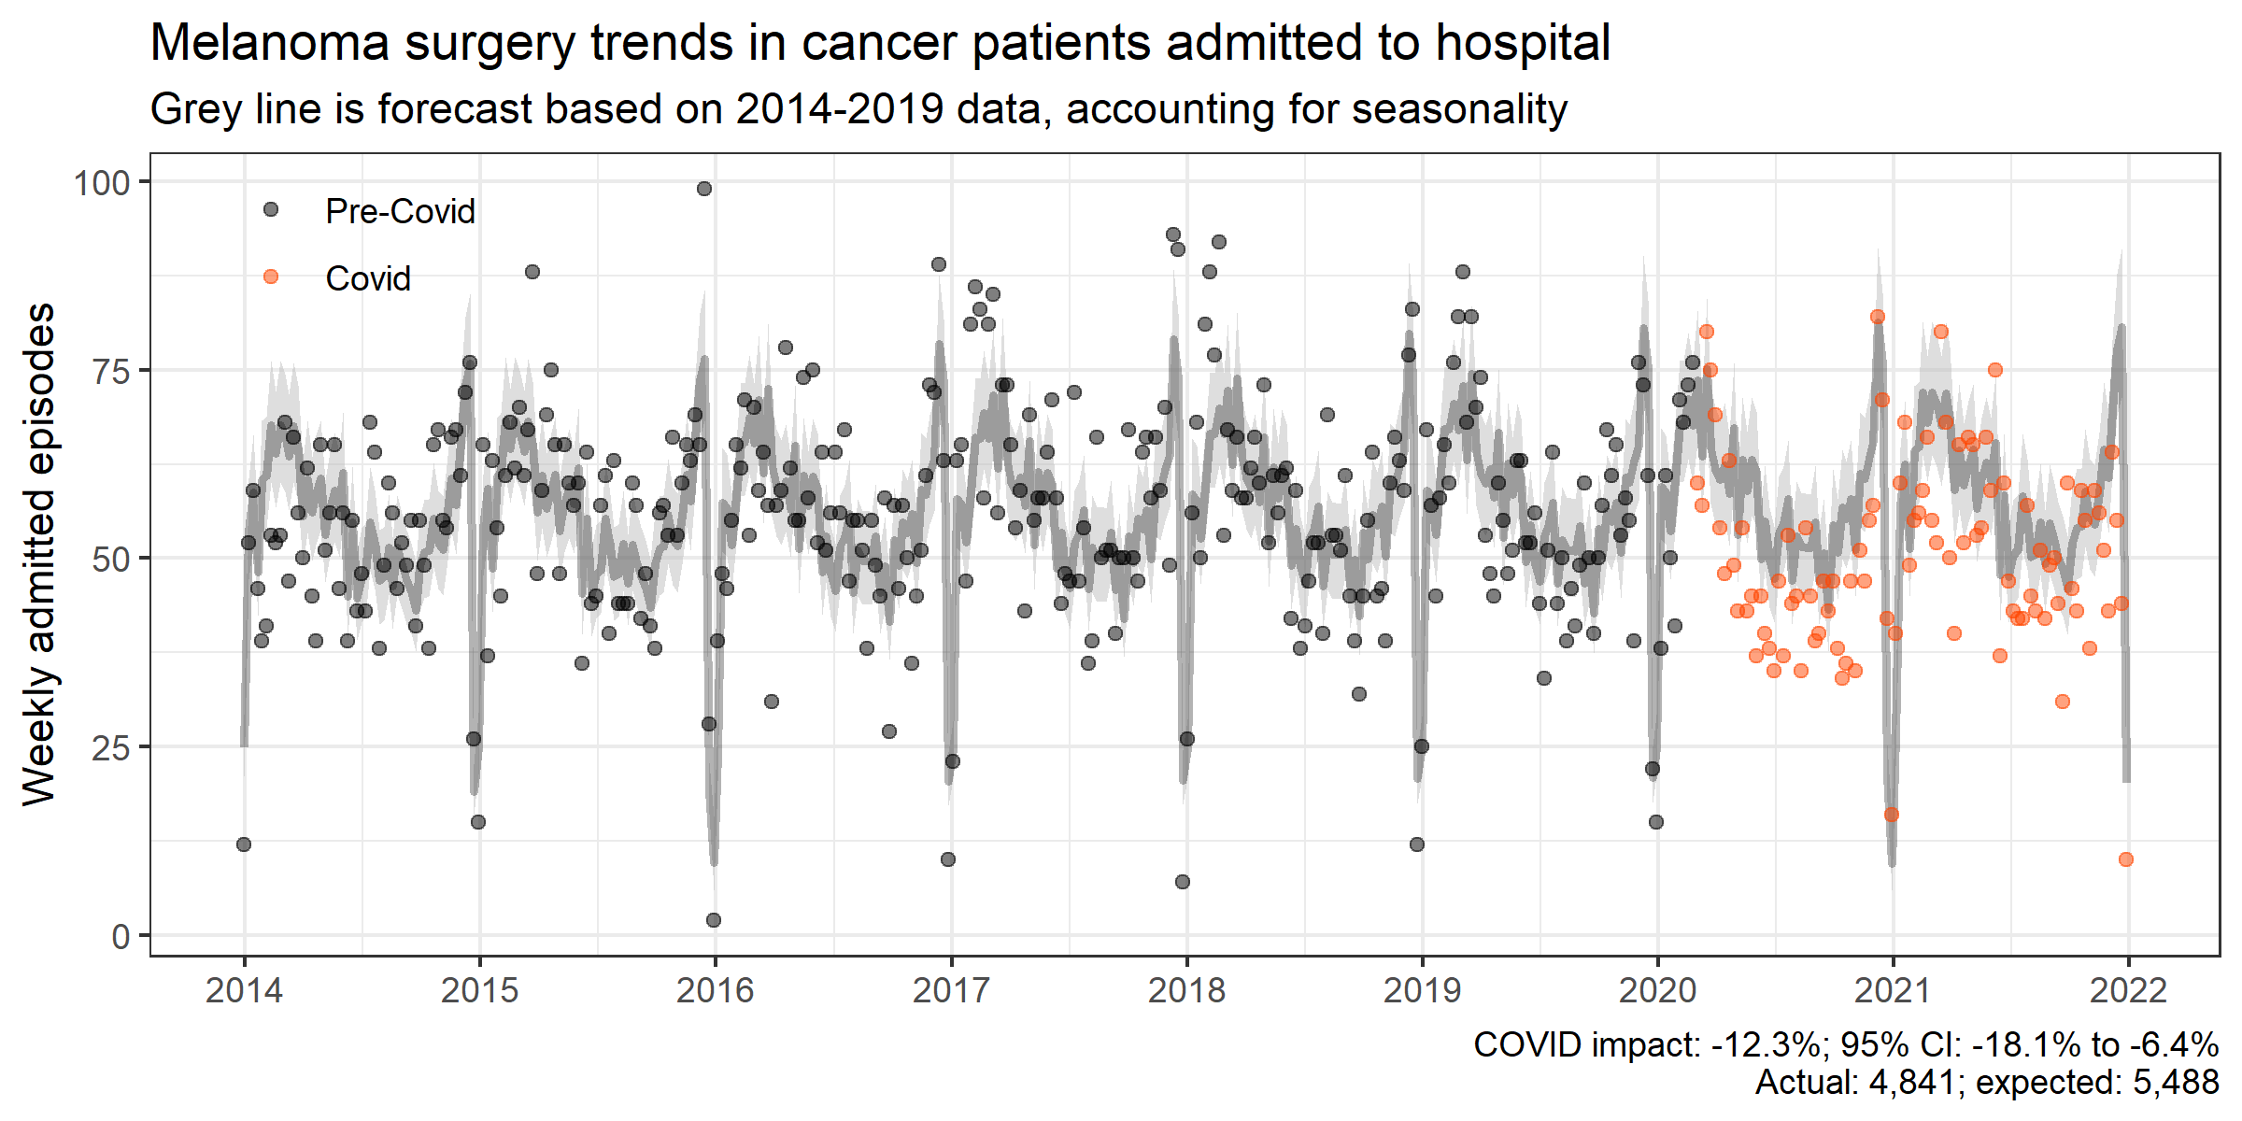
Source: VAED 2014–2021

Clinical commentary – COVID impacts
We don’t know whether there will be a surge in melanoma surgeries into 2022 or whether more surgery happened in primary care during this period.
There were fewer skin checks during the COVID-19 pandemic, and this would have led to fewer melanoma diagnoses. Many GP appointments were delivered using telehealth during this period, which, despite being an excellent tool for many purposes, is not very suitable for skin checks.
Melanoma surgery was allowed to continue during the pandemic, so we would not expect to see any declines. Despite this, there was a small reduction of 12% in melanoma surgical admissions. This may be due to a combination of fewer melanoma diagnoses and more melanomas resected in primary care to ease the burden on hospitals.

Abbreviations
CI | confidence interval
CSPI | Cancer Services Performance Indicator
ICS | Integrated Cancer Service
MDM | multidisciplinary meeting
OCP | optimal care pathway
SES | socioeconomic status
SLNB | Sentinel Lymph Node Biopsy
VAED | Victorian Admitted Episodes Dataset
VCR | Victorian Cancer Registry
VRMDS | Victorian Radiotherapy Minimum Data Set

Victorian Integrated Cancer Services
BSWRICS | Barwon South Western Regional Integrated Cancer Service
GICS | Grampians Integrated Cancer Service
GRICS | Gippsland Regional Integrated Cancer Services
HRICS | Hume Regional Integrated Cancer Service
LMICS | Loddon Mallee Integrated Cancer Service
NEMICS | North Eastern Melbourne Integrated Cancer Service
SMICS | Southern Melbourne Integrated Cancer Service
WCMICS | Western and Central Melbourne Integrated Cancer Service

Glossary
Term | Definition
Intravenous anticancer therapy | An admitted episode in the Victorian Admitted Episodes Dataset where the admission date was between 30 days prior and one year after the patient’s melanoma diagnosis date and included a intravenous anticancer therapy diagnosis, procedure or diagnosis related group code (Supplementary Table 3).
Comorbidity count | A count measuring the number of comorbid conditions a patient has at diagnosis, which may influence their prognosis. Data on patient comorbidities was extracted from diagnosis codes of admitted episodes in the Victorian Admitted Episodes Dataset in the year prior up until 30 days after the patient’s melanoma diagnosis date. Patients without admitted episodes were assumed to have no comorbidities. The comorbidity count was calculated for each patient according to Quan et al. (excluding cancer and metastases) and grouped into four categories (0, 1, 2 and 3+).  Diagnosis codes for comorbidities can only be assigned in the admitted episode when the comorbidities meet criteria for coding in line with the Australian Coding Standards. As a result, the identification of comorbidities is likely to be an underestimation.  Conditions included in the comorbidity count are:  - AIDS/HIV  - congestive heart failure  - chronic pulmonary disease  - dementia  - diabetes with chronic complications  - hemiplegia or paraplegia  - mild liver disease  - moderate/severe liver disease  - renal disease  - rheumatic disease.
Death certificate only | A method of cancer notification to the Victorian Cancer Registry whereby the death certificate provides the only notification of a person’s cancer to the registry.
Relative survival | A measure of survival of the cancer cohort relative to that of the general population, grouped by age and sex. For example, a 56% five-year relative survival indicates that the survival for the cancer cohort is just over half of what we would expect in a group of the same age and sex without cancer.
Socioeconomic status (SES) | A measure of a person’s economic and social position within society, which tends to be positively associated with better health. In this report SES is based on the Index of Relative Socio-Economic Disadvantage (IRSD) included in the Socio-Economic Index for Areas published by the Australian Bureau of Statistics. Victorians were assigned an IRSD score using their residential address at the time of their diagnosis. IRSD scores are grouped into quintiles (1st – most disadvantaged, 5th – least disadvantaged).
Surgery | An admitted episode in the Victorian Admitted Episodes Dataset where the admission date was between 30 days before and one year after the patient’s melanoma diagnosis date and the episode included a skin excision surgery procedure code (Supplementary Table 2, ‘Surgery (in-patient)’.
VCR diagnosis date | The date of the pathology report or other investigative report where the diagnosis of cancer was first confirmed to the Victorian Cancer Registry.

Supplementary material

Codes

Diagnosis
Supplementary Table 1: Melanoma diagnosis codes
ICD-10-AM | Description
C430 | Malignant melanoma of lip
C431 | Malignant melanoma of eyelid, including canthus
C432 | Malignant melanoma of ear and external auricular canal
C433 | Malignant melanoma of other and unspecified parts of face
C434 | Malignant melanoma of scalp and neck
C435 | Malignant melanoma of trunk
C436 | Malignant melanoma of upper limb, including shoulder
C437 | Malignant melanoma of lower limb, including hip
C438 | Overlapping malignant melanoma of skin
C439 | Malignant melanoma of skin, unspecified

Surgery
Supplementary Table 2: Surgical procedure codes used to identify patients who undergo melanoma surgery (inpatient surgery) and sentinel lymph node biopsies
Group | ICD-10-AM/ ACHI/ACS code | Description
Surgery (inpatient) | 3120500 | Excision of lesion of skin and subcutaneous tissue of other site
 | 3123500 | Excision of lesion of skin and subcutaneous tissue of other site of head
 | 3123503 | Excision of lesion of skin and subcutaneous tissue of leg
 | 3123501 | Excision of lesion of skin and subcutaneous tissue of neck
 | 3123504 | Excision of lesion of skin and subcutaneous tissue of foot
 | 3123002 | Excision of lesion of skin and subcutaneous tissue of ear
 | 3123000 | Excision of lesion of skin and subcutaneous tissue of eyelid
 | 3123001 | Excision of lesion of skin and subcutaneous tissue of nose
 | 3123502 | Excision of lesion of skin and subcutaneous tissue of hand
 | 4566502 | Full thickness wedge excision of ear
 | 3123004 | Excision of lesion of skin and subcutaneous tissue of finger
 | 3123003 | Excision of lesion of skin and subcutaneous tissue of lip
 | 4566500 | Full thickness wedge excision of lip
 | 4566501 | Full thickness wedge excision of eyelid
 | 3123005 | Excision of lesion of skin and subcutaneous tissue of genitals
 | 4566800 | Vermilionectomy
 | 3120501 | Excision of ulcer of skin and subcutaneous tissue
Sentinel lymph node biopsy | 3030000 | Sentinel lymph node biopsy of axilla
 | 3030001 | Sentinel lymph node biopsy, not elsewhere classified
 | 9624300 | Sentinel lymph node biopsy, head region
 | 9624301 | Sentinel lymph node biopsy, neck/cervical
 | 9624302 | Sentinel lymph node biopsy, axillary
 | 9624303 | Sentinel lymph node biopsy, intrathoracic
 | 9624304 | Sentinel lymph node biopsy, intra-abdominal
 | 9624305 | Sentinel lymph node biopsy, pelvic
 | 9624306 | Sentinel lymph node biopsy, inguinal
 | 9624307 | Sentinel lymph node biopsy, extremity
 | 9624308 | Sentinel lymph node biopsy, other and unspecified lymphatic sites

Intravenous anticancer therapy
Supplementary Table 3: Diagnosis, procedure and diagnosis related group codes used to identify patients who receive intravenous anticancer therapy
Code group | Code | Description
Diagnosis | Z511 | Pharmacotherapy session for neoplasm
Procedure | 9619900 | Intravenous administration of pharmacological agent, antineoplastic agent
Procedure | 9620900 | Loading of drug delivery device, antineoplastic agent
Diagnosis related group | R63Z | Chemotherapy
Where an admission had one of the codes listed in Supplementary Table 3 and also had a diagnosis code ‘Z53’, the admission was not included as a intravenous anticancer therapy admission.
Code group | Code | Description
Diagnosis | Z53 | Procedure not carried out

Refer to the ‘Abbreviations’ page for the naming of the eight participating Victorian ICS.
Quan H, Li B, Couris C, et al. 2011, ‘Updating and validating the Charlson comorbidity index and score for risk adjustment in hospital discharge abstracts using data from 6 countries’, American Journal of Epidemiology, vol. 173, no. 6, pp. 676–682.
Cancer services performance indicators 2020 audit <https://content.health.vic.gov.au/sites/default/files/2023-01/cancer-services-performance-indicators-cpsi-audit-2020.pdf>
Cancer services performance indicators 2020 audit <https://content.health.vic.gov.au/sites/default/files/2023-01/cancer-services-performance-indicators-cpsi-audit-2020.pdf>
Quan H, Li B, Couris C, et al. 2011, ‘Updating and validating the Charlson comorbidity index and score for risk adjustment in hospital discharge abstracts using data from 6 countries’, American Journal of Epidemiology, vol. 173, no. 6, pp. 676–682.
Australian Coding Standard ACS 0002 Additional Diagnoses.

