Specifications for revisions to the Agency Information Management System (AIMS) for 2024-25
December 2023
OFFICIAL

To receive this document in another format, email HDSS help desk <HDSS.helpdesk@health.vic.gov.au>.
Authorised and published by the Victorian Government, 1 Treasury Place, Melbourne.
© State of Victoria, Australia, Department of Health, December 2023.
Available at HDSS annual changes < https://www.health.vic.gov.au/data-reporting/annual-changes>

Contents
Executive summary 4
Introduction 5
Orientation to this document 5
Outcome of proposals 6
Proposals for revisions across multiple data collections [which impact AIMS data collections] for 2024-25: 6
Proposals for revisions to the Agency Information Management System (AIMS) for 2024-25: 6
Amend reporting of Victorian Respiratory Support Service (VRSS) Program Stream 7
S11: Sub Acute Non-Admitted Activity 7
S12: Self-administered Non-admitted Services 9
All sites with an Urgent Care Centre (UCC) to report UCC activity using the AIMS Urgent Care Centre form only. 10
AIMS Urgent Care Centre data collection 10
Cease reporting of urgent care activity on AIMS S10 Acute Non-Admitted Clinic Activity form 14

Executive summary
The revisions for the Agency Information Management System (AIMS) for 2024-25 are summarised below:

- Change to reporting of Victorian Respiratory Support Service (VRSS) Programs, which will impact two AIMS data collections:
  - Amend AIMS S11 Sub Acute Non-Admitted Activity: add Program/Stream VRSS General
  - Amend AIMS S12 Self-administered Non-admitted Services: remove reporting of VRSS Not on ventilation episodes.

- Change the AIMS data collection to which Small Rural Health Services (SRHSs) report their Urgent Care Centre (UCC) activity:
  - Cease reporting Urgent Care Centre activity using the AIMS S10 Acute Non-Admitted Clinic Activity form;
  - Commence reporting Urgent Care Centre activity using only the AIMS Urgent Care Centre form.

Introduction
Each year the Department of Health review the Agency Information Management System (AIMS) to ensure that these data collections support the department’s business objectives, including national reporting obligations, and reflect changes in hospital funding and service provision arrangements for the coming financial year.
Comments provided by the health sector in response to Proposals for revisions across multiple data collections for 2024-25 and Proposals for Revisions to the Agency Information Management System (AIMS) for 2024-25 have been considered, and where possible, suggestions have been accommodated.
The revisions set out in this document are complete as at the date of publication. Where further changes are required during the year, for example to data validation rules or supporting documentation, these will be advised via the HDSS Bulletin.
An updated AIMS manual will be published in due course. Until then, the current AIMS manual and subsequent HDSS Bulletins, together with this document, form the data submission specifications for 2024-25.
Victorian health services must ensure their systems allow capture and reporting of all data collections for their health service, and each campus, in accordance with the revised specifications and ensure reporting capability is achieved to maintain compliance with reporting timeframes set out in the relevant Department of Health policy and funding guidelines or the Health Services (Health Service Establishments) Regulations 2013.

Orientation to this document
- New data elements are marked as (new).
- Changes to existing data elements are highlighted in green
- Redundant values and definitions relating to existing elements are struck through.
- Comments relating only to the proposal document appear in [square brackets and italics].
- Validations to be changed are marked * when listed as part of a data element or below a validation table.
- Changes are shown under the appropriate manual section headings: the impact of the change is highlighted rather than reproducing the entire entry for the data collection from Section 3 of the AIMS manual.

Outcome of proposals

Proposals for revisions across multiple data collections [which impact AIMS data collections] for 2024-25:
Proposal 1 New and amended streams – Victorian Respiratory Support Service (VRSS) Program [AIMS, VINAH]
The proposal proceeds.

Proposals for revisions to the Agency Information Management System (AIMS) for 2024-25:
Proposal 3 Amend UCC Urgent Care Centre form – expand scope to include reporting from all Small Rural Health Services (SRHSs)
The proposal proceeds.
Proposal 4 Amend Statutory Duty of Candour data collection
Proposal withdrawn.

The decision to implement changes to key datasets in 2024-25 was based on a priority ranking, with only those proposals considered critical approved. Some reporting guide updates were also approved. All other proposals for changes for 2024-25 have been placed on hold.

Amend reporting of Victorian Respiratory Support Service (VRSS) Program Stream
Amendment to the reporting of the Victorian Respiratory Support Service (VRSS) Program Stream results in changes to two AIMS data collections:
- AIMS S11 Sub Acute Non-Admitted Activity data collection:
  - Add Program Stream ‘VRSS – general’ – both medical and non-medical.
- AIMS S12 Self-administered Non-admitted Services data collection:
  - Remove Program Stream ‘VRSS Not on ventilation’

S11: Sub Acute Non-Admitted Activity
Add to the list of in scope non-admitted subacute programs for which non-admitted subacute activity data must be reported on the S11 form by health services and non-government organisations (NGOs) that receive funding for delivering those services:
- Victorian Respiratory Support Service (VRSS) – general
This Program Stream has been separated into ‘medical’ and ‘non-medical’ substreams which aligns with ABF Tier 2 classes.

VRSS General definition
VRSS General program stream is used to report non-admitted service events with healthcare providers funded within the Victorian Respiratory Support Service program.
Form S11 image showing inclusion of VRSS General program stream
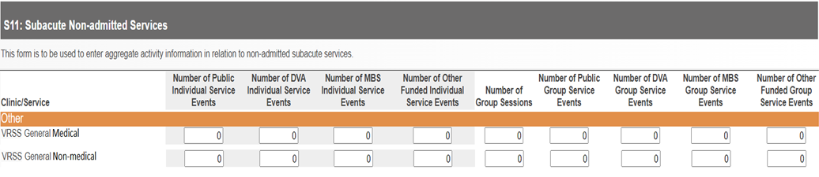

Program/Stream Identifier
The identifier of the subacute program/stream:
Code | Description
1 | Rehabilitation
2 | Specialist Continence
3 | Specialist Cognitive
4 | Specialist Pain Management
5 | Specialist Falls
6 | Specialist Wound Management
7 | Younger Adult/Transition
8 | Specialist Paediatric Rehabilitation
9 | Specialist Polio
11 | Specialist Movement Disorders
12 | Cardiac Rehabilitation
19 | Specialist Other
27 | HARP – HIV
28 | HARP
30 | HARP – Geriatric evaluation and management (GEM)
31 | Post Acute Care
41 | Community Palliative Care
54 | Complex Care (FCP) General
55 | Complex Care (FCP) HARP
56 | Complex Care (FCP) PAC
86 | Victorian Respiratory Support Service (VRSS) – general
1201 | Residential In-reach
1400 | Palliative Care Day Hospice
1600 | Statewide Palliative Care Service
1700 | Victorian Artificial Limb Program

S12: Self-administered Non-admitted Services
Remove ‘VRSS Not on ventilation’ from the list of Program Streams for which aggregate data on Active Episodes is reported on the AIMS Form S12 Self-delivered Non-admitted Services form.
Reporting of VRSS Not on ventilation moves to the AIMS S11 form, under the new title ‘VRSS – general’.
Form S12 image
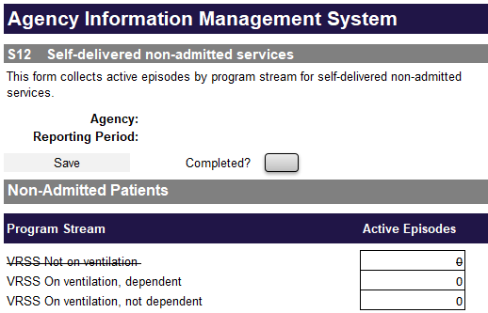

Scope
Non-admitted programs/program streams to be reported on the S12 form:
- Total Parenteral Nutrition
- Home Enteral Nutrition
- Victorian Respiratory Support Services
  - On ventilation, dependent
  - On ventilation, not dependent
  - Not on ventilation
- Complex Care (FCP)
  - On ventilation, dependent
  - On ventilation, not dependent

Victorian Respiratory Support Service (VRSS)
The Victorian Respiratory Support Service (VRSS) is a state-wide specialist program providing a range of services to adults with a chronic respiratory condition. VRSS activity is reported only by Austin Health.
An episode is to be opened for the period during which a patient/client is responsible for their administration of the treatment and the episode is to be closed when the patient/client ceases home self-administration of their treatment.
Service events in relation to the VRSS are to be reported on the AIMS S11 Sub Acute Non-Admitted Activity form, under Program Stream ‘Victorian Respiratory Support Service (VRSS) – general.

All sites with an Urgent Care Centre (UCC) to report UCC activity using the AIMS Urgent Care Centre form only.
From 1 July 2024, all campuses, including Small Rural Health Services (SRHSs), that provide urgent care/unplanned emergency medical treatment are to commence reporting urgent care presentations using the AIMS Urgent Care Centre (UCC) form instead of the AIMS S10 Acute Non-Admitted Clinic Activity form.
The AIMS Urgent Care Centre form is reported monthly, at health service campus level.
Data must be submitted by the 14th day after the end of each reporting month.
Please refer to the AIMS Urgent Care Centre reporting guidelines for details of the data items and definitions applicable. These are found in the AIMS manual < https://www.health.vic.gov.au/data-reporting/agency-information-management-system-aims >. .
The impact on the AIMS S10 form is summarised after the Urgent Care Centre form information.

AIMS Urgent Care Centre data collection
The AIMS Urgent Care Centre data collection reports aggregate data on number of presentations, by visit type, triage category and departure status, for selected payment categories, at all urgent care centres (UCCs) at selected campuses.
The AIMS Urgent Care Centre data collection provides details on the models of care and demand for UCC services, and supports funding emergency care using Urgency Disposition Group (UDG) as part of the National Health Reform Agreement.
Health services listed in Table 1 are required to submit the Urgent Care Centre data collection for each listed campus. From 1 July 2024, health services will no longer submit aggregate UCC service event activity on the AIMS S10 form.
Table 1: List of health service campuses reporting to the Urgent Care Centre data collection
Health Service | Campus
Alexandra District Health | Alexandra District Health
Alpine Health | Alpine Health [Bright]
Alpine Health | Alpine Health [Mount Beauty]
Alpine Health | Alpine Health [Myrtleford]
Barwon Health | Barwon Health [Barwon Health North]
Bass Coast Health | Bass Coast Health [Phillip Island Health Hub]
Beaufort & Skipton Health Service | Beaufort & Skipton Health Service [Beaufort]
Beaufort & Skipton Health Service | Beaufort & Skipton Health Service [Skipton]
Beechworth Health Service | Beechworth Health Service
Benalla Health | Benalla and District Memorial Hospital
Boort District Health | Boort District Health
Casterton Memorial Hospital | Casterton Memorial Hospital
Central Gippsland Health | Central Gippsland Health [Maffra]
Central Highlands Rural Health | Central Highlands Rural Health [Creswick]
Central Highlands Rural Health | Central Highlands Rural Health [Daylesford]
Central Highlands Rural Health | Central Highlands Rural Health [Kyneton]
Cohuna District Hospital | Cohuna District Hospital
Colac Area Health | Colac Area Health
Corryong Health | Corryong Health
Dhelkaya Health | Dhelkaya Health [Castlemaine]
Dhelkaya Health | Dhelkaya Health [Maldon]
East Grampians Health Service | East Grampians Health Service [Ararat]
East Wimmera Health Service | East Wimmera Health Service [Birchip]
East Wimmera Health Service | East Wimmera Health Service [Charlton]
East Wimmera Health Service | East Wimmera Health Service [Donald]
East Wimmera Health Service | East Wimmera Health Service [St Arnaud]
East Wimmera Health Service | East Wimmera Health Service [Wycheproof]
Gippsland Southern Health Service | Gippsland Southern Health Service [Korumburra]
Gippsland Southern Health Service | Gippsland Southern Health Service [Leongatha]
Grampians Health | Grampians Health [Edenhope]
Grampians Health | Grampians Health [Dimboola]
Grampians Health | Grampians Health [Stawell]
Great Ocean Road Health | Great Ocean Road Health [Apollo Bay]
Great Ocean Road Health | Great Ocean Road Health [Lorne]
Heathcote Health | Heathcote Health
Hesse Rural Health | Hesse Rural Health [Winchelsea]
Heywood Rural Health | Heywood Rural Health
Inglewood & Districts Health Service | Inglewood & Districts Health Service
Kerang District Health | Kerang District Health
Kooweerup Regional Health Service | Kooweerup Regional Health Service
Kyabram District Health Service | Kyabram District Health Service
Mallee Track Health and Community Service | Mallee Track Health and Community Service [Ouyen]
Mallee Track Health and Community Service | Mallee Track Health and Community Service [Sea Lake]
Mansfield District Hospital | Mansfield District Hospital
Maryborough District Health Service | Maryborough District Health Service [Maryborough]
Moyne Health Services | Moyne Health Services [Port Fairy]
NCN Health | NCN Health [Cobram]
NCN Health | NCN Health [Nathalia]
NCN Health | NCN Health [Numurkah]
Northern Health | Northern Health [Kilmore]
Omeo District Health | Omeo District Health
Orbost Regional Health | Orbost Regional Health
Portland District Health | Portland District Health
Robinvale District Health Services | Robinvale District Health Services [Manangatang]
Robinvale District Health Services | Robinvale District Health Services [Robinvale]
Rochester & Elmore District Health Service | Rochester & Elmore District Health Service [Rochester]
Rural Northwest Health | Rural Northwest Health [Hopetoun]
Rural Northwest Health | Rural Northwest Health [Warracknabeal]
Seymour Health | Seymour District Memorial Hospital
South Gippsland Hospital | South Gippsland Hospital [Foster]
South West Healthcare | South West Healthcare [Camperdown]
Tallangatta Health Service | Tallangatta Health Service
Terang & Mortlake Health Service | Terang & Mortlake Health Service [Terang]
Timboon & District Healthcare Service | Timboon & District Healthcare Service
West Wimmera Health Service | West Wimmera Health Service [Jeparit]
West Wimmera Health Service | West Wimmera Health Service [Kaniva]
West Wimmera Health Service | West Wimmera Health Service [Nhill]
West Wimmera Health Service | West Wimmera Health Service [Rainbow]
West Wimmera Health Service | West Wimmera Health Service [Rupanyup]
Western District Health Service | Western District Health Service [Coleraine]
Western Health | Western Health [Bacchus Marsh]
Western Health | Western Health [Melton]
Yarram & District Health Service | Yarram & District Health Service
Yarrawonga Health | Yarrawonga Health
Yea & District Memorial Hospital | Yea & District Memorial Hospital

Urgent Care Centre data collection sample form:
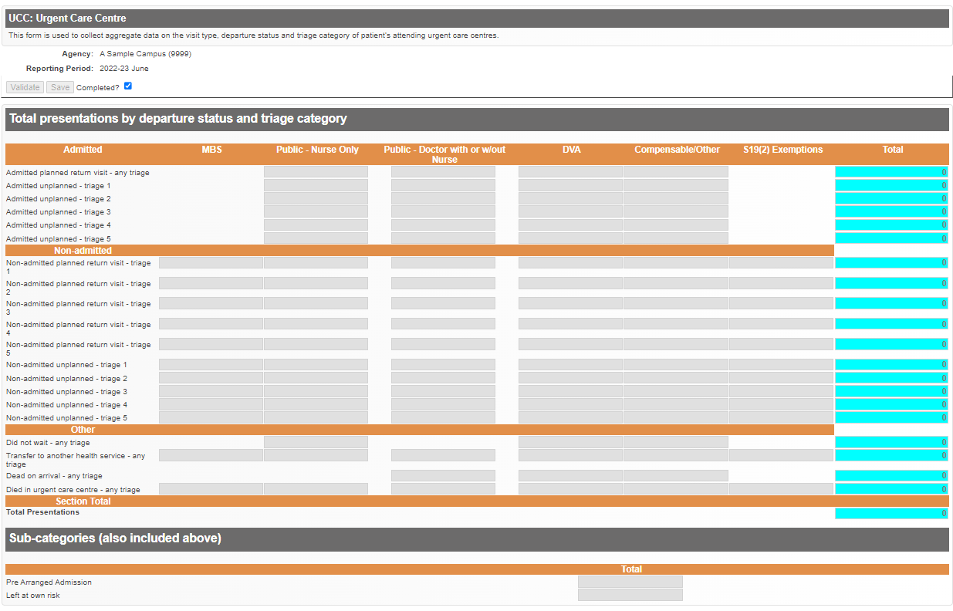

Further information
Questions about Urgent Care Centre reporting, including the data items to be reported, and accessing the Urgent Care Centre form in HealthCollect, or notification of inability to report by the due date, should be emailed to the HDSS HelpDesk <hdss.helpdesk@health.vic.gov.au> .

Cease reporting of urgent care activity on AIMS S10 Acute Non-Admitted Clinic Activity form
Reporting of urgent care centre activity using the AIMS S10 form will cease for all campuses from 1 July 2024. This includes:
- Health services that currently report on the UCC form
- Small rural health services that will transition from reporting on the S10 form to the UCC form
The row to report urgent care activity on the S10 form will be removed.
Form S10 image
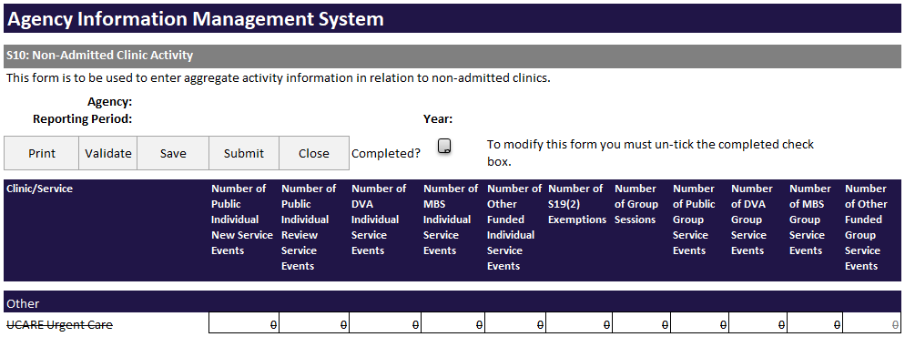

Sites that have no other acute non-admitted activity to report on the AIMS S10 form should contact the HDSS HelpDesk <hdss.helpdesk@health.vic.gov.au> to discuss ceasing AIMS S10 submissions.

