

|  |
| --- |
| Summary Serious Transfusion Incident Report 2021-22 |
|  |

**Number of validated clinical and procedural reports and health services reporting each financial year, FY2011–FY2022**

Data in this figure shows information from FY10 to current FY22.
The number of reporting health services ranges from a low of 32 in FY12 and FY17 to a high of 43 in FY14. FY22 had 38 health services reporting.
The number of procedural versus clinical reports for each financial year is also shown. FY10 had the largest number in total 211, with 102 procedural and 109 clinical. FY16 had the lowest total number 121, with 67 procedural and 54 clinical. 
FY 13-16 all had more procedural than clinical incidents reported, all other years more clinical incidents are reported.
FY22 shows total 186 reports, 60 procedural, 126 clinical.

216 notifications from health services

16 withdrawn by the health service

200 investigation forms returned and reviewed

14 excluded by expert review

Total validated reports are 186, 126 clinical and 60 procedural.

Chart icon

Open letter icon

**Abbreviations:**

ATR ─ acute transfusion reaction

DHTR ─ delayed haemolytic transfusion reaction

DSTR ─ delayed serological transfusion reaction

TACO ─ transfusion associated circulatory overload

TAD ─ transfusion associated dyspnoea

RhD Iso ─ RhD isoimmunisation

STIR is a voluntary haemovigilance reporting system that is used in four jurisdictions in Australia.

The annual report contains information on the number and types of reactions and events that occur, with case studies and key recommendations for improving transfusion and patient care.

For the complete report and further information on the STIR program go to the Blood Matters website [<](%3c) https://www.health.vic.gov.au/patient-care/blood-matters-program>

**Validated clinical reactions FY22 Types of acute transfusion reaction (ATR)**

|  |  |
| --- | --- |
| **Reaction** | **Number (68)** |
| Allergic/anaphylactic/anaphylactoid | 33 |
| Febrile non-haemolytic transfusion reaction (FNHTR) | 31 |
| Acute haemolytic (AHTR) | 2 |
| Hypotensive | 1 |
| Other | 1 |

# Pie chart showing the number of clinical reports in each category. ATR 68 (further description of the types of ATR in this category in chart), DHTR 6, DSTR 22, TACO 28, TAD 1, RhD-Iso 1.

**Key messages** **– clinical**

|  |  |
| --- | --- |
| **Area** | **Recommendation** |
| Pre-transfusion patient assessment | Assessing patients for risk factors for things such as TACO or previous confirmed reactions to blood components prior to transfusion is necessary to reduce the risk of further reactions. If required, slowing the transfusion rate, closer monitoring or administering premedication should be considered. |
| Communication | All communication needs to be clear and concise. This includes at handovers, between the laboratory and clinical areas, and with the patient.  Transcription of results into medical records should not occur routinely. When looking for blood group results go to the primary source, or documentation direct from the pathology service. When checking results, take the time to read them and be sure you have understood them. We have had several errors occur due to misreading of results. |
| Appropriate management of anaemia | Consideration of patient blood management strategies to reduce the need for transfusion improves patient safety by decreasing the number of times a patient may need to be transfused. |

**For the full key messages go to the annual report at Blood Matters <** **https://www.health.vic.gov.au/patient-care/blood-matters-program>**

**Validated procedural reports FY22 Reported IBCT* categories: FY10 – FY22**

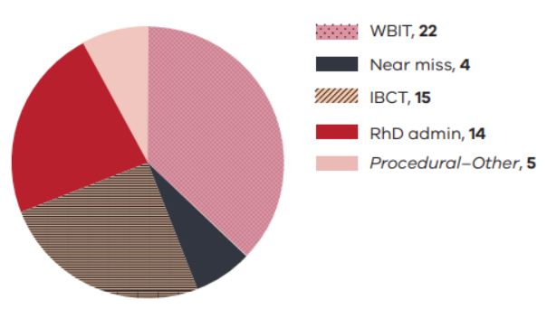 This graph shows the number and type of IBCT reports per financial year. The most commonly reported is inappropriate transfusions, followed by specific requirements not met.
FY 22 has the largest number of IBCT reports for all years, 20. Of these 8 were inappropriate transfusions, 6 did not meet specific requirements, 3 related to antigen-antibody issues, 2 were incorrect but ABO compatible and one was ABO incompatible.

**Abbreviations:** WBIT ─ wrong blood in tube IBCT ─ incorrect blood component transfused

**Key messages – procedural**

|  |  |
| --- | --- |
| Area | Recommendation |
| Patient identification | Patient identification (ID) remains an area in need of improvement, as per WBIT reports. Patient ID must be a part of all education as a key safety aspect of any procedure. |
| Blood administration | Two-person independent checking at the patient side is a must for health services. This process allows for each staff member to check each item required in the checking process and be certain the product they have is intended for this patient and is the correct product. Situations where one staff member checks some items and the other staff member other items has led to missed information and ABO incompatible transfusion in the past. |
| Fit for purpose information technology (IT) systems | Both clinical and laboratory systems rely more and more on IT systems to support work and safety. IT alerts should be relevant, understandable to the user, not easily overridden and have associated actions. These should be regularly reviewed and updated where appropriate. (SHOT 2022) |
| Patient safety culture | Fostering a strong and effective safety culture that is ‘just and learning’ is vital to ensure a reduction in transfusion incidents and errors, thus directly improving patient safety. (SHOT 2022) |

|  |
| --- |
| To receive this document in another format, phone 03 9694 0102, using the National Relay Service 13 36 77 if required, or [email Blood Matters](mailto:bloodmatters@redcrossblood.org.au) <bloodmatters@redcrossblood.org.au>.  Authorised and published by the Victorian Government, 1 Treasury Place, Melbourne.  © State of Victoria, Australia, Department of Health, September 2023.  **ISSN 2651-8872** (online/PDF/Word)  Available at [Blood Matters Serious Transfusion Incident Reporting](https://www.health.vic.gov.au/patient-care/serious-transfusion-incident-reporting-system) <https://www.health.vic.gov.au/patient-care/serious-transfusion-incident-reporting-system> |