Victorian public health and wellbeing progress report 2023
Report on priority measures in the Victorian public health and wellbeing outcomes framework
OFFICIAL

To receive this document in another format, email the Department of Health, <prevention@health.vic.gov.au>.
Authorised and published by the Victorian Government, 1 Treasury Place, Melbourne.
© State of Victoria, Australia, Department of Health, January 2024.
Except where otherwise indicated, the images in this document show models and illustrative settings only, and do not necessarily depict actual services, facilities or recipients of services.
This document may contain images of deceased Aboriginal and Torres Strait Islander peoples.
In this document, ‘Aboriginal’ refers to both Aboriginal and Torres Strait Islander people.
ISBN 978-1-76131-449-0 (online/PDF/Word)

Contents
Acknowledgement of Country 4
Introduction 5
About the outcomes framework 5
About this report 5
Impact of COVID-19 6
Themes and trends 6
Determinants of health and wellbeing 6
Aboriginal health 7
Healthy behaviours need healthy environments 8
Barriers to good health and wellbeing 9
Targets 10
Domain 1: Victorians are healthy and well 12
Outcome 1.1: Victorians have good physical health 12
Outcome 1.2: Victorians have good mental health 19
Outcome 1.3: Victorians act to protect and promote health 22
Domain 2: Victorians are safe and secure 29
Outcome 2.1: Victorians live free from abuse and violence 29
Outcome 2.2: Victorians have suitable and stable housing 30
Domain 3: Victorians have the capabilities to participate 30
Outcome 3.2: Victorians participate in and contribute to the economy 30
Outcome 3.3: Victorians have financial security 31
Domain 4: Victorians are connected to culture and community 32
Outcome 4.1: Victorians are socially engaged and live in inclusive communities 32
Outcome 4.2: Victorians can safely identify with their culture and identity 34
Domain 5: Victoria is liveable 35
Outcome 5.2: Victorians have access to sustainable built and natural environments 35
Appendix 1: Glossary of terms and acronyms 37
Appendix 2: Datasets 38
Limitations of datasets 38
A note on the breakdowns 38
References 41

Acknowledgement of Country
The Department of Health acknowledges Victoria’s Aboriginal communities and their rich culture and pays respect to their Elders past and present. Aboriginal people are Australia’s first peoples and the Traditional Owners and custodians of the land and water on which we live, work and play. We recognise and value the ongoing contribution of Aboriginal people and communities to Victorian life and how this enriches our society more broadly. We recognise the diversity of Aboriginal people living throughout Victoria.
This is a significant time for Aboriginal communities in Victoria and the Victorian Government. It is acknowledged that Treaty and Truth processes in Victoria may have a significant impact on government policy, governance and funding across all areas that affect Aboriginal people. The Victorian Government has committed to Aboriginal self-determination as the guiding principle and policy for Aboriginal affairs since 2015 and has a vision that ‘all Aboriginal Victorian people, families and communities are healthy, safe, resilient, thriving and living culturally rich lives’.
According to the National Aboriginal Community Controlled Health Organisation, self-determination is the ability of Aboriginal people to determine their own political, economic, social and cultural development as an essential approach to overcoming Indigenous disadvantage.
This means that rather than Aboriginal people merely being ‘engaged’ or ‘consulted’ as ‘advisors’ or ‘co-designers’ of services and policies, Aboriginal people need to be authorised and empowered to own, direct, and make strategic decisions about:
- the values and motivations on which a policy or program is based
- strategic intent
- policy or program design
- funding and allocation of resources
- implementation and operations
- evaluation measures and definitions of success.
Throughout this document, the term ‘Aboriginal’ is used to include all people of Aboriginal and Torres Strait Islander descent who are living in Victoria.

Introduction

About the outcomes framework
The Victorian public health and wellbeing outcomes framework (the outcomes framework) provides a consistent and transparent mechanism for monitoring health and wellbeing outcomes over time.
The outcomes framework is designed to track progress against consecutive Victorian public health and wellbeing plans and covers a comprehensive range of health and wellbeing topics. In particular, the outcomes framework includes priority areas of the Victorian public health and wellbeing plan 2023–27 and indicators spanning the social, emotional and environmental determinants of health, health behaviours and long-term health outcomes.
The outcomes framework aligns with a whole of Victorian Government outcomes-based approach to leverage existing government policies, outcomes frameworks, and targets where appropriate. Importantly, the outcomes framework encourages assessment of inequalities between population groups, such as people of different sex and gender, Aboriginal people, culturally and linguistically diverse groups, and geographic areas.
Adopting an outcomes-based approach allows us to set the vision for what we want to achieve and defines how to measure whether we are achieving this vision. Defining outcomes also communicates our priorities to others and sets a shared direction for change, supporting the Victorian population health and prevention sector to align efforts to improve our collective health and wellbeing.

Refreshing the outcomes framework
Following the release of the Victorian public health and wellbeing plan 2023–2027, the outcomes framework will be reviewed, and new measures and targets will be developed where appropriate. This process will provide consistency in measuring key health and wellbeing outcomes over time, and allow us to monitor contemporary and emerging health and wellbeing issues as they arise.

About this report
This report includes an examination of health and wellbeing data for 57 of the measures in the outcomes framework. Measures were prioritised based on relevance to the focus areas of the Victorian public health and wellbeing plan 2019–2023 and availability of data. All analysis has been completed in line with the specifications of the Victorian public health and wellbeing outcomes framework and data dictionary.3
All data are sourced from existing and reliable datasets that are representative of the Victorian population (see Appendix 2. Datasets). Observations made in this report are statistically significant, unless otherwise specified, and trends have been assessed using linear regression when appropriate.
Where data are available, this report compares changes over time since 2011, the year of the first Victorian public health and wellbeing plan, looking back further when needed. The report also provides an examination of variations in health and wellbeing outcomes between different population groups, and presents supporting evidence and insights relating to these variations. Data in this report are the most recently available at the time of publishing.
Progress and efforts towards achieving Aboriginal data sovereignty is recognised, and the capacity to adapt will support the key aspirations and outcomes of the Victorian Treaty process.
While this report examines health and wellbeing data at a granular level, it also looks beyond the details to consider what the findings mean more broadly. The report includes analysis of themes and trends that emerge from findings across multiple indicators. It also explores the underlying drivers of health behaviours and health outcomes to provide insights that can inform our actions to improve health and wellbeing in practice. This will help us to understand whether improvements in health and wellbeing, if any, are equally shared by all Victorians.

Impact of COVID-19
The conditions associated with the COVID-19 pandemic impacted the ability of data custodians to collect, analyse and report data. Several datasets informing this report were altered to adapt to these conditions, impacting the time series data for this period, which, in some cases, meant the impact of the pandemic was not captured. Other datasets face delays in analysis and release of data, meaning the most recently collected data is not available to be included in this report.
While any notable shifts in trends associated with the COVID-19 pandemic will be acknowledged where appropriate, the intention of this report is to adopt a long-term focus and examine trends in population health well beyond this period.

Themes and trends
In Victoria, population health status is high compared with other high-income countries. Life expectancy has increased over the past three decades, largely due to decreases in premature mortality.
Overall, Victorians experience a high prevalence of self-reported excellent or very good health, which is a reliable indication that, overall, we are in good health and we value good health. However, when we examine the data broken down into different population groups, it becomes clear these good health outcomes are not shared equally by all Victorians.

Determinants of health and wellbeing
Many factors combine to affect the health of individuals and communities. These factors are known as the social, emotional, environmental and commercial determinants of health. Determinants of health include personal factors such as gender identity, sexuality, ability, socio-economic status, cultural, religious, ethnic, and linguistic background, as well as broader factors relating to education, employment, housing, access to health care, education, food production systems, sanitation, and water systems.
The impact of identity and wider determinants of health is evident in the clear socioeconomic and intersectional disadvantage gradient that exists across the majority of the health and wellbeing outcome measures presented in this report. While the population-level data presented in this report is often not powerful enough to look at outcomes from multiple intersectional identities and determinants, looking at trends across breakdowns provides an indication of when intersecting identities might have a compounding impact on individual health outcomes.
For example, people of low socioeconomic status and people who identify as LGBTIQ+ are independently more likely to experience high levels of psychological distress, experience extreme food insecurity, smoke daily, and are more likely to die prematurely due to chronic disease. The drivers of poorer health outcomes likely stem from different but overlapping forces – discrimination and stigma for LGBTIQ+ Victorians, and income, education and employment for people of low socioeconomic status. When these identities and experiences are combined, the likelihood of experiencing poorer health outcomes is increased.
While this pattern is reflected across the spread of health and wellbeing outcomes for people of different overlapping intersectional identities, it is important to acknowledge that no two Victorians have the same experience, and that experiencing overlapping identities isn’t always linked with poor health outcomes.
Current evidence suggests that to reduce inequalities, the biggest gains are to be made by addressing the wider determinants that influence health, by focusing on community-wide influences on health and wellbeing, combined with targeted support for groups most at risk.
This requires a coordinated approach between different stakeholders across government, funded agencies, service providers, community, private industry and philanthropic sectors. It also means improving the systems that create and sustain overlapping forms of disadvantage and discrimination.

Environment as a determinant of health
The health and wellbeing of Victorians is dependent on a healthy environment. Access to clean water, clean air and a safe climate are all under threat from climate change. The changing climate also poses risks to health directly, through increasing frequency and severity of natural disasters, displacement and exposure to extreme temperatures, and indirectly, through food system impacts, loss of biodiversity and changing patterns of communicable diseases.
The impacts of climate change on health are felt more significantly by population groups experiencing disadvantage, including older people, people with chronic conditions and disability, socially isolated people, Aboriginal people, and culturally and linguistically diverse people.
Those who are financially disadvantaged are more likely to live in poor-quality housing located in areas prone to extreme weather events, and are less likely to be able to afford cooling and heating, and to insure their homes.
To avoid worsening existing inequity, the needs of priority communities must be central to the development of mitigation and adaptation strategies to prevent the impacts of climate change on health.

Aboriginal health
Aboriginal health is not just the physical wellbeing of an individual. It refers to the social, emotional and cultural wellbeing of the whole Aboriginal community where each individual is able to achieve their full potential as a human being for the total wellbeing of their community. It is a whole-of-life view and includes the cyclical concept of life-death-life.
The impacts of colonisation – while having devastating effects on the traditional life of Aboriginal Nations – have not diminished Aboriginal people’s connection to country, culture or community. There have, however, been significant impacts on Aboriginal people’s experience of health and wellbeing.
Key health indicators that impact on Aboriginal people’s health, wellbeing and safety reflect the legacy of trans-generational trauma and systemic racism. At the population level, there is a significant gap between the health status of Victoria’s Aboriginal population and the non-Aboriginal population. Although there are some areas of improvement, many areas have seen no significant change and some are getting worse.
To address the impact of ongoing colonisation, the Victorian Government has been working to embed Aboriginal self-determination approaches in our efforts to improve health and wellbeing, and delegating authority and control to Aboriginal community-led organisations and services focused on improving health and wellbeing.
Examples of action taken include the:
- Victorian Aboriginal Affairs Framework 2016-2023 (VAAF)
- Balit Murrup: Aboriginal social emotional wellbeing framework 2017–2027
- Aboriginal Health and Wellbeing Partnership Forum
- Aboriginal Health and Wellbeing Partnership Agreement
- Victorian Treaty Act 2018 and the Treaty Negotiation Framework.

Healthy behaviours need healthy environments
Despite our collective efforts to improve healthy eating and active living over the past decade, there has been no improvements in outcomes. Historically, efforts to improve healthy eating and active living have focused on encouraging individuals to change their behaviours, such as eating more vegetables and exercising more.
However, it is now understood that individuals need to be surrounded by environments that support choosing healthy options and that placing the burden on individuals does not support people trying to make the healthy choice. For example, our food environment and the marketing of food heavily influences the food and drinks we buy and consume.
The current food environment actively promotes unhealthy diets through the widespread availability of cheap, highly palatable, ultra-processed foods. These constant pressures make it difficult for individuals to choose the healthy option and are undermining efforts to promote a healthy diet.
Food environments that support healthy choices also benefit the planet, with analysis showing that a diet consistent with the Australian Dietary Guidelines had a 42 per cent lower climate footprint than the current average diet of Australian adults.
Living an active lifestyle also extends beyond individual choices and health behaviours, and is largely determined by our lifestyles and environments. Physical activity can be promoted by our built environment through walkable neighbourhoods, walking and bike paths, infrastructure such as parks and green spaces, and through promoting safe and accessible environments.
Our built environment and facilities need to be accessible to people of all abilities, and our efforts to promote physical activity should be inclusive, regardless of age, gender, cultural background or disability status. These features of a built environment also create environmental co-benefits, such as reducing the urban heat island effect and minimising emissions generated from transport.
While individual behaviour changes to increase healthy eating and active living is the outcome we are trying to achieve, the drivers of these behaviours are often beyond the scope of the Department of Health (the department), such as agriculture, transport and jobs. Meaningful change requires collaboration across government and industry, and stronger policy to shift the environments in which we live, work and play to support healthy and sustainable choices.

Barriers to good health and wellbeing
Exploring the underlying reasons behind inequity in health and wellbeing outcomes reveals that some Victorians face additional barriers to health and wellbeing, beyond the social and behavioural determinants of health.

Stigma
Stigma associated with certain health conditions can have broader impacts on the health and wellbeing of the affected individual, most severely through preventing help-seeking behaviour, and contributing to feelings of shame and poor mental health. There are documented incidents of this experience with mental health conditions and sexually transmitted diseases, such as HIV.
Years of campaigning to reduce the stigma associated with these conditions have led to higher numbers of people speaking up and seeking help, ultimately leading to better health outcomes.
More recently, the extent of the impact of weight stigma has been realised. Evidence shows experiencing weight stigma can contribute to overeating, avoidance of exercise, high levels of stress and poor mental health, all of which are risk factors for weight gain.,,,
People who are overweight or obese report experiencing weight stigma in healthcare settings, which leads to people avoiding seeking help and has significant implications for quality of care.
Public health messaging designed to prevent overweight and obesity must not place blame on individuals, perpetuating weight stigma. Instead, the focus needs to be on what changes are needed in our policies, programs and environments to support healthy behaviours for all people, regardless of weight.

Racism
Racism is a powerful determinant of health and is a known contributor to health inequity globally. Experiencing racial discrimination increases the likelihood of a wide range of physical and mental health conditions, such as cardiovascular disease and diabetes, as well as contributing to increases in harmful health behaviours like smoking and drug use.
The expectation of experiencing discrimination in certain settings can lead to sustained high levels of psychological distress and anxiety, which can result in withdrawal and isolation from communities.22 Racial discrimination can also impact health and wellbeing through influencing other determinants of health, such as education and employment opportunities, and by contributing to reluctance to seek health care.22
It is essential that we continue to celebrate different cultural backgrounds and increase tolerance of diversity throughout Victoria. Encouraging connection to culture and community will reduce racism in our society and have a protective effect on health and wellbeing. We can achieve this by listening to and learning from people of different backgrounds, and challenging the systems and structures in place that perpetuate systemic racism.

Access
The ability to access high-quality, affordable health care in a timely manner is critical to living a long and healthy life. People living in regional areas often face barriers accessing health care, such as getting an appointment with a GP close to home, ambulance response times and access to lifesaving treatment in hospital.
As a result, regional Victorians are more likely to die prematurely due to all causes, and due to non-communicable diseases, when compared with people living in metropolitan areas. The death rate due to road traffic accidents and the death rate due to injury in children (0–24 years) is three times higher for regional Victorians.
The impact of access on health extends to facilities, such as walking tracks, exercise facilities and opportunities for active transport, as well as to healthy, affordable and sustainable food. People who live in regional Victoria are more likely to smoke, be overweight or obese, and be diagnosed with cancer, compared with metropolitan Victorians.
While regional Victorians are more likely to belong to an organised group and have a strong sense of community, the impacts of geographic isolation can have a significant negative impact on mental health. The suicide rate for regional Victorians is 12.3 per 100,000, compared with 8.8 per 100,000 for metropolitan Victorians.23
The Royal Commission into Victoria’s Mental Health System found that many regional Victorians didn’t know where to go to seek help for their mental health, and identified limited access to Mental Health and Wellbeing Services in regional Victoria as a problem in regional areas.
All Victorians should have equal opportunity to access services and facilities that support their health, regardless of where they live.

Targets
The Victorian public health and wellbeing outcomes framework3 tracks progress against targets in line with state and national policies, as well as international government commitments. The Victorian Government is committed to these targets, most of which are to be achieved by 2025.
Measures within the outcomes framework help us to assess whether we are on track to achieve targets for the whole of the Victorian population, and whether improvements are shared equally between all Victorians.
Table 1 provides a summary of whether we are on track to meet our targets, and identifies where further effort is needed for outcomes heading in the wrong direction.
Table 1: Scorecard for targets
Target | Progress | Baseline | Current | Target projection
25% decrease in premature deaths due to chronic disease by 2025 | On track | 161 per 100,000  2010 | 132 per 100,000  2018 | 121 per 100,000  2025
20% increase in sufficient physical activity prevalence of adolescents by 2025 | Not on track | 26.0%  2014 | 23.4%  2018 | 31.2%  2025
10% increase in sufficient physical activity prevalence of adults by 2025* | No change | 47.3%  2015 | 51.7%  2019 | 52.0%  2025
30% decrease in smoking by adolescents by 2025 | No change | 4.2%  2014 | 4.0%  2018 | 2.9%  2025
30% decrease in smoking by adults by 2025 | On track | 12.0%  2011-12 | 10.1%  2022 | 8.4%  2025
5% decrease in prevalence of overweight and obesity in adults by 2025 | Not on track | 62.1%  2011-12 | 68.3%  2017-18 | 59.0%  2025
5% decrease in prevalence of overweight and obesity in children by 2025** | No change | 23.0%  2011-12 | 21.6%  2017-18 | 21.9%  2025
95% coverage of school-entry immunisation by 2025 | On track | 91.0%  2011 | 95.0%  2020 | 95.0%  2025
20% increase in resilience of adolescents by 2025 | Not on track | 70.1%  2014 | 67.3%  2018 | 84.1%  2025
25% of the state’s electricity from Victorian-built renewable generation by 2020; 40% by 2025 | On track | 12.8%  2013-14 | 35.1%  2021-22 | 40.0%  2025
Halt the rise in type two diabetes prevalence by 2025 | Not on track | 5.0%  2011-12 | 7.5%  2020 | 5.0%  2025
20% decrease in number of deaths due to road traffic crashes by 2020 | Not met | 252  2015 | 211  2020 | 201  2020
10% decrease in excess alcohol consumption by adults by 2025 | No change | 59.2%  2014 | 59.4%  2019 | 53.3%  2025
10% decrease in excess alcohol consumption by adolescents by 2025*** | No change | 20.6%  2014 | 18.1%  2018 | 18.5%  2025
Virtual elimination of HIV transmission by 2025 | On track | 2.8 per 100,000  2014 | 0.6 per 100,000  2021 | 0 per 100,000  2025
Note: Assessment of progress considers (1) statistical significance of the overall trend using Ordinary Least Squares regression (OLS) and (2) consideration of any statistically significant changes that may have happened more recently (but too soon to be picked up by OLS due to insufficient data points), determined by comparing 95 per cent confidence intervals.
Target projections and progress are determined based on relative change in the measure since baseline. For information about the measures and specifications used to calculate these targets, visit the Victorian public health and wellbeing outcomes framework and data dictionary <https://www.health.vic.gov.au/publications/victorian-public-health-and-wellbeing-outcomes-framework-and-data-dictionary>.
*The definition of sufficient physical activity changed in 2015, impacting the calculation of this target. Assessment of progress against this target has been made from 2015 onwards. No change was detected between 2011 and 2014. Although it appears this target is on track, the increasing trend is not statistically significant.
**Despite appearances that this target has been met, significant change in the trend cannot be detected, and confidence intervals are too wide to determine a significant change in any one year.
***Despite appearances that we have met the target of 10 per cent decrease in alcohol consumption for adolescents, there are not enough data points to assess whether this trend is significant, and further monitoring is required.

Domain 1: Victorians are healthy and well

Outcome 1.1: Victorians have good physical health
The ultimate measure of health and wellbeing is how long we can expect to live. Of course, it is equally important that we experience these years with good physical health, so we can fully participate in activities that we love and enjoy life. Over our lifespan, we are likely to be exposed to many threats to our physical health, including infections, harmful substances, injury and non-communicable diseases.
In Victoria, we are lucky to have one of the best health systems in the world, which can effectively treat illness and injury. However, preventing physical ill-health from occurring leads to far better outcomes for individuals and communities, and reduces the burden on our health services.
By looking at outcomes focusing on physical health, we can see whether our actions to prevent physical ill-health are working, and whether all groups of people have the same opportunities to enjoy good health throughout life.

Increase healthy start to life

Low birthweight
From the day a baby is born, their experiences can have a significant impact on their health and wellbeing later in life. Babies born of low birth weight are at greater risk of death, disability and developing long-term health conditions, such as type 2 diabetes, high blood pressure, metabolic and cardiovascular diseases., There are significant disparities in low birthweight outcomes between different population groups and these differences are not improving over time.
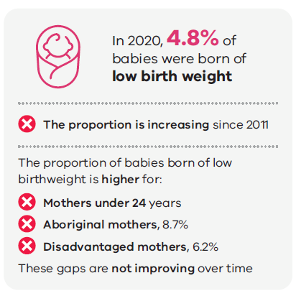
Source: Victorian Perinatal Data Collection

Exposure to harmful substances
Exposure to harmful substances, such as tobacco or alcohol, while in utero increases the likelihood of the baby being of low birth weight, and is associated with increased risks of miscarriage, birth complications, premature birth, birth defects and serious health implications later in life.,

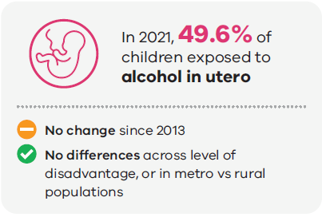
Source: Victorian Child Health and Wellbeing Survey

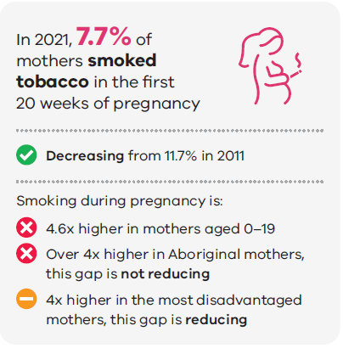
Source: Victorian Perinatal Data Collection26
These trends suggest that a different approach may be required to support our Aboriginal mothers to quit smoking during pregnancy, and efforts should include culturally safe and trauma-informed approaches to health and wellbeing. It is important to recognise the ongoing impact of colonisation, including intergenerational and child removal trauma.
While these behaviours are described as ‘modifiable’, it is important to consider the underlying social and psychological factors driving mothers to smoke tobacco and consume alcohol during pregnancy, rather than attributing blame to the individual for their choices and perpetuating stigma. It is critical to understand the overlapping drivers of smoking and alcohol consumption to inform how we can best support mothers to reduce alcohol and tobacco consumption during pregnancy.

Reduce premature death

Life expectancy
Australians enjoy one of the highest life expectancies compared to other countries across the world, at 83.0 years in 2020.
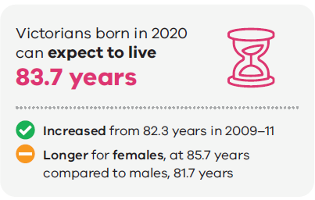
Source: Australian Bureau of Statistics (ABS), Life tables
National data shows that life expectancy for Aboriginal people is 10 years less than for non-Aboriginal Australians, with females living 75.6 years, and males living 71.6 years. While life expectancy for Aboriginal males and females has increased by 2.5 years and 1.9 years respectively since 2010–12, so has the life expectancy for non-Aboriginal Australians. Therefore, the gap in life expectancy has remained the same.

Premature death
Premature death is defined as death before the age of 75. While it is encouraging to see a decline in people dying before the age of 75, this is likely due to improvements in medical treatments, rather than a reduction in people diagnosed with chronic disease.
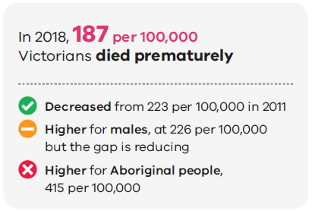
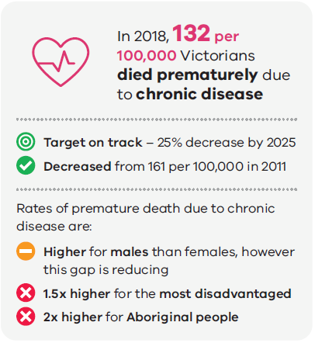
Source: ABS, Causes of Death23
Impact of cardiovascular disease on women’s health outcomes
Although cardiovascular disease causes more premature deaths in males than females, it is the leading cause of death for females. There is evidence that females with cardiovascular disease experience poorer outcomes than males due to differences in symptoms, underrepresentation of females in clinical trials and the assumption by clinicians that cardiovascular disease affects predominately males. This shows that care needs to be taken when interpreting population-level data, to look at differences between males and females, and how both sexes are being affected individually. Research is needed to further examine the underlying drivers of this difference in outcomes, and a sex and gender lens should be applied to all research on identification, treatment and management of non-communicable diseases.
Source: Vogel, B, et al. (2021), ‘The Lancet women and cardiovascular disease Commission: reducing the global burden by 2030’, < https://www.thelancet.com/commissions/women-cardiovascular-disease> The Lancet, 397(10292), accessed 13 November 2023.

Reduce preventable chronic disease
In 2017–18, around 47 per cent of Australians had one or more chronic conditions, increasing from 42.2 per cent of people in 2007–2008.33 It is expected that these numbers will continue to increase.
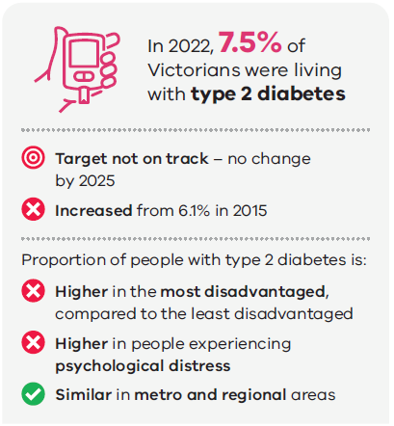
Source: Victorian Population Health Survey
The Victorian Population Health Survey data shows no difference in the prevalence rate of type two diabetes between Aboriginal and non-Aboriginal people.35 However, this data should be interpreted with caution, as the small number of Aboriginal people living in Victoria can lead to large variations in the data, and national trends show twice the proportion of Aboriginal people diagnosed with type two diabetes, compared with non-Aboriginal people.
Other measures of chronic disease
Despite decades of effort to reduce the impact of chronic disease, there has been no improvement in the prevalence of chronic disease, and more people are diagnosed with one or more chronic diseases. As the population increases, so will the number of people affected by chronic diseases, impacting quality of life and putting further pressure on our health services.
Measures to note include that:
- age-standardised rates of cancer incidence have remained constant since 2010
- data from the Victorian Population Health Survey shows no change in the proportion of people with cardiovascular disease since 2015.
Sources:
Victorian Cancer Registry (2022) ‘Cancer in Victoria in 2021’, <https://www.cancervic.org.au/research/vcr> accessed 13 November 2023.
Victorian Agency for Health Information, Victorian population health survey 2020, <https://vahi.vic.gov.au/reports/population-health/victorian-population-health-survey-2020-dashboards> accessed 13 November 2023.
ABS (2022), Health Conditions Prevalence, <https://www.abs.gov.au/statistics/health/health-conditions-and-risks/health-conditions-prevalence/latest-release#cite-window1>, accessed 14 April 2023.

Increase self-rated health
Self-reported health status is a reliable predictor of ill health, future healthcare use and premature mortality, independent of other medical, behavioural or psychosocial risk factors.
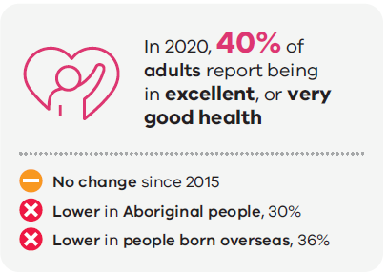
Source: Victorian Population Health Survey35
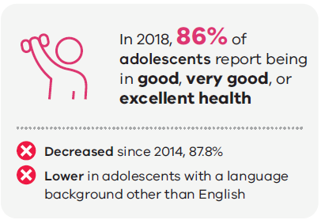
Source: Victorian Student Health and Wellbeing Survey
These figures reflect that while many Victorians feel they are in very good, or excellent health, the majority believe that their health could be better. Some groups are also being left behind, and are not adequately supported by our environments and health systems to be as healthy as they can.

Decrease unintentional injury
Injury is a complex public health issue and is the leading cause of death in people under 45 years of age in Victoria. Injury is the fifth leading health condition contributing to the burden of disease, accounting for nine per cent of the total disability adjusted life years in Australia. Injury prevention efforts across many sectors over the years have led to improvements in some causes of unintentional injury.
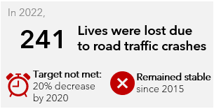
Source: Road Crash Information System
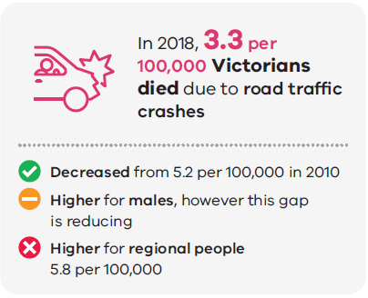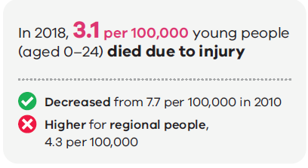
Source: ABS, Causes of Death23
Due to consistent reduction in the injury-related death rate for males and regional Victorians, gaps in outcomes between these groups has been decreasing over time. These trends are encouraging as they indicate that our injury prevention and management policies and interventions are reaching the people who are most at risk.
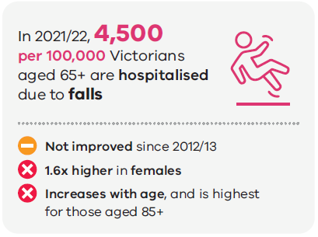
Source: Victorian Admitted Episodes Dataset

Increase oral health
Good oral health is fundamental to enjoying health and wellbeing. In contrast, poor oral health is both an outcome of and precursor to poor diet, and is often a result of consumption of sugar, lack of good oral hygiene, lack of fluoridated water and lack of access to dental health services.
Tooth decay is the most prevalent disease in Victoria, with 43 per cent of all children aged 5–10 years having signs of tooth decay. Dental conditions are the highest cause of all potentially preventable hospitalisations in children aged 0–9 years, predominantly because of tooth decay.43
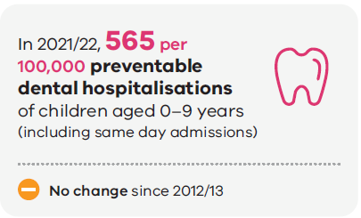
Source: Victorian Admitted Episodes dataset41
There are indications that hospital admissions are higher for Aboriginal people living in Victoria, compared with non-Aboriginal people, and higher for people living in the most disadvantaged areas, compared with the least disadvantaged. The data in Victoria is too small to definitively understand the scale of this difference and whether it is getting bigger or smaller over time. However, these indications are consistent with national trends.

Increase sexual and reproductive health

Pregnancy and contraception
Motherhood for women under the age of 20 can be a positive and maturing experience. However, mothers who give birth under the age of 20 are more likely to experience socioeconomic disadvantage, and have higher rates of behavioural risk factors that can have a compounding impact on the health and wellbeing of both the mother and child. As described earlier, mothers aged under 20 have a higher risk of smoking during pregnancy and giving birth to babies of low birth weight.
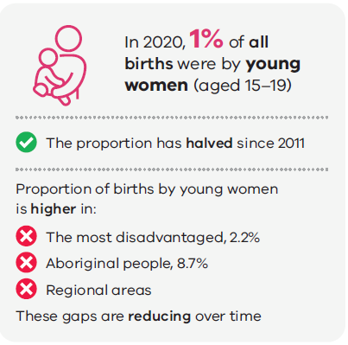
Source: Victorian Perinatal Data Collection26
Pleasingly, the gaps in outcomes between young women from all backgrounds has reduced over time, indicating our efforts to improve outcomes in groups most at risk have been working. However, given the intersection of this health outcome with other key indicators of health and wellbeing, it is clear that further work is required to reduce inequity in this area.
Condom use remains one of the most effective methods to prevent transmission of sexually transmitted diseases, such as HIV, gonorrhoea, chlamydia and human papilloma virus. While condoms aren’t the most effective form of contraception, they still play an important role in preventing unplanned pregnancies. The proportion of male and female adolescents who practice safe sex by always using a condom has remained constant at around 25 per cent from 2014 to 2018.37

Sexually transmitted infections
Consistent decreases over time and decreases in gaps between at risk population groups highlight the impact of sustained and targeted efforts at a state and local level to prevent transmission of HIV and hepatitis C in those most at risk. As both diseases have historically been associated with men who have sex with men and intravenous drug use, infection can come with stigma.,
Stigma perpetuates the cycle of transmission by making people reluctant to seek support and treatment for the disease.45 Breaking down the stigma associated with these diseases has been a key component in reducing transmission, and it is essential to continue work to eliminate them from the community.
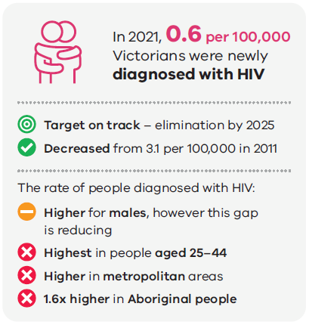
Source: Victorian Public Health Events Surveillance System
There were 19 cases of HIV among the Aboriginal population between 2016 and 2021. This represents a rate 1.6 times higher than for the non-Aboriginal population.
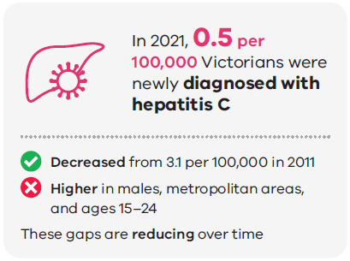
Source: Victorian Public Health Events Surveillance System47
The notification rate for gonorrhoea has been consistently increasing, from 30.1 per 100,000 in 2011 to 139.6 per 100,000 people in 2019.47 Rates of gonorrhoea improved marginally in 2020, likely due to reduced socialisation and testing throughout the COVID-19 pandemic. However, notifications rose again in 2021, suggesting a need to further promote safer sex practices in people most at risk.
Infection rates in Aboriginal communities
For many reasons that involve a complex interplay of cultural and social determinants of health, Aboriginal people in Victoria continue to experience poorer blood-borne virus and sexually transmitted infection health outcomes than non-Aboriginal Victorians. Gonorrhoea infection was over 2.5 times higher among the Aboriginal population than for the non-Aboriginal population in 2021.
In addition, rates of syphilis infection are a growing concern. The rates of infectious syphilis in Aboriginal Victorians increased by 85 per cent between 2016 and 2019. From 2020 to 2021, rates of infection increased by 96 per cent. The rate of infectious syphilis among the Aboriginal population was 4.5 times higher than the non-Aboriginal population in 2021.
Source: Victorian Department of Health (2022), Victorian Aboriginal sexual and reproductive health plan 2022–30, <https://www.health.vic.gov.au/victorian-sexual-reproductive-health-viral-hepatitis-strategy-2022-30>, accessed 13 November 2023.

Outcome 1.2: Victorians have good mental health
Maintaining high levels of mental wellbeing has a wide range of benefits to health, including:
- protecting against the risk of psychological distress
- improving recovery from mental health conditions
- improving physical health
- increasing participation in social and economic activities.
We are all likely to experience psychological distress in some form over the course of our lives. However, some people are affected more significantly than others, and our experience of psychological distress will vary across different stages of our lives.
The drivers of psychological distress are complex and are intrinsically linked with other social and behavioural determinants of health outcomes, such as experiences of racism or discrimination, socioeconomic status, employment, obesity and smoking., Recent stressors, such as the COVID-19 pandemic, the greater frequency and severity of natural disasters, and ensuing social and economic conditions, have led to an increase in the number of people experiencing poor mental health and wellbeing.
Adopting a preventative approach to improving wellbeing will put the focus on addressing the drivers of poor mental health and wellbeing, as well as identifying opportunities to improve other health and wellbeing outcomes more broadly.49
Mental health and wellbeing outcomes and performance framework
In response to recommendations from the Royal Commission into Victoria’s Mental Health System, the Victorian Government has developed a Mental health and wellbeing outcomes and performance framework with significant input from people with lived experience of the impact of poor mental health and wellbeing. This framework is aligned to the outcomes framework where relevant, but includes a more expansive range of measures that are specific to mental health and wellbeing outcomes. It also measures how mental health services, workforces and the system support improvements in outcomes.

Increase mental wellbeing
Experiencing persistent, high levels of psychological distress contributes to lower levels of life satisfaction and can having lasting impacts on physical health. People who experience trauma, discrimination, poverty or multiple forms of exclusion are at greater risk of mental distress.
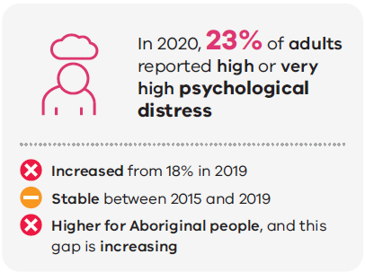
Source: Victorian Population Health Survey35
The level of psychological distress spiked in 2020. Further monitoring is needed to see if levels of psychological distress will continue to increase into the future or return to 2015-19 levels.
In older Aboriginal Australians, higher levels of psychological distress are largely attributable to the ongoing impact of colonisation, intergenerational trauma, child removal, experiences of racism and barriers to accessing health care, which also drive differences in socioeconomic status, morbidity, disability and social support access.
The Royal Commission into Victoria’s Mental Health System highlighted that one in three Aboriginal people living in Australia experience high or very high levels of psychological distress, which is almost three times the rate for non-Aboriginal people. One study found that twice as many Aboriginal adolescents as non-Aboriginal adolescents (aged 18–24 years) living in Australia experience considerable psychological distress.
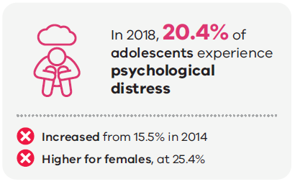
Source: Victorian Student Health and Wellbeing Survey37

Resilience
Resilience is the ability to recover from setbacks, adapt to difficult circumstances that can’t be changed, and to learn and grow from such experiences. Resilience is determined by various factors, including individual characteristics, personal and family relationships, and environmental influences, such as school and community – all of which are key protective factors for mental health and wellbeing.
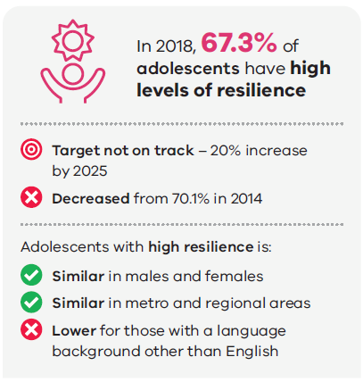
Source: Victorian Student Health and Wellbeing Survey37
Supporting adolescents to develop high levels of resilience will improve their capacity to maintain positive health and wellbeing at a critical stage of development and into adulthood.

Reduce suicide
Suicide has a devastating impact, and can have a long-lasting effect on families, friends, workplaces and communities. There are a range of complex factors that may influence our mental health and wellbeing, and may contribute to a person’s experience of suicidal behaviour. Reducing suicide is the goal, but to achieve this, we must address and reduce the factors that contribute to suicide and identify opportunities to build a stronger and more connected support system.
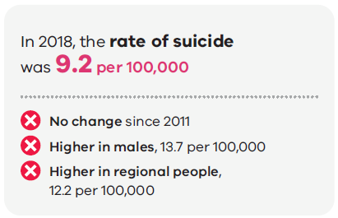
Source: ABS, Causes of Death23
The national suicide rate for Aboriginal people is estimated to be twice the rate of the general population, and suicide among Aboriginal people generally occurs at a much younger age. In 2021, the Coroners Court of Victoria reported that the number of suicides of Aboriginal people increased by 75 per cent in 2021.
Every incident of self-harm, suicide attempt and passing by suicide is a unique experience, which can improve our understanding of suicidality and instruct stronger foundations for suicide prevention and response.

Outcome 1.3: Victorians act to protect and promote health
For Victorians to be the healthiest people in the world, it is essential they are supported to make decisions that are good for their own health, and act to support the good health and wellbeing of others in the community. There are many behavioural risk factors, described as modifiable, that increase or decrease the risk of developing disease, such as smoking, healthy eating and physical activity.
Traditionally, health promotion interventions have had a strong focus on encouraging individuals to change their behaviours to reduce the risk of disease. However, the focus on behavioural risk factors assumes that all individuals have the freedom and capacity to choose a healthy lifestyle. Therefore, individuals who engage in unhealthy behaviours are seen to be responsible for their own ill health.
Focusing only on behavioural risk factors, without addressing the underlying causes of the behaviour, stigmatises people who engage in unhealthy behaviours and ignores the underlying social, emotional and environmental factors that are driving the unhealthy behaviours.59,
This highlights the importance of creating settings that support people to make healthier choices. This can be done by leveraging community-wide, structural influences on health, such as:
- green space for exercise
- access to affordable, fresh healthy food
- factors to reduce workplace and financial stress
- a reduction in violence.
These influences support individuals to make changes to behaviour that protect and promote their health for the long term.

Increase healthy eating and active living

Healthy eating
Good nutrition is essential for health and wellbeing. Dietary risk factors were the third-leading cause of modifiable disease burden in Australia in 2018, contributing to 9.9 per cent of deaths.61 Poor diet in early life can start a trajectory that increases the lifetime risk of cardiovascular disease, type 2 diabetes and some cancers associated with obesity.
Healthy eating has strong links to promoting mental health and treating mental illness, such as depression. For example, people who eat a healthy diet (a diet rich in vegetables, fruits, wholegrains and fish) are up to 35 per cent less likely to experience depression. Conversely, a diet high in processed and nutritionally poor foods is associated with increased risk of developing depression.
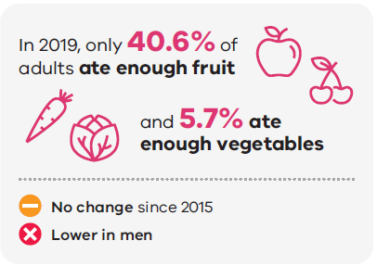
Source: Victorian Population Health Survey35
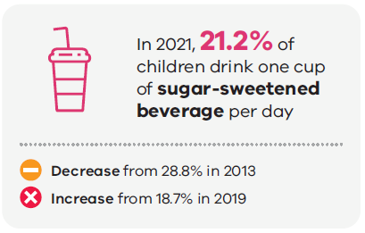
Source: Victorian Child Health and Wellbeing survey29
The World Health Organization recommends that all babies are exclusively breastfed for the first six months of life. Breastmilk is the best food to support the health and wellbeing of infants, and protects against development of non-communicable diseases later in life.
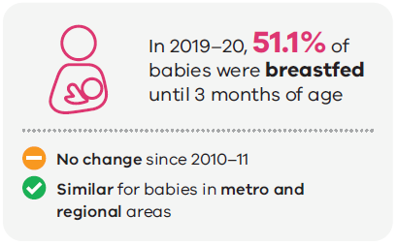
Source: Maternal Child Health Collection
However, there are some local government areas (LGAs) where the proportion of babies breastfed until three months of age is significantly lower than the state average, sometimes below 30 per cent. Place-based responses are needed to understand the barriers to mothers breastfeeding in these areas, and appropriate support and intervention services provided to enable more mothers to breastfeed for longer.

Physical activity
Physical activity has been shown to improve health-related quality of life, reduce mortality rates, significantly improve function, physical and mental health, and reduce pain and disability in people of all ages. In contrast, a sedentary lifestyle is a major risk factor for non-communicable diseases, such as cardiovascular disease, cancer and diabetes.65 In 2018, physical inactivity contributed to 3.6 per cent of fatal burden (84,717 years of life lost) and 1.5 per cent of non-fatal burden (37,966 years lived with disability) in Australia.
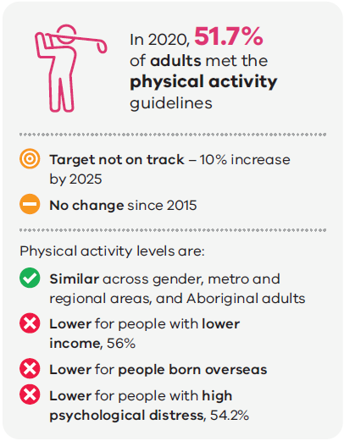
Source: Victorian Population Health Survey35
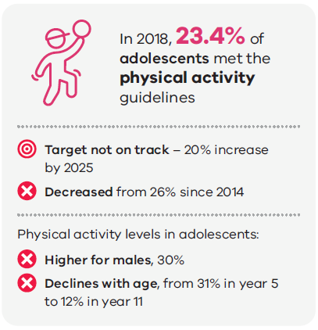
Source: Victorian Student Health and Wellbeing Survey³⁷
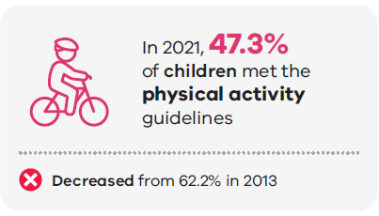
Source: Victorian Child Health and Wellbeing Survey²⁹

Screen time
The amount of time spent using screens has been linked with obesity, sleep problems, depression and anxiety, and sedentary behaviour. It can also impact development of physical and cognitive abilities. Over recent years, screen time has become more complicated, with an ever-expanding variety of electronic media devices available, including computer use, video games and ownership of devices, such as tablets and smart phones, which are frequently required for work and education, and from an increasingly young age.
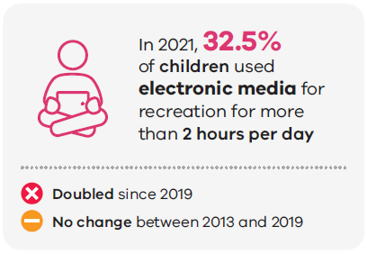
Source: Victorian Child Health and Wellbeing Survey29
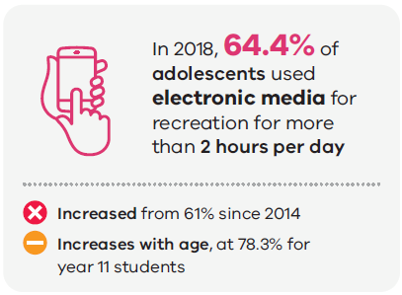
Source: Victorian Student Health and Wellbeing Survey³⁷

Reduce overweight and obesity
Obesity is close to overtaking tobacco as the leading risk factor contributing to non-communicable disease. Overweight and obesity increases the likelihood of developing many chronic conditions, such as cardiovascular disease, asthma, back problems, knee problems, chronic kidney disease, dementia, diabetes and some cancers.
Evidence shows that if Australians at risk of disease due to overweight and obesity reduced their body mass index (BMI) by one point, the burden of disease due to obesity would drop significantly.69 Halting the rise in obesity by maintaining weight over the lifetime would also prevent a significant portion of the burden of disease.
It is now well understood that short-term interventions aimed at individual weight loss do not support individuals to maintain a healthy weight over the long term. Australia needs action at all levels to change our food environments and built environments to be healthy and sustainable, to support people to make healthy and active choices in the settings where we live, work and play.
A note on using the BMI
At the population level, a commonly used categorisation of body weight status is the BMI, calculated using the height and weight of the individual [BMI = weight (kg)/height (m2)]. According to the BMI weight categories, anyone with a BMI of 25 or higher is overweight, and a BMI of 30 or higher is classified as obese.
However, BMI is a poor measure of body fat percentage, because it cannot distinguish between body fat and muscle. Therefore, an individual who is very muscular, with a low body fat percentage, could be classified as obese. Nevertheless, BMI still has a place in monitoring the health of a population, because the data is easy to collect and can be used to monitor trends over time (Victorian Agency for Health Information, 2021).
Self-reports and collecting physical measurements of height and weight result in different population estimates. People typically underreport their weight and over-report their height, leading to lower estimates of their BMI and, therefore, lower estimates of the prevalence of overweight and obesity (Victorian Agency for Health Information, 2021). In the National Health Survey undertaken by the ABS, height and weight measurements are collected by a researcher to generate the estimates. In the Victorian Population Health Survey, the height and weight estimates are self-reported. While this leads to discrepancies in the overall proportion of people who are overweight and obese, similar trends are reflected in both sources, and both are considered reliable.
Source: Victorian Agency for Health Information, Victorian Population Health Survey 2019 report, Victorian Department of Health, Melbourne.
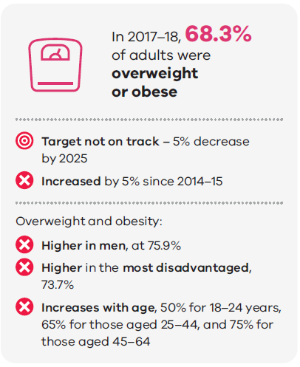
Source: ABS, National Health Survey
These findings indicate there is opportunity for primary prevention by focusing on healthy weight management at all stages of life, rather than only focusing on losing weight.
Trends are reflected in the self-reported data captured by the Victorian Population Health Survey, although the numbers are slightly lower, consistent with known limitations of self-reported height and weight data.
Recent results from the Victorian Population Health Survey show that the proportion of adults who are overweight or obese has been steadily increasing from 50 per cent in 2015 to 51.3 per cent in 2020, and with a significant jump to 56.2 per cent in 2022.35 This indicates that despite our collective efforts to reduce overweight and obesity across the state for many years, urgent action at all levels is needed if we are to meet our targets and see real improvements in this measure.

Children
Obesity in early life is linked to early-onset type 2 diabetes in children, which has a profound impact on physical and mental health, including life expectancy. Obese children and adolescents are five times more likely to be obese in adulthood than those who are not obese, with 80 per cent of obese adolescents going on to be obese in adulthood.
Although the rate of children and young people who are overweight has remained at 25 per cent from 2007 to 2019, this is concerningly high and a significant increase from 20 per cent in 1995.
Aboriginal children and adolescents, those who have a disability, those who live in inner regional areas and those who live in the lowest socioeconomic areas, are more likely to be overweight or obese than other children and adolescents.72

Reduce smoking
Smoking is the biggest single contributor to the burden of disease, contributing to 12 per cent of fatal and non-fatal burden. Smoking is associated with an increased risk of a wide range of health conditions, including heart disease, diabetes, stroke, cancer, kidney disease, eye disease and respiratory conditions, such as asthma, emphysema and bronchitis.
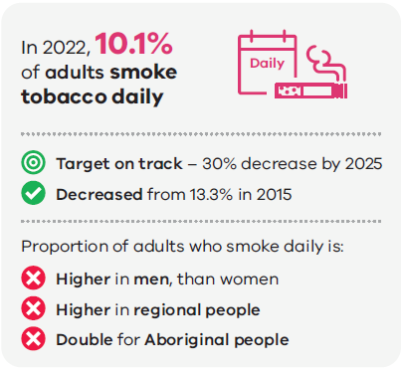
Source: Victorian Population Health Survey³⁵
In 2018, tobacco use was responsible for 20 percent of the health gap between Aboriginal Australians and non-Aboriginal Australians.73 While we can’t determine long-term trends from Victorian data, national trends show there has been no change to the gap in smoking prevalence between the Aboriginal adult population and the non-Aboriginal population from 1994 to 2018–1973, as rates for non-Aboriginal Australians are declining at a similar rate. The underlying drivers of this difference in outcomes is discussed later in this report.

Adolescents
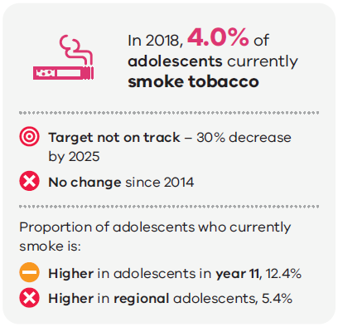
Source: Victorian Student Health and Wellbeing Survey37
The proportion of year 11 adolescents currently smoking has decreased from 20.3 per cent in 2014, to 12.4 per cent in 2018. However, more recent whole-of-population data is needed to properly assess how we are tracking against the target to reduce smoking in adolescents by 30 per cent by 2025, and to detect any impacts of COVID-19 and the rise in e-cigarettes on smoking behaviour.
E-cigarettes
The rapid rise in availability and use of e-cigarettes (commonly called vaping) is a threat to public health that requires urgent action.
There is clear evidence of widespread use and addiction to e-cigarettes in Australia, particularly among youth, which follows global patterns of consumption. In Australia, it is estimated that 11.3 per cent of people aged 14 and over (approximately 2.4 million people) reported ever having used e-cigarettes, up from 8.8 per cent in 2016 and 4.5 per cent in 2013 (Australian Institute of Health and Welfare (AIHW), 2020).
E-cigarette use was greater in young people aged 18–24 (26.1 per cent) (AIHW, 2020). A greater proportion of males aged 15–24 reported having ever used an e-cigarette, compared to females (26.8 per cent and 17.2 per cent respectively) (AIHW, 2020).
While the impacts of e-cigarette use on long-term health outcomes is unknown, there is conclusive evidence that nicotine e-cigarettes and their constituents can cause poisoning, acute lung injury, injuries and burns, and immediate toxicity through inhalation, including seizures (Banks, 2022). Environmental impacts of e-cigarettes include waste, fires and indoor airborne particulate matter, which, in turn, are likely to have adverse health impacts.
One of the greatest causes for concern is the potential for another generation of young people to become addicted to nicotine, undermining years of progress in reducing tobacco-related harm.
Sources:
AIHW (2020), National Drug Strategy Household Survey 2019, <https://www.aihw.gov.au/reports/illicit-use-of-drugs/national-drug-strategy-household-survey-2019/contents/summary>, accessed 17 April 2023.
Banks E, et al. (2022), Electronic cigarettes and health outcomes: umbrella and systematic review of the global evidence, <https://www.mja.com.au/journal/2023/218/6/electronic-cigarettes-and-health-outcomes-umbrella-and-systematic-review-global>, accessed 13 November 2023

Reduce harmful alcohol and drug use
Alcohol plays a significant role in Australian culture and is consumed in a wide range of social circumstances. There is no safe level of alcohol consumption that does not affect health, and drinking any amount of alcohol increases your risk of developing non-communicable diseases. However, the amount of alcohol consumed can significantly increase the risk of developing health problems and the risk of alcohol-related injury or harm.
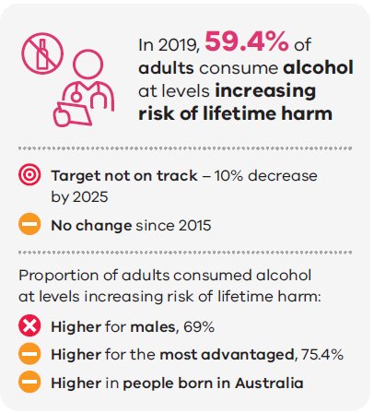
Source: Victorian Population Health Survey35
Similar trends are reflected in the proportion of adults who consume alcohol at levels that increase the risk of alcohol-related injury on a single occasion at least monthly, which has seen no significant change from 2015 to 2019 at 13.5 per cent.35 However, recent data from the National Drug Strategy Household Survey 2019 shows that young adults are drinking less alcohol overall, and more people in their 50s are consuming alcohol at risky levels.
There is no significant difference in these measures between Aboriginal and non-Aboriginal people living in Victoria, people experiencing different levels of psychological distress, and between people living in metropolitan and regional areas.35
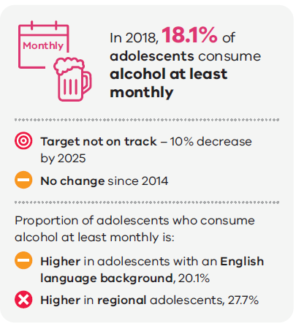
Source: Victorian Student Health and Wellbeing Survey³⁷
This data shows we are not on track to meet the target to reduce excess alcohol consumption by adolescents and adults by 2025, as there is no sign of change in any of these measures.

Increase immunisation
Immunisation remains the safest and most effective way to stop the spread of many of the world’s most infectious diseases.
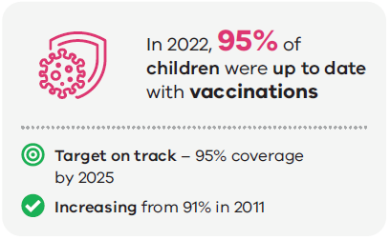
Source: Childhood Immunisation Coverage data
More striking improvements are seen in vaccination coverage by age five for Aboriginal children living in Victoria, which has increased from 86.5 per cent in 2011, to 95.6 per cent in 2022.77 These improvements are likely reflective of the successful public health interventions and policies to increase uptake of childhood immunisations across the state. The impact of this success is also reflected in the notification rate of vaccine-preventable diseases (diphtheria, tetanus, pertussis, poliomyelitis, measles, mumps and rubella), which has shown a steady decline from 159 per 100,000 people in 2011, to 4.7 per 100,000 in 2021.
Further examination of this data at an individual disease level can be done using the Interactive Infectious disease reports <https://www.health.vic.gov.au/infectious-diseases/interactive-infectious-disease-reports>.

Domain 2: Victorians are safe and secure

Outcome 2.1: Victorians live free from abuse and violence
Feeling safe in the areas that we live has a strong influence on our health and wellbeing. Alternatively, feeling unsafe causes stress and contributes to poor mental wellbeing. It can also affect our behaviour and engagement with the community, as people who feel unsafe in their neighbourhoods are less likely to engage in physical activity or social activities, and have fewer positive social interactions.79
Experiencing violence directly can influence our health and wellbeing beyond the direct harm to physical health. It impacts our perceptions of safety and contributes to mental illness, post-traumatic stress, cardiovascular disease and premature mortality.
Family violence and sexual violence can impact an individual’s ability to participate in employment, as well as their financial security and access to safe, affordable housing. It can impact relationships with family and friends, increase isolation, and can impact children’s emotional, behavioural and social wellbeing, including attendance and achievements at school.
All Victorians should be able to live free from violence and feel safe in the communities where we live, work, and play.

Increase community safety
Although violence can be experienced by people in a range of different ways, settings and relationships, violence is largely a gendered issue, perpetrated overwhelmingly by men against women. One third of women have experienced physical violence since the age of 15 years, and one in five have experienced sexual violence.
While hospital admissions rates due to assault are higher for men, many women do not present to hospital when they experience family or sexual violence for many reasons. Therefore, women may be underrepresented within hospital admissions data.

Hospitalisation rate due to assault
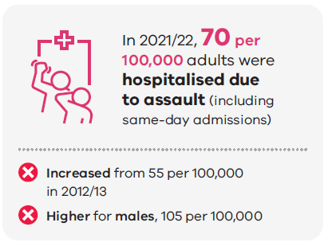
Source: Victorian Admitted Episodes Dataset⁴¹

Feeling safe
Data for the proportion of adults feeling safe walking in their street at night is only available from 2017 onwards. Therefore, there is not enough evidence to say if trends are increasing or decreasing over time. However, there are clear trends that women, people with low household income, people born overseas, people with high levels of psychological distress and those living in metropolitan areas are significantly less likely to feel safe walking down their street at night.

Outcome 2.2: Victorians have suitable and stable housing
In Australia, most people are lucky enough to enjoy safe and secure housing throughout their lives. However, tough economic conditions and the increasing cost of buying and renting a house is making it more challenging for Victorians to secure housing. These issues are becoming increasingly important, considering the increasing impact of climate change on health and due to changing demographic trends, including urbanisation and an ageing population.

Decrease homelessness
On census night in 2021, 30,660 Victorians were experiencing homelessness, which is 0.47 per cent of the Victorian population. This number has jumped from 22,306 in 2011. Of the people who are homeless, males make up 58 per cent and females make up 42 per cent. Aboriginal people living in Victoria are overrepresented, making up four per cent of the people who are homeless, while only representing one per cent of the Victorian population.

Domain 3: Victorians have the capabilities to participate

Outcome 3.2: Victorians participate in and contribute to the economy
There is a well-established relationship between employment and good health and wellbeing, where unemployment is associated with poorer health. This relationship is circular and complex. Poor health and wellbeing can lead to job loss and prevent re-employment, and unemployment can contribute to poor health and wellbeing through reduced financial security and participation in the community.,
For employment to be beneficial for health and wellbeing, it is important that people have good working conditions, are adequately paid, are supported by the workplace and feel safe at work.88
Employment is a fundamental underlying cause of health inequality and provides an indication of whether inequality exists. To reduce inequity, all Victorians must be provided with equal opportunity to access employment, and employers need to create workplaces that are inclusive for people of all ages, genders, abilities and cultural backgrounds.

Increase labour market participation
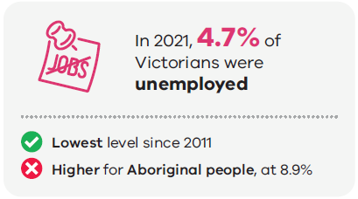
Source: Census of population and housing
There are early signs that the gap in unemployment between Aboriginal and non-Aboriginal people living in Victoria is decreasing over time, as the unemployment rate for Aboriginal people has dropped significantly from 14 per cent in 2016 to 8.9 per cent in 2021.
Employment for people living with disability
Workplaces that are inclusive of people with disabilities will contribute to better health and wellbeing outcomes and reduce inequities (Emerson et al. 2018). However, people living with a disability often face barriers to finding and engaging in employment, largely due to stigma and assumptions about people with disabilities that are not supported by evidence. Analysis by AIHW has shown that while 90 per cent of people with a disability aged 15-64 in the labour force are employed, this is lower than people of the same age without a disability (AIHW 2023). People with a disability are also twice as likely to be unemployed (10 per cent) compared with those without a disability (5 per cent). The percentage of unemployed people with a disability has increased since 2003 (8 per cent) while the rate of people without a disability has remained constant.
Sources:
Emerson E, et al. (2018) ‘The association between employment status and health among British adults with and without intellectual impairments: cross-sectional analyses of a cohort study’, <https://pubmed.ncbi.nlm.nih.gov/29587712/>, BMC Public Health 18(401), accessed 13 November 2023.
AIHW (2022) ‘People with disability in Australia’, https://www.aihw.gov.au/reports/disability/people-with-disability-in-australia/contents/about, accessed 22 March 2023.

Outcome 3.3: Victorians have financial security
Financial security can profoundly impact health, wellbeing and community participation. Financial insecurity can lead to an inability to pay for food, housing, energy and health care, all of which are key determinants of good health and directly impact mental and physical health.,

Decrease financial stress
Food insecurity exists ‘whenever the availability of nutritionally adequate and safe foods or the ability to acquire acceptable food in socially acceptable ways is limited or uncertain’. The inability to purchase food is at the extreme end of food security and is likely to result in skipping meals and severe hunger.
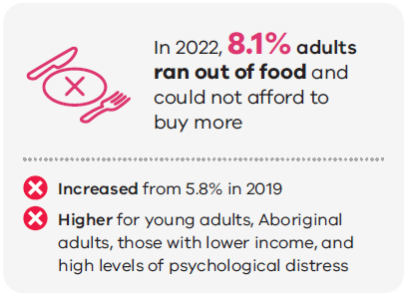
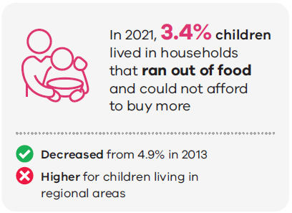
Source: Victorian Population Health Survey35, Victorian Child Health and Wellbeing Survey29

Domain 4: Victorians are connected to culture and community

Outcome 4.1: Victorians are socially engaged and live in inclusive communities
Social isolation and loneliness are risk factors for premature mortality, in the same way that smoking, obesity and physical inactivity have a known impact. Engaging in paid and volunteer work, caring for others, and being involved in sporting or community organisations are associated with reduced levels of isolation and loneliness.,
Feeling that the things that you do are worthwhile and being satisfied with your life are conducive to feelings of happiness and health and wellbeing. People with higher wellbeing and happiness have lower rates of illness, recover more quickly, and generally have better physical and mental health.

Increase connection to culture and communities
Social connectedness and feeling like you belong to a community are key social determinants of health. Belonging to an organised group can promote healthy behaviours, as well as directly leading to better health and wellbeing. Organised groups can relate to sport, religion, school, community or professional life.35
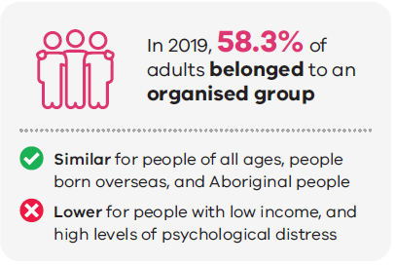
Source: Victorian Population Health Survey³⁵

Increase access to social support
Social capital is widely used to explain and describe the social environment of communities, and plays a significant role in individual health and wellbeing. Social and civic trust are important indicators of social capital and may be a cause or consequence of social capital. Concepts of trust and wellbeing are tightly linked.
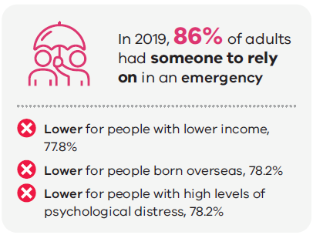
Source: Victorian Population Health Survey35
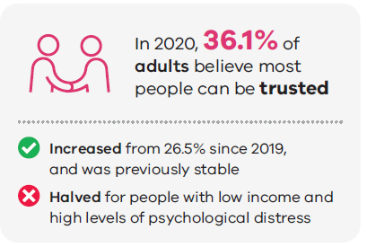
Source: Victorian Population Health Survey³⁵

Life satisfaction
Life satisfaction captures how people assess their life as a whole, rather than how they are feeling in that moment, or how they feel about particular aspects of their life. Feeling valued by society is an important component of social capital and wellbeing. The extent to which a person feels valued by others who are important to them is strongly related to psychological wellbeing and is a source of self-esteem.
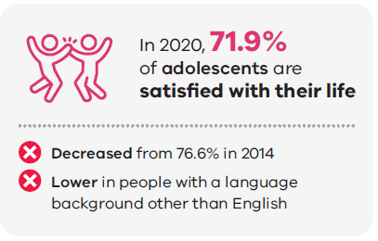
Source: Victorian Student Health and Wellbeing Survey³⁷
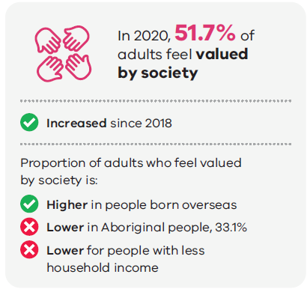
Source: Victorian Population Health Survey³⁵

Outcome 4.2: Victorians can safely identify with their culture and identity
Feeling safe to connect with and practice culture has a protective effect on health and wellbeing, and builds resilience. Evidence suggests that a strong cultural identity is associated with a stronger sense of purpose, increased self-esteem and self-worth, and stronger social networks, while also reducing the impact of experiencing discrimination.
Racism is a key barrier and determinant of health for Aboriginal people and other culturally and linguistically diverse groups in Victoria. For Victorians to enjoy the highest standards of health, wellbeing and participation, we need to support all Victorians of all ages to have positive relationships with others, and to provide safe environments that promote strong connections with culture.

Aboriginal cultural safety
For Aboriginal people, the concept of health encompasses the physical, social, emotional and cultural wellbeing of individuals, families, wider kinship groups and entire communities. Achieving good health and social and emotional wellbeing for Aboriginal people is equally dependent on experiences in the social, historical, political and cultural determinants of health.
Experiencing racism directly and living in anticipation of experiencing racism can have a significant impact on an individual’s mental and physical wellbeing. Living in a society with systemic and institutional racism prevents Aboriginal people from having the same opportunity and access to improve health and wellbeing. This is reflected in the evidence that Victorian adults who frequently experience racism are 2.5 times more likely to have poor physical health than those who do not experience racism.
The importance of recognising the strengths, resilience and connectedness of First Peoples and their communities to provide safe, supportive and culturally appropriate health care is at the heart of self-determination.
It is important that Aboriginal people in Victoria can access culturally safe and culturally responsive health services when they need them – whether this is from an Aboriginal organisation or a mainstream service. A culturally safe and racism-free health and community service system is one in which people feel safe, where they can freely affirm their identity and where their needs are met.

Increase acceptance of diversity
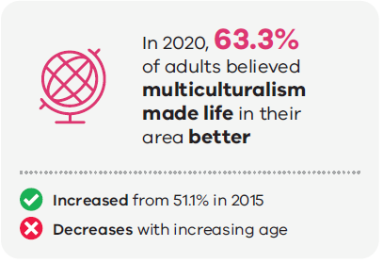
Source: Victorian Population Health Survey³⁵
In 2020, 75.9 per cent of people aged 18–24 believed multiculturalism definitely made their life better, compared with 62 per cent in 2015. While only 45 per cent of people aged 75–84 agreed in 2020, this has increased from 32 per cent in 2015.35
While this data shows we are heading in the right direction, it is clear there is still more we can be doing to celebrate the incredible cultural diversity we have in Victoria and make positive steps towards removing racism of all forms.

Domain 5: Victoria is liveable

Outcome 5.2: Victorians have access to sustainable built and natural environments
A leading threat to the health and wellbeing of Victorians is the impact of our changing climate, caused by global greenhouse gas emissions. Risks to health associated with climate change in Australia include:
- rising heat
- changing rainfall patterns leading to drought and flooding
- changing patterns of infectious disease
- changes to quality of our air, water, and food.
These changes can result in direct harms to health, such as heat-related morbidity and mortality, increased illness, displacement, and rising injuries and fatalities due to extreme weather events.⁹⁸
Since national climate records began in 1910, Australia’s climate has warmed by an average of 1.47± 0.24˚C. Victoria is already experiencing an increase in the number of very hot days and very high fire danger days, a decrease in average rainfall, and more intense extreme rainfall events. Victorian climate projections suggest that these trends and associated impacts are expected to continue in the future.,
A certain amount of climate change is locked in due to already increased concentrations of greenhouse gases in the atmosphere. However, how much the climate will change depends strongly on the greenhouse gas emissions pathway the world follows.
As a result, there is a need to accelerate both emissions reduction and implementation of adaptation actions to mitigate the impacts of climate events on health, and to ensure the health and wellbeing of Victorians into the future.
Updating Domain 5. Victoria is liveable
Since the release of the outcomes framework, the Victorian Government has committed to more ambitious greenhouse gas emission targets. This includes achieving net zero emissions by 2045. When the outcomes framework is refreshed, the climate change related targets will be updated to include more recent and relevant commitments, and the measures will be reviewed to ensure the impact of emerging climate mitigation and adaptation health issues is visible.

Increase environmental sustainability and quality

Energy
The proportion of electricity generated by renewable sources in Victoria has steadily increased each year, from 12.8 per cent in 2013–14 to 35.1 per cent in 2021-22. This means we have met the target of 25 per cent of Victoria’s electricity to be generated by Victorian-built renewable generation by 2020, and we are on track to meet the 40 per cent target by 2025.
Between 2005 and 2011, Victoria’s greenhouse gas emissions per capita remained constant at around 23–25 tonnes of carbon dioxide per person. There was a significant decline in greenhouse gas emissions per capita from 2011 to 2020, with emissions halving from 25 to 12.44 tonnes of carbon dioxide per person.
Good air quality is essential for health
Victoria’s air quality is considered good, relative to international standards, and readings of air quality throughout Victoria are almost always rated as Good (Good = particulate matter (PM)10 less than 40 μg/m³ and PM2.5 less than 12.5 over 24 hours).
However, the links between air pollution, population exposure to air pollution and adverse health effects are now well established, and exposure to even small levels of air pollution can increase the risk of respiratory and cardiovascular conditions, and premature death (Environment Protection Authority (EPA), 2018). Fine particles cause the largest health burden and any reduction in air pollution is beneficial to health (DELWP, 2019).
Air quality monitoring throughout Victoria recorded prolonged significant increases in the levels of PM2.5 and PM10 in Melbourne throughout January 2020, due to the severe bushfire event (EPA, 2018). Predictions for a drier, hotter climate means Victoria is likely to experience harsher bushfire seasons, which, together with projected population increases, pose challenges to Victoria’s future air quality.
Climate change may also indirectly increase natural sources of PM by increasing fire weather and dust storms, and affecting the production and dispersion of aeroallergens, such as pollens and moulds (DELWP, 2019).
Transition to cleaner energy sources and encouraging active transport have the potential to mitigate the effects of climate change, while improving our health and wellbeing. The Victorian Air Quality Strategy <https://www.environment.vic.gov.au/sustainability/clean-air-for-all-victorians>, sets out how we will further reduce air pollution and tackle major pollution sources.
Sources:
Environmental Protection Authority Victoria, 2022, Air quality, Victorian Government, https://www.epa.vic.gov.au/for-community/environmental-information/air-quality, accessed 17 April 2023.
Department of Environment, Land, Water and Planning (DELWP) 2019, Estimating the costs of air pollution in Victoria, <https://www.climatechange.vic.gov.au/climate-action-targets>, accessed 13 November 2023.
EPA Victoria (2018) 1709: Air pollution in Victoria – a summary of the state of knowledge, <https://www.epa.vic.gov.au/about-epa/publications/1709>, accessed 13 November 2023.

Appendix 1: Glossary of terms and acronyms
Term | Definition
AIHW | Australian Institute of Health and Welfare
Behavioural risk factors | Also known as modifiable risk factors, these are behaviours that lead to an increased likelihood of a person developing a disease or health condition
BMI | Body mass index
Commercial Determinants of Health | Commercial determinants of health are a key social determinant, and refer to the conditions, actions and omissions by commercial actors that affect health. Commercial determinants arise in the context of the provision of goods or services for payment, and include commercial activities, as well as the environment in which the commerce takes place. They can have beneficial or detrimental impacts on health.
Disease burden | The impact of living with illness and injury, and dying prematurely
Equity | The absence of unfair, avoidable or remediable differences among groups of people, whether those groups are defined socially, economically, demographically or geographically, or by other dimensions of inequality (such as sex, gender, ethnicity, disability or sexual orientation) (World Health Organization)
Fatal burden of disease (years of life lost) | Measures the years lost between the age at which a person dies and the number of years they could have potentially gone on to live, based on the current best life expectancy across the world
HIV | Human immunodeficiency virus
LGA | Local government area
LGBTIQ+ | People who identify as lesbian, gay, bisexual, transgender, intersex, queer, are questioning or asexual
Life expectancy | The number of years a newborn baby is expected to live
Non-communicable disease | Also known as chronic diseases, they are not passed from person to person
Non-fatal burden (years lived with disability) | Measures the proportion of healthy life lost due to living with a disease in a given year, and is influenced by the number of people with each disease, how long they spend living with it and how severe the effects are
OLS | Ordinary Least Squares
PM | Particulate matter
Psychological distress | Non-specific feelings of stress, anxiety and depression, as measured by the Kessler Psychological Distress Scale (K10)

Appendix 2: Datasets
The datasets used to inform the measures in the outcomes framework are all existing administrative data collections or population health surveys from a range of data custodians. For further information about each of the datasets, visit the website of the custodian provided in Table 2.

Limitations of datasets
Some datasets have been impacted by changes in methodology and by the COVID-19 pandemic. In some cases, these changes have impacted the content of this report.
The details of these impacts include:
- The methodology of the Victorian Population Health Survey was significantly changed in 2015 to include mobile phones in the sampling process, as well as other methodological changes. This resulted in significant changes to the estimates, meaning that estimates collected before 2015 are not directly comparable to estimates collected in 2015 and onwards.
- The 2020 Victorian Population Health Survey was largely co-opted to measure the impacts of the COVID-19 pandemic. This means that much of the data relied on for this report is not available for 2020. The survey was not conducted in 2021 and therefore, there is no 2021 data. The 2022 survey retained some of the new questions on the impacts of the pandemic, but did recommence reporting on many of the indicators relied on in this report. The 2023 Victorian Population Health Survey is currently in the field, with the data expected to be available later in 2024.
- Due to COVID-19, the National Health Survey did not collect measurements to calculate overweight and obesity data in the 2020–21 collection. This means we will have to wait for the 2023–24 collection to assess more recent trends in overweight and obesity.
- The Victorian Adolescent Health and Wellbeing Survey was not conducted in 2020 and 2022, due to the impact of COVID-19 on schools. To make up for the missing years of data, the Department of Education is running this survey in 2023.

A note on the breakdowns

Aboriginal data
The size of the Aboriginal population in Victoria results in smaller numbers for many of the measures and low numbers (and associated rates) have been suppressed where required. For some measures derived from survey data, the Aboriginal sample attained by the survey was not sufficient to allow for the measure to be reliably reported. Limitations relating to the identification of Aboriginal status in datasets can also contribute to the quality of available data.

Cultural and linguistic diversity
Datasets included in the outcomes framework use the variables country of birth and language background other than English to measure cultural and linguistic diversity. Country of birth is not an ideal measure of cultural and linguistic diversity, as it does not capture people who are Australian born, but whose parents are migrants, nor are the other social elements that have a significant impact on inequity and health, such as English language proficiency, and discrimination based on race or ethnicity.

LGBTQI+ data
It is well known that sexual orientation has an impact on health and wellbeing outcomes. It is the intent of the outcomes framework to be able to break data down by LGBTIQ+ status. At this point in time, no dataset in the outcomes framework had data of sufficient quality or sample size to assess trends in health and wellbeing over time by sexual orientation. Where appropriate, we have included data from a single point in time from supporting datasets to highlight important inequalities in health outcomes experienced by this group.

Sex or gender breakdowns
Some datasets included in this report collect sex, while others collect gender. These differences are reflected in the use of the terms male and female when reflecting sex, and men and women for gender. We acknowledge that not all Victorians identify with these binary categories, and this limits our understanding of health and wellbeing outcomes for these individuals.
Table 2: Summary of datasets
Data set | Custodian | Frequency of collection | Reference
Victorian Population Health Survey | Victorian Agency for Health Information | Yearly, LGA level every three years | https://vahi.vic.gov.au/reports/population-health
Victorian Child Health and Wellbeing Survey | Victorian Department of Education | Every two years | https://www.vic.gov.au/victorian-child-health-and-wellbeing-survey
Victorian Student Health and Wellbeing Survey | Victorian Department of Education | Every two years | https://www.vic.gov.au/victorian-child-health-and-wellbeing-survey
Victorian Perinatal Data Collection | Safer Care Victoria | Yearly | https://www.health.vic.gov.au/quality-safety-service/victorian-perinatal-data-collection
Victorian Admitted Episodes Dataset | Victorian Department of Health | Quarterly | https://www.health.vic.gov.au/data-reporting/victorian-admitted-episodes-dataset
Public Health Events Surveillance System | Victorian Department of Health | Yearly | https://www.health.vic.gov.au/infectious-diseases/interactive-infectious-disease-reports
Maternal and Child Health Collection | Victorian Department of Health | Yearly | https://www.health.vic.gov.au/maternal-child-health/maternal-child-and-health-reporting-and-data
National Causes of Death | ABS | Yearly | https://www.aihw.gov.au/about-our-data/our-data-collections/national-mortality-database/deaths-data
National Health Survey | ABS | Every three years | https://www.abs.gov.au/statistics/health/health-conditions-and-risks/national-health-survey-first-results/latest-release
Census | ABS | Every 5 years | https://www.abs.gov.au/census
Australian Energy Statistics | Australian Government Department of Climate Change, Energy, the Environment, and Water | Yearly | https://www.energy.gov.au/government-priorities/energy-data/australian-energy-statistics
National Greenhouse Gas Inventory | Australian Government Department of Climate Change, Energy, the Environment, and Water | Quarterly | https://www.dcceew.gov.au/climate-change/publications/national-greenhouse-accounts-2020/state-and-territory-greenhouse-gas-inventories-emissions-metrics
Australian Immunisation Register | Australian Government Department of Health and Aged Care | Quarterly | https://www.servicesaustralia.gov.au/australian-immunisation-register

References

Government of Victoria (2018) The Victorian Aboriginal Affairs Framework 2018–2023.
National Aboriginal Health Strategy Working Party (1989) A national Aboriginal health strategy, Australian Government Department of Aboriginal Affairs.
Department of Health and Human Services (2016) Victorian public health and wellbeing outcomes framework 2016 <https://www.health.vic.gov.au/publications/victorian-public-health-and-wellbeing-outcomes-framework-and-data-dictionary>, State Government of Victoria, Melbourne.
Department of Health (2023) Victorian public health and wellbeing plan 2023-27 <https://www.health.vic.gov.au/victorian-public-health-and-wellbeing-plan>, State Government of Victoria, Melbourne
Department of Premier and Cabinet (2019) Outcomes Reform in Victoria, State Government of Victoria, Melbourne.
Ebi KL, Hess JJ (2020) ‘Health Risks Due To Climate Change: Inequity In Causes And Consequences’, Health Affairs, 39(12):2,056–2,062.
Friel S (2022) ‘Climate change, society and health inequities’, Medical Journal of Australia, 217(9).
National Aboriginal and Torres Strait Islander Health Plan 2021–2031 (2021) <https://www.health.gov.au/resources/publications/national-aboriginal-and-torres-strait-islander-health-plan-2021-2031?language=en>, p. 18, accessed 13 November 2023.
Department of Premier and Cabinet (2018) Victorian Aboriginal Affairs Framework 2016–2023, State Government of Victoria, Melbourne.
Department of Health and Human Services (2017) Balit Murrup: Aboriginal social emotional wellbeing framework 2017-2027, State Government of Victoria, Melbourne.
The Aboriginal Health and Wellbeing Partnership Forum (2023) <https://www.vaccho.org.au/ahwpf/>, accessed 2 October 2023.
The Aboriginal Health and Wellbeing Partnership Forum (2023) Aboriginal Health and Wellbeing Partnership agreement, State Government of Victoria, Melbourne.
Victorian Government (2018) Advancing the treaty process with Aboriginal Victorians Act 2018, Victorian Government, Melbourne.
Watson W, Martin J (2019) ‘Countering commercial interests: building advocacy campaigns to protect children from food marketing’, Public Health Research & Practice, 29(3):e2931923.
Ridoutt B, Baird D, Hendrie GA (2021) ‘Diets within Environmental Limits: The Climate Impact of Current and Recommended Australian Diets’, Nutrients, 13(4):1,122.
Stangl AL, Earnshaw VA, Logie CH, et al. (2019) ‘The Health Stigma and Discrimination Framework: a global, crosscutting framework to inform research, intervention development, and policy on health-related stigmas’, BMC Med 17(31), <https://doi.org/10.1186/s12916-019-1271-3>, accessed 24 November 2023.
Major B, Tomiyama AJ, Hunger JM (2018) ‘The negative and bidirectional effects of weight stigma on health’, The Oxford Handbook of Stigma, Discrimination, and Health, pp. 499–519.
Major B, Hunger JM, Bunyan DP, Miller CT (2014) ‘The ironic effects of weight stigma’, J Exp Soc Psychol., 51:74–80.
Hatzenbuehler ML, Keyes KM, Hasin DS (2009) ‘Associations between perceived weight discrimination and the prevalence of psychiatric disorders in the general population’, Obesity, 17(11):2,033–2,039.
Hackman J, Maupin J, Brewis AA (2016) ‘Weight-related stigma is a significant psychosocial stressor in developing countries: evidence from Guatemala’, Soc Sci Med.,161:55–60.
Tomiyama A, Carr D, Granberg E, et al. (2018) ‘How and why weight stigma drives the obesity ‘epidemic’ and harms health’, BMC Med, 16(123) <https://doi.org/10.1186/s12916-018-1116-5> accessed 14 November 2023.
Ferdinand AS, Paradies Y, Kelaher M (2015) ‘Mental health impacts of racial discrimination in Australian culturally and linguistically diverse communities: a cross-sectional survey’, BMC Public Health, 15(401) <https://doi.org/10.1186/s12889-015-1661-1> accessed 14 November 2023.
Victorian Department of Health (2023), Causes of Death Dataset, ABS, Australia
Phillips D (2006) ‘Birth weight and adulthood disease and the controversies’, Fetal and Maternal Medicine Review, 17(3):205–27.
Verrips GE, Van der Pal S (2014) ‘Low birth weight babies’, Encyclopedia of Quality of Life and Well-Being Research, pp. 3,712–3,715.
Safer Care Victoria (2023), Victorian Perinatal Data Collection, Victorian Department of Health, State Government of Victoria, Melbourne.
National Health and Medical Research Council (2020) Australian Guidelines to Reduce Health Risks from Drinking Alcohol, Commonwealth of Australia, Canberra.
QUIT (2023) The risks of smoking while pregnant <https://www.quit.org.au/articles/the-risks-of-smoking-while-pregnant/>, accessed 14 April 2023.
Department of Education (2021), Victorian child health and wellbeing survey, State Government of Victoria, Melbourne.
AIHW (2022), Deaths in Australia <https://www.aihw.gov.au/reports/life-expectancy-death/deaths-in-australia/contents/life-expectancy> accessed 14 November 2023.
ABS (2023) Life tables, <https://www.abs.gov.au/statistics/people/population/life-expectancy/2020-2022>, accessed 14 April 2023.
ABS (2018) Life tables for Aboriginal and Torres Strait Islander Australians, 2015–2017 <https://www.abs.gov.au/statistics/people/aboriginal-and-torres-strait-islander-peoples/aboriginal-and-torres-strait-islander-life-expectancy/latest-release> accessed 14 November 2023.
Australian Government (2020) Life expectancy: Closing the gap report 2020 <https://ctgreport.niaa.gov.au/life-expectancy> accessed 14 November 2023.
ABS (2022), Health Conditions Prevalence <https://www.abs.gov.au/statistics/health/health-conditions-and-risks/health-conditions-prevalence/latest-release#cite-window1> accessed 14 April 2023.
Victorian Agency for Health Information (2023) Victorian Population Health Survey, State Government of Victoria, Melbourne.
Burström B, Fredlund P (2021) ‘Self rated health: Is it as good a predictor of subsequent mortality among adults in lower as well as in higher social classes?’ J Epidemiol Community Health, 55(11):836–840.
Department of Education (2023), Victorian student health and wellbeing survey, Victorian Government, Melbourne.
AIHW (2023), Injury in Australia, Commonwealth of Australia, Canberra.
AIHW (2022), Australian burden of disease study, Commonwealth of Australia, Canberra.
Road Crash Information Database (2022) Lives Lost – Annual <https://www.tac.vic.gov.au/road-safety/statistics/lives-lost-annual>, accessed 13 October 2023.
Victorian Department of Health (2023), Victorian Admitted Episodes Dataset, State Government of Victoria, Melbourne.
COAG Health Council (2015) Australia’s National Oral Health Plan 2015–2024, Australian Government, Canberra.
Victorian Department of Health and Human Services (2020), Victorian action plan to prevent oral disease 2020–30 <https://www.health.vic.gov.au/preventive-health/oral-health-planning> accessed 14 November 2023.
Better Health Channel, Contraception – Male (external) condoms, <https://www.betterhealth.vic.gov.au/health/healthyliving/contraception-condoms-for-men#bhc-content>, accessed 14 April 2023.
Golub SA, Gamarel KE (2013) ‘The impact of anticipated HIV stigma on delays in HIV testing behaviors: findings from a community-based sample of men who have sex with men and transgender women in New York City’, AIDS patient care STDS, 27(11):621–627.
Marinho RT, Barreira DP (2013) ‘Hepatitis C, stigma and cure’, World J Gastroenterol., 19(40):6,703–6,709.
Victorian Department of Health, Public Health Events Surveillance System, Victorian Government, Melbourne.
Victorian Department of Health (2022) Victorian Aboriginal sexual and reproductive health plan 2022–30, Victorian Government, Melbourne.
Prevention Coalition in Mental Health (2020) Primed for prevention: a consensus statement on the prevention of mental disorders, Australian Government, Canberra.
McLachlan KJJ, Gale CR (2018) ‘The effects of psychological distress and its interaction with socioeconomic position on risk of developing four chronic diseases’, J Psychosom Res., 109:79–85.
Barry V, Stout ME, Lynch ME, et al. (2020) ‘The effect of psychological distress on health outcomes: A systematic review and meta-analysis of prospective studies’, Journal of Health Psychology, 25(2):227–239.
McNamara BJ, Banks E, Gubhaju L, et al. (2018) ‘Factors relating to high psychological distress in Indigenous Australians and their contribution to Indigenous-non-Indigenous disparities’, Aust NZ J Public Health, 42(2):145–152.
AIHW (2015), The health and welfare of Australia’s Aboriginal and Torres Strait Islander peoples: 2015, <https://www.aihw.gov.au/reports/indigenous-australians/indigenous-health-welfare-2015/contents/table-of-contents> , accessed 21 September 2023.
Azzopardi PS et al. (2018) ‘Health and wellbeing of Indigenous adolescents in Australia: a systematic synthesis of population data’, The Lancet, 391(10122):766–782.
Luthar SS, Cicchetti D, Becker B (2000) ‘The construct of resilience: a critical evaluation and guidelines for future work’, Child Dev., 71(3):543–562.
VicHealth (2019), ‘Evidence Review: The primary prevention of mental health conditions’, Victorian Health Promotion Foundation, Melbourne.
AIHW, Suicide and self-harm monitoring – deaths by suicide among First Nations people, <https://www.aihw.gov.au/suicide-self-harm-monitoring/data/populations-age-groups/suicide-indigenous-australians>, accessed 21 September 2023.
Coroners Koori Engagement Unit (2021) Suicides of Aboriginal and Torres-Strait Islander people, Victoria 2018–2021, Coroners Court of Victoria, Melbourne.
Brown RC (2013), ‘Moral responsibility for (un)healthy behaviour’, J Med Ethics, 39(11):695–698.
Baum F, Fisher M (2011) ‘Are the national preventive health initiatives likely to reduce health inequities?’ Australian Journal of Primary Health 17(4): 320–326.
AIHW (2021), Australian Burden of Disease Study 2018 – Key findings, Australian Government, Canberra.
Ljungberg T, Bondza E, Lethin C (2020) ‘Evidence of the Importance of Dietary Habits Regarding Depressive Symptoms and Depression’, Int J Environ Res Public Health, 17(5):1,616.
World Health Organization (2023) Breastfeeding <https://www.who.int/health-topics/breastfeeding#tab=tab_1>, accessed 14 April 2023.
Victorian Department of Health, Maternal Child Health Collection, Victorian Government, Melbourne.
Posadzki P, Pieper D, Bajpai R, et al. (2020) ‘Exercise/physical activity and health outcomes: an overview of Cochrane systematic reviews’, BMC Public Health, 20(1):1,724.
ABS Australian Burden of Disease Study 2018 – Key findings. Australian Institute of Health and Welfare; 2021.
Australian Institute of Family Studies, Too much time on screens? Screen time effects and guidelines for children and young people, https://aifs.gov.au/resources/short-articles/too-much-time-screens#:~:text=For%20children%20and%20young%20people%20aged%205%E2%80%9317%20years%2C%20screen,self%2Desteem%20and%20psychosocial%20health, Accessed 14 April 2023.
AIHW (2021) Australian Burden of Disease Study 2018 – Key findings, Australian Government, Canberra.
AIHW (2022) Overweight and obesity, Australian Government, Canberra.
ABS (2022) National Health Survey: First results, Australian Government, Canberra.
Simmonds M, Llewellyn A, Owen CG, Woolacott N (2016) ‘Predicting adult obesity from childhood obesity: a systematic review and meta-analysis’, Obes Rev., 17(2):95–107.
AIHW (2020) Overweight and obesity among Australian children and adolescents, Australian Government, Canberra.
AIHW (2022) Alcohol, tobacco & other drugs in Australia, Australian Government, Canberra.
World Health Organization (2023) ‘Health and cancer risks associated with low levels of alcohol consumption’, The Lancet: Public Health, 8(1):e6–e7.
ABS (2022) Alcohol consumption, <https://www.abs.gov.au/statistics/health/health-conditions-and-risks/alcohol-consumption/latest-release> accessed 17 April 2023.
AIHW (2020) National Drug Strategy Household Survey 2019, Australian Government, Canberra.
Department of Health and Aged Care, Childhood immunisation coverage <https://www.health.gov.au/topics/immunisation/immunisation-data/childhood-immunisation-coverage>, accessed 14 April 2023.
Victorian Department of Health, Public Health Events Surveillance System, Victorian Government, Melbourne.
Pearson AL, Clevenger KA, Horton TH, et al. (2021) ‘Feelings of safety during daytime walking: associations with mental health, physical activity and cardiometabolic health in high vacancy, low-income neighbourhoods in Detroit, Michigan’, Int J Health Geogr, 20(19).
Norman RE, Byambaa M, De R, et al. (2012) ‘The long-term health consequences of child physical abuse, emotional abuse, and neglect: a systematic review and meta-analysis’, PLoS Med. 9(11):e1001349.
Australian Department of Social Services (2022) National Plan to End Violence against Women and Children 2022–2032, Australian Government, Canberra.
Our Watch (2021) Change the story: A shared framework for the primary prevention of violence against women in Australia, Melbourne.
Victorian Agency for Health Information, Victorian Population Health Survey, Victorian Department of Health, Melbourne.
World Health Organization (2018) Housing and health guidelines, Geneva.
ABS (2023), Estimating Homelessness: Census, <https://www.abs.gov.au/statistics/people/housing/estimating-homelessness-census/latest-release>, accessed 17 April 2023.
Dooley D, Fielding J, Levi L (1996) ‘Health and unemployment’, Annu Rev Public Health, 17:449–465.
Jin RL, Shah CP, Svoboda TJ. (1995) ‘The impact of unemployment on health: a review of the evidence’, CMAJ, 153(5):529–540.
Avendano M, Berkman LF (2014) 'Labor Markets, Employment Policies, and Health', Social Epidemiology, 2 edn <https://doi.org/10.1093/med/9780195377903.003.0006> accessed 21 March 2023.
ABS (2019) Census of Population and Housing, Australian Government, Canberra.
Weida EB, Phojanakong P, Patel F, Chilton M (2020) ‘Financial health as a measurable social determinant of health’, PLoS One 15(5):e0233359.
Beyond Blue (2022) Money and Mental Health Social Research Report, Heartward Strategic.
Radimer K (2002) ‘Measurement of household food security in the USA and other industrialized countries’, Public Health Nutrition, 5(6A):859–864.
Burns C (2004) A review of the literature describing the link between poverty, food insecurity and obesity with specific reference to Australia, Victorian Health Promotion Foundation.
Flood M (2005) Mapping Loneliness in Australia, The Australia Institute, Canberra.
Baker D (2012) All the Lonely people: Loneliness in Australia, 2001–2009, The Australia Institute, Canberra.
Shepherd SM, Delgado RH, Sherwood J, et al. (2018) ‘The impact of indigenous cultural identity and cultural engagement on violent offending’, BMC Public Health 18(50) <https://doi.org/10.1186/s12889-017-4603-2> accessed 14 November 2023.
Department of Health and Human Services (2017) Racism in Victoria and what it means for the health of Victorians, State Government of Victoria, Melbourne
Victorian Department of Health and Department of Families, Fairness and Housing (2022) Health and Human Services Climate Change Adaptation Action Plan 2022–2026, State Government of Victoria, Melbourne
CSIRO and The Bureau of Meteorology (2022) State of the Climate 2022 <http://www.bom.gov.au/state-of-the-climate>, accessed 14 November 2023.
Clarke JM, Grose M, Thatcher M, et al. (2019) ‘Victorian Climate Projections 2019 Technical Report’, CSIRO, Melbourne Australia.
Department of Environment, Land, Water and Planning (2019) Victoria’s Climate Science Report 2019, <https://www.climatechange.vic.gov.au/victorias-changing-climate> accessed 14 November 2023.
Department of Environment, Land, Water and Planning (2019) Victoria’s Climate Science Report 2019, <https://www.climatechange.vic.gov.au/victorias-changing-climate> accessed 14 November 2023.
Department of Industry, Science, Energy and Resources (2022) Australian Energy Statistics Table O, Electricity generation by fuel type <https://www.energy.gov.au/publications/australian-energy-statistics-table-o-electricity-generation-fuel-type-2020-21-and-2021> accessed 14 November 2023.
Department of Climate Change, Energy, the Environment and Water (2022) State and territory greenhouse gas inventories: emissions metrics <https://www.dcceew.gov.au/climate-change/publications/national-greenhouse-accounts-2020/state-and-territory-greenhouse-gas-inventories-emissions-metrics>, accessed 17 April 2023.

