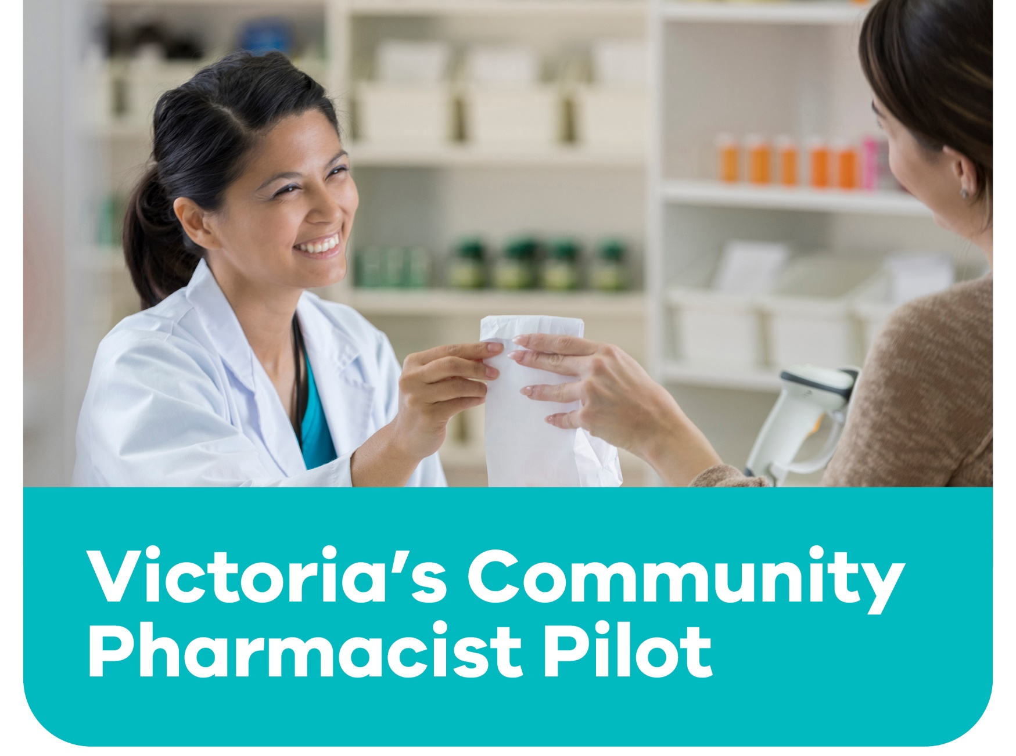

The 12-month pilot will allow people to receive some treatment at a local pharmacy without needing to see a doctor to get a prescription first.
Insert your logo then delete this text

For more information speak to your pharmacist, or visit Better Health Channel
Current services include:
- Continued supply of oral contraceptive pills, without a prescription.
- Antibiotics for uncomplicated urinary tract infections in women.
- Travel and other vaccines.
- Treatment for shingles and mild plaque psoriasis

