Perioperative capability self-assessment
Factsheet
OFFICIAL

Contents
The Perioperative service capability framework 1
Purpose of the self-assessment 1
Determining perioperative service capability levels 2
Completing the self-assessment 2
Different perioperative capability levels for adult and paediatric services 3
Monitoring perioperative capability levels 3
Self-assessment process 4
Appendix 1 5
More information 5

The Perioperative service capability framework
In December 2023, the Department of Health (the department) published Victoria’s first Perioperative service capability framework (the framework). The framework is a structured guideline for delivering optimal perioperative care in Victoria's health system.
The framework describes the essential elements required for perioperative services to function effectively and categorises these into six levels of capability. It does this through cumulative descriptions which defines the requirements for workforce, infrastructure, equipment, clinical support services and clinical governance at each of the six levels.
Establishing capability levels will foster a collaborative understanding, enabling patients, their families and carers to work with clinicians to plan for their care. This will also support the delivery of safe and high-quality perioperative care in Victoria and support health services to deliver the right care, at the right time to their communities.

Purpose of the self-assessment
Victoria has committed to providing transparent information to patients and communities on the capability levels of health services. To support this process, the self-assessment has been developed as an online tool for health services to evaluate the scope of perioperative service capabilities by:
- reviewing aspects of their perioperative care provision against the minimum criteria outlined in the framework.
- identifying any gaps in their perioperative services and how these may be addressed to meet their anticipated perioperative service capability level.
It is important to note the self-assessment is not an auditing tool; the documentation aligns directly with the framework and collects information on the current capability of perioperative services across key areas of delivery. Upon completing the self-assessment, a provisional capability level is generated. The results of the self-assessment and the provisional capability level are sent to the health service CEO for final endorsement and then to the Department of Health for review.
Perioperative services for some specific patient cohorts are addressed in other frameworks and lie beyond the Perioperative framework's scope. Hence, they are not part of the self-assessment. This includes:
- perioperative services related to obstetrics and newborn babies aged from birth to 28 days, such as lower uterine caesarean section (LUCS) – see the Capability frameworks for maternity and newborn services
- cancer surgery for children

Determining perioperative service capability levels
- Every two years, health services will be required to complete a self-assessment via an online platform. For multi-site services, each campus will be required to complete the documentation.
- The information collected will be compared with existing activity data relevant to the Perioperative service capability framework.
- The department will then collaborate with each health service to confirm the perioperative service capability level (at each campus where relevant).
- Once capability levels are agreed and endorsed, they will be published on the department’s website.

Completing the self-assessment
Health services will have 4 weeks to complete the self-assessment. The CEOs final endorsement and submission of responses is due on 22 March 2024.
The self-assessment will be completed online, accessible by an individualised link for each health service campus. Each campus must complete a self-assessment. The link/s will be emailed to the CEO of each health service for distribution to the campus delegate responsible for compiling the response.
It is estimated the survey will take approximately 90 minutes in total to complete. Work in progress may be saved and returned to at a later time. It is expected that various teams will need to be consulted to complete the self-assessment.
A word version of the self-assessment is available for download on the platform. This can assist with:
- reviewing all self-assessment questions
- gathering information to complete the self-assessment
- collaborating with colleagues across your health service campus
- seeking approval from your executives (where necessary) before submitting your responses.
It is important to note, that the Word version is a reference tool only; you will still need to enter your responses onto the platform before submitting it to your CEO. Please contact the System Design team if you are unable to access the word version perioperativeframework@health.vic.gov.au.

The self-assessment directly reflects the descriptions found in the perioperative service capability framework. To assist you with responding to the questions, it is highly recommended to have the framework available alongside for reference. Detailed instructions for completing the self-assessment are below under Self-assessment process.

Different perioperative capability levels for adult and paediatric services
The perioperative care needs for paediatric patients are different to adult patients. Hence, the perioperative capability levels may differ for adult and paediatric services at a given campus.
To determine levels, it is important to identify the required scope of healthcare, the workforce and clinical requirements for both adult and children’s services. For this reason, capability frameworks will identify separate capability levels for adult and children tailoring requirements to the specific needs of each group.
Paediatric perioperative service questions are included in the self-assessment and upon completion, provisional capability levels for adult and children will be provided.

Emergency surgery
Responses in the self-assessment should reflect the standard scope of practice of a given health service campus. In exceptional circumstances, where a patient may be at risk of serious harm if urgent treatment is not provided at a given campus, and where more appropriate options for alternative treatment or transfer are not immediately available, it is expected that the best available care is provided. This may include emergency surgical procedures that are not normally available at that campus. These exceptional circumstances do not need to be included in the self-assessment responses.

Monitoring perioperative capability levels
As the system steward, the Department of Health is responsible for regular performance monitoring of health services. The perioperative capability levels will be monitored on an ongoing basis in partnership with Safer Care Victoria, and the Department of Health performance teams. An annual performance monitoring meeting will include a discussion on the perioperative service capability levels. The self-assessment will be completed every second year to confirm any changes in service provision.

Self-assessment process
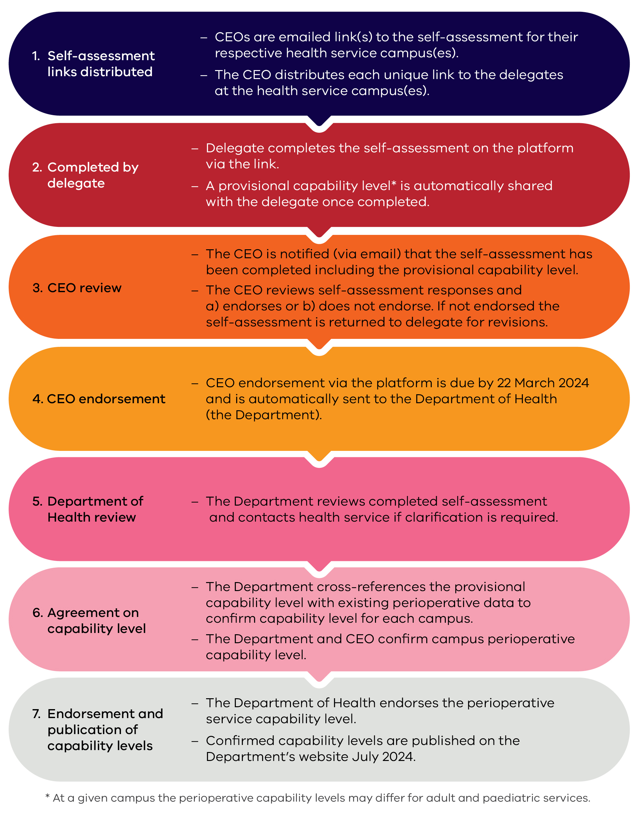

Appendix 1

- Self-assessment links distributed
  - CEOs are emailed link(s) to the self-assessment for their respective health service campus(es).
  - The CEO distributes each unique link to the delegates at the health service campus(es) to complete the self-assessment.

- Completion by delegate
  - Delegate completes the self-assessment on the platform via the link.
  - A provisional capability level* is automatically shared with the delegate once completed.

- CEO review
  - The CEO is notified (via email) that the self-assessment has been completed including the provisional capability level.
  - The CEO reviews self-assessment responses and a. endorses, or b. does not endorse. If not endorsed the self-assessment is returned to delegate for revisions.

- CEO endorsement
  - CEO endorsement via the platform is due by 22 March 2024 and is automatically sent to the Department of Health (the Department).

- Department of Health review
  - The Department reviews completed self-assessment and contacts health service if clarification is required.

- Agreement on capability level
  - The Department reviews the provisional capability level with existing perioperative data to confirm capability level for each campus.
  - The Department and CEO confirm campus perioperative capability level.

- Endorsement and publication of capability levels
  - The Department of Health endorses the perioperative service capability level.
  - Confirmed capability levels are published on the Department's website July 2024.

*At a given campus the perioperative levels may differ for adult and paediatric services.

More information
To learn more about Victoria’s perioperative capability framework you can explore the resources on the Perioperative service capability framework webpage. These offer detailed insights into the framework, the levels of capability, and how they support the delivery of safe, high-quality care.

Version Control
Version number | Author | Date approved
2.0 | Mary Benson | 12 March 2024

To receive this document in another format, use the National Relay Service 13 36 77 if required, or email Perioperative Framework <perioperativeframework@health.vic.gov.au>.
Authorised and published by the Victorian Government, 1 Treasury Place, Melbourne.
© State of Victoria, Australia, Department of Health, November 2023.
ISBN 978-1-76131-509-1 (pdf/online/MS word)
Available at Perioperative service capability framework for Victoria <https://www.health.vic.gov.au/health-system-design-planning/perioperative-service-capability-framework-for-victoria>

Capability frameworks for maternity and newborn services <https://www.health.vic.gov.au/patient-care/capability-frameworks-for-maternity-and-newborn-care-in-victoria>.
Service Capability Framework – A guide for Victorian health services providing primary treatment and shared care to children and adolescents with cancer <https://www.vics.org.au/pics-resources>.

