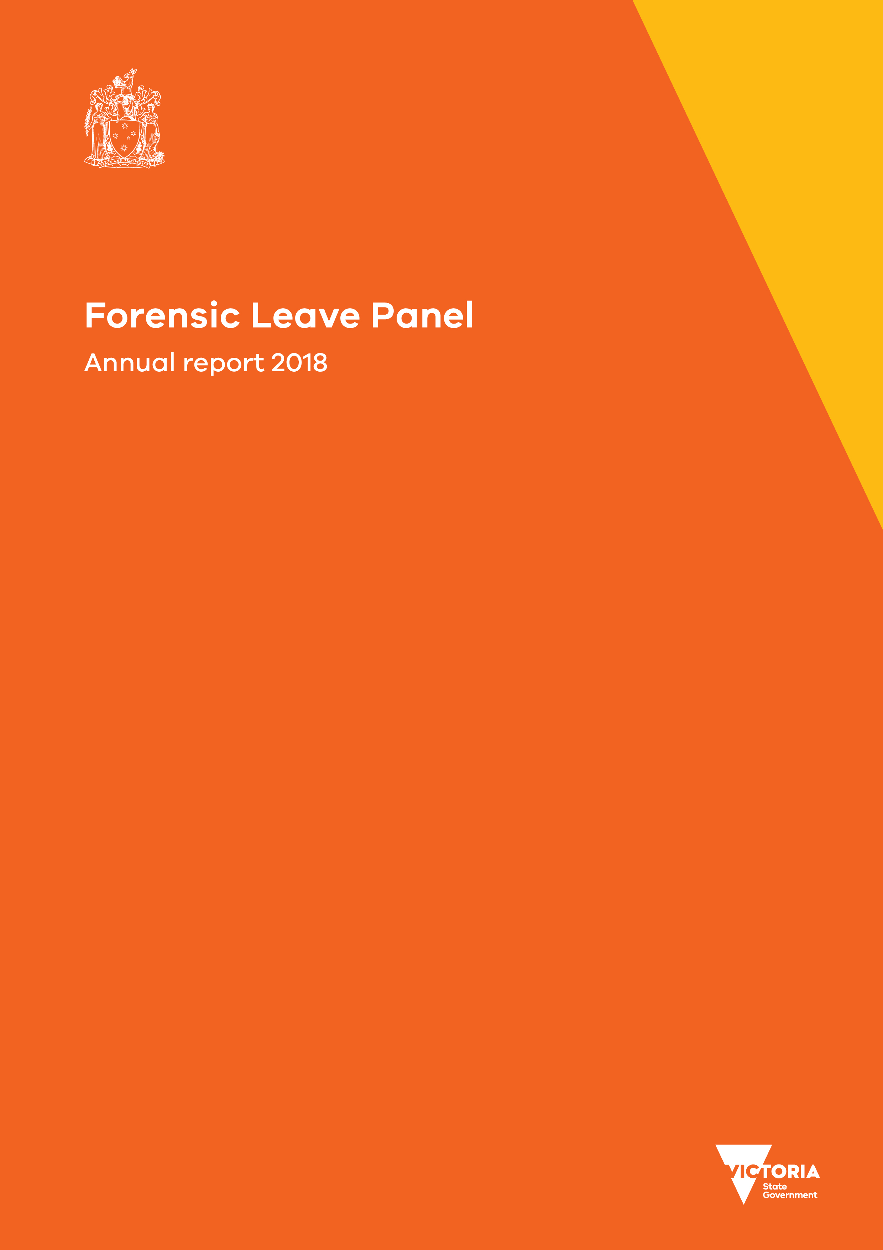

|  |
| --- |
| Forensic Leave Panel  Annual report 2018 |
|  |

|  |
| --- |
| Forensic Leave Panel  Annual report 2018 |
|  |

|  |
| --- |
|  |
| To receive this document in an accessible format phone 1800 222 987, using the National Relay Service 13 36 77 if required, or [email the Forensic Leave Panel](mailto:flp@dhhs.vic.gov.au) <flp@dhhs.vic.gov.au>.  Authorised and published by the Victorian Government, 1 Treasury Place, Melbourne.  © State of Victoria, Department of Health and Human Services, September 2019.  ISSN 2208-4673 (Print)  ISSN 2206-5962 (Online/PDF/Word)  Available at [Forensic Leave Panel](https://www2.health.vic.gov.au/mental-health/mental-health-services/services-by-type/forensic-mental-health-services/forensic-leave-panel) <https://www2.health.vic.gov.au/mental-health/mental-health-services/services-by-type/forensic-mental-health-services/forensic-leave-panel>  Printed by Digital House, Port Melbourne (1908439 cover and figures) |
|  |



1 October 2019

The Hon. Jill Hennessy MP  
Attorney-General  
Level 26, 121 Exhibition Street  
Melbourne VIC 3000

Dear Attorney-General

In accordance with s. 63 of the *Crimes (Mental Impairment and Unfitness to be Tried) Act 1997* (Vic), I am pleased to submit the annual report on the operations of the Forensic Leave Panel for the year ending 31 December 2018 for tabling in parliament.

A copy of this report has also been provided to the Minister for Mental Health, the Hon. Martin Foley MP, and the Minister for Disability, Ageing and Carers, the Hon. Luke Donnellan MP who are also responsible in part for the operation of the Act.

Yours sincerely

Kevin Bell signature

**The Hon. Justice Kevin Bell AM**  
President  
Forensic Leave Panel

Contents

President’s report 1

Forensic Leave Panel Reform Project 1

Statistical data 1

Royal Commission into Victoria’s Mental Health System 1

Forensic Leave Panel Members Forum 1

Acknowledgements 2

Common terms used in this report 3

The Forensic Leave Panel 3

Who we are 3

What we do 3

How we do it 3

Our people 4

Membership 4

Changes to our membership 5

The leave framework 6

On-ground leave and limited off-ground leave 6

Criteria for granting leave 6

Conditions attached to leave 6

Purpose of leave 7

Progression of leave 7

Suspension of on-ground and limited off-ground leave 7

The hearing process 8

Hearings 8

Applications for leave 8

Supporting documentation 8

Conduct of hearings 9

Decisions regarding leave 9

Operational report 10

The year in review 10

Our finances 12

Appendix 1: The legal framework 13

Appendix 2: Panel membership as at 31 December 2018 14

Appendix 3: Historical data 18

Appendix 4: figure description 21

# President’s report

I am pleased to present the annual report of the Forensic Leave Panel for 2018 – my fourth annual report as president of the panel.

## Forensic Leave Panel Reform Project

The panel is committed to continuously improving its operations. In 2018 the panel began a review of its processes and procedures to identify opportunities to achieve efficiencies and modernise the operations of the panel. Key objectives of this project are to improve understanding of panel’s processes, to support engagement by forensic patients and residents in forensic leave processes and to support panel members in their work by implementing a professional development program. This work is now underway with collaboration between the Department of Health and Human Services, Forensicare, the Disability Forensic Assessment and Treatment Service and the Long Term Residential Program and in close consultation with forensic residents and patients, their carers and family members and members of the panel.

## Statistical data

This annual report shows that during 2018 the panel conducted 27 hearings (four for forensic residents and 23 for forensic patients) over 24 hearing days.

There was a slight decrease in the number of forensic patients and residents making applications for on-ground and limited off-ground leave from 96 in 2017 to 92 in 2018. The panel considered 216 applications for on-ground and limited off-ground leave from the 92 forensic patients and residents, and granted 97 per cent of those applications. The data contained in this report show that the rates of refusal of applications is the lowest reported since 2008 (see Appendix 3: Historical data).

## Royal Commission into Victoria’s Mental Health System

On 24 October 2018 the Premier announced that the government would commit to a royal commission into Victoria’s mental health system. This was a welcome announcement across the mental health sector.

The terms of reference for the royal commission require it to inquire into how to improve mental health outcomes for people in contact or at risk of contact with the forensic mental health system. While forensic mental health will not be discussed during the public hearings, it is a topic that the royal commission will address through other mechanisms.

I welcome this focus on forensic mental health services and look forward to the report and recommendations of the royal commission, and determining how they can be used to improve the operations of the panel.

## Forensic Leave Panel Members Forum

In 2018 we held the first Forensic Leave Panel Members Forum on Thursday 6 December. This forum was not only a chance to bring the members together to celebrate the end of the year but also served to begin what I hope will be ongoing professional development opportunities.

I provided an opening address that updated the members on achievements for the year and plans for the year ahead, in particular providing an update on the Forensic Leave Panel Reform Project. We were also very fortunate to have Professor Bernadette McSherry give a very interesting and relevant talk on risk, recovery and rights in forensic mental health.

## Acknowledgements

I acknowledge the expertise and skill of the members of the Forensic Leave Panel and thank them for their invaluable contribution to the operation of the panel. In particular, I would like to thank our three members who retired in 2018: the Hon. Justice John Forrest, Ms Catherine Leigh-Smith and Dr Sally Wilkins, who have served a combined 36 years on the panel. Such dedication and commitment is what makes this panel unique.

I wish to acknowledge the important role of the lawyers from Villamanta Disability Rights Legal Service Inc. and Victoria Legal Aid in providing legal representation and advice to applicants at panel hearings.

I also wish to express my appreciation of the work and commitment of the staff of the Disability Forensic Assessment and Treatment Service, the Long Term Residential Service, the Thomas Embling Hospital, and the Mental Health Branch of the Department of Health and Human Services.

Kevin Bell signature

**The Hon. Justice Kevin Bell AM**  
President  
Forensic Leave Panel

# Common terms used in this report

Throughout this report, unless otherwise specified:

* ‘the Act’ refers to the *Crimes (Mental Impairment and Unfitness to be Tried) Act 1997*
* ‘the panel’ refers to the Forensic Leave Panel
* ‘forensic patient’ or ‘patient’ is a person remanded in or committed to custody in a designated mental health service under the *Mental Health Act 2014*
* ‘forensic resident’ or ‘resident’ is a person remanded in or committed to custody in a residential treatment facility or a residential institution under the *Disability Act 2006*
* ‘types of leave’ refers to on-ground and limited off-ground leave
* ‘purpose of leave’ refers to activities undertaken while a forensic patient or resident is on leave
* ‘DFATS’ refers to the Disability Forensic Assessment and Treatment Service, which is a part of the Victorian Department of Health and Human Services
* ‘Forensicare’ refers to the Victorian Institute of Forensic Mental Health, which is a statutory body established by the *Mental Health Act*.

# The Forensic Leave Panel

## Who we are

The Forensic Leave Panel is an independent statutory tribunal established under the Act to support the rehabilitation of forensic patients and residents and assist with their reintegration into the community.

The panel comprises members of the judiciary, the Chief Psychiatrist and nominees, psychiatrists, psychologists and members from the community.

## What we do

The main role of the panel is to hear applications for on-ground and limited off-ground leave from patients and residents to enable them to participate in a range of activities in the community to aid their rehabilitation. The panel also hears appeals from patients and residents regarding refusal of special leave and transfers from one designated mental health service to another.

## How we do it

The panel conducts hearings at the Thomas Embling Hospital campus of Forensicare and the Disability Forensic Assessment and Treatment Service at Fairfield to consider applications for on-ground and limited off-ground leave from forensic patients and residents.

The panel considers applications from forensic patients and residents over the duration of their custody or detention.

Over time the panel may grant incremental increases to a person’s leave into the community when it is appropriate to do so. Leave is granted for a maximum period of six months at any one time.

*Appendix 1: The legal framework* provides an overview of how a patient or resident may progress under the Act. It also identifies the panel’s responsibilities in the detention, management and release framework.

# Our people

## Membership

As at 31 December 2018, the panel comprised:

* six judicial members from the Supreme Court of Victoria
* six judicial members from the County Court of Victoria
* the Chief Psychiatrist
* four nominees of the Chief Psychiatrist
* seven registered medical practitioners with experience in forensic psychiatry
* three registered psychologists with experience in intellectual disability and forensic psychology
  + eight members to represent the views and opinions of members of the community.

The panel is supported by an executive officer who works from the Mental Health Branch of the Victorian Department of Health and Human Services.

The structure of the panel is outlined below.

Figure 1: Panel membership

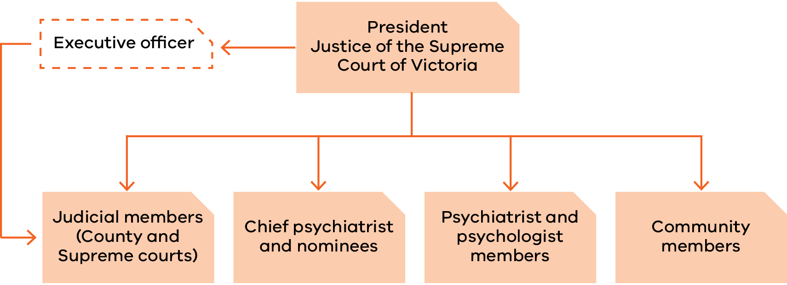

‘Appendix 2: Panel membership as at 31 December 2018’ contains a complete list of members, including their terms of appointment.

## Changes to our membership

Three psychiatrist members were appointed on 27 March 2018 – Dr Teresa Flower for her third term, and Associate Professor John Fielding and Dr Leon Turnbull both for their first term.

On 17 April 2018, the Hon. Justice Terry Forrest was reappointed as a judicial member for his second term and His Honour Judge James Parrish was appointed as a judicial member for his first term.

On 1 July 2018, Ms Janina Tomasoni was reappointed for her fifth term as a psychologist member and Dr Michelle Noon was appointed for her first term as a psychologist member.

Three psychiatrist members and three community members were also appointed on 1 July 2018. The psychiatrist members were Dr Michael Epstein for his sixth term, Dr Diane Neill for her third term and Dr Ahmed Mashhood for his first term. The community members were Mr Jack Nalpantidis for his fourth term, Mr George Jiang for his second term and Dr Patricia Mehegan for her first term.

Two nominees of the Chief Psychiatrist, Dr Paul Hantz and Dr Richard Yeatman, ended their time with the panel in September 2018 after serving 15 years and four years respectively.

We also had some retirements in 2018: the Hon. Justice John Forrest retired from the Supreme Court, with his final term ending on 3 March 2018, and psychologist member Ms Catherine Leigh-Smith had her final term end on 30 June 2018 due to retirement from practice.

In 2017 Dr Sally Wilkins resigned as a psychiatrist member of the panel due to her upcoming retirement from practice. Her resignation was accepted, effective from   
31 March 2018.

# The leave framework

## On-ground leave and limited off-ground leave

The panel has jurisdiction under the Act to grant on-ground and limited off-ground leave to forensic patients and forensic residents.

The maximum period for which on-ground and limited off-ground leave can be granted is six months. At the end of this period a patient or resident may reapply to the panel.

### On-ground leave

On-ground leave allows forensic patients and residents to be absent from the place of custody but within a defined area around the place of custody, known as ‘the surrounds’.

Forensic residents at the Long Term Residential Program in Bundoora make extensive use of on-ground leave. Forensic patients at the Thomas Embling Hospital campus of Forensicare and forensic patients at DFATS do not require on-ground leave because there are sufficient grounds within the secure perimeter. Accordingly, no grounds have been declared under s. 52 of the Act in relation to Thomas Embling Hospital or DFATS.

### Limited off-ground leave

Limited off-ground leave permits patients and residents to be absent from the place of custody between 6.00 am and 9.00 pm, or outside those hours for a maximum of three days in any seven-day period.

## Criteria for granting leave

The panel may grant on-ground or limited off-ground leave if it is satisfied that both:

* the proposed leave will contribute to the patient’s or resident’s rehabilitation
  + the safety of the person or members of the public will not be seriously endangered as a result of the patient or resident being allowed leave.

In determining whether to grant an application for leave or variation of leave, the panel must consider:

* the person’s current mental condition or pattern of behaviour
* the person’s clinical history and social circumstances
* the person’s applicant profile and leave plan or statement, prepared in accordance with the Act.

## Conditions attached to leave

The panel can place any conditions on leave that it considers appropriate. Conditions commonly relate to:

* how many, if any, escorts are required
* the duration and frequency of leave
* where a patient or resident may go (or where they may not go)
* the people a patient or resident can meet while on leave
* how a patient or resident is to travel to their leave destination
* drug and alcohol testing following leave.

# 

# Purpose of leave

The purpose of leave is to assist the rehabilitation process and provide a gradual progression towards a return to community living that is consistent with the person’s needs and community safety.

Patients and residents can apply to the panel to participate in a broad range of activities. All leave must form part of an overarching treatment and recovery plan. Common purposes of leave granted include leave to:

* attend medical, legal, dental or allied health appointments
* undertake activities of daily living, such as personal shopping, banking and exercise
* build or maintain relationships with family and friends in the community
* participate in therapeutic and rehabilitation groups, activities and programs
* attend educational and vocational activities, groups and courses
* participate in or seek voluntary and/or paid employment.

## Progression of leave

The panel takes a graduated approach to granting leave. Initially, a patient or resident is granted a small amount of leave and is escorted by two or three staff members. This could include leave to attend medical appointments or may allow a patient or resident to attend a nearby facility (such as a park or a café) for one hour a week.

If a patient or resident can successfully participate in leave over a sustained period, the panel may decrease the number of escorts and increase the number of approved locations and purposes, as well as the duration, of further periods of leave This process allows patients or residents to gradually increase their participation in a wide variety of activities that form part of everyday living to prepare them for release back into the community. This slow approach to leave allows for a steady reintroduction into the community and provides staff with a valuable opportunity to monitor how the person copes and adapts in a community setting.

A patient’s or resident’s progression depends entirely on individual circumstances. The progression outlined above may not be the path followed by all patients and residents, and some may move backwards and forwards between various stages of this process, depending on their progress and response to treatment.

## Suspension of on-ground and limited off-ground leave

Regular monitoring and review of the use of leave take place to ensure the safety of each patient or resident and members of the public are not seriously endangered. Before forensic residents or patients may access panel-granted leave they are subject to a clinical assessment.

The Act contains provisions that allow the Chief Psychiatrist (in the case of patients) and the Secretary to the Department of Health and Human Services (in the case of residents) to suspend leave granted by the panel if they are satisfied that the safety of the person or members of the public will be seriously endangered if leave is not suspended. The panel must report any suspensions of leave.

In 2018 the Secretary did not suspend any leave for residents. There were nine instances of the Chief Psychiatrist partially or wholly suspending leave during 2018.

# 

# The hearing process

## Hearings

The panel must conduct its hearings at the place where the patient or resident is detained to enable the person to attend and participate fully in the proceedings, unless the president determines otherwise.

Patient hearings are held at Thomas Embling Hospital where the panel comprises:

* a judge from the Supreme or County Court (depending on the patient’s original court of disposition)
* the Chief Psychiatrist or nominee
* a registered medical practitioner with experience in forensic psychiatry
  + a community member.

Resident hearings are held at DFATS in Fairfield where the panel comprises:

* a judge from the Supreme or County Court (depending on the resident’s original court of disposition)
* a registered psychologist with experience in intellectual disability and forensic psychology
* a community member.

## Applications for leave

A forensic patient or resident may apply to the panel for on-ground and limited off-ground leave. Each type of leave can include one or more purposes of leave.

All applications must specify:

* the type of leave
* the purpose(s) of leave (for example,   
  grocery shopping)
* the duration and frequency of each purpose (for example, two hours, once per week)
* the destination for each purpose (for example, the name of the shopping centre)
* the relationship to the person’s rehabilitation (for example, to build or maintain daily   
  living skills).

## Supporting documentation

Other documentation required to be submitted to the panel includes:

* an applicant profile
* a report from the consultant psychiatrist or psychologist
  + a detailed leave plan prepared by the patient’s or resident’s treating team.

These are described below.

### Applicant profile

The profile must contain the following information:

* the person’s impairment, condition or disability
* the relationship between the impairment, condition or disability and the offending conduct
* the person’s clinical history and social circumstances
* the person’s current mental state or pattern of behaviour
* the offence that led to the supervision order being made
* the date of the supervision order, its nominal term and the day from which the nominal term had been declared to run.

### Report from the consultant psychiatrist or psychologist

This report provides information on the person’s current mental state, prescribed medication, a risk assessment and any conditions that the clinician recommends should be placed on the leave. The clinician will also indicate if they support all or some of the purposes of leave being applied for by the patient or resident.

### Detailed leave plan prepared by the patient’s or resident’s treating team

This plan demonstrates how any previous periods of leave have progressed and how the present leave applied for may contribute to the person’s rehabilitation goals. The plan also allows the person’s treating team to recommend any leave conditions or to recommend that leave should not be granted.

## Conduct of hearings

Hearings are closed to the public unless the panel directs otherwise on the basis that it is in the best interest of the person or is in the public interest. Open hearings rarely occur, although the panel may occasionally allow an observer to be present for training or professional development purposes. No open hearings were conducted in 2018.

The panel must act according to equity and good conscience and is bound by the rules of natural justice.

The panel is not required to conduct its hearings in a formal manner. It is not bound by rules or practice relating to evidence and may inform itself on matters as it sees fit. This may include requests for additional information or, by way of summons, request that another party attend before the panel to assist.

During the hearing the panel discusses the leave application with the patient or resident and their treating team. Discussions focus on such things as the person’s current mental state and pattern of behaviour, any notable achievements or incidents since the person’s last hearing before the panel and how any previous panel-granted leaves have progressed.

If the patient or resident requires assistance during a hearing, the panel will engage an interpreter or other specialist, as necessary. During the year, the panel engaged an interpreter on 14 occasions, in the following languages:

* Arabic
* Auslan
* Italian
* Mandarin
  + Turkish.

Applicants have a right to legal representation at hearings. Four patients and four residents chose to be legally represented over the course of the year on 11 separate occasions. Five applicants were represented once, and three applicants were represented twice.

## Decisions regarding leave

At the end of each hearing the panel advises the patient or resident of its decision and gives verbal reasons. A written determination is issued to the patient or resident after the hearing outlining the leave that was granted or refused and any conditions attached to the leave.

A patient or resident has the right to request a written statement of reasons for the decision. In 2018 one patient requested a written statement of reasons.

# 

# Operational report

## The year in review

### Forensic patients

|  |  |  |  |
| --- | --- | --- | --- |
| Measure | 2018 | 2017 | Change |
| Applicants | 85 | 88 | –3 |
| Male applicants | 70 | 73 | –3 |
| Female applicants | 15 | 15 | 0 |
| Applicants on Supreme Court orders | 53 | 56 | –3 |
| Applicants on County Court orders | 32 | 32 | 0 |
| First-time applicants | 9 | 16 | –7 |
| Hearings | 23 | 21 | +2 |
| Applications received | 203 | 211 | –8 |
| Individual leave purposes requested | 939 | 990 | –51 |
| Applications for on-ground leave | 0 | 0 | 0 |
| Applications for limited off-ground leave | 203 | 211 | –8 |
| Leave granted without modification | 90% | 83% | 7% |
| Leave granted with modification | 7% | 10% | –3% |
| Total leave granted[1] | 97% | 93% | 4% |
| Leave refused | 4% | 7% | –3% |
| Leave suspensions by the Chief Psychiatrist | 9 | 17 | –8 |
| Leave suspensions by the Secretary to the Victorian Department of Health and Human Services | N/A | N/A | 0 |
| Times a patient or resident was assisted by an interpreter | 10 | 7 | 3 |
| Languages used | 5 | 4 | 1 |
| Legal representation | 4 | 15 | –11 |
| Appeals against refusal of special leave | 0 | 0 | 0 |

### Forensic residents

| Measure | 2018 | 2017 | Change |
| --- | --- | --- | --- |
| Applicants | 7 | 8 | –1 |
| Male applicants | 7 | 8 | –1 |
| Female applicants | 0 | 0 | 0 |
| Applicants on Supreme Court orders | 3 | 3 | 0 |
| Applicants on County Court orders | 4 | 5 | –1 |
| First-time applicants | 0 | 2 | –2 |
| Hearings | 4 | 6 | –2 |
| Applications received | 13 | 17 | –4 |
| Individual leave purposes requested | 86 | 117 | –31 |
| Applications for on-ground leave[2] | 4 | 17 | –13 |
| Applications for limited off-ground leave | 13 | 17 | –4 |
| Leave granted without modification | 99% | 99% | 0% |
| Leave granted with modification | 1% | 1% | 0% |
| Total leave granted | 100% | 100% | 0% |
| Leave refused | 0% | 0% | 0% |
| Leave suspensions by the Chief Psychiatrist | N/A | N/A | 0% |
| Leave suspensions by the Secretary to the Victorian Department of Health and Human Services | 0 | 0 | 0% |
| Times a patient or resident was assisted by an interpreter | 4 | 2 | 2 |
| Languages used | 1 | 1 | 0 |
| Legal representation | 8 | 5 | 3 |
| Appeals against refusal of special leave | 0 | 0 | 0 |

The panel’s statistical information has remained relatively constant over recent years. Although variations occur in the number of hearings, applicants and applications, these differences are consistent with changes in the forensic patient and resident population.

Individual applications for leave decreased from 228 in 2017 to 216 in 2018, and requests for distinct leave purposes decreased from 1,107 in 2017 to 1,025 in 2018. The number of leave applications made by patients and residents requests varied from one to four, and the average number of leave purposes per application in 2018 remained stable at 4.8 per applicant. Out of the 92 applicants over the calendar year:

* eight made one application
* 50 made two applications
* 28 made three applications
  + six made four applications.

*‘*Appendix 3: Historical data’ contains more information on the number of patients and residents, hearings, leave applications and other demographic data for the period 2009   
to 2018.

## Our finances

The Health and Wellbeing Division of the Department of Health and Human Services provided all operational support to the panel, managed the panel’s budget and maintained accounts and records. The department’s audited financial statements include the panel’s expenditure, which is reported in the department’s annual report.

# Appendix 1: The legal framework

The *Crimes (Mental Impairment and Unfitness to be Tried) Act 1997* provides for the management, detention and release of persons found unfit to stand trial or not guilty of an offence because of mental impairment.

Under the Act, a court can impose several different supervision orders if it finds a person unfit to plead or not guilty because of mental impairment:

* custodial supervision orders (CSOs), which commit a person to custody in a designated mental health service under the *Mental Health Act 2014*, or a residential treatment facility or residential institution under the *Disability Act 2006*
* CSOs, which commit a person to custody in a prison but only if the court is satisfied that no practicable alternative exists
  + non-custodial supervision orders (NCSOs), which allow the person to live in the community, subject to conditions decided by the court and specified in the order.

The court also has the discretion to release a person unconditionally.

Figure 2 below presents a brief overview of how a person may progress through the system under the Act and demonstrates where the panel resides within this framework.

**Figure 2: Legal framework for progression under the Act Crimes (Mental Impairment and Unfitness to be Tried) Act 1997**

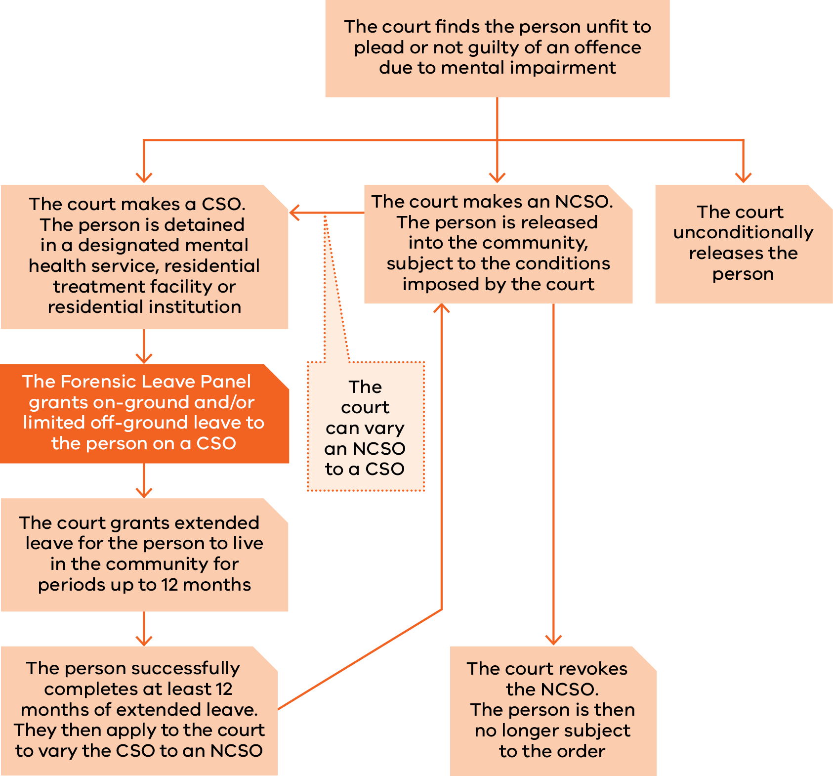

# Appendix 2: Panel membership as at 31 December 2018

Supreme Court judges

|  |  |  |
| --- | --- | --- |
| Panel member | Current appointment | Previous term/s of appointment |
| The Hon. Justice Kevin Bell  President of the Panel from February 2015 | 1 April 2014  to 31 March 2019 |  |
| The Hon. Justice Terry Forrest | 17 April 2018  to 16 April 2023 | 26 February 2013  to 25 February 2018 |
| The Hon. Justice Christopher Beale | 17 February 2015  to 16 February 2020 |  |
| The Hon. Justice Michael Croucher | 17 February 2015  to 16 February 2020 |  |
| The Hon. Justice Andrew Keogh | 25 July 2017  to 24 July 2022 |  |
| The Hon. Justice Jane Dixon | 25 July 2017  to 24 July 2022 |  |

County Court judges

| Panel member | Current appointment | Previous term/s of appointment |
| --- | --- | --- |
| Her Honour Judge Liz Gaynor | 2 February 2016 to 1 February 2021 | 25 May 2010  to 24 May 2015  3 May 2005  to 2 May 2010 |
| Her Honour Judge Sandra Davis | 4 October 2016  to 3 October 2021 | 4 October 2011  to 3 October 2016  5 September 2006 to 4 September 2011 |
| Her Honour Judge Susan Pullen | 20 November 2017  to 20 November 2022 | 20 November 2012 to 19 November 2017  20 November 2007  to 19 November 2012 |
| His Honour Judge Frank Saccardo | 31 October 2017  to 30 October 2022 | 1 May 2012  to 30 April 2017 |
| His Honour Judge Douglas Trapnell | 31 October 2017  to 30 October 2022 |  |
| His Honour Judge James Parrish | 17 April 2018 to 16 April 2023 |  |

Chief Psychiatrist and nominees

| Panel member | From | To |
| --- | --- | --- |
| Dr Neil Coventry  (Chief Psychiatrist) | 20 November 2014 | Ongoing |
| Dr Steve Macfarlane | 9 November 2012 | Ongoing |
| Assoc. Prof. Peter Burnett | 18 December 2015 | Ongoing |
| Dr Daniel O’Connor | 27 April 2016 | Ongoing |
| Dr Vinay Lakra | 18 July 2016 | Ongoing |

Psychologist members

| Panel member | Current appointment | Previous term/s of appointment |
| --- | --- | --- |
| Ms Janina Tomasoni | 1 July 2018  to 30 June 2022 | 24 October 2014  to 30 June 2018  24 October 2010  to 23 October 2014  24 October 2006  to 23 October 2010  10 September 2002  to 9 September 2006 |
| Dr Michelle Noon | 1 July 2018  to 30 June 2022 |  |
| Dr Marilyn McMahon | 30 August 2017  to 29 August 2019 |  |

Psychiatrist members

| Panel member | Current appointment | Previous term/s of appointment |
| --- | --- | --- |
| Dr Michael Epstein | 1 July 2018  to 30 June 2022 | 24 October 2014  to 30 June 2018  24 October 2010  to 23 October 2014  24 October 2006  to 23 October 2010  10 September 2002  to 9 September 2006  21 April 1998  to 20 April 2002 |
| Dr Diane Neill | 1 July 2018  to 30 June 2022 | 6 July 2014  to 30 June 2018  6 July 2010  to 5 July 2014 |
| Dr Teresa Flower | 27 March 2018  to 26 March 2022 | 30 August 2013  to 29 August 2017  30 August 2009 to 29 August 2013 |
| Dr Jennifer Torr | 2 June 2015  to 1 June 2019 |  |
| Assoc. Prof. John Fielding | 27 March 2018  to 26 March 2022 |  |
| Dr Leon Turnbull | 27 March 2018  to 26 March 2022 |  |
| Dr Ahmed Mashhood | 1 July 2018  to 30 June 2022 |  |

Community members

| Panel member | Current appointment | Previous term/s of appointment |
| --- | --- | --- |
| Mr Paul Newland | 30 August 2017  to 29 August 2019 | 30 August 2013  to 29 August 2017  30 August 2009  to 29 August 2013  30 August 2005  to 29 August 2009  12 December 2000  to 11 December 2004  21 April 1998  to 20 April 2000 |
| Ms Kathleen Bragge | 30 August 2017  to 29 August 2019 | 30 August 2013  to 29 August 2017  30 August 2009  to 29 August 2013  30 August 2005  to 29 August 2009 |
| Mr Jack (Kyriakos) Nalpantidis | 1 July 2018  to 30 June 2022 | 24 October 2014  to 30 June 2018  24 October 2010  to 23 October 2014  24 October 2006  to 23 October 2010 |
| Ms Patricia Harper AM | 30 August 2017  to 29 August 2019 | 30 August 2013  to 29 August 2017  30 August 2009  to 29 August 2013 |
| Dr Genevieve Grant | 30 August 2017  to 29 August 2019 | 30 August 2013 to  29 August 2017  30 August 2009  to 29 August 2013 |
| Mr John Leatherland PSM | 30 August 2017  to 29 August 2019 | 30 August 2013  to 29 August 2017 |
| Mr Jie (George) Jiang | 1 July 2018  to 30 June 2022 | 15 July 2014  to 30 June 2018 |
| Dr Patricia Mehegan | 1 July 2018  to 30 June 2022 |  |

# Appendix 3: Historical data

The tables below provide information on the number of patients and residents, hearings, leave applications and other demographic data for the period 2009 to 2018.

General information

| Application information | 2018 | 2017 | 2016 | 2015 | 2014 | 2013 | 2012 | 2011 | 2010 | 2009 |
| --- | --- | --- | --- | --- | --- | --- | --- | --- | --- | --- |
| Forensic patients | 85 | 88 | 74 | 74 | 76 | 75 | 69 | 67 | 65 | 70 |
| Forensic residents | 7 | 8 | 6 | 4 | 3 | 3 | 2 | 2 | 3 | 3 |
| Hearings[3] | 27 | 27 | 26 | 26 | 21 | 24 | 18 | 22 | 19 | 22 |
| Hearing days[4] | 24 | 23 | 21 | 21 | 18 | 18 | 18 | 19 | 18 | 18 |
| Total leave applications made to the panel | 216 | 228 | 201 | 180 | 227 | 216 | 181 | 184 | 182 | 179 |
| Average leave applications made per hearing | 8 | 8.4 | 7.7 | 6.9 | 10.8 | 9 | 10 | 8.4 | 9.6 | 8.13 |
| Average leave applications by each forensic patient or resident | 2.3 | 2.4 | 2.5 | 2.3 | 2.9 | 2.8 | 2.5 | 2.6 | 2.6 | 2.5 |
| Average leave purposes per application | 4.8 | 4.9 | 4.9 | 4.8 | 5 | 4.7 | 5 | 5.2 | 4.3 | 4 |

Type of leave applications

| Type of leave | 2018 | 2017 | 2016 | 2015 | 2014 | 2013 | 2012 | 2011 | 2010 | 2009 |
| --- | --- | --- | --- | --- | --- | --- | --- | --- | --- | --- |
| On-ground | 4 | 17 | 12 | 7 | 6 | 6 | 5 | 4 | 5 | 9 |
| Off-ground | 216 | 211 | 189 | 173 | 221 | 210 | 176 | 180 | 177 | 170 |
| Combined on-ground and limited off-ground leave[5] | 4 | 17 | 12 | 7 | 6 | 6 | 5 | 4 | 5 | 9 |
| Leave purposes | 1,025 | 1,107 | 980 | 874 | 1,139 | 1,023 | 913 | 962 | 786 | 724 |

Leave requests granted, suspended, appealed and revoked

| Leave measure[6] | 2018 | 2017 | 2016 | 2015 | 2014 | 2013 | 2012 | 2011 | 2010 | 2009 |
| --- | --- | --- | --- | --- | --- | --- | --- | --- | --- | --- |
| Granted | 90% | 85% | 86% | 91% | 90% | 85% | 86% | 87% | 87.7% | 91.7% |
| Modified and granted | 7% | 9% | 7% | 4% | 4% | 6.7% | 5.4% | 4.5% | 3.3% | 1% |
| Refused | 4% | 6% | 7% | 5% | 6% | 7.3% | 7.8% | 5.5% | 9% | 7.2% |
| Times applicants were assisted by interpreters | 14 | 9 | 7 | 8 | 18 | 13 | 14 | 11 | 13 | 13 |
| Times applicants were legally represented | 11 | 20 | 29 | 14 | 36 | 11 | 7 | 6 | 2 | 7 |
| Number of occasions patients or residents had on-ground or limited off-ground leave suspended | 9 | 17 | 10 | 14 | 10 | 12 | 16 | 9 | 11 | 6 |
| Appeals against refusal to grant special leave by the authorised psychiatrist or the Secretary to the Department of Health and Human Services | 0 | 0 | 0 | 1 | 0 | 0 | 0 | 0 | 0 | 0 |
| Appeals against the transfer of a forensic patient from one designated mental health service to another | 0 | 0 | 0 | 0 | 0 | 0 | 0 | 0 | 0 | 0 |
| Patients and residents granted extended leave  by a court | 11 | 10 | 9 | 6 | 6 | 8 | 9 | 4 | 4 | 10 |
| Revocation of extended leave by the court | 1 | 1 | 0 | 1 | 0 | 1 | 1 | 1 | 0 | 1 |

Applicant demographics

| Demographic | 2018 | 2017 | 2016 | 2015 | 2014 | 2013 | 2012 | 2011 | 2010 | 2009 |
| --- | --- | --- | --- | --- | --- | --- | --- | --- | --- | --- |
| Male | 77 | 81 | 67 | 64 | 67 | 65 | 57 | 58 | 59 | 63 |
| Female | 15 | 15 | 13 | 14 | 12 | 13 | 12 | 11 | 9 | 10 |
| Average age of applicants (years) | 44.7 | 43 | 43.1 | 42.5 | 42.7 | 41.9 | 41.3 | 40 | 40 | 41.5 |

Sentencing information

|  |  |  |  |  |  |  |  |  |  |  |
| --- | --- | --- | --- | --- | --- | --- | --- | --- | --- | --- |
| Sentencing court/period | 2018 | 2017 | 2016 | 2015 | 2014 | 2013 | 2012 | 2011 | 2010 | 2009 |
| County Court | 36 | 37 | 26 | 24 | 24 | 21 | 17 | 20 | 21 | 19 |
| Supreme Court | 56 | 59 | 54 | 54 | 55 | 57 | 52 | 49 | 47 | 54 |
| Average length of custody (years)[7] | 8.6 | 8.4 | 9.0 | 9.0 | 8.2 | 8.6 | 8.2 | 7.1 | 7.2 | 7.1 |
| Longest period of custody (years)[8] | 29.4 | 41.4 | 40.4 | 39.4 | 38.4 | 40.4 | 39.4 | 38 | 37 | 36 |

# Appendix 4: figure description

Figure 2: Legal framework for progression under the Act Crimes (Mental Impairment and Unfitness to be Tried) Act 1997

The diagram demonstrates what happens once the court finds a person unfit to plead or not guilty of an offence due to mental impairment, and how they progress through the system under the Act.

The court can make a custodial supervision order, which sees the person detained in a designated mental health service, residential treatment facility or residential institution. While detained, the Forensic Leave Panel grants on-ground and/or limited off-ground leave to that person until such time as the person applies for, and the court grants, extended leave for the person to live in the community for periods up to 12 months. Once the person successfully completes at least 12 months of extended leave they apply to the court to vary the custodial supervision order to a non-custodial supervision order.

The court can make a non-custodial supervision order, which sees the person released into the community, subject to the conditions imposed by the court. The court can revoke the non-custodial supervision order, meaning the person is no longer subject to the order. The court can also vary a non-custodial supervision order to a custodial supervision order.

The court can unconditionally release the person.

1. The percentage of leaves granted, modified or refused by the panel may not always total 100 per cent because at hearings applicants may withdraw leave requests, the panel may grant modified leave requests or, on occasion, grant additional leave requests.
2. Forensic residents made 13 applications for the year; of that four were a combination of on-ground and limited off-ground leave.
3. The number of hearings held for forensic residents and the number of hearings held for forensic patients.
4. Hearings at Thomas Embling Hospital and DFATS are scheduled (when possible) to coincide so that relevant members of a division of the panel can attend both hearings.
5. Forensic residents made the on-ground leave applications as part of an application, which included limited off-ground leave. In practice, forensic patients do not require on-ground leave because Thomas Embling Hospital has sufficient grounds within the secure perimeter.
6. The percentage of leaves granted, modified or refused by the panel may not always total 100 per cent because at hearings applicants may withdraw leave requests, the panel may grant modified leave requests or, on occasion, grant additional leave requests.
7. The reference date used to calculate the average length of custody was 31 December in each year. Prior to 2012, the reference date is likely to have been the undefined year, accounting for the percentage increase in 2012.
8. The decrease in 2018 is due to a long-term forensic patient receiving extended leave.