Child Development Information System external referral process
Victorian Maternal and Child Health (MCH) Child Development Information System (CDIS)
Contents
Making an external referral from client (child) consultation 1
Important notes for completing an external referral 2
External referral from client (child) consultation 3
Using the referral letter template for external referrals 5
Completed external referral in client (child) consultation 6
Edit and complete external referrals in client (child) referral screen 7
Completed external referral in client notes 8
Edit external referral notes in client notes 9
Completed external referral notes in client ‘History/Notes’ 10
Add referral letters and forms as attachments to client history 11
View, edit and delete attachments in client history 13
Add a ‘referral follow-up’ blue alert flag for external referrals 15
Update status of external referrals 16
Remove a ‘referral follow-up’ blue alert flag 17

Making an external referral from client (child) consultation
Important Note: All referrals (except Enhanced maternal and child health service) are recorded from child history. Referrals are counted for reporting purposes from child history.
- In ‘Client History’, open the ‘Clinical Activity’ menu and select ‘Consultations’
- Select and start the relevant consultation
- Complete the consultation
- Select ‘External Referral’
Figure 1: Referrals from this assessment
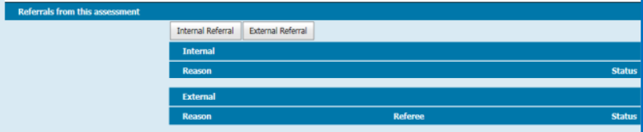

If the referral is relevant to someone other than the child (such as the mother, father or caregiver):
- Enter referral in ‘Child History’
    - in ‘Additional Comments’ add ‘attachments in [relevant client’s] history’
    - add ‘Referral Follow-up Blue Alert Flag’
- Ensure that the relevant client is open (such as the mother, father or caregiver)
- In the ‘Notes’ of the relevant client history, document:
    - date referral made
    - name of referee
    - brief referral reason
    - attachment of relevant documents/referral letter –.add any relevant documents or referral letters
    - add a ‘Referral Follow-up Blue Alert Flag’
- Document follow-up on referral status in:
    - relevant client history
    - child history
- On closure of the referral, remove ‘Referral Follow-up Blue Alert Flag’ from:
    - relevant client history
    - child history
- Close relevant client history if referral closed and no further action is required

Important notes for completing an external referral
1. Search by entering your Council name as Organisation
2. Select Search
3. Select appropriate referee or organisation – that is, external service provider as last name and your Council name as organisation
4. Select ‘Use service provider’.
Figure 2: Referee search
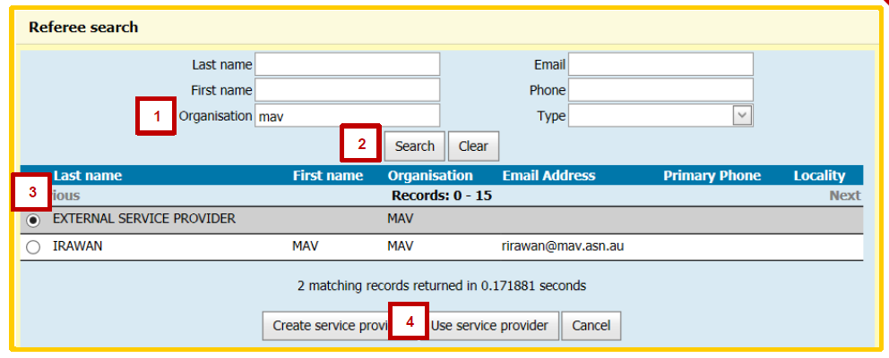
The referral letter template is not professionally sufficient to send as a referral in its current form (see ‘Using the referral letter template for external referrals’).
This referral letter template (viewed in ‘print preview’) will be amended as a CDIS enhancement and will be available in the future.
Note: While the referee is mandatory for filling out the screen, only the reason for referral is counted for reporting.
Searching, selecting and creating a referee is currently problematic – this is being investigated and will be rectified.
Note: Please ensure you select referee as per the process just outlined.
Figure 3: External referral pop-up box
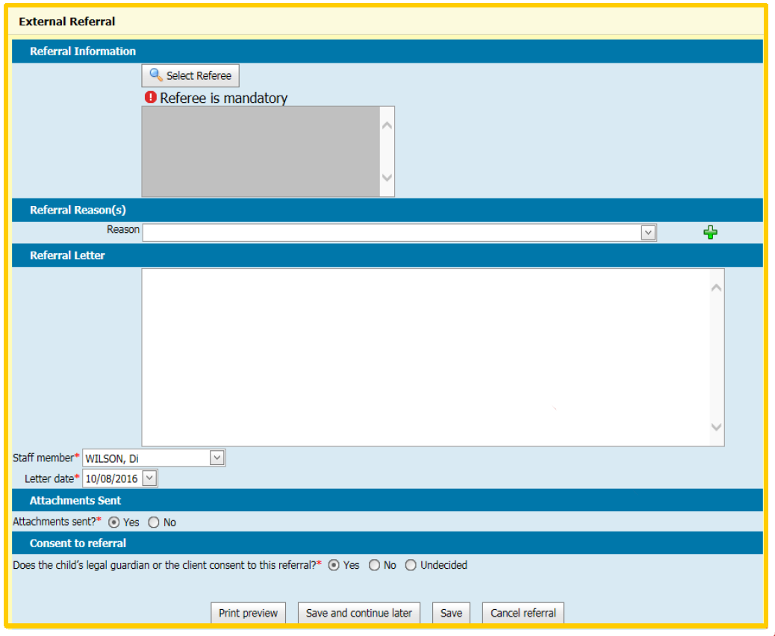

External referral from client (child) consultation
Note: All referrals are counted for reporting purposes in the child history (except Enhanced Maternal and Child Health). Only the reason for referral is counted for reporting purposes.
In the External Referral pop-up box:
- Pick referee, by selecting the ‘Select Referee’ button
- Referral reason: Select from look-up list – more than one reason can be selected by selecting the add green plus button and picking the next reason. Multiple reasons can be selected as all are counted – even if to different referees.
- Document referrals in Referral Letter free-text field – that is: reason for referral, name of actual referee & referral letter attached
- Ensure staff member is correct – this is set by default to your settings
- Ensure letter date is correct – this is set by default to today’s date
- Sending attachments with referral – pick by clicking Yes or No accordingly
- Informed consent to referral – Select ‘Yes’, ‘No’ or ‘Undecided’ accordingly
- Select the Save button or use the ‘Save and continue later’ button to allow further editing
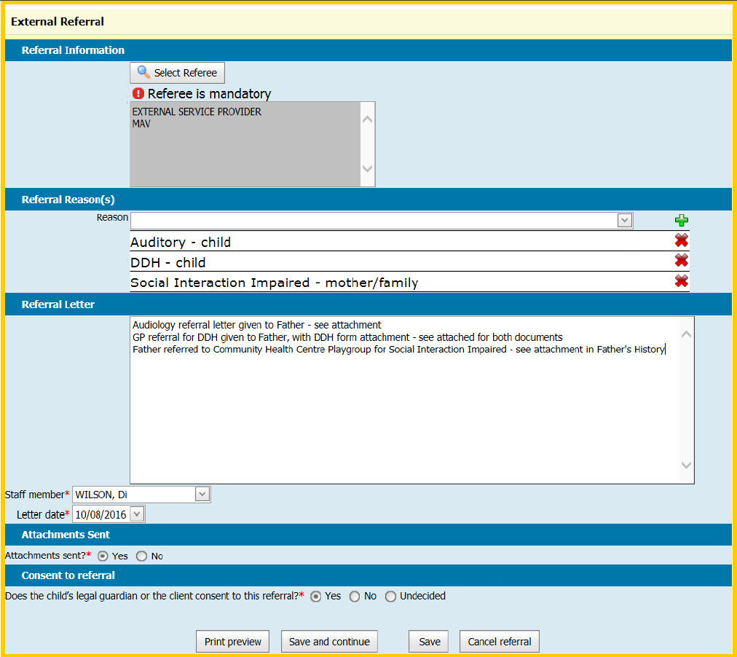
- Attach relevant documents to child or relevant client history (or both):
    - council templates or independent referral letter
    - supporting referral documents
- Ensure that the relevant client history is open (such as mother, father or caregiver)
- Document in Notes of relevant client history:
    - Date referral made
    - Name of Referee
    - Brief referral reason
    - Attachment of relevant documents or referral letter
- Add ‘Referral Follow-up Blue Alert Flag’ to child or relevant client history (or both.

Using the referral letter template for external referrals
Note: The referral letter template is not professionally sufficient to send as a referral in its current form – however it can be modified for use.
If using this referral letter template, the following details should be included.
Client family details | Referrer details
- Child date of birth  - Primary caregiver name  - Address  - Contact phone number | - Position  - MCH centre name  - Postal address  - Centre or organisation phone number  - Centre or organisation email address
If printing this referral letter, it is ideal to print on the organisation letterhead.
The completed referral letter is automatically saved in the client’s history (go to ‘Letters/Reports’ then ‘Correspondence History’).

Hint!
For a quick way of entering this information:
- Create a Word document with the following template and fields completed
- Save
- Copy (Ctrl + C) and paste (Ctrl + V) into referral letter free-text field
- Enter remaining information required

Template text
Child DOB:
Primary caregiver:
Address:
Contact phone:
---
Referrer details
Position:
MCH centre name:
Postal address:
Centre or organisation phone:
Centre or organisation email:
---
[Start letter here]
<template ends>
Figure 4: Pasted template text
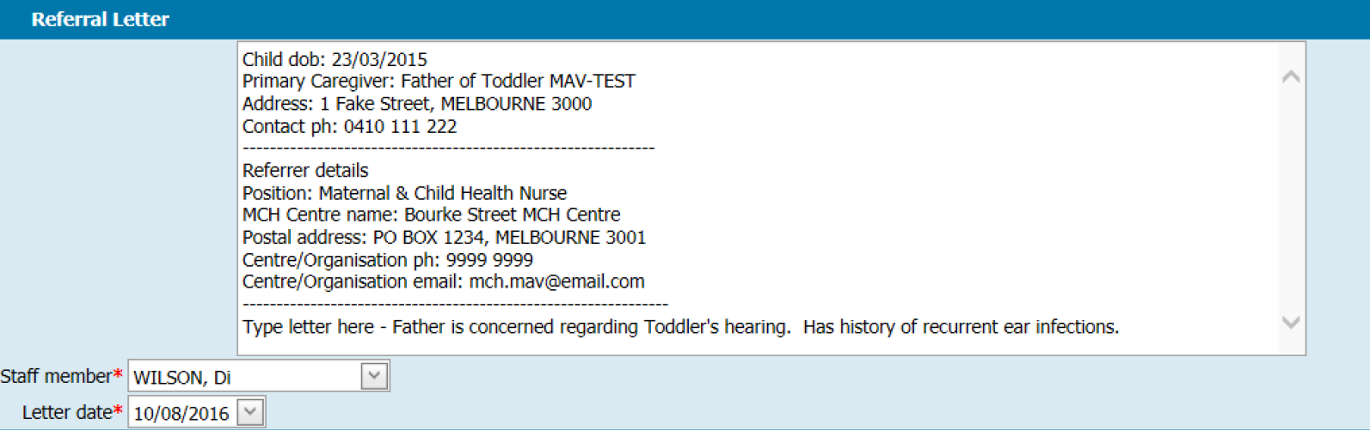

Completed external referral in client (child) consultation
In the client consultation screen, ‘Draft’ will be displayed in the ‘Referrals from the assessment’ section is the ‘Save and continue’ button was selected when adding an internal referral. Draft means the external referral can be edited and completed via Referrals (in the ‘Clinical Activity’ menu). See ‘Edit and complete external referrals in client (child) referral screen’.
Figure 5: Draft referral status
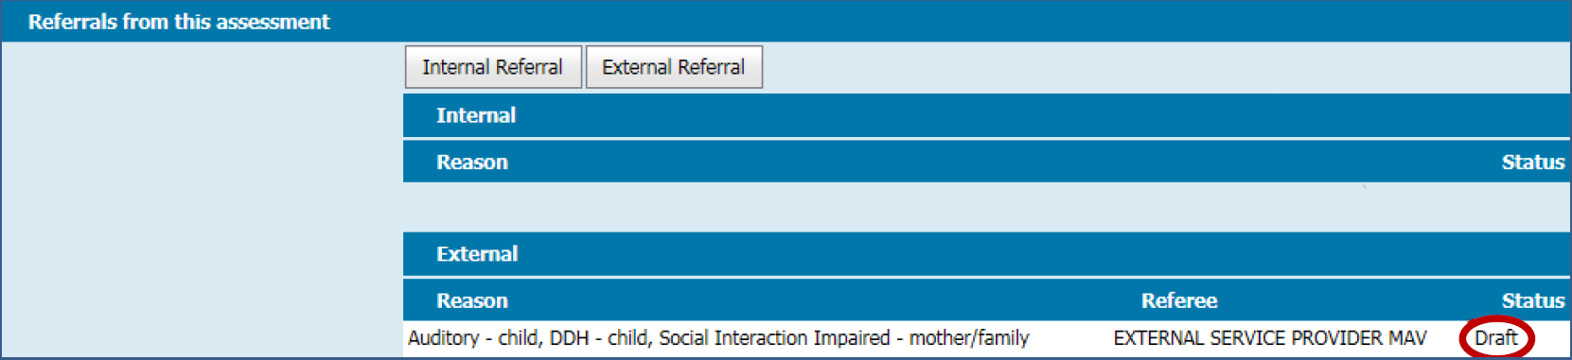
The status will be ‘Completed’ if the ‘Save’ button was selected. This external referral cannot be edited. Only the client notes associated with this external referral can be edited by going to ‘Notes’ under ‘History/Notes’ (see ‘Edit external referral notes in client notes’)
Figure 6: Completed referral status
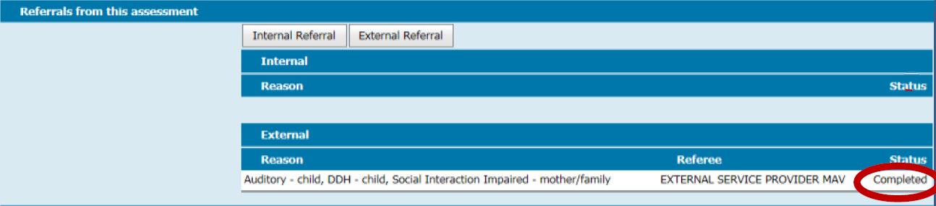

Edit and complete external referrals in client (child) referral screen
- In Client History, open the Clinical Activity menu and select Referrals
- Under ‘Incomplete Pending Referrals’, select the ‘Open’ button for the referral to be edited or saved (see Figure 3 for the ‘External Referral’ pop-up box interface)
    - ‘Incomplete Pending Referrals’ lists incomplete referrals
    - ‘Referral Status’ lists all complete referrals with their referral status as either pending, active, completed or declined
Figure 7: Incomplete pending referrals
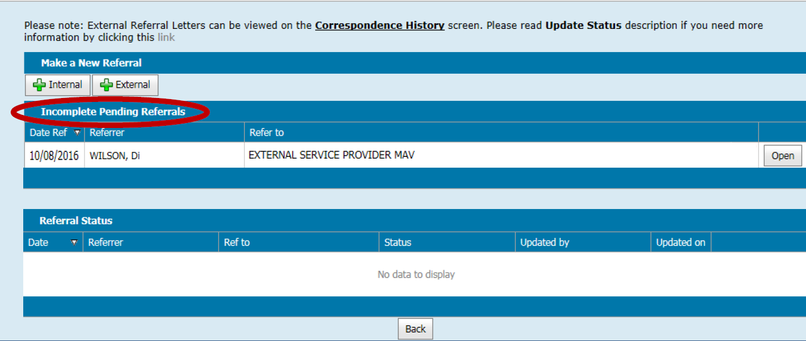
- Edit ‘Select Referee’ (required field) if needed – see ‘Important notes for completing an external referral’
- Edit Reason (required field) from look-up list – more than one reason can be selected
    - select one reason at a time and select the green plus button to add
    - a reason can be removed by selecting the red X button to delete
- Enter or edit Referral Letter (that is, to be record in ‘History/Notes’)
- Enter or edit ‘Staff member, ‘Letter date’ and ‘Attachments sent’
- Enter or edit ‘Other agencies/professionals involved’ if relevant
- Consent to referral (required): Confirm whether or not consent to the referral has been received by selecting the Yes or No radio button
- Select Save –no further editing will be possible
The completed referral will be displayed in the Referrals interface. Referral status may be either pending, active, completed or declined.
Figure 8: Pending referral status
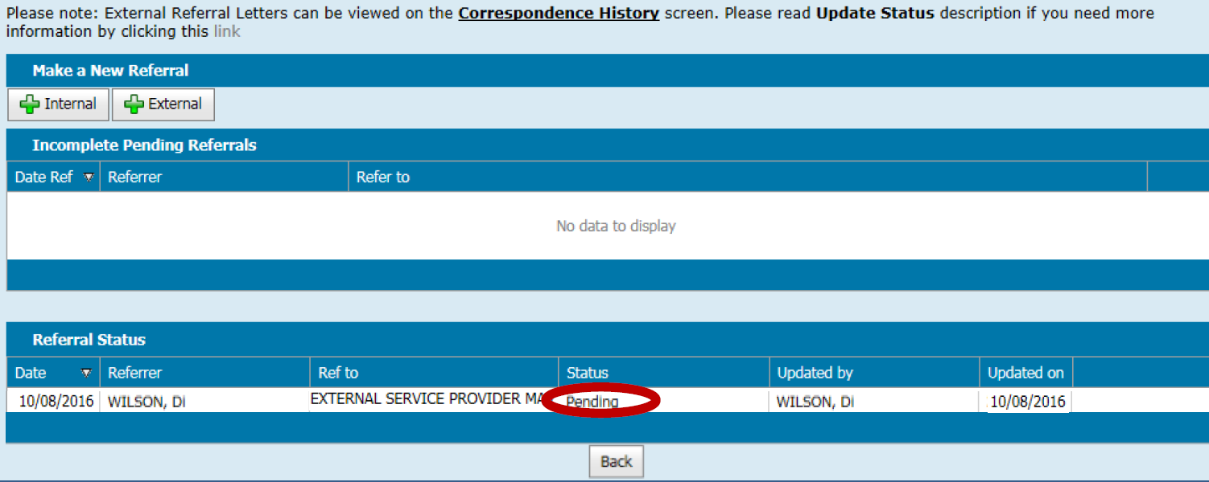

Completed external referral in client notes
Figure 9: Notes in child history
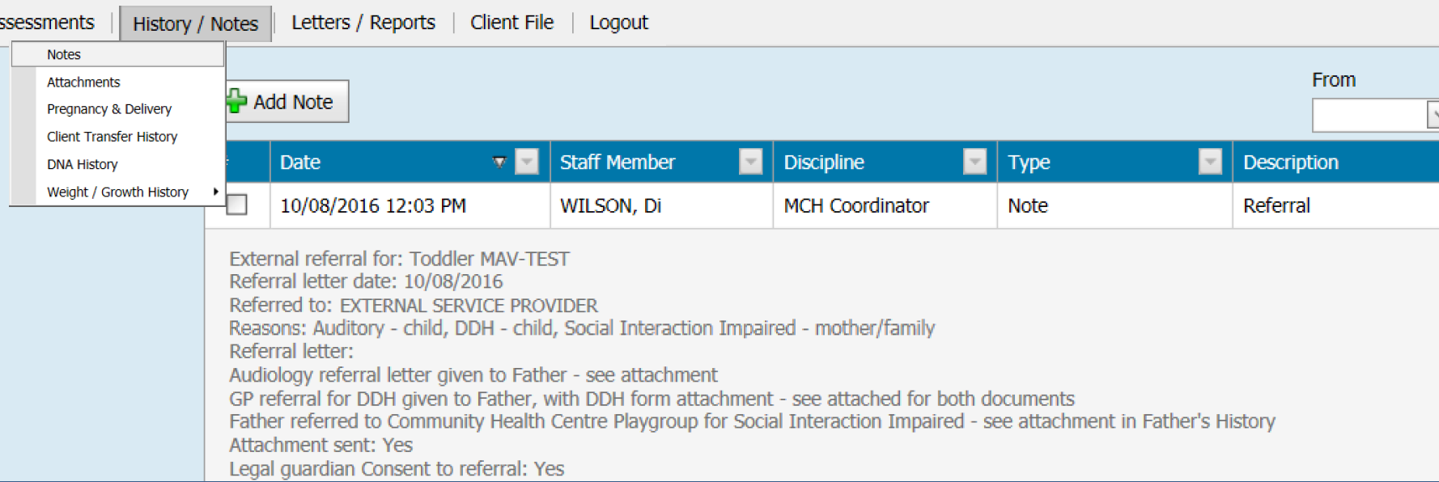
Figure 10: Notes in relevant client's (father) history
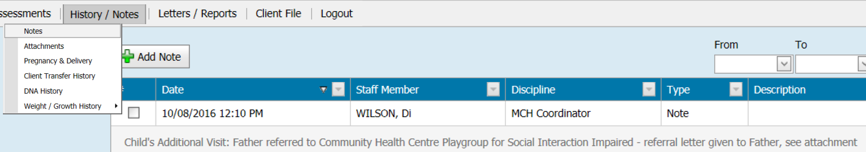

Edit external referral notes in client notes
Note: While there is the option to edit an external referral in the client notes section, this only edits the notes and not the external referral itself (see ‘Completed external referral in client notes’)
- In the Client History screen, open the ‘History/Notes’ menu and select ‘Notes’.
- Select the Edit button for the referral note you wish to edit
    - remember that this will only edit what has been documented in client notes and not the external referral.
Figure 11: Edit a referral note
- In the ‘Add/Edit Progress Note’ box:
    - add or edit the note
    - under ‘Edit reason’, select either ‘Incorrect Entry’ or ‘Incomplete Entry’
- Select ‘Save’.
Figure 12: Add or Edit Progress Note box
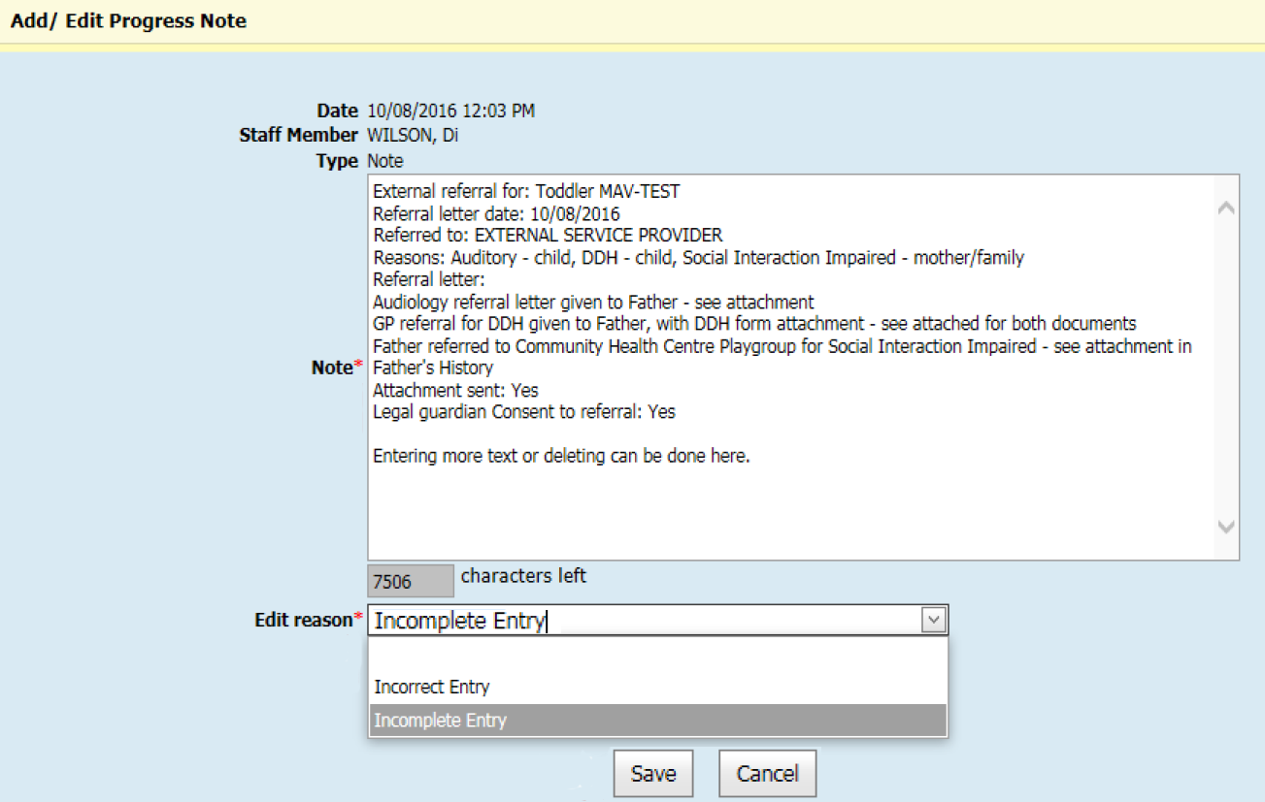

Completed external referral notes in client ‘History/Notes’
If external referral notes have been edited from client notes, the edited entry will be shown with the heading, ‘Supersedes Progress note previous entered on [date of original]’.
The original external referral note will have the heading, ‘Superseded by note entered on [date of edited version]’.
Figure 13: External referral progress notes
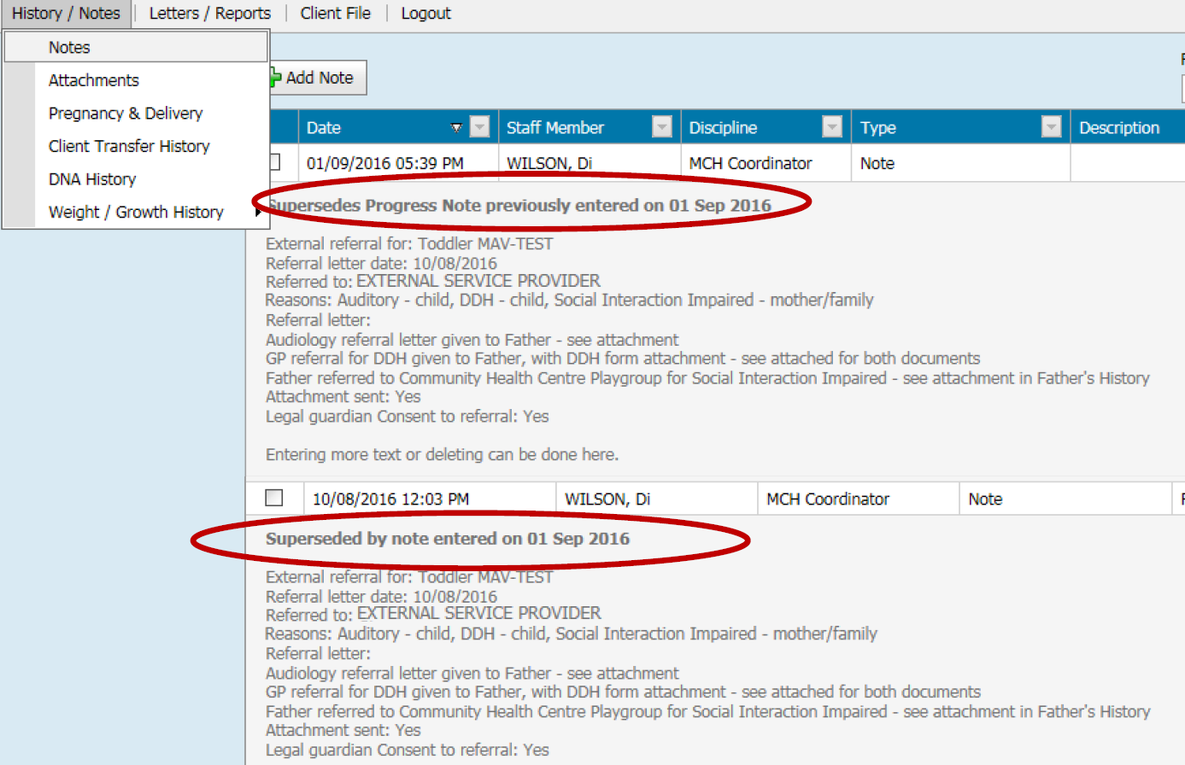

Add referral letters and forms as attachments to client history
- In the Client History screen, open the ‘History/Notes’ menu and select ‘Attachments’
- Select the ‘Add Attachment’ button
Figure 14: Attachments screen
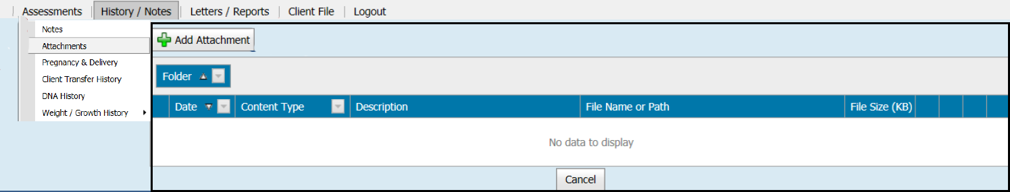
- Under attachment type, select either ‘Electronic Upload’ or ‘Physical Location’ – the default is electronic upload
- Enter an ‘Attachment description’
- Under ‘Type’, select the kind of attachment from the list (defaults to ‘Electronic Upload’)
Figure 15: Add Attachment pop-up box
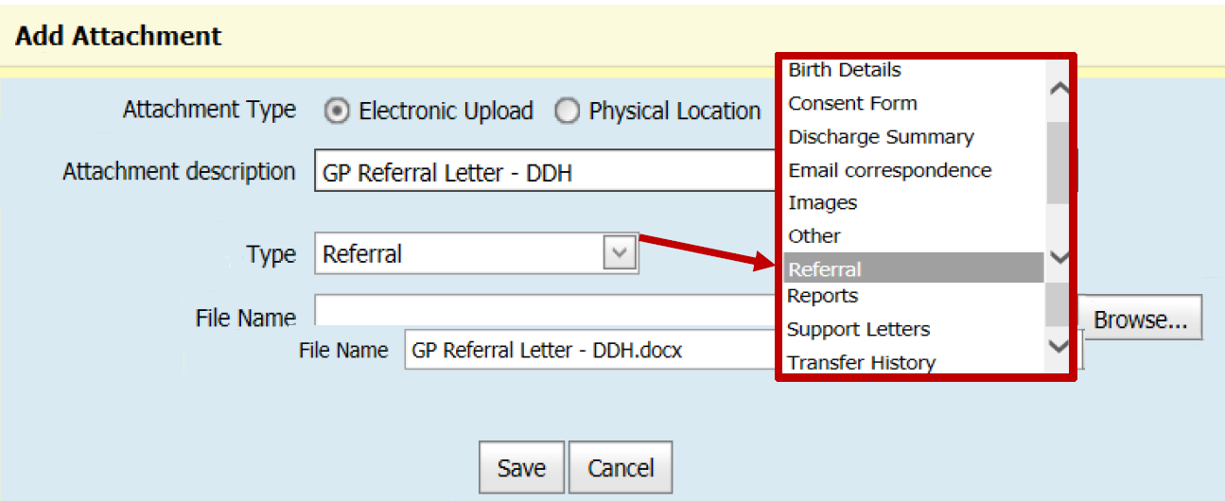
- Select the Browse button to pick the file to upload
- Find where the relevant file was saved, pick the file and select the Open button
    - the file name will then be displayed in ‘File Name’ field
    - best practice is to save the file in your personal drive and then delete the file once attached
Figure 16: Choose file to upload
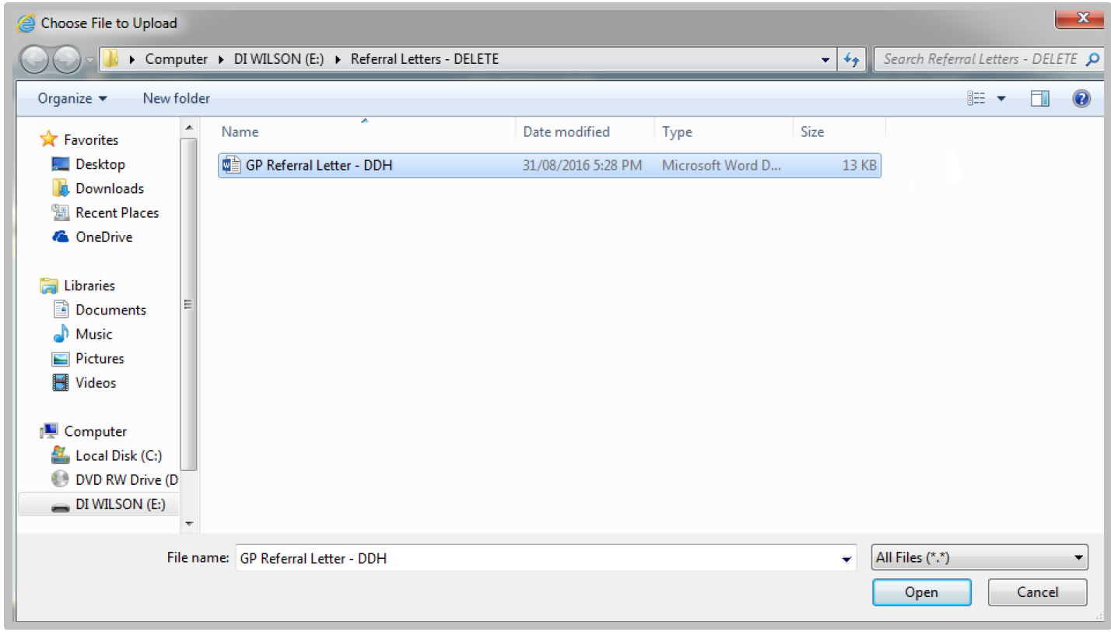
- Select Save
The referral letters and forms will be displayed in the table on the Attachments screen.
Figure 17: Updated Attachments screen
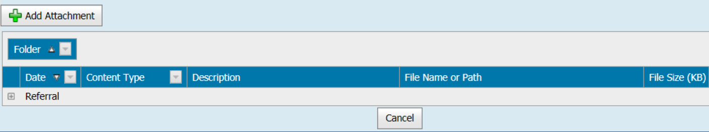

View, edit and delete attachments in client history
- In the Client History screen, open the ‘History/Notes’ menu and select ‘Attachments’
- Select the Expand button (plus sign in a square)
Figure 18: Attachments screen
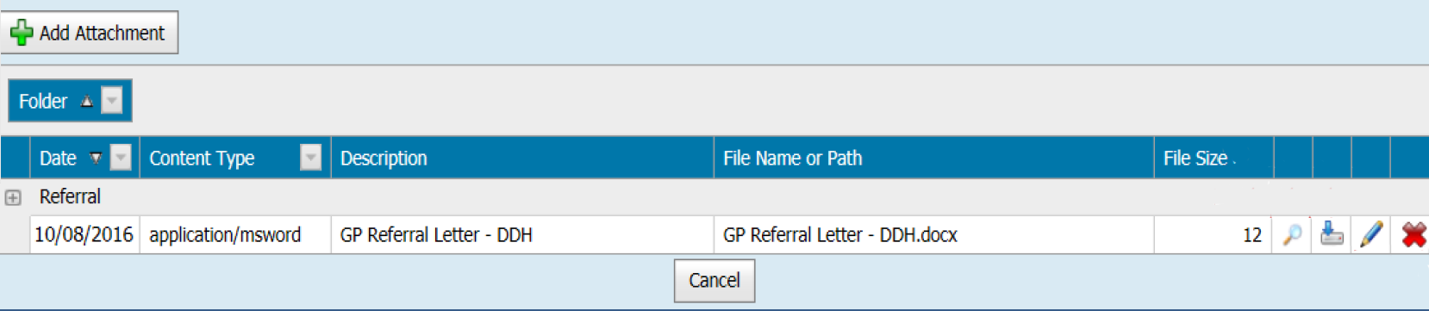
- View attachment details by selecting the view button (magnifying glass icon) – you can view attachment details or open or save files
Figure 19: View Attachment Details box
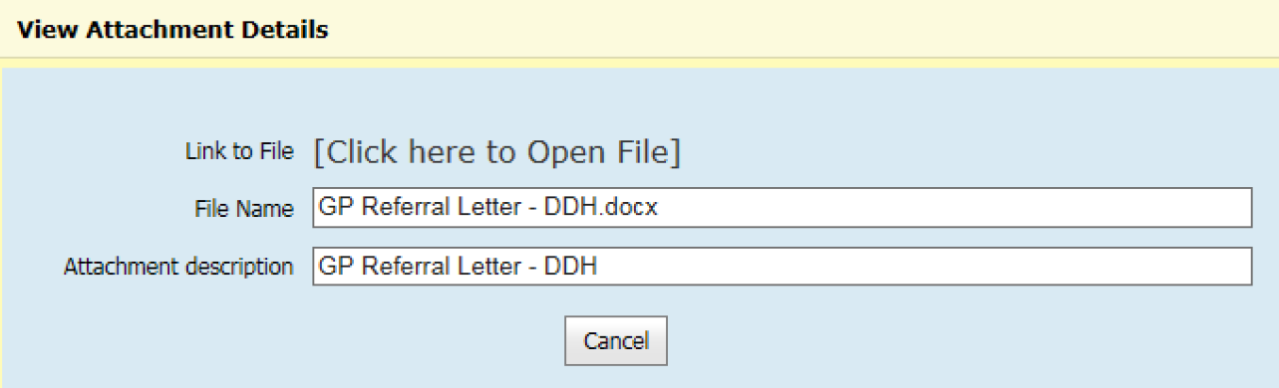
- Select the download button (icon of a drive with a down arrow) to download an attachment – select either Open or Save
Figure 20: Open or save message

- Select the edit button (pencil icon) to edit attachment details – you can edit the file name, attachment description and type
Figure 21: Edit Attachment Details box
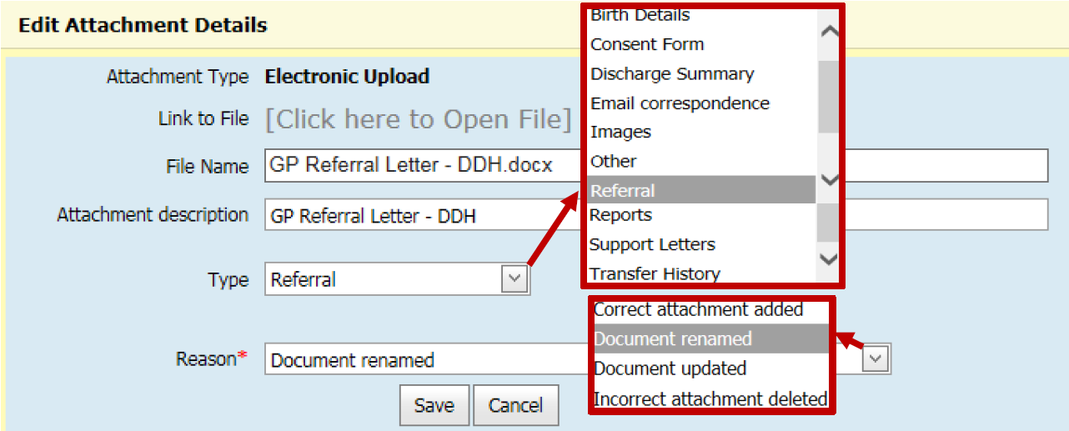
- Select the delete button (red X icon) to delete an attachment
    - note: only management can delete
    - include a reason for deleting the attachment
Figure 22: Delete Attachment box
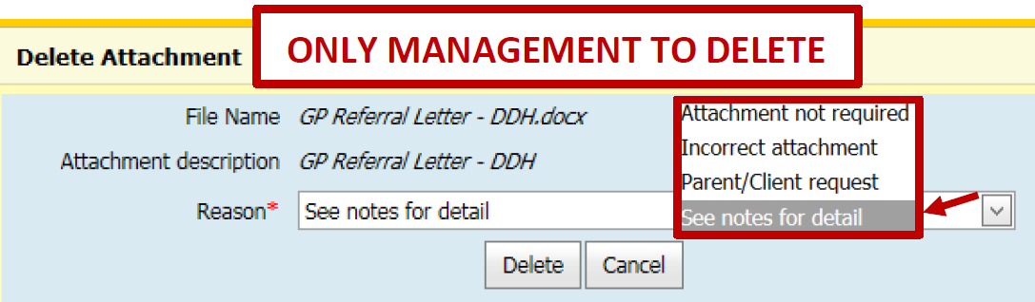
Figure 23: Notes for deleted attachments
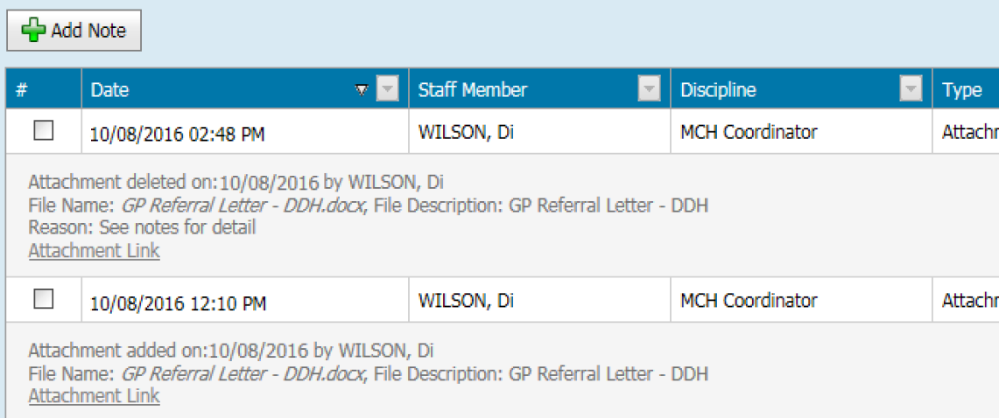

Add a ‘referral follow-up’ blue alert flag for external referrals
- In Child History, open the Clinical Activity menu and select ‘Flags/Alerts’
- Select ‘Add’ to add a flag or an alert
Figure 24: Flags/Alerts screen
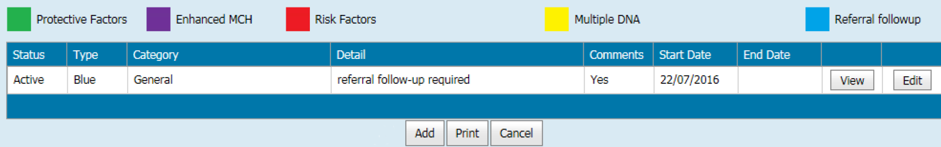
- In the ‘Add Flags/Alerts’ pop-up box:
    - under ‘Category’, select ‘General’
    - under ‘Details’, select ‘referral follow-up required’
    - enter the ‘Start Date’ by using digits or calendar box – the default is today’s date
    - enter comments if relevant
    - select the Confirm button
Figure 25: Add Flag/Alert box
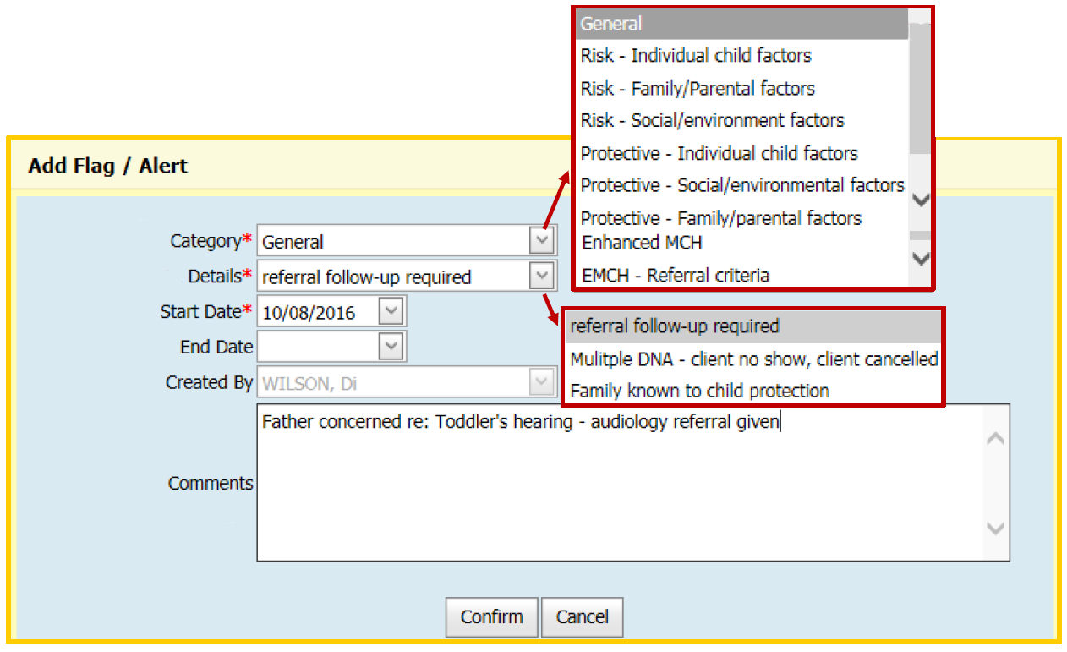
Blue alert flag box is now displayed in Child History
Figure 26: Blue alert flag
Repeat steps for relevant client history if appropriate.

Update status of external referrals
The status of external referrals can be either pending, active, assigned, completed or declined.
In the client Referral screen (open the Clinical Activity menu and select Referrals), the referral status may be:
- pending – referred but not yet accepted or declined
- active – being currently actioned or receiving service
- completed – episode of care has ended or been closed
- declined – referral declined.
Figure 27: Referral status on Referrals screen
To update the status from ‘Referral History’:
- select the ‘Update status’ button for the relevant referral
- Select the radio button for the new status
- If status is declined, include a reason from the list
Figure 28: Update referral status to declined
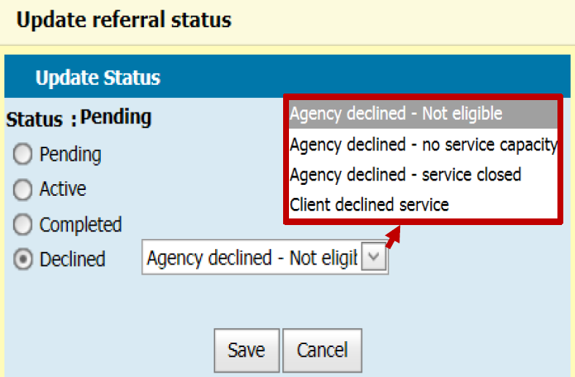
- Select ‘Save’.
Figure 29: Client notes
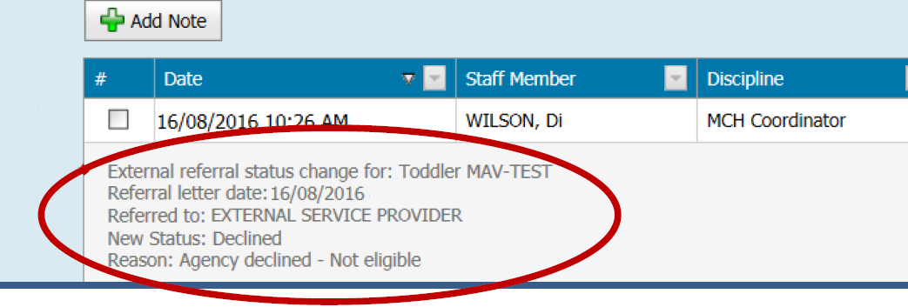

Remove a ‘referral follow-up’ blue alert flag
Note: Referral follow-up blue alert flags need to be reviewed at each consultation and removed if required. This is from both the child history and relevant client history.
- In child history, open the Clinical Activity menu and select ‘Flags/Alerts’
- Select Edit on relevant blue referral follow-up flag
Figure 30: Flag/Alerts screen
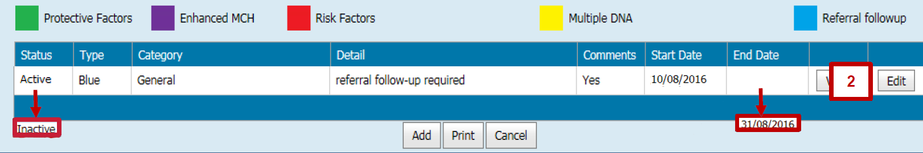
- In the ‘Edit Flag/Alert’ pop-up box:
    - check that the category and details are correct – these should be ‘General’ and ‘referral follow-up required’ (these fields are already filled)
    - End date: enter by using digits or calendar box (defaults to today’s date)
    - Comments: enter if relevant (such as outcome and recommendations)
Figure 31: Edit Flag/Alert box
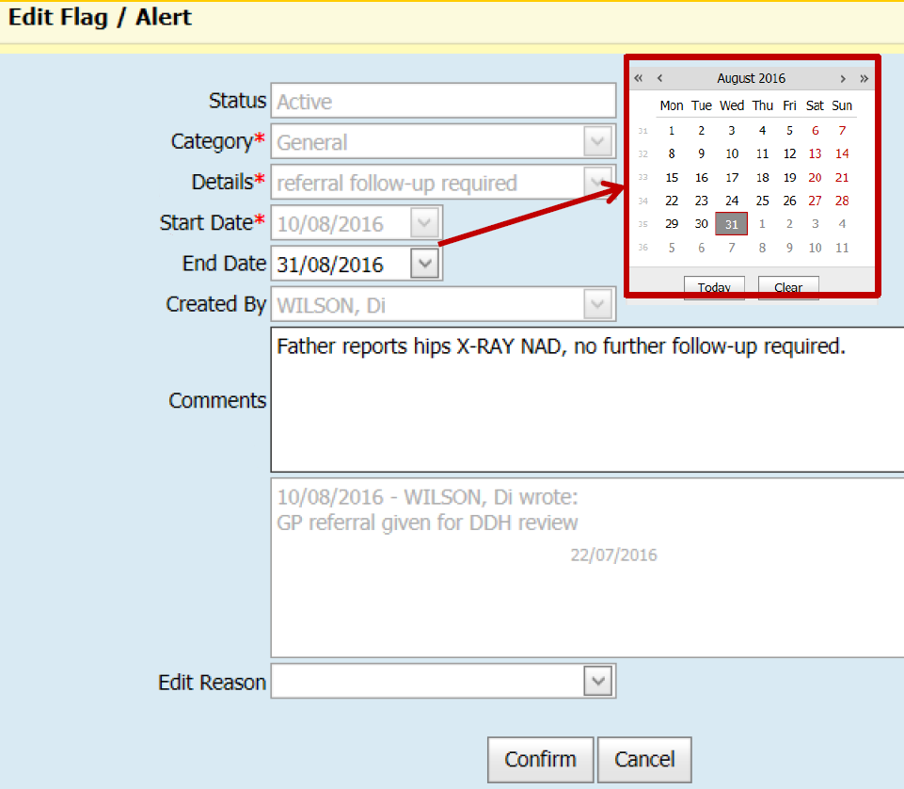
- Select the Confirm button to save.
Client history will now display:
- blue alert flag box with one less number or replaced with a light blue triangle
- inactive status in child ‘Flags/Alerts’
- end date in child ‘Flags/Alerts’.
Figure 32: Triangle flag
Note: Repeat steps for relevant client history if appropriate.
To receive this publication in an accessible format phone 1300 650 172, using the National Relay Service 13 36 77 if required, or email Commissioning Performance and Improvement Aged and Community Based Health Care and Cancer Services <mch@dhhs.vic.gov.au>
Authorised and published by the Victorian Government, 1 Treasury Place, Melbourne.
© State of Victoria, Australia, Department of Health and Human Services June 2020.
ISBN 978-1-76096-021-6 (online/print)
Available at health.vic – Child Development Information System <https://www2.health.vic.gov.au/primary-and-community-health/maternal-child-health/child-development-information-system>

