Residential rehabilitation treatment expansion – 100 new beds
Information for referrers to residential drug rehabilitation services
This factsheet explains some of the changes that are happening to expand access to residential rehabilitation across the state.
The expansion will create more treatment spots, reduce pressure on the system, and improve access to treatment for people who may struggle to attend community-based services.

What changes are happening?
The Victorian Government is delivering 100 additional adult residential rehabilitation beds to help more Victorians access treatment and reduce the impacts of drugs and alcohol on our local communities.
Announced in October 2017 as part of the new Drug rehabilitation plan, $53.2 million will go into establishing these beds, treating up to 400 extra people each year.
The beds will be provided through a combination of expanding existing rehabilitation services and other health facilities – see Figure 1 below.
The expansion will include establishing a new service for people with co-occurring alcohol and other drug and mental health needs (dual diagnosis), to be delivered at two new residential rehabilitation facilities.
Figure 1 Residential rehabilitation expansion
To receive this publication in an accessible format phone 9096 0000 using the National Relay Service 13 36 77 if required, or email aod.enquiries@dhhs.vic.gov.au
Authorised and published by the Victorian Government, 1 Treasury Place, Melbourne.
© State of Victoria, Department of Health and Human Services, March 2018.
Available at www2.health.vic.gov.au/alcohol-and-drugs/aod-treatment-services/aod-residential-treatment
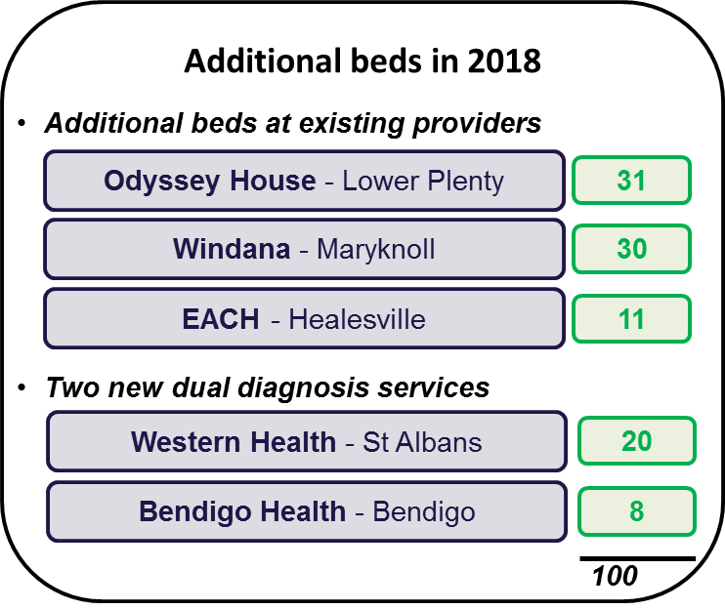

Why more beds?
Alcohol and other drug problems are complex, affecting not just individuals but their families, their friends and their communities.
Residential rehabilitation is one treatment option among a range of solutions funded across Victoria to save lives. It provides a structured and therapeutic environment for people to develop new skills and make positive life changes.
There have been growing calls from local communities, health services, and alcohol and other drug support providers for access to additional treatment and rehabilitation services across the state.
In addition to the 100 extra beds, new facilities in the Grampians, Gippsland, Barwon and Hume regions will progressively come online from October 2018.
Overall, these initiatives will more than double the number of drug rehabilitation beds in Victoria, from 208 beds in 2014–15 to 420 once fully operational. Over half of the new beds will be based in regional Victoria.
Where do I go for more information?
If you have any questions about residential rehabilitation or other drug treatment services, please:
- speak with your local catchment-based intake service or contact DirectLine on 1800 888 236 or at <www.directline.org.au>
  - see the factsheet About residential rehabilitation at <www2.health.vic.gov.au/alcohol-and-drugs/aod-treatment-services/aod-residential-treatment>.

