BLOOD REFRIGERATOR TEMPERATURE RECORD CHART-COPY TO LABORATORY FORM

Hospital: | Contact  Phone
Copy sent to lab name:  Address  Telephone: Fax: | Date/time sent
Sent by
Name: Signature: Title:
Position completed Blood refrigerator temperature chart in this space and photocopy
Send copy to your Transfusion Laboratory for checking.
Archive copy with Blood Refrigerator records.
SAMPLE ONLY DO NOT USE
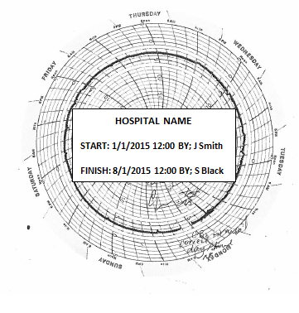
Transfusion Laboratory USE ONLY
Temperature chart check Passed □ Fail □
Store this hospital blood refrigeration temperature chart record sheet appropriately. NATA may require viewing for audit
Checked by……………………………………………Signature: ………………………………………….Date: …………………….Time: ………...

