Applying for leave
Plain English fact sheet for forensic residents

This is a fact sheet about forensic leave. We will call this leave.

Leave means you can go into the community to do an activity.

You can ask for leave if you are a forensic resident.

A forensic resident is someone who is on an order made by a court that says you must live at a disability service and get care and treatment there.

Do you need help with this fact sheet?

- This information is written in plain English.

- We use drawings to highlight key points.

- Hard words are written in blue and explained at the end.

- You might need help to read this information.

- A friend, family member or support person can help you.

What is leave?
Leave means you can go into the community to do an activity.

You could ask to:

- go shopping

- see your family or friends

- go to a class

- play sport.

Who decides if I can have leave?
If you want to go on leave you must ask the
Forensic Leave Panel. We will call it the panel.

The panel is made up of:

- a judge

- a psychologist

- a person from the community.

How do I ask for leave?

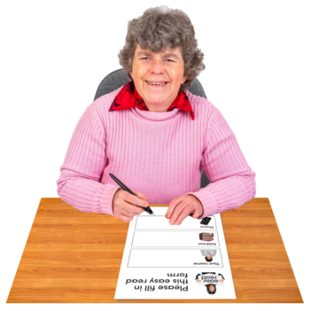
You need to fill out a form. You can get one from your
care team.

You need to tell the panel:

- where you want to go on leave

- why you want to go on leave

- how the leave will help you.

You need to sign your name on the form.

Can I ask someone to help me fill out the form?

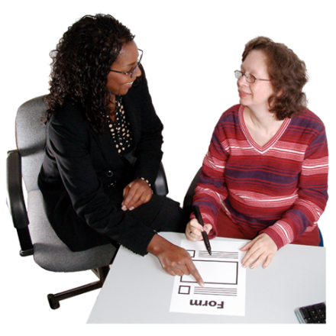
You can ask someone you know to help you. For example:

- someone in your care team

- an advocate

- a family member or your carer

- an interpreter.

You can call them yourself or ask someone in your care team to help you call them.

What type of leave can I ask for?
You can ask to do any activity that will help you with your rehabilitation. You can talk to your care team about the type of leave activities you would like to do.

The panel needs to make sure you are okay when you go on leave.

You will start by going on leave for a short time, before you can go on leave for a longer time.

Who can go on leave with me?

When you first go on leave, staff must go with you.

Over time, if your leave has been going well, you can ask to go on leave:

- with a support worker

- with a family member or carer

- by yourself.

What time can I go on leave?
You can ask to go on leave during the day or the night.

If you want to go on leave after 9 pm at night you can only do this 3 times in 7 days.

What will happen after I fill in my form?

When you have filled in your form you need to give it to someone in your care team.

Two things will happen next:

      - your care team will write a report for the panel

      - the panel will read the report and have a hearing to decide if you can go on leave.

What is a hearing?

A hearing is a meeting with:

- you

- your care team

- the panel.

When will my hearing happen?
It can take about 6 weeks to have a hearing.

Your care team will tell you when your hearing will happen.

You will get some reports about your hearing at least
1 day before your hearing.

Do I need to go to my hearing?

You do not have to go to your hearing.

If you go to your hearing you can talk about why you want to go on leave.

Can someone come with me to my hearing?

You can ask someone to come to your hearing with you. For example:

- a lawyer

- a family member or carer

- a support worker.

You must let the panel know who is coming to
your hearing. You can write their name on your form or tell someone in your care team.

Can I get an interpreter to come to my hearing?
You can ask for an interpreter to help you at your hearing.

You can write this on your form or tell someone in your care team.

How will the panel decide?

The panel will only let you go on leave if they think:
- it is safe

- the leave will help you.

The panel will talk to you and your care team about your application.

They will read your form and reports from your care team to help them decide if you can have leave.

How will I know if I can go on leave?

The panel will tell you if you can go on leave or not.

If you get leave, they will tell you the rules about your leave.

What if I do not get leave?

You cannot go on leave if the panel says no.

You can ask the panel to tell you why you cannot do the activities you want to do.

You can ask your care team to help you apply for
leave again.

When can I use my leave?
Before you go out on leave you must talk to your
care team.

They will ask you some questions to check that it is okay for you to go out on leave.

When can I apply for leave again?
You can fill out a form if you would like new leave, or if your needs change. You can do this at any time.

More information

You can ask for help from:
- your care team

- a lawyer or an advocate

- the panel – by calling 1800 222 987.

If you need a lawyer or an advocate you can contact:

- Victoria Legal Aid – by calling 1300 792 387

- Villamanta Disability Rights Legal Service – by calling 1800 014 111

- Victorian Advocacy League for Individuals with Disability – by calling 9416 4003.

What do these words mean?

Advocate – someone who can help you have your say.

Care team – the people who work at the disability service where you live and support you.

Disability service – the place where you must live and get care and treatment.

Forensic Leave Panel – a group of people who decide whether you can go on leave.

Forensic resident – someone who is on an order made by a court that says you must live at a disability service and get care and treatment there.

Interpreter – someone who can help you understand English.

Lawyer – someone who can help you with questions about the law and help you have your say.

Psychologist – someone on the Forensic Leave Panel who works with people who have intellectual disabilities.

Rehabilitation – learning skills and behaviours to help improve your life and help you live safely in the community.
To receive this document in another format phone 1800 222 987 or email flp@health.vic.gov.au
If you need help to speak or listen, you can use the National Relay Service.
Call 13 36 77.

Authorised and published by the Victorian Government, 1 Treasury Place, Melbourne.
© State of Victoria, Australia, Department of Health, February 2021.

ISBN 978-1-76096-322-4 (pdf/online/MS word)
Available at https://www2.health.vic.gov.au/mental-health/mental-health-services/services-by-type/forensic-mental-health-services/forensic-leave-panel

