Implementing a hospital PVC recycling program
Factsheet

Introduction
Plastics can account for up to a third of a hospital’s general waste. It is estimated that of all the plastic generated by a hospital, approximately one quarter is PVC medical products such as intravenous bags, face masks and oxygen tubes. It is estimated that Australia consumes around 50 million PVC intravenous bags each year.
PVC used in these common medical devices is recyclable (Recycling ID Code 3) and easily recycled by staff in theatres, wards, intensive care, renal and day surgery. This factsheet outlines the business case for participating in the PVC Recycling in Hospitals program and how to implement it in your hospital.

General waste disposal
Hospitals typically pay for three elements when disposing of general waste:
- a fee for every kilogram of waste sent to landfill (including the state landfill levy)
- a fee for hiring waste bins and/or a compactor
  - a fee for each ‘bin lift’ by the waste contractor.
If PVC is not recycled, it is disposed of through general waste at a financial cost. The exact cost of general waste disposal varies depending on a hospital’s waste contract and hospital staff can source waste cost data from their Sustainability Officer, Support Services, or Hotel Services.

The business case for recycling PVC
Through PVC recycling programs in hospitals, a significant percentage of PVC can be diverted from landfill to recycling at a lower cost, or cost neutral.
The cost varies by location, and in some cases it may even be free. If there is a cost, it is no more than $10 per 240-litre bin lifted, with no bin rental or weight charges. A standard 240 litre recycling bin will hold around 40 kilograms of PVC, resulting in a cost of around $0.25 per kilogram of PVC.
Recycling PVC has environmental and social benefits. Recycling PVC uses around 85 per cent less energy than producing virgin PVC. It also saves around 1.8 kilograms of carbon emissions per kilogram of medical product recycled. All PVC collected from Australian hospitals is processed and manufactured into new products in Australia. Due to the success of the program, it is being replicated in England, South Africa and Canada.

Implementing a hospital PVC recycling program
The flow chart on the next page shows the steps to implement a PVC recycling program in your hospital. It is likely that each hospital will need support from management, support services and infection control. Hospitals should start with one area, such as renal, where there is high volume and capacity to separate PVC items.
You can then build on successes to expand to areas such as theatres, recovery wards, intensive care units and day surgery. If your hospital has a sustainability officer, they can help to champion the program, promote outcomes and expand it across the health service.
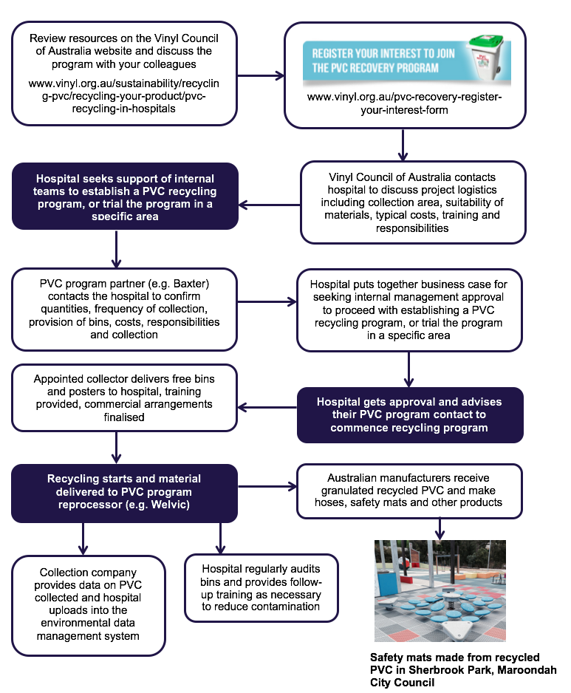

To receive this publication in an accessible format phone 03 9096 2119, using the National Relay Service 13 36 77 if required, or email Sustainability <sustainability@dhhs.vic.gov.au>
Authorised and published by the Victorian Government, 1 Treasury Place, Melbourne. © State of Victoria, Department of Health and Human Services April, 2017. ISBN 978-0-7311-7202-3 (pdf/online). Available on the Health.Vic website <www.health.vic.gov.au/sustainability>

