Victorian pharmacotherapy area-based networks

Background
Pharmacotherapy has become established in Australia and many other parts of the world as an effective treatment for opioid dependence. It is an important part of the Victorian Government’s community response to the treatment of drugs and alcohol in the state.
The Victorian pharmacotherapy system is a community-based model, where medical professionals and pharmacists work together to make pharmacotherapy for opioid dependence available in the community.
In 2014, five area-based pharmacotherapy networks were established to facilitate localised approaches in connecting care, driving best practice and improving health and wellbeing outcomes for opioid dependent patients.

Service objectives
Each of the five pharmacotherapy networks support health professionals (general practitioners, pharmacists and allied health clinicians) to prevent, identify and treat opioid dependence throughout the state.
The networks identify and provide local solutions to service need in their area, work with other services to form partnerships and referral pathways, facilitate ongoing training for pharmacotherapy providers and provide access for complex clients to addiction medicine specialists.

Contacts

Area 1: Barwon South West Pharmacotherapy Network
Holistic management support for prescription opioids, over the counter codeine and illicit opioids.
Access to specialists, mentors, professional development events and staff training.
Phone: 03 5222 0800
Email: info@westvicphn.com.au
Fax: 03 5223 2209

ORTicare (Area 2): Grampians and Loddon Mallee Pharmacotherapy Network
Workforce education, training and clinical networks of professional peers.
Clinical support, expert consultation and mentoring including the Rural Addiction Medicine Pharmacotherapy Specialist (RAMPS) service.
Phone: 03 5338 4500 or 5338 9142
Email: orticare@bchc.org.au

Area 3: Gippsland and Hume Pharmacotherapy Network

Gippsland Pharmacotherapy Network
Addiction Medicine Specialist support and consultations through the RAMPS service.
General practitioner, pharmacist, nurse practitioner and health care worker support and training.
Phone: 1800 242 696
Email: pharmacotherapy@lchs.com.au
Fax: 03 5136 5406

Hume Pharmacotherapy Network
General practitioner, pharmacist, nurse practitioner and counsellor support and training.
Telehealth secondary consultations with the RAMPS addiction medicine specialist service.
No-cost, weekly Project ECHO collaborative learning sessions, led by a specialist team available to all Victorian health practitioners.
Phone: 03 5823 3219
Email: info@hapn.org.au
Fax: 035823 3299
Website: https://echo.pabn.org.au

Area 4: South and Eastern Metropolitan Pharmacotherapy Network
Direct access to Addiction Medicine Specialist support and secondary consultation
General practitioner, pharmacist, nurse practitioner and practice manager support, mentoring and training.
Phone: 03 8514 6600
Email: A4PN@semphn.org.au
Fax: 03 8514 6699

Area 5: North and West Metropolitan Pharmacotherapy Network
General practitioner peer mentoring, education, training and community of practice for treatment providers.
Addiction Medicine Specialist support including specialist assessment and secondary consultation.
Phone: 03 9448 5507
Email: pharmacotherapy@cohealth.org.au
Fax: 03 7000 1811
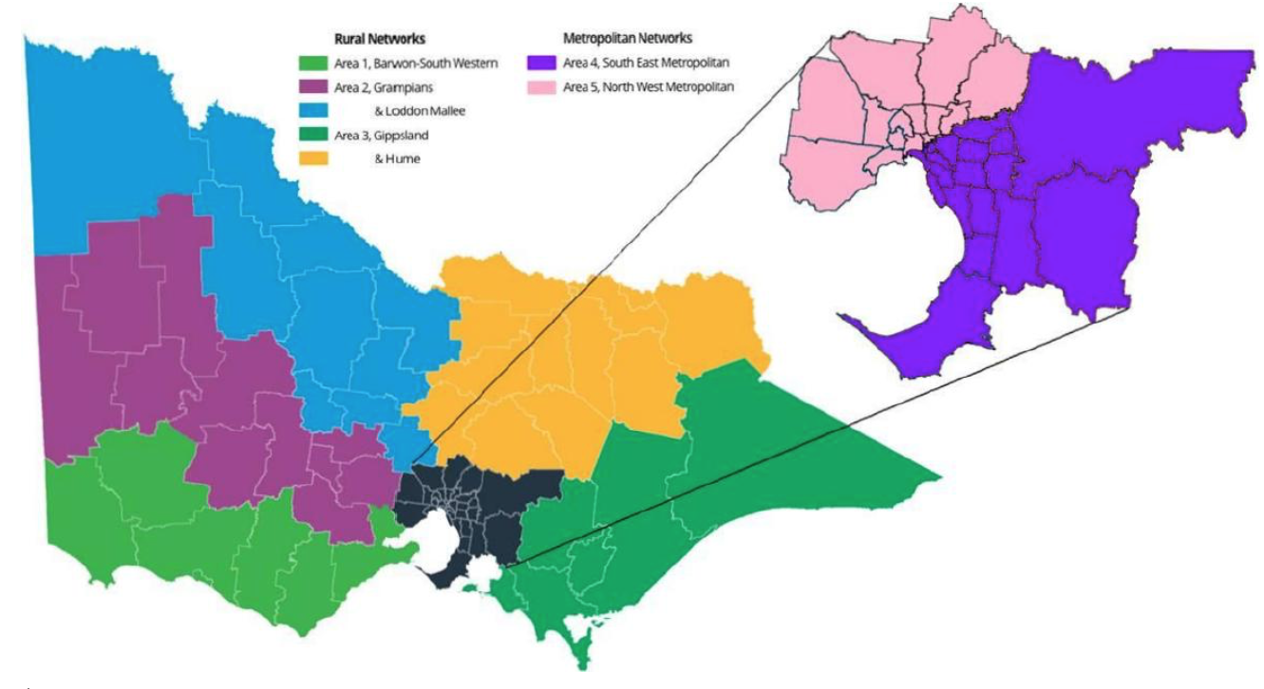

To receive this publication in an accessible format phone 1300 364 545, using the National Relay Service 13 36 77 if required, or email the Medicines and Poisons Regulation team <dpcs@dhhs.vic.gov.au>
Authorised and published by the Victorian Government, 1 Treasury Place, Melbourne.
© State of Victoria, Department of Health and Human Services February 2020
Available on the department’s website <https://www2.health.vic.gov.au/public-health/drugs-and-poisons>

