Patient blood management for consumers
Helping your blood work for you

Patient blood management (PBM) is the new standard of care. Standards of care ensure that everyone receives safe, high-quality and evidence-based treatment.
PBM focuses on actions to reduce or avoid the need for a blood transfusion.
If you need a transfusion, we will make sure you only receive what you really need, and that the transfusion is given safely.

PBM is best practice

Research tells us you may have: |  | PBM can reduce: |  | PBM requires a team approach involving:
 | - fewer complications  - a faster recovery  - less time in hospital. |  | - the need for blood transfusion  - the risks related to blood transfusion  - healthcare costs. |  | - you and your carers  - your doctors, nurses and pathology staff.

PBM focuses on three main areas

Identify and manage anaemia
 | Anaemia (low Hb) is common – 30 per cent of patients going to surgery have anaemia.
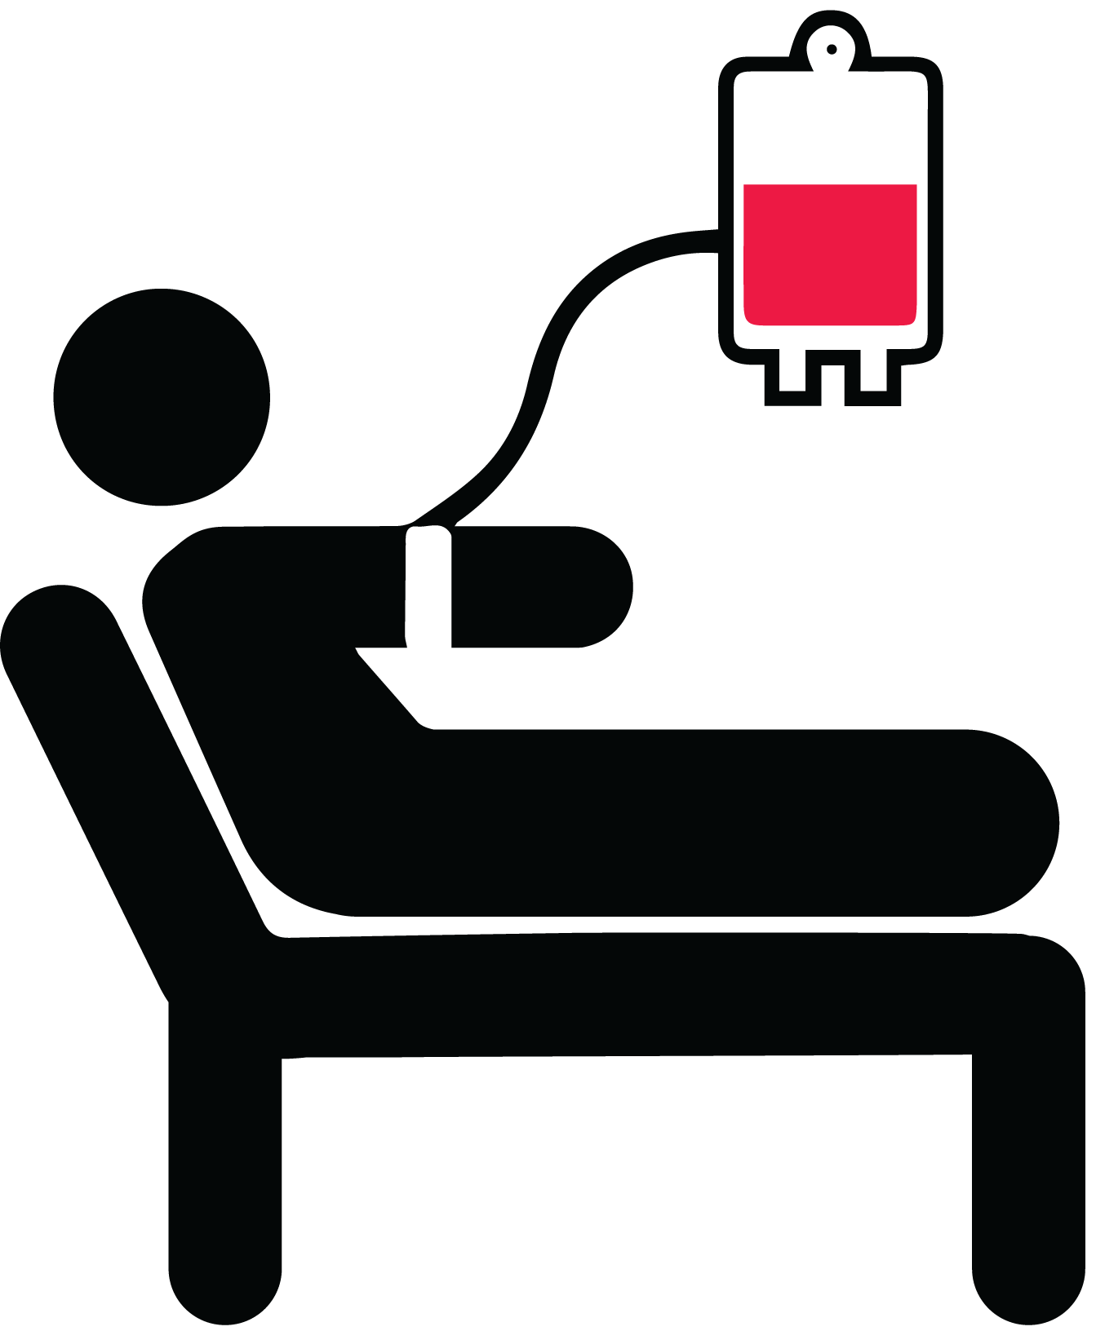 | Anaemia and low iron levels can increase your chances of needing a blood transfusion and other complications.
 | If your Hb or iron levels are low, you may need to take iron tablets or have an iron infusion.
 | For best results, anaemia or iron treatment should start four to six weeks before you have surgery. If your surgery is more urgent, you may need an iron infusion.
 | You may need further tests if there is no obvious reason for your anaemia or low iron levels.

Minimise the risk of bleeding
Tell the doctor about any medicines you are taking, prescribed or over-the-counter, including natural and herbal medicines, as some can affect clotting and bleeding.
If your doctor wants you to take a blood test, ask if the test is really needed. Taking less blood for tests can reduce the amount of blood lost and can help reduce the need for a blood transfusion.
In addition to your doctor paying careful attention to reduce bleeding during surgery, they may use new techniques, giving you back the blood you lose and the use of some medications to reduce bleeding during the procedure such as tranexamic acid.

Tolerating anaemia (low Hb)
After surgery, you will be carefully monitored to check for and stop any bleeding.
You may still need a blood transfusion if you have signs and symptoms of anaemia or significant bleeding. Before having a blood transfusion, the doctor will assess your condition. You should only receive a blood transfusion if the risk of the transfusion is less than the risk of you becoming unwell due to anaemia.
If you need a blood transfusion, the doctor should only order one unit of blood, and assess your condition again to see if you need any more. This may mean having another blood test and being examined by the doctor.

Find out more
Your doctor can tell you more about how PBM practices can help to reduce or prevent you needing a blood transfusion.
You can also find out more about transfusions on the Australian Red Cross Lifeblood’s Mytransfusion website <https://mytransfusion.com.au/avoid-transfusion-1>.
The National Blood Authority (NBA) website has more information and videos <https://www.blood.gov.au/patients>.

References
Australian Commission on Safety and Quality in Health Care 20190, ‘What is patient blood management?’, <https://www.safetyandquality.gov.au/national-priorities/pbm-collaborative/what-is-patient-blood-management#:~:text=PBM%20views%20a%20patient%27s%20own,of%20all%20other%20body%20systems>.
Australian Red Cross Lifeblood 2019, ‘PBM overview’, <https://transfusion.com.au/node/2364>.
To receive this publication in an accessible format phone 13 36 77, using the National Relay Service 13 36 77 if required, or email bloodmatters@redcrossblood.org.au <bloodmatters@redcrossblood.org.au>.
Authorised and published by the Victorian Government, 1 Treasury Place, Melbourne.
© State of Victoria, Australia, Department of Health and Human Services January, 2021.
ISBN 978-1-76096-324-8 (pdf/online/MS word)
Available on the Blood Matters webpage <https://www2.health.vic.gov.au/hospitals-and-health-services/patient-care/speciality-diagnostics-therapeutics/blood-matters>
Consumer input provided by the Blood Matters Advisory Committee member health services consumer participants.

