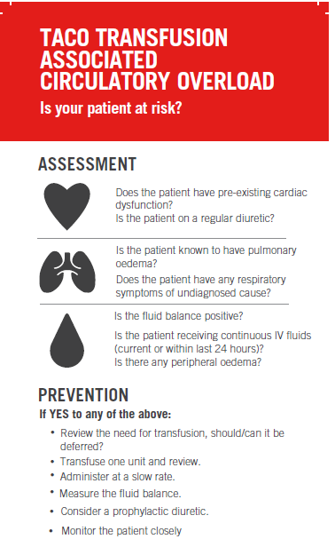
TACO awareness campaign feedback
Your feedback on the use and value of the TACO swing tags in your practice is important to us and greatly appreciated. This evaluation will help us in providing the direction for the initiative.

- Were you aware of the recent TACO awareness campaign within your health service?
  - Yes
  - No
  - unsure

- Did you notice any TACO awareness campaign tools around your health service?
  - Yes, TACO swing tags
  - Yes, TACO posters
  - Yes, on the blood fridges
  - No, go to question 6

- If yes to noticing the TACO swing tags and/or posters, please rate the following:
 | Strongly  agree | agree | disagree | strongly disagree
The layout was easy to follow
The language was easy to understand
The tools will guide my future decision making
Staff would be able to use these tools with minimal training & support

- Please comment on the strengths, limitations and your overall perception of the use of this tool in your practice.

- What is the impact of these TACO swing tags and/or posters on you or your practice?
Select all that apply.
  - I feel confident in assessing if a patient may be at high risk for TACO
  - I learnt something new
  - This information confirmed I did (am doing) the right thing
  - I am motivated to learn more
  - I am reassured
  - I am reminded of something I already knew
  - My practice is (will be) changed and improved
  - I am dissatisfied
  - There is a problem with this information
  - I disagree with the content of this information
  - I think the information is potentially harmful
  - I feel that this was not relevant for me

- How frequently are you involved in the issue/distribution/administration of blood?
  - More than once a week
  - About once a week
  - About once a month
  - Less than once a month

- How frequently do you see/treat a patient experiencing TACO?
  - More than once a month
  - About once every 6 months
  - About once a year
  - Less than once a year

- Your role
- Medical
- Nurse
- Scientist
- Other, please specify

- Name of your health service:

- Any other comments?

