Waste management plan
<<20xx – 20xx insert date>>

About the template
This template has been developed to assist Victorian public health services create a waste management plan with the aim of improving waste management at your health service. The plan should support your health services’ environmental management plan.

Email the Sustainability unit <sustainability@health.vic.gov.au>, if you would like assistance or advice in developing your plan.

Instructions for completing the template
The template has been developed with minimal formatting and is designed for use in your organisation’s corporate style.

Delete all instructional text (green), including all content on this page, and any sample text (black italics) before finalising.

See also:
- Your health services environmental management plan and checklist
- Health service environmental sustainability requirements: guide for compliance <https://www2.health.vic.gov.au/hospitals-and-health-services/planning-infrastructure/sustainability/planning-reporting>.

Scope of plan
[Outline the most important deliverables of the waste management plan. These include the major milestones, top level requirements and assumptions. Also identify any limitations or restrictions

Example: To implement an efficient, safe and environmentally friendly waste management system where waste to landfill is reduced and resource recovery increased. No new recycling collections will be established through this plan.]

Health service policies, procedures and guidelines relating to this document
The health service has a range of policies, procedures and guidelines that affect how waste is managed within the facility, as well as affecting the priorities and scope of a waste management plan.
State, federal and international policies, procedures and guidelines relating to waste management in Victorian public health services also affect this. These can be found in Appendix 1.

[List all documents developed by the Health Service that are relevant to the Waste Management Plan]

Existing or previous actions
The health service has previously delivered and is the process of completing a range of actions that fit within the scope of the waste management plan. These actions are:

[List previous achievements relating to waste management at your health service. Ensure any completed actions are also added to the environmental management action plan]
Project | Waste stream targeted | Department | Status (Complete, delayed, in progress) | Outcome(s) | Project lead
Introduce PVC recycling | PVC | Theatre, ICU, Dialysis | Complete | Collections in place in all departments from March 2020 | Sustainability Manager

Waste management committee
A waste management committee is a multidisciplinary initiative to coordinate, assess and review the health service’s compliance with legal, facility, operational and other requirements relevant to the management of waste.

The purpose of the committee is to provide guidance and input into the development and delivery of the Waste Management Plan. In delivering the functions of the committee, members will be responsible for contributing and co-ordinating input from across their area of responsibility.

The committee should:
- represent the broad range of views and experiences relating to waste management across the health service,
- provide advice relating to waste management across the health service and implementation of the Plan,
- contribute materials and/or data to assist delivery,
- review the Plan and related resources for appropriateness and technical accuracy,
- members may be invited to be join individual Intervention Working Groups, that may be established for some elements of the Plan,
- provide advice and support as necessary.

[Draft terms of reference for the waste management committee can be found in Appendix 2 recommended members are:
- Senior Responsible Officer
- Waste Management Officer
- Environmental services (including cleaners)
- Healthcare personnel (including doctors and nursing staff)

Additional members, or guest members, could include:
- Pharmacist
- Infection Control
- OHS
- Engineer
- Finance
- Kitchen staff
- Procurement / supply

List members and positions of the waste management committee here]

Management processes for waste streams
Hospitals and health services are responsible for ensuring the safe and correct storage, handling, transportation and disposal of hazardous waste. This includes Clinical and related waste, chemical waste and e-waste.

Appendix 1 lists relevant state, federal and international policies, procedures and guidelines. To ensure that these streams are managed appropriately the management process for each stream has been mapped.

[Mapping should be completed for all waste streams. Tables have been provided for all mandatory waste streams (clinical, sharps, pharmaceutical, anatomical, radioactive, chemical, e-waste and landfill) as well as commingled recycling, paper and cardboard and confidential paper. Any additional streams provided by the hospital (eg. PVC, paper and cardboard) should also be mapped here.

An example of how to complete the table is given below.]

Clinical waste
Collection receptacle(s) | 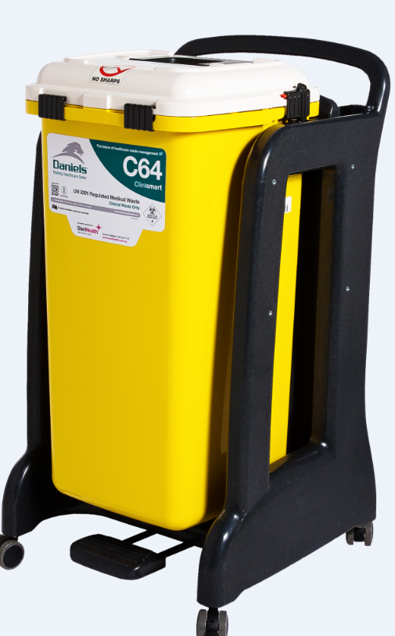 | Signage | 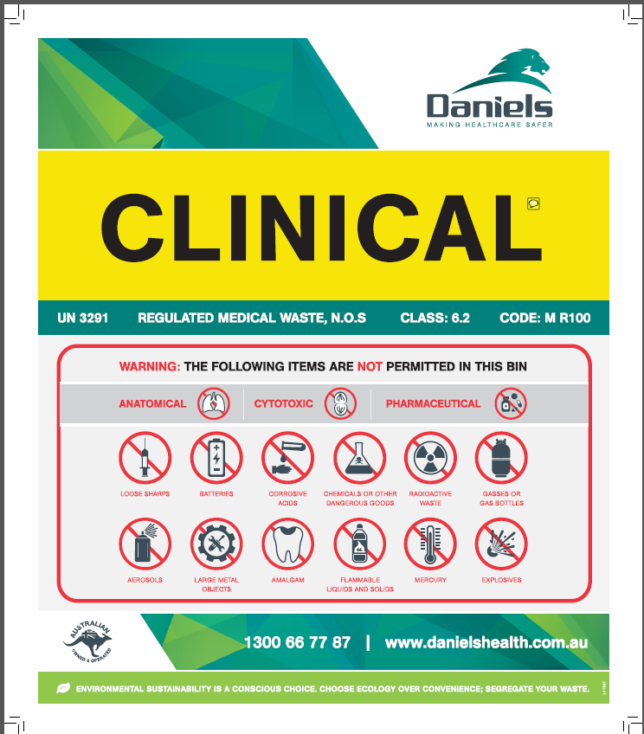
Contractor | Cleanaway Daniels
Staff education | Staff receive clinical waste training during on-boarding process
Operational procedures: on ward | Bins are located in dirty utilities of wards  Ward staff are responsible for sorting and disposal of clinical waste on ward
Operational procedures: ward to loading dock | Spotless staff collect clinical waste bins from wards twice a day and transport them to loading dock  Cleanaway Daniels collect bins from loading dock daily.
Data source | Provided monthly by Cleanaway Daniels. Automatically entered into EDMS via HPV.
Feedback process | Cleanaway Daniels rep informs Waste Management Officer of contamination or collection issues.

Sharps waste
Collection receptacle(s) |  | Signage
Contractor
Staff education
Operational procedures: on ward
Operational procedures: ward to loading dock
Data source
Feedback process

Pharmaceutical waste
Collection receptacle(s) |  | Signage
Contractor
Staff education
Operational procedures: on ward
Operational procedures: ward to loading dock
Data source
Feedback process

Anatomical waste
Collection receptacle(s) |  | Signage
Contractor
Staff education
Operational procedures: on ward
Operational procedures: ward to loading dock
Data source
Feedback process

Radioactive (cytotoxic) waste
Collection receptacle(s) |  | Signage
Contractor
Staff education
Operational procedures: on ward
Operational procedures: ward to loading dock
Data source
Feedback process

Chemical waste
Collection receptacle(s) |  | Signage
Contractor
Staff education
Operational procedures: on ward
Operational procedures: ward to loading dock
Data source
Feedback process

E-waste
Collection receptacle(s) |  | Signage
Contractor
Staff education
Operational procedures: on ward
Operational procedures: ward to loading dock
Data source
Feedback process

Landfill
Collection receptacle(s) |  | Signage
Contractor
Staff education
Operational procedures: on ward
Operational procedures: ward to loading dock
Data source
Feedback process

Commingled recycling
Collection receptacle(s) |  | Signage
Contractor
Staff education
Operational procedures: on ward
Operational procedures: ward to loading dock
Data source
Feedback process

Paper and cardboard
Collection receptacle(s) |  | Signage
Contractor
Staff education
Operational procedures: on ward
Operational procedures: ward to loading dock
Data source
Feedback process

Confidential paper
Collection receptacle(s) |  | Signage
Contractor
Staff education
Operational procedures: on ward
Operational procedures: ward to loading dock
Data source
Feedback process

Waste mapping on wards
[If a particular area of the hospital is being targeted for improvement it can be beneficial to map the waste flows (generation, disposal and movement of waste from ward to loading dock). This helps to identify potential stakeholders, areas of a ward generating large volumes of waste, and potential barriers and solutions to streamlining waste management processes. An action could be to map all hospital departments over time.
An example waste map is below. A blank waste map can be found in Appendix 3.]
Cleaner moves waste from ward to loading dock 2x per day morning and afternoon
Loading Dock

Waste contractors pick up waste
Dirty utility

Chutes: N/A

Available bins:
Clinical waste
  - 2 bins
  - 240 litre yellow wheelie bin
General waste
  - 2 bins
  - 240 litre black body red lid
Commingled recycling
  - 1 bin
  - 240 litre green body burgundy lid
Single use metal instrument
  - One collection tray
  - Collected by CSSD technician

Comments:
No room for additional bins
Ward: ICU
Types of rooms:7 beds, private rooms

Behaviour:
Nurses dispose of most if the waste
Doctor rarely disposes of waste
Technician does not dispose of waste. Empties bins

Available bins on the ward floor:
Clinical waste
  - 10 bins
  - P22 in each room, on wheels, always in room.
General waste
  - 10 bins
  - 1 small bin in each room, grey bin, black lining
  - 60 litre bin at desk
Sharps bin
- 3 bins
- P22, on wheels, moved between rooms
Comment:
Recycling also generated in ICU rooms. No bins so items taken to dirty utility

Bins are not labelled
Nurse moves recycling from ward/bed to dirty utility after treating each patient)
Number & type of compactor: N/A

Comment: Limited space for bins.
Cleaner moves waste from dirty utility to loading dock 2x per day morning and afternoon

Waste audits
Waste audits provide a detailed analysis of waste composition, assess contamination rates and identify potential opportunities to improve waste management and reduce costs. They also provide a baseline that can assist with trend reporting and benchmarking against other facilities.

[Audits require initial investment but in most cases the implementation of the improvement opportunities will pay back the investment.

Visual waste assessments, while providing a generalised overview of waste, do not generate the data required to establish a benchmark, making it difficult to assess whether improvements to waste management systems have been achieved.

It is recommended that DHHS’s Waste Audit Guidelines are used to ensure audit data is detailed enough to:
- assess contamination in waste streams
- characterise and quantify waste streams
- identify waste diversion opportunities
- identify source reduction opportunities
- assess effectiveness of waste management systems and identify ways to improve efficiency.
https://www2.health.vic.gov.au/hospitals-and-health-services/planning-infrastructure/sustainability/waste/audit-guidelines]

Waste audit plan
The majority of health services are not able to audit all waste generated across every site over a single 24-hour period. In order to gain a detailed analysis throughout the health service it may be necessary to audit individual waste streams/sites/wards separately over a 12 or 24-month period. A waste audit plan structures this audit process and ensures that areas are not overlooked, and an accurate baseline is recorded.
[Complete waste audit plan]

 | 20xx-20xx |  |  |  | 20xx-20xx
Timeline | Q1 | Q2 | Q3 | Q4 | Q1 | Q2 | Q3 | Q4
Budget | $1,000 | $1,000 | $1,000 | $1,000 | $2,000 | $0 | $2,000 | $0
Waste stream(s) | Clinical waste | Landfill | Commingled recycling | Other recycling | Clinical and landfill |  | Commingled and other recycling
Sites/Ward(s) | Theatre | Theatre and offices | Theatre and offices | Theatre and offices | Dialysis, ED, kitchens |  | Dialysis, ED, kitchens

Waste audit findings
A waste auditor has provided a report detailing audit findings and recommendations. A summary of the findings and recommendations are summarised here.
[Summarise the findings of all waste audits conducted by your health service over the past 24 months, including any recommendations.]

Waste data
[Information to complete this table can be found in the Waste Report on the EDMS reporting system* and through waste audit data]
 | 20XX – 20XX (Baseline) | 20XX – 20XX | 20XX – 20XX
Total waste generated
Waste per patient treated
Waste costs per patient treated
Waste to landfill
Waste to landfill per patient treated
Recycling
Recycling per patient treated
Recycling rate (%)
Contamination of waste streams (%)
Potential savings by removing contamination
* Refer to EDMS Waste Report for kg clinical, landfill and recycling and $ clinical, landfill and recycling

Objectives to improve waste management at X Health
Having reviewed the waste mapping, audit and collection data the following objectives have been identified by the health service.

[Identify a series of short and long-term objectives. These objectives should be quantifiable and have clear timelines. An example is below.

Victorian public hospitals and health services must develop and maintain a whole-of-organisation environmental management plan, and publicly report on their environmental performance. This plan should be considered when identifying objectives.

Guidance on how to develop the plan can be found on the DHHS website https://www2.health.vic.gov.au/hospitals-and-health-services/planning-infrastructure/sustainability/planning-reporting

A list of mandatory and recommended waste management actions is provided in the EMP actions template. Mandatory and recommended actions are:

Mandatory or Recommended | Action
Mandatory | Manage clinical waste in accordance with EPA publication IWRG61.1 Clinical and related waste – operational guidance and the department's supplementary guidance on clinical waste.
Mandatory | Divert e-waste from landfill.
Mandatory | (Metro health services only) PVC collection in Theatre, ICU and Dialysis departments
Recommended | (Regional health services only) PVC collection in Theatre, ICU and Dialysis departments
Recommended | complete waste mapping templates for all departments and administrative and support areas over a two-year period
Recommended | Develop and implement waste audit plan
Recommended | Identify improvement targets for existing waste collections (e.g. contamination levels, collection volumes/weights, availability of collection throughout hospital, streamlining of collection process).
Recommended | Use waste audit, contamination and litter audit findings to develop training program for all staff (clinical, environmental services, engineering etc.) to improve disposal of problem items, waste streams or areas experiencing high levels of littering and/or contamination rates.
Recommended | Introduce commingled recycling throughout the hospital.
Recommended | Introduce paper and cardboard recycling collection throughout the hospital.
Recommended | Arrange for collection and recycling of printer cartridges (if reuse option not available).
Recommended | Remove individual bins at desks and replace with bin stations (including landfill and recycling bins) at strategic points throughout office areas.

Objective 1
Increase the recycling rate across the health service from 20% in 2018-19 to 30% by 2021-22 and to 40% by 2024-25.

Activities
[Activities must achieve the objective, be within scope, meet requirements of Environmental Management Plan requirements and be supported by stakeholders.]
- Introduce commingled recycling to all wards
- Ensure bin colours and signage are consistent throughout the health service
- Introduce PVC and Kimguard recycling throughout X Health

Budget
$10,000 over 5 years

Timeline
- Complete commingled recycling activities by 2022.
- Introduce additional recycling streams by 2023

Monitoring
Bi-annual waste audits and monitoring EDMS reporting platform

Reporting
- Monthly update to Waste Management Committee
- Six-monthly update to senior management
- Recycling rate included in Health Services annual report.

Communication
Communicated through:
- CEO newsletter
- In service training for ward ‘green champions’ and senior nursing staff
- Changes introduced by senior nurses and ‘green champions’ during change over meetings Responsibility

Responsibilities
Waste Management Officer responsible for delivery

Periodic review of Waste Management Plan
[It is recommended that the Waste Management Plan is reviewed biannually.]

Appendix 1 - State, federal and international policies, procedures and guidelines relating to waste management in Victorian public health services
All waste streams
Acts | Environmental Protection Act (1970) | https://ref.epa.vic.gov.au/about-us/legislation/acts-administered-by-epa#EPAct
 | Environmental Protection Act (2017) | https://ref.epa.vic.gov.au/about-us/legislation/acts-administered-by-epa#EPAct
 | Occupational Health and Safety Act 2004 | http://www.legislation.vic.gov.au/Domino/Web_Notes/LDMS/PubLawToday.nsf
 | Public Health and Wellbeing Act 2008 | http://www.legislation.vic.gov.au/Domino/Web_Notes/LDMS/PubLawToday.nsf
Regulations | Environment Protection (Industrial Waste Resource) Regulations 2009 | http://www.legislation.vic.gov.au/Domino/Web_Notes/LDMS/PubLawToday.nsf
 | Waste Management Policy (e-waste) | https://ref.epa.vic.gov.au/about-us/legislation/waste-legislation/waste-management-policies#ew
 | Occupational Health and Safety Regulations 2017 | http://www.legislation.vic.gov.au/Domino/Web_Notes/LDMS/PubLawToday.nsf
Australian Standards | AS 4123.7 - 2006 (R2017) - Mobile waste containers Colours, markings, and designation requirements | https://www.standards.org.au/
 | AS 3816:2018 - Management of clinical and related waste | https://www.standards.org.au/
Guidance | EPA IWRG612.1 – Clinical and related waste – operational guidance | https://www.epa.vic.gov.au/about-epa/publications/iwrg612-1
 | DHHS – Clinical Waste Guidance – Supplement for Healthcare Staff | https://www2.health.vic.gov.au/hospitals-and-health-services/planning-infrastructure/sustainability/waste/clinical-related-waste
 | Waste Management Association of Australia - Industry code of practice for the management of biohazardous waste | https://www.wmrr.asn.au/Public/Our_services/Documentation/Public/Our_services/Documentation.aspx
 | DHHS - The Blue Book – Guidelines for the control of infection diseases | https://www2.health.vic.gov.au/about/publications/researchandreports/The-blue-book
 | World Health Organisation - Safe management of wastes from healthcare activities - guidance | https://www.who.int/water_sanitation_health/publications/safe-management-of-waste-summary/en/
 | EPA Publication 1695.1: Assessing and controlling risk: A guide for business | https://www.epa.vic.gov.au/about-epa/publications/1695-1
Policies | Sustainability Victoria – Recycling Victoria, A new economy | https://www.vic.gov.au/sites/default/files/2020-02/Recycling%20Victoria%20A%20new%20economy.pdf
 | Australian Packaging Covenant Organisation – Australia’s National Packaging Targets | https://www.packagingcovenant.org.au/who-we-are/australias-2025-national-packaging-targets
Pharmaceutical waste
Act | Drugs, Poisons and Controlled Substances Act 1981 | https://www.legislation.vic.gov.au/
Regulations | Drugs, poisons and controlled substances regulations 2017 | https://www.legislation.vic.gov.au/
Standards | NSQHS Standards – Medication management processes, Action 4.14 | https://www.safetyandquality.gov.au/standards/nsqhs-standards/medication-safety-standard/medication-management-processes/action-414
Guidance | DHHS – Drugs of dependence - guidance | https://www2.health.vic.gov.au/about/publications/policiesandguidelines/drugs-of-dependence-guidance
Radioactive waste
Act | Radiation Act 2005 | https://www2.health.vic.gov.au/public-health/radiation/radiation-regulatory-framework/radiation-laws/radiation-act-2005
Regulations | Radiation regulations 2017 | https://www2.health.vic.gov.au/public-health/radiation/radiation-regulatory-framework/radiation-laws/radiation-regulations-2017
Codes | Code for Disposal of Radioactive Waste by the User 2018 | https://www.arpansa.gov.au/regulation-and-licensing/regulatory-publications/radiation-protection-series/codes-and-standards/rpsc-6
 | National Directory for Radiation Protection 2017 | https://www.arpansa.gov.au/regulation-and-licensing/regulatory-publications/national-directory-for-radiation-protection
 | Code for the Safe Transport of Radioactive Material 2019 | https://www.arpansa.gov.au/regulation-and-licensing/regulatory-publications/radiation-protection-series/codes-and-standards/rpsc-2
Guidance | DHHS - Disposal of radioactive material - guidance | https://www2.health.vic.gov.au/about/publications/policiesandguidelines/disposal-of-radioactive-material

Appendix 2 - Waste management committee terms of reference (draft)

Background
The committee is a multidisciplinary initiative to coordinate, assess and review the health care facility’s compliance with legal, facility and other requirements relevant to the management of waste. Waste is generated by many different activities, not only from direct health care services. Many people in different departments and areas are involved in generating and managing waste, such as handling, storage, and transport. It is vital that these activities and personnel are coordinated to ensure waste is managed without harm to people and to minimize the environmental impact.
The management of waste is not confined to the facility’s premises. It may also involve off-site activities such as waste treatment, recycling and reuse, and disposal, with transport to and from these facilities. The management of waste, therefore, needs to include all the steps in the journey of the health care facility’s waste, from “cradle to grave.”

Waste management committee
The purpose of the Committee is to provide guidance and input into the development and delivery of the Waste management plan.

Functions
The Committee:
- represents the broad range of views and experiences relating to waste management across the health service,
- provides advice relating to waste management across the health service and implementation of the Plan,
- contributes materials and/or data to assist delivery,
- reviews Plan and education resources developed for appropriateness and technical accuracy,
- members may be invited to be join individual Intervention Working Groups, that may be established for some elements of the Plan,
- provides advice and support as necessary.
In delivering the functions of the Committee, members will be responsible for contributing and co-ordinating input from across their area of responsibility.

Membership
Membership has been chosen to reflect the broad range of waste management responsibilities within the health service. The Committee has a system-wide focus and members are expected to take a system-wide view in deliberations. Members are:
- CEO
- Senior Directors
- Waste Management Officer
- Pharmacist
- Environmental services
- Infection Control
- OHS
- Engineer
- Finance
- Procurement
- Healthcare personnel (doctors and senior nursing staff)
- Kitchen staff
- Cleaners

External attendance
The Chair may invite other parties to attend some, or part of Committee meetings, where their presence would deliver value to the project, and/or specialist advice on a specific topic of interest.

Secretariat

Communication
In order to establish and maintain transparency and collaboration, communication amongst Committee members will be ongoing and open. This will be achieved through:
- Fortnightly email updates from the Waste Management Officer regarding the progress of the project, with Committee members encouraged to comment and/or ask any questions that may arise from these updates.
- Monthly meetings to assist with progress and provide and provide advice and support.
- Waste Management Officer to be the primary contact for any questions, comments, concerns etc. Committee members may have.

Procedural issues
The Chair may choose to consider some issues out of session.
The Chair (or their delegate) and two other members must be present to constitute a quorum.
Meetings will last no longer than two hours and will be held at X. Video conferencing facilities will be available.

Responsibilities of Waste Management Officer
- Convene committee meetings
- Control and plan activities
- Oversee processes and audits to identify potential objectives and activities
- Determine compliance of objectives and activities with relevant policies, procedures and guidelines.
- Input waste data into EDMS reporting platform.

Appendix 3 – Waste Mapping template
Loading Dock

Waste contractors pick up waste
Dirty utility

Chutes

Available bins:
  - Bin types

Available bins:
  - Bin types

Ward:
Types of rooms: # beds

Behaviour:
Nurses
Doctor
Technician

Available bins on the ward floor:
Clinical waste
  - Number of bins
  - bin details (size, location, free standing, colour, lined with bag, always in room)
General waste
  - Number of bins
  - bin details

Comment:

What’s the role of doctors and technicians?
Whose task is cleaning up at the end?
[actor] moves waste from ward/bed to dirty utility (when/how)
Number & type of compactor

Comment: Anything that’s relevant
[actor] moves waste from ward/bed to dirty utility (when/how)

Waste Mapping Template (theatre)
Loading Dock

Waste contractors pick up waste
Set up room
Types of rooms: # set up rooms

Behaviour:
Nurses
Surgeon
Technician

Available bins in set up rooms:
Clinical waste
  - Number of bins
  - bin details (size, free standing, colour, lined with bag, always in room)
General waste
  - Number of bins
  - bin details
Commingled recycling
  - Number of bins
  - bin details

Comment:
Waste bay

Chutes

Available bins:
  - Bin types

Available bins:
  - Bin types

[actor] moves waste from operating theatre to waste bay (when/how)

Operating theatre
Types of rooms: # theatres

Behaviour:
Nurses
Surgeon
Technician

Available bins in theatres:
Clinical waste
  - Number of bins
  - bin details
General waste
  - Number of bins
  - bin details

Comment:

What’s the role of doctors and technicians?
Whose task is cleaning up at the end?
[actor] takes waste from ‘waste bay’ to loading dock (when/how)
[actor] moves waste from set up room to waste bay (when/how)
Number & type of compactor

Comment: Anything that’s relevant

Data calculations Total waste generated = kg clinical waste + kg landfill + kg recycling waste Waste per patient treated = (kg clinical waste + kg landfill + kg recycling waste)/PPT Waste costs per patient treated = ($ clinical waste + $ landfill + $ recycling waste)/PPT Waste to landfill = kg clinical waste + kg landfill Total waste to landfill per patient treated = (kg clinical waste + kg landfill)/PPT Total recycling per patient treated = kg recycling/PPT Recycling rate % = kg recycling / kg landfill + kg recycling Contamination of waste streams = ((% contamination clinical waste + % contamination landfill + % contamination recycling waste) / 300) X 100 Potential savings by removing contamination = - (($ clinical waste/100) X % contamination clinical waste) + (($ landfill/100) X % contamination landfill) + (($ recycling/100) X % contamination recycling) - Subtract part 1 from (kg contamination clinical waste X $ per kg landfill) + (kg contamination landfill X $ per kg recycling) + (kg contamination recycling X $ per kg landfill)
List is current as of 2nd November 2020. Other State, federal and international policies, procedures and guidelines relating to waste management in Victorian public health services may be available and this list may not be exhaustive.

