|  |
| --- |
| Blood Matters on the  Bench and Beyond |
| Issue 3 – July 2020 |

Welcome to the Blood Matters newsletter for Scientists, written for Victorian transfusion scientists. It will be distributed throughout the year to share information that may be helpful to you, and to let you know of upcoming activities which may be of interest.

##### Blood Matters Scientist Summit

*Wednesday 26th August 2020*

*Virtual meeting via Webex from 10.00am – 12.00pm*

***Registrations now open, see attached program***



* This education session is aimed at transfusion scientists of all levels, offering scientific and local industry updates.
* The session will include participant interaction to share expertise and experiences to contribute to the greater blood management community.
* Discuss your interest in attending this summit with your senior scientist for rostering purposes.
* See attached program and **register below**. Alternatively email [rfrench@redcrossblood.org.au](mailto:rfrench@redcrossblood.org.au) to be sent further information or assistance with registration.

**[Click here to register for Blood Matters Scientist Summit –](https://redcrossblood.webex.com/mw3300/mywebex/default.do?service=1&siteurl=redcrossblood&nomenu=false&main_url=%2Fmc3300%2Fmeetingcenter%2Fdefault.do%3Fsiteurl%3Dredcrossblood%26rnd%3D3265785577%26main_url%3D%252Fmc3300%252Fe.do%253Fsiteurl%253Dredcrossblood%2526AT%253DMI%2526EventID%253D1049813722%2526UID%253D552448517%2526Host%253DQUhTSwAAAATNn7VBXnOLCW2Cty7HfnG5l63HJXf-X6rlq-FLSar-Fasw5G2KJilZTC5-8j_Hzfrqagk19bSw-_H6dD2Yro3c0%2526RG%253D1%2526FrameSet%253D2%2526RGID%253Dr8ec28bf6b4b373d445ee34378b53e6bb" \o "Click to go to registration link)**

**[“It’s not all about COVID”](https://redcrossblood.webex.com/mw3300/mywebex/default.do?service=1&siteurl=redcrossblood&nomenu=false&main_url=%2Fmc3300%2Fmeetingcenter%2Fdefault.do%3Fsiteurl%3Dredcrossblood%26rnd%3D3265785577%26main_url%3D%252Fmc3300%252Fe.do%253Fsiteurl%253Dredcrossblood%2526AT%253DMI%2526EventID%253D1049813722%2526UID%253D552448517%2526Host%253DQUhTSwAAAATNn7VBXnOLCW2Cty7HfnG5l63HJXf-X6rlq-FLSar-Fasw5G2KJilZTC5-8j_Hzfrqagk19bSw-_H6dD2Yro3c0%2526RG%253D1%2526FrameSet%253D2%2526RGID%253Dr8ec28bf6b4b373d445ee34378b53e6bb" \o "Click to go to registration link)**

**A new look “Transfusion science and blood stewardship” page on the Blood Matters webpage**

Blood Matters is in the process of updating our webpages and we’ve started with the red blood cell wastage page.  See the new version now titled “Transfusion science and blood stewardship”.

<https://www2.health.vic.gov.au/hospitals-and-health-services/patient-care/speciality-diagnostics-therapeutics/blood-matters>

This new page incorporates the elements of the red blood cell wastage project into the new transfusion medicine scientist project. The aim is to assist transfusion medicine scientists in your role, with your professional development as well as a source of blood stewardship resources.

Monthly wastage figures will now be available on the webpage shortly after they are released around the 12th of each month.

**ISBT 128 Barcodes**

ISBT 128 DIN create a unique identifier for Australian blood components and will prevent duplication of DINs for 100 years worldwide.

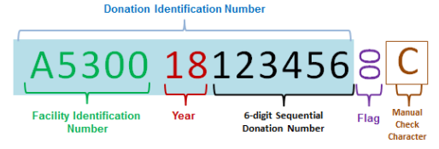

As you transition to ISBT 128 barcodes, it is important to remember that you will need to record the **14 alphanumeric characters** (whether recording manually or electronically).

This includes the facility identification number, the year, 6 digit sequencer and manual check character (the 2 digit flag character is optional to record).

In the example above, the ISBT 128 DIN should be recorded as:

A5300 18 123456 00 C or

A5300 18 123456 C

The 16 alphanumeric characters are made up of:

* 5 digit alphanumeric facility identification number
  + All blood processed at Melbourne Processing Centre will have the same facility identification number.
  + This must **always** be checked as part of the DIN, some components may be processed in a different state and therefore be different.
* 2 digit year
* 6 digit sequencer
* 2 digit flag character
  + These are for Lifeblood use. The ISBT 128 pack DIN located above the product label will always have flag characters that are “00” for Health Providers to reference.
  + Pathology services and blood banks who are ISBT ready must always scan this DIN barcode (not the DIN barcode located below this on the component release label).
* Manual check character
  + The manual check character can be a letter A-Z or a number 0-9 or an asterix *
  + This is not part of the DIN, but should be used to ensure the accuracy of manual keyboard data entry as it verifies that all characters corresponding to the DIN are correct.
  + When transcribing the DIN (e.g. on paper-based forms), the manual entry check character **must** be recorded as part of the unique identification of the product for traceability purposes. Lifeblood will need this character to source information about the component.
  + [The ICCBBA Technical Specification manual](https://www.iccbba.org/uploads/a3/56/a35603c2b626a45573cd98663086625f/ST-001-ISBT-128-Standard-Technical-Specification-v5.10.0.pdf) (p129) states that whenever the DIN is printed in eye readable format the manual check character is required.

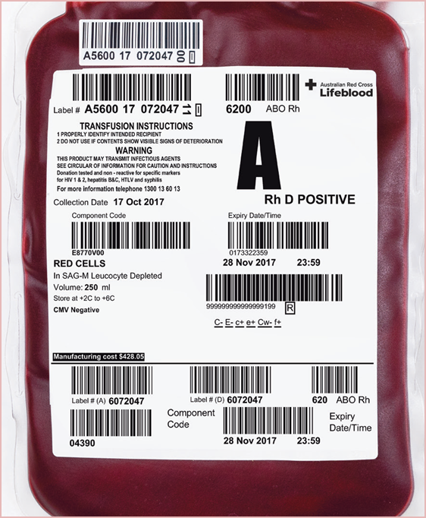

Pathology services and blood banks who are ISBT ready must always scan the DIN barcode located at the top left of the blood bag which contains the vertical “00” flag characters (not the DIN barcode located on the component release label below).

Codabar transition label

Lifeblood recommends the scanning of barcoded information from the Product label at all times as opposed to manual transcription.

ISBT 128 uses a different barcode symbology, your system (and scanners) will need to be configured to be able to read ISBT 128. Your LIS will need to be updated to capture the 14 alphanumeric DIN, regardless of when you plan on adopting ISBT 128.

Even if using Codabar barcodes you must record the ISBT 128 DIN as this will be used by Lifeblood to source information about the component and traceability in the event of a recall of the product if necessary. A solution of capturing the increased ISBT 128 DIN will be required

There are different blood group codes for each donation type – whether they are allogeneic, directed, reserved or autologous donation. A list can be found of page 15 of the Lifeblood publication [“Australian Guidelines for the labelling on blood components using ISBT 128”.](https://transfusion.com.au/system/files/resource_library/ISBT128%20Australian%20Guidelines%20V9%20final%2030032020.pdf)

For further information on ISBT 128 barcodes:

*Blood Matters*

<https://www2.health.vic.gov.au/hospitals-and-health-services/patient-care/speciality-diagnostics-therapeutics/blood-matters/consumer-information/isbt-128-labelling-changes>

*Lifeblood – see above link also*

[*https://transfusion.com.au/blood_products/ISBT_128_Transition_Label*](https://transfusion.com.au/blood_products/ISBT_128_Transition_Label)

*Technical information about ISBT 128 is available on the ICCBBA website*

[*https://www.iccbba.org/home*](https://www.iccbba.org/home)

*The National Blood Authority (NBA).*

[*https://www.blood.gov.au/blood-service-implementing-isbt-128-labelling-june-2018*](https://www.blood.gov.au/blood-service-implementing-isbt-128-labelling-june-2018)

[*https://www.blood.gov.au/barcoding*](https://www.blood.gov.au/barcoding)

If you have further questions please contact Lifeblood.

### cid:image003.jpg@01D5E0F2.D78F0700National certification of the medical scientist profession

A national professional certification scheme for the medical laboratory science profession in Australia has come into effect.

The Australian Council for Certification of the Medical Laboratory Scientific Workforce (ACCMLSW) is a newly created not for profit company established to administer the voluntary certification scheme.

* Join now at <https://accmlsw.wildapricot.org/>
* A 10% discount will apply to the normal certification fee for new registrants until the end of 2020
* You will need to upload
  + A certificate of primary qualification
  + Continuing professional development (CPD) record – PDF copy of the most recent CPD certificate or an outline of CPD activities in the previous 2 years
  + Declaration of competency assessment and experience (downloadable from the website) signed by your employer.

**Why become certified?**

* This can be seen as a first step towards mandatory certification, which would ensure only high calibre practitioners are employed in our laboratories, demanding recognition of our professional standing as part of Australia’s health service workforce.
* Certification will be the best benchmark available to assure competent professional practice.
* With a certified workforce there will be more obligation on the employer to ensure staff have professional development opportunities afforded to them.
* As a nationally certified medical scientist you can demonstrate your ongoing commitment to professional development and self-improvement and be recognised as passionate, progressive and pro-active.

Blood Matters is committed to providing support and education to assist in the early stages of this scheme, if you require any assistance or have any questions feel free to contact Rae French at [rfrench@redcrossblood.org.au](mailto:RFrench@redcrossblood.org.au) or by phone on 03 9694 3524.

**How can Blood Matters help you?**

The Blood Matters team is here to assist health services and laboratories through education and providing resources.

We welcome open and collaborative discussion to ensure we can work together to support and enhance your contribution to safe, efficient and effective blood management.

If you have suggestions, comments or ideas on tools and resources that could assist in day to day activities and towards achieving accreditation please let Rae or any of the Blood Matters team know by email to [bloodmatters@redcrossblood.org.au](mailto:bloodmatters@redcrossblood.org.au)

To receive this publication in an accessible format phone 03 9694 0102, using the National Relay Service 13 36 77 if required, or email Blood Matters [bloodmatters@redcrossblood.org.au](mailto:bloodmatters@redcrossblood.org.au)

**ISSN** 2652-7278 **- Online (pdf / word)**