CEO leadership capability framework

To receive this publication in an accessible format email Health Services Governance unit <ceonominations@dhhs.vic.gov.au >
Authorised and published by the Victorian Government, 1 Treasury Place, Melbourne.
© State of Victoria, Department of Health and Human Services October 2019.
ISBN/ISSN <ISBN 978-1-76069-938-3>
Available at health.vic – Sector Leadership <health.vic.gov.au/sectorleadership>

Contents

What Victoria needs from its health service CEOs 4
The ability to manage complex and demanding priorities 4
Sophisticated system thinkers with an external partnership focus 4
Overview of the framework 5
The framework in action 6
Identifying leaders of the future 6
Assessing the leaders we need 6
Informing CEO development needs 6
Important notes about the framework 6
The framework 8
Personal qualities 9
CEO leadership capabilities and behaviours 10
The domains 10
Appendix 1: How the framework was developed 12
Appendix 2: Sector engagement and feedback 14
Appendix 3: Text-equivalent descriptions of figures 15

What Victoria needs from its health service CEOs

The ability to manage complex and demanding priorities
Victoria’s health system leaders need to meet expectations in an increasingly demanding environment. Victorian health CEOs work in a system facing increasing pressures, including:
- a population and consumer cohort that is growing and ageing, and has multiple and complex comorbidities
- rising consumer expectations of quality, outcomes, access and experience
  - working with a finite budget to provide safe and effective care, and meet access and quality outcomes.
To address this, Victoria requires CEOs who can confidently and effectively meet the service delivery expectations Victorians demand of their health services.

Sophisticated system thinkers with an external partnership focus
The challenges of the current health system need to be met with collaborative and system-focused leadership capabilities.
Managing health services in Victoria in the future will require greater emphasis on partnerships and working collaboratively within and across organisational boundaries to meet growing consumer demands and expectations. CEOs will need to have sophisticated and complex stakeholder management capabilities, and to adopt a system view to forecast, plan and deliver future care needs.

These skills need departmental and board support
Victoria has considerable needs in terms of CEO capability. This CEO leadership capability framework will support the Department of Health and Human Services and health service board chairs to clearly articulate the expected skills and behaviours of CEOs, and to support leadership development, recruitment and retention across Victoria’s health system.

Overview of the framework
The CEO leadership capability framework supports the identification, development and management of CEO talent across the Victorian health system.
The framework provides greater clarity around the requirements of CEO candidates, and acknowledges the gaps in talent where development or recruitment effort may be required.
This document identifies the personal qualities and capabilities required of CEOs operating in the Victorian health system. It will assist in the identification and development of talented candidates, as well as broader succession planning and management in the system.
The framework was developed through:
- global research regarding best practice succession management and capability approaches
- relevant elements of existing capability frameworks in the health context
- research on CEO-specific capability sets (articulating the future requirements of CEO roles)
- consideration of the Victorian health system context, vision and strategic directions
- input from significant engagement across the Victorian health system
  - engaging specialist expertise in capability frameworks, talent management and the health sector.
This process led to the development of a set of personal qualities, leadership behaviours and capabilities and health system contextual factors.
The CEO leadership capability framework comprises three key elements:
- personal qualities – the core leadership attributes that underpin every CEO role
    - ‘Should this person be a leader in our system?’
- leadership capabilities and behaviours – four core capability areas and associated behaviours needed by CEOs operating in the Victorian health context
    - ‘Does this person exhibit the capabilities and behaviours for CEO leadership in our system?’
- health system leader requirements and role-specific requirements – contextual requirements that stem from role-specific requirements (for example, whether the health service is in a metro, regional or rural area) or the specific context of a health service (for example, a health service with a complex transformational agenda)
    - ‘Does this person have the experience and background to meet the specific health service challenges?’
    - ‘Is this person right for this particular CEO role?’

The framework in action
The CEO leadership capability framework has many practical applications, including supporting the identification of future CEO talent, informing executive development programs, and supporting succession planning and management.
The framework may be further expanded to the broader leadership levels within the Victorian health system, and the supporting processes and tools can be leveraged beyond CEO level.

Identifying leaders of the future
- The framework will be used internally and externally to inform recruitment approaches for future CEO leaders.
- The framework will inform the composition of CEO position descriptions and role requirements.
- The framework will support robust dialogue within and between boards, talent management teams and current CEOs regarding candidate pipeline and acknowledgement of gaps in CEO talent.
- The framework will inform the broader CEO succession management approach and individual development planning.

Assessing the leaders we need
The personal qualities set out in the framework seeks to answer the question: ‘Should this person be a leader in our system?’ This could be assessed in a number of ways (for example, via psychometric testing, self-identification or through a reference check).
CEO leadership behaviours and capabilities seek to answer the question: ‘Does this person have the capabilities and behaviours of CEO leadership in our system?’ This can be assessed via interviews, reference checks and via a 360-degree assessment.
These assessments inform the development needs of current and future CEO talent, and is part of the CEO identification process in recruitment. It also assists ongoing performance development of existing CEOs. For example, the CEO Leadership Assessment and Development Centre Day was attended by a pilot group of aspiring leaders to test the CEO personal qualities and leadership capabilities and behaviours. Prior to the day, participants completed a 360-degree assessment and psychometric testing and on the day completed an interview and scenario. This helped paint a clearer picture of the leader.

Informing CEO development needs
The framework and assessment approach directly link to a range of leadership development programs that aim to further build capability and capacity across the CEO talent pool, increasing readiness and preparation for transition into CEO roles.
The outcomes of the 360-degree assessment process should inform personal development plans for people with high potential to take on future CEO roles, as well as current CEOs.
Individuals should be encouraged to use the behaviours and capabilities as the starting point for professional development conversations with their one-up leaders.

Important notes about the framework
The CEO leadership behaviours and capabilities do not replace job specific expertise.
The leadership behaviours and capabilities set out the expectation for being a CEO leader in the Victorian health system.
They build on, rather than replace, CEO-specific technical expertise. The professional, technical and specialist skills and knowledge required to operate in a particular nature or context are assessed through the CEO Leadership Assessment and Development Centre Day.
The framework is not prescriptive. The specific requirements of the role and context will be a critical part of assessing CEO suitability.
The framework articulates the specific personal qualities, behaviours and capabilities required of CEOs in the Victorian public health system.
However, board chairs will also need to consider the specific context and nature of a CEO role, and the associated behaviours and capabilities required to operate successfully within this context. It is important to identify the contextual requirements of each CEO role, and what supporting mechanisms there are for assessing the suitability of candidates.
To narrow the candidate pool for a particular role, a ‘pivot’ should be identified. This will include the specific capabilities (1–3) that differentiate between candidates, and will be associated with a contextual need within a health service. The pivot should be agreed between the talent management team and the board, and will support a decision about the successful candidate.
Examples of pivots identified in recent CEO recruitment include:
- implementation of a major transformation agenda – health services with a major change and transformation agenda over the coming years, such as a rebuild or electronic medical record implementation, may need a CEO with specific experience of delivering large-scale transformation, robust governance and project delivery, strong stakeholder engagement and the ability to reform clinical pathways
- organisational change – health services with challenges in performance, whether clinical, financial or from a workforce or cultural perspective, may require a greater emphasis on changing behaviours and capabilities. This may include both short-term decision making and execution of a structured change program, and also an emphasis on building the capabilities and systems within the organisation to sustain change into the future and embed this into organisational culture.
- working collaboratively – health services that are heavily reliant on partnerships to deliver services may seek a CEO with experience of building win–win, successful and sustainable partnerships. This may include the ability to engage staff and the community in this journey, and to establish innovative approaches to models of care are required.

The framework
Figure 1: CEO leadership capability framework
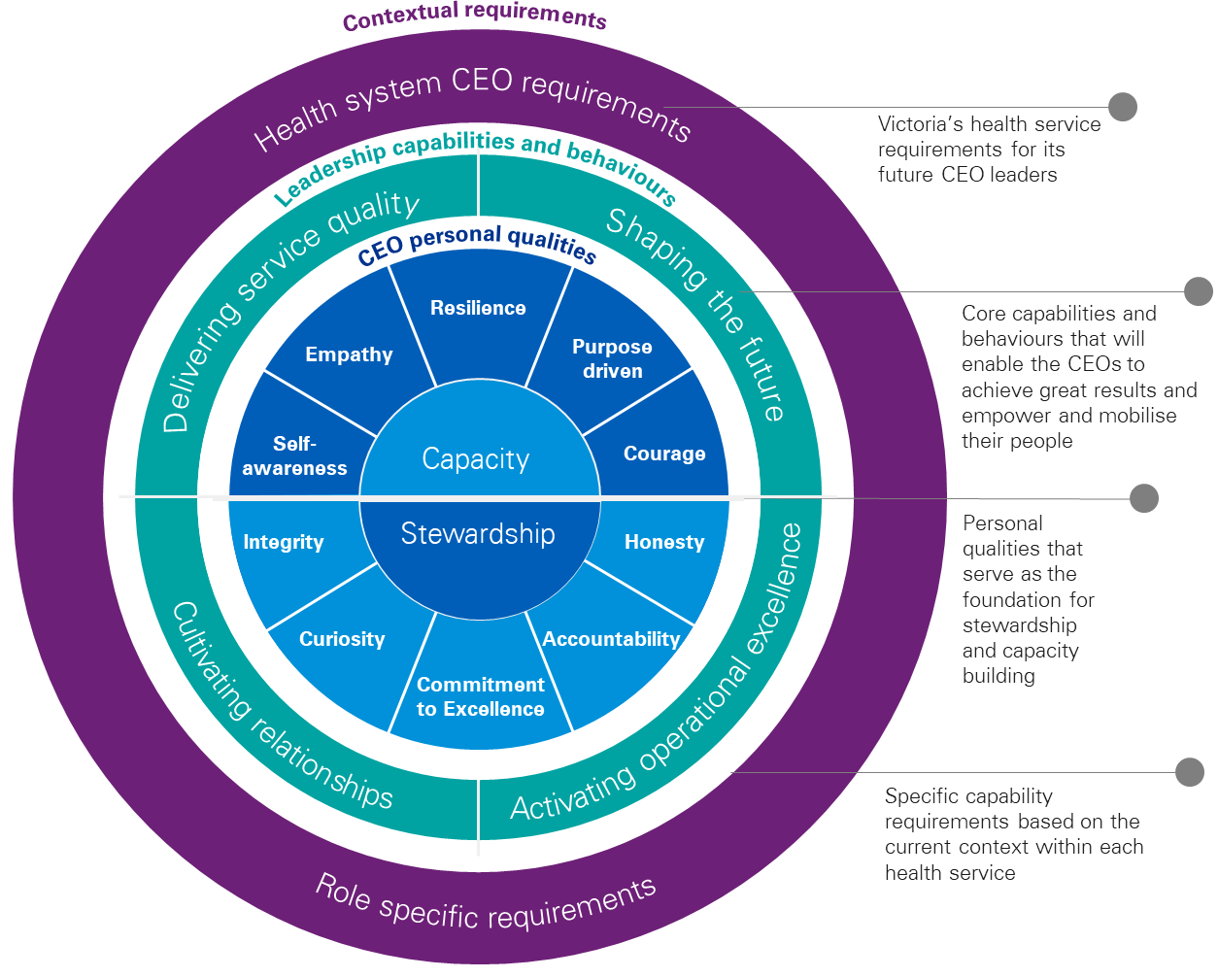

Personal qualities
- All CEOs in the Victorian health system are expected to have the personal qualities in the CEO leadership capability framework. Candidates will need to demonstrate these qualities in order to enter into the CEO talent program.
  - Personal qualities will be assessed via a psychometric tool at the start of the CEO assessment process.
Figure 2: CEO personal qualities
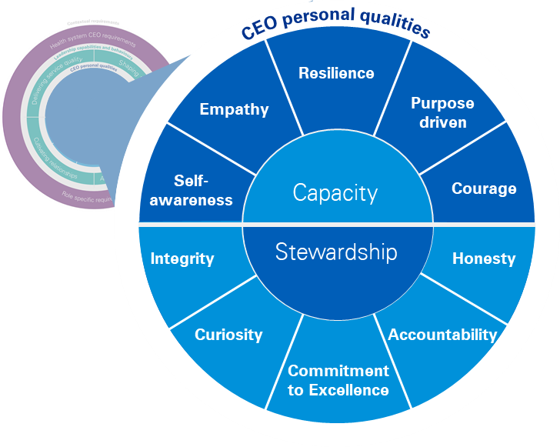

CEO leadership capabilities and behaviours
Our future CEOs need to be able to operate in a system facing pressures that will increase in the coming years. Victoria needs CEOs who can confidently and effectively meet service delivery expectations while maintaining a strategic focus and shaping the health system for the future.
Future CEOs will empower and mobilise diverse stakeholders and teams, create the conditions for collaborative effort, and strive for excellence and high performance within a complex and resource-constrained environment.
They have mastered a set of capabilities and demonstrate behaviours in four key domains:
- Shaping the future
- Cultivating relationships
- Delivering service quality
- Activating operational excellence
Each domain includes behavioural descriptors that each CEO will exhibit.
The behaviours are assessed through a 360-degree assessment process. This assessment will establish individual development plans, and behaviours will be further developed through a range of CEO leadership development approaches, including on-the-job learning as well as through other structured and unstructured development opportunities.

The domains
Domain | Behavioural descriptors
Shaping the future  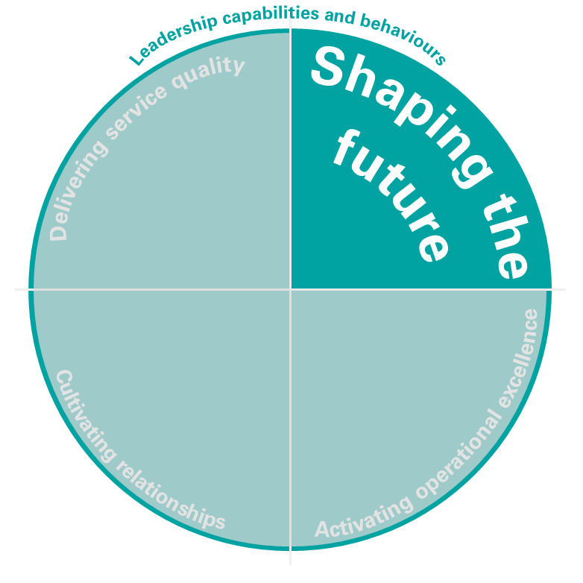 | - Shapes, articulates, inspires and mobilises others around a shared vision of the future health system  - Makes decisions in the context of uncertainty and ambiguity, and builds adaptive capability in self and others  - Applies political nous to strategy and communications  - Uses technological innovations and data to improve health care and drive digital change  - Thinks strategically and flexibly, challenges the status quo and fosters innovation  - Influences culture and creates opportunities to deliver system-wide change  - Encourages dialogue and engagement in decision making
Cultivating relationships  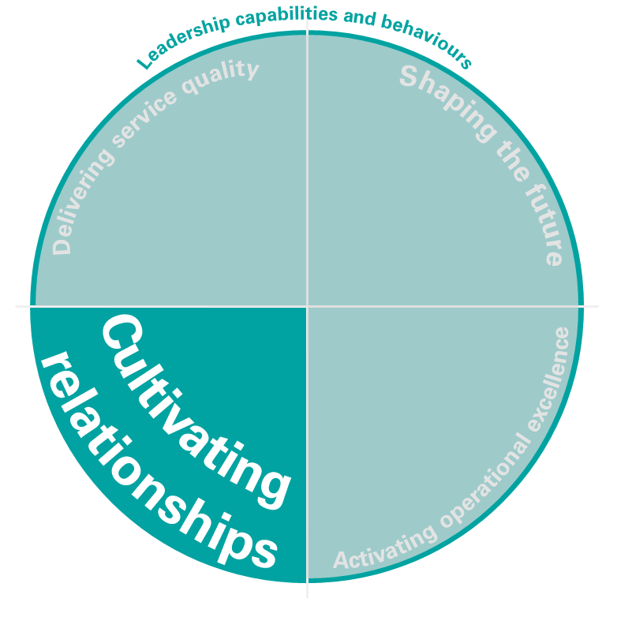 | - Builds trust and creates a climate of openness and collaboration  - Creates connections, cultivates and maintains broad and active networks and builds external partnerships  - Fosters diverse relationships with clinicians, non-clinicians and boards.  - Accepts responsibility and accountability, and seeks and values honest feedback  - Gives meaningful, concise and timely feedback that supports growth  - Builds self-efficacy in others, and gives credit where credit is due  - Values all contributions, navigates interpersonal conflicts and seeks out diverse perspectives  - Deals sensitively with the emotional reactions of others  - Promotes a spirit of cooperation and interdependency, fosters mutual respect, and shows genuine concern and regard for others (influences a positive internal culture)  - Attracts and develops highly talented people  - Projects confidence and credibility, even when not supported by all stakeholders
Delivering service quality  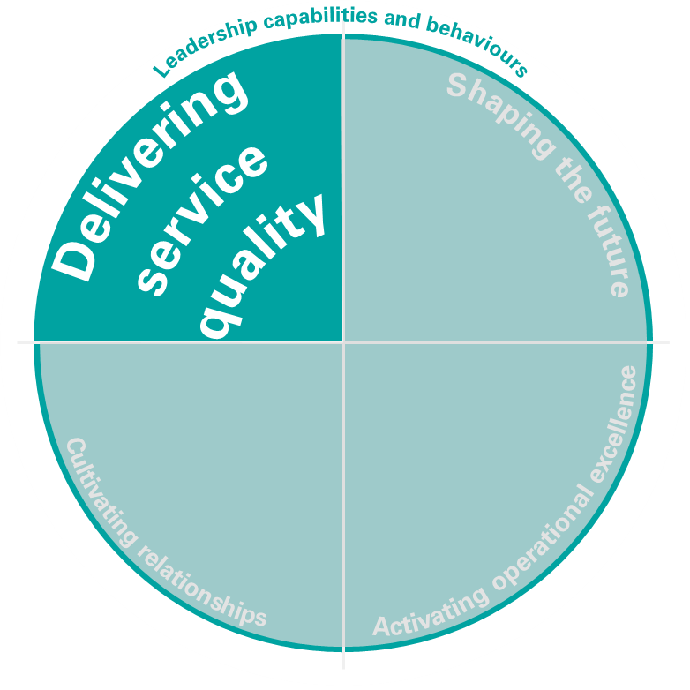 | - Puts patient/client needs at the heart of decision making, and challenges decisions that are not based on patient/client needs  - Constructs partnerships to enable new models for service delivery  - Creates a climate of performance, service delivery and accountability  - Commissions learning, research and development as integral elements to improve service delivery  - Encourages others to share knowledge and improvement ideas through networking and collaboration  - Diagnoses and tackles poor performance and facilitates high-performing teams as a vehicle to improve patient/client outcomes  - Sets and monitors quality and service delivery standards to deliver high-quality outcomes  - Focuses the team on the needs of staff, patients and public, ensuring adherence to appropriate standards of quality and safety
Activating operational excellence  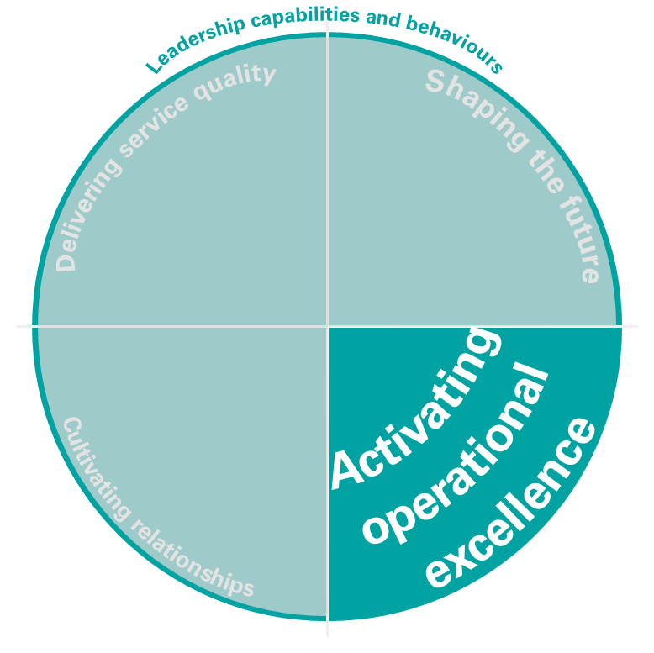 | - Sets clear goals and objectives, and aligns people, structures, systems and processes to support achievement of strategic priorities  - Addresses competing priorities and expectations, and focuses attention on the key priorities for delivery  - Applies cross-functional acumen to operationalise the strategic picture, and runs efficient and effective day-to-day operations  - Recognises excellence and celebrates successes, while managing pace and stress  - Identifies system risk and manages and balances risk appropriately  - Empowers others to make decisions, and promotes learning from mistakes  - Negotiates for and allocates finite resources, and drives innovation to find efficiencies

Appendix 1: How the framework was developed
The CEO leadership capability framework is an evidence-based model. It has been developed through a collaborative process involving representatives from the the Victorian public health sector, Department of Health and Human Services (DHHS), Safer Care Victorian and KPMG, as part of the Sector Leadership, Talent Management and Succession Planning Project.

Iterative drafting process
The framework has been iteratively drafted with inputs received as part of the Sector Leadership, Talent Management and Succession Planning Project.
Key inputs to the framework included:
- global best practice succession management and capability approaches
- existing Victorian capability frameworks in the health context
- CEO-specific capability sets, including outputs from the pilot CEO leadership capability development process
- the Victorian health system context, vision and strategic plan
- sector feedback received via Victorian public health service CEOs and Board Chairs forums, and direct submissions to KPMG
  - specialist expertise in capability frameworks, talent management and the health sector.
A description of inputs to the framework are provided in the following subsections of Appendix A.

Global best practice
KPMG undertook research on global best practice succession management and capability approaches. This involved desktop research and reviews of international literature, including:
Institute for Healthcare Improvement 2013, High-impact leadership: improve care, improve the health of populations, and reduce costs, IHI white paper, Cambridge, Massachusetts.
National Health Service (NHS) 2013, NHS healthcare leadership model, version 1, NHS, United Kingdom.
National Health Service (NHS) 2016, NHS culture and leadership programme, NHS United Kingdom.
Safer Care Victoria 2019, Leadership and learning action plan, State Government of Victoria, Melbourne.

Victorian capability frameworks
In November 2018, the Department of Health and Human Services called for health services and other organisations within the Victorian public health system to submit existing capability frameworks as input to the current framework.
Ten existing capability frameworks were received as part of the call for submission, which included:
Ambulance Victoria
- Ambulance Victoria behavioural capability framework 2018
  - Ambulance Victoria leadership development framework 2018
Barwon Health
- FY18–19 Barwon Health learning and development organisational curriculum 2018
  - Barwon Health leadership capability framework 2018, including Self-assessment tool for leading others profile 2018
Eastern Health
  - Eastern Health manager success profile 2018
Melbourne Health
- Melbourne Health capability framework: at a glance
  - Melbourne Health capability framework 2017
Monash Health
  - Monash Health capability framework 2016
The Royal Women’s Hospital
  - The Women’s competency framework – all levels (v0.1)
St Vincent’s Health Australia
- SVHA group core capability framework 2013

Victorian health system
The current framework was developed within the context of a rapidly evolving Victorian health system.
Within this context, the framework recognises that the Victorian health system leaders of the future need a diverse pool of skills and behaviours (as articulated in this framework) to meet a hugely challenging role with strong community expectations and multiple competing pressures and priorities.
The framework will continue to support future Victorian health system leaders in driving strategic directions around the Department of Health and Human Services’ strategic directions:
- person-centred services and care
- local solutions
- earlier and more connected support
  - advancing quality, safety and innovation.
The framework is aligned with the department’s vision:
- To achieve the best health, wellbeing and safety of all Victorians so that they can lead a life they value

Sector engagement and feedback
Extensive consultation was conducted to seek sector input into the development of the framework and the approach to talent identification and development.
Between December 2018 and early 2019, representatives from the department and KPMG presented at various CEO and board chair forums on the pilot CEO leadership capability development process. This involved calling for general feedback and responses to targeted questions about the current framework.
Appendix 2 provides a list of all forums attended, as well as a list of feedback submissions.

Leadership oversight
The Sector Leadership, Talent Management and Succession Planning Project was led by a steering committee of senior staff within the deaprtment, together with experienced health service board chairs and CEOs, Safer Care Victoria and KPMG. This group oversaw the development of the draft framework, sector consultation, endorsement of the content and sign-off of the final version.

Appendix 2: Sector engagement and feedback

CEOs and board chairs forums and meetings
- Sector Leadership Steering Committee meeting
- Barwon Board Chairs meeting
- Council of Board Chairs
- Gippsland Board Chairs and CEO forum
- Grampians Board Chairs and CEO forum
- Hume Board Chairs and CEO forum
- Loddon CEO forum
- Loddon Board Chairs forum
- Public Health Services CEO forum (metro and regional)
- Rural Directors of Medical Services meeting
- Small Rural Health Services and Multipurpose Services CEO forums

Sector feedback submissions
In addition to the forums held above, 10 CEOs and board chairs from across rural and regional Victoria separately provided feedback and input into various aspects of the CEO leadership capability framework.
Additional input was also provided by a range of Department of Health and Human Services and Safer Care Victoria staff outside of the steering committee processes.

Appendix 3: Text-equivalent descriptions of figures
Figure 1: CEO leadership and capability framework
The elements of the framework are divided into concentric circles.
The outermost circle is labelled ‘Contextual requirements’.
The next circle is labelled ‘Health system CEO requirements’, with the descriptor ‘Victoria’s health service requirements for its future CEO leaders’.
The next circle is labelled ‘Leadership capabilities and behaviours’, with the descriptor ‘Specific capability requirements based on the current context within each health service’.
The next circle is divided into four segments, labelled ‘Shaping the future’, ‘Activating operational excellence’, ‘Cultivating relationships’, and ‘Delivering service quality’, with the descriptor ‘Core capabilities and behaviours that will enable the CEOs to achieve great results and empower and mobilise their people’.
The next circle is labelled CEO personal qualities, with the descriptor ‘Personal qualities that serve as the foundation for stewardship and capacity building’.
The centre layer is divided into two semi-circles. The first semi-circle has five segments, representing ‘Capacity’. The segments are labelled ‘Self-awareness’, ‘Empathy’, ‘Resilience’, ‘Purpose driven’ and ‘Courage’.
The second semi-circle has five segments, representing ‘Stewardship’. The segments are labelled ‘Integrity’, ‘Curiosity’, ‘Commitment to excellence’, ‘Accountability’ and ‘Honesty’.
Figure 2: CEO personal qualities
This figure breaks out the centre circles from Figure 1.
This layer is divided into two semi-circles. The first semi-circle has five segments, representing ‘Capacity’. The segments are labelled ‘Self-awareness’, ‘Empathy’, ‘Resilience’, ‘Purpose driven’ and ‘Courage’.
The second semi-circle has five segments, representing ‘Stewardship’. The segments are labelled ‘Integrity’, ‘Curiosity’, ‘Commitment to excellence’, ‘Accountability’ and ‘Honesty’.

