Code Grey Standards
September 2017 (accessible version)
Contents
Background 1
Purpose 2
Using the standards 2
Timeline for implementation 2
Principles 2
Principle 1. 2
Principle 2. 2
Principle 3. 3
Definitions 3
Code Grey Standards 3
1. Governance 3
2. Personnel 4
3. Other resources 4
4. Procedures 5
5. Outcomes 6
Calling a Code Grey 7
Descriptive text for figures 1 and 2 9

Background
Occupational violence and aggression (OVA) is a significant risk for healthcare workers and has the potential to result in physical and/or psychological injury. Following the Inquiry into Violence and Security Arrangements in Victorian Hospitals (2011), the Department of Health and Human Services introduced Code Grey Standards to promote consistency in organisational responses to incidents of OVA, based on best practice principles and minimum practice standards.
Since June 2015, all Victorian public health services have been required to have:
- a procedure that defines the organisational Code Grey response that is separate from Code Black
- an alert of Code Grey that is separate from Code Black.
A Review of Code Grey and Code Black (2016) has revealed variability in the approach to, and level of implementation of, the Code Grey Standards. Extensive consultation was undertaken with other sector representatives.
This document brings together the findings from the review and provides a more comprehensive set of standards to update those originally introduced in 2014.

Purpose
The Code Grey Standards set out the minimum requirements for a coordinated organisational response to prevent and manage occupational violence and aggression. The standards are designed to:
- reduce the risk of injury to staff, patients and visitors
- ensure patients are treated safely, with dignity, and with clinical needs met
- ensure health services implement a standard escalation process to any actual or potential threat, allowing staff to have a consistent response.

Using the standards
The Code Grey Standards prescribe a step-by-step approach for designing and implementing a standardised Code Grey response. Whether establishing the foundations of a Code Grey response, or improving processes already incorporated into everyday practice, the standards are designed to provide health services with minimum requirements for:
- the personnel and other resources required to prepare the organisation for an effective Code Grey response
- the procedures required to implement a Code Grey response within the organisation
- the requirements for monitoring the effectiveness of Code Grey responses through evaluation of outcomes and operational governance arrangements.
All Victorian public health services are required to have an implementable Code Grey policy. It is acknowledged that some sites and rural health services may, at known times, not have the staffing capacity to meet the standards. In these instances, it is expected that those health services will initiate a Code Black and apply their pre-determined localised plan to activate an immediate response. This must be made clear in the health service’s Code Grey and Code Black policies and procedures.

Timeline for implementation
Health services are required to implement the revised Code Grey Standards by 31 March 2018.

Principles
The following principles underpin the Code Grey Standards. The principles should be applied to guide actions to implement individual standards.

Principle 1
Standardised Code Grey responses support healthy and safe work environments for staff, and quality care for patients across the Victorian health system.

Principle 2
Code Grey responses are clinically led and promote safety for staff, patients and visitors.

Principle 3
Code Grey responses are based on a risk-assessment approach that is integrated into a broader organisational Framework for Preventing and Managing Occupational Violence and Aggression.

Definitions
Occupational violence and aggression involves incidents in which a person is abused, threatened or assaulted in circumstances relating to their work.
A Code Grey is an organisation-level response to actual or potential violent, aggressive, abusive or threatening behaviour, exhibited by patients or visitors, towards others or themselves, which creates a risk to health and safety. In addition:
- A Code Grey is an emergency response initiated by staff for immediate assistance with a current incident.
- A planned Code Grey is initiated by staff for anticipated assistance with a scheduled event (such as a patient appointment), where following a risk-based assessment, it is anticipated that an incident may occur.
A Code Grey team comprises designated staff who are specifically trained and immediately available to respond to Code Grey incidents at the health service. In addition:
- The Code Grey team must include clinically trained and security trained staff members.
- The composition of the Code Grey team must comply with relevant hospital policies and procedures and be consistent with relevant statewide guidance, including those related to the use of seclusion or restraint, and/or weapons searching and management.
- Where health services (or specific units or sites within an individual health service) do not have operational policies relating to the use of seclusion and restraint, or weapons searching and management (that is, the health service or area of the health service does not undertake these practices), the Code Grey and Code Black teams/responders must comprise the same staff members who respond to each incident, to allow for immediate escalation to a Code Black response if required.
- The composition, scope of practice and specialised training of the Code Grey (and Code Black) teams must be pre-determined and clearly documented for each area of the organisation, in health service emergency procedure manuals. It must be clear at all times who comprises the Code Grey and Code Black response onsite for the organisation.

Code Grey Standards

1. Governance
At a minimum, health services will:
1.1 have a designated committee responsible for oversight of the organisation’s prevention and response to occupational violence and aggression, including Code Grey
1.2 obtain chief executive officer endorsement of the health service’s Code Grey policies and procedures
1.3 designate executive accountability for monitoring and evaluation of the organisation’s Code Grey responses
1.4 undertake regular reporting of the number of Code Grey requests and the outcome of each Code Grey request to the designated committee, chief executive officer and board. Provide qualitative information on the effects on healthcare workers of incidents arising from Code Greys to give insight and context to the statistical information presented
1.5 audit and report annual compliance with the Code Grey Standards to the Department of Health and Human Services, using the tool provided by the department
1.6 provide the number of Code Grey calls, planned Code Grey and Code Grey, and the outcome of each Code Grey request to the Department of Health and Human Services for system-wide monitoring on an annual basis
1.7 record board-level review and actions arising from organisational Code Grey performance against other peer-group health services, provided by the Department of Health and Human Services on an annual basis.

2. Personnel
At a minimum, health services will:
2.1 based on comprehensive site-specific risk assessments, allocate a sufficient number of specially trained staff to site-specific Code Grey teams, both during and after business hours
2.2 utilise data on Code Grey incidents to determine the need for multiple Code Grey teams per site
2.3 ensure that personnel requirements are consistent with relevant statewide guidance for practices being undertaken at the health service or health service site, such as the use of seclusion and restraint, or weapons searching and management
2.4 consult with staff identified as potential members of Code Grey teams to determine suitability for the role, including capability
2.5 designate staff as members of site-specific Code Grey teams, including a clinical Code Grey team leader for each team
2.6 allocate responsibility as required by a risk assessment to individual unit leaders for assisting to co- ordinate Code Grey responses within their clinical area
2.7 designate an emergency management coordinator for Code Grey responses at each hospital site, during and after business hours.

3. Other resources
At a minimum, health services will:
3.1 make Code Grey procedures available to all staff, which include methods of:
- prevention
- early intervention
- response, including escalation procedures
- reporting
- post-incident support
- incident investigation
3.2 provide guidelines to recognise and describe behaviours that may require a Code Grey response
3.3 provide written instructions for activating a Code Grey response to all staff.

4. Procedures
At a minimum, health services will implement procedures for:
4.1 conducting risk assessments, including appropriate criteria to identify and assess the risk of patients or others accompanying them becoming violent or aggressive. These risk assessments must be initiated as soon as practicable when a patient presents without notice, as part of pre-admission practices and throughout the patient’s stay
4.2 having alert systems in place that flag a history of Code Grey incidents or other aggressive behaviours in patient records (both hard copy and electronic), at handover and prior to patient transfer within a facility, or to/from an external facility
4.3 documented behaviour management plans and escalation processes in place for patients where previous Code Greys have been called, including the need for a planned Code Grey
4.4 having a system in place to record the occurrence of every Code Grey request
4.5 having a protocol at the commencement of every Code Grey response whereby the Code Grey team verbally confirms the:
- presence of a clinical lead
- presence of a security-trained member of staff
- presence of other staff members (predetermined following site-specific risk assessments)
- roles and responsibilities of each team member
- predetermined criteria that will trigger escalation to a Code Black response
4.6 activating plans to respond when multiple, concurrent Code Greys (or Code Blacks) are called
4.7 allocating responsibility after each incident for:
- following up staff who have been involved in or witnessed an incident or see their colleagues in distress
- following up the individual for whom the Code Grey was called to ensure appropriate management strategies are implemented (including ongoing prevention of incident occurrence such as clinical review and establishment of behaviour management plans)
- commencement and completion of incident reporting
4.8 providing immediate relief from duties if required and referral of staff to relevant support services following a Code Grey incident
4.9 recording the outcome of each Code Grey
4.10 classifying all Code Grey incidents according to severity
4.11 reviewing all Code Grey incidents, including a review of risk control measures
4.12 actioning Code Grey investigation findings, including documenting completed and outstanding items, and scheduled dates for review of revised control measures
4.13 providing regular feedback to staff about Code Grey incident investigations, including contributing factors and actions taken as a result of incident reports
4.14 providing annual training for all Code Grey team members that includes theoretical and practical components
4.15 practising Code Grey responses, including trialling responses to multiple, concurrent Code Grey incidents in various locations throughout the health service
4.16 regularly reviewing Code Grey procedures and practices for consistency and integration with related health service policies, such as security, training and post-incident support policies.

5. Outcomes
At a minimum, health services will:
5.1 evaluate the effectiveness of training provided to Code Grey team members to ensure that training programs meet their stated objectives
5.2 in consultation with Code Grey team members, assess implementation of the knowledge and skills covered by training programs (including situational awareness, de-escalation, containment, and escalation) to provide ongoing opportunities for learning and improvement
5.3 evaluate the consistency of Code Grey responses across all areas of the organisation
5.4 evaluate the effectiveness of all Code Grey responses
5.5 integrate staff, patient and carer feedback into annual reviews of the organisation’s Code Grey response
5.6 analyse trends to identify any patterns that may assist to improve prevention of occupational violence and Code Grey responses.

Calling a Code Grey
Figure 1: Calling a Code Grey
To be read in conjunction with Code Grey Standards – September 2017.
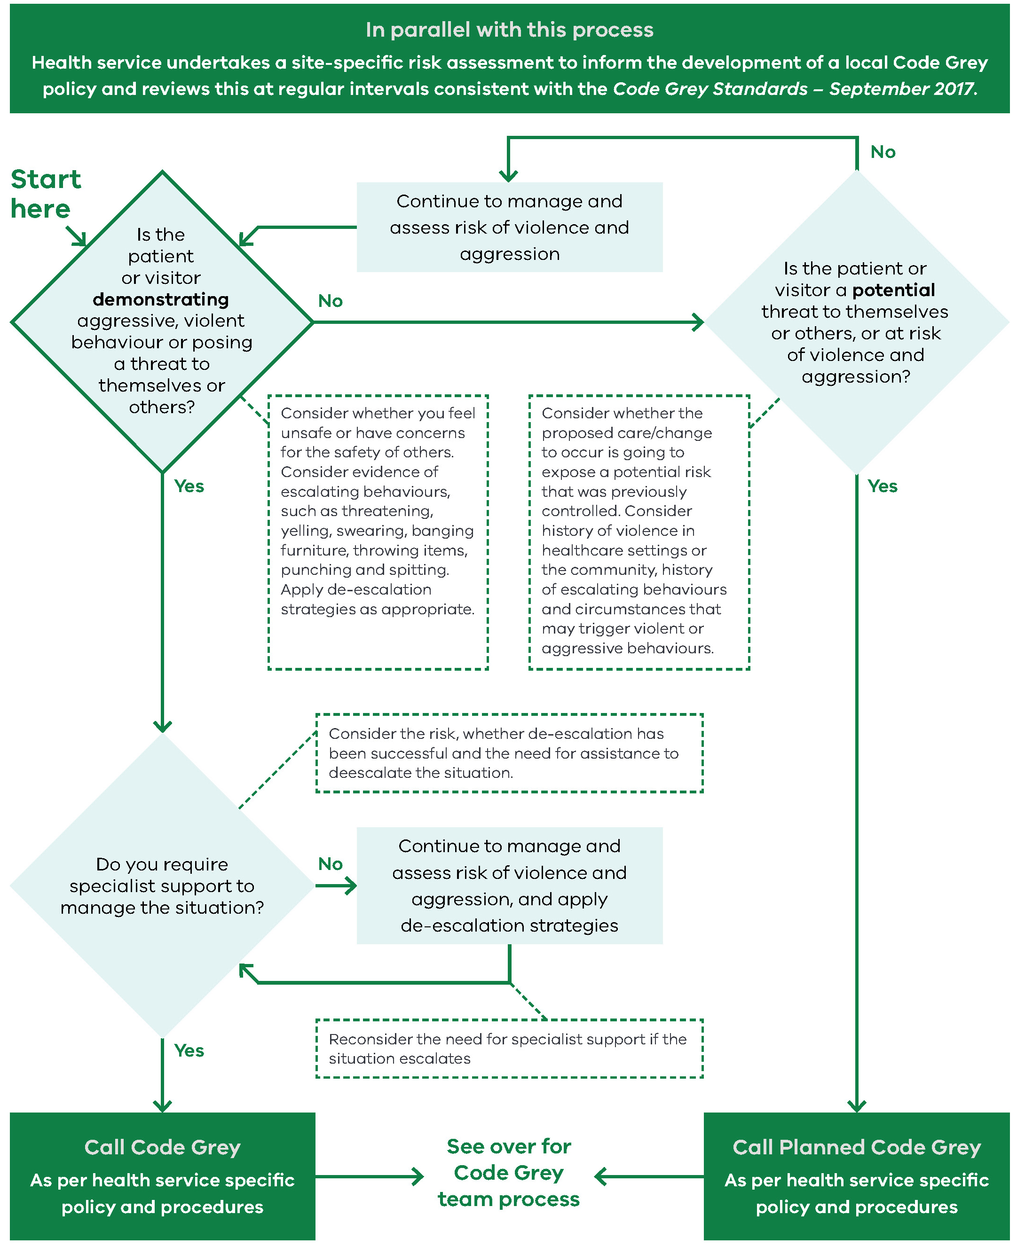
Figure 2: Situational awareness and dynamic risk assessment by Code Grey team
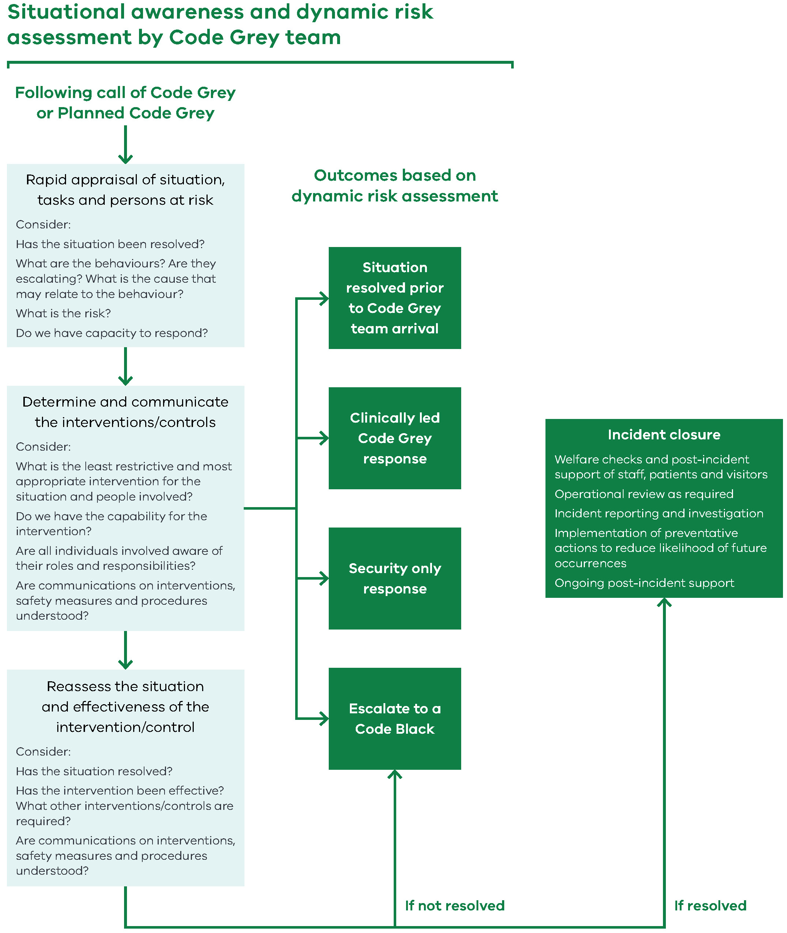

Descriptive text for figures 1 and 2
This process should be read in conjunction with Code Grey Standards – September 2017. In parallel with this process, the health service undertakes a site-specific risk assessment to inform the development of a local Code Grey policy and reviews this at regular intervals consistent with the Code Grey Standards – September 2017.
Section A: Process for deciding whether to call a Code Grey
Question 1: Is the patient or visitor demonstrating aggressive, violent behaviour or posing a threat to themselves or others?
To answer question 1, you should:
- consider whether you feel unsafe or have concerns for the safety of others
- consider evidence of escalating behaviours, such as threatening, yelling, swearing, banging furniture, throwing items, punching and spitting
- apply de-escalation strategies as appropriate.
If the answer to question 1 is ‘yes’, go to Question 2(a).
If the answer to question 1 is ‘no’, go to Question 2(b).
Question 2(a): Do you require specialist support to manage the situation?
To answer question 2(a), you should consider the risk, whether de-escalation has been successful, and the need for assistance to de-escalate the situation.
If the answer to question 2(a) is ‘yes’, call a Code Grey as per health service specific policy and procedures, and follow the Code Grey Team Process outlined in Section B.
If the answer to question 2(a) is ‘no’, continue to manage and assess the risk of violence and aggression, and apply de-escalation strategies. You should also reconsider the need for specialist support if the situation escalates, and return to question 2(a). If your answer to question 2(a) then changes to ‘yes’, call a Code Grey as per health service specific policy and procedures, and follow the Code Grey Team Process outlined in Section B.
Question 2(b): Is the patient or visitor a potential threat to themselves or others, or at risk of violence and aggression?
To answer question 2(b), you should:
- consider whether the proposed care/change to occur is going to expose a potential risk that was previously controlled
- consider history of violence in healthcare settings or the community, history of escalating behaviours and circumstances that may trigger violent or aggressive behaviours.
If the answer to question 2(b) is ‘yes’, call a Planned Code Grey as per health service specific policy and procedures, and follow the Code Grey Team Process outlined in Section B.
If the answer to question 2(b) is ‘no’, continue to manage and assess the risk of violence and aggression, and return to Question 1.
Section B: Code Grey Team Process
Following a call of Code Grey or a Planned Code Grey, the Code Grey team carries out a situational awareness and dynamic risk assessment as described in the following steps.
Step 1: Rapid appraisal of situation, tasks and persons at risk. You should consider:
- Has the situation been resolved?
- What are the behaviours? Are they escalating? What is the cause that may relate to the behaviour?
- What is the risk?
- Do we have capacity to respond?
Step 2: Determine and communicate the interventions/controls. You should consider:
- What is the least restrictive and most appropriate intervention for the situation and people involved?
- Do we have the capability for the intervention?
- Are all individuals involved aware of their roles and responsibilities?
- Are communications on interventions, safety measures and procedures understood?
There are four possible outcomes based on this dynamic risk assessment:
- Situation resolved prior to Code Grey team arrival
- Clinically led Code Grey response
- Security only response
- Escalate to a Code Black.
Step 3: Reassess the situation and effectiveness of the intervention/control. You should consider:
- Has the situation resolved?
- Has the intervention been effective?
- What other interventions/controls are required?
- Are communications on interventions, safety measures and procedures understood?
If the situation has not been resolved, escalate to a Code Black.
If the situation has been resolved, go to Step 4.
Step 4: Incident closure. This involves:
- welfare checks and post-incident support of staff, patients and visitors
- operational review as required
- incident reporting and investigation
- implementation of preventative actions to reduce likelihood of future occurrences
- ongoing post-incident support.

To receive this publication in an accessible format email Worker Health and Wellbeing team <whwb@dhhs.vic.gov.au>
Authorised and published by the Victorian Government, 1 Treasury Place, Melbourne.
© State of Victoria, Department of Health and Human Services September 2017
Available at Vic.Health, Code Grey and Code Black <https://www2.health.vic.gov.au/health-workforce/worker-health-wellbeing/occupational-violence-aggression/code-grey-black>

Code Black is an Australian emergency standard and therefore, these Code Grey Standards should be read in conjunction with Australian Standard (AS) 4083 – 2010 Planning for emergencies – Health care facilities
Framework for preventing and managing occupational violence and aggression (2017) <https://www2.health.vic.gov.au/about/ publications/policiesandguidelines/occupational-violence-aggression-healthcare-framework-2017>
Information for employers – Prevention and management of violence and aggression in health services (June 2017), WorkSafe Victoria at <https://www.worksafe.vic.gov.au/ data/assets/pdf_file/0006/210993/ISBN-Prevention-and-management-of-violence-and-aggression- health-services-2017-06.pdf>
Clinically trained – staff member with clinical responsibilities within their job description and current registration relevant to their clinical profession, such as a nurse or emergency physician
Security trained – security staff and non-clinical staff who support and are specifically trained in hospital security responses. Refer to DHHS security guidance to be available later in 2017.
At a minimum, reporting requirements will align with the Framework for preventing and managing occupational violence and aggression (2017) at <https://www2.health.vic.gov.au/about/publications/policiesandguidelines/occupational-violence-aggression- healthcare-framework-2017>
The outcome of each Code Grey called must be recorded as either: No violence or aggression occurred (NVA); Situation resolved prior to Code Grey team’s arrival (SR); Clinically-led Code Grey response implemented (CG); Security-only response implemented (SO); Code Black response implemented (CB). Each Code Grey called must also be recorded as either Planned (P) or Unplanned (U).
This tool will be provided to health services in 2017 to assist with identifying gaps and areas for improvement.
Site-specific risk assessments should consider, but not be limited to: the risks associated with the services provided at the health service, population and demographics in which service is provided, the environment, including the built design of the facilities, geographical characteristics, including proximity and availability of emergency responders and other supports, staffing capacity and capability.
Systems may include hospital switchboard or security logs.
Note that ‘staff’ includes designated members of the Code Grey team.
The outcome of each Code Grey called must be recorded as either: No violence or aggression occurred (NVA); Situation resolved prior to Code Grey team’s arrival (SR); Clinically-led Code Grey response implemented (CG); Security-only response implemented (SO); Code Black response implemented (CB). Each Code Grey called must also be recorded as either Planned (P) or Unplanned (U).
Local processes are to be implemented pending the development of a statewide (standardised) method of classification.
The severity classification will determine the depth of review required, however, health services should be mindful of the potential cumulative effects of exposure to multiple incidents over sustained periods of time. Health services should also examine the circumstances that led to the incident occurring to gain valuable knowledge about possible contributory factors, which may assist with the identification of preventative measures.
Health services must disseminate incident review findings without employee and patient privacy being breached.
Training must align with the principles detailed in the Guide for violence and aggression training in Victorian health services (2017) at <https://www2.health.vic.gov.au/health-workforce/worker-health-wellbeing/occupational-violence-aggression/training>. Additional information is available in Information for employers – Prevention and management of violence and aggression in health services (June 2017), WorkSafe Victoria, <https://www.worksafe.vic.gov.au/ data/assets/pdf_file/0006/210993/ISBN-Prevention-and-management-of- violence-and-aggression-health-services-2017-06.pdf>
During 2017, an evaluation framework will be made available to assist health services.

