
Allied health assistant core competency: equipment and environment
Learning package

Department of Health
Allied health assistant core competency: equipment and environment
Learning package

Acknowledgment

The Department would like to acknowledge the contribution of Members of the Stage 3 Allied Health Assistant Working Group who developed the AHA Core Competency resources: Sally Butzkueven (Chair) Western Health; Casie Barrette, St. Vincent’s Hospital; Sally Russell, North East Primary Care Partnership: Austin Health, Banyule Community Health Service Darebin Community Health Service, and Nillumbik Health; Leanne de Vos, Manningham Community Health Service, Link Community and Health, and Carrington Health; Karen Dundules, North East Primary Care Partnership: Austin Health, Banyule Community Health Service Darebin Community Health Service, and Nillumbik Health; Liz Gavin ISIS Primary Care; Kellie Guthridge, Alfred Health; Desiree Terrill, Department of Health and Human Services.

To receive this publication in an accessible format phone 9096 8817 using the National Relay Service 13 36 77 if required, or email workforce@dhhs.vic.gov.au
Authorised and published by the Victorian Government, 1 Treasury Place, Melbourne.
© State of Victoria, Department of Health and Human Services December, 2016.
Available at https://www2.health.vic.gov.au/health-workforce/allied-health-workforce/victorian-assistant-workforce-model

Contents
Introduction 6
Task list 7
Common issues and possible solutions 7
Occupational therapy 8
Over-toilet frame 8
Raised toilet seat 9
Shower chairs and shower stools 9
Bedside commode 10
Wheeled (shower) commode 11
Bath board 12
Transfer bench 12
Bed stick 13
Chairs – adjustable height 14
Portable ramps 15
Physiotherapy 17
Walking sticks 17
Walking frames 17
Crutches 19
Stationary bike 20
Arm ergometer 20
Steps/stairs and parallel bars (walking rails) 21
Manual handling 22
Slide board 22
Hoists 22
Slide sheets 23
Wheelchairs 24

Introduction
This learning package was developed as part of the Allied Health Assistant (AHA) Workforce Project, to support the ‘AHA core competency: equipment and environment’
It has been written for AHAs who provide equipment that has been clinically prescribed by an allied health professional (AHP). The AHP delegating the task will need to give you detailed clinical reasoning and make sure you are properly trained.
This resource provides an overview – it does not replace hands-on training with the equipment. Some pieces of equipment come in a wide range of models, which may have different adjustment processes. You may need workplace training to use specific items.
You should also use the ‘AHA core competency: equipment and environment’ in the context of local policies and procedures, the other AHA core competency learning resources, and other relevant information, such as:
- infection control policies and procedures
- manual handling policies and procedures
- purchasing and ordering policies and procedures
- ‘AHA core competency: individual therapy and associated learning package’
- ‘AHA core competency: group therapy and associated learning package’
- ‘AHA core competency: communication of patient information and associated learning package’
- equipment manufacturer and supplier manuals and websites
- departmental business rules.
This resource specifies the tasks involved in working with equipment, and includes a general information, cleaning, maintenance and safety requirements for a range of equipment and equipment types. It is not designed as an exhaustive reference.
The author would like to acknowledge the work of both the community acute/post-acute care team, Hunter New England local health district and the Independent Living Centre, which was used as a key reference for developing this resource:
<www.hnehealth.nsw.gov.au/facilities/community%20health/Pages/Newcastle-Community-Health-Centre.aspx>
<ilcaustralia.org.au/>

Task list
Before the session:
- Check the patient information.
- Locate the piece of equipment and check it for purpose, cleanliness and safety.
- Try the equipment yourself and make sure you know how to demonstrate its use.
During the session:
- Check the patient’s function against the information from the delegating AHP.
- Explain the purpose of the session, and obtain consent.
- Demonstrate the use of the equipment to the person and their family or carer, including transportation and maintenance.
- Supervise the patient using the equipment, providing training and assistance as needed.
- Explain costs and funding options to patient, including supply procedures.
After the session:
- Clean and replace equipment.
- Report outcome of session to delegating AHP, including documentation.
Other activities:
- Order equipment.
- Monitor and maintain stock levels.
- Arrange repairs and maintenance.
- Clean and safely store equipment.

Common issues and possible solutions
Issue | Solution
Equipment is faulty/dirty. | Clean and maintain; do not proceed if dirty/faulty.
You are unable to use the equipment yourself. | Check supplier manual.  Search for a demonstration video online.  Ask the delegating AHP.  Ask a colleague.
Patient function differs from AHP referral at any point during the process. | Postpone the session and discuss with the delegating AHP.

Occupational therapy equipment

Over-toilet frame
An over-toilet frame (OTF) is designed to fit over a toilet to increase the ease of toilet transfers. It has bilateral armrests and the legs can be adjusted in height. An optional splash guard can be supplied to prevent soiling on the floor.

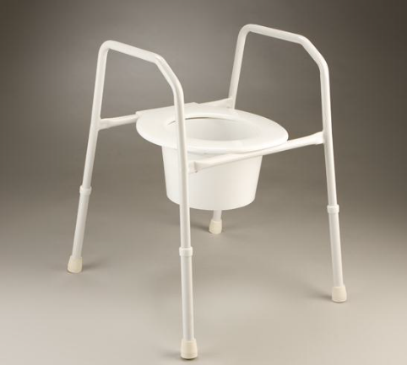

Adjusting the height
- The legs of the OTF are height adjustable via a push-button action. To adjust the height, press the spring-loaded button on each leg and move to the correct height.
- Adjust the height of the OTF so the person’s feet are resting flat on the ground. Their hips should be higher than their knees.
- Ensure the OTF legs are stable on the floor surface. OTFs often have one leg with additional adjustable holes that can be interchanged to accommodate an uneven floor surface.
- Ensure the user pushes equally on the both arm rests when sitting or standing so as not to tip the frame.

Cleaning, maintenance and safety
- Ensure the OTF is clean and in good working order.
- Check for cracks in the seat.
- Check legs are easily adjustable and not rusted.
- Ensure the height adjustment push button is fully extended through the desired hole before putting weight on it.

Raised toilet seat
Raised toilet seats (RTS) help to increase the height of the toilet seat, to assist people who struggle to get on and off the toilet.
They are secured to the top of the toilet bowl and come in a variety of heights (usually 50 mm, 100mm and 150 mm). Some are available with lids or armrests.

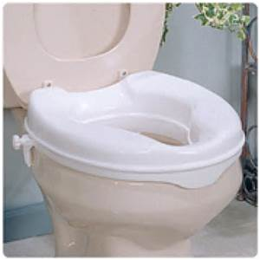

Installation
- Lift the existing toilet seat lid and seat, and position toilet seat raiser in direct contact with the porcelain bowl.
- The seat is attached to the toilet using adjustable brackets.
- Adjust brackets to ensure firm contact with the sides of the porcelain bowl.
- Ensure the lip at front of raised toilet seat (if applicable) is firmly against the front of bowl.
- If the RTS cannot be fitted correctly, the existing toilet seat may need to be removed.

Cleaning, maintenance and safety
- Ensure the RTS is clean and in good working order
- Check for cracks in the seat
- Ensure rubber surface of adjustable brackets is in good working order
- Advise patient of need to regularly check firmness of adjustable brackets
- If the RTS cannot be fitted correctly, do not proceed with trial and provide feedback the prescribing therapist.

Shower chairs and shower stools
A shower chair or stool is a device that is designed to allow a client to sit while showering or dressing.
A shower stool does not have a back rest and may be used instead of a shower chair due to space and access limitations in a client’s shower recess.
Both devices have bilateral armrests and the legs can be adjusted in height.

Adjusting the height
- The four legs of the chair or stool are height adjustable via a push button action. To adjust the height press the spring-loaded button on each leg and move to the correct height.
- The height of the chair or stool should be adjusted so the person’s feet are resting flat on the ground. Their hips should be higher than their knees.
- Ensure all legs of the chair or stool are stable on the shower floor surface. Both devices often have a leg with additional adjustable holes that can be interchanged to accommodate shower floor gradients.
- Ensure the person pushes equally on the both arm rests when sitting or standing so as not to tip the frame.

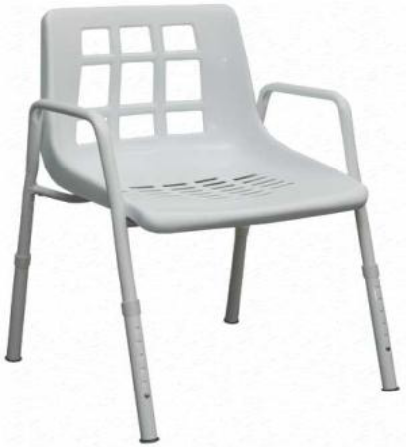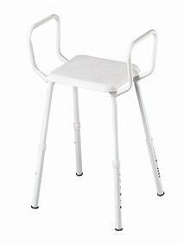

Cleaning, maintenance and safety
- Ensure the chair or stool is clean and in good working order.
- Check for cracks in the seat.
- Check legs are easily adjustable and not rusted.
- Check all stoppers are intact.
- Ensure the height adjustment push button is fully extended through the desired hole before putting weight on it.

Bedside commode
A bedside commode is a portable toilet with a seat, cover and pan underneath. The pan can be removed for cleaning after the commode is used.
A commode can be used beside the bed if a person is unable to access the toilet safely.
A commode may have swing back or removable armrests to accommodate slide transfers.

Adjusting the height
- The four legs of the commode chair are height adjustable via a push button action. To adjust the height press the spring-loaded buttons on each leg and move to the correct height.
- The height of the commode should be adjusted so the person’s feet are resting flat on the ground. Their hips should be higher than their knees.
- Ensure all legs of the chair are stable on the floor surface.
- Ensure the user pushes equally on the both arm rests when sitting or standing so as not to tip the frame.

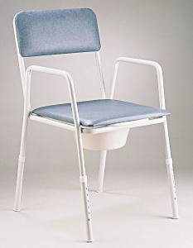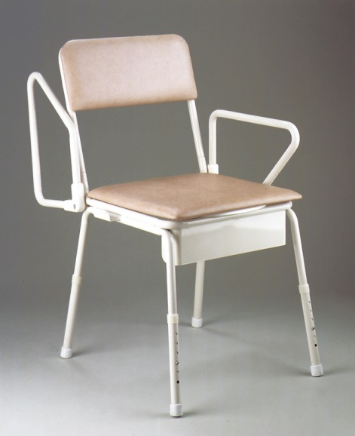

Cleaning, maintenance and safety
- Ensure the commode is clean and in good working order.
- Check for rips, tears and cracks in the cushion, back-rest and lid.
- Check legs and adjustable armrests (if applicable) are easily adjustable and not rusted.
- Ensure the height-adjustment push button is fully extended through the desired hole before putting weight on it.

Wheeled (shower) commode
A wheeled shower commode can be used in a level-access shower or over a toilet.
They are available as attendant propelled (four small wheels) or self-propelled (two large wheels and two small wheels). Attendant-propelled commodes require a carer for all aspects of mobility.
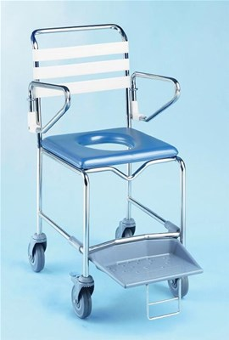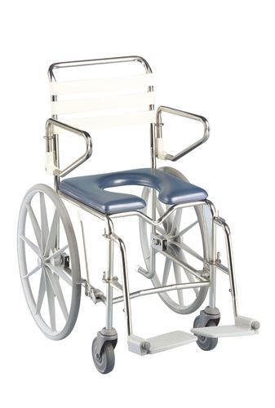

Key features
- Seat options – open/ closed front, left or right side opening
- Brakes – on castors or large self-propelled wheels
- Footplates – swing away versus slide out
- Armrests – swing back
- Commode pan (with lid) slides in from the rear (if required for use)

Cleaning and maintenance
- Check metal components regularly for any signs of rust.
- Castors should be checked regularly to ensure smooth ride for occupant.

Bath board
Bath boards are for people who have difficulty getting in and out of the bath. They are fitted across the top of the bath and allows the person to sit over the bath without needing to step into the bath. Users of a bath board would find a hand-held shower hose useful.
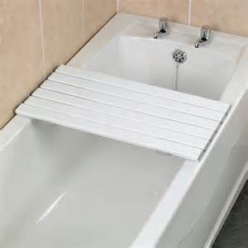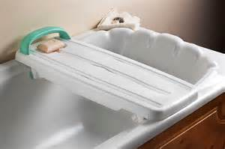

Installation
- Ensure adequate width of supporting edge available on both sides of the bath (minimum 30 mm).
- Ensure the adjustable brackets underneath the bath board are correctly adjusted to the width of the bath and secured in place before use.
- Ensure the bath board is firmly in place before demonstrating or attempting transfer.

Cleaning, maintenance and safety
- Check surface of the bath board is clean and in good working order.
- Ensure the rubber surface of adjustable brackets is in good working order.
- Advise the person to regularly check the adjustable bracket is firmly in contact with the supporting surface.

Transfer bench
Bath transfer benches may assist people who have difficulty stepping in and out of the bath or shower safely. The bench is positioned over the bath edge or shower lip, with two legs inside the bath and two legs outside. It allows the user to shuffle across into the bath. Some backrests can be removed for use in confined spaces.
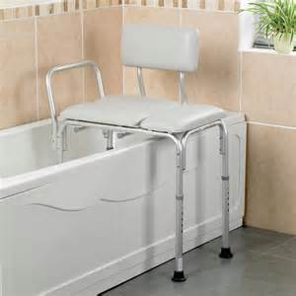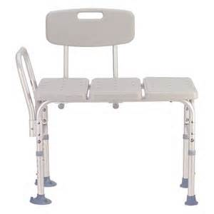

Installation
- Push and hold the push button while sliding the extension leg up or down to the desired set of holes. Make sure the push button is fully extended through the desired hole before putting weight on the item.
- Ensure the bench surface is level and all four legs are adjusted to have full contact with supporting surfaces.
- Ensure the legs with suction cups (if applicable) are placed against the inside bath surface.
- Ensure the handle is positioned closest to the wall of the bath or shower.
- Reposition the backrest and handle to suit the orientation of the bath or shower.
- The height of the transfer bench should be adjusted so the person’s feet are flat on the ground. Their hips should be higher than their knees.

Cleaning, maintenance and safety
- Position as much of the transfer bench as possible over the bath to decrease water spillage.
- Check for rips, tears and cracks in the bench and back rest.
- Check legs and adjustable armrests (if applicable) are easily adjustable and not rusted.
- Ensure the height adjustment push button is fully extended through the desired hole before putting weight on it.
- If suction cups are present on legs, use removal tabs to release suction.

Bed stick
A bed stick is anchored beneath a mattress to provide support while completing transfers, repositioning and/or rolling in bed.
Warning: due to the high level of risk associated with incorrect bed stick use, practical demonstration by an AHP is necessary. You should also check your organisation’s policies and procedures when determining the suitability of the client, equipment and fitting.
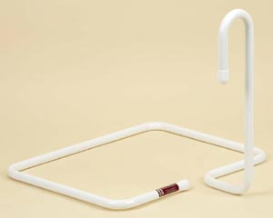

Installation
- Lift the top end of the mattress and slide the base of the bed stick between the bed base or frame and the mattress.
- It should be positioned so it does not interfere with getting in or out of bed (approximately 560 mm from the head end of bed).
- Ensure it is always positioned as close to the mattress edge as possible. It should not be used if there is a gap between the bed stick and the mattress.
- The installation of a single or double bed stick is best performed by two people.

Cleaning, maintenance and safety
- Ensure the bed stick is clean and in good working order.
- Check the end caps are in situ to prevent damage to the mattress.
- Ensure that the bed stick is firmly held in place by the weight of the mattress and the person’s body weight when seated on the edge of the bed.
- Ensure there is no gap between the mattress and bed stick.
- Refer to your organisation’s policies and procedures (if applicable).

Chairs – adjustable height
Orthopaedic chairs are designed for people with reduced strength and mobility. These chairs are height adjustable and have bilateral armrests to assist with independent and safe transfers.
The back of many high-backrest chairs can be removed from the seat base to enable easier and safer transportation.
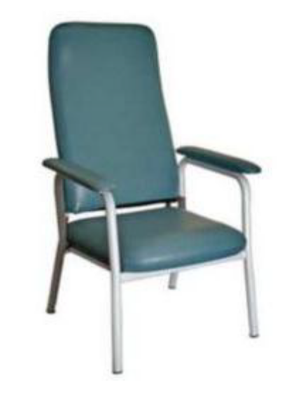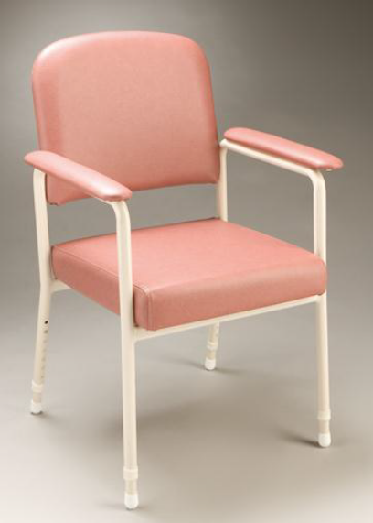
Hi-Lite chair Utility chair

Adjusting the height
- The four legs of the chair are height adjustable via a push button action. To adjust to the correct height, press the spring-loaded buttons on the legs and move to the required height.
- The height of the chair should be adjusted so the person’s feet are resting flat on the ground. Their hips should be higher than their knees.
- Ensure all legs of the chair are stable on the floor surface.

Cleaning, maintenance and safety
- Ensure the chair is clean and in good working order.
- Check for cracks in the vinyl.
- Check the legs are easily adjustable and not rusted.
- If the high-back chair has been disassembled, ensure the back rest is fitted securely and evenly to the seat base.
- Ensure the height adjustment push button is fully extended through the desired hole before putting weight on it.

Portable ramps
Portable ramps are designed to assist an occupant in a wheelchair or scooter to transition over curbs, thresholds and other obstacles. They are available in different fixed lengths.
Many different models of portables ramps exist. Practical training is essential before using the equipment. Be aware that steep ramp gradients may pose safety risks.

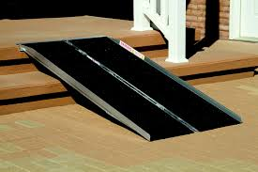

Installation
- The bottom of the ramp must be set firmly on the ground and the top of the ramp must be set flush with the step or vertical lip.
- The ramp has a rubber slip-resistant strip on the underside of the upper lip to assist with stabilising the ramp on a step.
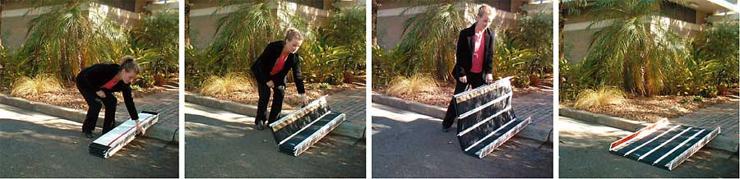

Cleaning, maintenance and safety
- A pinch point may exist in the ramp hinge. Keep fingers away from the hinge while folding or unfolding the ramp.
- Use manual handling precautions when handling portable ramps.

Physiotherapy Equipment

Walking sticks
A walking stick is a device used to facilitate balancing and walking.
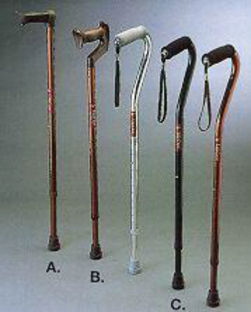

Adjusting the height
- Some walking sticks are height adjustable via a push button action. To adjust to the correct height press the spring-loaded buttons on the stick and move to the required height.
- With shoes on, the person’s arm should be relaxed and hanging loosely at their side.
- The hand grip should be level with the wrist joint.

Cleaning, maintenance and safety
- Ensure the walking stick is clean and in good working order.
- Check the push buttons are easily adjustable and not rusted.
- Check stoppers are intact.
- Ensure the height-adjustment push button is fully extended through the desired hole before putting weight on it.

Walking frames
A walking frame is a device used by people who need additional support to maintain balance while walking. The client walks with the frame surrounding their front and sides, with their hands providing additional support by holding on to the top of the frame.

Four-wheeled walker / A-frame
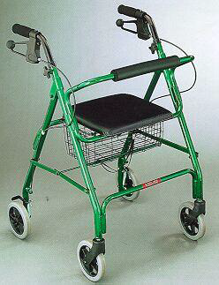

Adjusting the height
- Twist and remove the toggles and bolt located on the frame of the walker below the handgrips. Adjust to the required height and replace the toggle and bolt.
- When adjusting the height of a walking frame for someone, ensure they are wearing everyday shoes and are standing in a relaxed position with their hands resting comfortably beside their body.
- In this position, the walking frame handgrips should sit approximately at wrist-joint height.

Pick-up frame (PUF)
Some models may have two wheels at the front or skis at the back in place of the rubber stoppers.

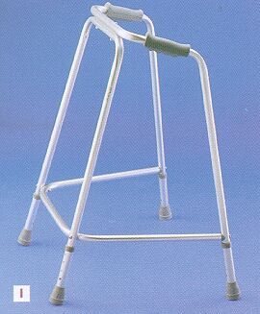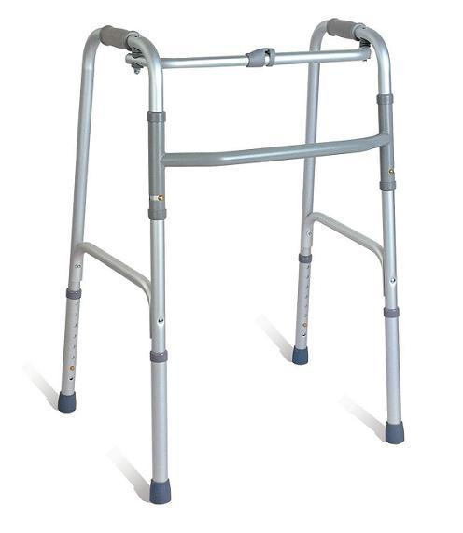

Adjusting the height
- These types of walking frames are height adjustable via a push button. To adjust to the correct height, press the spring-loaded buttons on the legs of the walker and move to the required height.
- When adjusting the height of a walking frame for someone, ensure they are wearing everyday shoes and are standing in a relaxed position with their hands resting comfortably beside their body.
- In this position, the walking frame handgrips should sit approximately at wrist-joint height.

Crutches
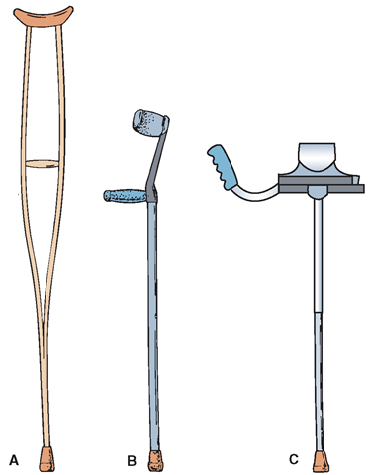
A – Axilla crutch
B – Forearm crutch
C – Gutter crutch

Cleaning, maintenance and safety
- Ensure the walking frame is clean and in good working order.
- When relevant, check rubber tips and brake cables for signs of wear and rust.
- Ensure all handle height-adjustment fastenings are secured tightly.
- Ensure the height-adjustment push button is fully extended through the desired hole before putting weight on it.
The main use for the following items of equipment are for cardio exercise. Each model has different specifics and hands-on training in the workplace is essential. Individual adjustments may be required for each item. See the delegating clinician for details.

Stationary bike
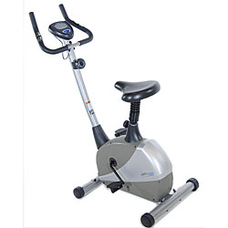

Key features
- safe mounting/ dismounting
- safe braking
- resistance control
- seat-height adjustment may be required.

Arm ergometer
Arm ergometers work like a bicycle for the arms.
Some are designed to sit on a table, others are designed for wheelchair access.
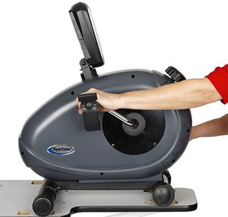

Steps/stairs and parallel bars (walking rails)
These are used as part of retraining a person’s walking abilities. The activities done using these items of equipment will be specific to the individual, and will be carefully prescribed by the clinician.
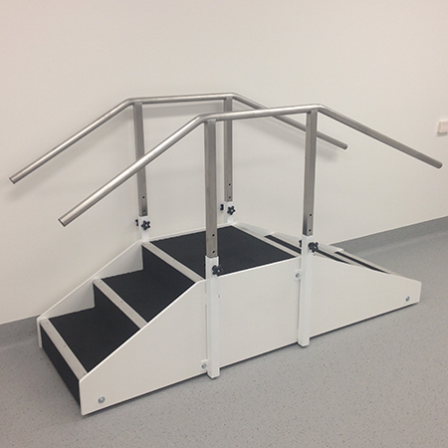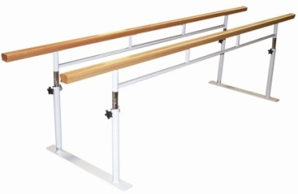

Manual handling equipment
Warning: before using any manual handling products, complete training in the correct use of specific equipment. This document provides only a basic overview of equipment.

Slide board
A slide board is designed to assist a seated user to transfer from one surface to another. It can be curved or straight, and may include an optional handle cut out.
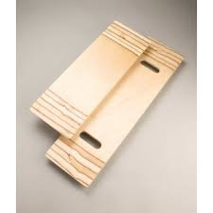

Hoists
Hoists are designed to provide assistance with moving a person with reduced mobility from one place to another, without manually lifting them. Different types of hoists are used depending on the person’s abilities and the skills of the carer.

Mobile hoist
A mobile battery-operated hoist that may be used to lift and transfer a person from a seated or lying position, or on and off the floor.
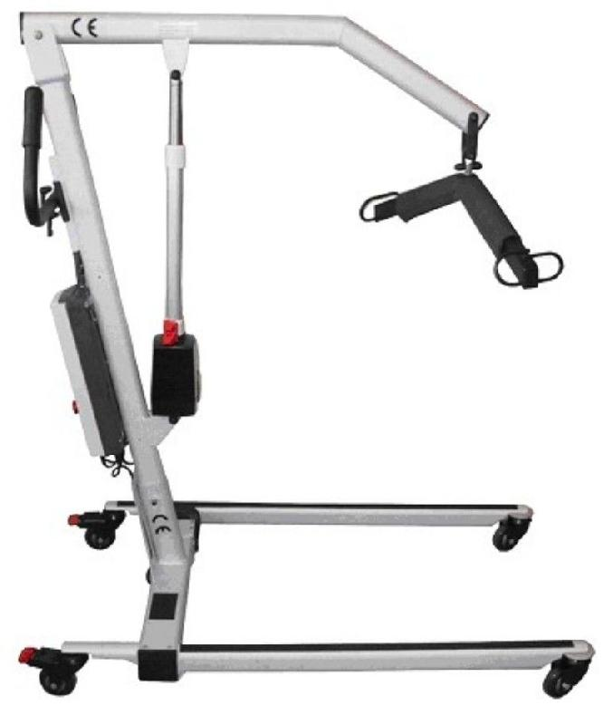
Key features to be aware of:
- sling selection and fitting
- yoke versus pivot frame for sling attachment
- hand held control – for lift and lower function
- appropriate use of brakes
- appropriate use of spreader bar
- communication with the user when using equipment
- mechanical emergency lowering device.

Standing hoist
This hoist is designed to assist with the transfer of a person from one seated position to another seated position. The person needs to be able to bear weight with their legs and arms.
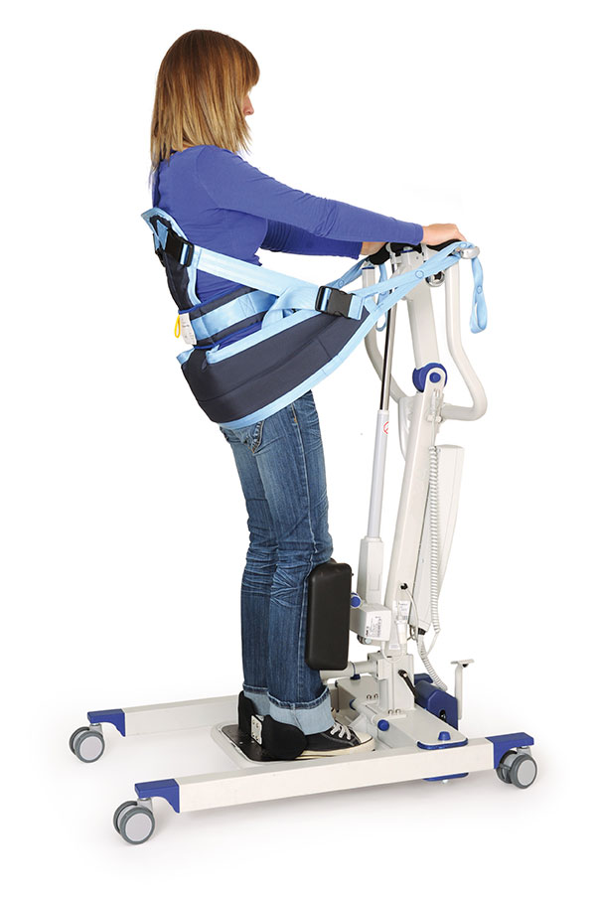

Slide sheets
A slide sheet is a slippery piece of material, designed to reduce friction and make it easier to move people in bed or on a chair.
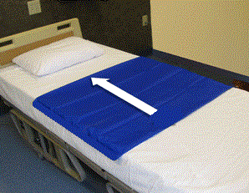

See step-by-step instructions for use:
<ahcnweb.net/aged-care/staff-education/using-a-slide-sheet>
<www.pelicanmanufacturing.com.au/images/product/Bed-Slide-Sheet-Web-Flyer.pdf>

Wheelchairs

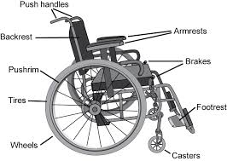

Cleaning, maintenance and safety
- Clean the wheelchair’s upholstery and frame with a damp cloth.
- If the wheelchair gets wet or has something spilt on it, wipe it immediately to avoid rust on metal parts.
- Check tyres regularly. To do this, press the tyre with your thumb. If you can depress the tyre, pump up the tyre to the pressure indicated.
- Check the brakes regularly. To do this:
    - lock both brakes and then face empty wheelchair
    - grasp the armrests and attempt to push the empty chair backwards
    - if the wheels move (rather than sliding on the ground), you need to adjust the brakes.
Part | Cleaning and maintenance
Frame | Clean as needed (remove dirt, food, mud etc.)  Lubricate moving parts (folding mechanism, cross brace, bottom rail tube)  Tighten nuts, check rivets and welds
Upholstery | Clean as with damp soapy cloth  Check tension, upholstery and screws  Inspect for tears and rips
Arm rest | Lubricate mechanism (WD 40)
Leg rest | Lubricate mechanism (WD 40)
Foot plates | Check action and engagement of mechanism
Brakes | Check action for safety, adjust as required
Push rims | Ensure clean and burr free
Tyres/tubes | Check pressure weekly and inflate if needed  Check for wear; replace tyre/tube as necessary

