Long-acting injectable buprenorphine
Brief clinical guidelines for use in the treatment of opioid dependence
OFFICIAL

Authorised and published by the Victorian Government, 1 Treasury Place, Melbourne.
© State of Victoria, Australia, Department of Health, March 2021.
ISBN 978-1-76096-196-1 (pdf/online/MS word)
Available at Pharmacotherapy policy in Victoria <https://www2.health.vic.gov.au/public-health/drugs-and-poisons/pharmacotherapy/pharmacotherapy-policy-in-victoria>
Adapted from: Lintzeris N, Dunlop A, Masters D 2019, Clinical guidelines for use of depot buprenorphine (Buvidal® and Sublocade®) in the treatment of opioid dependence, New South Wales Ministry of Health, Sydney.

Contents
Members of Expert Advisory Committee on Medical Issues Related to Drugs of Dependence 4
Acknowledgements 4
Introduction 5
Abbreviations 5
About long-acting injectable buprenorphine products: Buvidal® and Sublocade® 6
Framework for treatment with long-acting injectable buprenorphine products 7
Delivering treatment with long-acting injectable buprenorphine 8
Dosing recommendations for Buvidal® 8
Dosing recommendations for Sublocade® 11
Safety issues regarding use of long-acting injectable products 13
Summary of buprenorphine products 15
Getting support and more information 18

Members of Expert Advisory Committee on Medical Issues Related to Drugs of Dependence
Dr Paul Grinzi, General Practitioner, Member of Royal Australian College of General Practitioners Victorian Drug and Alcohol Committee;
Ms Edita Kennedy, Project Worker, Association of Participating Service Users, Self Help Addiction Resource Centre
Ms Sarah Lord, Program Manager, Pharmacotherapy, Advocacy, Mediation and Support Service (PAMS), Harm Reduction Victoria
Dr Paul MacCartney, General Practitioner, cohealth - Fitzroy, Primary Care Connect – Shepparton
Professor Dan Lubman, Eastern Health Clinical School, Monash University; Executive Clinical Director, Turning Point Alcohol and Drug Centre
Dr Clayton Thomas, Pain Management Specialist, Melbourne Pain Group
Dr David Jacka, Addiction Medicine Specialist, Monash Health
Dr Leanne Beagley, Chief Executive Officer, Western Victoria Primary Health Network
Associate Professor Malcolm Hogg, Head of Pain Services, Royal Melbourne Hospital
Ms Marina Hanna, Professional Practice Pharmacist, Pharmaceutical Society of Australia
Ms Rose McCrohan, Manager/AODMH Nurse Practitioner, Uniting ReGen,
Dr Rob Phair, Rural GP Anaesthetist, Central Gippsland Health Service; Vice President, Rural Doctors Association of Victoria
Associate Professor Nico Clark, Addiction Medicine Specialist, Royal Melbourne Hospital; Medical Director of Medically Supervised Injecting Room, North Richmond Community Health
Dr Ohnmar John, General Practitioner, CoHealth Health Services, Collingwood
Mr Angelo Pricolo, Community Pharmacist
Dr Shalini Arunogiri, Addiction Psychiatrist, Turning Point Alcohol and Drug Centre; Senior Lecturer, Eastern Health Clinical School, Monash University
Mr Tim Griffiths, Hume Area Pharmacotherapy Network Manager; Primary Care Connect, Shepparton

Acknowledgements
Associate Professor Yvonne Bonomo, Director, Department of Addiction Medicine, St Vincent’s Hospital; Melbourne and Women’s Alcohol and Drug Service, Royal Women’s Hospital, Melbourne
Dr Martyn Lloyd-Jones, Addiction Specialist, Department of Addiction Medicine, St Vincent’s Hospital; Melbourne and Alfred Hospital, Melbourne
Professor Edward Ogden, Addiction Specialist, Department of Addiction Medicine, St Vincent’s Hospital; Melbourne and Goulburn Valley Health
Dr Adam Pastor, Addiction Physician, Department of Addiction Medicine, St Vincent’s Hospital, Melbourne
Dr Greta Moon, Addiction Psychiatrist, Department of Addiction Medicine, St Vincent’s Hospital, Melbourne
Dr Adam Straub, Department of Addiction Medicine, St Vincent’s Hospital, Melbourne
Ms Helen O’Neill, Drug and Alcohol Nurse, Department of Addiction Medicine, St Vincent’s Hospital, Melbourne
Ms Amanda Norman, Senior Project Officer, Department of Addiction Medicine, St Vincent’s Hospital, Melbourne

Introduction
This guideline is to be used in conjunction with the full version of the Victorian Policy for maintenance pharmacotherapy for opioid dependence and the National guidelines for medication-assisted treatment of opioid dependence 2014.

Abbreviations
BPN | Buprenorphine
BPN+NX | Buprenorphine/Naloxone
COWS | Clinical Opiate Withdrawal Scale
CS | Consensus Statement
CYP450 | Cytochrome P450 enzyme
DDI | Drug–Drug Interaction
LAIB | Long-Acting Injectable Buprenorphine
MAOI | Monoamine Oxidase Inhibitor
SC | Subcutaneous
SL | Sublingual
SL BPN | Sublingual Buprenorphine
SSRI | Selective Serotonin Reuptake Inhibitor
TCA | Tricyclic Antidepressant

About long-acting injectable buprenorphine products: Buvidal® and Sublocade®
This brief clinical guideline will help clinicians and patients make decisions about using the following long-acting injectable buprenorphine (LAIB) products.
Note: although these products have been introduced at similar times, they differ in formulations, administration and pharmacology. Differences are highlighted in these brief clinical guidelines and in the addendum to the Victorian Policy for maintenance pharmacotherapy for opioid dependence.
Buvidal® is an extended-release formulation of buprenorphine (BPN), administered weekly or monthly by subcutaneous (SC) injection and provides sustained plasma levels of BPN over the dosing interval. Buvidal® is designed to be administered once a week (Buvidal® Weekly) or once a month (Buvidal® Monthly).
- Buvidal® Weekly is available in four dose strengths in prefilled syringes with a 23-gauge needle
8mg/0.16 mL, 16 mg/0.32 mL, 24 mg/0.48 mL or 32 mg/0.64 mL
- Buvidal® Monthly is available in three dose strengths in prefilled syringes with a 23-gauge needle
64 mg/0.18 mL, 96 mg/0.27 mL or 128 mg/0.36 mL
Sublocade® is an extended-release formulation of BPN, administered monthly by SC injection and provides sustained plasma levels of BPN over the monthly dosing interval.
- Sublocade® is available in two dose strengths in prefilled syringes with a 19-gauge needle
100 mg/0.5 mL and 300 mg/1.5 mL

Framework for treatment with long-acting injectable buprenorphine products
The key elements of safe and effective BPN treatment for opioid dependence are:
- safe and effective use of medicine
- regular clinical reviews and monitoring
- participation in psychosocial interventions
- addressing physical health, mental health and social comorbidities.
Patients need accurate information and options regarding their medication and treatment, as part of informed decision making and consent. Once-a-week and once-a-month long-acting injections reduce the need for daily supervised and/or take-away doses of sublingual (SL) BPN formulations.
Potential benefits of LAIB treatment include:
- greater convenience for patients in that they will not have to attend dosing sites (pharmacies, clinics) on a frequent basis for supervised dosing
- reduced treatment costs
- greater medication adherence, retention in treatment, and enhanced treatment outcomes for some patients who struggle to attend regularly for dosing with SL BPN
- less risk of diversion and non-medical use of the medication, enhancing community safety.
However, LAIB formulations may not suit all patients, and some will prefer SL BPN or methadone treatment, and these options should be available.
Buvidal® and Sublocade® must be administered by registered health professional. Buvidal® and Sublocade® medications should not be handled by, or dispensed to, patients or carers.

Delivering treatment with long-acting injectable buprenorphine
Specific recommendations regarding medication regimens for each product are described below.
Refer to product information for additional information on the clinical pharmacology, evidence of safety and efficacy of these products, and issues regarding special populations.
Currently, there is a lack of research regarding LAIB for patients with chronic pain who are dependent on pharmaceutical opioids.
There is no evidence directly comparing the safety or efficacy of Buvidal® and Sublocade® products.
Neither Buvidal® nor Sublocade® have standard regimens for patients treated with SL BPN doses greater than 24mg/day.

Dosing recommendations for Buvidal®
Transferring from sublingual buprenorphine
Patients should be treated with seven or more days of continuous SL BPN prior to transferring to Buvidal®, with either Buvidal® Weekly or Buvidal® Monthly starting on the day after the last daily SL dose. Buvidal® doses are ‘matched’ to SL BPN doses as shown in Table 1.
Table 1: Dose conversions between SL BPN, Buvidal® Weekly and Buvidal® Monthly doses
Daily SL BPN dose | Buvidal® Weekly long-acting injectable dose | Buvidal® Monthly long-acting injectable dose
≤ 6mg | 8 mg | No monthly equivalent
8–10 mg | 16 mg | 64 mg
12–16 mg | 24 mg | 96 mg
18–24 mg | 32 mg | 128 mg
Patients should be reviewed prior to the next scheduled dose and assessed for adverse events, withdrawal, cravings, substance use and patient’s rating of dose adequacy.
Titrate doses upwards or downwards accordingly. Steady-state equilibrium is usually achieved after three to four doses.

Commencing BPN treatment with Buvidal®
While not recommended as routine practice, Buvidal® Weekly or Monthly can be initiated directly from short-acting opioids (such as heroin) or after fewer than seven days of SL BPN treatment (for example, if the patient unable to access dosing sites for daily SL dosing). In some circumstances, where stabilising on SL BPN is difficult, commencement directly onto LAIB may be possible, although this is not the standard practice recommended at present.

Buvidal® flexible dosing schedule
Patients may switch between Buvidal® Weekly and Buvidal® Monthly (see Table 1). Individual dose adjustment may be required.
- Buvidal® Weekly doses may be given up to two days before or after the weekly time point (days five to nine)
- Buvidal® Monthly may be given up to one week before or after the monthly time point (weeks three to five).
If a dose is missed, the next dose should be administered as soon as possible. Re-induction may be required if more than 10 to 14 days have elapsed between Buvidal® Weekly doses, or more than eight weeks between monthly doses.

Supplemental or ‘top-up’ BPN doses
Supplemental Buvidal® injections may be used if clinically indicated (patient experiencing opioid withdrawal, cravings or persistent unsanctioned opioid use).
Patients may receive additional 8 mg Buvidal® Weekly injections at least 24 hours apart, to a maximum total weekly dose of 32 mg, and maximum total monthly dose of 128 mg.
If supplemental Buvidal® Weekly doses cannot be administered, supplemental doses of SL BPN (≤ 8 mg daily) may be used for a limited time until the next long-acting injection can be organised.

Figure 1: Overview of dosing with Buvidal®
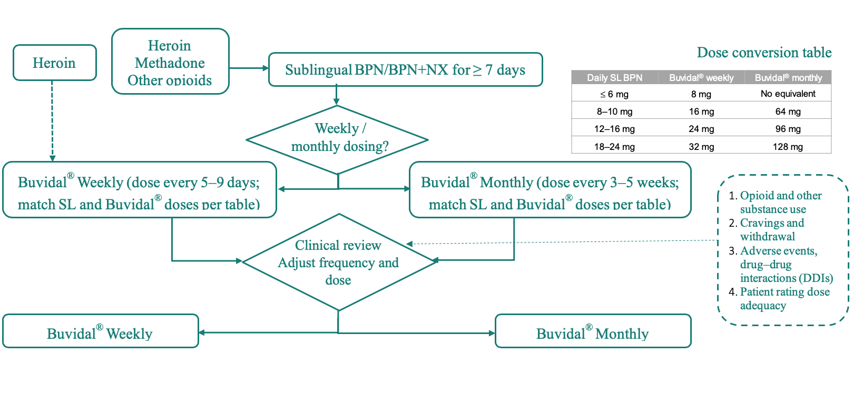

Dosing recommendations for Sublocade®
Transferring from sublingual buprenorphine
Patients should be treated with seven or more days of continuous SL BPN prior to transferring to Sublocade® treatment, preferably achieving SL doses ≥ 8mg daily.
Sublocade® is generally not recommended for patients on daily SL BPN doses < 8mg.
The first Sublocade® dose should be administered approximately 24 hours after the last SL BPN dose.
For most patients, commence 300 mg doses for the first two months (two x monthly doses), reflecting ‘loading’ doses that elevate plasma BPN levels more rapidly.
Sublocade® may be initiated with 100 mg doses where there may be safety concerns of high BPN plasma levels (e.g. mild hepatic disease, low weight, uncertain opioid tolerance levels, drug-drug interactions).
After the initial two monthly Sublocade® doses, select a maintenance dose of either 100 mg or 300 mg every four weeks.
For most patients, 100 mg monthly Sublocade® doses will be adequate, maintaining plasma levels (at steady state equilibrium) achieved with the first two 300 mg ‘loading’ doses.
Maintenance 300 mg doses should be considered for those patients who had previously stabilised on high-dose SL BPN (e.g. 24 to 32 mg daily), or continue to experience cravings, withdrawal or unsanctioned opioid use.

Commencing BPN treatment with Sublocade®
Initiating buprenorphine treatment with Sublocade® has not been studied. As such, it is not recommended at this time. Current recommendations are based on an initiation and stabilisation phase with SL BPN for ≥ seven days prior to the first injection of Sublocade®.

Sublocade® flexible dosing schedule
Sublocade® doses can be administered up to two days before or up to fourteen days after the 28-day interval (days 26 to 42) without dose adjustments.
If a dose is missed, the next Sublocade® dose should be administered as soon as practicably possible. Re-induction may be required if more than eight weeks between Sublocade® doses has elapsed.

Supplemental or ‘top up’ BPN doses
Supplemental SL BPN doses may be given if clinically indicated (patient experiencing opioid withdrawal, cravings or persistent unsanctioned opioid use).
Additional SL BPN (≤ 8 mg daily) may be used for a limited time until the next long-acting injection can be organised.

Figure 2. Overview of dosing with Sublocade®
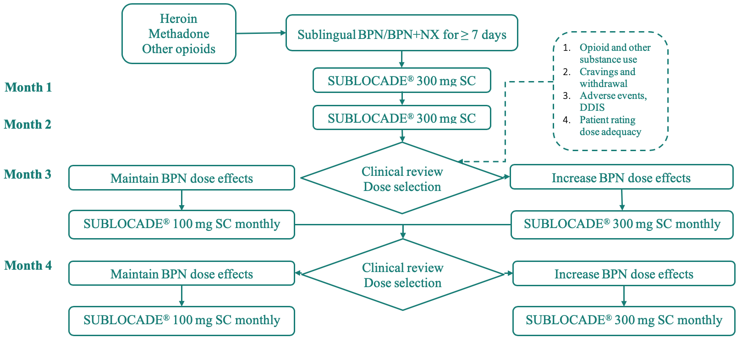

Safety issues regarding use of long-acting injectable products

Precautions and contraindications
LAIB products should not be administered to anyone hypersensitive to BPN or any of the excipients of Buvidal® or Sublocade® (see product information for details).
Precautions regarding the use of Buvidal® and Sublocade® are similar to treatment with SL BPN and include patients with high-risk sedative use (for example, alcohol, benzodiazepines), severe hepatic disease, cardiac arrhythmias and respiratory insufficiency (see product information for details).

Adverse events
Both LAIB products can be associated with local injection-site adverse events – redness, pain, tenderness and swelling in 5–10 per cent of patients.
These are usually mild, transient and resolve spontaneously.
Sublocade® doses appear to be more commonly associated with a palpable lump at the injection site, which resolves with time.
Systemic adverse events as per SL BPN (for example, nausea, headache, constipation).

Drug–drug interactions (DDI)
DDIs are expected to be the same as for SL BPN, however the long duration of LAIB effects may result in prolonged DDI.
If there are concerns, stabilise the patient on SL BPN and monitor DDI before transferring to LAIB products.

Pregnancy and breastfeeding
SL BPN has an acceptable safety profile and is effective in pregnancy.
There is a lack of research data on the safety and effectiveness of LAIB formulations in pregnancy and breastfeeding. LAIB may be considered in situations in which the potential benefits justify potential (as yet unknown) risks to mother and baby. Consultation with an Addiction Medicine Specialist is recommended in this situation.
A neonatal opioid withdrawal syndrome may occur.

Driving, operating machinery
BPN may impair the mental or physical abilities required for the performance of potentially dangerous tasks such as driving a car or operating machinery.
Once patients have been stabilised, opioids have little evidence to suggest impairment of mental or physical abilities required for performing potentially dangerous tasks such as driving a car or operating machinery. This is due to rapid establishment of neuroadaptation. Note: performance can be impaired in the initial treatment phase and patients should be cautioned about driving or operating hazardous machinery for several weeks, particularly at commencement of LAIB treatment. Clinicians and patients need to be particularly aware of DDIs such as LAIB and other sedating medications (eg benzodiazepines) or substances (eg alcohol). Refer to AustRoads guidelines for further information (https://austroads.com.au)

Withdrawal from long-acting injectable buprenorphine products
The prolonged duration of action of the LAIB products means that withdrawal symptoms are likely to emerge long after the last injected dose.
Withdrawal features may emerge four to 12 weeks after the last Buvidal® Monthly dose, or one to four weeks after the last Buvidal® Weekly dose.
Peak withdrawal features may emerge four to 24 weeks after last Sublocade® 300 mg dose or four to 12 weeks after last 100 mg dose.
Withdrawal symptoms may persist for weeks (or months) and are expected to be less severe than withdrawal from shorter-acting opioids.
However, there is little documented experience of withdrawal from LAIB products.
It is generally recommended to taper to the lowest possible long-acting injectable dose before discontinuing treatment, and to review the patient at regular intervals.
Practitioners can also consider bridging with SL BPN to minimise withdrawal symptoms as the long-acting preparation dissipates.

Administration of long-acting injectable products by other routes
Both long-acting injectable products are intended for subcutaneous administration and should never be injected intramuscularly, intra-dermally, intravenously or intra-arterially.
For this reason, long-acting injectable formulations must be administered by a registered health professional, and never be dispensed or supplied directly to the patient or carer.

Transfer from methadone
There is limited experience and no documented evidence regarding transferring patients from methadone directly to LAIB products. Transfer to SL BPN is recommended for at least seven to 14 days prior to commencing on long-acting injectable treatment.

Summary of buprenorphine products
Table 1: Summary of buprenorphine products available for treatment of opioid use disorder in Australia
 | SL Suboxone® and Subutex ® | Buvidal ® Weekly and Monthly | Sublocade ®
Formulations | Suboxone® contains BPN and naloxone in 4:1 ratio  2/0.5 mg and 8/2 mg SL film  Subutex® contains BPN in 0.4 mg, 2 mg and 8 mg SL tablets. | Buvidal® Weekly and Monthly contain BPN in FluidCrystal® injection from long-acting injectable technology.  SC injections in prefilled syringes with 23-gauge needle. Administration via upper arm, thigh, abdomen or buttocks.  Buvidal® Weekly: 8 mg/0.16 mL, 16 mg/0.32 mL, 24 mg/0.48 mL; 32 mg/0.64 mL  Buvidal® Monthly: 64 mg/0.18 mL, 96 mg/0.27 mL; 128 mg/0.36 mL | Sublocade® contains BPN in the ATRIGEL® delivery system  SC injections in prefilled syringes with 19-gauge needle. Administration via abdomen.  Monthly doses: 100 mg/0.5 mL or 300 mg/1.5 mL
Storage requirements | Store at room temperature (below 30º C) | Store at room temperature (below 25º C)  Do not refrigerate or freeze. | Cold storage requirements (2–8ºC).  May be stored at room temperature (below 25ºC) for up to either 7 or 28 days before use (check individual package for details).  Remove from cold storage for at least 15 minutes prior to SC injection.
Clinical pharmacology | Bioavailability 10–30%  Onset effects within 1 hour, with peak effects 2-4 hours after dose.  Duration effects usually 24 hours but dose dependent and can vary from 8 to 72 hours. | Bioavailability = 100%  Time to peak plasma level (t_{max})  Buvidal® Weekly = 24hrs  Buvidal® Monthly = 6–10 hrs  Half life  Buvidal® Weekly = 3–5 days  Buvidal® Monthly = 19–25 days  Steady-state equilibrium by 4th dose | Bioavailability = 100%  Time to peak plasma levels ((t_{max}) = 24hrs  Half-life = 43 to 60 days  Steady‐state equilibrium by 4th (300/100 mg) to 6th dose (300/300 mg)
Frequency of dosing | Daily, two or three day doses  Take-aways and unsupervised dosing available for low risk | Buvidal® Weekly dose can be administered every 7±2 days (5–9 day schedule)  Buvidal® Monthly dose can be administered every 4±1 weeks (3–5 week schedule) | Sublocade® dosed every 4 weeks (26–42 day schedule)
Key drug–drug interactions | Systemic BPN DDI include:  Opioids agonists: can reduce effects other opioids (blockade); BPN may precipitate withdrawal on induction.  Sedatives (e.g. benzodiazepines, alcohol, TCAs, antipsychotics, gabapentinoids): sedation, respiratory depression, overdose.  A number of potential DDI can occur but are rarely of clinical significance (e.g. medications that induce or inhibit CYP450 and can lower or increase BPN plasma levels); or are rare (e.g. serotonergic syndrome in combination with medication such as SSRIs, MAOIs, tramadol; or medications that can cause QT prolongation and increase risk of cardia arrhythmias). | As for SL Suboxone® and Subutex®  Long duration of effects of from LAIB products precludes timely dose adjustment for DDI.  If concerned re: potential DDI – initiate treatment with ‘short acting’ SL BPN for 1-4 weeks, monitor DDI and adjust medications accordingly, prior to transfer to long-acting injection. | As for SL Suboxone® and Subutex®  Long duration of effects of from LAIB products precludes timely dose adjustment for DDI.  If concerned re: potential DDI – initiate treatment with ‘short acting’ SL BPN for 1-4 weeks, monitor DDI and adjust medications accordingly, prior to transfer to long-acting injection.
Key adverse events | Systemic BPN adverse events  For example: nausea and vomiting, constipation, drowsiness, dizziness and headache. | As for systemic BPN adverse events  Local injection site:  - Redness, pain, tenderness, swelling in approximately 5–10% patients.  - Usually mild and transient and resolves spontaneously

 | SL Suboxone® and Subutex ® | Buvidal ® Weekly and Monthly | Sublocade ®
Dosing regimen:  Commencing treatment | From heroin, morphine:  Commence 8 mg Day 1 when patient in early / mild opioid withdrawal (usually > 8–12 hrs after last dose or use).  Titrate upwards on daily basis as required.  From methadone:  Initiate BPN when patient in moderately severe withdrawal (e.g. COWS ≥ 12) (e.g. 1–2 days after last methadone dose).  Day 1: 2 mg + 6 mg after 1–2 hrs, with additional 2–8 mg doses every 2–4 hrs as required to alleviate opioid withdrawal  Day 2 onwards: titrate BPN dose daily as required. | Buvidal® dose should be determined according to patient’s SL BPN dose (see Table 1: Dose conversions between SL BPN, Buvidal® Weekly and Buvidal® Monthly doses).  Titrate subsequent doses after clinical review.  Note increasing effects during first few doses (accumulation to steady state after about 4 doses)  Buvidal® may be initiated directly (without transition via SL BPN) if required. Initiate 24 mg Buvidal® Weekly dose and titrate dose until stable. | Initiate treatment with SL BPN (at least 8 mg) for ≥ 7 days, then transfer to Sublocade®.  Recommended induction:  300 mg monthly injections x 2 doses (8 weeks)  Then 100 mg monthly doses (if patient ‘stable’ on initial 2 x 300 mg doses) or 300 mg monthly doses if require additional BPN effects (e.g. cravings, withdrawal, continued opioid use)  Patients may be initiated with 100mg Sublocade® (after at least 7 days SL BPN treatment) doses if:  Safety concerns (e.g. severe hepatic disease)  DDI concerns (e.g. overdose risk from polysubstance use)  There is no published safety data for initiating Sublocade® in patients on low dose SL BPN (< 8mg), and Buvidal® should be preferred for such patients.
Dosing regimen:  Maintenance phase | Adjust dose to achieve treatment goals (reduced use of other opioids, reduced withdrawal and cravings; blockade effects). Range 2-32mg daily; most patients require 12-24mg daily. | Titrate dose to achieve treatment goals.  Adjust doses when transferring between weekly and monthly doses. | Titrate dose to achieve treatment goals.  100mg or 300mg monthly injections.
Withdrawal phase | Gradually taper dose over several weeks-months (e.g. 2–4 mg weekly reductions). | Gradually taper doses (reducing dose strengths every 1–2 injections). Peak withdrawal features may emerge 4–12 weeks after last Buvidal® Monthly dose, or 1–4 weeks after last Buvidal® Weekly dose (CS). | Reduce dose to 100 mg monthly injections prior to stopping. Peak withdrawal features may emerge 4–24 weeks after last 300 mg dose or 4–12 weeks after last 100 mg dose (CS).

Getting support and more information
Policy for maintenance pharmacotherapy for opioid dependence (addendum) - Summary of changes related to the use of long-acting injectable buprenorphine
<https://www2.health.vic.gov.au/public-health/drugs-and-poisons/pharmacotherapy/pharmacotherapy-policy-in-victoria>
National Guidelines for Medication-Assisted Treatment of Opioid Dependence (MATOD) <https://www.health.gov.au/resources/publications/national-guidelines-for-medication-assisted-treatment-of-opioid-dependence>
Drug and Alcohol Consultant Advisory Service (DACAS) <https://www.dacas.org.au/>
Buvidal Weekly product information Australia <https://www.ebs.tga.gov.au/ebs/picmi/picmirepository.nsf/pdf?OpenAgent&id=CP-2018-PI-02610-1>
Buvidal Monthly product information Australia <https://www.ebs.tga.gov.au/ebs/picmi/picmirepository.nsf/pdf?OpenAgent&id=CP-2018-PI-02611-1>
Sublocade product information Australia <https://www.ebs.tga.gov.au/ebs/picmi/picmirepository.nsf/pdf?OpenAgent&id=CP-2019-PI-01756-1>
Sublocade prescribing information US <>https://www.sublocade.com/Content/pdf/prescribing-information.pdf

