Recycling single use metal instruments
A guide to establishing a single use metal instrument
recycling program in healthcare settings
Single use metal instruments (SUMIs), such as tweezers, scissors, forceps and clamps, are increasingly being adopted by health services in place of reusable devices due to their reduced infection risk, limited sterilisation capacity and economic cost.
Despite being fully recyclable, most health services dispose of SUMIs in clinical or sharps waste bins as it is often not known how to recycle them safely. This comes at an economic and environmental cost.
This guidance note outlines how SUMIs can be safely and cost effectively removed from the clinical waste stream and recycled. Instruments can be cleaned within the hospital and collected by a metal recycler, who smelts and reforms the instruments into new metal products.

Why recycle SUMIs?
The majority of SUMIs are currently disposed of as sharps waste. It is more cost effective to recycle rather than dispose of SUMIs through the sharps waste streams.
A Victorian health service piloted a system to recycle SUMIs. Prior to the pilot the health service generated 45.2 tonnes of sharps waste per annum at a cost of $420,000, generating 54.27 tonnes of carbon dioxide equivalents (CO2-e).
Audits showed that approximately 19 percent, or 8 tonnes of the sharps waste generated were recyclable SUMIs. By diverting SUMIs from the sharps waste stream was estimated that the health service would save $80,000 per annum in sharps disposal costs and reduce emissions by 10.3 tonnes CO2-e.

Establishing a SUMI recycling program
There are several steps that must be taken to establish a safe, effective and sustainable SUMI recycling program. Engagement with a wide range of stakeholders will ensure buy in and approval from all interested parties and increase the likelihood of success.
Due to the high level of engagement required it could take 6 – 12 months to establish a SUMI recycling program.

Step 1 – Develop a business case
A business case provides justification for undertaking a project. It compares estimated cost and risks of project against the anticipated benefits and savings to be gained.
A business case should identify an objective, the rationale/case for delivering the project and any resource considerations (monetary savings from diverting SUMIs from sharps bins, cost of new infrastructure, time invested etc.)

Objective
While the primary objective will be to introduce SUMI recycling into the health service consider whether it will be introduced in all wards or trialled in areas where there is a high level of interest.

Rationale
The rational may change based on the audience the business case will be presented to. Take into account what will influence them to agree to the project rather than what motivates you. Rationales can include:
- The environmental case, particularly if the health service has pre-existing policies, plans or commitments relating to sustainability.
- The financial case – in the majority of cases SUMI recycling can reduce waste management costs.
- Staff sentiment – environmental issues are important to many people and taking action on them can help support a more desirable workplace.
- Leadership – this may be an opportunity to show leadership in an area that’s receiving increased attention.

Data
Data gathering is an important part of business case development as it identifies potential volumes of SUMIs that will be collected, which will help with workflow planning, as well as identifying potential costs savings.

SUMI usage
Procurement will be able to provide data regarding the number of SUMI items purchased by individual wards. This data can be used to calculate potential volume, weight and cost savings from diverting these items from the sharps bin to a SUMI recycling stream.

Waste audits
Waste audits provide a detailed analysis of waste composition, assess contamination rates and identify potential opportunities to improve waste management and reduce costs.
Auditing sharps bins prior to introducing a SUMI recycling system provides a clear, quantitative means of identifying potential volume, weight and cost savings by diverting SUMIs from the sharps bin. Conducting a second audit, a few months after the introduction of the recycling stream, will identify whether all SUMIs are being diverted from the sharps bin, as well as showing whether your predicted cost savings have been realised.
DHHS has produced Waste Audit Guidelines. These should be used when setting up waste audits in a hospital setting.

Resource considerations
When quantifying resource considerations use the data gathered to complete the following table. This will provide an estimate of cost savings, as well as identifying the budget needed to deliver the project.
Estimated costs
Resources (bins, signage etc.) | $ /year
Labour (additional time to implement) | $ /year
Service costs (collections) | $ /year
Total | $ /year
Estimated financial benefits
Reduction in sharps waste costs | $ /year
Reduction in waste to landfill | $ /year
Other savings | $ /year
Total | $ /year
Total benefits minus total costs | $ /year

Step 2 – Identify a SUMI recycler
Identify a contractor willing to collect SUMIs for recycling as, without a metal recycler, there is little point continuing with the other steps.
Contact existing waste contractors to gauge their interest. Existing metal and e-waste recyclers may be willing to add SUMIs to their collection. Some may already be providing this collection at other hospitals.
If existing contractors are not willing to accept SUMIs use Plant Ark’s ‘Find a Recycler’ tool to identify metal recyclers servicing your area.
Some contractors may be cautious of collecting SUMIs due to a perceived risk that the materials are infectious. SUMIs must be washed prior to being collected by a recycler therefore there is minimal risk to the collector.
In order to reassure the contractor of this the health service may want to provide them with a letter outlining the processes the hospital will take to clean SUMIs prior to collection.
In order to track the progress of the SUMI program it is valuable to gather collection data. Discuss with the contractor whether this can be provided as part of the service. Hospitals may wish to ask the contractor for a statement outlining their processes and instrument destination as a duty of care to ensure that no single use instruments are diverted back to medical use.

Step 3 – Establish a project working group
The purpose of the project working group is to provide guidance and input into the development and delivery of a SUMI recycling program. Members will be responsible for contributing and co-ordinating input from across their area of responsibility.
Several people in departments and areas throughout a health service are involved in generating and managing waste. It is vital that these activities and personnel are represented. The project working group should:
- represent the broad range of views and experiences relating to clinical processes and waste management across the health service,
- contribute materials and/or data to assist delivery,
- review workflows, resources and education materials for suitability,
- provide advice and support as necessary,
- contribute and co-ordinate input from each member area of responsibility.
Membership should reflect the broad range of waste management responsibilities within the health service. It is recommended that members of the project working group include:
- waste management officer,
- operations/support/environmental services,
- infection control,
- Occupational Health and Safety (OHS),
- NUM of participating ward(s),
- CSSD manager, and
- environmental sustainability officer.

Step 4 – Develop a workflow
A workflow identifies the process required to collect, transport, clean and store SUMIs in a way that is safe and efficient.
Appendix 1 includes an example workflow. It was developed for a busy hospital based in metropolitan Melbourne with a CSSD department washing SUMIs from emergency, theatre and ICU departments.
There are a series of questions that must be answered when developing a workflow. The main questions are discussed below however it is likely that other questions will be identified as the workflow is developed.

What receptacle will the SUMIs be collected in?

Collection on wards
As the majority of SUMIs are sharp it is important that the receptacle they are collected in does not introduce any increased risk of injury compared to standard sharps containers. Metal wash baskets with handles and lids are recommended as:
- small holes in basket mesh makes it unlikely that sharps will poke out of the receptacle and cause injury,
- lids and handles minimise risk of people touching the sides of the basket, where some sharps may be poking through,
- the baskets can be placed directly into washers, minimising risk of injury from transferring SUMIs from collection to washing receptacles.
In some cases, such as where space is limited, small buckets, also with lids and handles, could also be used.
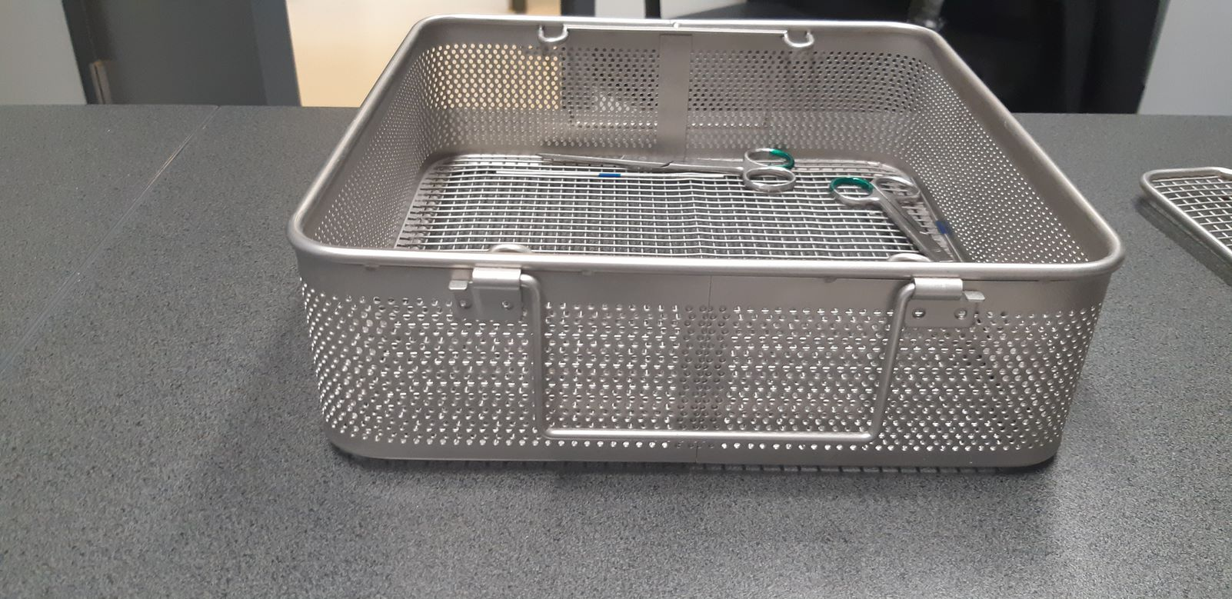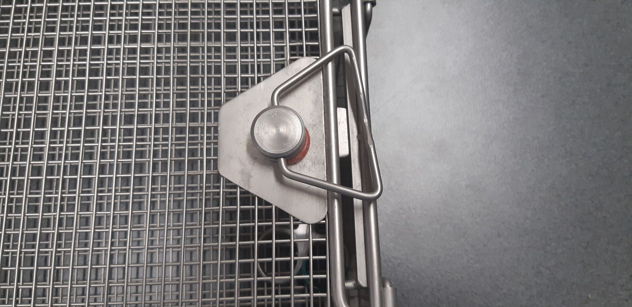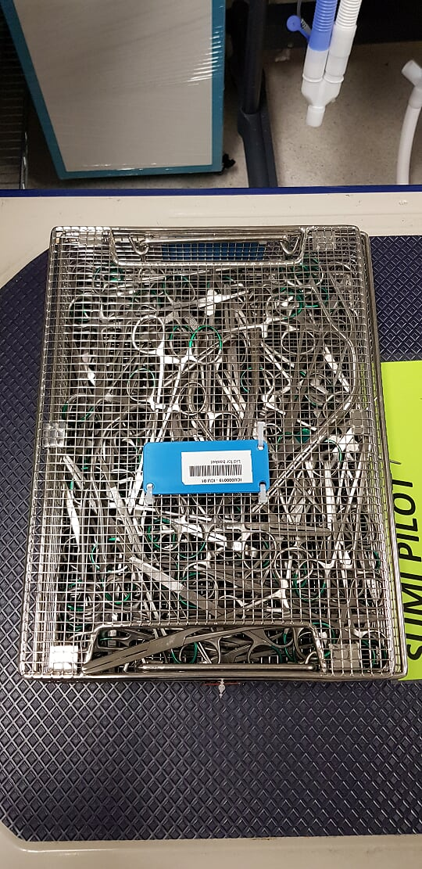
Figure 1: Collection receptacles approved by OHS and infection control representatives
If baskets are used, they should be clearly marked as SUMI use only. This minimises the risk of the baskets being used for other purposes and not being returned to wards.
A minimum of two receptacles should be available at each collection location. This minimises risk of receptacles becoming too full and overflowing as the second receptacle should be used once the first is full.
Safe handling training is required for all staff who will use the receptacles

Storage after SUMIs are washed
Once SUMIs have been washed they can be decanted into a receptacle suitable for collection by the recycling contractor. Ideally this receptacle will have the following features:
- clear signage identifying the bin as SUMI use only,
- lockable so that the SUMIs cannot be accessed by anyone but approved staff,
- small slit in bin lid for disposal of SUMIs,
- third wheel on front of bin to reduce injury risk of moving bin,
- fill line half or two thirds up the outside of the bin. This is to ensure that the bin is not filled to a point that it is too heavy to be moved.

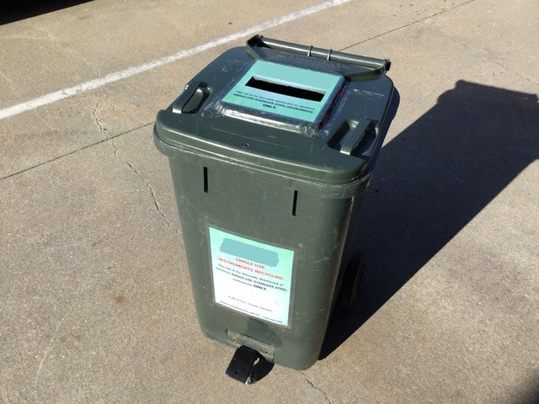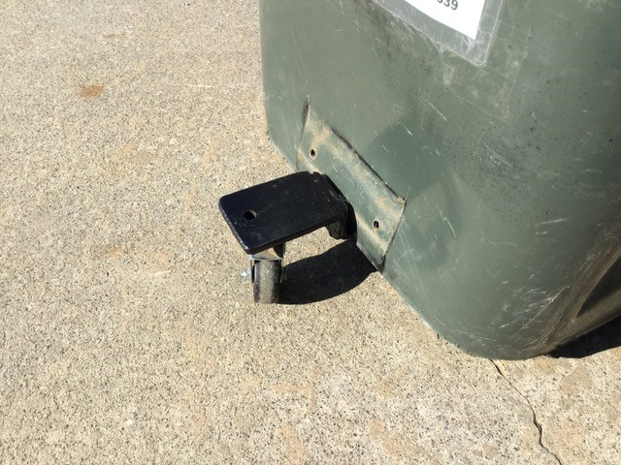
Figure 2: Bin approved by OHS and infection control representatives

Where will the SUMIs be washed?
SUMIs that leave a hospital setting with blood or body fluids, or if they are potentially infectious, are classed as clinical waste and can only be removed from the premises by a clinical waste contractor.
To make the instrument safe and legal to transport, SUMIs must be washed at 75⁰C prior to being collected by a recycler. Washing can take place in CSSD or, if they are available, pan washers within dirty utilities or pan rooms. When deciding where SUMIs will be washed it is important to consider:
- if baskets are being used for collection, will these baskets fit into the washer,
- whether the washer will reach 75⁰C during the wash process,
- who will be performing the wash and what training is required to do this safely,
- if the SUMIs are to be washed in CSSD how they will be transported from the ward to CSSD,
- whether the process is the same on all wards,
- if a pan washer is to be used is it currently used for other purposes that may create cross-contamination problems, such as washing water jugs for patient use, and
- who is responsible for the maintenance of the washer (servicing, descaling, supply of detergent, replacement of parts).
The majority of SUMIs have a green or blue plastic band on the handle. During washing this band can flake off the item and remain in the washer once the wash cycle has completed. A Melbourne hospital has been washing SUMIs weekly for seven years and has never had an issue with this flaking as washer filters are cleaned regularly.

Where will SUMIs be collected on wards?
With the majority of waste being disposed of in dirty utilities it is recommended that this is where SUMI receptacles are located. The SUMI collection could be integrated with pre-existing procedures for the return of instruments to CSSD where it can be guaranteed that they are not mixed-up with multi-use instruments.
It is also important to identify where, within the dirty utility, the receptacle can be located. Take into account the size of the receptacle, other functions the space is used for and whether there is space for a recycling poster directly above the receptacle.

Who will be responsible for each step of the process?
At least one staff member will be required to contribute time and/or resources to ensure that each step of the workflow is delivered. For example, for collection baskets to be moved from a ward to CSSD by a member of the Environmental Services department would need to be scheduled within daily / weekly tasks.
Each department should be made aware of the expectations of work that will be placed on them and be willing to deliver this work on an ongoing basis.
Training requirements must be considered. For actions that have an OHS risk, for example moving baskets containing SUMIs to CSSD, safe handling training will need to take place for all staff who will undertake this task.

When will each step of the workflow take place?
To ensure consistency and reduce the risk of full baskets accumulating on wards, each step of the workflow should be scheduled.
When developing a schedule consider how often collection of baskets should take place, how quickly bins will be filled, and whether there are quite periods within certain wards or departments when it would be more convenient for a step in the workflow to take place. For example, in hospitals where CSSD wash SUMIs this is often performed on weekends as this is a quiet period for the department.
It may be difficult to predict how quickly baskets and bins will fill and so the schedule may need to be adjusted after the first few weeks of the collection commencing.

Step 5 – Receive approvals from key stakeholders
Once a workflow has been established and collection receptacles identified, OHS may want to perform a risk assessment. If OHS has been part of the working group, or has been consulted throughout the workflow development, it is unlikely that any significant issues would be identified through the risk assessment.
If OHS approves the workflow, final approval from all other stakeholders should be sought to ensure they are still willing to dedicate staff, time and/or space to the process.

Step 6 – Education strategy
In order for the SUMI recycling system to be used correctly it is vital that an education strategy is implemented. The strategy should reach all staff who will be recycling SUMIs. An education strategy should:
- provide clear guidance on how to recycle SUMIs,
- identify the items that can/cannot be recycled through the SUMI recycling stream,
- provide a point of contact if staff have any questions, and
- communicate benefits to maintain commitment.
An effective education strategy should include all of the following elements.

Recycling champion
A Recycling Champion should be chosen for from each ward. They will:
- be the ‘go to’ person for staff queries on the SUMI recycling system,
- observe recycling practices, including staff behaviours and attitudes and bin contamination, and identify whether further education is needed,
- report back on general observations and make recommendations for improvements to the system, and
- ensure signage is visible and baskets are located correctly.
Because the role of the recycling champion will be in addition to their primary role bear in mind workload and choose somebody that is enthusiastic and passionate about recycling and sustainability.

Signage
Clear signage is a key element of an education strategy as they are an important reminder, or nudge, to help staff know when and how to recycle. Signs must be visible at the point of collection and provide clear guidance on what can and cannot be place in the SUMI recycling baskets.
SUMI recycling signs have been developed by DHHS and are available to download.
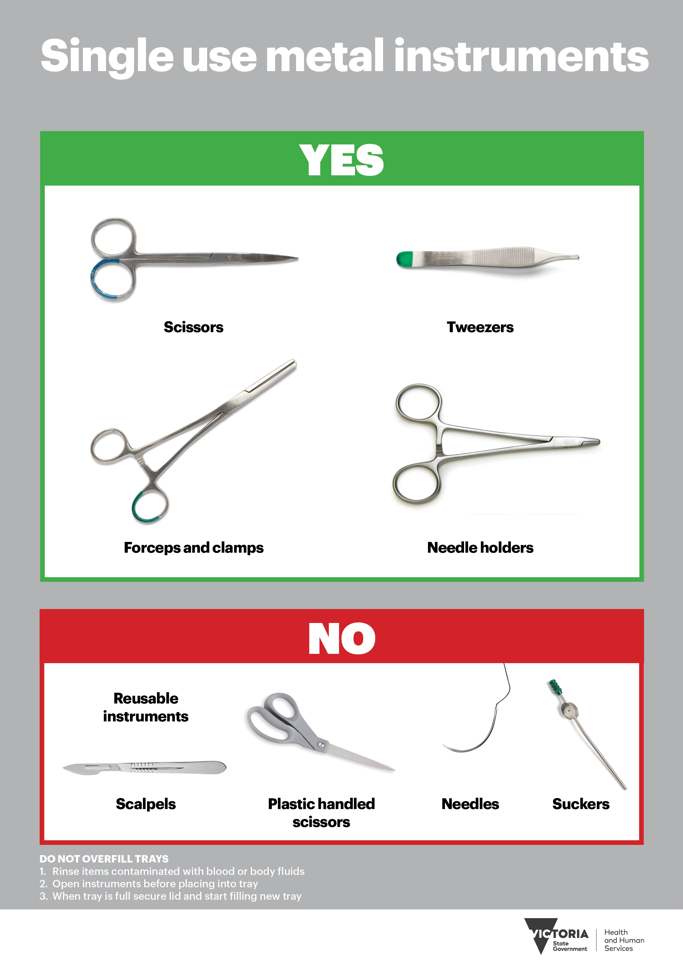
Figure 3: DHHS SUMI recycling sign

Training
Placing SUMIs in a recycling basket instead of a sharps bin is a behavioural change. It is important to provide clear and simple training to all staff who are expected to adopt this new behaviour.
Ideally this training will be delivered in person through in-services or as part of muster/hand-over. If this is not possible then detailed instructions through emails or newsletters could also be effective.
Training should be delivered as close to the launch of the recycling process as possible. This ensures that people are aware of the behaviours expected of them as soon as the recycling receptacles are available to use.

Step 7 – Launch and monitor
Once the previous 6 steps have been finalised it is time to launch the recycling program.
Set a date and ensure that all equipment will be in place, training delivered and staff aware of their responsibilities prior to launch. Be prepared for some teething problems and be open to adapting and adjusting elements of the workflow if required.
After 6-12 weeks after the launch:
- gather all available collection data and compare it to the projections made in Step 3,
- if possible, conduct a second audit to identify whether SUMIs are still being placed in the sharps bin,
- meet with the project working group to discuss any issues and potential solutions,
- talk to the recycling champions to gauge how the project is going and if there are areas for improvement.

And finally, pat yourself on the back and be proud of your achievement. You have made a huge contribution to making the health system more sustainable and transitioning to a net zero carbon economy.

Appendix 1 - Workflow example