Victorian allied health clinical supervision framework

To receive this publication in an accessible format phone (03) 9096 7324,
using the National Relay Service 13 36 77 if required, or email Allied Health and Community Services Workforce at the Department of Health and Human Services <alliedhealthworkforce@dhhs.vic.gov.au>.
Where the term ‘Aboriginal’ is used it refers to both Aboriginal and Torres Strait Islander people. Indigenous is retained when it is part of the title of a report, program or quotation.
Authorised and published by the Victorian Government, 1 Treasury Place, Melbourne.
© State of Victoria, Department of Health and Human Services, May 2019.
ISBN 978-1-76069-889-8 (pdf/online/MS word)
Available at Allied Health and Community Services Workforce – Department of Health and Human Services website <https://www2.health.vic.gov.au/health-workforce/allied-health-workforce>.
(1812007)
Contents
Acknowledgements 4
Project reference group 4
In consultation with 4
Foreword 5
Section 1: Introduction 6
Introduction 6
Terminology used in the framework 7
Key elements of clinical supervision for allied health 9
How the framework was developed 12
How to use the framework 14
The framework 15
Key stakeholders for implementing this framework 16
Clinical supervision for allied health 17
Supporting safe and high-quality patient care 19
Section 2: Principles and outcomes of success 20
Goals of the framework 20
Outcomes of the framework 20
Overview of this section 20
Principles 22
Outcomes of success 23
Description of principles and associated element statements for key levels of stakeholders 24
References 27
Appendix 1: Clinical supervision resources 29
Supporting tools and resources 29
Templates and examples of policies and procedures 29
Other clinical supervision resources 29
Appendix 2: Text-equivalent descriptions of figures 32
Figure 1: Elements of clinical supervision 32
Figure 2: Victorian allied health clinical supervision framework 32
Figure 3: Clinical supervision stakeholders 33
Figure 4: Domains to ensure high quality clinical supervision 33

Acknowledgements
The Victorian allied health clinical supervision framework (the framework) was adapted with permission from the New South Wales Health clinical supervision framework. The Victorian Department of Health and Human Services would like to acknowledge the generous support of New South Wales Health and the Health Education and Training Institute (HETI) for providing permission to use the New South Wales Health framework.
The Victorian allied health clinical supervision framework has been developed with the support of the following:

Project reference group
Kathy Maggs, Allied Health Lead, Clinical Education Unit, Austin Health
Fiona Kent, Collaborative Care Curriculum Lead, Faculty of Medicine, Nursing and Health Sciences, Monash University
Melanie Farlie, Allied Health Education Lead, Monash Health
Adrian Weeks, Senior Education Pharmacist, Western Health
Joan Leo, Allied Health Education Lead, Mercy Health
Peter Brack, Clinical School Coordinator, Allied Health and Interdisciplinary Programs, Northern Health
Chris O’Brien, Allied Health Clinical Support Lead, Bendigo Health
Emma Scott, Senior Policy Advisor, Allied Health and Community Services Workforce, Department of Health and Human Services
Project Manager: Marcus Gardner, Manager Allied Health Education and Research, Bendigo Health

In consultation with
allied health workers; employers of allied health workers; unions representing allied health workers; professional associations for allied health; and other relevant allied health stakeholders.

Foreword
I am delighted to introduce the Victorian allied health clinical supervision framework.
Over the course of my career, clinical supervision has supported me to develop the skills and confidence that I needed to take on and put my hand up for increasingly complex and challenging roles. It has enabled me to grow as a clinician, manager and leader. It has also helped me to become a better supervisor and mentor for others.
Through this framework, we have a common understanding of what high quality clinical supervision looks like in practice, and the value that it provides to clinical practice in our health and community services.
The framework is central to supporting allied health worker wellbeing and enables our professionals and assistants to continue to deliver the best care possible to all Victorians.
I would like to thank the many people who contributed their time, expertise, support and ideas to the development of this framework through its extensive consultation and feedback stages. I would also like to acknowledge the leadership and enthusiasm of the allied health sector in adopting this framework for use in our Victorian services.
Adj. Associate Professor Donna Markham
Chief Allied Health Officer
Safer Care Victoria
May 2019

Section 1: Introduction

Introduction

Purpose
The framework provides guidance for clinical supervision stakeholders to develop, implement, evaluate and maintain clinical supervision of allied health professionals and assistants working in Victoria.

Scope
The framework’s scope is the clinical supervision of allied health professionals and allied health assistants. This does not include student supervision, managerial supervision, operational/line management or performance management.
The framework covers allied health therapy and allied health science professions as defined in the Victorian context, which includes, but is not limited to:

- allied health assistants
- art therapy
- audiology
- biomedical science
- chiropractic
- diagnostic imaging medical physics
- dietetics
- exercise physiology
- medical laboratory science
- nuclear medicine
- music therapy
- occupational therapy
- oral health (not dentistry)
- osteopathy
- orthoptics
- orthotics and prosthetics
- pharmacy
- physiotherapy
- podiatry
- psychology
- radiation oncology medical physics
- radiation therapy
- radiography
- social work
- sonography
- speech pathology

The framework complements, rather than replaces, existing professional requirements for clinical supervision. These include:
- where professions have specific requirements set by the Australian Health Practitioner Registration Agency (AHPRA) or the relevant professional body/association
- professions that support graduate-entry allied health intern positions and which have specific requirements for clinical supervision and assessment prior to achieving independent practice
- Victoria’s Supervision and delegation framework for allied health assistants, which provides guidance on the supervision and delegation requirements for allied health assistants.

Aim
The framework aims to provide guidance to health and community service organisations and to inform the development of processes and protocols which support and enhance allied health clinical supervision. The framework will ultimately help to enhance and maintain the quality and safety of patient care and allied health worker wellbeing.

Terminology used in the framework
For ease of reading, a number of key terms are applied throughout the framework. These terms are not intended to preclude the language used by allied health working in different practice settings and sectors.

Clinical supervision
Clinical supervision may also be known in different professions/sectors as staff supervision, professional supervision or peer supervision.

Patient
The term ‘patient’ may be substituted for client, consumer, participant and resident (or related terms) as relevant to the setting where care is provided.

Allied health worker
The term ‘allied health worker’ includes both allied health professionals and allied health assistants.

Point of care
Point of care refers to the place where the patient receives care or support from an allied health worker. Examples of point of care include a hospital unit, outpatient clinic, community setting or a patient’s home. Point of care may be described as the ‘point of practice’ in some allied health contexts.

Defining clinical supervision
Clinical supervision is widely accepted as an essential part of health and human services systems for allied health (Milne 2007). Clinical supervision is acknowledged as a mechanism to promote the professional development and wellbeing of allied health workers and the delivery of safe, high-quality patient care. Numerous definitions of clinical supervision currently exist for allied health practitioners working in different practice settings, and there are a variety of models of practice and frameworks for clinical supervision influencing its implementation and modes of delivery (Pearce et al. 2013; Dawson et al. 2013).
For the purpose of this framework, clinical supervision is defined as a structured process to:
- support allied health workers to reflect on their own practice in a safe, confidential and supportive environment
- enable teaching and learning at the point of care
- enhance the professional support and wellbeing of allied health workers.

Clinical supervision for allied health includes:
- reflective practice
- teaching and learning (both direct and indirect) at point-of-care
- facilitation of professional development.
Clinical supervision for allied health is not:
- an operational/line management tool
- a method of surveillance
- a formal performance review
- counselling or a form of therapy
- mentoring
- coaching.

Key elements of clinical supervision for allied health

Reflective practice
Reflective practice is a structured process whereby health professionals identify their strengths and weaknesses and analyse responses to situations with the intention of determining actions required to improve skills. The process also develops clinical reasoning skills to ensure the delivery of safe and effective patient care.
One of the most important skills allied health workers can develop is the ability to critically reflect on their own practice (Schön DA 1987). Reflection in the context of clinical supervision may occur in day-to-day clinical practice, be triggered by a challenging clinical encounter or be in anticipation of having to manage a complex situation. It is essential that reflective practice is conducted in a supportive, safe and confidential environment to allow supervisees to freely share information that promotes learning (Health Education and Training Institute 2012).

Teaching and learning at point of care
Theoretical knowledge can be translated into practice at the patient care interface. Clinical supervisors may use opportunities to observe supervisees’ practice and to teach in the presence of patients by identifying patients from their own case load, or work with a patient from the supervisee’s caseload. The level of emphasis on providing clinical supervision at the point of care will differ according to the developmental level and learning needs of the supervisee and the patient context.

Facilitation of professional development
Professional development is the means by which members of a profession maintain, improve and broaden their knowledge, expertise and competence, whilst developing the personal and professional qualities required throughout their professional lives. Professional development may consist of a range of activities that help to support learning through the development of knowledge, skills and attitudes. Clinical supervision is a key activity that facilitates professional development by promoting informal and formal opportunities for reflective learning (Pearce et al. 2013; Martin et al. 2017).

Figure 1: Elements of clinical supervision
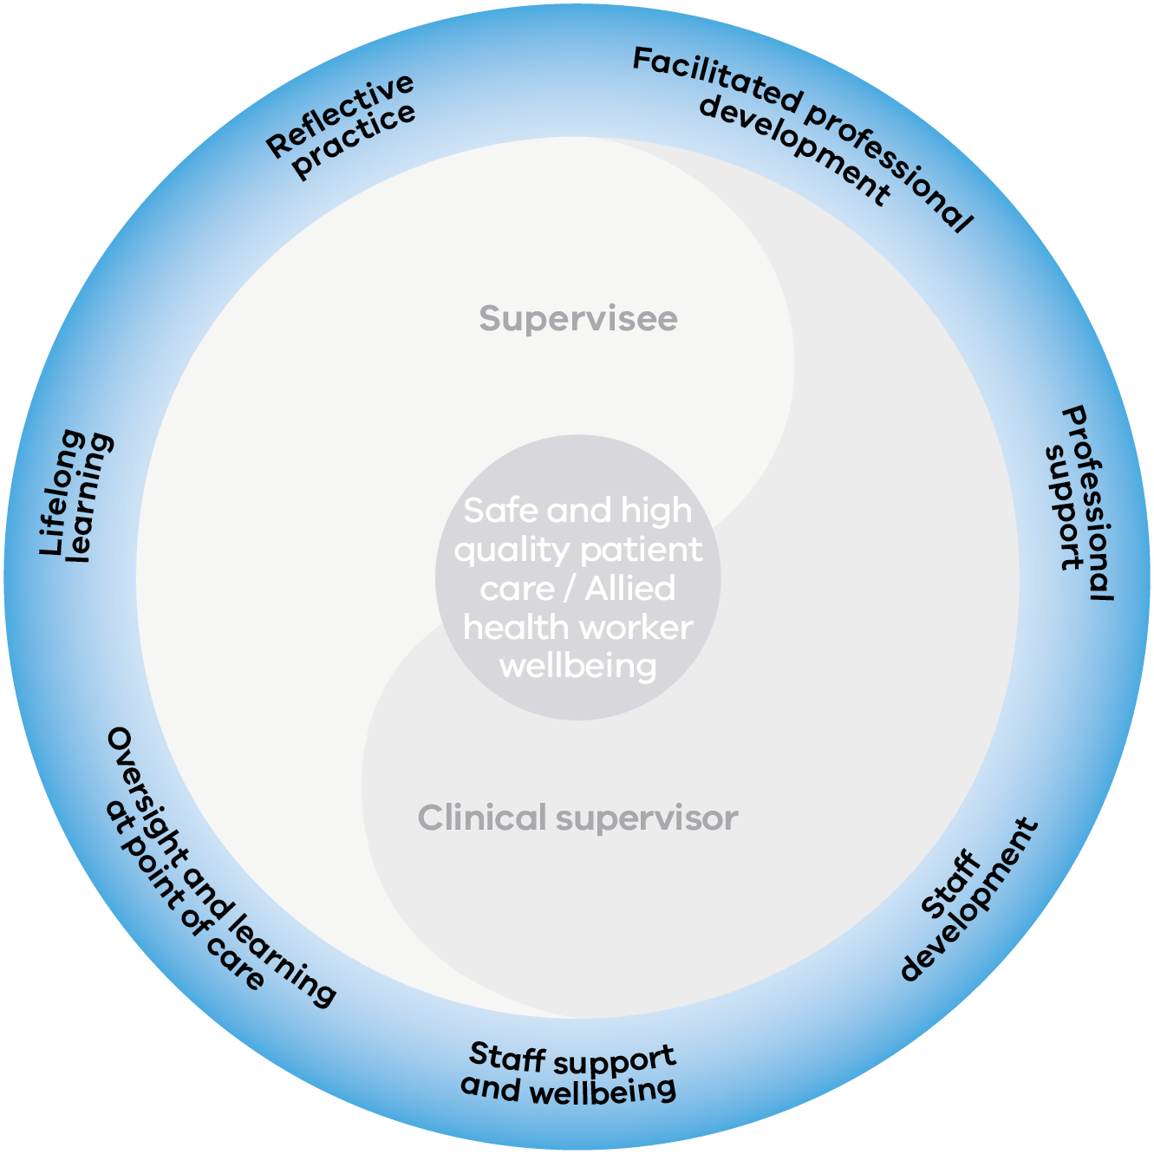
Text-equivalent description of Figure 1

Other forms of professional development and support
While there may be overlap between some of the functions of clinical supervision and those of other forms of professional development, formalised professional support relationships, such as coaching and mentoring are generally considered to be separate processes from clinical supervision. Similar to clinical supervision, other forms of professional development and support used for allied health may also be conceptualised differently depending on the practice setting (Bond and Holland 2011; Swanwick 2013).
The following descriptions of other common forms of professional support are used to assist stakeholders to interpret the Framework in a consistent manner.

Coaching
Coaching is a professional support relationship that aims to develop specific knowledge and skills and usually involves mutual engagement and orientation to learning and development. While coaching is generally considered an activity independent from clinical supervision, it may be a strategy used within clinical supervision.

Mentoring
Mentoring is usually a voluntary professional support relationship that involves nurturing and improving health professionals’ skills, through the sharing of expertise and knowledge by experienced staff. Mentees are usually actively involved in selecting their mentor(s). While there are many different definitions and understandings of mentoring, influenced by the professional context of the mentee and mentor, for allied health there is usually less of an emphasis on clinical governance in mentoring as compared to clinical supervision.

Peer review
Peer review is a means of professional support that encourages health professionals to actively participate in monitoring and improving each other’s practice and enhancing the safety and quality of care.

Preceptorship
Preceptorship is usually a formal, short-term professional support relationship that is a method of preparing and teaching new practitioners in a clinical setting. Preceptorship often occurs as a part of a formalised transition program.

How the framework was developed

Rationale
Clinical supervision is an important element of clinical governance and professional support for allied health professionals and assistants (Dawson et al. 2013). Clinical supervision is described as a structured process that supports reflection, learning and wellbeing, and enables allied health professionals and assistants to practice effectively and within their scope of practice in a complex health and human services system (Dawson et al. 2013; Ducat and Pearce 2011).
A shared vision and understanding of the purpose of allied health clinical supervision is needed in order to optimise its contribution to allied health professional and assistant wellbeing, and to promote high quality and safe patient care (Dawson et al. 2013; Fitzpatrick et al. 2012). The framework was developed to provide guidance for clinical supervision stakeholders to promote consistent and effective clinical supervision practices for allied health.
Allied health comprises a diverse range of professions with different training requirements, technical expertise and continuing professional development needs (Department of Health and Human Services 2015). Allied health workers are employed in a variety of health and human services contexts in Victoria, including public and private hospitals, primary and community health services, alcohol and other drugs services, aged care, mental health, non-government organisations, disability services, Aboriginal community and health services and private practice. As such, allied health professionals and assistants work within a range of professional governance and support arrangements, influenced by factors including their profession and service delivery context and setting.
While clinical supervision is widely practised and highly valued in some allied health professions, inconsistency in access to clinical supervision is reported, particularly in rural settings, and in the implementation of clinical supervision across different professions and contexts (Dawson et al. 2013; 3, Ducat and Pearce 2011; Fitzpatrick et al. 2012). Additionally, access to training and evaluation of clinical supervision practice is variable.
Clinical supervision models also vary across allied health professions and settings, with a greater emphasis on reflective practice clinical supervision in some areas, and point of care clinical supervision in others (Fitzpatrick et al. 2012; Leggat et al. 2016; Snowdon et al. 2016). Different approaches to clinical supervision reflect different contexts, professions and career stage of allied health workers. Structured frameworks for clinical supervision have been proposed as a means to provide guidance to stakeholders (including supervisees, supervisors and health and community service organisations) to improve access to clinical supervision and to support its implementation and evaluation (Fitzpatrick et al. 2012; Health Workforce Australia 2014; Department of Health and Human Services 2015; Health Education and Training Institute 2012).
This framework builds on the strength of existing allied health clinical supervision practices to present a consistent statewide approach with the aim of maintaining a highly skilled and sustainable health and community services workforce, and to ensure clinical supervision is better understood, accepted and practiced.

Process
The development of the framework was overseen by a reference group comprising allied health clinical education and academic leads with expertise in the provision of clinical supervision. The reference group initially highlighted gaps including access to clinical supervision training and evaluation of clinical supervision effectiveness. A rapid review of clinical supervision literature relating to allied health and an analysis of contemporary issues in allied health clinical supervision practice in Victoria were also undertaken. Existing Australian clinical supervision frameworks were reviewed to identify examples that could be used to inform the development of a framework for Victorian allied health. The New South Wales Health clinical supervision framework was chosen as a key reference based on its design for use across multiple professions for qualified health professionals (rather than students), alignment with clinical governance structures, potential for evaluating and monitoring clinical supervision practice and alignment with existing resources supporting clinical supervision.
A two-phase consultation process with Victorian allied health stakeholders was undertaken to inform the development of the framework. The initial phase involved an electronic survey distributed to key stakeholders including health and community service organisations and professional associations. The survey findings supported the need for this clinical supervision framework for Victoria and informed its development.
Other themes arising from the survey findings were a need to:
- increase the emphasis of the importance of clinical supervision to worker professional support and wellbeing along with patient safety and quality of care
- revise the wording of principles and element statements to reflect the Victorian allied health context
- develop practical tools to assist organisations in implementing the framework.
Expressions of interest from stakeholders to participate in further consultation were sought during this phase. At this point, the framework was further revised and a second phase of consultations, predominantly face to face workshops, was used to inform the final document.

How to use the framework
The framework comprises two sections and is designed to be read in the order in which it is presented. Supporting tools and resources are have been developed to assist with implementing the framework.
Section 1: Introduction provides contextual information to enable the reader to understand the framework’s development, purpose and scope. The introduction also defines and describes clinical supervision for allied health and outlines key elements for clinical supervision stakeholders in the Victorian allied health context.
Section 2: Principles and outcomes of success is designed to support the development and maintenance of effective clinical supervision practice aligned to the framework. Principle statements describe the key factors that underpin effective clinical supervision practice, and outcome statements describe the successful implementation the framework. The six principles include element statements at the level of allied health worker, health and community services, and health and human services system.
Supporting tools and resources: an organisational self-assessment and performance indicator tool has been developed to assist organisations to review their performance against the framework and to identify areas for further development where required.
Clinical supervision templates are provided to assist clinical supervision stakeholders (supervisees, clinical supervisors and health and community services organisations) with the practical implementation of the framework.
Clinical supervisors and supervisees may use the framework to promote a shared understanding of roles and responsibilities in clinical supervision and to ensure that clinical supervision provided aligns with best practice.
Health and community service organisations may use the framework to guide the development or review of organisational processes relating to clinical supervision, including policies and protocols, training and support for clinical supervisors and supervisees, and evaluation and monitoring of clinical supervision practice. At a health and human services systems level, the framework may be used to promote common standards for clinical supervision, and to inform the evaluation and benchmarking of clinical supervision outcomes.
The framework is not intended to supersede any local arrangements, guidelines or clinical supervision models that may apply in any specific settings, sites and professions. The framework has been designed to complement existing resources including the National clinical supervision competency resource (Health Workforce Australia 2014), the Clinical supervision skills review tool (Department of Health and Human Services 2015) and The superguide developed by the New South Wales Health Education and Training Institute (2012) and to ensure a consistent approach to clinical supervision across allied health in Victoria.

The framework
Below is a schematic representation of the framework. Further explanation and detail on the components of the diagram are provided in the remainder of this document.
Figure 2: The Victorian allied health clinical supervision framework
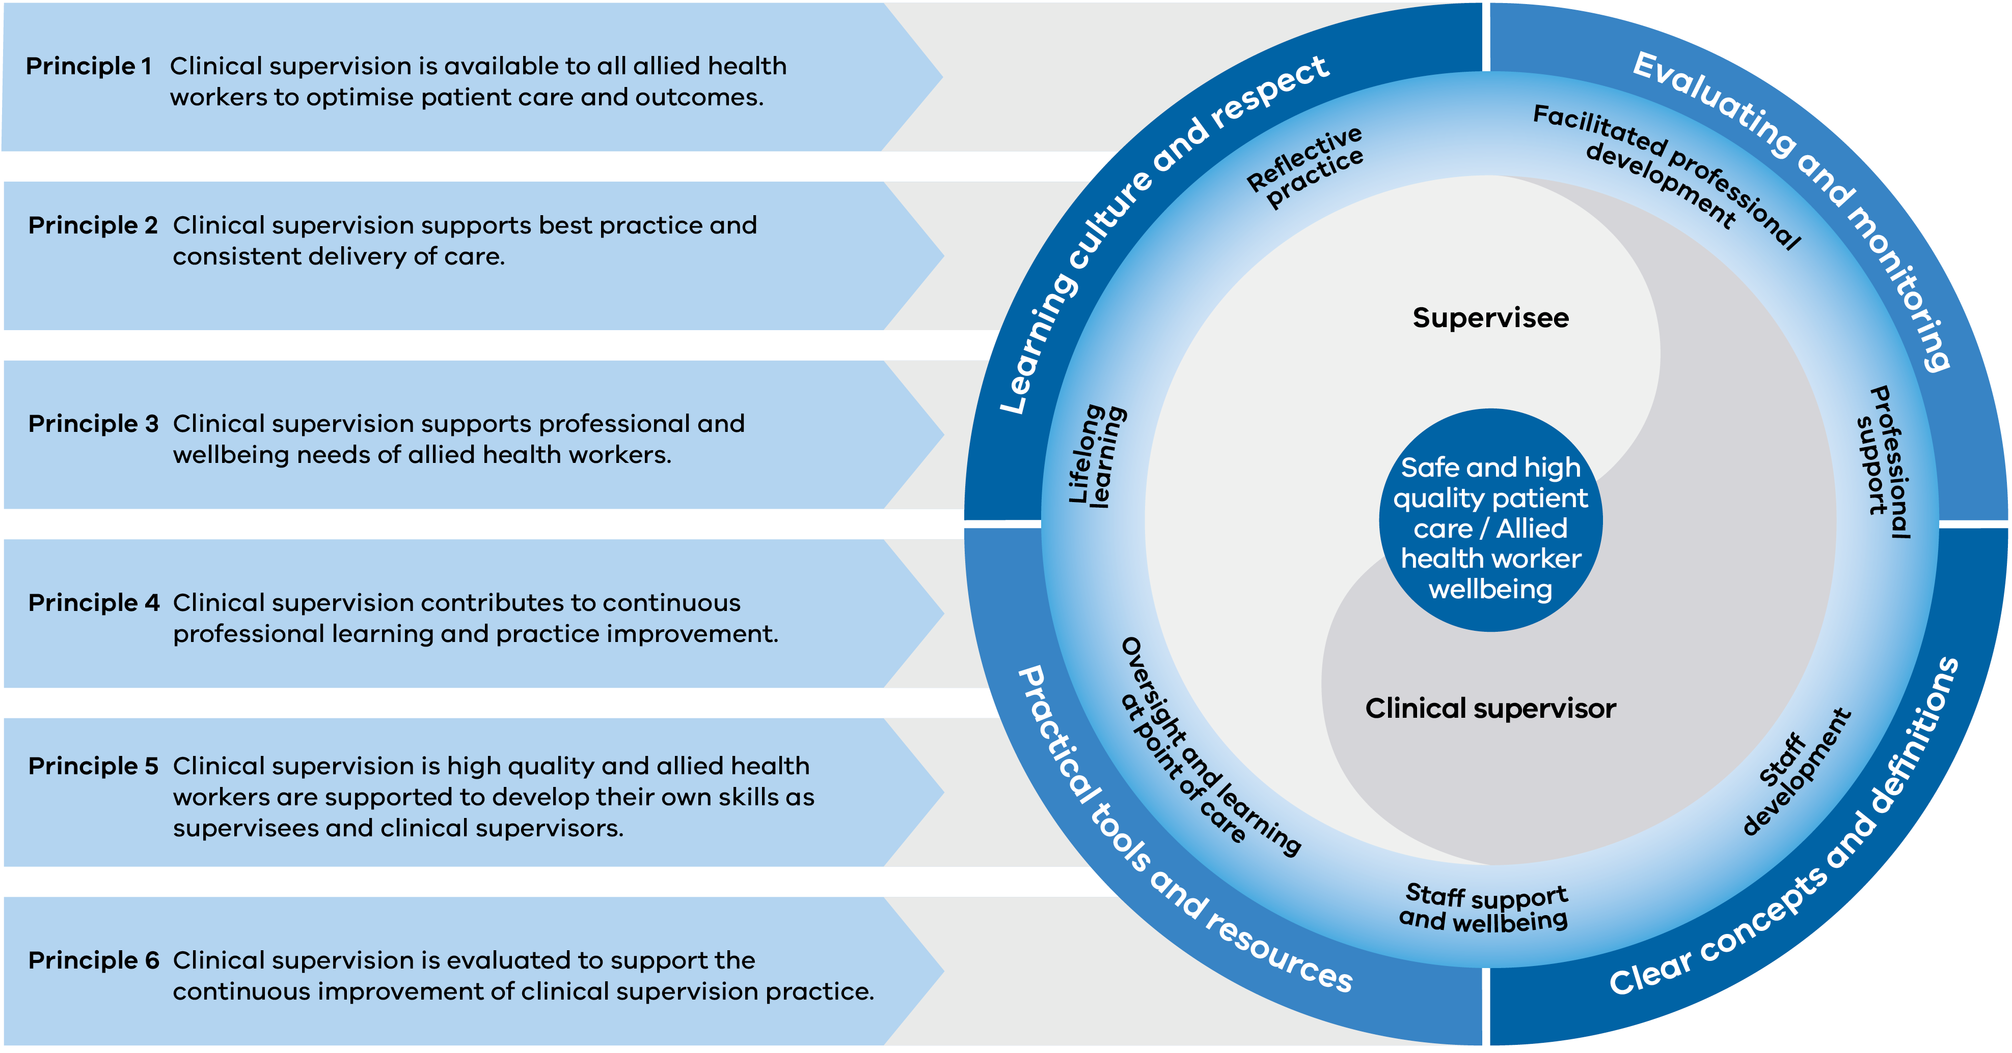
Text-equivalent description of Figure 2

Key stakeholders for implementing this framework
A number of stakeholders have a role in supporting and delivering clinical supervision for allied health in Victoria (Figure 3). The primary audience for the framework includes allied health professionals and assistants who are providing and receiving clinical supervision to enhance and maintain the quality and safety of patient care and allied health worker wellbeing.
Figure 3: Stakeholders in the support and delivery of clinical supervision
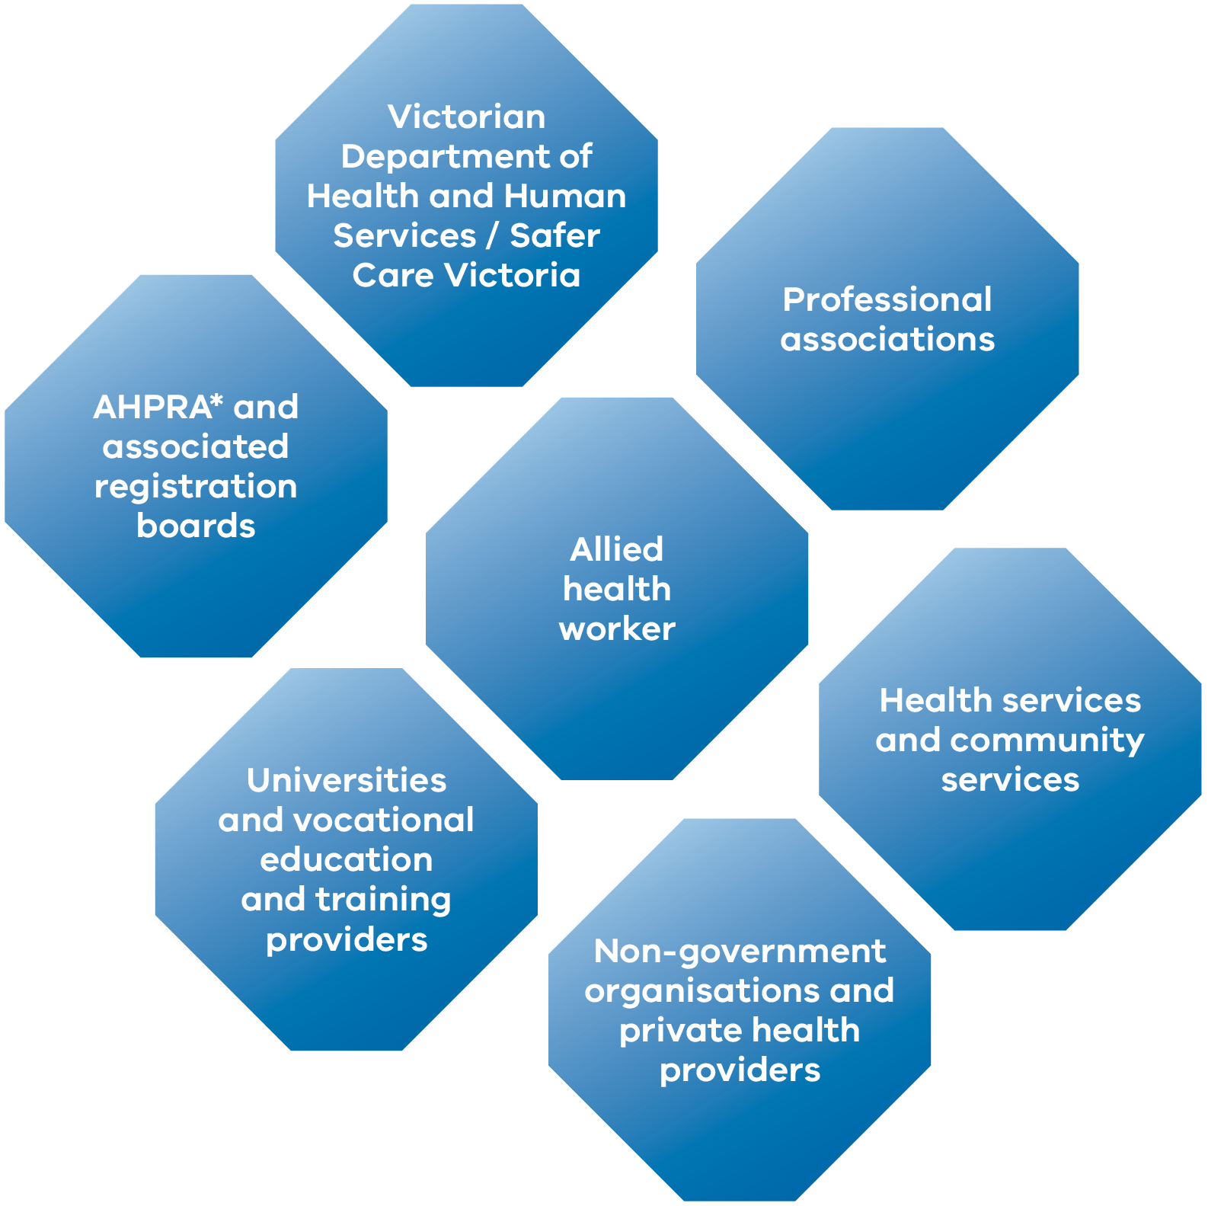
* Australian Health Practitioner Regulation Agency
Text-equivalent description of Figure 3

Clinical supervision for allied health

Objectives of clinical supervision
Clinical supervision is a key component for the provision of safe and high quality patient care and allied health worker wellbeing. Best practice clinical supervision supports the development of a professional relationship between the supervisee and their clinical supervisor, using methods appropriate to the needs of supervisees (Martin et al. 2015).
The principles and outcomes of success included in the framework are based on best practice clinical supervision and will support supervisees, clinical supervisors and health and community services to implement effective clinical supervision. An organisational self-assessment and performance indicator tool has been developed to enable stakeholders to evaluate and monitor clinical supervision practice against the framework.

Importance of clinical supervision
While there is currently limited empirical evidence demonstrating the direct impact of clinical supervision on patient outcomes and safety (Farnan et al. 2012; Snowdon et al. 2016; Snowdon et al. 2017; White and Winstanley 2010), it is proposed that clinical supervision provides benefits to both patients and to allied health workers providing care.
These benefits include:
- improved patient care and safety
- increased allied health worker learning, skill development and clinical team building, promoting the delivery of best practice care
- reduced professional isolation, levels of stress, emotional exhaustion and burnout, providing a positive impact on allied health worker retention and satisfaction.

Models of clinical supervision
There are different models of clinical supervision, reflecting differing work contexts and professional training needs and expectations of staff. There is no one model of clinical supervision that will suit all professions or settings. The models of Proctor (1994) and Kadushin (Harkness et al. 2002) are widely used to inform the practice of clinical supervision for allied health. These models suggest that the functions of clinical supervision should be overlapping and complementary, contributing to an interacting framework made up of the following domains:
- normative (administrative): supporting the supervisee to practice effectively within organisational and professional contexts, including policies and procedures, boundaries, ethics and confidentiality
- formative (educational): the development of skills, reflective practice and embedding evidence-based practice
- restorative (supportive): professional and wellbeing support for the supervisee to build resilience and deal with work-related challenges and stress.
When determining the clinical supervision methods that will provide workers with the most effective clinical supervision to meet individual needs, consideration should be given to the supervisee’s and clinical supervisor’s:
- experience and knowledge
- learning preference
- work related needs and context.

Effective clinical supervision practice
Continuous building of knowledge and skills for allied health professionals and assistants occurs through experiences encountered over the course of a lifetime. Participation in supervision should continue through a health worker’s career, regardless of whether they are in a clinical, leadership, education or research role (Bond and Holland 2011).
Clinical supervision is a continuum of activities, extending from the point of care through to reflective clinical supervision and facilitated professional development (Martin et al. 2017). It may occur ‘on the job’, while a practical task is being carried out, formally, informally, in a one-to-one meeting, or through group or peer supervision. In some contexts, such as rural settings, supervision may be conducted remotely via telephone or videoconferencing. The method of delivery will be influenced by both the developmental level of the supervisee and their clinical practice setting. Less experienced supervisees, or those developing skills and competencies, will generally require more direct guidance in clinical supervision, often at the point of care. By contrast, supervisees with more experience, or with established skills and competencies, will often benefit from more facilitative or self-directed approaches to clinical supervision.
Increasingly, person-centred care is provided by a multidisciplinary team. In this context, it is important that allied health workers (supervisees and clinical supervisors) involved in the process of clinical supervision have a shared understanding of the roles, responsibilities and purpose of clinical supervision. It may not always be practical to enable supervisees to choose their clinical supervisor or to appoint clinical supervisors from the same profession or background as supervisees, and in some circumstances clinical supervisors may need to be sourced externally to the employing organisation. Regardless of the clinical supervisory arrangements in place, it is essential that clinical supervisors understand their supervisee’s professional role and have the core supervisory skills required to support their supervisees. Health and community services also need to have agreed processes to link supervisee learning needs with performance development plans, and to address any risks relating to patient care or supervisee wellbeing that are raised in supervision.
The clinical supervision relationship is a key factor influencing the quality of clinical supervision provided (Spence et al. 2001; Kilminster and Jolly 2000). An effective clinical supervision relationship, based on mutual trust and respect between the clinical supervisor and supervisee, promotes an environment that optimises the learning and support functions of clinical supervision. This requires a shared understanding of the roles and responsibilities and boundaries of clinical supervision, such as confidentiality.
Ensuring a shared understanding is particularly important in settings where it is not practical to completely separate clinical supervision from managerial supervision due to organisational structures. Organisational policies and protocols should outline expected roles and responsibilities for managers, clinical supervisors and supervisees in clinical supervision. The process of establishing a supervisory relationship can be supported by the use of clinical supervision agreements to promote shared understanding. The framework includes clinical supervision templates (examples of organisational policies and protocols and clinical supervision templates) to support a shared understanding of clinical supervision.

Supporting safe and high-quality patient care
The fundamental components needed to support safe and high-quality patient care through clinical supervision in various clinical/professional settings form four distinct domains (Figure 4). These are:
- clear concepts and definitions – foundational building blocks that are required in order to provide clarity and understanding about clinical supervision
- practical tools and resources – practical approaches that support clinical supervision and enhance clinical practice in various settings. See ‘Appendix 1: Clinical supervision resources’ for a list of practical tools and resources
- positive learning culture and respect – emphasising the importance of two-way feedback, prioritising patient needs and supporting the supervisee in discussing their clinical supervision needs
- evaluation and monitoring – clear and structured mechanisms for accurately evaluating clinical supervision practices.
Environmental factors refer to the broader policy and regulatory context in which clinical supervision is undertaken.
The principles and outcomes of success outlined in this framework have been developed considering these domains.
Figure 4: Domains to ensure high-quality clinical supervision
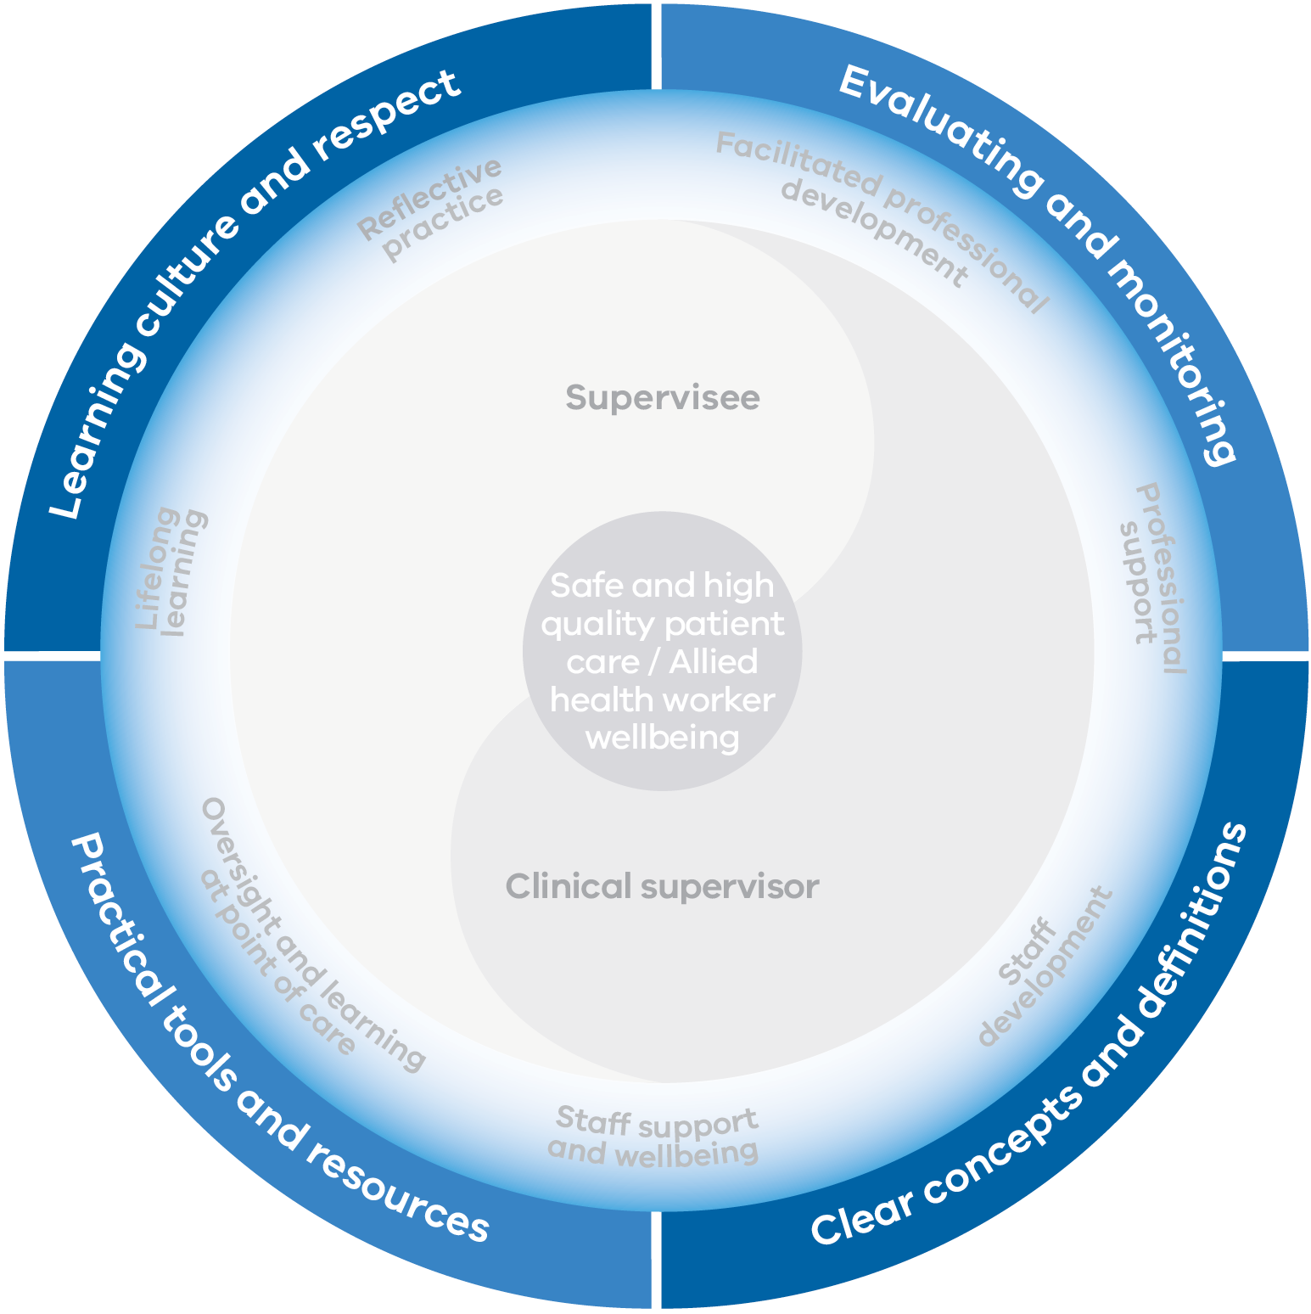
Text-equivalent description of Figure 4

Section 2: Principles and outcomes of success

Goals of the framework
The framework has two goals:
- to optimise patient care and outcomes
- to support allied health worker wellbeing.
These will be achieved through lifelong learning for allied health professionals and/or allied health assistants.

Outcomes of the framework
The outcomes of the framework are:
- improved patient care and outcomes
- enhanced allied health worker wellbeing.

Overview of this section
This section sets out the principles for effective clinical supervision and associated outcomes of success to support the development and maintenance of effective clinical supervision practice aligned to the framework.

Principles
The ‘Principles’ section describe the key factors that underpin effective clinical supervision practice.
The framework’s principles are broken down into measurable element statements for different stakeholder levels:
- allied health worker – allied health workers undertaking the role of supervisees and/or clinical supervisors
- health and community service – organisations employing allied health workers such as public and private hospitals, community health services, community service organisations, non-government organisations and private providers
- health and human services system – the Department of Health and Human Services and Safer Care Victoria, Australian Health Practitioner Regulation Agency and association registration boards and professional associations.

Outcomes of success
The ‘Outcomes of success’ section describes the outcomes that reflect successful implementation of the framework. While the outcomes of success may relate to multiple principles, they are mapped against the most relevant principles and element statements (see ‘Description of principles and associated element statements for key levels of stakeholders’).

Self-assessment and performance indicator tool
A self-assessment and performance indicator tool < https://www2.health.vic.gov.au/health-workforce/allied-health-workforce> has been developed to assist organisations to review their performance against the principles and outcomes and to identify areas for further development where required. Examples of performance indicators at allied health worker and health and community service levels have been developed to enable organisations to undertake detailed evaluation and planning against areas of identified need.

Principles

Principle 1
Clinical supervision is available to all allied health workers to optimise patient care and outcomes.

Principle 2
Clinical supervision supports best practice and consistent delivery of care.

Principle 3
Clinical supervision supports professional and wellbeing needs of allied health workers.

Principle 4
Clinical supervision contributes to continuous professional learning and practice improvement.

Principle 5
Clinical supervision is high quality and allied health workers are supported to develop their own skills as supervisees and clinical supervisors.

Principle 6
Clinical supervision is evaluated to support the continuous improvement of clinical supervision practice.
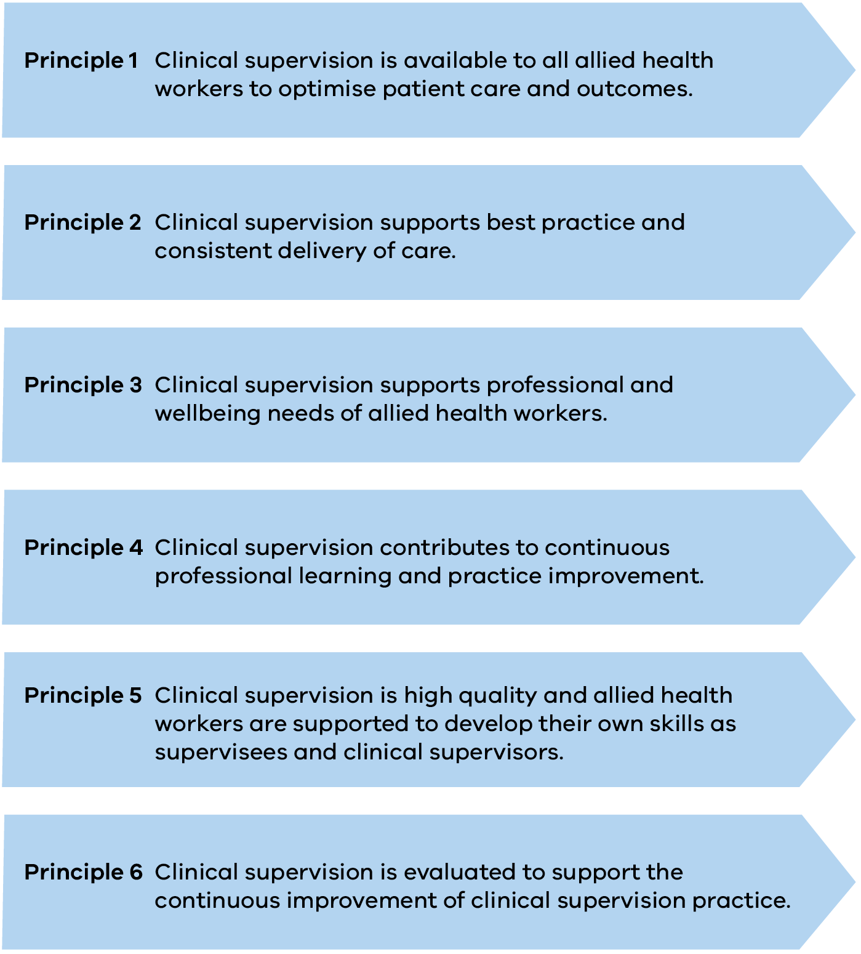

Outcomes of success

Outcomes of the Framework have been identified to assist in the review of the implementation of clinical supervision at individual health professional, health service and health system levels.
These outcomes include:
- Allied health workers are receiving clinical supervision at appropriate times to ensure high quality and safe care.
- The process of providing formal and informal feedback is embedded into routine practice.
- Clinical supervisors have an opportunity to supervise, and practically develop their clinical supervision skills.
- Allied health workers seek out employment in Victorian health and community services because of the supervisory environment.
- Clinical supervision contributes to meeting allied health worker wellbeing and support needs.
- Clinical supervision assists allied health workers in their professional development and career pathways.
- Clinical care is supervised, and provision is appropriate to patient condition/complexity and supervisees’ skills/scope of practice.
- Clinical supervision is included in allied health workers’ professional development plans.
- Resources and tools are available to support high quality clinical supervision.
- Clinical supervision is integrated into health and human services workforce programs.
- Health and community services use relevant and appropriate data about clinical supervision practices to inform continuous improvement of clinical supervision practice.
- Health and community services have mechanisms in place to assess the quality and outcomes of clinical supervision.
- Clinical supervision is viewed as integral to the quality of the health and human services system.

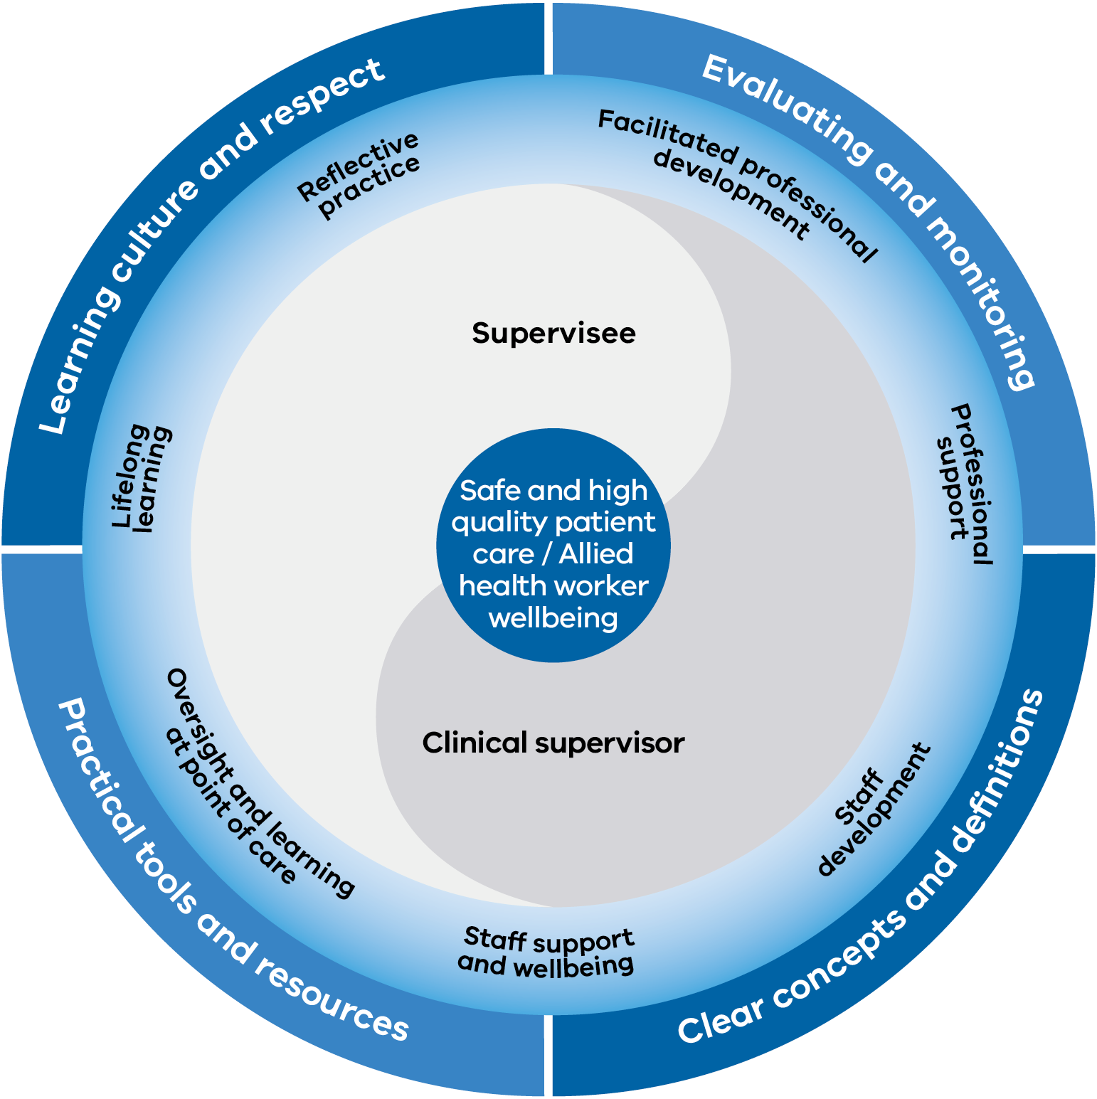

Description of principles and associated element statements for key levels of stakeholders

Principle 1: Clinical supervision is available to all allied health workers to optimise patient care and outcomes
Outcomes 1, 10
Impact level | Element statements
Allied health worker | - Supervisees are responsible for, and committed to, receiving clinical supervision and ongoing professional development.  - Clinical supervisors are committed to ensuring they provide effective clinical supervision.
Health and community service | - Health and community services provide access to clinical supervision at a level appropriate for the supervisee’s qualifications, experience and needs.  - Health and community services provide a strong and measurable commitment to their staff accessing clinical supervision.
Health and human services system | - Access to clinical supervision is included in health and human services workforce programs and guidelines.

Principle 2: Clinical supervision supports best practice and consistent delivery of care
Outcomes 2, 7, 9 ,11, 12
Impact level | Element statements
Allied health worker | - Supervisees and clinical supervisors have a shared understanding of the purpose of clinical supervision and their roles and responsibilities.  - Supervisees and clinical supervisors are responsible for maintaining appropriate records of clinical supervision sessions.
Health and community service | - Organisational processes and resources are in place outlining the purpose of clinical supervision.  - Organisational governance arrangements are in place to support clinical supervision for all health professionals.
Health and human services system | - Health and human services systems play a key role in setting standards for clinical supervision across Victoria.

Principle 3: Clinical supervision supports professional and wellbeing needs of allied health workers
Outcomes 2, 4, 5
Impact level | Element statements
Allied health worker | - Approaches to clinical supervision are tailored to meet the professional and wellbeing needs of the supervisee, based on mutual agreement between the clinical supervisor and supervisee.  - Clinical supervisors ensure that a safe and effective supervisory relationship is developed and maintained to meet supervisee wellbeing and support needs.
Health and community service | - Organisational processes and resources are in place outlining the purpose of clinical supervision programs, and policies are supervisee-centred and based on a shared understanding of expected clinical supervision standards.  - Organisational processes are in place to enhance supervisee professional support and wellbeing.
Health and human services system | - The benefits of clinical supervision for worker support and wellbeing are valued by the health, human services and education sectors, particularly as they relate to workforce recruitment and retention.

Principle 4: Clinical supervision contributes to continuous professional learning and practice improvement
Outcomes 2, 4, 6, 7, 8, 13
Impact level | Element statements
Allied health worker | - Clinical supervision is recognised as an essential component of the health professionals’ (clinical supervisor and supervisee) role and is incorporated into their professional development plan.  - Clinical supervisors facilitate feedback dialogue in clinical supervision practice to support ongoing learning.
Health and community service | - Health and community services support learning and development in a safe and supportive work environment.  - Structured, transparent processes are in place for issues related to patient safety/risk concerns raised in clinical supervision sessions, to inform service management, development and planning.
Health and human services system | - The benefits of clinical supervision are acknowledged and valued by the health, human services and education sectors, particularly as they relate to workforce recruitment and retention and safe clinical practice.

Principle 5: Clinical supervision is high quality and allied health workers are supported to develop their own skills as supervisees and clinical supervisors
Outcomes 3, 9
Impact level | Element statements
Allied health worker | - Allied health workers use reflection to identify areas for skill development in clinical supervision.  - Clinical supervisors access training addressing the core knowledge and skills required to provide effective clinical supervision.
Health and community service | - Health and community services support clinical supervisors to undertake training to encourage them to build on their clinical supervision skills.  - Health and community services ensure that clinical supervision resources and tools are available to support supervisee and clinical supervisor skill development.
Health and human services system | - Resources and tools are developed for both supervisees and clinical supervisors, to support high-quality clinical supervision.  - Standards for clinical supervision and associated training including education requirements are developed by relevant state, national and health professional bodies.

Principle 6: Clinical supervision is evaluated to support the continuous improvement of clinical supervision practice
Outcomes 11, 12, 13
Impact level | Element statements
Allied health worker | - Evaluation and review of clinical supervision provision is an essential component of allied health professionals’ and assistants’ roles, to support reflection and continuous improvement of clinical supervision practice.
Health and community service | - Health and community services have processes in place to monitor and evaluate the programs and models of clinical supervision in place.
Health and human services system | - Support the use of validated tools to continually evaluate and benchmark clinical supervision outcomes and provide evidence-based guidance.  - Continue to build on the evidence-base for the contribution of clinical supervision to patient safety and quality of care and allied health worker support and wellbeing.

References
Bond M and Holland S 2011, Skills of clinical supervision for nurses: a practical guide for supervisees, clinical supervisors and managers, McGraw-Hill Education, UK.
Dawson MMBA, Phillips BP and Leggat SP 2013, 'Clinical supervision for allied health professionals: a systematic review', Journal of Allied Health, vol. 42, no. 2, pp. 65–73.
Department of Health and Human Services 2015, Clinical supervision skills review tool, State Government of Victoria, Melbourne.
Department of Health and Human Services 2015, Position paper: allied health – therapy and science disciplines, State Government of Victoria, Melbourne.
Ducat W and Pearce S 2011, 'Professional supervision for allied health practitioners working in non-metropolitan health care settings: a comprehensive systematic review', The JBI Database of Systematic Reviews and Implementation Reports, vol. 9 (48 suppl), pp. 52–65.
Farnan JM, Petty LA, Georgitis E, Martin S, Chiu E, Prochaska M, et al. 2012, ‘A systematic review: the effect of clinical supervision on patient and residency education outcomes’, Academic Medicine, vol. 87, no. 4, pp. 428–42.
Fitzpatrick S, Smith M and Wilding C 2012, 'Quality allied health clinical supervision policy in Australia: a literature review', Australian Health Review, vol. 36, no. 4, pp. 461–65.
Harkness D and Kadushin A 2002, Supervision in social work, Columbia University Press, New York Chichest West Sussex.
Health Education and Training Institute 2012, The superguide: a handbook for supervising allied health professionals, New South Wales Health, Sydney.
Health Workforce Australia 2014, National clinical supervision competency resource, HWA, Melbourne.
Kilminster SM and Jolly BC 2000, ‘Effective supervision in clinical practice settings: a literature review’, Medical Education, vol. 34, no. 10, pp. 827–40.
Leggat SGMBAMP, Phillips BPPD, Pearce PB, Dawson MB, Schulz DPMDB and Smith J 2016, ‘Clinical supervision for allied health staff: necessary but not sufficient’, Australian Health Review, vol. 40, no. 4, pp. 431–7.
Martin P, Kumar S and Lizarondo L 2017, 'When I say… clinical supervision', Medical Education vol. 51, no. 9, pp. 890–1.
Martin P, Kumar S, Lizarondo L and VanErp A 2015, ‘Enablers of and barriers to high quality clinical supervision among occupational therapists across Queensland in Australia: findings from a qualitative study’, BMC Health Services Research, vol. 15, no. 1, p. 413.
Milne D 2007, 'An empirical definition of clinical supervision', British Journal of Clinical Psychology, vol. 46, part 4, pp. 37–47.
Pearce P, Phillips B, Dawson M and Leggat SG 2013, 'Content of clinical supervision sessions for nurses and allied health professionals: a systematic review', Clinical Governance: An International Journal, vol. 18, no. 2, pp. 139–54.
Proctor B 1994, ‘Supervision: competence, confidence, accountability’, British Journal of Guidance & Counselling, vol. 22, no. 3, pp. 309–18.
Schön DA 1987, Educating the reflective practitioner: toward a new design for teaching and learning in the professions, Jossey-Bass, USA.
Snowdon D, Leggat SG and Taylor NF 2017, ‘Does clinical supervision of healthcare professionals improve effectiveness of care and patient experience? A systematic review’, BMC Health Services Research, vol. 17, no. 1, p. 786.
Snowdon DA, Hau R, Leggat SG and Taylor NF 2016, ‘Does clinical supervision of health professionals improve patient safety? A systematic review and meta-analysis’, International Journal for Quality in Health Care, vol. 28, no. 4, pp. 447–55.
Snowdon DA, Millard G and Taylor NF 2016, ‘Effectiveness of clinical supervision of allied health professionals’, Journal of Allied Health, vol. 45, no. 2, pp. 113–21.
Spence SH, Wilson J, Kavanagh D, Strong J and Worrall L 2001, ‘Clinical supervision in four mental health professions: a review of the evidence’, Behaviour Change, vol. 18, no. 3, pp. 135–55.
Swanwick T 2013, Understanding medical education: evidence, theory and practice, Wiley Blackwell, UK.
White E and Winstanley J 2010, ‘A randomised controlled trial of clinical supervision: selected findings from a novel Australian attempt to establish the evidence base for causal relationships with quality of care and patient outcomes, as an informed contribution to mental health nursing practice development’, Journal of Research in Nursing, vol. 15, no. 2, pp. 151–67.

Appendix 1: Clinical supervision resources
The following resources can be used by supervisees, clinical supervisors, managers, teams, organisations and education providers to assist with the practical implementation of this framework.

Supporting tools and resources

Organisational self-assessment and performance indicator tool
The organisational self-assessment and performance indicator tool assists organisations to review their performance against the framework and to identify areas for further development where required. Examples of performance indicators at allied health worker and health and community service levels have been developed to enable organisations to undertake detailed evaluation and planning against areas of identified need.
This organisational self-assessment and performance indicator tool can be used to:
- enable health and community services organisations to identify areas of clinical supervision practice for targeted action
- prioritise which framework principles and associated elements to focus on
- develop associated action plans aligned to the area/s of focus.
The organisational self-assessment and performance indicator tool is not designed for use by individuals. Clinical supervisors and supervisees may use the Clinical supervision skills review tool <https://vicknowledgebank.net.au> to undertake self and/or peer-assessment for their own development needs.

Templates and examples of policies and procedures
A registry of examples of clinical supervision templates and policy and procedure examples have been sourced to assist supervisees, clinical supervisors and health and community services organisations with the practical implementation of the Victorian Allied Health Clinical Supervision Framework.
These documents are stored on the Knowledgebank website <https://vicknowledgebank.net.au/>.
The following resources are included:
- clinical supervision agreement templates
- clinical supervision log template
- clinical supervision record templates
- clinical supervision evaluation templates
- organisational clinical supervision policy and procedure examples

Other clinical supervision resources

National clinical supervision competency resource and Clinical supervision skills review tool
The National clinical supervision competency resource provides a national benchmark that describes the core competencies of clinical supervision, across all health disciplines, settings and sectors, and provides a framework to inform clinical supervision training programs and professional development of clinical supervisors and supervisees. The Clinical supervision skills review tool and The resource guide: implementing the national clinical supervision competency resource and the clinical supervision skills review tool are practical resources that have been developed to complement the National clinical supervision competency resource. These resources are not intended to supersede any local arrangements, guidelines or clinical supervision models that may apply in any specific settings, sites and professions.
The Clinical supervision skills review tool assists clinical supervisors to review their skills in clinical supervision. The easy to use tool assists supervisors to identify their strengths in clinical supervision, and any areas that may need further development. The Resource guide provides a helpful guide to implementing the National clinical supervision competency resource and the Clinical supervision skills review tool in Victoria.

Supervision and delegation framework for allied health assistants
The Supervision and delegation framework for allied health assistants has been developed by the Victorian Department of Health and Human Services to guide the utilisation and development of the allied health assistant role across health and community services throughout Victoria. This framework has also been contextualised for the disability sector: Supervision and delegation framework for allied health assistants and the support workforce in disability.

HETI Superguides
Allied health and oral health Superguides have been developed by the Health Education and Training Institute (HETI) in New South Wales to support health professionals (supervisees and clinical supervisors) at different stages of their careers and working in different settings. Each HETI Superguide places an emphasis on different aspects of clinical supervision. All highlight the importance of clinical supervision to patient safety and quality of care. This overarching framework provides a strategic, aligned and informed approach to clinical supervision, which complements the practical guidance included in the HETI Superguides.

Other related resources
Victoria has developed a number of other resources that focus on areas related to clinical supervision that may complement the application of the framework. These resources include:

Best practice clinical learning environment framework
The Best practice clinical learning environment (BPCLE) framework is a guide for health and human services organisations, in partnership with education providers, to coordinate and deliver high-quality training for learners.
Allied health credentialing, competency and capability framework
The Allied health credentialing, competency and capability (CCC) framework provides guidance to allied health managers and clinicians in developing structures and processes to build an effective workforce through the appropriate selection, recruitment and training of staff, and maintenance of professional standards, and monitoring scope of practice.

Quality and accreditation standards
National safety and quality health service standards <https://www.safetyandquality.gov.au/our-work/assessment-to-the-nsqhs-standards>
Community services quality governance framework <https://dhhs.vic.gov.au/publications/community-services-quality-governance-framework>

Professional practice standards
Professional practice standards for allied health professions with the National Registration and Accreditation Scheme are available on the Australian Health Practitioner Regulation Agency website <https://www.ahpra.gov.au>. For information relating to professional practice standards for other allied health professions, please refer to the relevant professional association.

Appendix 2: Text-equivalent descriptions
of figures

Figure 1: Elements of clinical supervision
- Reflective practice
- Facilitated professional development
- Professional support
- Worker development
- Worker support and wellbeing
- Teaching and learning at point of care
- Lifelong learning
Return to text following Figure 1

Figure 2: Victorian allied health clinical supervision framework
- Principle 1: Clinical supervision is available to all allied health workers to optimise patient care and outcomes.
- Principle 2: Clinical supervision supports best practice and consistent delivery of care.
- Principle 3: Clinical supervision supports professional and wellbeing needs of allied health workers.
- Principle 4: Clinical supervision contributes to continuous professional learning and practice improvement.
- Principle 5: Clinical supervision is high quality and allied health workers are supported to develop their own skills as supervises and clinical supervisors.
- Principle 6: Clinical supervision is evaluated to support the continuous improvement of clinical supervision practice.
At the centre of the circle is safe and high-quality patient care / allied health worker wellbeing, linked to the supervisee and the clinical supervisor.
The circle is divided into four quadrants:
- evaluating and monitoring, containing facilitated professional development; and professional support
- clear concepts and definitions, containing self-development and staff support and wellbeing
- practical tools and resources, containing oversight and learning at point of care, and overlapping with staff support and wellbeing
- learning culture and respect, containing lifelong learning and reflective practice
Return to text following Figure 2

Figure 3: Clinical supervision stakeholders
- Victorian Department of Health and Human Services / Safer Care Victoria
- Professional associations
- Allied health workers
- Australian Health Practitioner Regulation Agency and associated registration boards
- Universities and vocational education and training providers
- Non-government organisations and private health providers
- Health services and community services
Return to text following Figure 3

Figure 4: Domains to ensure high quality clinical supervision
- Learning culture and respect
- Evaluating and monitoring
- Clear concepts and definitions
- Practical tools and resources
Return to text following Figure 4

