Victorian Perinatal Data Collection (VPDC) manual 2021-22
Section 5a Web form and HealthCollect
Version 9.0
OFFICIAL

To receive this document in another format email HDSS Helpdesk <HDSS.Helpdesk@health.vic.gov.au>.
Authorised and published by the Victorian Government, 1 Treasury Place, Melbourne.
© State of Victoria, Australia, Department of Health, June 2021.
ISBN 978-1-76096-467-2 (pdf/online/MS word)
Available at VPDC website <https://www2.health.vic.gov.au/hospitals-and-health-services/quality-safety-service/consultative-councils/council-obstetric-paediatric-mortality/perinatal-data-collection>

Contents
Introduction 4
General information about the HealthCollect portal 5
Requesting access to HealthCollect for VPDC reporting 5
Logging into the HealthCollect Portal 5
Username and password 5
Password reset 6
Help with using the VPDC Webform 8
Changing password 9
Change user contact details 9
VPDC webform via HealthCollect portal 10
Introduction 10
HealthCollect – contexts, functions and announcements 10
Perinatal context and functions 10
Link to VPDC manual 11
VPDC webform 11
Navigating between the VPDC webform pages 12
Page 1 – Mother’s details 13
Page 2 – Baby’s details 14
Page 3 – Reproductive history 15
Page 4 – This pregnancy 16
Page 5 – Labour, birth & postnatal 17
Data entry completed 18
Amending, updating or correcting details in a VPDC webform – before submission for processing 19
Submitting the VPDC webform record 19
VPDC transmission reports 21
Download and save transmission reports 22
Reviewing transmission reports 23
Amending, updating or correcting details in a VPDC webform – after submission for processing 24
Deleting a webform 25

Introduction
The VPDC webform is available to health services and other health care providers that do not have an information system with the capacity to report birth data to the VPDC.
Authorised users can enter data in the webform, compile completed webforms into VPDC submission files and send those submissions through the HealthCollect secure portal to the department for processing.
Reports generated by this data processing are returned to the user through the HealthCollect portal. These reports highlight data errors so users can correct and resubmit those records.
This document provides information on obtaining a user login to access the VPDC webform, entering data into the VPDC webform, creating a submission file and sending that file for processing, and how to access and download reports sent back through the HealthCollect portal.
Webform users will also find it beneficial to refer to other sections of version 9.0 of the VPDC manual, in particular Section 3 Data definitions, for data item descriptions, code sets and reporting guides.

General information about the HealthCollect portal

Requesting access to HealthCollect for VPDC reporting
To request access to HealthCollect for VPDC reporting purposes:
- Visit the HDSS website at: https://www2.health.vic.gov.au/hospitals-and-health-services/data-reporting/health-data-standards-systems/health-collect
- Under the title ‘HealthCollect portal access’, click on the ‘HealthCollect portal user request form’ link.
- You will be taken to the ‘HealthCollect Portal User Request’ page which explains information prior to completing the online form. To proceed with requesting a username and login for the HealthCollect Portal, click on ‘Next’. If you choose not to continue, select ‘Cancel’ to exit.
- Complete the details requested, including the health service/entity and campus for which data will be reported by this user.
- If the request is for a homebirth midwife, indicate this in the health service/entity and campus fields. A homebirth midwife code will be assigned by the department for VPDC reporting when your request is processed.
- Select ‘VPDC Web form’ on the page listing the range of data reported via HealthCollect.
- Once you have completed all required details, submit the request.
- An email will be sent to the address provided in the request, notifying you of the UserName assigned and other access information. This last step may take 1 to 2 business days.

Logging into the HealthCollect Portal
- Open an internet browser, and enter the HealthCollect address: https://www.healthcollect.vic.gov.au and press ‘Enter’.
- Bookmark this address to facilitate easy access in future.

Username and password
Enter your ‘UserName’ and ‘Password’ in the boxes provided, then click on the ‘Logon’ button. Note that passwords are case sensitive.
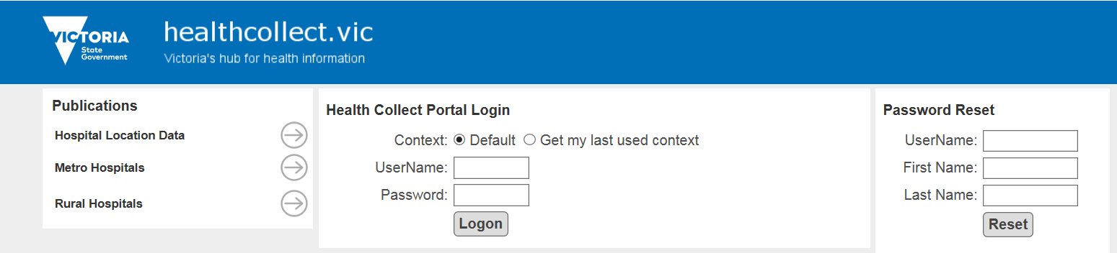
Click ‘Logon’ button
Enter UserName and Password

3 The HealthCollect Default page will appear (see ‘VPDC webform via HealthCollect portal, below, for further details on accessing the webform through the Perinatal context).

Password reset
To reset your password, go to the HealthCollect Portal Login screen using an internet browser.
- In the ‘Password Reset’ portion at the right side of that screen, enter your current UserName, and First Name and Last Name as they are registered with HealthCollect.
- Click the ‘Reset’ button.
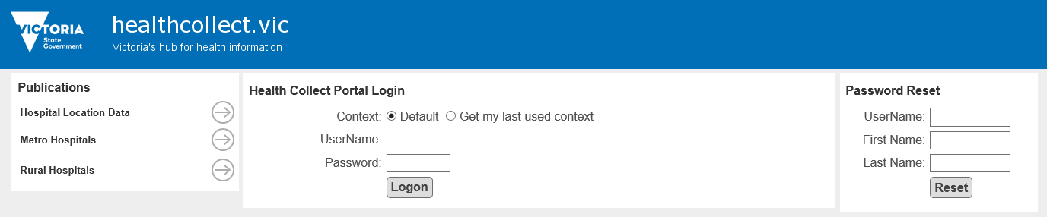
- A message will appear in red, beneath the Password Reset area, indicating ‘a link to reset your password has been emailed to your nominated email address’. This is the email address provided when your HealthCollect user access was requested.
- Contact the HDSS HelpDesk (email hdss.helpdesk@dhhs.vic.gov.au) if an email is not received within a few minutes.
- The email will be sent from the HDSS HelpDesk, with the highlighted link to the password reset screen:
- Follow the instruction in the email above to ‘click here’. A new screen will open, in which you can enter a new password.

- Advice on password strength will appear as you progress. If your new password does not meet system requirements, your proposed new password will disappear, and a message will be shown to provide advice on minimum requirements:
- When an acceptable password has been entered, repeat it in the ‘Confirm new password’ window, and click the ‘Change Password’ button. When the new password is acceptable, and confirmed, you will receive confirmation that your password has been changed:
- Click the ‘Return Home’ button to be taken back to the HealthCollect login screen.
- Login using the new password.
- Refer to the ‘VPDC webform via HealthCollect portal’ section below.

Help with using the VPDC Webform
- Questions about using the HealthCollect portal for VPDC reporting, or entering data into the VPDC Webform, can be directed to the HDSS HelpDesk via email to hdss.helpdesk@dhhs.vic.gov.au.
- The VPDC Manual is accessible at the VPDC website, https://www2.health.vic.gov.au/hospitals-and-health-services/quality-safety-service/consultative-councils/council-obstetric-paediatric-mortality/perinatal-data-collection . Be sure to check that the manual you access is the correct version for the year of the birth you are reporting, as different code sets may apply in different years.

Changing password
Another pathway to changing password is available after login.
In the HealthCollect Default page, click on ‘My Account’: your current HealthCollect login details will be displayed beneath the heading ‘Edit My Details’ near the centre of the screen.
- In the ‘Change Password’ portion at the right of the screen, complete ‘Enter current password’.
- Type the new password in the ‘Enter new password’ box, then enter the same new password in the ‘Confirm new password’ box.
- Click ‘Change Password’ to save the new password details.
- Log out of the HealthCollect portal: click on ‘Logoff’ in the black bar at the top of the screen.

Change user contact details
Authorised users can update selected contact details through the HealthCollect Default page.
- Log in to the HealthCollect portal, and in the Default page, click on ‘My Account’.
- In the ‘Edit My Details’ portion in the centre of this page, users can update their own name, and telephone and email contact details, by entering relevant details in the appropriate box.
- Click ‘Save’ to submit the changes.
- Click ‘Log Off’ in the black bar at the top of the screen.

VPDC webform via HealthCollect portal

Introduction
Data can be submitted to the VPDC by health services and other health care providers that do not have an information system to capture and report birth information. The VPDC webform lists all the VPDC data items for the current year. The webform is accessible to those with a HealthCollect login and VPDC authorisation. Refer to ‘Requesting a HealthCollect log in and password’. Email questions about the VPDC webform to the HDSS HelpDesk at hdss.helpdesk@dhhs.vic.gov.au.

HealthCollect – contexts, functions and announcements
The HealthCollect portal’s Default page provides links to a number of ‘contexts’ which appear across the screen beneath the blue banner. Each user will have access to different ‘contexts’ depending on the data collections to which they have requested, and been provided, access. When a context is selected, functions relevant to that context appear on the left side of the screen. Announcements may also appear when posted by DHHS.

Perinatal context and functions
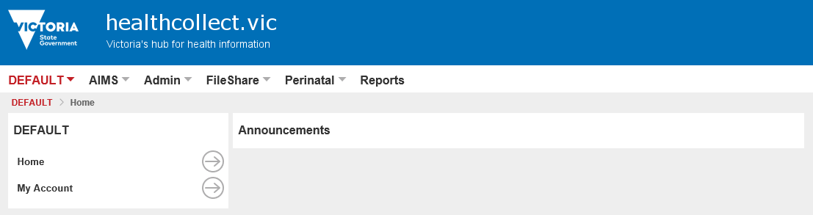
To access the VPDC webform, select the ‘Perinatal’ context in the row beneath the blue banner.
Announcements (if any) appear here
Click on ‘Perinatal’ to access the VPDC webform
Selecting the Perinatal context reveals Perinatal functions, listed at the left of the screen:
- Home
- Secure Data Exchange
- VPDC Selector

Link to VPDC manual
Once in the Perinatal context, a link is provided to the VPDC manual, for reference when entering data.
The two latest versions of the VPDC manual are held at the VPDC website at any time: be sure to refer to the version of the manual for the year of the birth being reported.
Section 3 of the VPDC manual provides codesets and reporting guidelines for all webform data fields.
Click to open VPDC webform
Click to link to VPDC manual

VPDC webform
Click the VPDC Selector in the Perinatal functions list on the left of the screen to open the initial page of the ‘Victorian Perinatal Data Online Entry and Transmission System’, and select key items:
- Birth Year: select the Birth Year that includes the baby’s birth year, to ensure all relevant data items are listed in the webform.
- Agency: click the drop-down list to display health services. Select the site at which the birth occurred. Homebirth midwives registered with the department as VPDC webform users are listed in alphabetical order under ‘Midwife’. Contact the HDSS HelpDesk if your name is not present.
- If you are starting a new birth record, the ‘Birth record Mother UR:’ drop-down box must be left at the pre-set value of ‘New Record’.
- To open a new VPDC webform, click on ‘Create Birth Record’: the webform’s first page will open.
Select health service/midwife from dropdown list

Navigating between the VPDC webform pages
The webform opens in a new browser window.
Each VPDC webform is comprised of the five pages/screens listed in the blue bar across the screen:
- Mother’s details
- Baby’s details
- Reproductive history
- This pregnancy
- Labour, birth & postnatal
The title of the page currently open is shown in white.
Maximise the window to full screen and scroll down to ensure all items are completed on each page.
Print the current page by clicking the ‘Print’ button at the top right corner of the page (grey bar).
Click the ‘Save’ button (upper left of ‘Mother’s details’ page; upper right of other pages) before leaving any page to ensure details are retained. You can return to the page, or record, later to update or add further details throughout the pregnancy or delivery episode, before and after data submission.
Click the ‘Continue’ button (upper right of all pages except ‘Labour, birth & postnatal’) to move to the next page listed in the blue bar near the top of the screen.
Click the ‘Go Back’ button (upper left of all pages except ‘Mother’s details’ page) to return to the previous page.
Movement between pages can only occur to the adjacent page by clicking the ‘Continue’ or ‘Go Back’ buttons, as above. For example, click ‘Continue’ to move from ‘Mother’s details’ to ‘Baby’s details’; click ‘Go Back’ button. It is not possible to move directly from ‘Mother’s details’ to ‘Reproductive history’.

Page 1 – Mother’s details
The first webpage records ‘Mother’s details’.
To print this page
Move to the next page
SAVE before leaving each page
Enter mother’s unique identifier (UR No.)
- Begin by entering the mother’s UR number: this must be unique to the mother, and never re-issued to another mother or used to identify a baby. The details entered on the ‘Mother’s details’ page will be carried over to subsequent pages.
- Many data fields have drop-down lists to allow selection from the valid range of codes or options for that data item.
- Other data items require details to be entered in a specific format.

Page 2 – Baby’s details
- The option selected in some data items will determine whether details are required in other data items (for example, on the ‘Baby’s details’ page, shown above, in the field Plurality, selecting ‘Singleton’ prevents selection of Chorionicity, which only needs to be reported for multiple births; the Birth order field is also automatically populated with the relevant code for a single birth).

Page 3 – Reproductive history
- The VPDC webform includes some validations to assist reporting of accurate data. One example, on the ‘Reproductive history’ page, will display in red where an invalid combination has been selected: the page below has Gravidity of 2, Parity of 1, and Number of previous caesareans is 1. The validation is caused by the ‘Was the last birth a caesarean’ being reported as ‘Last birth was not caesarean section’. One of the inconsistent fields is highlighted in a red box. The user must correct the error before moving to the next screen.

Check highlighted field to resolve validation issue
Validation message

Page 4 – This pregnancy
Resequence conditions using ^ and v arrows; remove with - button
Click ‘Add’ to open another drop-down list to report more conditions: report most significant first
- Some data items allow selection of multiple responses but initially show only the item name and one place for a response. An ‘Add’ button appears above (see Obstetric Complications, above).
- To report more than one response, select one option from the drop-down list, then click the ‘Add’ button to open a space to select another response, and repeat as many times as needed or allowed (see Maternal Medical Conditions, above).
- When reporting multiple responses, always report the most significant response first.
- Re-sequence responses by clicking on the small black ^ (up arrow) or v (down arrow) buttons to the right of the selections listed.
- Remove a selection by clicking on the small black ‘-‘ button.

Page 5 – Labour, birth & postnatal
- This final page has a large number of data items: scroll down the page to complete all items.
- Whenever changes are made, click ‘Save’ again. A reminder message appears at the top left.

Data entry completed
- When all details have been entered click the ‘Complete Form’ button at the top right corner of the ‘Labour, birth and postnatal’ page.
- The VPDC webform will then close, and a query box will appear.
To confirm that you want to close the webform, click ‘Yes’.
If you want to return to the webform, click ‘No’, then click the back arrow in your browser to return to the webform.

- If you select ‘Yes’ and close the webform, you will return to the VPDC webform homepage screen.
Click UID of record to be amended/ updated/ corrected
- Webforms that have at least some data entered, but have not been submitted to the VPDC, are listed as ‘Outstanding Birth Records’.
- Webforms should be checked before submission to ensure all required details have been completed.

Amending, updating or correcting details in a VPDC webform – before submission for processing
- Amending, updating or correcting details in a VPDC webform may be required where details are added at different stages of the pregnancy and delivery, and to ensure all details are complete before the webform is submitted for processing.
- When changes are required to details entered previously, return to the original webform for that birth. Do not create a new record, as that risks duplicate reporting of the same birth.
- To access a webform before submission for processing, find the record in the list beneath the Outstanding Birth Records heading, and click the UID number, which appears in red font.
- Clicking on the UID re-opens that webform at the ‘Mother’s details’ page. Navigate through the webform as described above to update or correct details as required.
- Save before moving on from each successive page to ensure updates are retained.
- When amendments are completed, click the ‘Complete Form’ button at the top right corner on the ‘Labour, birth & postnatal’ page, and confirm that you want to close the tab. You will be taken back to the VPDC webform home screen again.

Submitting the VPDC webform record
- When a VPDC webform is complete, it must be formatted into a VPDC transmission file and forwarded to the department for processing against the VPDC business rules. The data will then be included in the VPDC database along with birth records reported by other health care providers.
- To create a transmission file, click the ‘Create VPDC Transmission File’ button. The file will include all webforms that have been marked as ‘complete’ but have not previously been submitted.
Click to submit record to DHHS for processing
- A new window will open, showing – for the Birth year selected in the VPDC home screen – the number of webforms to be included in this submission (‘Total New Birth Records’), and those already sent for this calendar year (‘Total Existing Birth Records’).
- To create and submit the transmission file, click the ‘Submit Transmission File’ button in this screen. Where multiple webforms are ready for submission, they will be combined into a single submission file and be submitted together.
- When the ‘Submit Transmission File’ button is selected, a confirmation screen will appear after a few moments, to indicate the record/s that have been transmitted successfully. The ‘Submission identifier’ and ‘Submission Number’ for this submission are displayed, with confirmation of the number of records (webforms) included in the file:
Frankie Nurk (fnurk2512),
- Select ‘Close’ to return to the Perinatal context (home screen).
- The HealthCollect secure portal will forward the transmission file to the department, where it will be transferred for processing against VPDC system validations.

VPDC transmission reports
- For each transmission file submitted, the VPDC processor generates four reports:
- Submitted Data Report (Excel)
- Clinician Report (.pdf)
- Error Summary Report (.pdf)
- Vendor Report (.pdf).
- These four transmission reports are returned to the user’s HealthCollect portal, usually within one business day of the transmission being submitted through HealthCollect.
- To access these reports, login to HealthCollect, select Perinatal, and click on ‘Secure Data Exchange’ in the functions menu on the left. The Perinatal File Download window will open and display the reports.
- Click ‘Refresh File List’ if the reports are not found. Contact the HDSS HelpDesk if the reports still do not appear.

- The report filename includes:
- Agency code: the four-character Health Service Identifier for the agency selected in the Victorian Perinatal Data Online Entry and Transmission System screen, before the webform was opened;
- Submission identifier and Submission number: these will be the same as those shown on the ‘Transmission Successful’ screen;
- Report name.
Submission number
Submission identifier
Agency code (Health Service Identifier)

Download and save transmission reports
- Download all reports from HealthCollect and save them in a suitable directory on your health service’s computer. Remember that they contain confidential identifying details and save them accordingly.
- Select the reports to download (click on the ‘All’ box, or click the box next to each report’s name individually), then click the ‘Get Selected Files’ button.
- A pop up will appear at the base of the screen with the options Open, Save or Cancel.
Select ‘Save’: this will save the files to the Downloads directory in your computer. The files are saved as a zipped folder with the user’s HealthCollect identifier as the zipped filename.

- Another pop up will then appear in the same location, with the options Open, Open folder or View downloads. Select ‘Open folder’.
- The Downloads directory in your computer will open. Click on the zipped folder to open it, showing the four files. Save the files separately.

Reviewing transmission reports
- Each of the four reports indicates how many birth records were processed in the transmission file and how many were rejected. The three .pdf reports show the reason/s for those rejection/s. The explanation of rejections is to help users go to the VPDC webform for the birth with the error, correct the error, and resubmit that birth record (see below).
- Check that the number of records submitted is consistent with the number you expected to be sent.
- Using the Clinicians Report, which is the most detailed, check all error messages that indicate a record was rejected. The reason/s for any rejections will be listed in detail. All rejections must be checked and the data in the webform corrected and then resubmitted.
- The Submitted Data Report lists the value reported in each data field for each record in that submission file, in Excel format, which can be sorted and filtered. It is useful for reviewing records for data quality purposes.
- Review Section 3 Data definitions and Section 4 Business rules to clarify reporting rules or data code set restrictions. Contact the HDSS HelpDesk if unable to identify the cause of any rejection.

Amending, updating or correcting details in a VPDC webform – after submission for processing
- To correct details in a webform that has been submitted, return to the Victorian Perinatal Data Online Entry and Transmission System screen, click to open the list of ‘Birth record Mother UR’ and select the record to be corrected:
- When the record is selected, two options will be offered: ‘Edit Birth Record’ or ‘View Birth Record’: select ‘Edit Birth Record’ to open the webform with the details as submitted.
- Navigate to the page with the details to be corrected, make appropriate changes, and click ‘Save’.
- When all corrections have been made, progress to the ‘Labour, birth & postnatal’ page, and click ‘Complete Form’, and confirm as before.
- Return to the Victorian Perinatal Data Online Entry and Transmission System screen again, and click ‘Create VPDC Transmission File’, check the number of records in the submission file is as expected, and click ‘Submit Transmission File’, in the same way as was done for the original submission.
- In a day or two, check the Secure Data Exchange, and download the files, check again and repeat until all rejections have been resolved.
- To view or print an entire webform record, select ‘View Birth Record’: all data items will be displayed in a single window: scroll down to see all data entered. Click the ‘Print’ button (top right corner, in the grey bar) to print all details.

Deleting a webform
- If an error has been made, and the birth record is no longer required (for example, it is identified before submission that details for one birth have been entered twice by mistake), return to the ‘Mother’s details’ page, and click the ‘Delete’ button. This will remove all the details entered for this birth record. Always double check before deleting a webform, as this cannot be reversed.

