Food safety recalls
2018/2019

To receive this publication in an accessible format phone 1300 364 352, using the National Relay Service 13 36 77 if required, or email <foodsafety@dhhs.vic.gov.au>
Authorised and published by the Victorian Government, 1 Treasury Place, Melbourne.
© State of Victoria, Department of Health and Human Services, October 2020.
Available at <https://www2.health.vic.gov.au/public-health/food-safety/publications-guides-resources>

Contents
Food safety recalls 4
Australian food safety recalls 4
Food safety recalls affecting Victorians 5
How are food safety recalls initiated? 6
Victorian recalls triggered by the Victorian anaphylaxis reporting scheme 7
Allergen related recalls of food produced or imported into Victoria 7
What happens to recalled food? 8
What are the costs of a recall on business and the community? 8
What if I think there is a problem with food that I have purchased? 8
Where to report a problem with purchased food or from where food is purchased 9
References 9

Food safety recalls
Food safety recalls generally relate to pre-packaged foods that have been offered for retail sale. A food safety recall occurs when it becomes necessary to remove a product from sale, either because it has been found to be unsafe to consume, or because it poses a specific health risk to the community. Whenever a recall is initiated, steps must be taken by the food business responsible for the product (the recall sponsor) to inform anyone who may have purchased the product about the nature of the food safety hazard, and to provide guidance on what they should do with product that may be in their possession.

Australian food safety recalls
Nationally, food safety recalls are co-ordinated by Food Standards Australia New Zealand (FSANZ). Any company considering a food safety recall of their product will first report the issue to the relevant food regulatory authority in that company’s home state or territory. That authority will provide the company with initial advice. In Victoria, companies will contact the Department of Health and Human Services and, if the recall relates to dairy products, they will contact Victoria’s dairy regulator, Dairy Food Safety Victoria. If the recall relates to meat or seafood, they will contact PrimeSafe, Victoria’s meat and seafood regulator.
If a recall is conducted, the company (the recall sponsor) then contacts FSANZ who will guide them through the requirements, communicate the incident to other government agencies as required, and inform consumers via their website (<https://www.foodstandards.gov.au/Pages/default.aspx>).
Recalls continue to be a regular occurrence in Australia. Over the past decade the number of food safety recalls co-ordinated by FSANZ have continued to trend upwards as shown in Figure 1 (Food Standards Australia New Zealand, 2020). In 2018, 100 recalls were conducted in Australia, with 87 recalls occurring in 2019.
Figure 1: The number of recalls coordinated by FSANZ each year between 1 January 2010 and 31 December 2019 (Food recall statistics, 2020)
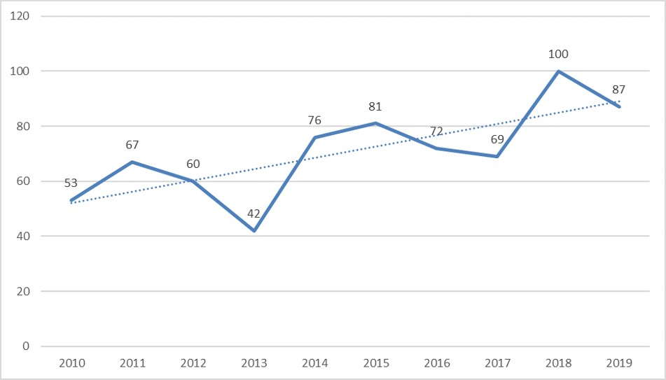
The types of incidents that can trigger food safety recalls include, but are not limited to:
- contamination of food products with foreign matter such as metal, glass or plastic
- contamination of food products with chemicals such as cleaning agents, pesticide residues above permitted levels, or biotoxins
- the presence of pathogenic bacteria that can cause food poisoning such as Salmonella, E.coli, Listeria monocytogenes
  - the presence of unlabelled ingredients that can trigger potentially harmful reactions in people who have specific food allergies, sensitivities, or intolerances. These include cereals, lupin, fish, crustacea, milk, soy, peanuts, tree nuts, sesame seeds, egg, and added sulphites at levels above 10mg/kg.
Figure 2 shows the recalls by type for both 2018 and 2019. Allergen related recalls were the most significant cause across this two-year period, followed by microbiological contaminants.
Figure 2: Australian recalls by type (n)
Australian recall by type | 2018 | 2019
Allergen | 46 (46%) | 32 (37%)
Micro | 21 (21%) | 30 (34%)
Foreign Matter | 17 (17%) | 5 (6%)
Biotoxin | 2 (2%) | 3 (3%)
Other | 6 (6%) | 12 (14%)
Labelling | 6 (6%) | 1 (1%)
Chemical | 2 (2%) | 4 (5%)
Total | 100 (100%) | 87 (100%)

Food safety recalls affecting Victorians
In 2018, 64 food safety recalls directly affected Victoria, representing 64 per cent of the total number coordinated nationally by FSANZ. In 2019 there were 48 recalls that affected Victoria, representing 55 per cent of the total number coordinated by FSANZ in that year.
Figure 3 shows those recalls affecting Victoria categorised by type. Allergens were the most significant cause of food recall, representing 53 per cent of Victorian recalls in 2018, and 46 per cent in 2019.
Figure 3: Recalls affecting Victoria by type (n)
Victorian recall by type | 2018 | 2019
Allergen | 34 (53%) | 22 (46%)
Micro | 10 (16%) | 11 (23%)
Foreign Matter | 12 (19%) | 4 (8%)
Biotoxin | 2 (3%) | 0
Other | 3 (5%) | 10 (21%)
Labelling | 2 (3%) | 0
Chemical | 1 (1%) | 1 (2%)
Total: | 64 (100%) | 48 (100%)

How are food safety recalls initiated?
There a number of situations that can lead to a food safety recall being initiated, some of these are detailed below:
- A consumer complaint
The Food Safety Unit (FSU) receives food related complaints from the public and from other state-based enforcement agencies under the home state rule. The complaints are assessed, and on most occasions referred to the responsible registering authority for follow up with the manufacturer or importer.
Example: A consumer complained after finding foreign matter, in this case glass, in an imported nut product purchased at a local store. Following an investigation by the recall sponsor it was determined that there was a risk of glass being present in other packs of the same product too. As a result, the product was recalled nationally.
- A food manufacturer
In some cases, a food manufacturer’s internal testing program can identify a problem with a product that has already been distributed for sale. A food manufacturer may become aware of a contamination event that took place during manufacture or be notified by one of their ingredient suppliers that an ingredient they have used may have been unsafe. In many cases the food manufacturer or importer will begin a food safety recall themselves after discovering a problem with a specific batch of product.
Example: A dairy manufacturer’s internal checks determined that for a specific batch of product, they could not prove that the pasteurisation process had been effective at removing pathogenic bacteria which could potentially have been present in the raw milk. As a precaution the manufacturer conducted a recall of the product batch concerned.
- A regulator’s testing program
Food regulators and registration authorities conduct routine surveillance testing of food products in the marketplace. Such testing programs can sometimes lead to food safety recalls being conducted.
Although most food safety recalls are initiated by the food business who produced or imported the product, the department has powers under the Victorian Food Act 1984 to order a Victorian food business to conduct a food safety recall if required.
- A reported food poisoning outbreak
The Food Safety Unit is advised of any food poisoning outbreaks linked to Victorian businesses. If packaged food is identified as a likely source, an investigation is conducted by the relevant registration authority. In some cases, this can lead to a food safety recall.
Example: Following over 50 cases of food poisoning related to Salmonella nationally, an investigation identified that the most likely cause was a manufacturer of frozen meals in Victoria who supplied several national retailers. The company voluntarily recalled an extensive range of its products from the Australian market and worked with its registration authority to ensure that its internal food safety controls were improved.
- Reported case of anaphylaxis linked to packaged food
Food safety recalls can sometimes be initiated following a reported case of anaphylaxis through the mandatory Victorian anaphylaxis notification scheme. This is discussed in more detail in the following section.
The decision to recall a food product normally follows a detailed investigation by the recall sponsor to determine the nature and extent of the food safety risk. This includes identifying and documenting the specific retail products implicated, how much product is affected, and where to where that product has been distributed. This information must be provided to FSANZ by the recall sponsor at the start of the recall process.
After the recall has been completed the recall sponsor has an obligation to ‘reset’ and ensure that any food they sell is both safe and suitable for human consumption.
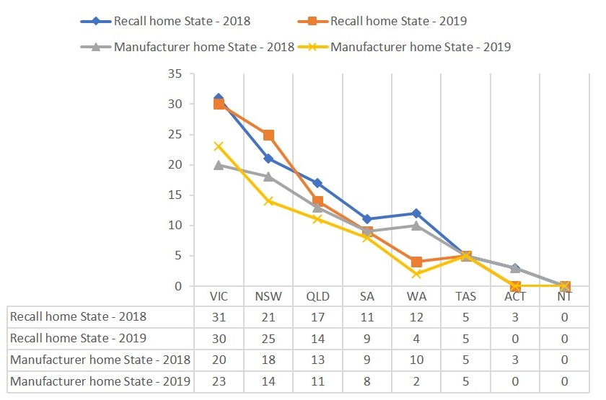

Victorian recalls triggered by the Victorian anaphylaxis reporting scheme
Under the Public Health and Wellbeing Act 2008, Victorian anaphylaxis reporting bodies (hospitals) are required to notify the department when a registered medical practitioner has reasonable grounds to believe that a person presenting for treatment to the hospital has anaphylaxis. The purpose of the reporting requirement is to allow for a timely investigation, particularly if the case involves packaged food that may need to be recalled. In 2018, one reported case triggered a recall, in 2019 two recalls were triggered by anaphylaxis investigations.

Allergen related recalls of food produced or imported into Victoria
There were 22 recalls relating to undeclared allergens in 2019 that involved food produced in Victoria or imported into Victoria from overseas. Figure 4 shows how many of these recalls involved Victorian manufacturers or imported foods.
Figure 4: Origin of allergen recalls
Origin of allergen recalls | 2019
Victorian food manufacturer (n) | 9
Imported food (n) | 4
Figure 5 shows some of the trends identified in the Victorian recalls for 2019. The most significant trends involved the undeclared presence of dairy, gluten, peanuts or tree nuts.
Figure 5: Trends in food safety recalls (Victoria) in 2019
Reason for recall | 2019
Undeclared dairy (n) | 7
Undeclared peanuts or tree nuts (n) | 6
Undeclared Gluten (n) | 4
All these packaged food products were recalled due to the presence of undeclared allergens. This means that they were found to contain, but not to declare on the labelling, ingredients listed under the Australia New Zealand Food Standards as requiring mandatory labelling because they can cause adverse health reactions in people with specific food allergies, intolerances or sensitivities.
Amongst these allergen related recalls, five products were recalled in 2019 for undeclared dairy or egg that also made the claims that they were suitable for vegans.

What happens to recalled food?
Recalled food can be returned to the place of purchase or disposed of by the consumer. Recalled food within the supply chain (that is, food not yet in stores) may also be returned to the manufacturer or importer. In many cases recalled food is unfit for human consumption and is therefore destroyed.

What are the costs of a recall on business and the community?
Food businesses are required under the Food Act 1984 to produce food that that is safe, suitable, and compliant with the law. When packaged food is found to be unsafe the responsibility generally lies with the food manufacturer or importer of that food.
The financial cost of a food safety recall on a food manufacturer or importer can be considerable, including the cost to recover the unsafe product, to pay any administrative costs that may be charged by the retailers, to quickly produce or import extra product to re-fill the supply chain and replace the stock that has been recalled from retail, and to pay any legal costs or penalties that may arise from any legal action.
A food safety recall can also damage consumer trust in the company and its brands.
For the community, the costs of unsafe food can include physical harm, illness, even death.

What if I think there is a problem with food that I have purchased?
If you believe that there may be a problem with food that you have purchased, do not eat the food product you are concerned about. Report the problem to the relevant food regulator (see below) and provide:
- your name, address and phone number
- the brand name, food product name and manufacturer
- the size and package type
- package codes and dates
  - name and location of the store and the date you purchased it.
Remember to keep the original container or packaging and if relevant, the foreign object (for example, a metal washer that you found in the food). Refrigerate any uneaten portion of the food.

Where to report a problem with purchased food or from where food is purchased

Dairy Food Safety Victoria
Contact Dairy Food Safety Victoria if your enquiry relates to the selling, transport, or preparation of dairy products (like a cheesemaker, ice creamery or dairy).
Phone: +613 9810 5900
Website: www.dairysafe.vic.gov.au
Email: info@dairysafe.vic.gov.au

PrimeSafe Victoria
Contact PrimeSafe if your enquiry relates to the selling, transport, or preparation of meat (for example, a butcher) or seafood (for example, a fishmonger).
Phone: +61 3 9685 7333
Website: www.primesafe.vic.gov.au
Email: enquiries@primesafe.vic.gov.au

Local government
Contact your local council (ask for an environmental health officer) if your enquiry relates to:
- the selling, transport, or preparation of all other foods
- registrations of food businesses (both making and selling of food)
- food safety programs
- mobile or temporary food premises
  - complaints about a food or food premises (such as, suspected food-borne illness, contamination of food, labelling, undeclared food allergens, advertising and composition of food).
Website: https://knowyourcouncil.vic.gov.au/home

Department of Health and Human Services - Food Safety Unit
Contact the Department of Health and Human Services if your enquiry relates to general food compliance issues (and you are unsure of where to start) or you are looking for publications on food safety or information on legislation.
Phone: 1300 364 352 (Free Call within Australia)
Website: www.health.vic.gov.au/foodsafety
Email: foodsafety@health.vic.gov.au

References
Food Recall Statistics. [online] Available from: <https://www.foodstandards.gov.au/industry/foodrecalls/recallstats/Pages/default.aspx>

The home state is the state or territory where the head office of the sponsor is located.
The responsible registration authority is determined by sections 35 and 38 of the Food Act 1984. In Victoria, the responsible registration authority will be the business’ local council, PrimeSafe or Dairy Food Safety Victoria.

