

|  |
| --- |
| Malnutrition in Victorian Cancer Services 2017–2018: summary report  Learnings and recommendations from the statewide Malnutrition in Victorian Cancer Services program of work 2017–2018 |
|  |

Department of Health

|  |
| --- |
| Malnutrition in Victorian Cancer Services 2017–2018: summary report  Learning’s and recommendations from the state-wide Malnutrition in Victorian Cancer Services program of work 2017–2018 |
|  |

|  |
| --- |
| *.* |
| To receive this publication in an accessible format phone (03) 9096 2136, using the National Relay Service 13 36 77 if required, or [email Cancer Strategy and Development](mailto:cancerplanning@dhhs.vic.gov.au) <cancerplanning@dhhs.vic.gov.au>.  Authorised and published by the Victorian Government, 1 Treasury Place, Melbourne.  © State of Victoria, Department of Health and Human Services, August 2019.  Where the term ‘Aboriginal’ is used it refers to both Aboriginal and Torres Strait Islander people. Indigenous is retained when it is part of the title of a report, program or quotation.  **ISBN** 978-1-925947-64-9 **(pdf/online/MS word)**  Available at [www.health.vic.gov.au/cancer](https://www2.health.vic.gov.au/about/health-strategies/cancer-care/cancer-projects/investigating-practices-relating-to-malnutrition-in-victorian-cancer-services) <<https://www2.health.vic.gov.au/about/health-strategies/cancer-care/cancer-projects/investigating-practices-relating-to-malnutrition-in-victorian-cancer-services>> |
|  |

Contents

Authorship 1

Executive summary 2

Background 4

Cancer Malnutrition: Feeding Everyone From Hospital to Home 7

Background 7

Aims 7

Methods 8

Outcomes 8

Implications and recommendations 10

Cancer malnutrition point prevalence study 2016: final results 11

Background 11

Aims 11

Methods 11

Outcomes 12

Implications and recommendations 14

Victorian Cancer Malnutrition Collaborative program of work: the steps forward 15

Optimising the cancer nutrition path 16

Cultural adaptation of the *Malnutrition screening tool* and associated education resources 16

Cancer malnutrition point prevalence study 2018 16

Malnutrition in Cancer eLearning: furthering education program 18

Malnutrition governance toolkit update 18

Communication and collaboration 19

Community of Practice evaluation 19

e-newsletters 20

Program branding 20

Program of work outcomes, lessons, challenges and enablers 22

Recommendations and future actions 24

Key recommendations 24

Appendix 1: Cancer Malnutrition: Feeding Everyone From Hospital to Home project – factsheet 26

Appendix 2: Cancer malnutrition point prevalence study 2016: final results – factsheet 29

Appendix 3: The Victorian Cancer Malnutrition Collaborative program of work at a glance – factsheet 32

Abbreviations 35

References 36

# Authorship

The Malnutrition in Victorian Cancer Services program of work is a collaboration of dietitians, health service dietetic managers and interested health professionals aiming to reduce the burden of cancer malnutrition within our health system. Part funding is provided by Cancer Strategy and Development, as an initiative of the Victorian Government. The Nutrition Department at Peter MacCallum Cancer Centre was commissioned to provide statewide leadership and overall project management.

This report was written by Ms Jenelle Loeliger from Peter MacCallum Cancer Centre Nutrition Department, with support from Belinda Steer and Jane Stewart.

**Preferred citation:** Loeliger J, Stewart J, Steer B 2019, *Malnutrition in Victorian Cancer Services 2017–2018: summary report*, Department of Health and Human Services, State Government of Victoria, Melbourne.

# Executive summary

|  |
| --- |
| **The key points from this report:**   1. The 2017–2018 Malnutrition in Victorian Cancer Services program of work has successfully extended beyond the acute setting into the primary care and community sector, which has enabled greater reach, transferability of tools and resources and greater impact across the entire continuum of care for patients. 2. The overall cancer malnutrition prevalence rate in Victoria has reduced from 31 per cent in 2012, to 26 per cent in 2014, with a further reduction in 2016 to 23 per cent alongside other clinical improvements. 3. Greater awareness and promotion of cancer malnutrition as a quality and safety concern in health care has been achieved and will be an important inclusion in future work. 4. Further collaborative efforts with consumers, health professionals and policymakers needs to be continued to address identified clinical service and education gaps as outlined in the recommendations and future actions section of this report. |

Malnutrition remains a prevalent concern in health care that carries a significant health burden (1). This is particularly the case in the cancer population whereby approximately one in four patients undergoing treatment in Victoria are malnourished (2-5) Nutrition is well recognised as playing a key role within multimodal cancer care and can have a significant impact on improving the health and wellbeing of people with cancer (2, 6). The Malnutrition in Victorian Cancer Services (MVCS) collaborative is a group of dietitians and interested health professionals who are focused on delivering a program of work to help reduce the burden of cancer malnutrition in Victoria. The expertise, ability to collaborate and dedication to this cause should be commended by all involved in this work.

The MVCS program of work in 2017–18 has achieved the following outcomes:

1. Successful completion of the Cancer Malnutrition: Feeding Everyone From Hospital to Home project (refer to Appendix 1 for a factsheet summary). This project has explored our understanding of cancer malnutrition in the primary care and community sector and found that:
   1. General practitioners’ and general practice nurses’ understanding and awareness of cancer malnutrition is relatively poor.
   2. There is a need for (and clinicians are requesting) targeted cancer malnutrition education and resources to be made available.
   3. Identification of nutrition risk and management of cancer malnutrition needs improvement across the entire continuum of care.
   4. The transition of nutrition care for patients with or at risk of cancer malnutrition from acute health services into primary care and community services is poor.
2. The result of the 2016 cancer malnutrition point prevalence study has demonstrated that the overall malnutrition prevalence of cancer patients receiving active treatment in Victoria significantly reduced from 31 per cent in 2012 to 26 per cent in 2014 and down to 23 per cent in 2016 (3). Pleasingly, the proportion of patients with malnutrition receiving dietetic intervention has increased in 2016 to 68 per cent (previously 56 per cent in both 2012 and 2014) (2). Refer to Appendix 2 for a factsheet summary.
3. Awareness raising and promotion of cancer malnutrition as a quality and safety concern in health care has been achieved within both Safer Care Victoria and the Victorian Agency for Health Information. Positive gains were also made, with a malnutrition performance indicator being included within the *Victorian cancer plan monitoring and evaluation framework*, which complements the addition of nutrition within the new ‘comprehensive care’ standard in the second edition of the National Safety and Quality Health Service Standards (7, 8). These gains will provide further impetus for health services to improve and adhere to published clinical practice recommendations in the absence of a mandatory indicator for cancer malnutrition. Further promotion of the issue of cancer malnutrition, malnutrition in general and exploration into the potential development of a statewide nutrition policy is required.

|  |
| --- |
| **The key recommendations derived from the 2017–18 MVCS program of work are:**   1. Improvements have been made; however, gaps in nutrition cancer care continue to exist across a patient’s continuum of care. 2. Targeted and easily accessible education and resources on cancer malnutrition are needed for health professionals. 3. Cancer malnutrition awareness is increasing, but it remains an under-recognised quality and safety issue in health care. 4. Further analysis of statewide cancer malnutrition data is required. |

The recommendations above have been used to design and plan the 2018–19 MVCS program of work. Stakeholder engagement and general momentum is currently high, which places the MVCS in an excellent position to deliver further successful projects in 2018–19.

This report summarises the 2017–18 MVCS program of work project outcomes and lessons learnt. Refer to Appendix 3 for a factsheet summary that outlines the MVCS program of work since starting in 2011. The target audience for the report is policymakers, health service managers, health professionals, cancer-related organisations, primary care organisations and interested consumers. It is envisaged that the content and recommendations will be used to help further reduce the burden and impact of malnutrition on people with cancer and equip the health sector to more effectively care for this patient group.

# Background

Cancer malnutrition is a prevalent quality and risk issue for patients with cancer that commonly leads to poor clinical outcomes (2-4). The impact of cancer malnutrition on patients is significant from a physical and psychosocial perspective and is also associated with reduced treatment tolerance, increased morbidity and mortality and higher healthcare costs (3-5, 9,10). Effective and timely nutrition care can improve clinical and cost outcomes for patients and health services (4, 5, [10](#_ENREF_12" \o "Isenring, 2013 #65)). A substantial and growing body of evidence including a number of national and international evidence-based guidelines, consensus statements and calls to action supporting common malnutrition diagnoses and good nutrition processes and practice, help health providers to synthesise available evidence and provide strategies for effective clinical translation (1, 2, 4, 6, 11). Despite this growing body of work and efforts by the Malnutrition in Victorian Cancer Services (MVCS) collaborative and other groups, adherence to such guidelines and the translation of evidence into practice across the entire continuum of care is relatively slow (6). Predominantly, work targeting improving malnutrition practices focuses on health services and less so in the primary and community care sector (12).

|  |
| --- |
| **Definitions:**  ***Disease-related malnutrition*** has been defined as a condition that results from the activation of systemic inflammation by the underlying disease. The inflammatory response causes anorexia and tissue breakdown that can, in turn, result in significant loss of bodyweight, loss of skeletal muscle mass and declining physical function (11). Patients may suffer from malnutrition irrespective of initial bodyweight.  ***Malnutrition*** has been classified as a body mass index under 18.5kg/m2 or unintentional loss of weight more than 5 per cent *with* evidence of suboptimal intake resulting in subcutaneous fat *and/or* muscle wasting (13). |

The MVCS collaborative convened in 2011, starting as a group of dietitians from 15 health services, but has now expanded to include any interested dietitians and health professionals from any healthcare setting within Victoria. The MVCS collaborative has undertaken a wide range of initiatives including establishing a statewide biennial cancer malnutrition point prevalence study (PPS), projects developing and evaluating resources for patients and health professionals in relation to cancer malnutrition, targeted clinical redesign and implementation projects and investigations into system-wide improvements, all in an effort to reduce the burden of cancer malnutrition on our patients and on our health system (see Figure 1). Funding has been provided for each project phase by the Cancer Strategy and Development unit at the Victorian Department of Health and Human Services (‘the department’) and leadership and project oversight is provided by the Peter MacCallum Cancer Centre Nutrition Department.

Figure 1: Summary of Malnutrition in Victorian Cancer Services to date

|  |  |
| --- | --- |
| Phase I 2011-12  Investigating practices relating to cancer malnutrition in Victorian Cancer Services | |
| * Cancer malnutrition point prevalence study (PPS) 2012 * Organisational survey of nutrition managers * Multidisciplinary clinician survey * Victorian Admitted Episode Dataset (VAED) malnutrition coding analysis * Development of a consumer resource on cancer malnutrition | |
| Phase II 2013-14  Malnutrition in Victorian Cancer Services (MVCS) program of work | |
| * Repeat cancer malnutrition PPS 2014 * Development of the Cancer Malnutrition eLearning Program * Development of the malnutrition governance toolkit * 17 local health service initiatives targeting locally identified areas of need | |
| Phase III 2016-17  Malnutrition in Victorian Cancer Services (MVCS) program of work | |
| * Rollout, implementation and evaluation of the cancer malnutrition eLearning package and the Malnutrition Governance Toolkit (2 projects) * Establish sustainable methodology for repeat cancer malnutrition PPS and repeat cancer malnutrition PPS 2016 * Improve methods for malnutrition identification in culturally and linguistically diverse (CALD) populations * Evaluate patient food service models to best support improving nutrition care | |
| 2017-18  Malnutrition in Victorian Cancer Services (MVCS) program of work | |
| * Cancer malnutrition: feeding everyone from hospital to home * Reporting of the repeat cancer malnutrition PPS 2016 | |
| 2018-19  Victorian Cancer Malnutrition Collaborative (VCMC) program of work | |
| * Optimising the cancer nutrition path * Cultural adaptation of MST and associated education resources * Repeat cancer malnutrition PPS 2018 * Cancer Malnutrition eLearning Program update * Malnutrition Governance Toolkit update | *Planned for 2018-19: refer to VCMC program of work: the steps forward chapter* |

Building on the previous phases of work, the 2017–18 MVCS program of work focused on one main project (Cancer Malnutrition: Feeding Everyone From Hospital to Home), reporting on the 2016 cancer malnutrition PPS results and focusing on communication and consolidation of relationships to enable the MVCS program to have broad applicability and reach. This report provides an overview of the MVCS program of work conducted throughout 2017–2018 and a summation of the findings, project impacts and recommendations for action moving forward.

# Cancer Malnutrition: Feeding Everyone From Hospital to Home

## Background

Malnutrition remains a prevalent issue for cancer patients across the continuum of care and commonly leads to poor clinical outcomes (3, 4, 10, 14). Studies into cancer malnutrition-related prevalence and outcomes have primarily been conducted within acute health services and often do not extend into the primary and community care sector (3, 4, 10, 14). Studies conducted within the general patient population in the United Kingdom have found that malnutrition (not cancer-specific) is under-detected and under-treated within primary care (15). In Australia, the prevalence of malnutrition in the community has been shown to range from 1 per cent to 8 per cent, with those being ‘at risk’ of malnutrition ranging from 15 per cent to 40 per cent (16–18). The cost of managing malnourished patients in the community is more than twice that of managing well-nourished patients due to increased use of healthcare resources including more frequent drug prescriptions, laboratory tests, diagnostic procedures, general practitioner (GP) visits and hospital admissions (19).

To effectively address the issue of cancer malnutrition, any approach to improve its diagnosis and management must extend beyond hospitals and consider the entire continuum of care. This project sought to build on previous MVCS work and investigate nutrition care practices, awareness, education needs, nutrition governance and quality indicators in relation to cancer malnutrition across acute, primary care and community settings.

## Aims

1. Form a partnership between acute, primary care and community health sectors to:
   * + 1. ascertain current knowledge, nutrition practice and nutrition governance in the primary care and community sector regarding cancer malnutrition
       2. understand education needs regarding cancer malnutrition and identify existing/new resources that may be beneficial in the primary care/community setting.
2. Modify and target existing cancer malnutrition resources developed by the MVCS program for the primary care and community sectors and promote them to clinicians working with oncology patients.
3. Promote the value of statewide cancer malnutrition and nutrition care indicators to be mandatory and/or included within an appropriate quality framework for health services, primary care and community settings.

## Methods

|  |
| --- |
| **Aim 1: Cancer malnutrition beyond hospitals**  Key stakeholders within the primary care and community sector were engaged to form a statewide partnership in relation to cancer malnutrition.  A literature review was completed on malnutrition screening, on management of malnutrition in primary care and community settings, and on the transition of nutrition care from acute to community sectors.  A questionnaire was distributed to Victorian dietitians working in acute cancer services, community rehabilitation, community health services and private practice.  A questionnaire was distributed to Victorian GPs and general practice nurses (GPNs). |

|  |
| --- |
| **Aim 2: Package and translate cancer malnutrition**  A plan to modify existing MVCS resources (and to develop new resources) was developed to meet the needs of clinicians working with cancer patients in the primary care and community sectors.  An implementation plan was developed to help promote the MVCS resources to clinicians working in primary and community care.  New branding was developed for the entire program of work and associated resources. |

|  |
| --- |
| **Aim 3: Transform cancer malnutrition**  A review of grey and published literature was conducted to identify Australian and international quality frameworks, nutrition care standards and nutrition performance indicators.  Key stakeholders were identified and engaged with to promote the value of mandatory statewide nutrition care standards/performance measures to be included within relevant quality frameworks. |

## Outcomes

Refer to Appendix 1 for a factsheet summarising the entire project, specifically covering key outcomes.

### Form a statewide partnership in relation to cancer malnutrition

* Excellent engagement from steering committee members and broader stakeholders.

### Management of cancer malnutrition in primary care and community settings

* A total of 152 dietitians, 22 GPs and 10 GPNs completed the questionnaires.
* GPs and GPNs have limited knowledge of cancer malnutrition, and the majority (91 per cent) would like additional support, education or resources on cancer malnutrition.
* Eighty-eight per cent of GPs and GPNs believe they should have primary responsibility for screening patients for malnutrition, and almost all (94 per cent) would see benefit in having access to a validated malnutrition screening tool to help assess a patient’s nutrition risk.
* Nutrition risk screening is routinely completed on initial presentation in less than half (43 per cent) of services in the community sector. The *Malnutrition screening tool* (MST) is the screening tool predominantly used.
* Seventy-eight per cent of GPs and GPNs and 63 per cent of dietitians working in primary care or community settings believe there are patients with cancer malnutrition going unrecognised in their service.
* Despite there being a range of cancer malnutrition education resources specifically for dietitians, these resources are poorly accessed by dietitians working in primary care and community settings, with a quarter of dietitians surveyed not aware of those currently available. The majority (75 per cent) of respondents reported they would like additional support or resources on cancer malnutrition.
* Only a small number (9 per cent) of dietitians working in the primary care / community sector reported using the *Malnutrition governance toolkit*. This result is not unexpected because the tool was developed with an acute health service focus.
* Nutrition governance in the primary care / community sector is complicated. There are a number of quality frameworks for this sector; however, only those community health centres and community rehabilitation services integrated with a health service are required to meet nutrition care standards.

### Transition of care post treatment

* Thirty per cent of acute oncology dietitians rarely or never refer their patients to dietitians in the primary care or community sector. Approximately half of respondents’ report providing follow-up care in outpatient clinics or over the phone. Reasons for not referring patients to dietitians in the primary care / community sector include: complex care needs of patients; time/resources required to make the referral; long wait lists; and don’t know where to refer.
* Only 54 per cent of acute oncology dietitians were aware of cancer rehabilitation programs running in Victoria, and only 20 per cent of dietitians who were aware of these programs have made a referral.
* Two-thirds of acute oncology dietitians reported never or rarely providing a discharge summary to GPs.

### Cancer malnutrition education resources for the primary care and community sector

* + Existing MVCS education resources require modification and targeting for the primary care and community sector, and implementation of this has occurred / is planned within future projects.

### Transform cancer malnutrition

* The nutrition information captured by the Victorian Admitted Episode Dataset (VAED) is the only centralised statewide nutrition data source that can be used to develop statewide nutrition performance indicators.
* A malnutrition performance indicator has been included within the *Victorian cancer plan monitoring and evaluation framework*.
* A number of meetings have occurred that have raised the profile of malnutrition as a quality and safety issue within Safer Care Victoria (SCV) and the Victorian Agency for Health Information (VAHI). An additional outcome via SCV included the MVCS project team coordinating the first SCV clinical advisory in relation to prolonged fasting.

|  |
| --- |
| **New ‘look and feel’ for the program of work and associated resources**  An important outcome of this project was the development of a new name and ‘look and feel’ for the program of work and associated resources. Refer to the *Communication and collaboration* chapter in this report for further detail. |

* Ongoing work is required to promote the value of statewide malnutrition performance indicators and the development of a statewide nutrition care policy for Victoria.

## Implications and recommendations

1. Efforts should be made to better identify nutrition risk and management of malnutrition in general practice including:
   * + - * improving access to a validated malnutrition screening tool
         * implementing appropriate malnutrition risk screening at first presentation to general practice and on transition back into primary care after treatment
         * promoting the use of chronic disease management plans and incorporating team care arrangements with dietitians to better support the nutritional management of malnourished patients in primary care.
2. Efforts should be made to improve the transition of care for patients with cancer malnutrition into primary care and community services after treatment is completed. It is important to capture the voice of patients and their carers regarding cancer malnutrition to better define what consumers want regarding their nutrition care.
3. There is a need for targeted cancer malnutrition education resources for health professionals working in the primary care and community sector. The following have been identified:
   * + - * specific general practice and community module within the Cancer Malnutrition eLearning Program
         * an *Understanding malnutrition and cancer for health professionals* factsheet (incorporating a malnutrition screening tool) that can be used by any clinicians working with cancer patients but will specifically fill a need for health professionals working in primary care.
4. Further work should be undertaken to improve the integrity of the cancer malnutrition coding data in the VAED for use as a data source for future statewide nutrition indicators. We need to better understand the data gaps between the percentage of patients coded for malnutrition in the VAED (or other relevant datasets) and the actual prevalence of malnutrition.
5. Continue to explore possibilities for a statewide malnutrition clinical indicator and the development of a nutrition care policy for Victoria. Work with relevant bodies to ensure nutrition care standards are included within quality frameworks relevant to the primary care and community sectors. Leveraging what we have learnt about cancer malnutrition within the MVCS program of work may help to apply to other high-risk patient groups and/or the general population.

Refer to the full report for further details: Stewart J, Steer B, Loeliger J 2018, *Cancer Malnutrition: Feeding Everyone From Hospital to Home final report*, Department of Health, State Government of Victoria, Melbourne. This is available from the department’s website (20).

# Cancer malnutrition point prevalence study 2016: final results

## Background

The Victorian cancer malnutrition PPS, first conducted in 2012 and repeated in 2014, has been conducted as part of the MVCS program of work (21, 22). This study has been instrumental in determining the proportion of Victorian adults with cancer who have malnutrition within the hospital setting and for identifying areas for improvement regarding cancer malnutrition. In addition, the PPS has demonstrated that malnourished patients have poorer outcomes and more complications compared with well-nourished patients, leading to increased healthcare costs (3).

The results from the previous PPS have been used by both the state government and individual health services. This evidence has been used to:

* increase the awareness of a malnutrition diagnosis and its implications
* demonstrate areas of most need for resourcing and process improvement projects
* support business cases and grant applications to better manage malnutrition
* raise the profile of cancer malnutrition as a quality and risk issue
  + increase awareness of the importance of nutrition care processes and dietetic practice.

Significant improvements in awareness and a reduction in malnutrition prevalence have occurred from 2012 to 2016 within Victoria. Findings from the 2016 PPS highlight particular clinical areas that continue to require targeted improvements. Ongoing assessment and monitoring of the nutrition care provided to patients with cancer, through repeated PPSs, is essential to achieving further improvements in patient safety and their overall quality of care.

In 2016 the cancer malnutrition PPS was undertaken using a newly developed, sustainable methodology that built on the 2012 and 2014 study methodology. Refer to the *Phase III Malnutrition in Victorian Cancer Services: summary report* for further details (12).

## Aims

* To undertake the 2016 Victorian cancer malnutrition PPS using a newly developed, sustainable methodology to determine the prevalence of malnutrition within the cancer population in acute Victorian health services.
* To report on clinical characteristics.
  + To identify areas requiring improvement (2, 12).

The long-term goal is to reduce cancer malnutrition prevalence and burden within Victorian cancer services.

## Methods

Patients invited to participate in the study included those who were admitted as acute care inpatients for cancer treatment or related care (≥ two-night stay), attending for ambulatory intravenous chemotherapy, immunotherapy or radiotherapy. Patients were excluded if they were receiving terminal care, when participation was likely to be too burdensome, if they were admitted to subacute, rehabilitation or hospice care or if they were unwilling/unable to consent.

Low-negligible risk multisite ethics approval was granted by the Peter MacCallum Cancer Centre Ethics Committee, with site-specific assessment authorisation obtained at each of the individual participating health services. All patients provided verbal consent to allow data collection.

Data was collected in a common four-week period (14 November – 9 December 2016) across all health services. Either dietitians employed in the health service or dietetic students who had competently completed their clinical placement at that health service conducted the nutrition screening, assessment and data collection. All patient information was de-identified and entered by sites into a central database via REDCap. The department’s Cancer Strategy and Development unit is the custodian of this dataset.

## Outcomes

A total of 1,340 participants from 12 health services (16 individual sites) were included in the study. Of these, 49 per cent were male. The average age of participants was 67.3 years, almost half (49 per cent, *n* = 660) were 65 years or older, and 9 per cent (*n* = 115) were over 80 years. Twenty-three per cent of participants identified as being from a culturally diverse background, and 1 per cent identified as Aboriginal.

The majority of participants were being treated in the ambulatory setting (*n* = 1,019; 76 per cent), with the largest patient groups being haematology (19 per cent), breast (18 per cent), colorectal (14 per cent) and lung (11 per cent).

Table 1 provides a summary of the study findings and implications. Refer to Appendix 2 for a factsheet summarising the major outcomes of the PPS.

Table 1: Summary of the 2016 Victorian cancer malnutrition point prevalence study findings

| Variable | Findings | Comments |
| --- | --- | --- |
| Malnutrition risk | Thirty-seven per cent of patients in Victorian health services were at risk of malnutrition in 2016 | The 2016 data continues to indicate that approximately one-third of all patients with cancer are at risk of malnutrition |
| Overall malnutrition prevalence | The prevalence of malnutrition was 23 per cent in Victorian health services in 2016  Significantly more inpatients were malnourished compared with ambulatory patients (37 per cent vs 18 per cent respectively; *p* < 0.001) | As the malnutrition diagnosis was determined using an alternative diagnosis, a direct comparison to previous study results cannot be made, only a general comparison  This result indicates that more than one-fifth of cancer patients are malnourished[1] |
| Cancer type | Malnutrition is more likely in cancer patients with the following tumour streams: upper gastrointestinal (43 per cent), lung (29 per cent) head & neck (28 per cent) and colorectal (24 per cent)  Breast and skin and melanoma cancer patients had the lowest rate of malnutrition (8 per cent each) | Malnutrition prevalence ranges from 8 per cent to 43 per cent depending on the type of cancer  The 2016 data continues to indicate that malnutrition can occur in all tumour streams[2]  Timely and repeated nutrition risk screening is essential for identifying patients at risk of malnutrition, regardless of their diagnosis |
| Treatment type | Malnutrition status varied between treatment types, with patients receiving combined chemoradiation therapy having the highest rate of malnutrition (27 per cent) compared with single modality treatments of chemotherapy (23 per cent), radiation therapy (22 per cent), surgery (20 per cent) and stem cell transplant (11 per cent) | The 2016 data continues to indicate that malnutrition is more common in patients receiving multimodal treatment compared with those receiving single modality treatments |
| Age | Malnutrition prevalence increased with age, with a significant difference between patients under 65 years compared with those over 65 years (17 per cent vs 28 per cent; *p* < 0.001)  The age group with the lowest prevalence was the 35–49-year age group at 11 per cent, compared with 39 per cent in those aged over 80 years | The 2016 data confirms that older cancer patients are more likely to be malnourished |
| Social situation | Malnutrition prevalence was significantly higher in patients who live alone compared with those living with family or a carer (30 per cent vs 21 per cent; *p =* 0.003) | Eighteen per cent of the study population lived alone compared with 82 per cent living with family or a carer |
| Nutrition support | Almost one-third (32 per cent) of the patients assessed as malnourished were not receiving nutrition care from a dietitian  Inpatients with malnutrition were more likely to be receiving dietetic care than those in the ambulatory setting (74 per cent vs 64 per cent; *p =* 0.202)  Oral nutritional support (52 per cent) and oral nutrition supplements (49 per cent) were the most common forms of nutrition support | The 2016 data continues to indicate that a clinically significant proportion of malnourished patients are not receiving care from a dietitian, with a higher proportion of malnourished ambulatory patients not receiving dietetic care[3]  The quality and nutritional content of food in hospitals continues to be an important factor to ensure adequate nutrition and to reduce the risk of nutritional decline during hospital admission |
| Outcomes | The 30-day mortality rate was higher in malnourished patients compared with well-nourished patients (5 per cent vs 2 per cent)  Malnourished inpatients were nearly four times more likely to be readmitted to hospital within 30 days of data collection compared with well-nourished patients (14 per cent vs 4 per cent)  The majority of readmissions were unplanned (74 per cent unplanned for malnourished patients; 63 per cent for well-nourished patients) | The 2016 data continues to indicate that malnourished patients have poorer outcomes, including higher mortality and readmission rates[4]  These findings have an impact on health service utilisation and healthcare costs, as well as patient costs |

## Implications and recommendations

Overall, there is a continued downward trend in the prevalence of malnutrition in Victorian cancer services, from 31 per cent in 2012, 26 per cent in 2014 and 23 per cent in 2016. Although it is important to note that different malnutrition criteria were used for the 2016 study and there were some differences in the health services involved, this trend is promising.

Over the past six years, some of the key objectives of the MVCS program of work have been to raise the awareness of cancer malnutrition and to identify areas for improvements to reduce the cancer malnutrition burden on our health services. The results of the 2016 PPS indicate that the MVCS program of work has been successful in achieving these goals, which had led to reductions in the cancer malnutrition burden on our health services. We can assume that improvements in screening and referral rates have resulted in a higher percentage of patients receiving dietetic care, ideally translating into improved patient and health service outcomes.

These results do, however, indicate that cancer malnutrition remains a significant quality and risk issue for health services, with almost one in four patients with cancer still being malnourished. More work focusing on cancer malnutrition is still warranted. Future PPSs can provide an important mechanism for monitoring changes in prevalence and up-to-date identification of areas of need at an individual health service level and for Victoria overall.

Targeted improvements are still required for the following:

* early identification of malnutrition risk, leading to dietetic referral and intervention, especially in admitted patients, traditionally low-risk tumour streams, the elderly and patients who live alone
* development of sustainable models of care to effectively manage the high volume of malnourished patients identified, especially in the colorectal and haematology tumour streams
* improved discharge planning for malnourished patients, including initiation of appropriate community-based monitoring and interventions to maintain nutrition care outside the acute care setting, with the subsequent potential to reduce unplanned admissions
  + investigation into more effective interventions or models of care to manage the traditionally high-risk tumour streams, including upper gastrointestinal, that continue to have high rates of malnutrition despite relatively high rates of dietetic intervention.

Refer to the full report for further details: Steer B, Marshall K, Kiss N, Loeliger J 2018, *Cancer malnutrition point prevalence study 2016: summary report,* Department of Health, State Government of Victoria, Melbourne. This is available from the department’s website (2).

# Victorian Cancer Malnutrition Collaborative program of work: the steps forward

The MVCS program of work has been rebranded and renamed to the Victorian Cancer Malnutrition Collaborative (VCMC) program of work (note: it will be referred to as the VCMC in this chapter only). The VCMC is now established to include a number of projects that span clinical care improvements, education, quality improvement, research and consumer and community engagement. Each of the current and future projects have built on each other and aim to further extend the reach of the program to a greater audience and target broad improvements that can ideally benefit many more patients. Figure 2 summarises the critical components of the VCMC program of work planned for 2018–19, and further details of each are provided below.

Figure 2: Critical components of the VCMC program of work planned for 2018–19

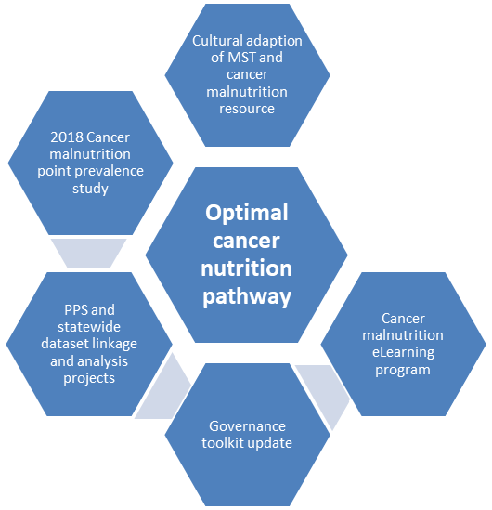

*Promotion of malnutrition as a quality and safety issue:*

* *SCV/VAHI*
* *Statewide nutrition policy*
* *SCV clinical fasting advisory*

## Optimising the cancer nutrition path

### Current status

This is the major project for the VCMC moving into 2018–19, newly funded by the department’s Cancer Strategy and Development unit. This project aims to explore consumer (patient and carers) experiences and clinician expertise to co-design a cancer nutrition care pathway across the care continuum. This project will be led by Peter Mac (project manager: Jenelle Loeliger; project officer: Sarah Dewar) and will begin in late September 2018, running for 14 months.

### Future directions

This project will build on findings from the Cancer Malnutrition: Feeding Everyone From Hospital to Home project and help to enable greater consistency and quality of nutrition care for patients following a cancer diagnosis. This project will bring together the patient/carer voice in addition to the substantial body of nutrition and cancer evidence including national and international evidence-based guidelines, which will help provide a strong framework for a cancer nutrition care pathway across the continuum of care. Each component of the pathway requires attention because it will help highlight the important considerations of addressing nutrition needs at critical time points in the patient journey following a cancer diagnosis (prehabilitation, during active treatment, post-treatment rehabilitation, transition to primary and community care) and cuts across all health settings and sectors to promote consistent care. Not only will it deliver a pilot-tested cancer nutrition care pathway for health professionals to use in practice but be accompanied by a suite of educational resources that will ensure its implementation is as easy as possible.

## Cultural adaptation of the *Malnutrition screening tool* and associated education resources

### Current status

This is another new project for the VCMC in 2018–19, with project funding received from Western and Central Melbourne Integrated Cancer Services (WCMICS). This project aims to translate and culturally adapt the MST and Peter MacCallum Cancer Centre’s *Preventing weight loss for people with cancer* factsheet into Victoria’s top 10 languages other than English (23, 24). This project will be led by Peter Mac (project manager: Jane Stewart: project officer: Emma McKie) and will begin in October 2018, running for 12 months, with a formal evaluation after a further 12 months.

### Future directions

This project will build on findings from the phase III MVCS project Improve Methods for Malnutrition Identification in CALD Populations completed in 2016–17 (12). This project will enable health professionals to have a malnutrition screening tool available to them that is culturally appropriate for patients from a culturally diverse background.

## Cancer malnutrition point prevalence study 2018

### Current status

The 2018 cancer malnutrition PPS will be conducted in July 2018 and is being enabled through a partnership between Peter Mac, all participating health services, WCMICS and the department (Figure 3). This work is being conducted without dedicated funding and will be led by Peter Mac (project lead: Belinda Steer and participation from health services is encouraged but voluntary).

The phase III MVCS program project Establish Sustainable Methodology for Repeat Cancer Malnutrition Point Prevalence Study (2)developed the new methodology that is now collected and based in a REDCap database. Improvements to the 2016 version of the database have been made for the 2018 PPS (malnutrition is now automatically identified in database; sites can only see/change their own data).

WCMICS is providing valuable support for adjustments and troubleshooting with the REDCap database and will provide assistance with data analysis and reporting following data collection. Further enhancements to the process were made through establishing research agreements between Peter Mac and each participating health service (with no end date), rather than biennially, supporting long-term efficiencies and the sustainability of future PPSs.

Figure 3: Cancer malnutrition PPS partnership project collaborators

### Future directions

The results of the 2018 cancer malnutrition PPS will be published in a summary report following the conclusion of the study and after all data analysis is completed. Data linkage and the potential for further analysis of the 2018 cancer malnutrition PPS dataset (and subsequent PPS datasets) is currently under investigation, with one focus of analysis being malnutrition coding within the VAED. Ongoing expansion of the cancer malnutrition PPS to other Victorian health services (public and private) and potentially interstate will be investigated in the future to enable greater benchmarking and learning.

## Malnutrition in Cancer eLearning: furthering education program

### Current status

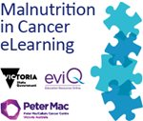This joins the suite of projects for the VCMC in 2018–19 as a Peter Mac funded update of the Malnutrition in Cancer eLearning program. The Malnutrition in Cancer eLearning program, hosted on the eviQ Education website, was developed in 2014 within phase II of the MVCS program (25). An evaluation of the program’s effectiveness was undertaken within phase III of the MVCS program 2016–17, which demonstrated it was an effective platform to improve and sustain clinician knowledge and practice relating to malnutrition.

This project aimed to review, update and re-launch the eLearning program. This project was led by Peter Mac (project lead: Lauren Atkins) and began in May 2018, with completion planned for December 2019.

### Future directions

This project will review and update the eLearning program through literature, key stakeholder feedback and incorporating relevant findings of the Cancer Malnutrition: Feeding Everyone From Hospital to Home project (specifically around the education needs/requests of GPs and practice nurses, the education needs of dietitians and to incorporate the VCMC program’s ‘new look and feel’). In addition, the eLearning program will be re-launched and consideration given to the ongoing sustainability of the program.

## Malnutrition governance toolkit update

### Current status

The *Malnutrition governance toolkit* was developed in 2014 within phase II of the MVCS program. A project to evaluate the program’s effectiveness and to support its implementation was undertaken within phase III of the MVCS program 2016–17, which demonstrated the toolkit was highly regarded within health services and a benchmarking pilot of two common malnutrition indicators was completed. Investigation into work and funding required to update the toolkit are underway.

### Future directions

Once the scope of the work and funding are secured, this project would aim to review and update the toolkit through key stakeholder feedback, incorporating findings of theCancer Malnutrition: Feeding Everyone From Hospital to Home project (specifically around the second edition of the NSQHS Standards and the addition of a primary care/community chapter), and ensure appropriate sustainability plans are put in place (7).

# Communication and collaboration

## Community of Practice evaluation

The Community of Practice (CoP) meetings for the MVCS program of work were established within phase III and have continued into the 2017–18 program based on high satisfaction and success. The broad aim of the CoP meetings is to provide a forum for participants to interact, share their practice, deepen their knowledge of nutrition care and assist in guiding the statewide projects.

Three CoP meetings were held within the main project timelines of the 2017– 2018 program of work (February, May and August 2018). Meetings were held at Peter Mac’s Melbourne campus and participation was open to interested health professionals (consideration was given to alternative venues but cost is a barrier). An evaluation of each CoP meeting was completed. A typical meeting ran for three hours including:

* one to three invited speaker presentations (variety of topics chosen to align with current projects and identified gaps)
* presentation update of all relevant MVCS projects by project managers/leads
* a mastermind session – this was a new addition in the 2017–2018 program, designed from previous CoP feedback and an opportunity to improve connectivity among participants (these sessions were designed as small, group solution-based brainstorming and allowed for detailed discussions of a practice issue/dilemma relating to cancer malnutrition and/or current projects)
  + a short morning tea and lunch served at the conclusion of the meeting.

### Aims

To evaluate the perceived value and effectiveness of the two completed CoP meetings within the MVCS program of work held throughout 2017–2018.

### Method

A questionnaire was developed and provided both in hard copy and sent to all attendees via email with an online link (SurveyMonkey) after each CoP meeting. Questions were designed to capture participants’ views.

### Summary of findings

* Between 25 and 30 participants were in attendance at both CoP meetings, with 24 and 23 participants completing evaluations at the February and May 2018 meetings respectively.
* We had relatively broad representation of CoP participants. Collectively at both meetings, the largest group was made up of acute oncology dietitians (47 per cent), followed by health service dietetic managers (21 per cent) and smaller representation from primary care clinicians, government/other agencies, community dietitians and other health professionals.
* Overall, participants were ‘very satisfied’ with the invited speaker and project update presentations (87 per cent at the February meeting and 100 per cent at the May meeting).
* Participants were ‘very satisfied’ with the mastermind sessions (94 per cent at the February meeting and 100 per cent at the May meeting). Feedback was very positive regarding this new addition to the meetings, in particular because it allowed the brainstorming of ideas and ability to find collaborative solutions/pathways forward. Some comments to consider for future CoP meetings included that the session felt somewhat rushed.
* Further suggestions for future speakers were useful and used for the May meeting. Others to consider in future include: health professionals’ views on nutrition (GPs, oncologists, surgeons) and discussion about non-nutrition but transferable/related projects.

### Recommendations

* Feedback from participants to be incorporated into planning of future CoP meetings.
* The CoP meetings are a highly valued and an effective enabler of collaboration as part of the MVCS program of work. A similar format should continue in the future to support collaboration, communication and professional development within the MVCS program of work.
* CoP meetings enable key stakeholders and those involved with providing nutrition cancer care to:
  + - meet regularly and directly to connect with others to share experiences, tools and resources
    - receive interim project updates and enable face-to-face involvement in project group meetings
    - network and form collaborations
    - engage with external speakers and attend professional development on relevant topics of interest.

## e-newsletters

Three e-newsletters were developed and distributed to key stakeholders throughout the 2017–18 program of work. The purpose of the e-newsletter was to broadly communicate updates and key information to key stakeholders and those interested in the statewide cancer malnutrition projects and/or program of work. These e-newsletters included updates of projects in progress, opportunities for involvement in project surveys and key dates for upcoming events/deadlines and served as a general project communication tool. Further work to evaluate and expand the participant reach for both our CoP meetings and the e-newsletters was undertaken in 2018–19.

## Program branding

One aim of the project Cancer Malnutrition: Feeding Everyone From Hospital to Home was to modify (through packaging/branding) the existing cancer malnutrition resources developed by the MVCS program of work. It was established that a new ‘look and feel’ should be developed, rather than a logo for branding of these resources. Graphic design company Green Scribble were engaged to develop this ‘look and feel’ based on the project steering committee branding brief. Several branding concepts were explored and reworked, with consensus on the idea of ‘coming to the table’ best representing a place to both eat and collaborate. The name of the program of work was also revised to become the Victorian Cancer Malnutrition Collaborative (VCMC) to better represent the program’s focus on managing cancer malnutrition across the continuum of care and not just within health services (previously known as Malnutrition in Victorian Cancer Services). The final VCMC ‘look and feel’ concept (the main banner) is shown in Figure 4. The concept has been provided by the design company in many templated forms (email banner, factsheets, e-newsletters, agenda/minutes, reports, presentations) and will be incorporated onto all program materials moving forward. It can have health service/organisation logos added where appropriate.

Figure 4: The Victorian Cancer Malnutrition Collaborative (VCMC) new ‘look and feel’



# Program of work outcomes, lessons, challenges and enablers

The MVCS program of work for 2017–18 focused on one major funded project; however, in addition, the collaborative has progressed a number of other pieces of work through promotion, commitment and engagement with others. Notably, the 2018 publication of collective work from the 2012 and 2014 cancer malnutrition PPSs in the peer-reviewed journal *Clinical Nutrition* titled ‘Prevalence of malnutrition and impact on clinical outcomes in cancer services: a comparison of two time points’, is a great outcome for the MVCS collaborative (3). Outcomes, lessons, challenges and enablers for conducting similar collaborative projects are summarised here under themed headings.

|  |
| --- |
| Stakeholder engagement  Engagement by dietitians across all sectors was excellent, with the response rate to the dietitian questionnaire exceeding expectations. Recruitment and survey uptake among GPs and GPNs proved more difficult whereby an incentive had to be added to increase recruitment. Targeting and attending professional development events for GPs demonstrated the most effective means for survey completion. In general, we had outstanding engagement from our project steering committee members and broader stakeholders, which enabled broad outputs of the main project. |

|  |
| --- |
| Cancer malnutrition as a multidisciplinary issue across the care continuum  The questionnaire for dietitians, GPs and GPNs were effective in highlighting gaps in practice in relation to cancer nutrition care, most notably the poor transition of nutrition care between the acute and community sectors. The project validated the need to broaden the program of work’s scope to reach outside of the hospital setting and into the primary care and community sector, whereby GPs, GPNs and dietitians all felt the responsibility for good nutrition care sat with them. The downward trend in cancer malnutrition prevalence in Victorian health services over time (from 31 per cent in 2012, 26 per cent in 2014 to 23 per cent in 2016) is a very positive indication of improvements; however, it also highlights that dietitians cannot be the only workforce to address the issue of malnutrition; it must be seen as a multidisciplinary problem. The new program name (VCMC) and branding now reflects the focus of cancer malnutrition across the care continuum, which will become the focus for the 2018–19 program of work and beyond. |

|  |
| --- |
| Collaboration is key  The entire program of work has been shaped since 2012 to ensure collaboration and input from a broad range of stakeholders is central to all projects. The use of a detailed communication strategy within the main project enabled relevant stakeholder engagement, consideration of a high number of ideas, greater information sharing and linkages to groups not previously engaged, resulting in additional project outputs not anticipated in the original project plan such as the SCV clinical advisory on prolonged fasting (first in Victoria). Challenges for the project came with GP and GPN engagement within the primary care sector, which is relatively well documented. Scoping, relationship building and pursuing broad options for funding has resulted in positive outcomes for the 2018 cancer malnutrition PPS (with support from WCMICS) and the Cultural Adaptation of the MST project (funding from WCMICS). The large number of health services participating in the PPS indicates the commitment of Victorian health services to the collaborative study, leading to a large dataset with high reliability and integrity. |

|  |
| --- |
| System approach to improvements  The main project was exploratory in nature, looking into knowledge, nutrition practice and education needs in the primary care and community sector. The needs identified through surveying GPs, GPNs and dietitians have led to possible solutions to address the gaps. Closing these gaps has the ability to help and influence a large number of health professionals and patients, as well as more broadly across the entire health sector.  Work within the 2017–18 program has not been limited to one health service or area of health, therefore project outcomes are more likely to have greater applicability and transferability. We faced challenges with the promotion of a statewide malnutrition indicator because this required a huge amount of awareness raising to various groups at the state level. This activity, however, resulted in good stakeholder engagement, and the use of prior PPS and project data enabled some wins such as the inclusion of cancer malnutrition as an indicator in the *Victorian cancer plan monitoring and evaluation framework* and submission of the first Victorian clinical advisory on prolonged fasting to SCV.  The MVCS collaborative will continue to look for further recognition from government and policymakers for cancer malnutrition quality indicators and higher participation rates for MVCS activities such as the PPS. This may help lead to new policies, indicators and drivers of improved system solutions to help reduce the cancer malnutrition burden. Within the 2018–19 program of work, the translation and cultural adaptation of the MST into other languages is an excellent example of a system-wide approach to an improvement that is likely to have a national, and potentially international, reach. |

# Recommendations and future actions

The 2017–18 MVCS program of work has elicited a number of future directions. The following recommendations with associated actions have been formed through considering the outcomes of the main project Cancer Malnutrition: Feeding Everyone From Hospital to Home, the cancer malnutrition PPS and progress with other initiatives progressed within the MVCS program of work.

## Key recommendations

1. **Improvements have been made; however, gaps in nutrition cancer care continue to exist across a patient’s continuum of care.**

The 2017–2018 program of work has clearly highlighted that practices relating to cancer malnutrition are poor in the transition between hospital and primary care, nutrition care in the primary and community setting is inconsistent and clinicians believe ‘at risk’ and malnourished patients are being missed. Inconsistencies in clinical care continue to exist across health services, primary and community care, and guidance and tools to better support clinicians are warranted.

**Actions:**

Develop a cancer nutrition care pathway that provides guidance for evidence-based and appropriate care for patients at critical time points across the continuum of care. This department-funded project Optimising the Cancer Nutrition Path will enable the development and testing of a clinical pathway that is co-designed by patients/carers and health professionals.

The WCMICS-funded project Cultural Adaptation of the Malnutrition Screening Tool (MST) and Associated Education Resources within the 2018–19 VCMC program of work will help address this recommendation through making the translated and culturally adapted MST widely accessible. This will enable malnutrition screening to be available for a large proportion of patients, which has not been possible previously.

1. **Targeted and easily-accessible education and resources on cancer malnutrition are needed for health professionals.**

GPs, GPNs and dietitians in the primary and community care setting want more education and resources about cancer malnutrition to use in practice. Clinicians expressed that they need greater access to malnutrition screening tools, best practice nutrition advice for patients at risk or with cancer malnutrition, and patient information relating to cancer malnutrition.

**Actions:**

Update existing MVCS resources based on clinician feedback including:

* + - the Malnutrition in Cancer eLearning program, as planned in 2018–19
    - the *Malnutrition governance toolkit*, as being investigated in 2018–19
    - the Cancer Council’s *Understanding malnutrition and cancer* factsheet (for patients) within the Cultural Adaptation of the Malnutrition Screening Tool (MST) and Associated Education Resources project and development of an *Understanding malnutrition and cancer for health professionals* factsheet (host to be determined) and any other identified education resources required within the Optimising the Cancer Nutrition Path project in 2018–19.

1. **Cancer malnutrition awareness is increasing but it remains an under-recognised quality and safety issue in health care.**

Malnutrition is not reported within VAHI or as an indicator within any other statewide framework. Malnutrition coding is reported within the VAED; however, there is no statewide malnutrition policy in place in Victoria. Positively, malnutrition is now included in the NSQHS Standards (second edition) to take effect within accreditation standards in health services from January 2019, and a cancer malnutrition indicator will be included in the upcoming *Victorian cancer plan monitoring and evaluation framework*. In addition, the Cancer Malnutrition: Feeding Everyone From Hospital to Home project (alongside other external work) has demonstrated significant steps forward in raising the profile of the issue of malnutrition as demonstrated through input into the VAHI consultation (to suggest malnutrition be added as a mandatory data element) and the first SCV Clinical Advisory in relation to prolonged fasting.

**Actions:**

VCMC team to investigate with SCV or other agencies the potential for a statewide nutrition care policy and/or malnutrition indicator within relevant quality, safety and risk frameworks. By using the VCMC program of work as an exemplar (highlighting project outcomes and PPS data to date) it may help to promote the value of malnutrition being recognised as a statewide quality and risk issue.

Local promotion of malnutrition as a quality and risk indicator or key performance indicator within health services, primary and community care.

1. **Further analysis of statewide cancer malnutrition data is required.**

To date, the biennial cancer malnutrition PPS has been conducted through collecting de-identified data. This has not allowed data linkage, for example, to malnutrition coding in the VAED/other linked datasets, or investigation into other clinical outcomes relating to malnutrition in the VAED/other linked datasets. In phase I, a VAED coding analysis was conducted that indicated there was a large gap between inpatient cancer malnutrition prevalence (57 per cent) and the statewide malnutrition coding in the VAED of a matched cohort (7 per cent). This highlighted that in 2012 the VAED did not accurately reflect what was occurring in clinical practice. To allow for malnutrition coding in the VAED to be used as a reliable data source (as a statewide nutrition indicator), improvements in this data source must be addressed and monitored.

**Actions:**

To conduct further data linkage of cancer malnutrition PPS data and malnutrition coding data in the VAED (and/or other linked datasets) to understand and quantify any gap in 2018 and beyond, and develop recommendations to improve malnutrition coding data integrity in the VAED (or other linked datasets).

In addition to addressing the key recommendations stated in this report, the VCMC will continue to work with existing and developing programs (Australian Cancer Survivorship Centre, other Australian jurisdictions on nutrition initiatives (Dietitians Association of Australia, Clinical Oncological Society of Australia, COSA Nutrition Group)) to ensure ongoing work complements but does not duplicate.

# Appendix 1: Cancer Malnutrition: Feeding Everyone From Hospital to Home project – factsheet

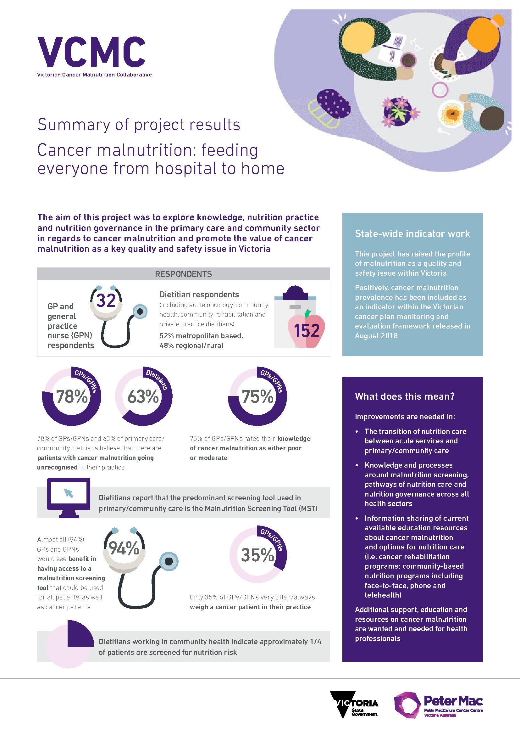

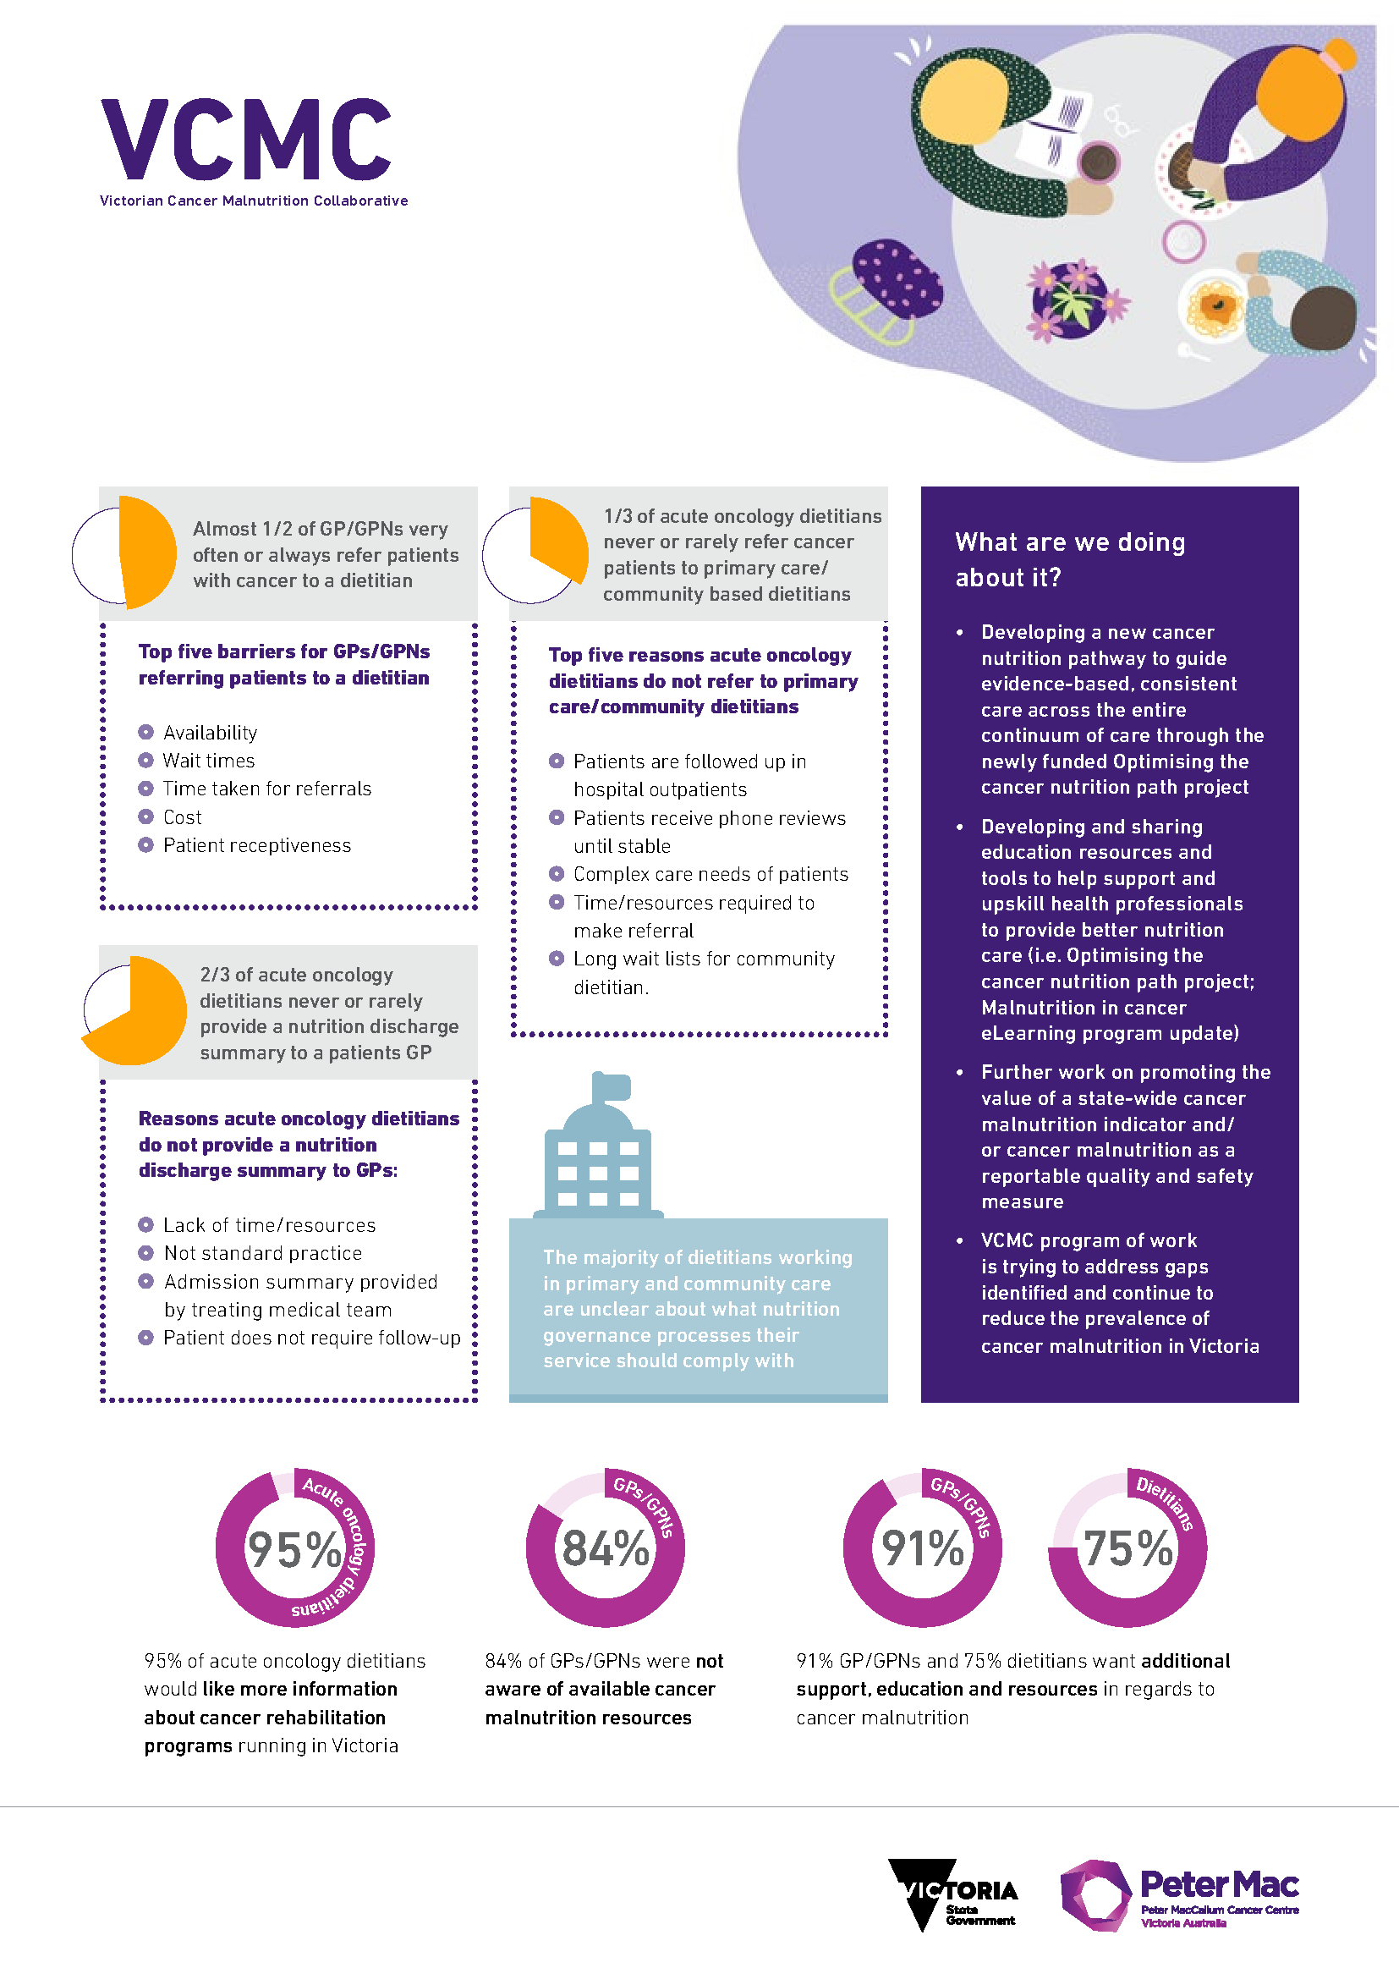

# Appendix 2: Cancer malnutrition point prevalence study 2016: final results – factsheet

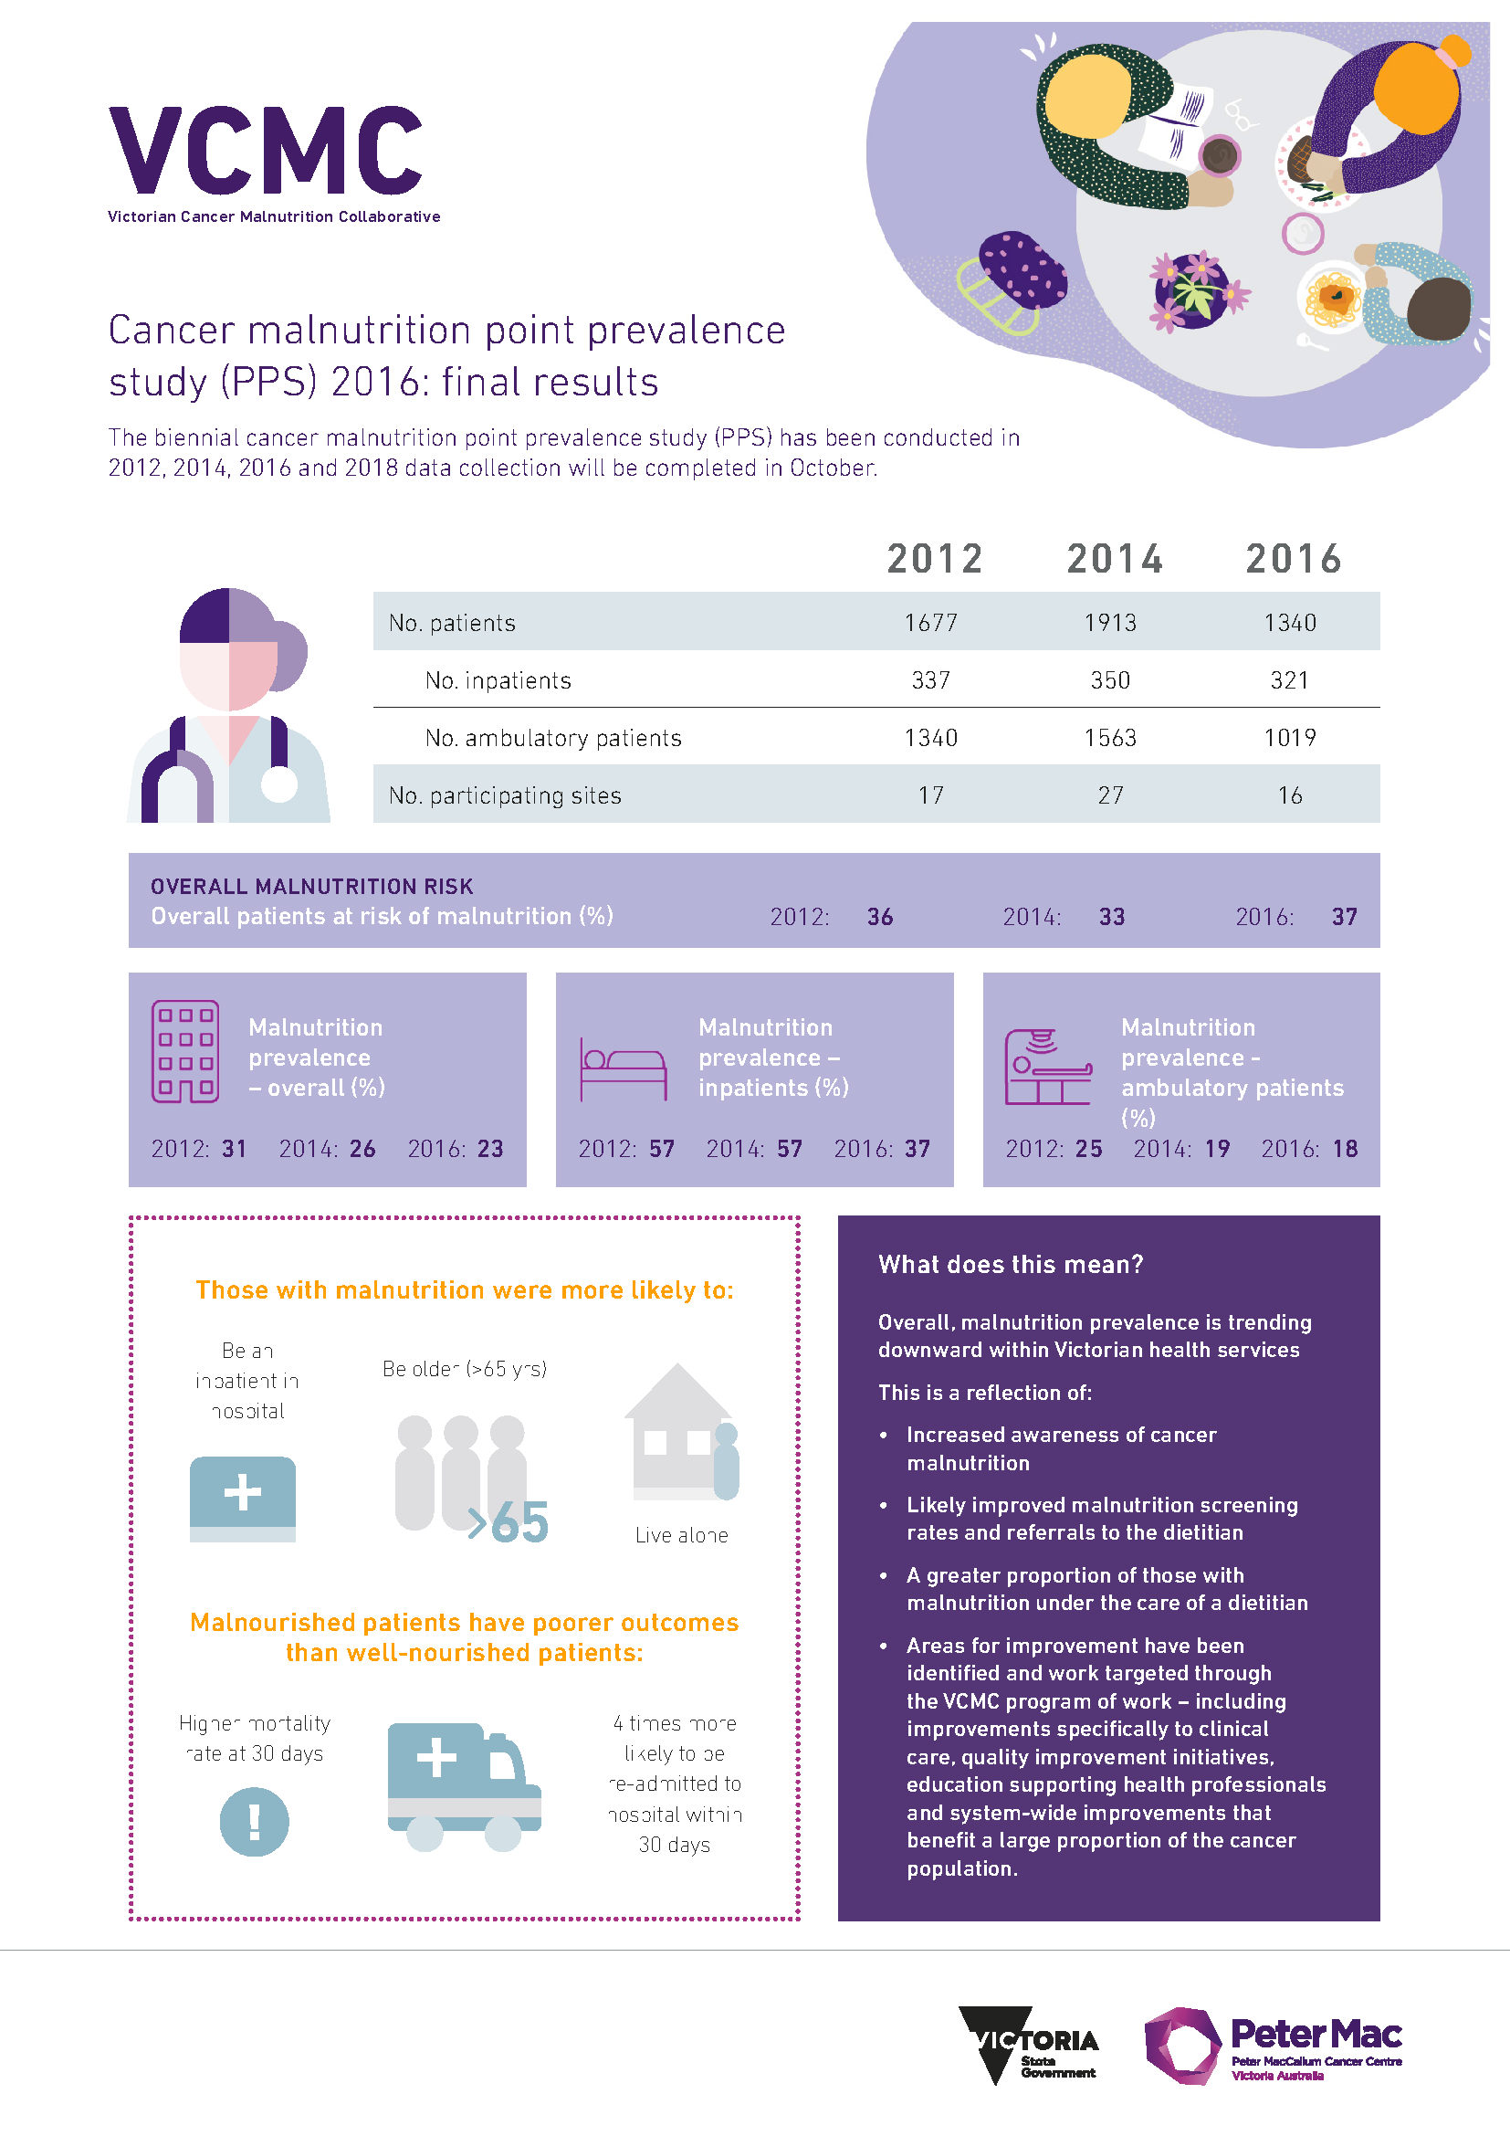

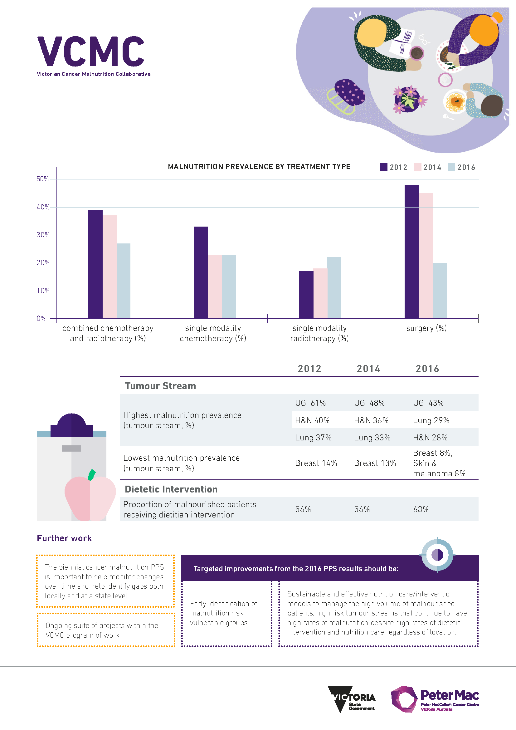

# Appendix 3: The Victorian Cancer Malnutrition Collaborative program of work at a glance – factsheet

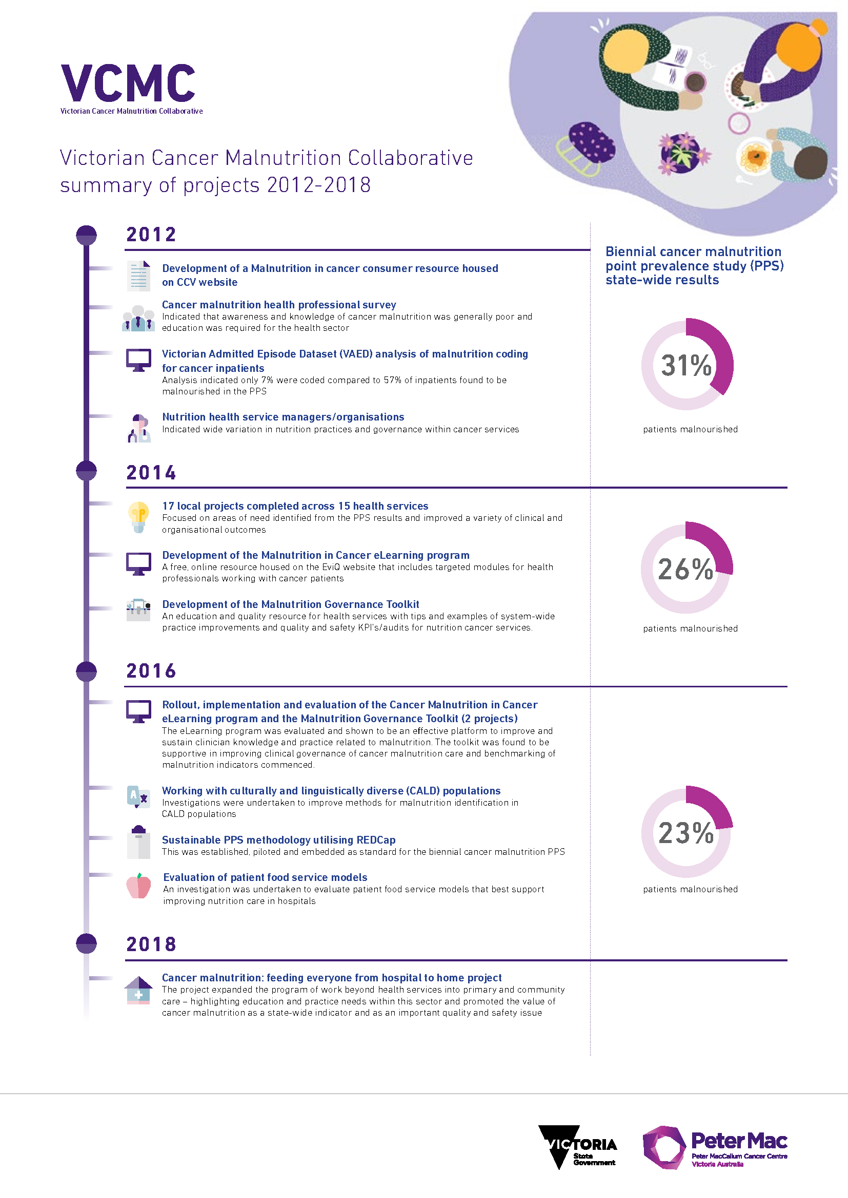

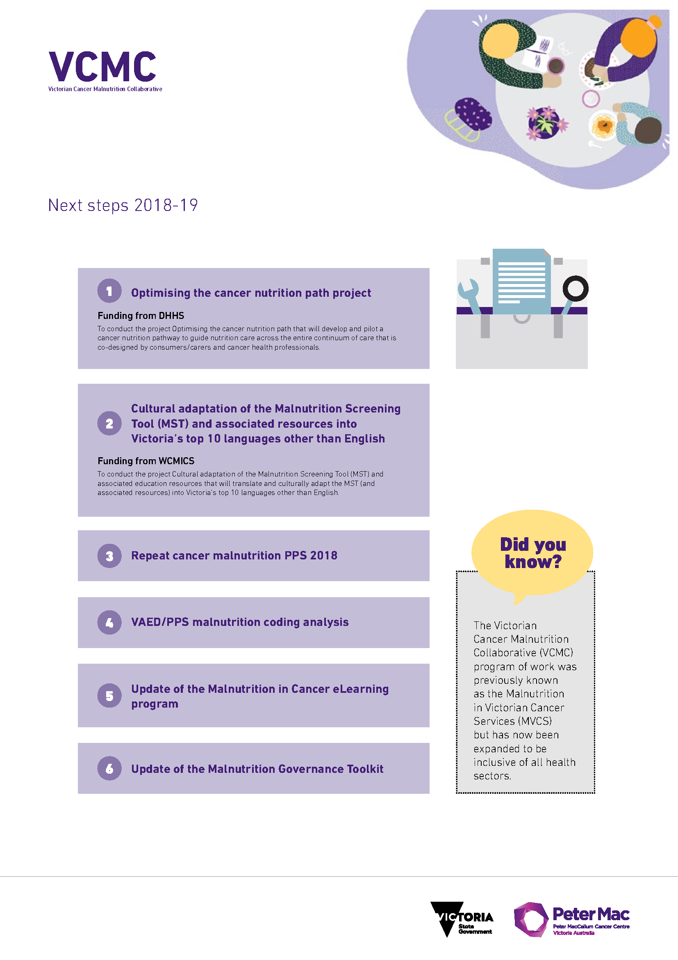

# Abbreviations

CoP Community of Practice

GP general practitioner

GPN general practice nurse

NSQHS National Safety and Quality Heath Service Standards

MST Malnutrition Screening Tool

MVCS Malnutrition in Victorian Cancer Services

PPS point prevalence study

SCV Safer Care Victoria

VAED Victorian Admitted Episode Dataset

VAHI Victorian Agency for Health Information

VCMC Victorian Cancer Malnutrition Collaborative

WCMICS Western and Central Integrated Cancer Services

# References

1. Cederholm T, Jensen GL, Correia M, Gonzalez MC, Fukushima R, Higashiguchi T, et al. GLIM criteria for the diagnosis of malnutrition: a consensus report from the global clinical nutrition community. Clin Nutr. 2018 Feb;38(1):1-9.
2. Steer B MK, Kiss N, Loeliger J. Malnutrition in Victorian Cancer Services – Cancer Malnutrition Point Prevalence Study 2016 summary report. Department of Health, editor. Melbourne: 2018.
3. Marshall KM, Loeliger J, Nolte L, Kelaart A, Kiss NK. Prevalence of malnutrition and impact on clinical outcomes in cancer services: a comparison of two time points. Clin Nutr. 2019 Apr;38(2):644-51.
4. Arends J, Bachmann P, Baracos V, Barthelemy N, Bertz H, Bozzetti F, et al. ESPEN guidelines on nutrition in cancer patients. Clin Nutr. 2017;36(1):11-48.
5. Freijer K, Tan SS, Koopmanschap MA, Meijers JM, Halfens RJ, Nuijten MJ. The economic costs of disease related malnutrition. Clin Nutr. 2013;32(1):136-41.
6. Arends J, Baracos V, Bertz H, Bozzetti F, Calder P, Deutz N, et al. ESPEN expert group recommendations for action against cancer-related malnutrition. Clin Nutr. 2017;36(5):1187-96.
7. Australian Commission on Safety and Quality in Health Care. National Safety and Quality Health Service (NSQHS) Standards: second edition <https://www.safetyandquality.gov.au/our-work/assessment-to-the-nsqhs-standards/>: ACSQHC; 2018.
8. Department of Health and Human Services. Victorian cancer plan monitoring and evaluation framework <https://www2.health.vic.gov.au/about/health-strategies/cancer-care/victorian-cancer-plan-monitoring-and-evaluation>: State Government of Victoria; 2018.
9. Pressoir M, Desne S, Berchery D, Rossignol G, Poiree B, Meslier M, et al. Prevalence, risk factors and clinical implications of malnutrition in French Comprehensive Cancer Centres. Br J Cancer. 2010;102(6):966-71.
10. Isenring E, Zabel R, Bannister M, Brown T, Findlay M, Kiss N, et al. Updated evidence-based practice guidelines for the nutritional management of patients receiving radiation therapy and/or chemotherapy. Nutr Diet. 2013;70(4):312-24.
11. Cederholm T, Barazzoni R, Austin P, Ballmer P, Biolo G, Bischoff S, et al. ESPEN guidelines on definitions and terminology of clinical nutrition. Clin Nutr. 2017;36(1):49-64.
12. Loeliger J, Kiss N. Phase III Malnutrition in Victorian Cancer Services: summary report. Department of Health and Human Services, editor. Melbourne; 2017.
13. The International Statistical Classification of Diseases and Related Health Problems, tenth revision, Australian modification (ICD-10-AM/ACHI/ACS). Darlinghurst, NSW: Independent Hospital Pricing Authority; 2017.
14. Hebuterne X, Lemarie E, Michallet M, de Montreuil CB, Schneider SM, Goldwasser F. Prevalence of malnutrition and current use of nutrition support in patients with cancer. JPEN J Parenter Enteral Nutr. 2014;38(2):196-204.
15. Elia M, Russell C. Combating malnutrition: recommendations for action. Nutrition Advisory Group on Malnutrition BAPEN; 2009.
16. Winter J, Flanagan D, McNaughton S, Nowson C. Nutrition screening of older people in a community general practice, using the MNA-SF. J Nutr Health Aging. 2013;17(4):322-5.
17. Leggo M, Banks M, Isenring E, Stewart L, Tweeddale M. A quality improvement nutrition screening and intervention program available to Home and Community Care eligible clients. Nutr Diet. 2008;65(2):162-7.
18. Visvanathan R, Macintosh C, Callary M, Penhall R, Horowitz M, Chapman I. The nutritional status of 250 older Australian recipients of domiciliary care services and its association with outcomes at 12 months. J Am Geriatr Soc. 2003;51(7):1007-11.
19. Guest J, Panca M, Baeyens J, de Man F, Ljungqvist O, Pichard C, et al. Health economic impact of managing patients following a community-based diagnosis of malnutrition in the UK. Clin Nutr. 2011;30(4):422-9.
20. Stewart J SB, Loeliger J Cancer malnutrition: feeding everyone from hospital to home final report. Department of Health, editor. Melbourne; 2018.
21. Marshall K, Loeliger J. Investigating practices relating to malnutrition in Victorian cancer services – full technical report. Department of Health, editor. Melbourne; 2012.
22. Loeliger J, Kiss N. Phase II Malnutrition in Victorian Cancer Services: summary report. Department of Health and Human Services, editor. Melbourne; 2015.
23. Ferguson M, Capra S, Bauer J, Banks M. Development of a valid and reliable malnutrition screening tool for adult acute hospital patients. Nutrition. 1999;15:458-64.
24. Peter MacCallum Cancer Centre. Preventing weight loss for people with cancer [https://www.petermac.org/nutritioninfo](https://urldefense.proofpoint.com/v2/url?u=https-3A__www.petermac.org_nutritioninfo&d=DwMFAg&c=JnBkUqWXzx2bz-3a05d47Q&r=Dbx1DR23EGPRweZxdawbSsx38lZ9WSIQpx3zCZrra2o&m=6u2vAo4ClUN7zRp_MMMcB1Nq0h6dlVkl3ZrsJ1YVOIg&s=8Q3Hw1iiBzRAAsH_ht1-TaILuYfj-Rb4iHkbWvGEnkA&e=) (in English and 10 other languages); 2019
25. eviQ Education. Malnutrition in cancer eLearning program: [https://education.eviq.org.au/courses/supportive-care/malnutrition-in-cancer](https://urldefense.proofpoint.com/v2/url?u=https-3A__education.eviq.org.au_courses_supportive-2Dcare_malnutrition-2Din-2Dcancer&d=DwMFAg&c=JnBkUqWXzx2bz-3a05d47Q&r=Dbx1DR23EGPRweZxdawbSsx38lZ9WSIQpx3zCZrra2o&m=6u2vAo4ClUN7zRp_MMMcB1Nq0h6dlVkl3ZrsJ1YVOIg&s=kT4xFoxLbSmB_lv53H2sVa8KoRKnLYLk7u03S5VMSec&e=); 2019

1. Malnutrition prevalence has been trending downwards over the past six years (31 per cent → 26 per cent → 23 per cent).
2. Upper gastrointestinal, head & neck and lung remain the top three tumour streams with the highest prevalence of malnutrition, consistent with 2012 and 2014 results.
3. The percentage of patients with malnutrition receiving dietetic intervention has improved in 2016 to 68 per cent (56 per cent in 2012 and 2014).
4. Thirty-day mortality rate was 2.5 times higher in malnourished patients.