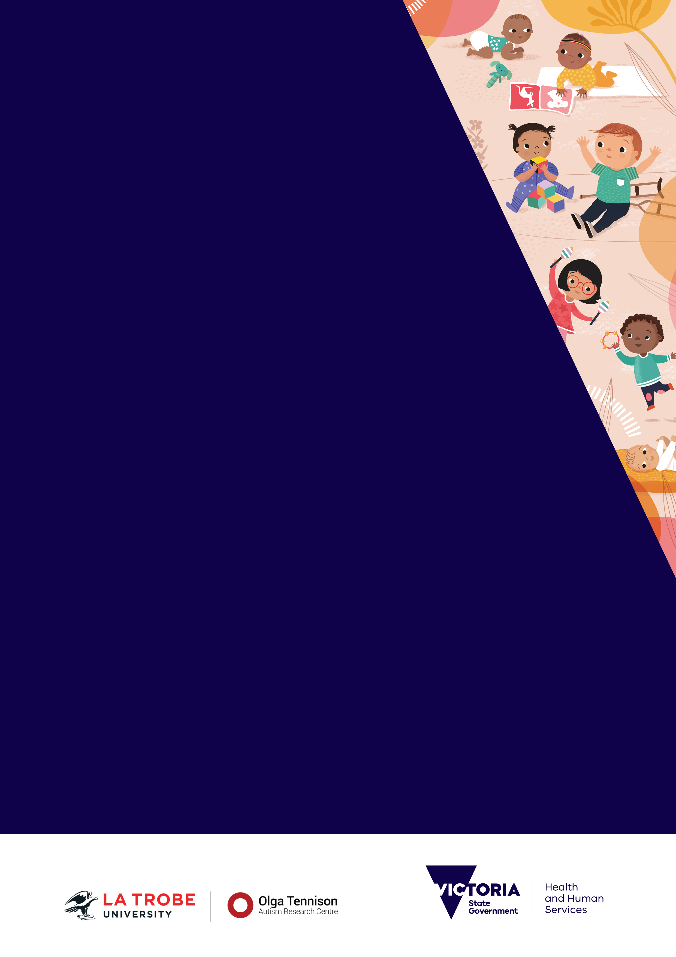
Promoting social attention, interaction and communication skills
Accessible

Acknowledgement
The Victorian State Government funded La Trobe University through its Olga Tennison Autism Research Centre (OTARC) to develop this booklet.

To receive this publication in an accessible format email Maternal and Child Health <MCH@dhhs.vic.gov.au>
Published in Australia by La Trobe University.
© La Trobe University 2019.
First published 2019.
Copyright in this work is vested in La Trobe University.
Material within this work is licensed under a Creative Commons Attribution-Non Commercial-Non Derivatives License.
Enquiries should be made by emailing the Olga Tennison Autism Research Centre at La Trobe University <SACS.Vic@latrobe.edu.au>
Authorised and published by the Victorian Government, 1 Treasury Place, Melbourne under licence from La Trobe University.
Where the term ‘Aboriginal’ is used it refers to both Aboriginal and Torres Strait Islander people. Indigenous is retained when it is part of the title of a report, program or quotation.
ISBN 978-1-925947-70-0 (Print)
ISBN 978-1-925947-71-7 (pdf/online/MS word)
Available online at health.vic - Maternal and child health <https://www2.health.vic.gov.au/maternal-child-health>
Printed by OTARC (August 2019) (1907406)

About this booklet
This booklet is designed for interacting with children aged between 11 months and 30 months. If you would like more information, talk to a Maternal and Child Health Nurse.
Young children are constantly learning. They learn from interactions with other people. If a child has difficulties with their social attention, interaction and communication skills, their ability to learn from others is affected.
Social attention, interaction and communication difficulties can include reduced, infrequent, or inconsistent:
- eye contact
- response to name
- pointing to ‘show’, following gaze
- waving, clapping and other gestures
- copying others
- pretend play
- showing toys to others
- shared smiles
- sharing emotions.
Every child is different.
Using simple and effective strategies matched to their interests and learning style can help them to develop communication and social skills.
Contents
About this booklet 3
Talk 6
Watch and comment 6
Describe what is happening 6
Exaggerate key words for example: 6
Build on what your child says 7
Ask questions 7
Talk tips 7
Show 8
Show what you want your child to do 8
Say what you want your child to copy 8
Use real objects 8
Use gestures and actions 9
Use pictures 9
Show tips 9
Play 10
Toys that encourage communication include: 10
Games to play together include: 11
Play tips 11
Sing 12
Songs appropriate for all ages 12
Songs involving movement 13
Sing tips 13
Read 14
Books appropriate for 12 months and older 14
Books appropriate for 24 months and older 15
Read tips 15
More information 16
Monitoring your child’s social-communication skills at home 16
Workshops and support groups 16
Accessing supports and services 17
Helplines 17
References 18

Talk
Talking to your child helps to develop their:
- understanding of language
- use of language
- vocabulary.

Watch and comment
Talk about the objects, people, actions and events your child is interested in.

Describe what is happening
When playing with your child, talk about what you are doing.
For example, while ‘feeding’ a baby doll, say ‘baby is hungry, baby is eating the food’.
Repeat the sounds and words that your child says.
Pause between words and phrases and wait to see if your child responds or copies what you say.

Exaggerate key words for example:
- ‘Look, a train’
- ‘It’s a dog’
- ‘Give me the book, please’.

Build on what your child says
For example, if your child has:
- no words – use only one word when speaking with them, for example, ‘drink’
- single words – use two words when speaking with them, for example, ‘More drink?’
- two words – use three words when speaking with them, for example, ‘You want drink?’.

Ask questions
Encourage your child to respond by asking questions and then pausing.
Image: Talk with me about everyday things, and things I look at and point to.
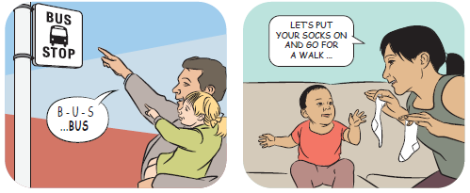
Images courtesy of Raising Children Network <raisingchildren.net.au>.

Talk tips
Speak to your child in the language you know best. Information for parents on the State Government Education and Training website <http://bit.ly/2XhrIdt>.
Raising multilingual and bilingual children on the Raising Children Network <http://bit.ly/2Gp02hp>.

Show
Showing helps children to:
- learn new ways of behaving
- increase understanding
- learn new skills.
You can support your child’s learning and communication by showing them what you are talking about. There are a number of ways you can do this.

Show what you want your child to do
Children learn by watching others. When you have your child’s attention, slowly break down a task and provide step-by-step guidance so they can see what you’re doing.
For example, you can demonstrate how to read a book by showing your child how to turn the pages. You can also show them how to do it themselves by physically guiding their hand.

Say what you want your child to copy
You can verbally model words or phrases for your child to use.
For example, as you give something to your child, say ‘Thank you’.

Use real objects
Showing your child the object you are talking about can help them to understand that they have names.
For example, as you say ‘book’, you hold up the book to show your child.

Use gestures and actions
You can help your child to understand the meaning of your words by adding gestures and actions. Make these movements obvious so your child notices!
For example, gestures include head nod for ‘yes’ and head shake for ‘no’, waving for ‘good-bye’.

Use pictures
Showing your child pictures of what you are talking about can also help them to understand the meaning of your words.
For example, show your child a picture of their shoes, and then say, ‘get your shoes’.
Image: Explore outside and talk with me about what we see.
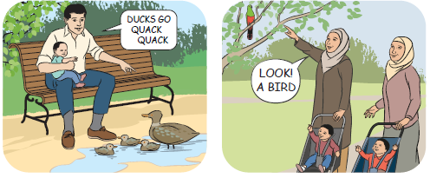
Images courtesy of Raising Children Network <raisingchildren.net.au>.

Show tips
Read Teaching skills to children: different approaches for more information about different approaches to teaching skills to children <http://bit.ly/2KUCHsn> on the Raising Children Network.

Play
Playing teaches children how to:
- use sounds, actions and words as part of a game
- connect with others for social purposes
- problem solve
- take turns.
When playing, follow your child’s lead by joining in with whatever they are doing or the things they are playing with. This makes play enjoyable for both you and your child.
Playing with toys and games together can encourage your child to communicate with you by asking for help, asking for more, taking turns, looking at you, making sounds or saying words, etcetera.

Toys that encourage communication include:
- Bubbles – blow some bubbles for your child to catch. Wait and see if your child will look at you, gesture, or use a sound or word to tell you they want you to blow more bubbles.
- Wind-up toys and music boxes – wait and see if your child asks you for help. Notice if they look at you, gesture, or make a sound when something happens.
- Balls – roll a ball towards your child and then encourage them to roll it back to you.
- Blocks – build a tower and knock it over. Does your child look at you, gesture towards you, or make a sound? Keep some blocks to yourself and see if your child asks for more.

Games to play together include:
Peekaboo – hold up a blanket and say, ‘where’s (child’s name)?’ Then pull blanket down with excitement and say ‘Peekaboo’. Repeat.
Tickles – hold your hands up in front of child and move hands in tickling motion while saying, ‘Tickle, tickle, tickle’.
Chasey / I’m gonna get you – say ‘I’m gonna get you’ several times, as you keep moving closer to your child with your hands out in front of you.
Images: Visit my local playgroup and Give me a plastic bowl or a cardboard box and watch my imagination go wild
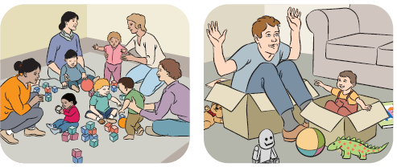
Images courtesy of Raising Children Network <raisingchildren.net.au>.

Play tips
Borrow fun and educational toys, games, puzzles and activities from a toy library! Visit Toy Libraries Australia to find a toy library near you <https://www.toylibraries.org.au>.
Attend a community playgroup or a supported playgroup. Contact Playgroup Victoria to find out about groups in your area <http://playgroup.org.au>.
Enhance your child’s home learning environment with ideas from Small Talk <http://www.smalltalk.net.au> on the Parenting Research Centre website.

Sing
Singing improves children’s:
- confidence and identity
- communication skills
- language
- speech.
Sing songs that use rhyme and repetition.
Sing familiar songs and repeat over and over
After singing the song a few times, pause and watch to see if your child will use their body or words to tell you they want the song to continue.
Add simple actions or movements
You can help your child to copy your actions or movements. Gradually reduce the help you provide them until they are able to copy the actions by themselves.
Try sitting in front of your child when singing
so they can watch your actions.
Remove distractions such as the iPad or television so they can focus on interacting with you.

Songs appropriate for all ages
- This Little Piggy
- Open Shut Them
- Twinkle Twinkle
- Old MacDonald Had a Farm
- Incy Wincy Spider
- Children of the Dreaming
- Inanay.

Songs involving movement
(for children 24 months and older)
- Hokey Pokey
- Ring-Around-a-Rosey
- Sleeping Bunnies
- Head, Shoulders, Knees and Toes
- Row, Row, Row your boat.
Images: Play music and sing and dance with me.
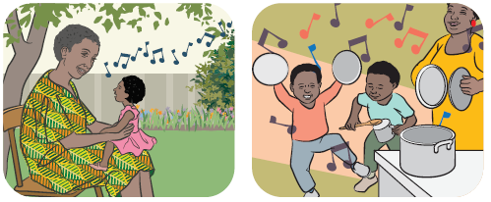
Images courtesy of Raising Children Network <raisingchildren.net.au>.

Sing tips
Watch and learn popular children’s songs and nursery rhymes on the Raising Children’s Network Baby Karaoke page <http://bit.ly/2IzXCy4>
Watch and learn popular nursery rhymes in Aboriginal and Torres Strait Islander languages can be found on the first5forever website <http://bit.ly/2Zdqlyr>.
Watch Aboriginal karaoke Inanay – with lyrics <https://raisingchildren.net.au/guides/baby-karaoke/inanay-with-lyrics>

Read
Reading supports children’s:
- brain and cognitive development
- language skills and vocabulary
- understanding of emotions.
Read books that have good rhyme, rhythm and repetition and readability.
Watch to see what pictures your child looks at and name the object
Ask simple questions about the pictures such as, ‘Where is the dog?’ and watch to see if your child points or gestures.
Pause before saying a certain line or phrase in the book to see if your child will complete it.
Link to your child’s interests Let them choose a book in the library. Show them two to choose from if they find it hard to make a decision.

Books appropriate for 12 months and older
- ‘That’s not my….’ books
- Spot books
- Where is the Green Sheep?.

Books appropriate for 24 months and older
- Brown Bear, Brown Bear
- The Very Hungry Caterpillar
- Wombat Stew
- How the birds got their colours
- Big rain coming.
Images: Read books with me. Help me to hold the book and turn the pages.
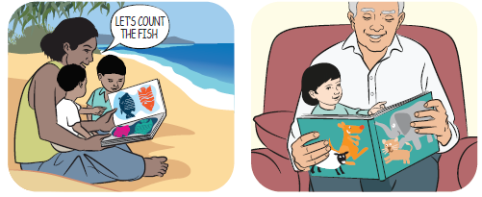
Images courtesy of Raising Children Network <raisingchildren.net.au>.

Read tips
Visit your local library to borrow a range of children’s books for free or attend a storytime session. Visit Public Libraries Victoria to find a library near you <http://publiclibrariesvictoria.net.au>.
Read some tips for sharing books with babies and young children on the Raising Children’s Network <http://bit.ly/2Ghydq4>.

More information

Monitoring your child’s social-communication skills at home
ASDetect <http://asdetect.org>
A free mobile application that parents and caregivers can use to track children’s social-communication milestones and the early signs of autism.
Additional parent resources are available at the La Trobe University Early Autism detection website <http://asdetect.org/for-parents>
Information about autism
Amaze (Autism Victoria) <https://www.amaze.org.au>
The peak body for autism in Victoria, providing information and resources connecting individuals, families and professionals to supports for autism.
Autism Awareness Australia <https://www.autismawareness.com.au>
A not-for-profit autism education and awareness organisation.
The Parenting Spectrum Podcast <https://www.abc.net.au/radio/programs/the-parenting-spectrum>
Raising Children Network <https://raisingchildren.net.au> Research-based information about autism and general child development.
Understanding Autism A short video featuring a young boy called Ned created to help Aboriginal and Torres Strait Islander families understand and recognise the early signs of autism. <https://www.youtu.be/bQcWvYi5EqY>

Workshops and support groups
Early Days <https://www.amaze.org.au/support/early-days>
Amaze has free workshops about autism.
PlayConnect <https://playgroupaustralia.org.au/national-programs/playconnect>
A network of autism-specific playgroups by Playgroup Australia.
My Time <https://www.mytime.net.au>
A parent support program for parents and carers of children with a disability, developmental delay or chronic medical condition.

Accessing supports and services
Early intervention: For information about referral services and supports, and eligibility for the NDIS contact your local Early Childhood Early Intervention (ECEI) partner office <https://www.ndis.gov.au/about-us/locations.html#vic>
The Early Intervention Indigenous Liaison Officer (EIILO) Program <https://www.eiilo.com.au> Provides families in Aboriginal and Torres Strait Islander communities with the tools, language and information to ensure they are confident to visit a GP or paediatrician.
Raising Children Network Therapy Guide <https://raisingchildren.net.au/autism>
Therapy Connect <http://www.therapyconnect.amaze.org.au>

Helplines
Amaze autism information advisor service: 1300 308 699
Maternal and Child Health Line: 13 22 29
Parent Line: 13 22 89

References
The following sources were used in developing this booklet.
Barbaro, J. & Dissanayake, C. (2013). Early markers of Autism Spectrum Disorders in infants and toddlers prospectively identified in the Social Attention and Communication Study (SACS). Autism: International Journal of Research and Practice, 17, 64-86.
Barbaro, J. & Dissanayake, C. (2010). Prospective identification of Autism in infancy and toddlerhood using developmental surveillance: The Social Attention and Communication Study (SACS). Journal of Developmental and Behavioral Pediatrics, 31, 376-385.
Sussman, F. (1999). More than words. Toronto: The Hanen Centre.
Rogers, S., Dawson, G. and Vismara, L. (2012). Early start for your child with autism. New York: Guilford Publications.
ASDetect <http://asdetect.org>
Talk With Me Baby <http://www.talkwithmebaby.org>
Raising Children Network <https://raisingchildren.net.au>

