

Staff-driven sustainability initiatives at Dandenong Hospital
Case study: Conversation Series #3

Overview
Monash Health is the largest metropolitan health service in Victoria and provides services at more than 40 locations including six hospital sites across south-east Melbourne. It employs more than 16,000 staff.
This case study is a practical example of staff-led sustainability initiatives. It provides tips on how to connect with resources that the department has developed and how to link in with the health service’s own environmental management planning process.
Staff from the department’s Sustainability Unit spoke to Roslyn Morgan, Intensive Care Unit (ICU) nurse at Dandenong Hospital’s intensive care unit, who is also on secondment in the role as sustainability officer at Monash Health.

Can you provide some background on how the green initiatives were established within Dandenong Intensive Care Unit?

In 2010 a colleague was conducting home sustainability evaluations as a part of a course she was undertaking. Chatting about this in the tearoom, we thought it would be appropriate to do something like that in our workplace. We got together a group of interested staff in our unit and formed a ‘green group’.
We started by focusing on improved waste practices and by introducing recycling stations. This meant identifying the waste streams already in place, opportunities for recycling, and getting new bins. Education tools specific to local stock and practice were developed and implemented that focused on correct segregation. In 2014 this initiative diverted five tonnes of comingled resources from landfill from the 14-bed ICU alone.
Our stock inventory revealed another obvious target – our use of polystyrene cups. These were removed from the Dandenong ICU in 2010. We were able to take this initiative to the Monash Health Eco Champions Committee, who conducted a larger scale trial with the result that Monash Health has now completely removed polystyrene drinking cups from its inventory. Gradually we introduced more recycling streams such as PVC, single-use stainless steel instruments and bluewrap. These initiatives have been expanded across Monash Health with the support of networks built through Monash Health Eco Champions.

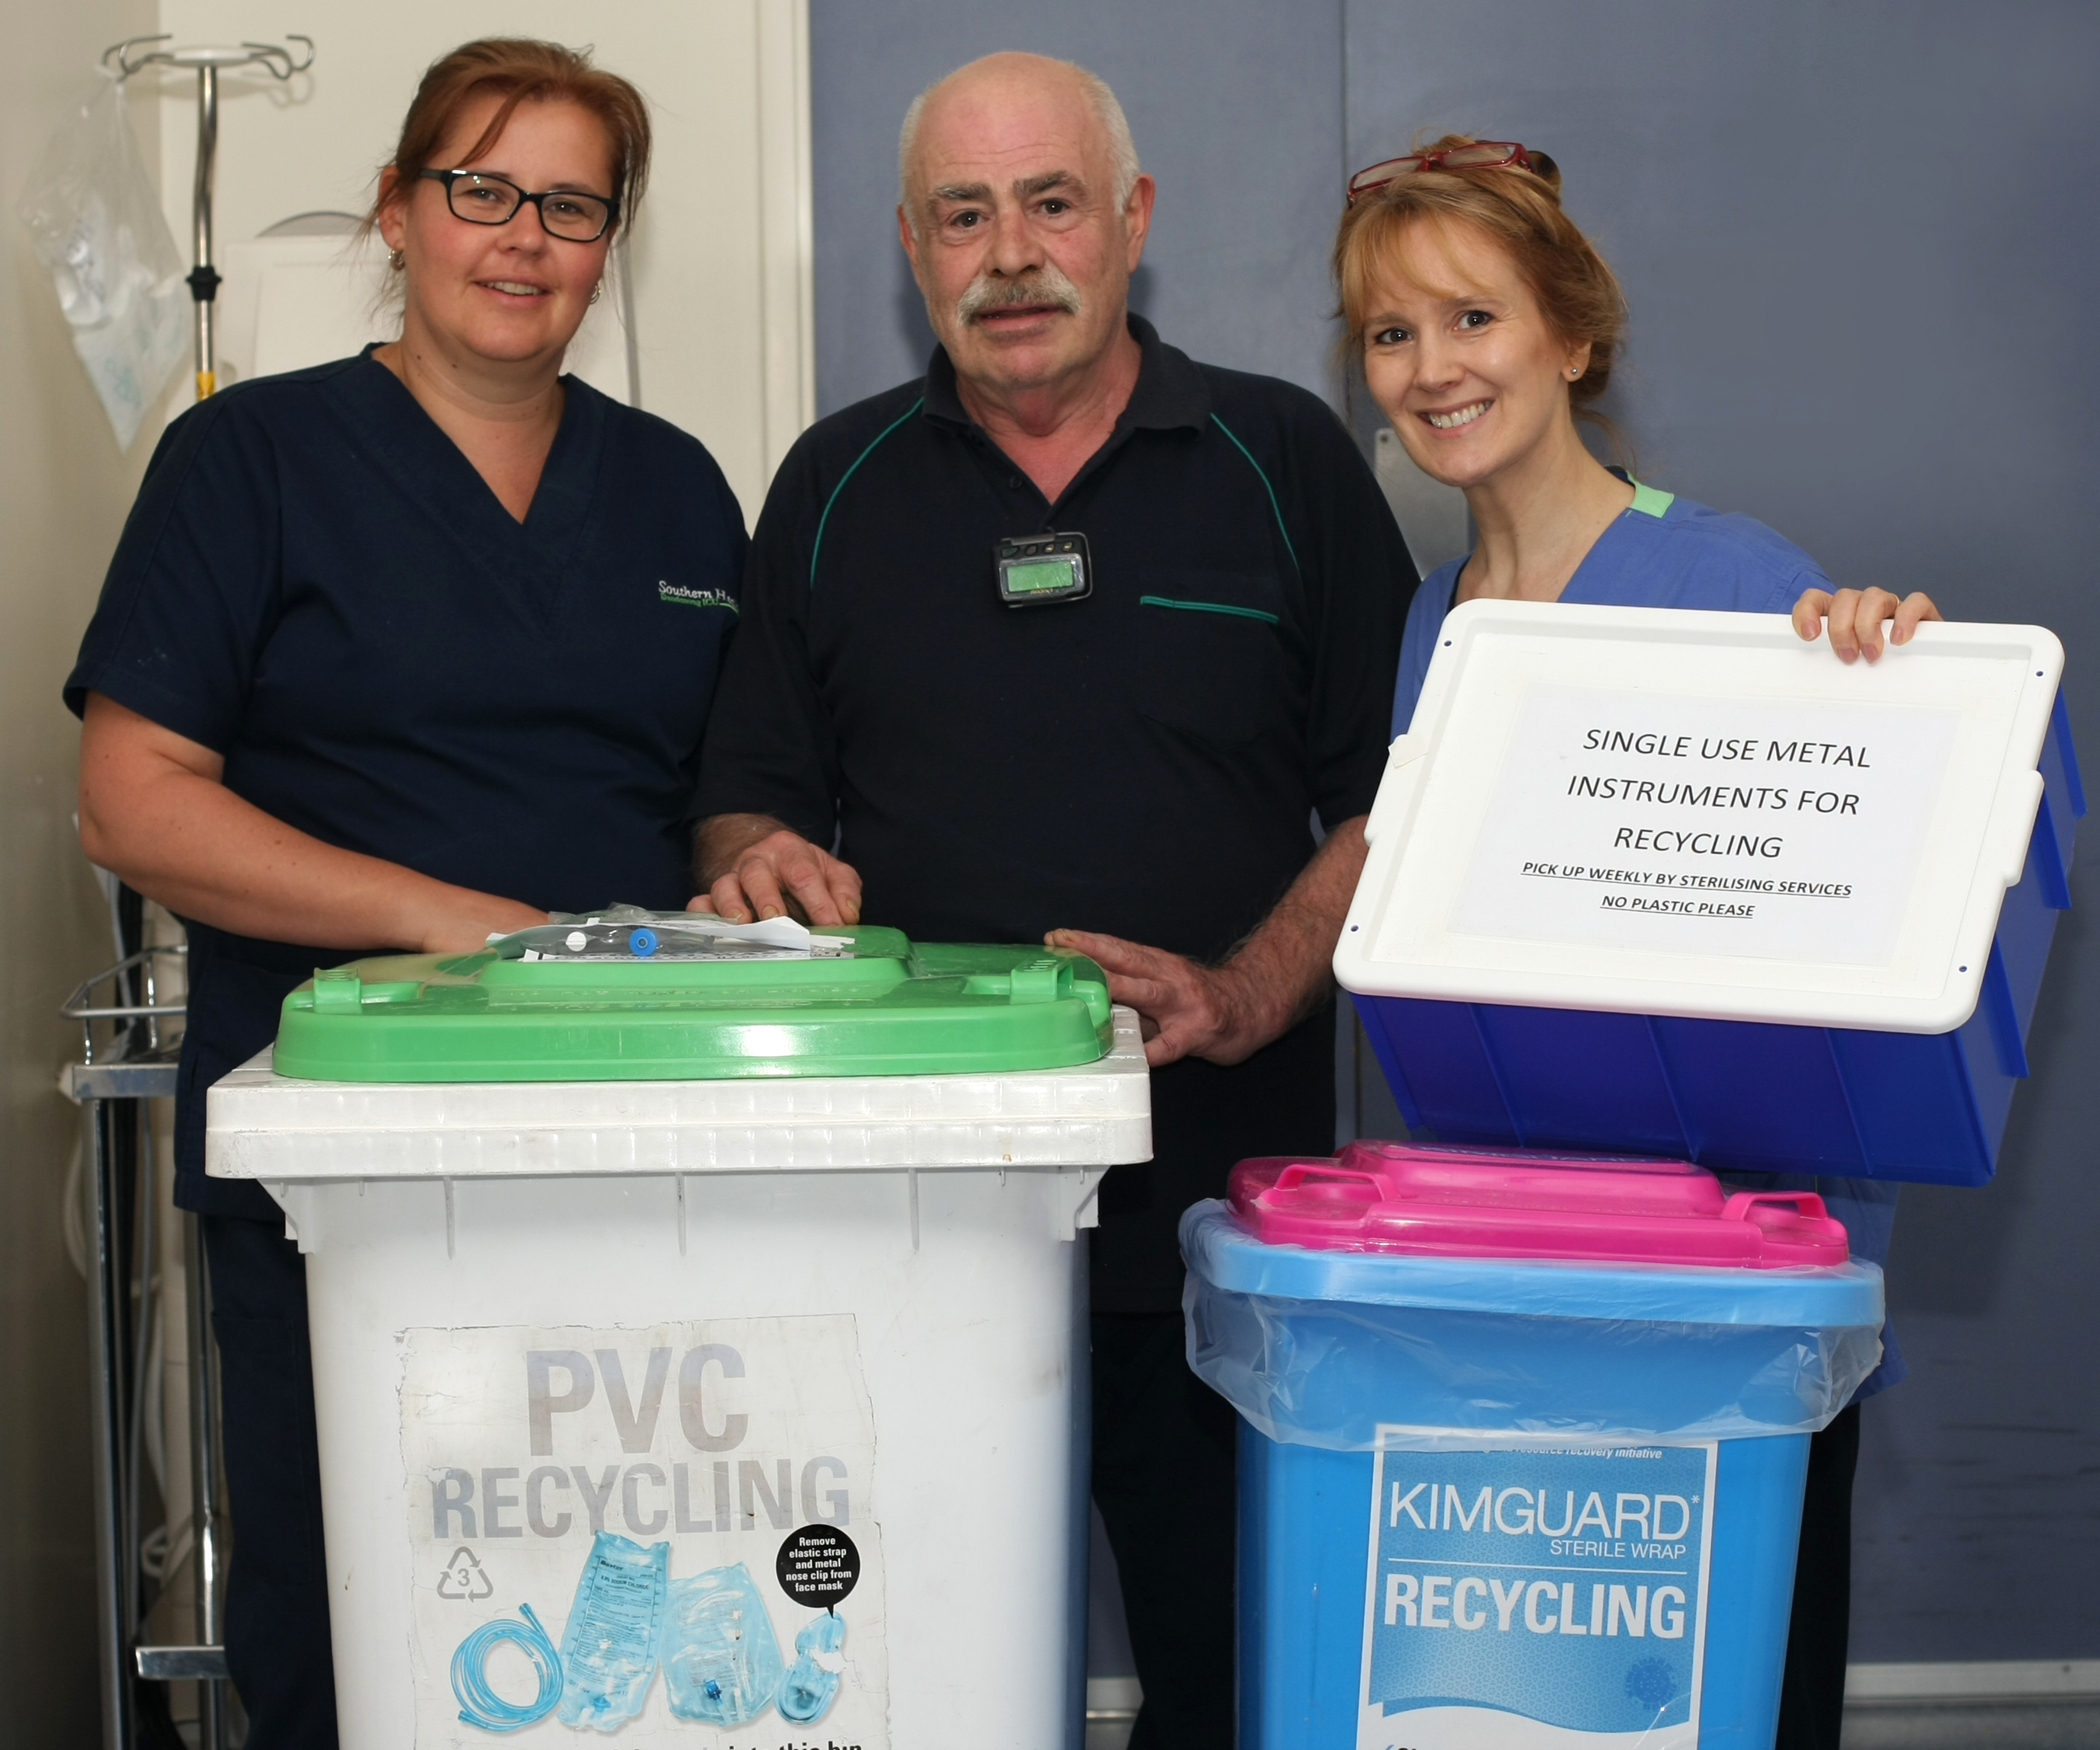
Dandenong intensive care unit recycling initiatives

I heard you have also undertaken redistribution of some less obvious items?
Since 2010 Dandenong ICU has run events on World Environment Day. We decided to try to take this wider than just our department and in 2013 our bra collection for Uplift went health service wide.
The result was a collection of more than 2,000 bras for Uplift to send overseas for distribution to women who do not normally have access. Staff in the Dandenong ICU also sponsored 25 nurse kit bags fully stocked with quality items for nurses in a hospital in the Solomon Islands. Other collections have been nursing and medical textbooks, fob-watches, stethoscopes, children’s books and reading glasses.

When you were first starting out, where did you find information, and what tools were helpful?

We started by collecting relevant policies, plans and statements made by our health service including the Monash environmental management plan. We developed aims and objectives that were in line with those stated by our organisation as we felt it was important to use a shared vocabulary.
We were also interested what other sustainability in healthcare initiatives were occurring both internationally and locally and so internet searches were really useful to find this information.
We also discovered the department’s Waste minimisation in healthcare user guide, which helped by providing evidence of tangible outcomes and approaches, and had examples of what other health services were doing.
Through reviewing the materials it also validated for us the link between human health and that of the environment.
Through the Monash Health intranet, we discovered and joined the Green Champions group (now called Eco Champions). This helped us access information and establish relevant contacts and link to executive support. We deliberately included other key stakeholders such as occupational health and safety, infection control and other support staff.
Through joining Monash Health Eco Champions we also found out about the Green Steps program run by the Monash Sustainability Institute. The program places students with organisations, and through the program we engaged students to undertake research and implement programs, which gave us additional capacity.
The Australian Nursing and Midwifery Foundation (ANMF) has also been a tremendous support and validation, particularly their Environment and Sustainability Conferences. When you start on initiatives like this, you can feel quite isolated. The conferences showed us that we weren’t alone. They have been informative, supportive and also provided networking and encouragement. It was through the ANMF that we found out PVC could be recycled. Within a year, we had PVC recycling in place. The Climate Change and Healthcare Alliance has individual membership available and are tapped into a large diversity of different groups and events, so this is another good resource.
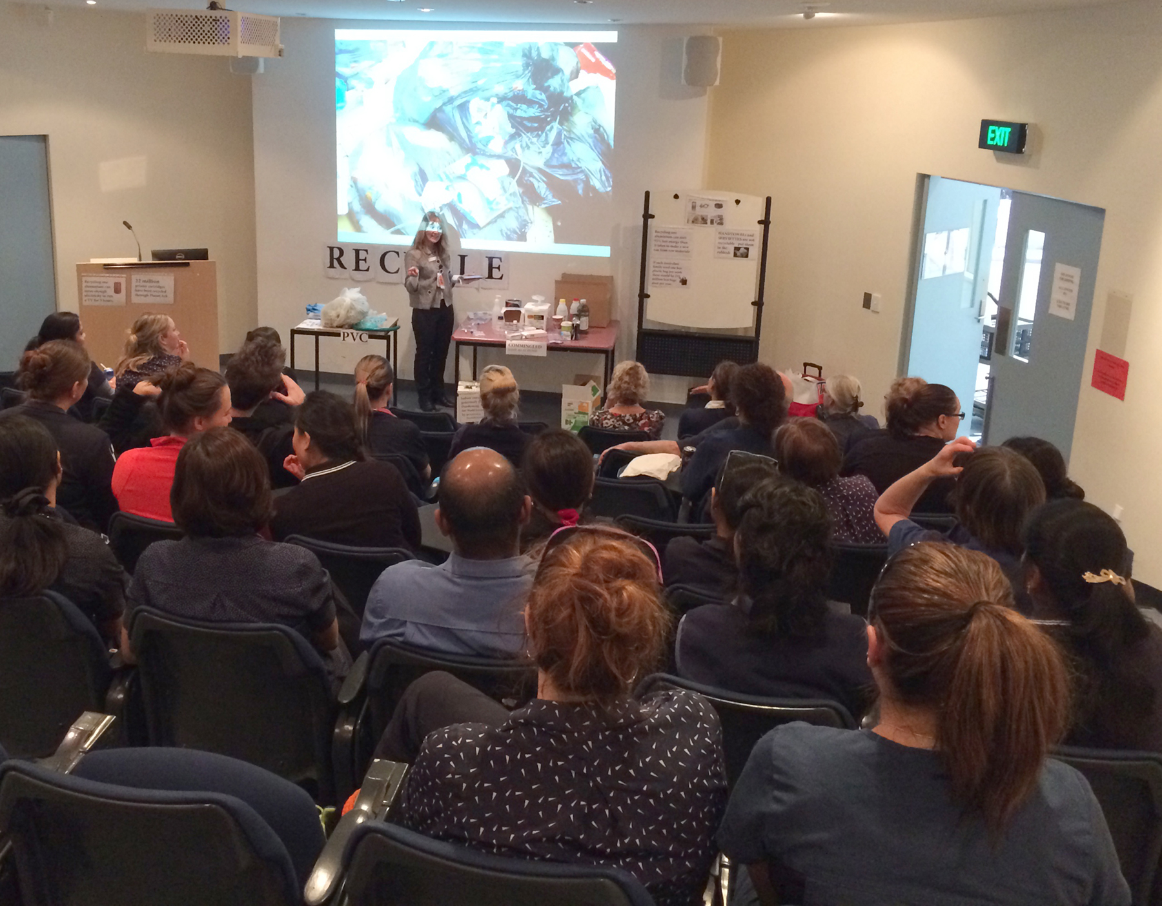
Recycling seminar run by Dandenong ICU at Dandenong Hospital

How important is leadership and management support?
Management support is crucial, and it’s very hard to create change without it. We wouldn’t have got our initiatives off the ground without the support of our nurse unit manager. Joining the Eco Champions group was also very useful because it helped to ensure everyone was working together to address sustainability.

Have you had support of the sustainability officer and how has the initiative sat alongside Monash’s environmental management plan?
When we started there was no sustainability officer. The appointment of the sustainability officer made a big difference. Many clinicians on the floor are so busy with patient care that they don’t have time to undertake initiatives that are not core priority, and even reading and researching materials online can sometimes be challenging. The sustainability officer was interested, helpful, accessible and informed – all of which assisted with resourcing and moving projects though the right channels.

How do you get engagement of clinicians in such a busy and high-pressured environment?
The key to this is developing and communicating a clear rationale as to why the sustainability initiatives are a health concern. So if we want to undertake behaviour change – for example, recycling – we preface our education with how this behaviour change fits in with our health agenda. A health rationale inevitably touches on the values we have as healthcare professionals. We don’t want to be a part of contributing to ill health, pollution or suffering.
Once staff are in agreement with the rationale it is really important that there is a sense of local ownership. There’s not much use imposing on an area where staff have not connected with the values or do not see an issue. For initiatives to work you need local champions who participate in education, new staff orientation, checking on the bins and procedures and working to cement a new culture in their work area.
A Lancet report on climate change released in 2015 emphasised that it’s not only what we say, but how we say it that is important. Framing actions in ways that connect with people’s core values and identities is motivating and energising and can lead to change. It’s important to know that those changes really do matter and that they are making a difference as a part of the collective whole.
The changes also have to be practical and realistic, and sustainable behaviour change means it has to be tailored to workflow. Even so, there may be some shifts where we just can’t manage it. We need to avoid an ‘all or nothing’ mentality as well as judgement and comparison. All of us can start where we are, using what we have and do what we can. Maybe we can’t do everything but we can do something, and each success becomes a platform to build on.

What are some of the ways to communicate sustainability information to staff?
Getting information up on the staff intranet is a great way of regularly communicating initiatives. Recycling Week or World Environment Day create opportunities to hold a special event that continue cultural exposure, education and publicity. Generally healthcare people have good hearts, so this can be combined with a humanitarian collection such as those mentioned above.
With the Eco Champions we have designed acknowledgement posters and as a sustainability officer I reward staff with on-the-spot cards with chocolates for doing the right thing – for example, using reusable cups.
In my secondment as a sustainability officer, I am able to contribute to the Monash Health Eco Champions website and promote stories and photos of staff sustainability initiatives. There is a lot of anonymity in a large organisation, and I think it’s rewarding to show what quiet champions are doing – even simple things like starting a battery collection.

What tips would you give to hospital staff who may want to do something similar?
Ask questions. What’s already in place that you can tap into and would work in your area? What are others doing that you could try? Brainstorm potential opportunities. Perhaps you want to start small, for example, in your tearoom with reduce/reuse/recycle/relationship ideas. Can you make it a quality project and establish a baseline that will reflect your changes? Don’t fall for the misconception that if you can’t do everything, you can’t do anything. Even if you start with something small like batteries, at least start. It all adds up.
Establish area manager support. Develop a rationale and statement of purpose that complements your hospital’s vision statement/values. Establish a green team of likeminded people to work with you so you can encourage each other. Brainstorm and share endeavours. Conduct a staff survey for buy in, suggestions and introducing your ideas. Link up with other green teams or sustainability officers.
Develop education based on your changes. Personalise them to your area and staff. Keep it simple. Educate yourself too. Have some fun with it. Reward people for doing the right thing. Persevere. Be patient.

Summary of Dandenong ICU initiatives undertaken
- Along with others, established the Dandenong ICU green group called Greenlink.
- Replaced polystyrene drinking cups with recyclables in Dandenong ICU; expanded to all of Monash Health.
- Introduced recycling stations into Dandenong ICU – comingled, PVC, Kimguard, single-use steel instruments; developed educational tools such as PowerPoint presentations and posters.
- Participated in education for staff at various Monash Health sites and taught others how to introduce sustainable practices.
- Ran a showerhead exchange and a raffle for National Water Week.
- Developed an action plan for recycling single-use stainless steel instruments, which was trialled and implemented within Dandenong ICU and the short-stay unit and has now expanded to other sites.
- Participated in Earth Hour.
- Conducted multiple World Environment Day collections for charitable organisations.

Further information
For further information visit the Monash Health website <www.monashhealth.org.au>, or e-mail Roslyn.Morgan@monashhealth.org.

To receive this publication in an accessible format phone 9096 2119 using the National Relay Service 13 36 77 if required, or email sustainability@dhhs.vic.gov.au
Authorised and published by the Victorian Government, 1 Treasury Place, Melbourne.
© State of Victoria, Department of Health and Human Services June, 2016
ISSN 2206-4966 (pdf)
Available at www.health.vic.gov.au/sustainability

