|  |
| --- |
| Summary STIR Report 2018-19 |

**Number of validated clinical and procedural reports and health services reporting each financial year: FY2006- FY2019**





**Validate clinical events reported to STIR FY19**

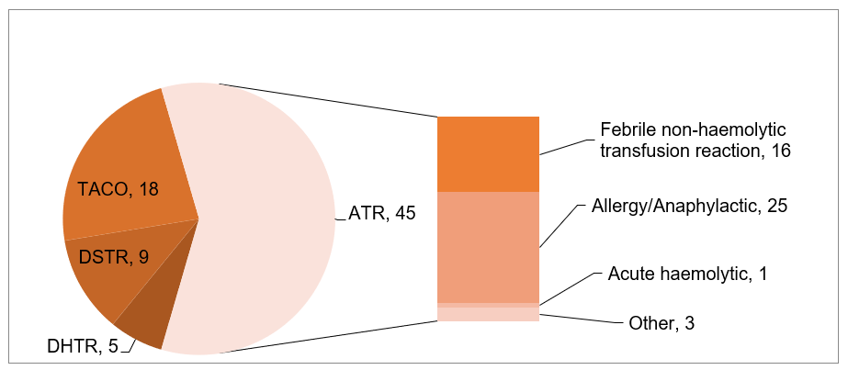

 Acute haemolytic reactions, often preventable with good lab and bedside checking processes, still occur.

**Validated procedural events reported to STIR FY19**

Wrong blood in tube events continue to be the largest proportion of procedural reports received. These are preventable events, that could lead to an ABO incompatible transfusion.

Many WBITs are likely never reported as the blood group of the intended patient and the one bled are the same.

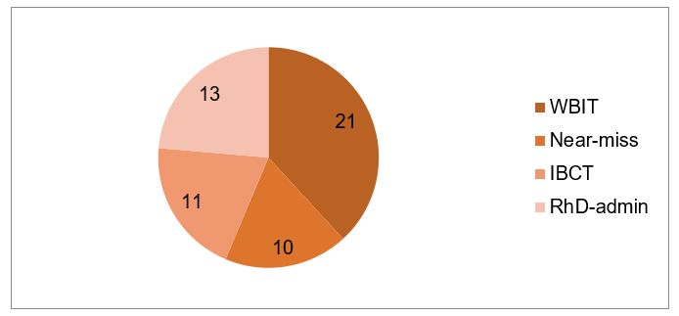

**Key messages and recommendations**

|  |
| --- |
| **Clinical** |
| For warfarin reversal, Prothrombinex® is preferred over FFP, and its use should be encouraged for all clinicians, following the [warfarin reversal guidelines](https://www.mja.com.au/journal/2013/198/4/update-consensus-guidelines-warfarin-reversal) <https://www.mja.com.au/journal/2013/198/4/update-consensus-guidelines-warfarin-reversal>.  FFP is not routinely needed in combination with Prothrombinex®, and should only be used according to the guidelines, such as when Prothrombinex® is unavailable  Case study 3: allergic (FFP) |
| Patients undergoing transfusion should be assessed for risk factors for overload and the rate of transfusion adjusted to run at the slowest rate appropriate to the situation. Where possible, a single unit should be administered and the patient assessed for both the need for further transfusion and indications of overload before any further transfusions occur.  Case study 4: TACO in patient with risk factors |
| **Procedural** |
| Positive patient identification (PPID) at each step in the transfusion process is vital, regardless of the situation. This includes asking the patient to state their name and date of birth where possible, use of an interpreter when required and confirmation of stated identity with name band, blood product or labelled specimens and order/prescription.  Case study 7: WBIT |
| Blood administration must only occur after double independent checking has occurred. This involves both staff performing all checks at the patient side. Both staff should be able to independently confirm that the product to be commenced is intended for the patient and must include checks that blood groups are compatible for both ABO and Rh groupings and that any special requirements are met, for example irradiation.  Case study 5: RhD incompatible red cell units cross matched and transfused |
| **General** |
| Education of all staff involved in the transfusion chain to ensure appropriate handling, ordering and administration is important to address safety issues. |
| Reporting of reactions to STIR assists in local and national reporting, including to the NBA National haemovigilence report, and the health service requirements for accreditation.  All incidents and reactions that meet STIR criteria should be reported to STIR in a timely manner. |

**The full STIR report is available on the Blood Matters website**

**https://www2.health.vic.gov.au/hospitals-and-health-services/patient-care/speciality-diagnostics-therapeutics/blood-matters/serious-transfusion-incidents**

Authorised and published by the

Victorian Government, 1 Treasury Place, Melbourne.

© State of Victoria, July 2020

(2008773)