
-

Sustainability reporting at Eastern Health and East Grampians Health Service
Case study: Conversation Series #4

Overview
All Victorian public health services are required to have a current environmental management plan and to publicly report on its progress. A number of health services have chosen to produce standalone sustainability reports. We spoke to Antony Howard, Independent Engineer for Eastern Health (EH) and Linden Marland, Infection Control Coordinator at East Grampians Health Service (EGHS) about the process of developing their health services’ sustainability reports and asked them for tips for other health services on bringing together reports as well as for those wishing to develop standalone reports.

Why did you decide to go beyond what is required and develop a standalone report?

EH: Eastern Health included sustainability as part of its strategic direction back in 2010 and soon after decided to create a separate report focusing on our sustainability initiatives. During the initial stages of the annual reporting regime we approached Eastern Health’s communications team to develop a format and design to best present our work in a way that would engage both our staff and other stakeholders. Having a relationship with the communications department really helped. We worked with them to find a balance on presenting information that is different from how I would present things as an engineer. A standalone sustainability report is a useful communication tool because it tells the story of the people behind the data and goes beyond the presentation of figures. We hope that by sharing their stories, achievements and passion for sustainability we will inspire others to think about what they can do to make a difference.
EGHS: We decided to do a standalone report because the annual report already contained a lot of information but is not widely circulated. EGHS valued the sustainability report enough that it was decided that it should be a standalone report. It also meant that the health service’s board of management could be presented with a separate document. EGHS has a website, so it was easy to publish the information and make the report easily accessible. We also have included environmental performance in our quality of care report, but it’s only a short summary.
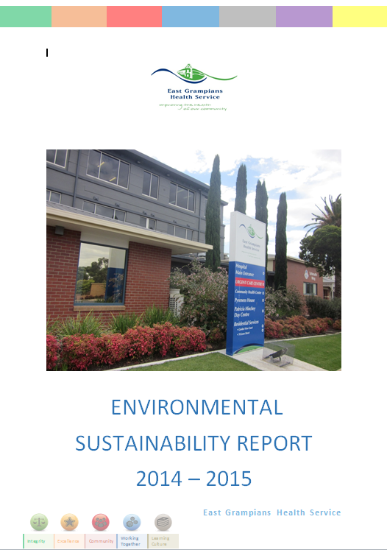
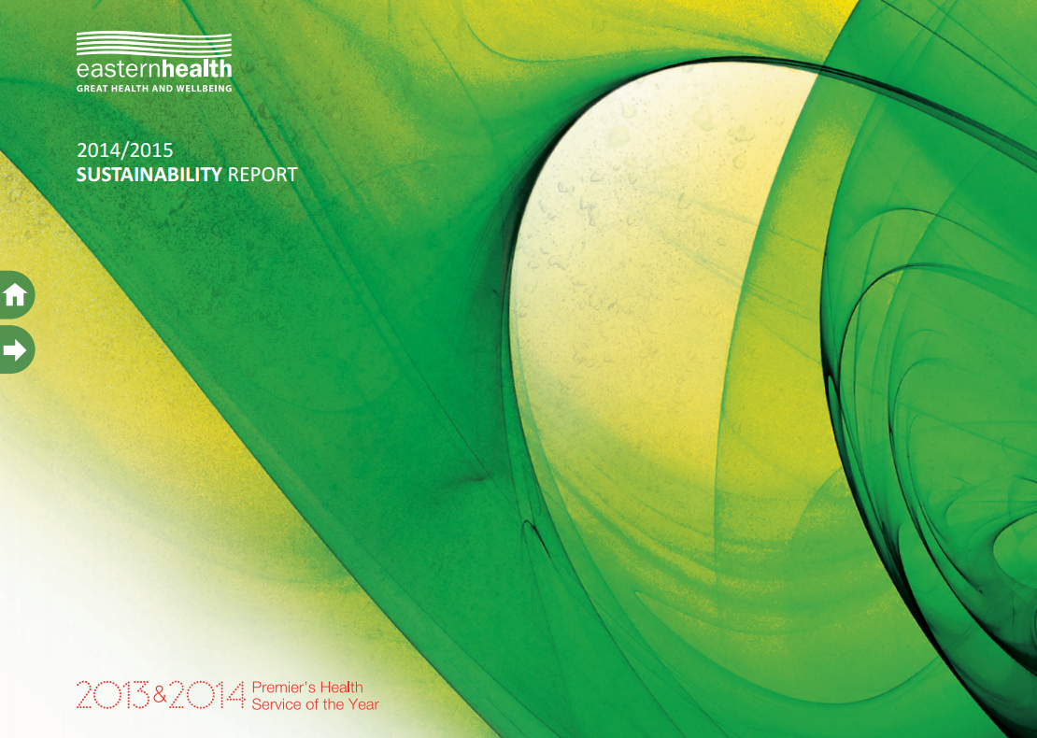

This year’s report is not the first for either of your health services, how did you go about creating your first?
EH: The Environmental Committee talked through a number of ideas for stories and then presented these to our communications department to further develop. In most instances we knew what we wanted to report, and the core environmental performance data formed the foundation of the report. Since the first report published in 2013–14, the processes and formats have developed, allowing me to concentrate on improving the accuracy of the data.
EGHS: We produced the first report in 2014. This first report was the most challenging, but once one report had been completed, the process is now less onerous.

How important is executive support in achieving good sustainability reporting outcomes?
EH: Executive support is very important. The executive director of Corporate Projects and Sustainability chairs the Environment and Sustainability Committee. You need someone in the role who has a passion for sustainability and allows the committee members to be empowered and involved.

What feedback have you received?
EH: Feedback from staff and management has been positive and it’s understood that we are aiming to be transparent. The report provides a pretty good picture about what’s happening in sustainability across our health service.
EGHS: We received positive feedback from the health service executive and the Environment Management Committee. We conducted a staff survey to gauge awareness of environment management at EGHS. Some respondents were aware of the sustainability report and their department committee representative, as well as other issues. This was useful as we could publish articles in the health service newsletter for staff information. We also mention it at our regular staff briefing, which tends to be well attended, and it helps raise attention. Reaching all staff is always a challenge.

Eastern Health’s report contains interviews with a number of champions. How did you seek these?
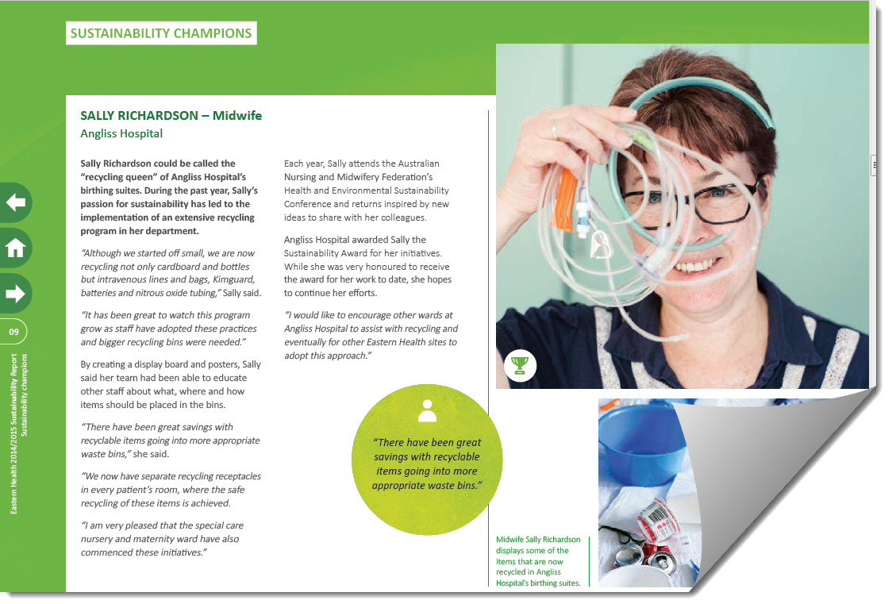
An excerpt from the Sustainability Champions Section of Eastern
Health’s Sustainability Report 2014–15
EH: Eastern Health has an annual staff recognition and award program where staff can nominate and vote for their colleagues at their site or program for a number of awards. The aim of these awards is to recognise staff who go above and beyond their everyday jobs and take the initiative to make improvements in their workplace. One of the awards is for sustainability. The sustainability award not only acknowledges the extra effort that individuals and teams put into their work but is intended to inspire others to work as sustainably as possible.
These awards, which have been running at Eastern Health for five years now, help us identify sustainability champions across the service. In large organisations with limited time and resources you only have a certain reach, and it is impossible to connect with each individual. Through these nominations and awards, I’ve been able to find out about many different initiatives being undertaken each year across our sites and programs. This has helped me tap into projects, connect with individuals and groups and share their results with others.
Connecting with groups (we often call them ‘green teams’) is a great way to educate people about our platforms and let their creativity guide the way they interact with our environmental support resources.
Waste and waste reduction is the face of sustainability. While we’ve saved incredible amounts of energy and slowed growth in consumption, non-engineers tend not to easily engage with building efficiency. This does not seem to be the case with waste, particularly recycling. Providing staff with tools and giving them positive feedback, which is a large part of any successful sustainability program, drives change. Waste programs lend themselves to this.

How do you see the rollout of the department’s system-wide environmental data management system changing reporting?
EH: I have been involved in this project and we actually included a small section on it in our 2014–15 sustainability report. The environmental data management system will create a standardised report from standardised data and means that everyone will be measuring the same things. I look forward to it making reporting easier and the results being of higher quality. It will be especially useful for health services that do not have specialist engineering teams to focus on detailed analysis of this information.

Have the reports and data presented led to change or outcomes?
EH: The acquisition of data is being taken seriously, and involvement in projects like the environmental data management system enables me to place greater emphasis on improving the data. This is important because it’s easy to have good numbers when data is low-quality. Omissions can reduce the validity of results. Interestingly, as the standard of data acquisition improves, the reported performance often appears to decline, but with greater accuracy and transparency people can start to see what is actually going on with performance. We hope that it inspires our staff to take action – for example, to recycle or request a degree or two change in their air temperature to save energy. Broadcasting high-quality data tends to lead to performance improvement organically.
EGHS: I receive the waste reports monthly from the Director of Support Services department and then produce graphs. Developing a spreadsheet that converts into carbon dioxide emissions was extremely useful. The reports and data have led to an increased awareness of the energy consumption at EGHS and furnishes us with evidence we can improve on.

Does collecting data help with identifying areas for improvements?
EGHS: We would love to be doing more recycling, which would create further reductions in waste, but being located where we are, with some distance from the regional cities, we are limited by the lack of service availability or costs involved with recycling. Rural health services can be restricted; for example, collection is often cheaper in the metropolitan areas than in rural/remote areas, and is not financially effective for us.
Collecting data has also helped EGHS to target areas that can be improved such as programs to reduce paper usage, water and electricity.
Our clinical waste has been assessed in the Perioperative Unit and, following education, we are undertaking an audit of this. We hope that our clinical and landfill waste will reduce and our recycling rate will increase.

Do you have tips for other health services considering developing a standalone report or for reporting in general?
EGHS: Use the tools, such as environmental data management system, or the waste tool spreadsheets provided by the Department of Health and Human Services and allow time once a month to input data, so you are not time-short when the report is due.
Engage Environment Committee members to proof read and add suggestions.
Copy and paste as much as you can.
Use a different photo for the front cover to make each year stand out.

Further information
Sustainability Unit <www.health.vic.gov.au/sustainability>. Email: sustainability@health.vic.gov.au
For examples of the sustainability reports listed above and other examples please follow the links below.
Eastern Health sustainability report <www.easternhealth.org.au/about-us/publications/item/5-sustainability-reports/591-sustainability-report-2014-15>
East Grampians Health Service <eghs.net.au/wp-content/uploads/2015/11/Sustainability-Report-2014-2015.pdf>
Goulburn Valley sustainability report <www.gvhealth.org.au/wp-content/uploads/GV-Health_Environmental-Sustainability-Report-2013-14.pdf>
Austin Health sustainability report <www.austin.org.au/Assets/Files/Austin%20Health%20Sustainability%20Report%202014-15.pdf>
Melbourne Health sustainability report <www.thermh.org.au/sites/default/files/media/misc/Melbourne%20Health%20Environmental%20Report%202014-15.pdf>

To receive this publication in an accessible format phone 9096 2119, using the National Relay Service 13 36 77 if required, or email sustainability@dhhs.vic.gov.au
Authorised and published by the Victorian Government, 1 Treasury Place, Melbourne.
© State of Victoria, Department of Health and Human Services, June 2016
ISSN 2206-4966 (pdf)
Available at www.health.vic.gov.au/sustainability

