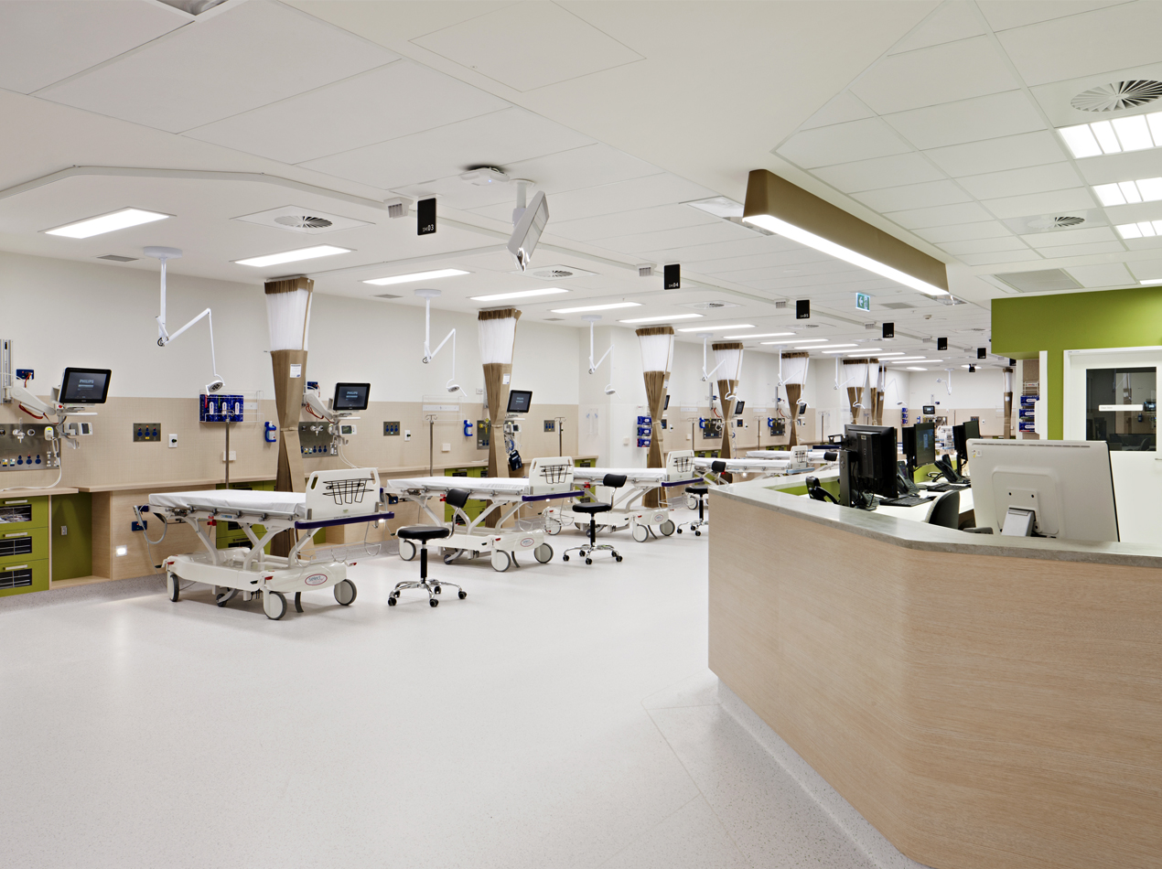
WASTE EDUCATION IN HEALTHCARE
Summary report
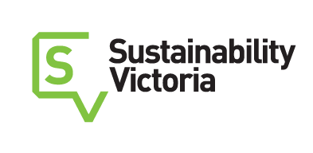
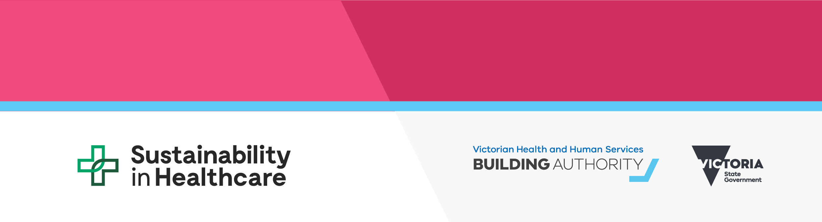

To receive this publication in an accessible format, email <rachel.mcconville@dhhs.vic.gov.au>
Authorised and published by the Victorian Government, 1 Treasury Place, Melbourne.
© State of Victoria, Department of Health and Human Services, October 2018.
Available at the Department of Health and Human Services website <https://www2.health.vic.gov.au/hospitals-and-health-services/planning-infrastructure/sustainability/waste>

WASTE EDUCATION
IN HEALTHCARE
Summary report

Contents
Executive summary 3
Introduction 4
Objectives 4
Project advisers 4
Project methodology 5
Phase 1: Research 5
Phase 2: Implementation 5
Phase 1: Findings and recommendations 6
Preliminary insights 6
Infection control 6
Procurement 7
Survey findings 7
Recommended intervention areas 7
Summary of factors contributing to better waste management outcomes 8
Phase 2: Intervention development 10
Intervention 1: Waste audit guidelines 10
Intervention 2: Clinical waste guidelines clarification and FAQs 10
Intervention 3: E-waste to landfill ban 11
Intervention 4: Piloting waste segregation in theatre 11
Intervention 5: PVC recycling 11
Intervention 6: Single-use metal recycling 12
Intervention 7: Mentoring workshops 12
Intervention 8: Online education resource 12
Recommendations from phase 1 beyond the scope of the project 13
Appendix: Survey findings 14
Priority waste streams 14
Priority locations 14
Results based on geography 15

Executive summary
Sustainability Victoria (a Victorian Government agency with a statutory objective to facilitate and promote environmental sustainability in the use of resources), in partnership with the Department of Health and Human Services, identified priority procedures, locations and waste materials for a two-year behaviour change intervention program to achieve environmental and financial benefits within waste management in the public hospital system.
The research identified the following priorities for immediate intervention based on time, cost and effectiveness:
Materials | Locations
- Food waste | - Cafés and cafeterias
- Commingled recycling | - Public spaces
- PVC items | - Theatre departments
- Single-use metals | - Emergency departments
- Polystyrene | - Intensive care units
 | - Dialysis units
The key learnings from those implementing successful waste management initiatives were as follows:
Executive priority and support
Executive support of projects validates the work being done by health service staff and increases the likelihood of project success.
Internal engagement and buy-in, especially from infection control, procurement, environmental services and facilities managers
Engagement of a range of stakeholders within health services allows collaboration and the sharing of ideas, experiences and values, strengthening the likelihood of project success.
Clear, consistent support from the state and in regional Victoria
Departmental support sends a clear message to health service executives, staff and the general public that sustainability, and particularly effective waste management, is a priority that must be integrated into the day-to-day operations of Victorian public health services.
Regulatory certainty and consistent requirements
There is a lack of consistent definitions across different regulations, codes of practice and guidelines used by hospitals and their waste services. Ambiguous terminology relating to waste items, and a lack of clarity regarding the definition of infectious, hazardous, clinical or related waste, results in confusion for health service staff.
From 2018 to 2020 the Victorian Health and Human Services Building Authority will deliver the following interventions, with support from a project working group:
- Intervention 1: Waste audit guidelines
- Intervention 2: Clinical waste guidelines clarification and FAQs
- Intervention 3: E-waste to landfill ban
- Intervention 4: Piloting waste segregation in theatre
- Intervention 5: PVC recycling
- Intervention 6: Single-use metal recycling
- Intervention 7: Mentoring workshops
- Intervention 8: Online education resource.

Introduction
In 2016, Sustainability Victoria released the Victorian waste education strategy with the aim to increase the awareness of the environmental and economic impacts of waste management and to establish consistent approaches to waste education for business and the community.
Based on available data, in 2017–18 Victorian public health services generated approximately 35,060 tonnes of solid waste. Around 7,551 tonnes of this was recycled, 4,566 tonnes was clinical waste and the remainder was classified as general waste. Disposal costs were close to $17 million, of which half was for treating and disposing of clinical waste.
Working to achieve the Victorian waste education strategy, the Department of Health and Human Services (‘the department’) and Sustainability Victoria are undertaking a two-year project to explore waste avoidance and resource recovery education opportunities in the public healthcare system.

Objectives
The main objectives of the project are to:
- identify gaps, issues, barriers and opportunities and recommend potential intervention points through collecting and analysing a range of evidence (phase 1)
- assess, prioritise and recommend targeted intervention points against sets of criteria (with oversight from a project working group) to ultimately support the delivery of a successful behaviour change program carrying meaningful outcomes (phase 2).
In implementing behaviour change programs aimed at addressing the findings from phase 1, the project will assist public hospitals to implement effective, efficient and consistent waste management systems that ultimately:
- reduce the environmental impact of the healthcare sector through a reduction in waste generation and recoverable resources going to landfill
- reduce the cost of waste management (for example, via correct use of clinical waste bins) to the Victorian public healthcare system.

Project advisers
This project is supported by a project working group comprising:
- Sustainability Victoria <https://www.sustainability.vic.gov.au/>
- Department of Health and Human Services
- Australian Nursing and Midwifery Federation (Victorian Branch)
- Health Purchasing Victoria
- Barwon Health
- Western Health
- East Grampians Health Service
- Mercy Health
- Environment Protection Authority (EPA) Victoria
- Tandem Solutions Pty Ltd, waste data and healthcare expertise.

Project methodology

Phase 1: Research
The research aim was to create an evidence base to determine a set of priority intervention points (materials, processes, wards/units, etc.) that would be the focus of a behaviour change program intended to improve waste management practices.
The following stages were carried out by a specialist waste consultancy:
- preliminary investigation through a desktop literature review, data review and site visits to metropolitan regional and rural public health services
- collecting data on systems, materials and social behaviours through an online survey and interviews
- applying a set of criteria based on data, ease of implementation, demonstrated need and replicability to identify the priority points of intervention
- making recommendations to the department and Sustainability Victoria to develop a behaviour change program.

Phase 2: Implementation
The department engaged a waste education officer. The waste education officer’s role was to use the report findings from phase 1, as well as the input from the project working group, to identify a series of intervention projects that, if delivered effectively, could meet the project’s objectives.
These interventions were prioritised using a series of weighted criteria. These criteria included alignment with project objectives, whether the intervention was educational or would result in behaviour change and whether the intervention would be sustainable beyond the project.
This process provided an unbiased framework from which eight intervention projects were selected to be developed and delivered over the course of the project.

Phase 1: Findings and recommendations

Preliminary insights
Site visits identified the need for health services to have confidence in affordable and reliable waste management services. This confidence has a direct bearing on what recycling outcomes each health service can achieve.
In some instances, particularly in regional and rural locations, there is a perception that recycling small volumes of waste, or specialist streams, is cost-prohibitive or that the hospital is too isolated from existing services and infrastructure.
Health service staff raised the need for greater regulatory clarity regarding the management of wastes. Some hospital representatives reported that it is sometimes difficult to come to a common view with their waste service providers regarding whether an item should be designated clinical, general or recyclable waste. Various underlying causes for this are identified as:
- a lack of consistent definitions across different regulations, codes of practice and guidelines used by hospitals and their waste services
- the use of ambiguous terminology relating to waste items and a lack of clarity regarding the definition of infectious, hazardous, clinical or related waste and therefore requiring specialist treatment
- confusion regarding which regulatory articles carry primacy given multiple directives from state environmental regulation and guidelines, industry codes of practice, national standards and other statutory and non-statutory documents that may be cited in contracts and service agreements.
Health service staff shared details of the level of support and leadership that they can call on to introduce new waste management services and practices. There appears to be a direct relationship between the level of leadership across the health service hierarchy and the support that waste management staff and champions have in pursuing improved waste management practices.
The site visits and literature review both identified infection control and procurement as areas of the health service that, depending on individual health service arrangements, often have substantial bearing on the success of waste management practices both in diverting material from clinical and landfill streams and adopting waste avoidance measures.

Infection control
Patient care outcomes and infection management fall within the core business of health services. Given the primacy of these functions, waste management procedures that are perceived as contributing to the spread of infection are not supported.
When medical staff have limited time and attention to inspect waste items for possible contamination, standard practice is often to treat most items as an infection risk, irrespective of their actual level of risk. The trend towards using single-use items in health services may be reinforced by the perception that the reduced handling and sterilisation requirements of disposable items prevents infection and simplifies workflows.
Anecdotal insights, such as the work currently being done by East Grampians Health, show that working with infection control staff to introduce recycling practices ensures that their responsibilities are accounted for, and these staff are therefore more supportive of new waste management arrangements. Health services that have little success in introducing recycling streams to procedural locations often have limited connections between waste management and infection control staff.

Procurement
Waste management staff and various champions are aware that procurement decisions, both within health services and Health Purchasing Victoria, can have a significant bearing on what can be recycled. Despite this, within health services, procurement is seldom factored into waste management decisions.
Procurement teams could have a role in waste reduction – for example, through ensuring that reusable items are given sufficient prominence as an alternative to single-use items, and in preferentially purchasing items that are able to be recycled.

Survey findings
A survey was released to health service staff in May 2018. This survey gathered data on health service needs regarding waste management practice, informing the prioritisation process and other planning activities scheduled for phase 2 of the project.
The survey received 470 responses from 63 health services. Most responses came from nursing and midwifery staff; however, there was also a strong response from management, support services, engineering and administration staff.
Respondents were asked to identify waste streams and health service locations that they perceived to be important to focus on and those that posed difficulty in terms of correct waste management. The priority waste streams identified from the survey are food waste, commingled recycling, PVC items, single-use metals and polystyrene. Priority locations are cafés and cafeterias, public spaces, theatre, emergency departments and intensive care units.
Responses differed between regional, rural and public health services, with aged care and non-clinical areas such as public spaces and cafés being prioritised by rural and regional health services more than metropolitan services. There was, however, consensus from all areas in prioritising emergency departments and operating theatres.
Further detail regarding survey findings can be found in the appendix.

Recommended intervention areas
Eleven clinical and non-clinical streams were recommended to include in the program, as set out in Table 1. Early deployment priorities could be those items where a program could realistically be rolled out in the first 12 months; and later deployment priorities could be deployed in the second 12 months, following more involved research and engagement. These timeframes are suggestions only.
Table 1: Priority waste streams
Early deployment
Higher importance | Lesser importance
Commingled recycling | Polystyrene foam (metropolitan only)
Paper and board (and confidential paper) | Sterilisation wrap
Single-use medical PVC items | Continence pads/aids
Single-use metal instruments
Small electrical items and consumables
Food organics (existing services)
Later deployment
Higher importance | Lesser importance
Food organics (new services) | Medical plastics and hollowware
Larger electrical equipment
Table 2 shows the clinical and non-clinical locations in order of priority.
Table 2: Prioritisation of streams, based on importance and practicality of including in earlier and later deployment
Non-clinical locations | Clinical locations
Cafés and staff cafeterias | Theatre (surgery)
Public spaces (for example, foyers) | Emergency
Kitchen and catering | Intensive care
Aged care | Medical/surgical wards
Administration | Acute ward
Pharmacy | Dialysis
Environmental services, engineering and supply

Summary of factors contributing to better waste management outcomes

1. Executive priority
- Executive accountability (key performance indicators, evaluation, reporting)
- Active and authorised committee and action plans
- Financial and resourcing recognition
- Methods and pathways to lodge the case for action
- Improvement-driven measurement and audit regimes
- Formal ties with procurement, infection control and clinicians
- Consultation/input during major works and renovations

2. Internal engagement and buy-in
- Close relationship with infection control
- Effective induction and education, training and feedback
- Clarity and consistency on disposal outcomes arising from different practices
- Effective bins, signage, manuals, protocols
- Leadership across hospital departments
- Clear pathways to act on initiatives proposed by champions and other staff
- Internal examples to show what can be achieved

3. State/regional support
- Support for how to get the best results from contractors
- Guidance in catalogues on suitability for recycling and composition
- Guidance on single-use versus reusable items (for example, life-cycle assessments and cost-benefit analyses)
- Funding for initiatives, beyond capital expenditure
- Engagement and incentives for clinical specialists to adopt waste minimisation
- Support for building regional economies of scale
- Support for regional networks of practice
- Guidance to support consistent data gathering and management practices

4. Regulatory uncertainty
- Clearer direction from EPA Victoria on the regulatory status of each stream
- More consistent definitions of prescribed, clinical, infectious and related wastes
- Contamination definitions that make it easier for staff to separate based on risk
- Additional guidance to minimise risks of disputes in interpretation

5. Contract compliance
- Contractors and waste teams working closely to divert more from landfill
- Systems to measure and verify service delivery and correct underperformance
- Recourse to report lapses to Health Purchasing Victoria as a clear means to drive improvement
- Low cost of opting out and seeking alternatives

Phase 2: Intervention development
In consultation with the project working group, the findings from phase 1 were used to identify a series of intervention projects that, if delivered effectively, would meet the project’s objectives.
These interventions were prioritised using a series of weighted criteria, including alignment with the project’s objectives, whether the intervention is educational, or will result in behaviour change, and whether the intervention will be sustainable beyond the project.
This process provided an unbiased framework through which nine interventions were selected. The selected interventions are being developed and will be delivered over the duration of the project, concluding in March 2020.

Intervention 1: Waste audit guidelines
The department will develop waste audit guidelines, making them available to all health services. The purpose of the guidelines is twofold:
- to provide a comprehensive approach to conducting waste audits so health services are confident that the information they are receiving is able to inform decisions regarding the management of waste and the associated costs, resulting in improved recovery outcomes
- to develop a comparable baseline of waste management for health services throughout the state. This will allow health services to compare their own figures with those of other health services and the department to assess the effectiveness of any waste programs being delivered.
Waste stream targeted | Ward/department targeted
- Clinical waste | - All health service locations
- General waste
- Commingled recycling

Intervention 2: Clinical waste guidelines clarification and FAQs
Both clinical and non-clinical health service staff often experience confusion when deciding whether an item is clinical or non-clinical waste. A key reason for this confusion is a lack of clarity within EPA Victoria’s Guidelines for clinical and related wastes (IWRG612.1).
Different health services interpret the guidelines in a range of ways, leading to variability in clinical waste policies. This lack of consistency has resulted in many clinical staff adopting a ‘minimal risk’ approach, disposing of the majority of waste items generated in a clinical setting into the clinical waste stream. This has led to high levels of contamination and therefore cost, with the clinical waste stream costing four times that of general waste.
The aim of this work will be to provide clear and consistent guidance to Victorian public health services about how to apply the Clinical and related waste guidelines (IWRG612.1).
This will be achieved by making minor changes to the wording of the guidelines, as well producing an FAQ document to assist in interpreting elements of the guidelines.
Waste stream targeted | Ward/department targeted
- Clinical waste | - All clinical locations

Intervention 3: E-waste to landfill ban
In July 2019 the Victorian Government is introducing a ban on e-waste being sent to landfill.
E-waste is defined as all electrical or electronic equipment with a power cord or battery where its parts have been discarded by the owner as waste without the intention of re-use.
Because health services generate large volumes of e-waste it is important that support services are informed of the e-waste ban, how it will affect them and what can be done to prepare for its implementation.
The aims of this intervention will be to:
- inform health services of upcoming changes to regulatory measures and what they must do to comply
- promote alternatives to disposing e-waste to landfill.
Waste stream targeted | Ward/department targeted
- E-waste | - Various locations

Intervention 4: Piloting waste segregation in theatre
A broad range of resource recovery opportunities are currently available to health services in clinical areas; however, anecdotal evidence suggests that these collections are difficult to instigate and are often poorly used by staff.
The department will work with Behaviour Works, a social research enterprise within the Monash Sustainable Development Institute, to investigate the behavioural reasons behind waste stream contamination in theatre departments and the causes of these behaviours.
The findings will be used to develop and test a series of interventions designed to modify the behaviours of staff so that waste streams are used more effectively, reducing contamination.
Waste stream targeted | Ward/department targeted
- Commingled | - Theatre department
- Paper and cardboard
- Metals
- PVC
- Sterilisation wrap
- Plastic and hollowware
- Continence aids
- Clinical waste

Intervention 5: PVC recycling
Plastics make up a significant share of hospital general waste, of which PVC medical products represent approximately 25 per cent. While an increasing number of health services are adopting PVC recycling collections, it is not currently available in all areas where PVC waste is generated, and many Victorian public health services do not yet have a collection.
The Vinyl Council of Australia, a peak organisation representing the Australian PVC value chain, delivers the PVC recycling program in hospitals. The department will work with the Vinyl Council of Australia to accelerate the recovery of PVC from Victorian public health services.
The aims of this project will be to:
- increase the quantity and quality of PVC recovered from health services
- provide feedback to health services to support them in improving contamination levels.
Waste stream targeted | Ward/department targeted
- PVC | - ICU
 | - Theatre
 | - Dialysis

Intervention 6: Single-use metal recycling
Health services are increasingly adopting single-use metals such as tweezers, scissors and clamps due to the low infection risk they pose when compared with reusable metal instruments.
In most health services these items are disposed of in general or clinical waste streams, despite being recyclable.
The department will work with a pilot health service to develop a single-use metals recycling program. The learnings from this pilot will be used to support health services statewide to recover single-use metals from the general and clinical waste streams.
Waste stream targeted | Ward/department targeted
- Single-use metals | - All clinical wards/departments

Intervention 7: Mentoring workshops
Clinicians are often working to introduce new, or to improve existing, recycling collections. As clinicians are often time poor, and unaware of best practice waste management or implementation strategies, delivering an effective project can be time consuming.
Six mentoring workshops will be held throughout Victoria during which nurses and other health service stakeholders will work with a facilitator and the waste education officer to develop a project plan to either introduce a new recycling collection or to improve an existing system.
The waste education officer will then provide ongoing support to workshop attendees as they implement their project plans.
Waste stream targeted | Ward/department targeted
- All waste streams | - All wards/departments/areas

Intervention 8: Online education resource
Health service employees are reporting that they are not able to access the information required to effectively and efficiently improve waste management within their health service.
An online education platform will be developed to provide Victorian health service employees with information, guidance and tools to help them implement, or improve, waste management programs.
The resource will provide tailored guidance for each priority waste stream identified in phase 1, with the information expected to include:
- waste assessment guidelines for clinical staff
- case studies of health services that have introduced successful programs
- key contacts including collection contractors, auditors, support and training
- step-by-step guides to implement best practice waste diversion programs
- guidelines regarding bin colours, bin placement, signage and technical and regulatory guidance
- general information regarding the environmental, financial and social benefits of introducing a program, what happens to the waste after has been collected, alternative products and so on
- clear pathways to funding including business cases to present to finance departments.
Waste stream targeted | Ward/department targeted
- Commingled recycling | - All wards/departments/areas
- Food waste
- Paper and cardboard
- Polystyrene
- E-waste
- Single-use metals
- PVC
- Sterilisation wrap
- Continence aids

Recommendations from phase 1 beyond the scope of the project
The report made recommendations and identified potential interventions that did not fall within the scope of the project. This was because they were infrastructure or systems-dependent and therefore not able to be addressed through education or behavioural interventions.
These recommendations include:
- Establish food waste collections at health services.
- Increase the scope of recycling contracts to increase the range of materials recovered. This could include:
  - e-waste
  - sterilisation wrap
  - metals
  - polystyrene.
- Introduce executive accountability for health services against their environmental management plans.
- Engage waste management consultants and health service staff during major works or renovations to health services to ensure waste management needs are integrated into the design.
Adopting these interventions has the potential to improve waste management in health services. The department will consider these opportunities in its broader work on improving the environmental sustainability of the health system. For example, Health Purchasing Victoria is sourcing a food organics recycling service offer for metropolitan hospitals, and waste management will be considered in the review of the department’s sustainability guidelines for capital works.

Appendix: Survey findings

Priority waste streams
The survey asked respondents to identify waste streams they considered important to recycle but were presently unable to in their workplaces, and which streams they were presently able to recycle but found difficult to.
Table 3 presents average response rates from across the two questions and was used to quantify the demand component for improving the management of each waste stream.
The items shaded in grey only showed modest recognition in the importance of and/or difficulty in recycling.
Table 3: Combined scores for each stream, factoring importance and difficulty response rates
Non-clinical items | % freq | Score | Clinical items | % freq | Score
Food waste | 27.0 | 1.00 | Single-use PVC items | 28.9 | 1.00
Commingled recycling | 26.9 | 1.00 | Single-use metal items | 25 | 0.87
Polystyrene foam | 23.7 | 0.88 | Single-use plastic items | 18.8 | 0.65
Packaging films | 21.3 | 0.79 | Bowls, dishes and trays | 16.75 | 0.58
Batteries | 18.4 | 0.68 | Continence pads/aids | 14.05 | 0.49
Cardboard | 15.7 | 0.58 | Sterilisation wrap | 13.6 | 0.47
Office paper | 12.5 | 0.46 | Single-use linen, blue towel | 10.7 | 0.37
Mattresses | 10.8 | 0.40 | Powered medical devices | 8.75 | 0.30
Computers/monitors/printers | 10.4 | 0.39
Furniture | 9.8 | 0.36
Toner and print cartridges | 9.5 | 0.35
Fluorescent tubes | 6.8 | 0.25
Confidential documents | 6.2 | 0.23
Wood | 5.1 | 0.19
Mobile phones / pagers | 5.1 | 0.19
Garden organics | 3.9 | 0.14

Priority locations
The survey asked respondents to indicate the locations where they considered it most important to have good waste separation and the locations where they considered it difficult to embed good waste separation.
In considering locations that may be the focus of a behaviour change program, locations that were seen as important and/or difficult places to embed good waste separation were considered relevant.
For locations shaded in grey there was only modest recognition of the importance of and/or difficulty in recycling (see Table 4).
Table 4: Combine scores for each location, factoring importance and difficulty responses
Non-clinical locations | % freq | Score | Clinical locations | % freq | Score
Cafés and staff cafeterias | 25.9 | 1.00 | Theatre (surgery) | 37.8 | 1.00
Public spaces (such as foyers) | 23.45 | 0.91 | Emergency | 29.45 | 0.78
Kitchen and catering | 13.95 | 0.54 | Intensive care | 23.85 | 0.63
Aged care | 13.95 | 0.54 | Medical/surgical wards | 21.8 | 0.58
Administration | 13.05 | 0.50 | Acute ward | 17.55 | 0.46
Pharmacy | 11.55 | 0.45 | Dialysis | 15.3 | 0.40
Environmental services | 10.25 | 0.40 | Oncology | 5.4 | 0.14
Supply | 8.05 | 0.31 | Maternity | 3.75 | 0.10
Engineering | 4.65 | 0.18 | Outpatient | 3.75 | 0.10
Central sterile services department | 3.95 | 0.15 | Subacute ward | 3.55 | 0.09
Laundries | 3.55 | 0.14 | Day procedure | 3.4 | 0.09
Mental health | 3.35 | 0.13 | Radiology/x-ray | 3.35 | 0.09
 |  |  | Pathology | 3 | 0.08
 |  |  | Paediatrics | 2.4 | 0.06

Results based on geography
Responses were grouped according to whether respondents’ health services predominantly operated in metropolitan Melbourne (136 responses), regional centres (35 responses) or smaller rural communities (68 responses). Results showed a high level of coherency between these groups and the statewide results.
Rural health service respondents displayed a substantially lesser interest in items associated with clinical and medical procedures and had a greater focus on more ‘generic’ items such as packaging, e-waste, food waste and obsolete furnishings.
Priority locations differed between regional, rural and public health services. Aged care and non-clinical areas, such as public spaces and cafés, were prioritised by rural and regional health services more than metropolitan services. There was, however, consensus from all areas in prioritising emergency departments and operating theatres.

