Epidemic thunderstorm asthma campaign
Social media posts – for health professionals

Social media tiles available
“Protect yourself this pollen season” | “Do you have asthma or hay fever?” |  | “Do you have asthma?” | “Do you have hay fever?” | “Do you know the four steps of asthma first aid? |  | Asthma First Aid grid
 |  |  | 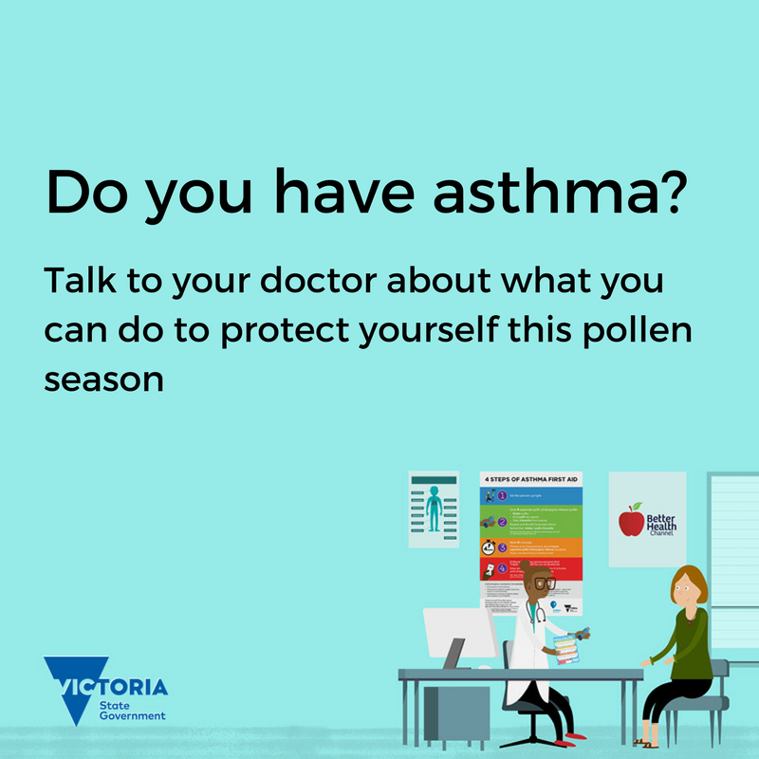 | 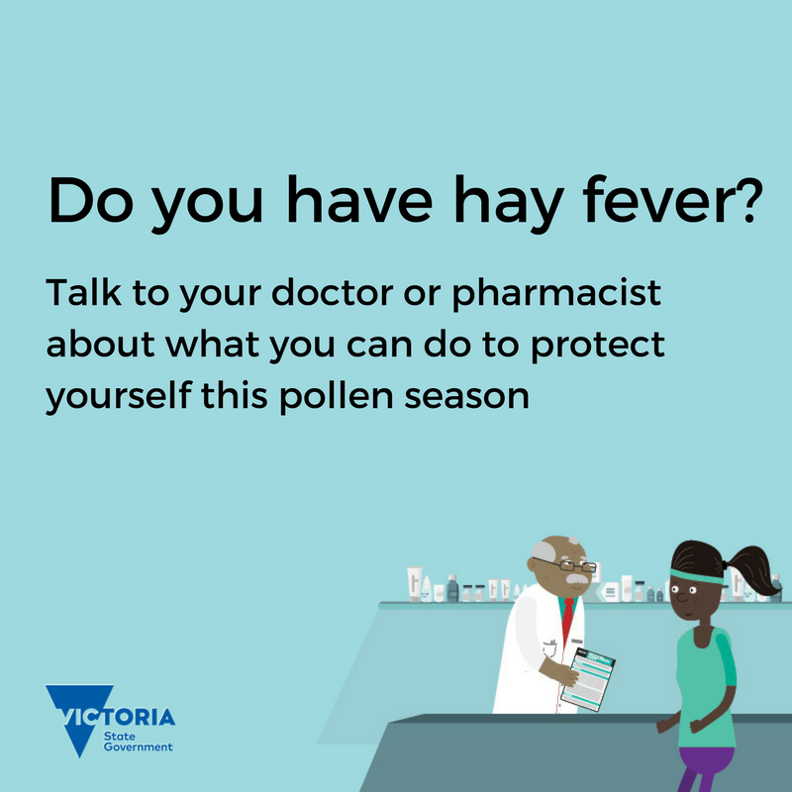 | 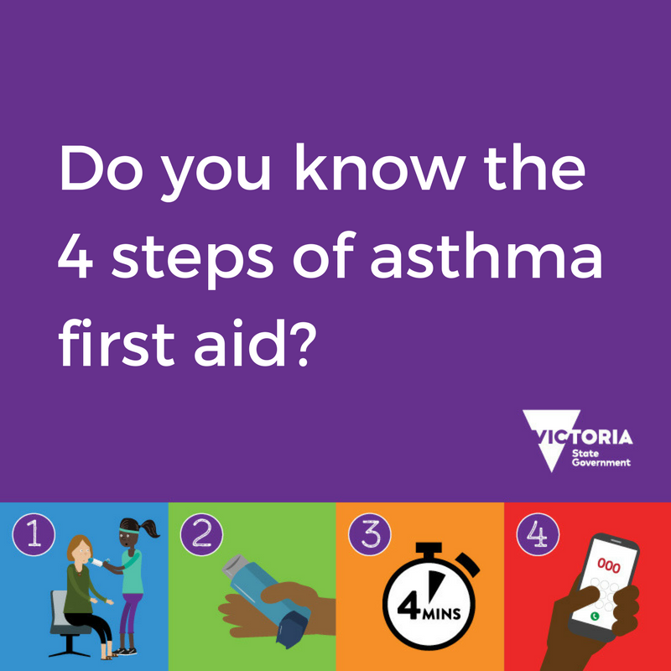 |  | 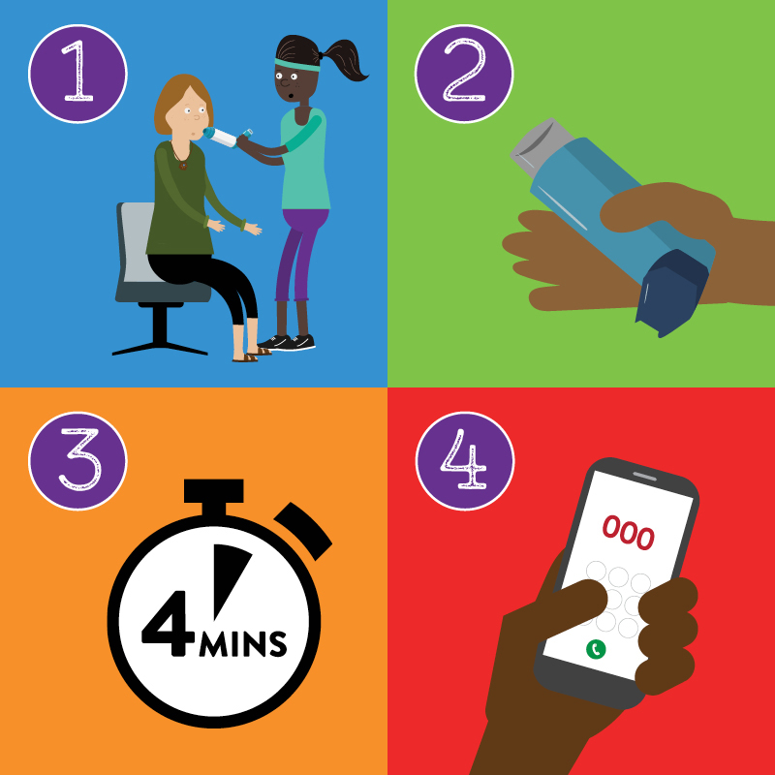
Four steps of asthma first aid: Please note, these tiles must be used together as a Facebook carousel post, as individually they provide no context and no informative advice on learning asthma first aid.
 |  | 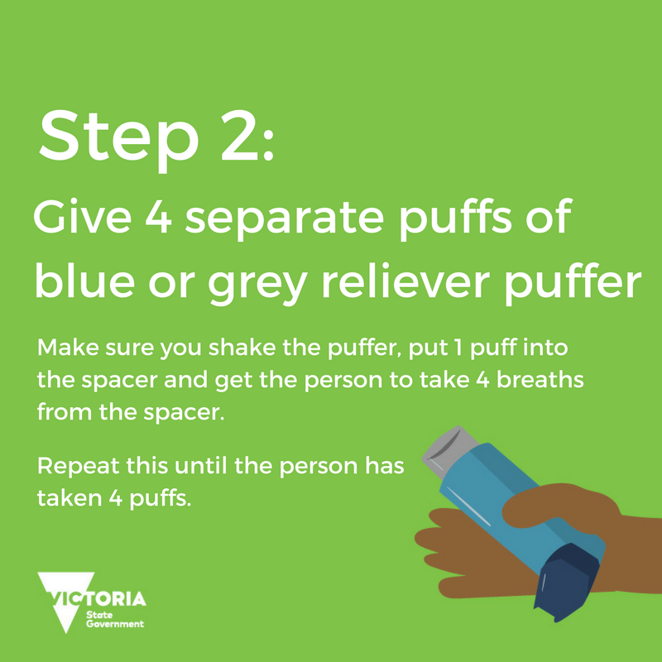 |  | 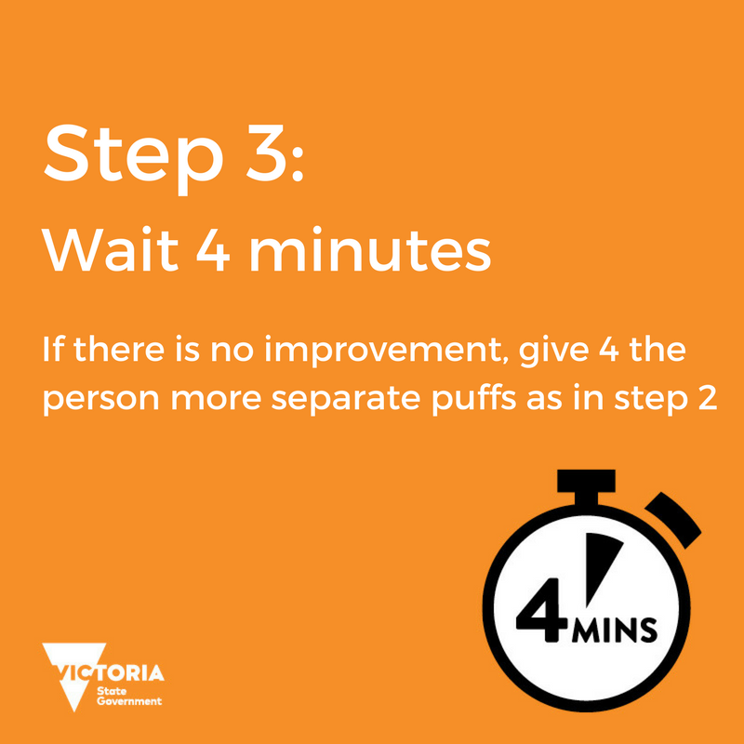 |  | 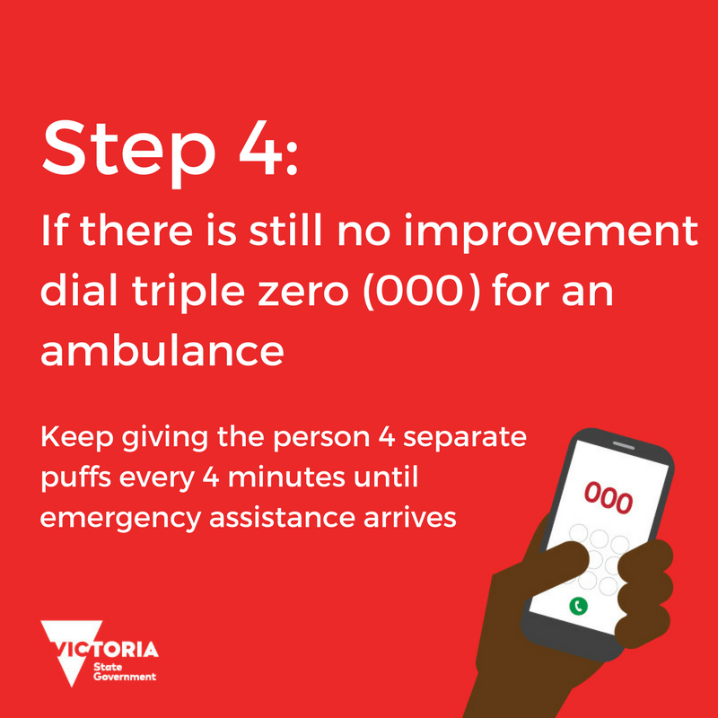

Suggested Facebook posts
Grass pollen season brings an increase in asthma and hay fever. It also brings the chance of thunderstorm asthma. Help your patients prepare for grass pollen season by supporting them to better manage their asthma and hay fever and reduce their risk of thunderstorm asthma. Information and resources for health professionals is available on the Health website: https://www2.health.vic.gov.au/public-health/environmental-health/climate-weather-and-public-health/thunderstorm-asthma
For patients with hay fever, especially those who experience wheezing and coughing with their hay fever, it’s important to make sure they don’t also have asthma. Speak to your patients today and support them to better manage their hay fever and reduce their risk of thunderstorm asthma. Find out more at www.betterhealth.vic.gov.au/thunderstormasthma

Suggested Twitter post
Grass pollen season brings the chance of #ThunderstormAsthma. If you have a patient with asthma or hay fever, help them prepare www.betterhealth.vic.gov.au/thunderstormasthma

For advice related to COVID-19 restrictions please go to https://www.dhhs.vic.gov.au/coronavirus

To receive this document in another format email environmental.healthunit@health.vic.gov.au <environmental.healthunit@health.vic.gov.au>
Authorised and published by the Victorian Government, 1 Treasury Place, Melbourne.
© State of Victoria, Australia, Department of Health, August 2021.
Available at Epidemic thunderstorm asthma campaign toolkit <https://www2.health.vic.gov.au/public-health/environmental-health/climate-weather-and-public-health/thunderstorm-asthma/toolkit>

