Nursing and Midwifery Workforce Data Collection
HealthCollect guidelines
OFFICIAL

Introduction
The Nursing and Midwifery Workforce Data Collection was developed to monitor workforce vacancy and other workforce pressures across the Victorian public health system as a result of the COVID-19 pandemic. The Department of Health requires regular and up-to-date data from all participating health services including maternity and newborn services, and non-maternity and newborn services. The data will be used to monitor and determine where there are significant vacancy levels, compare other workforce indicators across like services and inform workforce priority actions inclusive of the COVID-19 workforce surge response.

Reporting requirements
The Nursing and Midwifery Workforce Data Collection is available on the HealthCollect portal.
Reporting is at health service level. That is, multi-campus health services should provide aggregated data.
The Nursing and Midwifery Workforce Data Collection must be completed by 11.59pm on the 21st day of each month. For each reporting period, data from the previous full calendar month must be reported. For example, your report on the 21 December 2021 should relate to the full month of November 2021.
Refer to the document Nursing and Midwifery Workforce Data Collection Guidelines for reporting for further information on reporting requirements and definitions.

System Information

Access to HealthCollect
The Nursing and Midwifery Workforce Data Collection is available on the HealthCollect portal. <https://www.healthcollect.vic.gov.au/>.
Services are required to have a login to the HealthCollect portal. Please notify the Health Services Data Helpdesk hdss.helpdesk@health.vic.gov.au or complete the HealthCollect User Request Form if a new user login is required to submit these data.
The HealthCollect User Request Form is available on the HDSS website. When completing the HealthCollect User Request Form, select AIMS and tick the box next to Nursing and Midwifery Workforce.
New HealthCollect users will be registered and instructions emailed to them on how to activate and log on to the HealthCollect portal. The Password Reset function is available on the right-hand side of the login page.
HealthCollect portal login screen
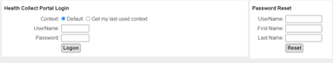
For any queries about becoming a user of the HealthCollect portal or users who experience difficulties with access, please contact HDSS.Helpdesk@health.vic.gov.au

How to open the Nursing and Midwifery Workforce data collection
The Nursing and Midwifery Workforce data collection is located under the AIMS tab.
Select AIMS tab, then AIMS Selector to open the Select a Data Collection web page.
Under Select a Data Collection, select options available using the drop-down boxes to request and open the collection to be updated:
- Year: 2021-22
- Health Service: select your health service at the auspice level (AU)
- Collection: select Nursing and Midwifery Workforce
- Period: select Month of data being entered
- Select Get Collection button and the report will open.
Screen view of AIMS Selector

A sample form view
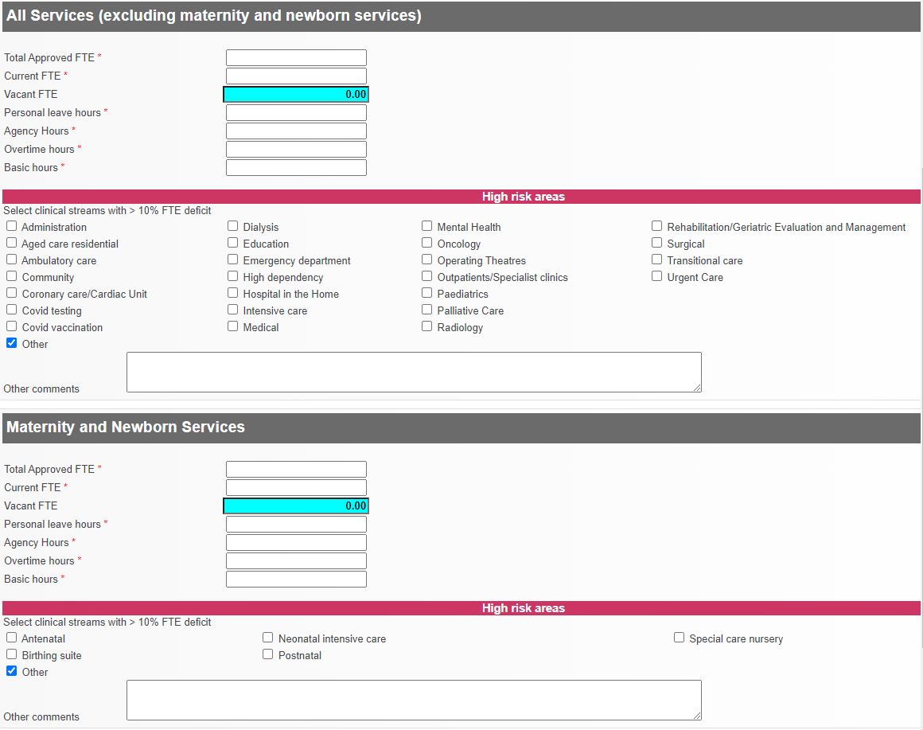

Form business rules
Data items with a red asterisk (*) at the end of the label are mandatory and a value must be entered. Use the tab key to move between data fields, or click on the next input field.
Under the category High risk areas with >10% FTE deficit, select one or more clinical streams. If a clinical stream is not listed, tick the Other box to open a comments text field and enter other clinical streams.
When data entry is complete, press the ‘Validate’ button to check the data meets the form business rules. When data doesn’t meet the business rules, a validation message will appear in red font and the related data field will be shaded red. Correct any errors and click the ‘Save’ button.
Sample validation error message
The report cannot be ‘Saved’ or ‘Submitted’ until all validations are correct.

Data submission
The Nursing and Midwifery Workforce Data Collection must be completed by 11.59pm on the 21st day of each month. For each reporting period, data from the previous full calendar month must be reported. For example, your report on the 21 December 2021 should relate to the full month of November 2021.

To submit form
When data is complete and all errors are resolved, you’re ready to submit the form.
To submit the report, tick the ‘Completed’ checkbox. The message ‘Submission transmitted to the department successfully’ appears when the form has been sent. When the Completed checkbox is ticked, the Validate and Save buttons are disabled and the form is not able to be edited.
Autogenerated reminder emails are sent to contacts if the submission has not been completed on time. Recipients of this email are asked to submit data immediately on receipt of the email. It is the responsibility of the health service to organise alternative access to the portal if the person who usually completes this reporting is on leave.

Correction of data
Services should update any previously submitted data if it is determined that an error has occurred. To amend a report, open the report and uncheck the Completed box. This will unlock the form to allow changes to be made. When amendments are complete, recheck the Completed box.
To receive this document in another format, email the HDSS HelpDesk at <hdss.helpdesk@health.vic.gov.au>.
Authorised and published by the Victorian Government, 1 Treasury Place, Melbourne.
© State of Victoria, Australia, Department of Health, November 2021.
Available at HDSS Communications <https://www2.health.vic.gov.au/hospitals-and-health-services/data-reporting/health-data-standards-systems/hdss-communications>

