Victorian Early Parenting Centres Outcomes Framework
Accessible version

Victorian Early Parenting Centres Outcomes Framework Accessible version

To receive this publication in an accessible format the Early Parenting Centres Expansion Project team <EPCproject@health.vic.gov.au>.
Authorised and published by the Victorian Government, 1 Treasury Place, Melbourne.
© State of Victoria, Australia, Department of Health October 2022 [updated March 2023].
Except where otherwise indicated, the images in this publication show models and illustrative settings only, and do not necessarily depict actual services, facilities or recipients of services. This publication may contain images of deceased Aboriginal and Torres Strait Islander peoples.
In this document, ‘Aboriginal’ refers to both Aboriginal and Torres Strait Islander people. ‘Indigenous’ or ‘Koori/Koorie’ is retained when part of the title of a report, program or quotation.
ISBN 978-1-76131-000-3 (pdf/online/MS word)
Available on the Department of Health < https://www.health.vic.gov.au/maternal-child-health/early-parenting-centres>

Contents
Acknowledgments 7
Acknowledgement of Country 7
Funding Acknowledgement 7
Executive Summary 8
Section 1 9
Why 9
How 11
Framework Structure 14
Section 2 15
Victorian Early Parenting Centres Outcome Framework 15
Summary of the Early Parenting Centres Outcomes Framework 16
Outcome Domain 1- Health and Wellbeing 17
Outcome Domain 2 - Connection 21
Outcome Domain 3 - Growth 24
Outcome Domain 4 - Learning 27
Outcome Domain 5 - Safe and Secure 31
Measures and Tools 34
Table 6. Primary Measures and Tools 35
Table 7. Additional Measures and Tools for use in the local context 37
Section 3 40
Implementing the Early Parenting Centres Outcomes Framework 40
Implementation Determinants 41
EPC Outcomes Framework Implementation Plan 43
Implementation roles and responsibilities 43
Local EPC Implementation Team 43
Community of Practice 43
State-wide implementation support 43
Implementation Strategies 44
Data and monitoring strategies 47
Proposed next steps 49
References 50
Appendix A Victorian Public Health and Wellbeing Outcomes Framework 51
Appendix B Implementation Plan Template 52
Terminology 53
Text-equivalent descriptions of figures 54

Acknowledgments

Acknowledgement of Country
The Victorian Department of Health proudly acknowledges Victoria’s Aboriginal communities and their rich culture and pays respect to Elders past and present.
We acknowledge Aboriginal people as Australia’s first peoples and as the Traditional Owners and custodians of the land and water on which we rely.
We recognise and value the ongoing contribution of Aboriginal people and communities to Victorian life and how this enriches us.
We embrace the spirit of reconciliation, working towards equality of outcomes and ensuring an equal voice.

Development acknowledgement
This Early Parenting Centre Outcomes Framework was developed by Monash University and The Queen Elizabeth Centre in consultation with over 100 stakeholders, including members of the Victorian Early Parenting Centre network.
The Department of Health would like to acknowledge and thank the following co-developers:
- Dr Mandy O’Connor, Research Fellow, Health and Social Care Unit, Monash University
- Professor Helen Skouteris, Monash Warwick Alliance Joint Professor of Health and Social Care Improvement and Implementation Science, Head of the Health and Social Care Unit, Monash University
- Helen Cunningham, Director of Clinical Innovation and Development, The Queen Elizabeth Centre
- Sue White, Chief Executive Officer, The Queen Elizabeth Centre.

Funding acknowledgement
This project was funded by the Victorian Department of Health and The Queen Elizabeth Centre (Wendy Spry and Frank Slutzkin Fund).

Learning acknowledgement
The Victorian Early Parenting Centre Outcomes Framework is a living document. It will evolve as the framework is embedded in practice through the Early Parenting Centre Outcomes Framework Implementation Pilot Project, which will be delivered across 2022-23.
The framework will be regularly reviewed and refined to reflect implementation learnings as the EPC service network expands across Victoria.

Executive Summary
The Victorian Government has provided significant new investment to expand and reform the Early Parenting Centre (EPC) network in Victoria.
The reform will build new EPCs across Victoria and deliver more support for families with children aged 0 – 4 years to promote happy, healthy, safe, and thriving children, and to enhance parent-child relationships.
The goals for the expanded network are stepped out in the Expanding Victoria’s Early Parenting Centre Network 2019 – 2024 Strategic Framework. It identifies four key elements for the development of the expanded network.
The Outcomes, data and reporting element recognises the importance of research and evaluation in building the evidence base for innovation, improvement, and learning capability. The development of a common EPC Outcomes Framework is also recommended to provide the basis for care, planning, review, and ongoing quality improvement.
In 2021, the Queen Elizabeth Centre and Monash University’s Health and Social Care Unit were commissioned to develop an Outcomes Framework for use across the expanded EPC network. This report presents the Victorian Early Parenting Outcomes Framework and provides detail of its development, theoretical framing, and the collaborative process used in the design.
The comprehensive framework uses a socio-ecological approach to ensure the overarching outcome domains of Health and Wellbeing, Connection, Growth, Learning, and Safe and Secure, are considered across multiple levels of the EPC network.
Each domain has a set of indicators that have been designed to monitor and measure change, with suggested measures and tools included. This report also includes an implementation plan outlining implementation strategy designed to embed the framework into practice within EPCs.
Monitoring and reporting on progress across the expanded EPC network will contribute significantly to the EPC evidence base. It will also enable research and evaluation to inform innovation, quality improvement, and most importantly, ensure Victorian families are receiving optimal care and support.

Section 1

Why

Background
Early Parenting Centres (EPCs) strive to support happy, healthy, safe and thriving, babies and toddlers by promoting the parent-child relationship, and equipping parents with strategies to achieve their parenting goals. These goals are often in areas such as sleep and settling, child behaviour, and parent and child health and wellbeing. EPCs recognise that the health and wellbeing of the primary caregiver, and whole family, is vital to children’s development and outcomes. EPCs provide specialist support for Victorian families with children aged 0–4 years. They deliver flexible and targeted services that are part of the wider service system supporting families, including: hospitals, maternal and child health services, supported playgroups and community-based parenting programs.
In 2019–20 the Victorian State Budget included $135.1 million, over four years, to build seven new Early Parenting Centres (EPCs) in the local government areas of Ballarat, Bendigo, Casey, Geelong, Frankston, Whittlesea, and Wyndham.
The goals for the expanded EPC network, as outlined in Expanding Victoria’s early parenting centre network 2019–24: strategic framework (Vic Gov, 2019), include the following:
- Current EPC services reach around 1% of Victorian families with 0–4-year-olds. The planned expansion will allow for coverage to grow to around 3%, with reach depending on the exact mix and intensity of services.
- Many families who seek EPC support cannot access the residential programs they need. The expansion will increase the number of residential family units from 43 to more than 100 across the state.
- Approximately 27% of families wait more than 30 days to be assessed, and 42% then wait more than 30 days for admission to a program. The expansion will significantly increase capacity and choice, and redesign service models.
- The current EPC services notionally support families with children 0–4 years old, but 70% of services are provided to families with children younger than 12 months old. The expansion provides an opportunity to increase capacity to support older children and siblings.
- EPCs are currently accessed by many different kinds of families, but there is limited capacity to respond to the specific needs and preferences of all groups. The new and expanded EPCs will be designed to provide more inclusive and tailored responses to diverse populations.

EPC Model of Care
The EPC Model of Care was developed in 2019 to support consistent and high-quality services.
It contains the following principles:
- Child-centred and family focused care – dedicated to the wellness and safety of the child, and providing flexible, tailored care that accounts for the critical role and needs of the whole family
- Integrated and seamless service provision – ensuring that families experience EPC services as part of a single pathway meeting their needs, with smooth transitions, including between health and social care components
- Prevention and early intervention – promoting positive health and wellbeing, and identifying and responding to the short, and long-term risks of illness or harm at the earliest stage possible
- Quality care, innovation and accountability – improving the availability and transparent use of data, shared information, and evidence to drive quality and service improvement
- Workforce expertise – developing the professional workforce for services to meet diverse and changing client needs, and drawing on the expertise in the workforce to continuously improve delivery
- Equity of access and responsiveness to diverse families – removing barriers to access and actively providing a culturally safe service that responds to the different needs of all Victorians, including families from diverse cultural backgrounds, sexuality and gender identities, disabilities and other communities.
- Aboriginal self-determination – modelling and promoting self-determination in decision making regarding care for Aboriginal children and families, and supporting Aboriginal-led service provision
- Sustainable use of resources – using available resources effectively and efficiently to produce maximum value and benefit for families now and into the future.
The EPC Model of Care outlines the following short and long-term outcomes for the expanded network.
Short-term outcomes | Longer-term outcomes
Strengthened parent–child relationships | Children are happy, healthy, safe and thriving
Parents and children feel supported, connected and accepted | Stronger family relationships, with the child at the centre
Parents have the knowledge, skills and confidence to support their children’s health, wellbeing and development and their own health and wellbeing | Families are well connected to supportive communities and services
Families are connected back into MCH and other services and informal support networks.

One of the key elements for the development of the EPC network is outlined in the Expanding Victoria’s early parenting centre network 2019–24: strategic framework (Vic Gov, 2019), it includes Outcomes, and data and reporting, as detailed here:
Outcomes, data and reporting
We propose developing a common outcomes framework that would provide the basis for care planning, review, and ongoing quality improvement.
Key performance indicators for EPCs will be redeveloped to better identify whether needs are being met efficiently and effectively. We will also consider streamlining EPC client service reporting, and ways to bring EPC data systems into better alignment with maternal and child health and other health services.

How
The Victorian Early Parenting Centres Outcomes Framework project will:
- Develop an outcomes framework to measure the impact of the work of Victorian Early Parenting Centres
- Develop a roadmap to embed implementation science around the Outcomes Framework to ensure an effective and sustainable model
- Increase capacity across the sector in building implementation science and outcome measurements.

Alliance model
The project methodology builds an alliance with all Early Parenting Centres across Victoria to:
  - Develop a true partnership that is governed in a way that demonstrates engagement and collaboration between all stakeholders
  - Reduce duplication and increase consistency
  - Consolidate and share learnings equitably across the sector to foster shared vision and collective impact.

Methodology

Key stakeholder engagement
There is an established governance structure for the EPC expansion project which informed the development of the EPC Outcomes Framework. The Monash University research team presented regular ongoing progress reports and requested feedback during the information collection and development phases.

Workshops
A series of consultation workshops were held with 107 key stakeholders, including: staff from EPC providers, Department of Health, Aboriginal community representatives, Maternal and Child Health staff and course providers, and consumers.
The workshops, held online due to COVID19 restrictions, outlined the purpose of the Outcomes Framework, and provided key stakeholders with an opportunity to provide information and feedback on the components of the EPC Outcomes Framework.
Collaboration and co-design of the framework with all key stakeholders was vital to the development of the Outcomes Framework, and for ensuring that the multi-level systemic framework is suitable for use across all EPCs statewide.

Data analysis
The Monash University research team collated, synthesised, and identified common elements from the information collected using thematic analysis. The research team used Braun and Clarke’s (2006) five stages of inductive thematic analysis: (1) Becoming familiar with the data, (2) Generating initial codes, (3) Searching for themes, (4) Refining, and (5) Defining and naming themes. In order to provide an accurate account of the key stakeholders’ perspectives, the research team crosschecked the identified themes ensuring a consensus was reached. The data was organised across the components, and contributed to the development of the Outcomes Framework.

Theoretical Framing

Socio-ecological systems theory
The socio-ecological approach recognises the importance of addressing individual and population level determinants and understanding the interaction of many factors across the multiple levels of the ecological system to support and guide human development and behaviour (Bronfenbrenner, 1974).
Due to the complex needs of families, the services required to support them and the system in which they live, a socio-ecological approach has been applied in the development of the Victorian Early Parenting Centres Outcomes Framework.

Outcome domains
The five outcome domains identified through the data analysis process include:
- Health and Wellbeing
- Connection
- Growth
- Learning
- Safe and Secure.

Ecological levels
Outcomes have been derived across the five outcomes domains and are considered across all ecological levels: child, parent/carer/family, community, workforce, EPC, and government (see Figure 1).
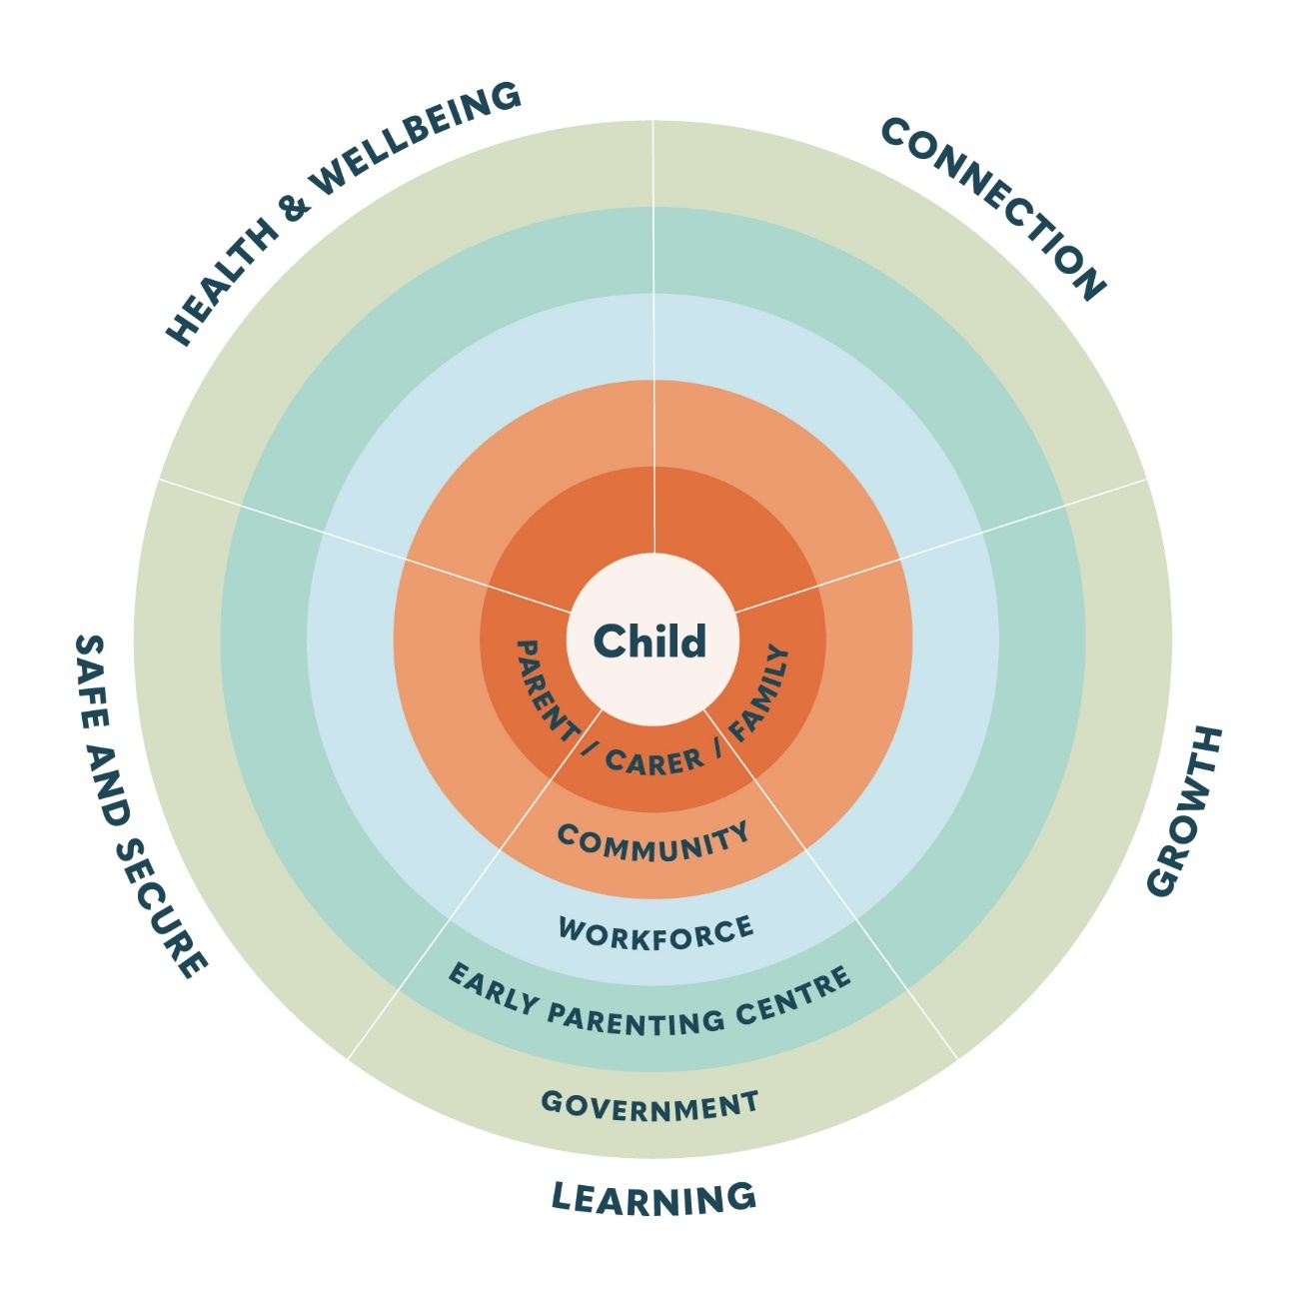

Figure 1. Socio-ecological levels of the EPC Outcomes Framework

Logic Model
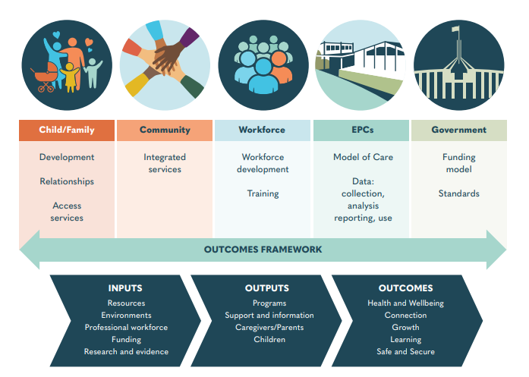Logic models use graphic depictions to represent shared relationships between various elements of a program, intervention, or framework (Smith, Li & Rafferty, 2020). They can be used as an explicit statement of how a program, framework or policy links to the intermediate results that eventually contribute to intended impacts and outcomes (Davidoff et al., 2015). This logic model represents the purpose and proposed impact of the EPC Outcomes Framework across the socio-ecological levels of the EPC network (Figure 2).
Figure 2. Logic model of the Outcomes Framework

Framework Structure
The Outcomes Framework is structured using overarching outcome domains, outcome areas, key results indicators and measures, as represented in Figure 3. Each outcome domain (Health and Wellbeing, Connection, Growth, Learning, and Safe and Secure) contains outcomes areas, and each outcomes area has a set of key result indicators that have been designed to examine and report change within the outcome area.
Key results indicators operationalise expected change in the outcome area for the multiple levels identified in the Outcomes Framework. Key results indicators were developed using SMART (Specific, Measurable, Achievable, Relevant and Timely) principles (Doran, 1981) to ensure the indicators have the capacity to map progress in the outcome areas.
Extensive research and a key stakeholder workshop was conducted to identify appropriate measures and tools required to examine change across the outcome areas.
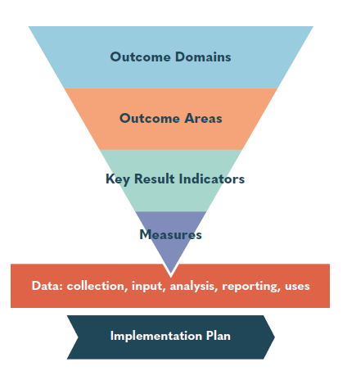
Figure 3. Framework structure

Key terms
Outcome Domains | Overarching categorisation of outcomes in order to apply general principles
Outcome Areas | Specific benefit that may occur due to the participation in an activity or programs or involvement with a service
Key Result Indicator | The measure of change or progress in associated outcomes due to participation in an activity or program or involvement with a service
Measures | A tool used to quantify change and enable reporting of variation in outcomes

Section 2

Victorian Early Parenting Centres Outcome Framework
This section of the report is the EPC Outcomes Framework and includes:
  - an Outcomes Framework Summary
  - general information about the outcome domains
  - outcome domain tables detailing outcome areas and key results indicators and measures.
  - additional measures and tools tables (Table 6 and 7) with further information of the measures recommended for use by the EPCs.
Aboriginal community-controlled organisation representatives were consulted during the development of this Outcomes Framework and their contributions are included.
To ensure Aboriginal early parenting outcomes and measures are tailored for these Aboriginal communities, the Department of Health will separately commission an Aboriginal Outcomes Framework.
The Aboriginal Outcomes Framework will be instrumental in:
  - determining Aboriginal measures of success and key outcome areas required to meet the needs and aspirations of Aboriginal children, parents and families within an early parenting context
  - informing a future Aboriginal led EPC model of care and service model for early parenting support, and
- exploring key outcome areas to improve Aboriginal health, wellbeing, development, access and cultural safety across the expanded EPC network.
Aboriginal children and families have unique strengths and experiences that require acknowledgement of culture and culturally safe practices as determined by Aboriginal families and services. Outcomes for Aboriginal families may include outcomes other than those contained in this framework.

Summary of the Early Parenting Centres Outcomes Framework (top level heading column is outcomes)
 | Outcomes
Socio-ecological level | Health and Wellbeing | Connection | Growth | Learning | Safe and Secure
Child | Children are healthy and well | Children are nurtured, engaged and supported | Children are constantly developing | Children have skills and knowledge to be successful learners and teachers | Children are safe and secure
Parent  /Carer/Family | Families are healthy and well | Families are nurtured, engaged and supported | Families and children are developing together | Families have skills and knowledge to be successful learners and teachers | Families are safe and secure
Community | EPCs and communities together support health and wellbeing | EPCs and communities together nurture, engage and support families | EPCs and communities together support child and family development | EPCs and communities together contribute to learning success | EPCs and communities together are safe and secure
Workforce | Workforce is healthy and well | Workforce is nurtured, engaged and supported | Workforce is developing together and with families | Workforce has skills and knowledge to be successful learners and teachers | Workforce is safe and secure
Early Parenting Centre | EPC environments are healthy | EPCs nurture, engage and support families, staff and community | EPC environments support child, family and workforce development | EPCs contribute to learning success | EPC environments are safe and secure
Government | Governments support the health and wellbeing of children and families | Governments support and engage communities, EPCs and families | Governments support EPCs and communities to promote child, family and workforce development | Governments contribute to child, family and EPC learning success | Governments support safe and secure environments for families, the workforce and communities

Outcome Domain 1- Health and Wellbeing

Health and Wellbeing: to have optimal health
General information: Health and wellbeing outcomes have been extensively explored and documented in the following Australian and Victorian Government plans and frameworks. These have been applied to the development of the Victorian EPC outcomes.
The Australian Health Performance Framework is a conceptual framework categorising the health system components, their inter-relationships and scope, and the measurement of performance across the system. The overall objective is to improve health outcomes for all Australians and ensure the sustainability of the Australian health system (NHIPPC, 2017). Health outcomes for families include:
- Health conditions: incidence and prevalence of disease, disorder, injury or trauma or other health related states.
- Human function: alterations to body, structure of function (impairment), activity limitations and restrictions in participation.
- Wellbeing: measures of physical, mental and social wellbeing of individuals.
The following priority areas and objectives in the Victorian public health and wellbeing plan 2019 – 2023 are associated with the health and wellbeing outcomes for families (Vic. DHHS, 2019):
Priority Area | Objective
Reducing injury | Decrease injury across the population, with an emphasis on priority populations: children 0–14 years, young adults 15–24 years, older adults 65+, Aboriginal Victorians and rural populations
Preventing all forms of violence | Women, men, girls and boys are treated equally with respect and dignity  All parts of the community are engaged in practical and creative ways to learn about respectful, safe and equitable relationships  Women and children are resourced, supported and empowered to make decisions regarding their safety and wellbeing  All Victorians feel safe and empowered to take a stand against family violence
Increasing healthy eating | Increase capacity to breastfeed, and prepare and consume healthier foods and drinks  Increase socio-cultural norms reinforcing healthier eating, drinking and breastfeeding
Increasing active living | Increase accessible and adaptable spaces for active living, ensuring compliance with appropriate state and national regulations and standards  Increase socio-cultural norms reinforcing active living  Increase capacity to be more physically active and less sedentary  Decrease sedentariness in workplaces, schools and early learning centres and during leisure time
Improving mental wellbeing | A reduction in the prevalence of mental illness, and increased resilience among Victorian individuals, families and communities  Reductions in the gap in social and emotional wellbeing for at-risk groups, including Aboriginal Victorians, with an emphasis on  loneliness and increasing social connectedness  Reductions in the occurrence of suicide deaths, suicidal ideation and suicidal attempt, and the gap between the suicide rates for vulnerable groups and the general population
See Appendix A for the Victorian Public Health and Wellbeing Outcomes Framework.
Table 1 details the health and wellbeing outcomes, key results indicators and suggested measures/tools for each socio-ecological level.

Table 1. Health and Wellbeing Outcome Domain
Socio-ecological Level Outcomes | Outcome Area | Key Result Indicator | Measure/Tool
Child  Children are healthy and well | Mental and emotional wellbeing | Increase mental and emotional wellbeing, by decreasing risk factors and increasing protective factors | Karitane Parenting Confidence Scale  Family Violence Screening and Identification  Pre-Admission Form (PAF)  Newborn Observation*
Child  Children are healthy and well | Physical health including sleep and nutrition | Increase physical health | Child Family Action Plan  Karitane Parenting Confidence Scale  Immunisation status  Feed and sleep chart  Child Review  Breastfeeding status  Family Violence Screening and Identification  Pre-Admission Form (PAF)
Parent/Carer  /Family  Families are healthy and well | Mental health and emotional wellbeing | Increase support of mental health and emotional wellbeing  Identify and refer to health professionals | Child Family Action Plan  Family Violence Screening and Identification  Depression Anxiety Stress Scale (DASS21)  Links/referrals to other support services  Pre-Admission Form (PAF)  Edinburgh Postnatal Depression Scale (EPDS)*  Antenatal Risk Questionnaire*  Karitane Family Outcomes Tool*  Difficult Life Circumstances (DLC)*
Parent/Carer  /Family  Families are healthy and well | Physical health including:  Ante and post-natal care  Breast feeding  Sleep | Increase support of healthy eating and active lifestyle strategies  Decrease smoking, drug and alcohol use | Links/referrals to other support services.  i.e QUIT, GP, allied health and community services  Family Violence Screening and Identification  Pre-Admission Form (PAF)  Community Life Skills (CLS)*  Difficult Life Circumstances (DLC)*
Parent/Carer  /Family  Families are healthy and well | Wellbeing | Increase sense of wellbeing | Personal Wellbeing Index
Community  EPCs and communities together support health and wellbeing | Early intervention and preventive health care (physical and emotional) | Increase early intervention and preventive care integrated across services | Links/referrals between services  Service partnerships
Workforce  Workforce is healthy and well | Mental and emotional wellbeing | Increase support of mental health and emotional wellbeing | People Matter Survey  No. of reflective practice and supervision sessions  EAP usage
Workforce  Workforce is healthy and well | Wellbeing | Increase sense of wellbeing | People Matter Survey
Workforce  Workforce is healthy and well | Physical health | Increase physical health | Immunisation rates  Engagement in staff health and wellbeing program
Early Parenting Centre  Early Parenting Centres environments are healthy | Workplace culture | Increase positive beliefs, interactions, behaviours, and attitudes in the workplace | People Matter Survey
Early Parenting Centre  Early Parenting Centres environments are healthy | Early intervention and preventive health care (physical and emotional) | Increase support for workforce and families to engage in preventive health care  Referrals to appropriate support for staff and families | Links/referrals  Employee Assistance Program (EAP) usage
Government  Governments support the health and wellbeing of children and families | Federal government | Children and families are healthy and well | Services aligned to: National Safety and Quality Health Care Standards (NSQHS)
Government  Governments support the health and wellbeing of children and families | State government | Children and families are healthy and well | Service outcomes aligned to:  Victorian Public Health and Wellbeing Plan  Human Services Standards  Best Interests Framework
Government  Governments support the health and wellbeing of children and families | State government | Children have a strong sense of wellbeing | Service outcomes aligned to:  Victorian Public Health and Wellbeing Plan
Government  Governments support the health and wellbeing of children and families | State government | Safe, effective child/family centred care | Services aligned to:  Safer Care Victoria Clinical Governance Framework  Victorian Child Safe Standards  Mandatory Reporting  Best Interests Framework  Client Voice Framework for Community Services
*Optional measure/tool

Outcome Domain 2 - Connection

Connection: to be nurtured, engaged and supported
General information: Connection outcomes consider the relationships, connections, or networks that a system, person or object has with someone/thing else, the act or process of joining and the combined outcome. Relational factors contributing to connection include:
- Attachment: recognises the affectional bond or connection between a person and an attachment figure, usually a caregiver. Attachment styles can influence children’s health, behaviour, and developmental wellbeing.
- Relationship satisfaction: the interpersonal evaluation of the feelings towards another person characterised by trust, respect, honesty, support, and communication.
- Interactions: considers both the process and the content of the connection between people.
- Communication: the use of language to talk, write, listen or reading in order to give, receive and share information.
- Engagement: in the context of the act of engaging. To be involved in the process of connecting with something or someone that is grounded in the act of reciprocity or mutual benefit.
- Partnerships: a relationship of ongoing connection working towards a mutual goal, traditionally defined by a formal arrangement.
Table 2 details the connection outcomes, key results indicators and suggested measures/tools for each socio-ecological level.

Table 2. Connection Outcome Domain
Socio-ecological Level Outcomes | Outcome Area | Key Result Indicator | Measure/Tool
Child  Children are nurtured, engaged and supported | Relationships (attachment, interactions, sensitivity, engagement) | Increase quality of relationships with primary caregivers  Increase connection to culture and community for Aboriginal and Torres Strait Islander children | Karitane Parenting Confidence Scale  Child and Family Action Plan  Newborn Observation*
Parent/Carer/  Family Families are nurtured, engaged and supported | Support  Engagement  Network | Increase support and engagement with family, peers, professionals  Increase connection to culture and community for Aboriginal and Torres Strait Islander families | Child Family Action Plan  Family Violence Screening and Identification  Link to MCH services  Number of referrals  Family Experience Survey  Antenatal Risk Questionnaire*
Community Life Skills (CLS)*
Difficult Life Circumstances (DLC)*
Parent/Carer/  Family Families are nurtured, engaged and supported | Relationship with child | Increase quality of relationships with children  - Strengthen responsiveness and communication with child  - Strengthen interactions and engagement with child | Karitane Parenting Confidence Scale  Kansas Parental Satisfaction Scale (KANSAS)  Me as a Parent  Family Experience Survey
Community  EPCs and communities together nurture, engage and support families | Relationships and partnerships with communities and sector | Promote connection of Aboriginal and Torres Strait Islander children and families to their communities | No. of service partnerships
Community  EPCs and communities together nurture, engage and support families | Relationships and partnerships with communities and sector | Promote connection of Aboriginal and Torres Strait Islander children and families to their communities | No. of service partnerships
Workforce  Workforce are nurtured, engaged and supported | Relationships | Increase engagement and support through supervision, peer relationships and team connection | Supervision and reflective practice sessions  People Matter Survey
Early Parenting Centre  Early Parenting Centres nurture, engage and support families, staff and community | Referrals | Increase internal and external referrals to connect workforce, families and community | Links/referrals
Early Parenting Centre  Early Parenting Centres nurture, engage and support families, staff and community | Networks and partnerships | Increase and strengthen networks and partnerships | No. of service partnerships
Early Parenting Centre  Early Parenting Centres nurture, engage and support families, staff and community | Sector visibility | Increase visibility of services | Website and social media activity  Links/referrals  No. of community engagement activities
Government  Governments nurture, support and engage communities, EPCs and families | State government | Victorians are connected to culture and community | Service outcomes aligned to:  Victorian Public Health and Wellbeing Plan  Human Services Standards  Client Voice Framework for Community Services
Government  Governments nurture, support and engage communities, EPCs and families | State government | Children are connected with and contribute to their world | Service outcomes aligned to:  Victorian Public Health and Wellbeing Plan
Government  Governments nurture, support and engage communities, EPCs and families | State government | Continuous monitoring and improvement of consumer partnerships and workforce | Services aligned to:  Safer Care Victoria Clinical Governance Framework  EPC Model of Care
* Optional measure/tool

Outcome Domain 3 - Growth

Growth: to be developing individually and together
General information: Growth outcomes recognises changes in development and behaviour across time.
Development is the act or process of growing, progressing or developing and includes the following areas:
- Cognitive: the ability to think, reason and make decisions using knowledge, skills and problem-solving strategies as the brain grows and matures.
- Physical: the progression and refinement of gross and fine motor skills through regular movement and activity in order to control and use our bodies and healthy weight development.
- Social: the process of learning and gaining skills, knowledge and values to interact socially and relate to others.
- Emotional: the process of learning and understanding feelings and emotions, the emergence and regulation of feelings and the capacity to recognise feelings in others.
- Language: the process of understanding language and learning to use words and sentences through auditory and oral strategies in order to communicate.
Behavioural development is the progression of actions, reactions and functioning in response to the environment, events and situations. The development of the above key growth areas can significantly influence behaviour and response mechanisms.
*Note developmental and behavioural milestones and growth can occur at different timepoints for children during the early childhood period.
Table 3 details the growth outcomes, key results indicators and suggested measures/tools for each socio-ecological level.

Table 3. Growth Outcome Domain
Socio-ecological Level Outcomes | Outcome Area | Key Result Indicator | Measure/Tool
Child  Children are constantly developing | Behaviour | Identify age-appropriate behavioural milestones | Kansas Parental Satisfaction Scale (KANSAS)  My Health, Learning and Development Record  Difficult Life Circumstances (DLC)*
Child  Children are constantly developing | Development: physical, social-emotional, cognitive, language | Identify age-appropriate developmental milestones | My Health, Learning and Development Record  Child Review  Difficult Life Circumstances (DLC)*  Parents’ Evaluation of Developmental Status (PEDS)*  Ages and Stages Questionnaire (ASQ)*  Brigance Developmental Screening*
Child  Children are constantly developing | Physical growth | Identity age-appropriate physical growth | My Health, Learning and Development Record  Pre-Admission Form (PAF)  Child Review  Feed-Sleep Chart  WHO Growth Charts*
Parent/Carer/  Family Families and children are developing together | Behaviour and development | Increase support of child development and prosocial behaviours | Karitane Parenting Confidence Scale  Kansas Parental Satisfaction Scale (KANSAS)  Karitane Family Outcomes Tool*
Community  EPCs and communities together support child and family development | Partnerships | Increase partnering opportunities for children, families and EPCs with community organisations and service providers | No. of service partnerships
Workforce  Workforce is developing together and with families | Behaviour and development | Decrease developmental vulnerability for children and families | Annual Performance Review and Development Plan
Workforce  Workforce is developing together and with families | Psychological (trauma, stress minimised) | Increase awareness of psychological stressors | Reflective practice Supervision  EAP usage
Workforce  Workforce is developing together and with families | Empowerment (decision making/planning) | Increase engagement in career planning | Annual Performance Review and Development Plan
Workforce  Workforce is developing together and with families | Team building | Increase and strengthen team building | People Matter Survey
Early Parenting Centres  Early Parenting Centre environments support child, family and workforce development | Continual improvement | Increase engagement in continual improvement processes and safe, effective child/family centred care | Measures aligned to Safer Care Victoria Clinical Governance Framework  Accreditation status
Government  Governments support EPCs and communities to promote child, family and workforce development | State Government | Children have a sense of identity  Children are effective communicators | Services aligned to:  Vic Early Years Learning and Development Framework  Vic Child and Adolescent Outcomes Framework
Government  Governments support EPCs and communities to promote child, family and workforce development | State Government | Children are safe | Services aligned to:  Victorian Child Safe Standards
* Optional measure/tool

Outcome Domain 4 - Learning

Learning: to have the skills and knowledge to be successful learners
General information: Learning outcomes describe the attainment of knowledge, skills or expertise gained through involvement in learning activities including programs, interventions, education, training and courses and can include the following:
- Intellectual skills: the ability to think, plan, learn and function through comprehension, reasoning, analysis, problem solving and memory. Also includes the understanding of how to do something such as concepts, procedures, rules and execution in practice.
- Cognitive strategies: personal capabilities to think, learn, organise and behave through the use of rehearsal, elaboration, mental imagery and reflection strategies.
- Verbal information: the articulation of learned knowledge and skills through the use of language and communication strategies.
- Attitudes: represented by a) feelings and emotions; b) cognitive beliefs and knowledge and c) behaviours towards an event, person, idea or object. Assessments of self and others can influence knowledge functioning and social thought and can also predict behaviour.
- Practical skills: real activities, strategies or work requiring special training and knowledge. Skills and lessons that can be learnt, taught and practiced enabling self-help and provision of assistance to others.
Table 4 details the learning outcomes, key results indicators and suggested measures/tools for each socio-ecological level.

Table 4. Learning Outcome Domain
Socio-ecological Level Outcomes | Outcome Area | Key Result Indicator | Measure/Tool
Child  Children have skills and knowledge to be successful learners and teachers | Sleep | Increase self-settling techniques  Enhance age-appropriate sleep patterns | Child Family Action Plan  Karitane Parenting Confidence Scale  Feed-Sleep Chart
Child  Children have skills and knowledge to be successful learners and teachers | Play | Increase the use of play in learning | Karitane Parenting Confidence Scale
Child  Children have skills and knowledge to be successful learners and teachers | Communication, language and cues | Increase intentional communication exchanges  Increase acquisition of first language through exposure and modelling  Increase the use of cues to express self | Karitane Parenting Confidence Scale
Parent/Carer/  Family  Families have skills and knowledge to be successful learners and teachers | Goal setting | Development of action plan and goals | Child and Family Action Plan  Family Experience Survey
Parent/Carer/  Family  Families have skills and knowledge to be successful learners and teachers | Awareness and knowledge | Increase knowledge and understanding of child behaviours and development, parenting, sleep, feeding, play, communication and cues | Karitane Parenting Confidence Scale  Kansas Parental Satisfaction Scale (KANSAS)  Family Experience Survey  Karitane Family Outcomes Tool*
Parent/Carer/  Family  Families have skills and knowledge to be successful learners and teachers | Strategies and skills | Increase use of strategies and skills relating to child behaviour and development, parenting, sleep, feeding, play, communication and cues | Child Family Action Plan  Karitane Parenting Confidence Scale  Family Experience Survey  Karitane Family Outcomes Tool*
Parent/Carer/  Family  Families have skills and knowledge to be successful learners and teachers | Confidence, independence, engagement and empowerment | Increase parenting confidence, independence, engagement and empowerment | Karitane Parenting Confidence Scale  Kansas Parental Satisfaction Scale (KANSAS)  Family Experience Survey  Me as a Parent  Karitane Family Outcomes Tool*
Parent/Carer/  Family  Families have skills and knowledge to be successful learners and teachers | Capacity, motivation and expectations | Increase capacity and motivation to learn strategies and skills  Understanding of realistic parenting expectations | Child Family Action Plan  Family Experience Survey
Community  EPCs and communities together contribute to learning success | Awareness and knowledge | Increase awareness and knowledge EPCs services | Links/referrals/enquiries  Engagement through websites
Community  EPCs and communities together contribute to learning success | Communication | Increase communication with communities and service providers | No. of Consumer and Community Involvement activities
Workforce  Workforce has skills and knowledge to be successful learners and teachers | Supporting families:  Confidence  Engagement  Awareness  Motivation  Communication and language  Risk assessment | Increase knowledge, skills, and strategies to support families | Annual Performance Review and Development Plan
Workforce  Workforce has skills and knowledge to be successful learners and teachers | Personal/professional development: Knowledge  Skills and strategies  Core competencies | Increase knowledge, skills, strategies and core competencies | Annual Performance Review and Development Plan
Early Parenting Centres  Early Parenting Centres contribute to learning success | Supporting staff:  Professional development  Orientation  Supervision | Provision of learning opportunities to support staff | Learning and development data
Early Parenting Centres  Early Parenting Centres contribute to learning success | Competencies | Provision of core competencies and role expectations | Clinical competencies – scope of practice reviewed
Early Parenting Centres  Early Parenting Centres contribute to learning success | Continual improvement | Opportunities for revision of systems and processes  Compliance with accreditation processes  Provision of safe, effective, child/family centred care | Measures aligned to Safer Care Victoria Clinical Governance Framework  Accreditation status
Early Parenting Centres  Early Parenting Centres contribute to learning success | Model of Care | Provision and implementation of Model of Care | Learning and development data  Aggregated child/family outcomes measures
Government  Governments contribute to child, family and EPC learning success | Federal government | Monitoring, compliance and enforcement of relevant standards | Services aligned to:  National Safety and Quality Health Services Standards
Government  Governments contribute to child, family and EPC learning success | State government | Children are confident and involved learners  Children are effective communicators | Services aligned to: Victorian Child Safe Standards
Government  Governments contribute to child, family and EPC learning success | State government | Victorians have the capabilities to participate | Services aligned to:  Safer Care Victoria Clinical Governance Framework  Client Voice Framework for Community Services
Government  Governments contribute to child, family and EPC learning success | State government | EPCs provide learning environments for children and families | Services aligned to:  EPC Model of Care
* Optional measure/tool

Outcome Domain 5 - Safe and Secure

Safe and Secure: to be protected and included
General information: Safe and secure outcomes acknowledge the internal and external conditions or surroundings in which people live and work including place and social environments. such as:
- Culture: the ways of life, ideas, customs, beliefs, and social behaviours of a population passed on through generations.
- Diversity: the uniqueness of humanity through ability, personality, life experiences, beliefs, ethnicity, gender and sexual orientation.
- Inclusion: the practice or quality of including people with a range of capabilities from different social and ethnic backgrounds.
- Safety: the freedom from harm or danger and the state of being safe - physically, emotionally, psychologically, financially, culturally, sexually.
Table 5 details the safe and secure outcomes, key results indicators and suggested measures/tools for each socio-ecological level.

Table 5. Safe and Secure Outcome Domain
Socio-ecological Level Outcomes | Outcome Area | Key Result Indicator | Measure/Tool
Child  Children are safe and secure | Physical, psychological and emotional wellbeing | Increase physical, mental and emotional health and wellbeing  Reduce preventable injury and harm  Reduce exposure to abuse and neglect | Child and Family Action Plan  Child Review  Karitane Parenting Confidence Scale  Safe Sleeping Checklist  Safety Checklist  Family Violence Screening and Identification
Child  Children are safe and secure | Diversity and intersectionality:  Children from CALD families  Children experiencing differing abilities  Gender equity | Recognition, acknowledgement and celebration of diversity | Child and Family Action Plan  Pre-Admission Form (PAF)
Parent/Carer/  Family  Families are safe and secure | Access and opportunity | Increase opportunities to access supportive service environments that respond to family’s needs | Waitlist times  Service Usage data  Family Experience Survey
Parent/Carer/  Family  Families are safe and secure | Physical, psychological and emotional wellbeing | Increase physical, mental and emotional health and wellbeing  Reduce preventable injury  Reduce exposure to abuse and harm | Depression Anxiety Stress Scale (DASS21)  Family Violence Screening and Identification  Karitane Parenting Confidence Scale  Links/referrals to other support services  Edinburgh Postnatal Depression Scale (EPDS) *  Difficult Life Circumstances (DLC)*
Parent/Carer/  Family  Families are safe and secure | Diversity and intersectionality:  Families who identify as CALD  Parents/caregivers experiencing differing abilities  Parents/caregivers who identify as LGBTIQA+  Gender equity | Recognition, acknowledgement and celebration of diversity | Child and Family Action Plan  Family Experience Survey  Pre-Admission Form (PAF)
Community  EPCs and communities together are safe and secure | Safe and accessible | Increase safe, welcoming and accessible environments for communities to gather | No. of Consumer and Community Involvement activities
Community  EPCs and communities together are safe and secure | Integrated services | Increase opportunities for communities to integrate and care for families | No. of formal partnerships
Community  EPCs and communities together are safe and secure | Equality, equity, diversity and intersectionality for families and staff:  Identify as CALD  Experiencing differing abilities  Identify as LGBTIQA+  Gender equity | Recognition, acknowledgement and celebration of diversity | Organisational equity and inclusion plan
Workforce  Workforce is safe and secure | Diversity and intersectionality:  Workforce who identify as CALD  Workforce experiencing differing abilities  Workforce who identify as LGBTIQA+  Gender equity | Recognition, acknowledgement and celebration of diversity | Organisational Diversity and Inclusion Plan
Workforce  Workforce is safe and secure | Accessible and safe | Increase accessible, safe and secure workplace environments | OHS standards and reporting  People Matter Survey
Workforce  Workforce is safe and secure | Psychological and emotional | Increase promotion of supportive and positive workplace culture | People Matter Survey
Early Parenting Centre  Early Parenting Centre environments are safe and secure | Equality, equity, diversity and intersectionality for families and staff:  Identify as CALD  Experiencing differing abilities  Identify as LGBTIQA+  Gender equity | Recognition, acknowledgement and celebration of diversity  Provision of equitable rights and opportunities | Organisational equity and inclusion plan  People Matter Survey
Early Parenting Centre  Early Parenting Centre environments are safe and secure | Physical environment | Increase safe, welcoming and accessible environments for clients, workforce, and community members | Building compliance with disability standards  People Matter Survey  Family Experience Survey
Early Parenting Centre  Early Parenting Centre environments are safe and secure | Organisational integrity | Provision of ethical and moral principles and values  Provision of equitable rights and opportunities | Mission/values statement  People Matter Survey
Government  Governments support safe and secure environments for families, the workforce and the community | State government | Victorians are safe and secure  Victoria is liveable | Service outcomes aligned to:  Victorian Public Health and Wellbeing Plan
Government  Governments support safe and secure environments for families, the workforce and the community | State government | Victorians are connected to culture and community | Services outcomes aligned to:  Cultural Responsiveness Framework: guidelines for Victorian Health Services
Government  Governments support safe and secure environments for families, the workforce and the community | State government | Continuous monitoring and improvement of clear commitment to child safety standards | Victorian Child Safe Standards
* Optional measure/tool

Measures and Tools
The following measures and tools are recommended to measure the outcomes included in this framework. Administration of the measures will be dependent on program delivery and it is suggested the data collection time points should be specified in EPC practice and program guidelines and frameworks.
The primary measures outlined here in Table 6 are required to be completed by all EPCs to ensure consistency in reporting and data analysis.

Table 6. Primary Measures and Tools
Name of Measure/Tool | Measures | Outcome domain | Level | Completed by | Modality
Annual Performance Development Review Appraisal Plan | Individual work performance, professional development and goal planning | Connection  Growth  Learning | Staff | Staff | Review  Interview
Breastfeeding status | Use of breastfeeding | Health and Wellbeing  Growth | Child | Staff | Interview
Child Review | Physical health including sleep and nutrition  Injury, harm, abuse and neglect | Health and Wellbeing  Growth  Safe and Secure | Child | Staff | WHO Grow Charts  Feed-Sleep Chart  Oral Health
Child Family Action Plan | Develop goals, outcomes and actions | Health and Wellbeing  Connection  Growth  Learning  Safe and Secure | Child  Caregiver/  Parent | Caregiver/  Parent  Staff | Written plan
Depression Anxiety Stress Scale  (DASS21) | Depression, anxiety and stress | Health and Wellbeing | Caregiver/  Parent | Caregiver/  Parent | Survey21 items
Family Experience Survey | Program and service satisfaction and outcomes | Connection  Learning  Safe and Secure | Caregiver/  Parent  EPC | Caregiver/  Parent | Survey
Family Violence Screening and Identification | Physical  Environment | Health and Wellbeing  Connection  Safe and Secure | Child  Caregiver/  Parent | Staff | MARAM Tools
Feed-Sleep Chart | Food and fluid intake  Settling behaviour | Health and Wellbeing  Growth  Learning | Child | Staff | Ongoing chart
Immunisation status | Immunisation status | Health and Wellbeing | Child | Staff | Review:  Australian Immunisation  Register  Child Health Record
Kansas Parental Satisfaction Scale  (KANSAS) | Satisfaction with:  - Child’s behaviour  - Self as a parent  - Relationship with child | Connection  Growth  Learning | Child  Caregiver/  Parent | Caregiver/  Parent | Survey  3 items
Karitane Parenting Confidence Scale (KPCS) | Assess Parenting Confidence | Health and Wellbeing  Connection  Growth  Learning  Safe and Secure | Child  Caregiver/  Parent | Caregiver/  Parent | Survey  15 items
Me as a Parent | Caregivers/parents sense of being able to engage confidently with the responsibilities of being a parent | Connection  Learning  Safe and Secure | Caregiver/  Parent | Caregiver/  Parent | Survey  4 items
Personal Wellbeing Index | Satisfaction of seven quality of life domains | Health and Wellbeing | Caregiver/  Parent  Staff | Caregiver/  Parent  Staff | Survey  9 items
People Matter Survey | Workplace aspects including job satisfaction, diversity and inclusion and work-related stress | Health and Wellbeing  Connection  Growth  Safe and Secure | Staff | Staff | Survey  206 items
Pre-Admission Form (PAF) | Intake, referral, demographic and general child and family information | Health and Wellbeing  Growth  Safe and Secure | Child  Caregiver/  Parent | Caregiver/  Parent  Staff | Referral, intake and admission data collection
Safe Sleeping Checklist | Safety of sleeping environments | Safe and Secure | Child | Staff | Survey  10 items
Safety Checklist | Comprehensive safety checklist for each area of the home | Safe and Secure | Child | Caregiver/  Parent | 83 items

The additional measures included here in Table 7 recognise the need for EPCs to understand their families and services within their local context and can be utilised for internal review purposes.

Table 7. Additional Measures and Tools for use in the local context
Name of Measure/Tool | Measures | Outcome domain | Level | Completed by | Modality
Ages and Stages Questionnaire (ASQ) | Developmental and social-emotional screening for children | Growth | Child | Caregiver/  Parent  Staff | Questionnaire  30 items
Antenatal Risk Questionnaire  (ANRQ) | Past mental health, physical, sexual, emotional abuse, current support, relationship with mother and partner, anxiety and obsessive behaviours, stressors | Health and Wellbeing  Connection | Caregiver/  Parent | Caregiver/  Parent | Survey  9 items
Brigance Developmental Screening | Developmental screening and assessment for children | Growth | Child | Staff | 10 – 15 mins assessment
Community Life Skills (CLS) | Use of community resources and ability to negotiate for self and family in the community | Health and Wellbeing  Connection | Caregiver/  Parent | Staff | Survey  33 items
Difficult Life Circumstances (DLC) | Stressors or chronic challenges in families | Health and Wellbeing  Connection  Growth  Safe and Secure | Child  Caregiver/  Parent | Caregiver/  Parent | Survey  38 Items
Edinburgh Postnatal Depression Scale (EPDS) | Postnatal depression and sensitive to antenatal depressive symptoms and anxiety | Health and Wellbeing  Connection | Caregiver/  Parent | Caregiver/  Parent | Survey10 items
Karitane Family Outcomes Tool  (KFOT) | Parental feelings  Reading cues and meeting child’s needs  Perception of child behaviour | Health and Wellbeing  Growth  Learning | Caregiver/  Parent | Caregiver/  Parent | *Survey under development with UNSW
Karitane Parenting Confidence Scale  (KPCS) | Assess parenting confidence | Learning | Caregiver/  Parent | Caregiver/  Parent | Survey  15 items
Newborn Observation  (NBO) | Describe the newborn’s responses to their new extrauterine environment and document the contribution of the newborn infant to the development of the emerging parent-child relationship. | Health and Wellbeing  Connection | Child | Staff | 18 neuro-behavioural observations
Parent-Child Interaction Scale  NCAST | Parent-child feeding and teaching interactions | Health and Wellbeing  Growth  Learning | Child  Caregiver/  Parent | Staff | Video  Assessment
Parents’ Evaluation of Developmental Status (PEDS) | Child development from the parent perspective | Growth | Child | Caregiver/  Parent | Survey  10 items

Section 3

Implementing the Early Parenting Centres Outcomes Framework

Purpose
This plan has been created to support the implementation of the EPC Outcomes Framework.
The objectives of the implementation plan are to:
- guide the embedding of the Outcomes Framework across the existing EPCs
- support EPCs to consider the key implementation determinants (barriers and enablers) and enable EPCs to successfully test and embed the Outcomes Framework, and tailor implementation based on their local context and needs
- provide practical steps to assist EPCs to test the transition of the state-wide Outcomes Framework into practice.

Development of the Implementation Plan
The Implementation Plan has been developed by Monash University in consultation with key stakeholders and is informed by implementation science. The following terminology and theoretical approaches have been used throughout this plan to guide its development:
- Implementation science examines the methods and strategies to encourage adoption
and integration of evidence-based practices, interventions, policies and frameworks into routine practice in order to improve outcomes.
- Implementation planning is the vital pathway between the adoption of frameworks and interventions and the routine use of recommended activities into practice.
- Planning for implementation processes and systems to monitor outcomes and translating evidence into practice may significantly lead to improvements in outcomes and engagement with organisational frameworks and interventions
(Damschroder et al., 2009; de Jong et al., 2014).
The key areas informing the development of the Implementation Plan include:
- Implementation Determinants (barriers/enablers): understanding and/or explaining what influences implementation such as characteristics, settings and processes.
- Implementation Goals: state the desired aims or results following engagement in implementation strategies and mechanisms.
- Implementation Strategies and Approaches: vital practice focused approaches and activities required to accomplish translating frameworks and programs into practice.
- Roles and responsibilities (ownership): a person or team or in a workplace and the tasks and duties of the particular role or job description.
- Milestones/timeframes: a significant, target or deadline stage of the implementation process.
- Measures: measurement of implementation outcomes including acceptability, adoption, appropriateness, costs, feasibility, fidelity, penetration, and sustainability.
(Damschroder et al., 2009; Proctor et al., 2009; Smith & Rafferty, 2020).

Implementation Determinants
The Child Outcomes Research Consortium’s seven determinants for implementation of an outcomes framework (see Figure 2. Marriott, Sleed, & Dalzell, 2019) has been applied to inform this plan. This includes the synthesis of the information collated during development of the outcomes framework and additional sessions held with a wide range of staff from The Queen Elizabeth Centre.
Barriers and enablers for the following determinants were identified and used to develop the implementation plan’s goals, strategies and activities.
#1 Leadership, vision and culture: Senior organisational leaders share a consistent vision and support is provided for meaningful collection and use of outcome measures; ensuring that staff collecting and using data feel empowered and supported.
- Determinants identified include communication, culture, prominence, interpretation, training and budget.
#2 Embedding measures as part of the everyday: Support is required to embed the measures and tools required to measure outcomes.
- Determinants identified include meetings, roles and responsibilities, supervision and transparency.
#3 Building staff confidence and capability: Keeping staff engaged with the implementation process and developing strategies to remove implementation barriers.
- Determinants identified include starting small, new starters, training and peer supervision.
#4 Practical considerations and processes: Ensure environments are designed to support data collection, analysis and use.
- Determinants identified include measure formats (e.g., online/electronic/hard copy), access to measures and tools, practice guidelines and data input.
#5 Basic IT considerations: Ensure data is accessible beyond collection by providing local IT systems that are functional for collecting, storing and reporting data.
- Determinants identified include electronic recording, reporting plan and IT training.
#6 Sustaining the effort: Maintain a sustained focus on implementation beyond the initial introduction of the framework.
- Determinants identified include sharing successes early and often, creating a community of practice, and building collaborative partnerships across EPCs.
#7 Analysing and reporting aggregate data to inform service decisions: Data analysis and interpretation should be consistent, appropriate for all possible key stakeholders audiences and directly related to the identified outcomes.
- Determinants identified include data completeness, range of impact information and socio-ecological level groupings.

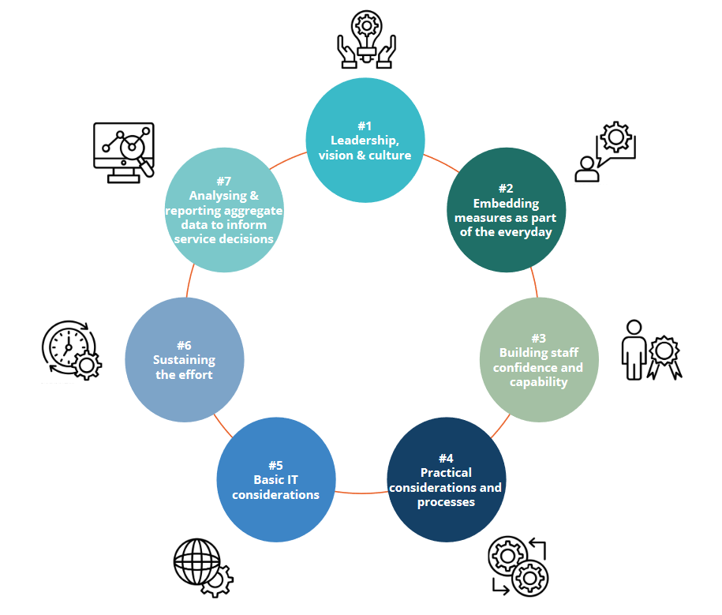
Figure 4 Seven determinants of implementation (Marriott, Sleed, & Dalzell, 2019)

EPC Outcomes Framework Implementation Plan
The following implementation plan outlines implementation roles and responsibilities and provides the strategies, approaches and activities to support the implementation of the Outcomes Framework into EPC practice.
This is not a linear implementation plan - rather it is suggested that EPCs engage in the areas concurrently and utilise a phased approach to implementing the Outcomes Framework.
Further, the Outcomes Framework and this implementation plan will be ‘living’ documents that can be refined over time as new learning arise and as more efficient methods are realised.

Implementation roles and responsibilities
Implementation owners for activities within this plan have been identified to ensure they are actioned in a timely manner by staff/teams with appropriate expertise.

Local EPC Implementation Team
In order to support implementation of the Outcomes Framework, the creation of a local implementation team for each EPC is advised. The local implementation team may consist of senior representation from: People and Culture, Education, Information and Technology, Quality, Safety, Risk and Clinical areas. The role of the local implementation team is to plan for and action the implementation strategies and activities within their EPC. A local implementation plan template has been developed to support EPC service providers (see Appendix B) to map implementation strategies, approaches, activities and can be utilised by the team to capture who will be responsible, milestones/timeframes and implementation measures for each activity.

Community of Practice
Establishing an EPC Community of Practice consisting of key representatives from each EPC will enable the coming together and sharing of information, skills, ideas, and learnings from the implementation process to support successful implementation of the Outcomes Framework across the EPC network. It will be critical that this group works together during the expansion of Victoria’s EPC network in order to share learning and expert knowledge, particularly regarding what is working well and what needs to be strengthened; and to document implementation outcomes from the whole of network perspective.

State-wide implementation support
The Department of Health will support EPCs to implement the Outcomes Framework by providing overarching guidance and resources to support consistency of practice across the expanded EPC network. This will include guidance to support EPC operation and clinical practice, such as the development of the state-wide Clinical Practice Framework, and implementation guidelines for areas such as intake, referral, and prioritisation. The Department will partner with existing EPCs to develop these resources and materials to ensure they are accepted and adopted into practice.

Implementation Strategies
To successfully plan for the implementation of the Outcomes Framework, a set of common implementation strategies are required to ensure consistency, fidelity, and sustainability of embedding the Outcomes Framework into practice across the EPC network.
The following key strategies have been identified:
Planning: To successfully plan for the implementation of the Outcomes Framework.
Education: To have the resources and support to educate and inform staff, consumers, community members and stakeholders about the Outcomes Framework and how it will be utilised in practice.
Data and Monitoring: To ensure outcomes data, reporting and monitoring is consistent, accessible, streamlined and readily used across all levels of the Outcomes Framework.

Planning strategies
Implementation goal 1: To successfully plan for the implementation of the Outcomes Framework
Consideration of planning elements including leadership, knowledge, internal reviews, and stakeholder and consumer engagement. Collectively these provide a strong foundation for the implementation of the Outcomes Framework. These strategies have the capacity to influence and promote positive communication, culture, leadership and vision in the adoption of the Outcomes Framework in EPCs.
Implementation approaches | Activities | Implementation owner
Leadership | Ensure representation on the state-wide EPC groups including workforce, funding and implementation. | State-wide implementation support  Local implementation team
Leadership | Establish a local implementation team.  Include the Outcomes Framework within strategic and operational planning (including communications).  Embed an organisational culture that celebrates outcomes.  Support a continuous improvement and learning culture.  Recruit, designate and train leaders for the change effort. | Local Implementation Team
Readiness | Map current practice with the Outcomes Framework and identify areas for change and new learning.  Determine degree of readiness to implement, barriers and strengths to implementation.  Assess staff knowledge, beliefs and self-efficacy.  Conduct information sessions for staff, key stakeholders, governing boards, consumers, community members relating to the Outcomes Framework. | Local Implementation Team
Knowledge | Map current clinical practice with state-wide practice guidance (yet to be developed).  Identify areas that require de-implementation and new areas that require implementation. | State-wide implementation support
Knowledge | Internally review and revise all guidelines, frameworks, procedures, protocols and policies to reflect the Outcomes Framework.  Revise role descriptions and performance management tools to reflect Outcomes Framework implementation. | Local Implementation Team
Stakeholder Engagement | Identify and engage stakeholders to oversee implementation efforts, and to provide advice and make recommendations.  Build a local alliance (staff, governing boards, key stakeholders, academic partnerships).  Recruit and foster relationships with partners to support the implementation effort.  Engage advisory boards and working groups to support implementation. | State-wide implementation support  Community of Practice  Local Implementation Team
Stakeholder Engagement | Foster relationships with staff to champion the implementation of the Outcomes Framework.  Ensure consumer representation on the Local Implementation Team. | Local Implementation Team

Education strategies
Implementation goal 2: To have the resources and support to educate and inform staff, consumers, community members and stakeholders about the Outcomes Framework and how it will be utilised in practice.
Embedding the Outcomes Framework into practice will involve: scoping existing training and practices, developing resources, preparing and delivering training, supporting translation to practice and establishing EPC Communities of Practice. These elements will influence building staff confidence and capability, embedding the measures, and contribute to sustaining the use of the framework.
Implementation approaches | Activities | Implementation owner
Scope current enablers | Assess state-wide resources.  Identify learning, development and training opportunities that already exist that could be adapted to support the Outcomes Framework implementation. | State-wide implementation support
Scope current enablers | Identify clinical champions to lead implementation. | Local Implementation Team
Scope clinical practice requirements | Map current practice (tools/measures) with the Outcomes Framework and identify areas for change and new learning. | Local Implementation Team
Prepare clinical practice resources | Align program development and professional development with outcomes.  Redevelop current clinical practice framework to support implementation of the Outcomes Framework.  Include current and any future state-wide EPC resources (e.g., Victoria Sleep and Settling Model of Care).  Develop or align guidelines, procedures, training manuals, toolkits and other supporting materials to the Outcomes Framework.  Include information resources to promote common understanding about the Framework and the implementation.  Prepare internal and external communications promoting the framework. | State-wide implementation support  Local Implementation Team
Prepare and deliver training | Align training with respective evidence-informed tools/measures guidance.  Develop individual and organisation training plans that support the implementation of the Framework and meets the training needs of the organisation’s workforce.  Deliver this training plan across the organisation tailoring to level of competency, skill and knowledge.  Deliver training across a range of modalities: in-person, live online, technology assisted (e.g. videos, eLearning, modules).  Provide live in the moment training (on the ward/floor) to contextualise the Outcomes Framework and demonstrate use of tools/skills/knowledge. | Local Implementation Team
Supporting translation to practice | Information and knowledge exchange opportunities – internally and across the EPC network. | Community of Practice
Supporting translation to practice | Train designated clinicians/champions to support and coach others.  Provision of reflective practice and supervision, regular updates and ongoing consultations.  Provision of peer support program, individual learning plans and reviews.  Training in how to engage with the data to measure impact (outcomes).  Working in partnership with families to achieve these outcomes. | Local Implementation Team
EPC Community of Practice | Provide representation (educator and clinician) on the state-wide EPC Community of Practice.  Share information and learnings with the state-wide Community of Practice.  Provide opportunities to experience other EPC environments - secondments, placements. | Community of Practice
EPC Community of Practice | Establish a Local Implementation Team forum for:  Exchange of ideas  Information sharing  Peer support  Exploration of issues  Review of recent development and practices | Local Implementation Team

Data and monitoring strategies
Implementation goal 3: To ensure outcomes data, reporting and monitoring is consistent, accessible, streamlined and readily used across all levels of the Outcomes Framework.
A range of data and monitoring approaches / elements will enable the review of systems and alignment of the Outcomes Framework in existing systems; development of systems and tools; recording, translating and reporting of data and supports required. Collectively these will ensure interpretation, consistency and fidelity of outcomes being measured, and contribute to the understanding of the impact of EPCs.

Implementation approaches | Activities | Implementation owner
Review and align | Review current systems and align with the Outcomes Framework. | State-wide implementation support  Local Implementation Team
Systems and Tools | Provide systems and processes that monitor all outcomes.  Provide IT systems that are streamlined, accessible and easy to use for all staff.  Provide IT systems which enable easy data input, access to collated data and detailed reporting.  Develop, test and introduce IT systems which also address language, protocols, algorithms, standards, measures, outcomes and implementation.  Embed measures and tools into client management system. | State-wide implementation support  Local Implementation Team
Data recording, translating and reporting | Collect and collate outcome data.  Provide data to clinicians and administrators to inform practice, audit processes and standards.  Enable clinicians to interpret data and translate it into practice with the families.  Ensure data is accessible for reporting across all outcomes. | Local Implementation Team
Support  - ensure data quality | Develop processes and strategies for staff to encourage consumers to complete outcomes measures  Dedicated IT training support for data collection, analysis and reporting  Collect local information and knowledge about implementation and share with Communities of Practice | Local Implementation Team

Proposed next steps
This implementation process should be conducted, in conjunction with the existing EPCs to begin the introduction and implementation of the Outcomes Framework. A collaborative, partnership approach towards implementation across the existing EPCs prior to the scale-up and expansion of the EPC network, will enable: knowledge and learnings to be shared; the identification of additional implementations strategies, activities and areas not previously considered; and can inform the refinement of the implementation plan and Outcomes Framework as the new EPCs join the network.

References
Braun, V., & Clarke, V. (2006). Using thematic analysis in psychology. Qualitative research in psychology, 3(2), 77-101.
Bronfenbrenner, U. (1974). Developmental research, public policy and the ecology of childhood. Child development, 45(1), 1-5.
Damschroder, L. J., Aron, D. C., Keith, R. E., Kirsh, S. R., Alexander, J. A., & Lowery, J. C. (2009). Fostering implementation of health services research findings into practice: a consolidated framework for advancing implementation science. Implementation science, 4(1), 1-15.
Davidoff, F., Dixon-Woods, M., Leviton, L., & Michie, S. (2015). Demystifying theory and its use in improvement. BMJ quality & safety, 24(3), 228-238.
Department of Health and Human Services. (2019). Victorian public health and wellbeing plan 2019–2023. Victorian State Government. https://www2.health.vic.gov.au/about/publications/policiesandguidelines/victorian-public-health-wellbeing-plan-2019-2023
De Jong, K., Timman, R., Hakkaart-Van Roijen, L., Vermeulen, P., Kooiman, K., Passchier, J., & Busschbach, J. V. (2014). The effect of outcome monitoring feedback to clinicians and patients in short and long-term psychotherapy: A randomized controlled trial. Psychotherapy Research, 24(6), 629-639.
Doran, G. T. (1981). There's a S.M.A.R.T. way to write management's goals and objectives. Management Review. 70 (11): 35–36.
Marriott, S., Sleed, M., & Dalzell, K. (2019). Implementing routine outcome monitoring in specialist perinatal mental health services. Child Outcomes Research Consortium. https://www.corc.uk.net/media/2311/perinatal-roms-manual-a4-final-print-december-2019.pdf
NHIPPC (National Health Information and Performance Principal Committee) (2017). Adelaide: COAG Health Council. The Australian Health Performance Framework
Proctor, E. K., Landsverk, J., Aarons, G., Chambers, D., Glisson, C., & Mittman, B. (2009). Implementation research in mental health services: An emerging science with conceptual, methodological, and training challenges. Administration and Policy in Mental Health and Mental Health Services Research, 36(1), 24–34.
Smith, J. D., Li, D. H., & Rafferty, M. R. (2020). The implementation research logic model: a method for planning, executing, reporting, and synthesizing implementation projects. Implementation Science, 15(1), 1-12.
Victorian Government (Vic Gov) (2019) Expanding Victoria’s early parenting centre network 2019 – 2024 Strategic framework. https://www.dhhs.vic.gov.au/early-parenting-centres-expansion-and-upgrade [Accessed 15 February 2021].
Victorian Government (Vic Gov) (2020) Early parenting centre model of care. https://www.dhhs.vic.gov.au/early-parenting-centres-expansion-and-upgrade [Accessed 15 February 2021].

Appendix A
Victorian Public Health and Wellbeing Outcomes Framework
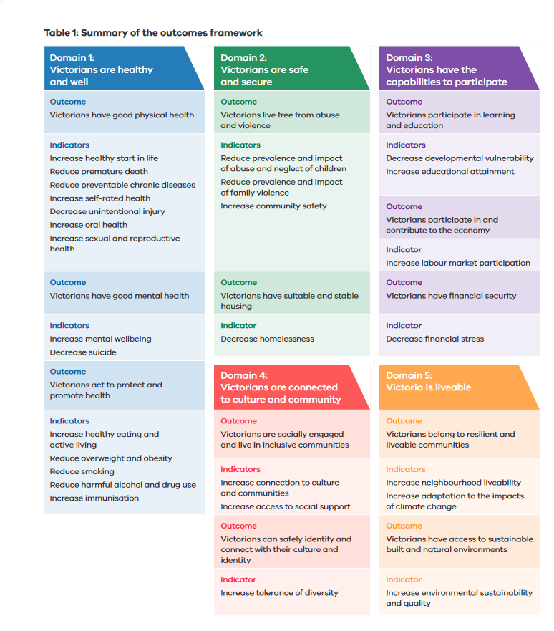

Appendix B
Implementation Plan Template
Strategy | Approach | Activity | Roles/  Responsibility | Milestones/  Timelines | Implementation Measures
Example
Planning | Leadership | Include the Outcomes Framework within strategic and operational planning (including communications) | People and Culture  Communication team  Executive Leadership Team | 2 months | Adoption  Sustainability

Terminology
ANRQ | Antenatal Risk Questionnaire
CALD | Culturally and Linguistically Diverse
CFAP | Child Family Action Plan
DASS21 | Depression Anxiety Stress Scale
EAP | Employee Assistance Program
EPC | Early Parenting Centre
EPDS | Edinburgh Postnatal Depression Scale
GP | General Practitioner
KANSAS | Kansas Parental Satisfaction Scale
KPSC | Karitane Parenting Confidence Scale
LGBTIQA+ | Lesbian Gay Bisexual Transgender Intersex Queer Asexual and other diverse sexual orientations and gender identities
MARAM | Family Violence Multi-Agency Risk Assessment and Management Framework
MCH | Maternal and Child Health
OHS | Occupational Health and Safety
PEEM | Parent Empowerment and Efficacy Measure
SCV | Safer Care Victoria
SNAICC | Secretariat of National Aboriginal and Islander Child Care
Vic | Victoria/Victorian

Text-equivalent descriptions of figures

Figure 1. Ecological levels
Five outcome domains:
- Health and Wellbeing
- Connection
- Safe and Secure
- Learning
- Growth
Six ecological levels:
- Child
- Parent/Carer/Family
- Workforce
- EPC
- Community
- Government

Figure 2. Logical model
Outcomes Framework
Child/Family
- Development
- Relationships
- Access services
Community
- Integrated services
Workforce
- Workforce development
- Training
EPCs
- Model of Care
- Data: collection, analysis, reporting, use
Government
- Funding model
- Standards
Inputs
- Resources
- Environments
- Professional workforce
- Funding
- Research and evidence
Outputs
- Programs
- Support and information
- Caregivers/Parents
- Children
Outcomes
- Health and Wellbeing
- Connection
- Growth
- Learning
- Safe and Secure

Figure 3. Framework Structure
- Outcome Domains
- Outcome Areas
- Key Result Indicators
- Measures
- Data: collection, input, analysis, reporting, uses
- Implementation Plan

Figure 4. Seven determinants of implementation
- Leadership, vision and culture
- Embedding measures as part of the everyday
- Building staff confidence and capacity
- Practical considerations and processes
- Basic IT considerations
- Sustaining the effort
- Analysing and reporting aggregate data to inform service directions

Appendix. A Summary of the Victorian Public Health and Wellbeing Outcomes Framework

Domain 1: Victorians are health and well
Outcome: Victorians have good physical health
Indicators
- Increase healthy start in life
- Reduce premature death
- Reduce preventable chronic diseases
- Increase self-rated health
- Decrease unintentional injury
- Increase oral health
- Increase sexual and reproductive health
Outcome: Victorians have good mental health
Indicators
- Increase mental wellbeing
- Decrease suicide
Outcome: Victorians act to protect and promote health
Indicators
- Increase healthy eating and active living
- Reduce overweight and obesity
- Reduce smoking
- Reduce harmful alcohol and drug use
- Increase immunisation

Domain 2: Victorians are safe and secure
Outcome: Victorians live free from abuse and violence
Indicators
- Reduce prevalence and impact of abuse and neglect of children
- Reduce prevalence and impact of family violence
- Increase community safety
Outcome: Victorians have suitable and stable housing
Indicator
- Decrease homelessness

Domain 3: Victorians have the capabilities to participate
Outcome: Victorians participate in learning and education
Indicators
- Decrease developmental vulnerability
- Increase educational attainment
Outcome: Victorians participate in and contribute to the economy
Indicator
- Increase labour market participation
Outcome: Victorians have financial security
Indicator
- Decrease financial stress

Domain 4: Victorians are connected to culture and community
Outcome: Victorians are socially engaged and live in inclusive communities
Indicators
- Increase connection to culture and communities
- Increase access to social support
Outcome: Victorians can safely identify and connect with their culture and identity
Indicator
- Increase tolerance of diversity

Domain 5: Victoria is liveable
Outcome: Victorians belong to resilient and liveable communities
Indicators
- Increase neighbourhood liveability
- Increase adaption to the impacts of climate change
Outcome: Victorians have access to sustainable built and natural environments
Indicator
- Increase environmental sustainability and quality

