Ban on smoking and vaping at childcare centres, kindergartens, preschools, and schools
Factsheet for visitors

By law, smoking and the use of e-cigarettes (vaping) is banned within the grounds of, and within four metres of an entrance to, all childcare centres, kindergartens, preschools, and schools.

Where does the ban apply?
Smoking and vaping is banned within the grounds of all Victorian childcare centres, kindergartens, preschools, and primary and secondary schools in Victoria. This includes all Government, independent and Catholic schools.
Smoking and vaping is also banned within four metres of all entrances (pedestrian access points) to the premises.
The diagram below shows an example of where the smoking and vaping ban applies at a childcare centre.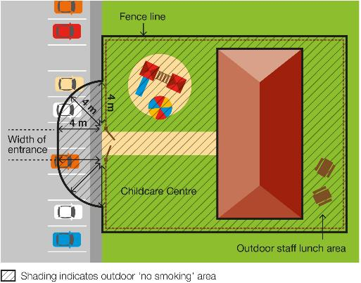
The diagram below shows an example of where the smoking ban applies at a school.
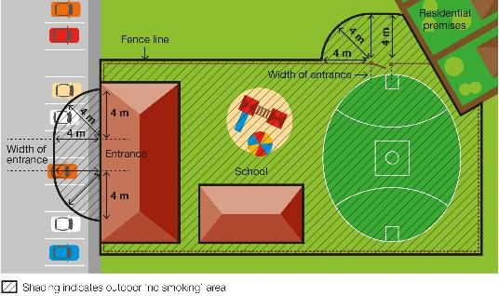

When does the ban apply?

Childcare centres, kindergartens, and preschools
The smoking and vaping ban applies to childcare, kindergartens, and preschools while they are being used to provide a children’s service.

Schools
The smoking and vaping ban applies at primary and secondary schools at all times, no matter whether the building or school grounds are being used for education purposes or other purposes. The ban therefore applies when other activities are taking place on the school grounds, such as fetes or sporting events, as well as during school hours.

How will people know about the ban?
Signs will be displayed in the smoke-free and vape-free area.

Why does the ban exist?

To protect children and young people from the dangers of second-hand smoke
This ban ensures that children and young people can enter and leave these areas without being exposed to harmful second-hand smoke.
Second-hand tobacco smoke is particularly dangerous to children and young people because they have smaller airways and less developed immune systems compared to adults.

To reduce the role modelling of smoking and vaping behaviours around children and young people
Children and young people are more likely to view smoking and vaping as socially acceptable when they regularly see people smoking and vaping.
Banning smoking in areas used by children and young people will help to de-normalise smoking and vaping behaviour and discourage children and young people from taking up smoking and vaping.

Where does the ban not apply?
The ban does not apply:
- to private homes that provide family day care services
- to an emergency exit that is locked to entry
- to a person walking through the smoke-free and vape-free area
- to a person in a motor vehicle that is driving or being driven through the smoke-free and vape-free area
- to a person in an area that is separated from the smoke-free and vape-free area by a road
- to a person in an outdoor drinking area located within the smoke-free and vape-free area
- to a person at a residential premises (at privately owned homes and land).

How will the ban be enforced?
There is strong community support for banning smoking and vaping at public places regularly attended by children. This means most people will voluntarily comply with the smoking and vaping ban and expect others to do so.
Inspectors authorised under the Tobacco Act 1987 may provide information about and, when necessary, enforce the ban. The first priority of the inspector is to make sure smokers and vapers understand the ban.
Inspectors may not be available to respond to every complaint, but where circumstances allow, may attend in response.

What penalties might apply?
The maximum penalty for someone breaking these laws is five penalty units, with an infringement penalty of one penalty unit.

How can I find out more?
For more information:
- visit the tobacco reforms website <www.health.vic.gov.au/public-health/tobacco-reforms>
- call the Tobacco Information Line on 1300 136 775
To view the legislation visit the Victorian Government’s legislation website <www.legislation.vic.gov.au> and search Tobacco Act 1987.
DISCLAIMER: Please note that any advice contained in this factsheet is for general guidance only. The Department of Health does not accept any liability for any loss or damage suffered as a result of reliance on the advice contained in this factsheet. Nothing in this factsheet should replace seeking appropriate legal advice.

To receive this document in another format, phone 1300 136 775, using the National Relay Service 13 36 77 if required, or email tobacco.policy@health.vic.gov.au
Authorised and published by the Victorian Government, 1 Treasury Place, Melbourne.
© State of Victoria, Australia, Department of Health, November 2023.
Except where otherwise indicated, the images in this document show models and illustrative settings only, and do not necessarily depict actual services, facilities or recipients of services.
ISBN 978-1-76131-088-1 (pdf/online/MS word)
Available at tobacco reforms website <www.health.vic.gov.au/public-health/tobacco-reforms>

Section 5RD of the Tobacco Act 1987.
A pedestrian access point in relation to premises is defined in the Tobacco Act 1987 as a door or gate by which a pedestrian can enter or exit the premises.
For current penalty unit values, visit the Department of Treasury and Finance website <www.dtf.vic.gov.au/financial-management-government/indexation-fees-and-penalties>

