Ban on smoking and vaping during organised underage sporting events
Information for sporting organisations and clubs

Under section 5RI(1) of the Tobacco Act 1987, smoking and the use of e-cigarettes (vaping) is banned within 10 metres (about two car lengths) of a sporting venue that is an outdoor public place during an organised underage sporting event in Victoria.
This ban also includes training or practice sessions to prepare for participation in an organised underage sporting event and breaks or intervals during the course of the event, training, or practice session.
The ban applies to outdoor drinking areas that are situated within 10 metres of an outdoor public sporting venue during an organised underage sporting event or training session.
These diagrams show examples where the ban applies.
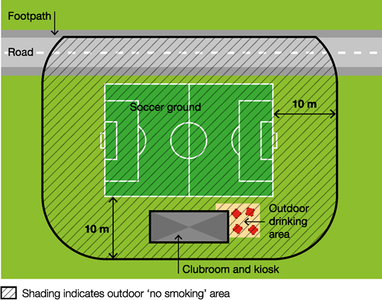
In the above diagram workplace smoking and vaping laws apply to the enclosed clubroom and kiosk.
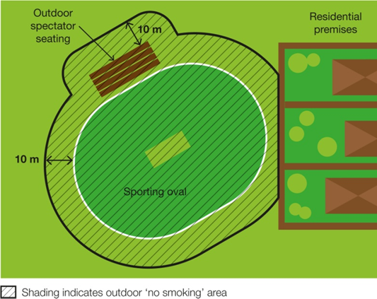
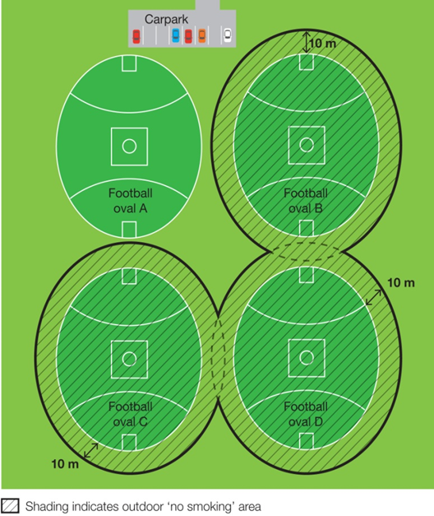
In the above diagram football ovals B, C and D are being used for underage sporting events.
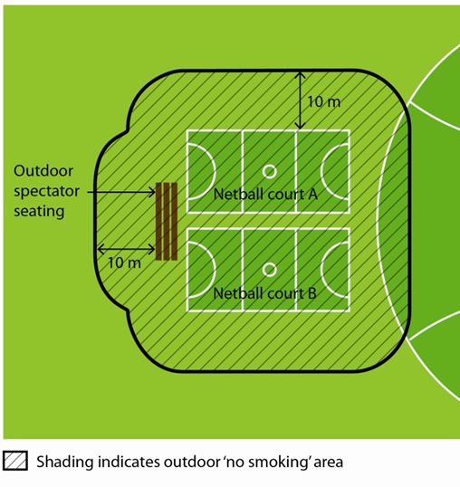
In the above diagram courts A and B are being used for underage sporting events.
This ban is part of a range of measures the Victorian Government has introduced to reduce the exposure of children and young people to second-hand tobacco smoke, the aerosol from e-cigarettes, and smoking and vaping behaviours. Bans also apply within 10 metres of outdoor children’s playground equipment and skate parks, and within outdoor areas of public swimming pool complexes.

Why does the ban exist?
Underage sporting events attract a wide variety of patrons, including families with children and young people.
This ban creates a smoke-free and vape-free environment where children and young people can enjoy sporting and recreational activities without being exposed to harmful second-hand tobacco smoke and the aerosol from e-cigarettes. Second-hand tobacco smoke exposure is particularly dangerous for children and young people due to their smaller airways and undeveloped immune systems compared to those of adults.
Children and young people are impressionable and are more likely to view smoking and vaping as socially acceptable when they regularly see people smoking and vaping in different settings. Banning smoking and vaping in areas frequented by children and young people will help to de-normalise smoking and vaping behaviour and discourage children and young people from taking up smoking and vaping.

What is considered a sporting venue?
Under this law, a ‘sporting venue’ includes:
- a playing field
- a track
- an arena
- a court or rink
- any permanently or temporarily erected public seating at the venue
- any seating, marshalling area, warm-up area, podium or other part of the venue reserved for the use of competitors or officials
- any part of the venue used to conduct the actual organised underage sporting event.
For example, if there are courts or ovals next to one another, the sporting venue is considered to be the court/s or oval/s where the actual underage sporting event is taking place.
Each sporting venue will be different. The examples above can help you to understand where the ban applies.

What is considered an underage sporting venue?
Under this law, an ‘organised underage sporting event’:
- is planned in advance
- is organised or intended for, or predominantly participated in by, persons under the age of 18 years
- is conducted according to established rules by a professional or amateur sporting body or by an educational institution
- may be a one-off event or part of a series of events.
Examples
An organised underage sporting event | Not an organised underage sporting event
A Little Athletics meet | An open netball game where some of the players are minors
An interschool/school sporting event participated in by people in their final years of secondary school, some of whom may be over the age of 18 | An open-age football match in which most of the players are over the age of 18
An underage football match run by regional football league | An informal or impromptu sporting activity involving minors at an outdoor public sporting venue

How will spectators and parents know when the ban applies?
The smoking and vaping ban applies when an underage sporting event is taking place. To help spectators and parents determine whether an underage sporting event is taking place, they may consider whether:
- children under 18 years old are playing in a match, game, tournament or other event conducted by an amateur or professional sporting body or educational institution
- participants are wearing sporting uniforms
- there is supervision that may consist of coaching, officiating or umpiring of underage people
- a whistle, siren or other alert is used to indicate the match, game or event has started or finished.
In most cases, spectators and parents will know an organised underage sporting event is occurring based on the way the event has been described. Underage sporting events are likely to be described as age-limited, for example ‘under 16s’ or ‘junior’.
There may also be ‘No smoking’ or ‘No smoking or vaping’ signs displayed at the venue to inform you of the ban.
Note that the ban also includes training or practice sessions to prepare for an underage sporting event and breaks and intervals in play.

When does the ban not apply?
The ban does not apply:
- if no underage sporting event is currently underway
- to a person at a residential premises (at privately owned homes and land)
- to a person in a motor vehicle that is driving or being driven past the sporting venue
- to a person in an area that is separated from the sporting venue by a road.

Am I or my staff expected to enforce the ban?
No. Sporting venue staff, operators and volunteers are not expected to enforce the ban and are not empowered to do so.
Compliance with the ban is expected to occur through a public education and awareness campaign and changed community expectations.
Consultation undertaken by the Department of Health shows strong community support for banning smoking and vaping at public places regularly attended by children. These factors are likely to result in high levels of voluntary compliance with the smoking and vaping ban.
Inspectors, authorised under the Tobacco Act 1987, may provide information about and, when necessary, enforce the ban. The maximum penalty for an individual breaching this law is five penalty units, with an infringement penalty of one penalty unit.
Inspectors may not be available to respond to every complaint, but where circumstances allow, may attend in response.
The primary goal of inspectors is to make sure smokers and e-cigarette users understand that smoking and vaping is banned within the outdoor areas of outdoor sporting venues during organised underage sporting events in Victoria.
You and your staff can assist to raise awareness of the ban by providing your patrons access to promotional resources.
Sporting venue operators are not liable if smoking and vaping occurs in outdoor areas of their sporting venues during underage sporting events.
Smoking and vaping will continue to be banned in enclosed areas of sporting venues under the enclosed workplace smoking provisions in the Tobacco Act 1987.

What resources are available to promote the ban?
Posters, brochures and palm cards
Sports venue operators are able to request posters, brochures and palm cards to help educate and inform patrons of the new ban. Order the free resources online from the tobacco reforms website <www. health.vic.gov.au/public-health/tobacco-reforms>
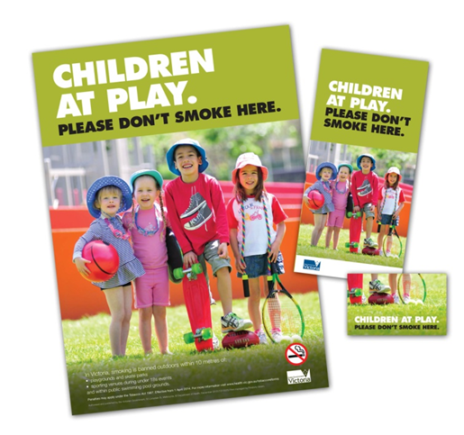
Signage
Local councils may choose to install ‘No smoking’ signs at sporting venues within their municipality to advise patrons of the ban.
Sports venue operators can order free signs by emailing: tobacco.policy@health.vic.gov.au.
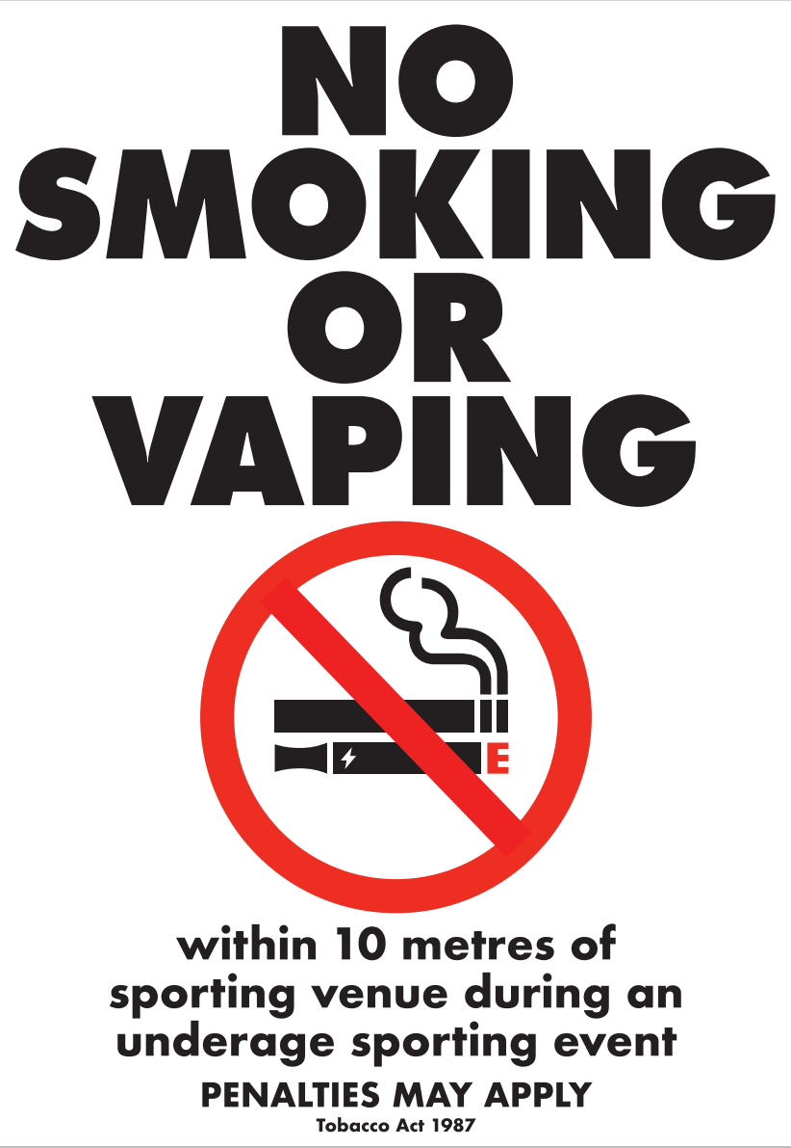
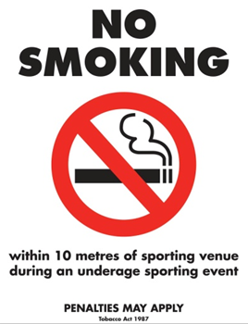
Templates for paper signs can also be downloaded from the tobacco reforms website <www. health.vic.gov.au/public-health/tobacco-reforms>

What if my sports venue already has a smoke-free and vape-free policy?
The bans are intended to complement and provide legislative support to any existing smoke-free and vape-free policies at sports venues.
If a sports venue has its own smoking and vaping ban in place, the statewide ban will act as a minimum standard, with any further requirements put in place by the sports venue applying in addition to the legislative ban.
For example, if your sporting club has a smoke-free and vape-free policy for all sporting events, both your club’s policy and the statewide ban will apply during children’s sporting events at the venue. The club’s policy only would apply during other sporting events at the venue.
Quit Victoria has developed a useful publication to guide sporting clubs wishing to implement smoke-free and vape-free areas, available from the Quit Victoria website <www.quit.org.au>

How can I find out more?
For more information:
- visit the tobacco reforms website <www. health.vic.gov.au/public-health/tobacco-reforms>
call the Tobacco Information Line on 1300 136 775
To view the legislation visit the Victorian Government’s legislation website <www.legislation.vic.gov.au> and search Tobacco Act 1987.
To receive this document in another format, phone 1300 136 775, using the National Relay Service 13 36 77 if required, or email tobacco.policy@health.vic.gov.au
Authorised and published by the Victorian Government, 1 Treasury Place, Melbourne.
© State of Victoria, Australia, Department of Health, November 2023.
Except where otherwise indicated, the images in this document show models and illustrative settings only, and do not necessarily depict actual services, facilities or recipients of services.
DISCLAIMER: Please note that any advice contained in this factsheet is for general guidance only. The Department of Health does not accept any liability for any loss or damage suffered as a result of reliance upon the advice contained in this factsheet. Nothing in this factsheet should replace seeking appropriate legal advice.
ISBN 978-1-76131-095-9 (pdf/online/MS word)
Available at tobacco reforms website <www. health.vic.gov.au/public-health/tobacco-reforms>

¹ For current penalty unit values, visit the Department of Treasury and Finance website <www.dtf.vic.gov.au/financial-management-government/indexation-fees-and-penalties>

