Influenza vaccination program
Guidance for immunisation providers
March 2024
OFFICIAL

Contents
Key points 3
2024 NIP Influenza vaccines 3
Pre-season preparation 4
Update your practice software 4
Identify NIP eligible patients 4
Children aged 6 months to less than 5 years 4
Aboriginal and Torres Strait Islander People aged 6 months and over 5
Pregnant women 5
Medically at-risk 5
Aged 65 years and over 5
Ordering vaccines 5
Vaccine storage and cold chain management 6
Professional development 6
Vaccine administration 6
Intramuscular injection 6
Vaccine choice 7
Schedule 7
Coadministration 7
After vaccination 7
Reporting to the AIR 7
Vaccine Safety 7
Contraindications and precautions 7
Adverse events following immunisation 8
Vaccine errors 8
Key reference documents 9
Appendix 1 10
Appendix 2 - 2024 NIP funded Influenza vaccines 11
All infants and children - aged 6 months to under 5 years 11
Aged 5 years to 64 years 11
Aged 65 years and over 11
Appendix 3 - Influenza vaccine storage labels 12

Key points
The Victorian Department of Health (the department) have developed this guidance document to assist immunisation providers to manage the timely roll-out and safe implementation of the influenza vaccination program in 2024. Refer to Appendix 1 for a seasonal activity timeline.
- Annual vaccination is the most important measure to prevent influenza and its complications and is recommended for all people aged 6 months and older.
- A recommendation from a healthcare professional plays an important role in improving vaccination uptake.
- The National Immunisation Program (NIP) provides free influenza vaccines for people most at risk.
- Identify your eligible patients. Consider local initiatives to improve vaccine uptake in those most at-risk including children aged 6 months to under 5 years, pregnant women and Aboriginal and Torres Strait Islander people.
- Ensure your vaccine Cold Chain Management policy and practices are up to date.

2024 NIP Influenza vaccines
The Australian Government, through the NIP, provides free seasonal influenza vaccine to the following groups at higher risk of complications from influenza:
- children aged six months to less than five years
- Aboriginal and Torres Strait Islander people
- pregnant women
- people with medical risk conditions
- people aged 65 years and older.

Table 1. 2024 NIP-funded influenza vaccines
Make sure you have the correct vaccine for age
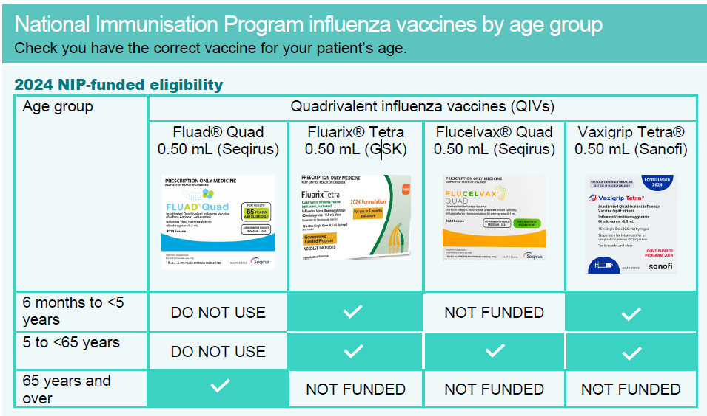
Note: For further information regarding NIP-funded Influenza vaccines refer to
- ATAGI clinical statement on the administration of seasonal influenza vaccines in 2024 <https://www.health.gov.au/resources/publications/atagi-statement-on-the-administration-of-seasonal-influenza-vaccines-in-2024?language=en>
- Australian Immunisation Handbook – Influenza (flu) <https://immunisationhandbook.health.gov.au/contents/vaccine-preventable-diseases/influenza-flu>

Pre-season preparation
Annual vaccination should ideally occur before the onset of each influenza season. Immune responses take about 2 weeks to fully develop after vaccination. The period of peak influenza circulation is typically June to September in most parts of Australia. Advanced preparation is vital for a successful influenza vaccination program. See Appendix 1 for a timeline of required actions.

Update your practice software
Check you have updated your medical practice software with the latest version. This will ensure the correct vaccine brand and fields are accurately reported to the Australian Immunisation Register (AIR).

Identify NIP eligible patients
Review your patient cohort in your health service and assess how many patients are:
- aged 6 months to less than 5 years
- Aboriginal and Torres Strait Islander people
- pregnant women
- have medical risk conditions
- aged 65 years and over.
Send a personalised invitation for vaccination to your clients before the end of March. Phone calls and text messages can be more effective than emails.
Patients aged 5 to 64 years who are not eligible for NIP-funded vaccine should be advised that they can purchase private influenza vaccine. Promote opportunistic vaccination where possible.

Children aged 6 months to less than 5 years
Key messages | Vaccine brands
Recommended for people from 6 months of age.  Children aged 6 months to less than 9 years receiving influenza vaccine for the first time need 2 doses given at least 4 weeks apart. | Fluarix® Tetra  Vaxigrip Tetra®

Aboriginal and Torres Strait Islander People aged 6 months and over
Key messages | Vaccine brands
Recommended for ALL Aboriginal and Torres Strait Islander people from 6 months of age. | Fluarix® Tetra | 6 months to 64 years
 | Vaxigrip Tetra® | 6 months to 64 years
 | Flucelvax® Quad | 5 years to 64 years
 | Fluad® Quad | 65 years and over

Pregnant women
Key messages | Vaccine brands
Recommended for pregnant women at any stage of pregnancy.  Vaccination in pregnancy protects both pregnant women and their babies from influenza and its complications. | Fluarix® Tetra  Vaxigrip Tetra®  Flucelvax® Quad

Medically at-risk
Key message | Vaccine brands
Recommended for people aged 5 years and over with medical risk conditions such as severe asthma, lung or heart disease, low immunity or diabetes. | Fluarix® Tetra  Vaxigrip Tetra®  Flucelvax® Quad
Refer to the Australian Immunisation Handbook |Influenza (flu) for further details.

Aged 65 years and over
Key messages | Vaccine brand
Vaccination is important for people from the age of 65 years as they are at high risk of complications from influenza.  The adjuvanted influenza vaccine is preferentially recommended over standard quadrivalent vaccine for adults aged 65 years and over. | Fluad® Quad

Ordering vaccines
Use your Onelink account to order seasonal influenza vaccines online. The department will advise government vaccine account holders when ordering commences.
Immunisation providers are eligible for two (2) vaccine orders per month during the influenza season (April - June 2024). Orders must be placed at least 14 days apart.
Aim to have no more than a month’s stock in your vaccine refrigerator to reduce the risk of stock loss through cold chain breaches or expiry before use.
Order limits may be restricted to assist with equitable and timely distribution of vaccines.

Vaccine storage and cold chain management
All influenza vaccines must be stored in a purpose-built vaccine refrigerator, in the cold chain range (+2 to +8°C). Store vaccines in their original boxes and do not overcrowd shelves in the vaccine refrigerator. For further details, refer to the National Vaccine Storage Guidelines – ‘Strive for 5’ . <https://www.health.gov.au/resources/publications/national-vaccine-storage-guidelines-strive-for-5?language=en>
Ensure your service’s Vaccine Coordinator and back up person have completed the mandatory Victorian Cold Chain eLearning module and uploaded their certificates of completion to the department’s Cold Chain certificate portal.
To avoid vaccine administration error, label and store different influenza vaccine brands separately. Refer to the template examples in Appendix 3.

Professional development
Refresh your knowledge of Influenza disease and 2024 Influenza vaccines:
- Complete the department’s Influenza eLearning module (2024)
<https://vic-immunisation-learning.com/immunisation/>
- Visit the department’s Seasonal influenza vaccine web page, and review all updated influenza vaccine resources.
<https://www.health.vic.gov.au/immunisation/seasonal-influenza-vaccine>
- Review the Australian Government’s Getting vaccinated against influenza - resource collection for resources, fact sheets and posters for your patients and your health service.
<https://www.health.gov.au/resources/collections/getting-vaccinated-against-influenza-resource-collection?language=en>
- Visit the Sharing Knowledge About Immunisation (SKAI) webpage to prepare for conversations with your patients, parents and carers.
<https://skai.org.au/>
- Be aware of any age limitations and conditions associated with your Secretary Approval as a Nurse Immuniser or Pharmacist Immuniser and/or scope of practice for health professionals.
<https://www.health.vic.gov.au/immunisation/nurse-immunisers>
<https://www.health.vic.gov.au/immunisation/pharmacist-immunisers>

Vaccine administration

Intramuscular injection
Influenza vaccines are preferably given via the intramuscular route. Review the Melbourne Vaccine Education Centre (MVEC) Vaccine administration web page for information on injection techniques and anatomical markers for persons of different ages.
<https://mvec.mcri.edu.au/references/vaccine-administration/>
- Complete the MVEC Shoulder Injury Related to Vaccine Administration (SIRVA) eLearning module to learn how to prevent injury relating to incorrect injection technique.
<https://education-mvec.mcri.edu.au/courses/shoulder-injury-related-to-vaccine-administration-sirva/>

Vaccine choice
- Always CHECK you are using correct vaccine for age. Refer to Table 1.
- Influenza vaccines come in pre-filled syringes of 0.5 mL. Administer the full content as this is required for the optimal immune response.
- Fluad® Quad (an adjuvanted influenza vaccine) is preferentially recommended for adults aged 65 years and over only. The adjuvant boosts the immune system’s response to the vaccine and provides better protection for people aged 65 years and over.
- If a person had a 2023 influenza vaccine in late 2023 or early 2024, they are still recommended to receive a 2024 vaccine when available, at least 4 weeks apart.

Schedule
- Children aged 6 months to less than 9 years receiving influenza vaccine for the first time need 2 doses given at least 4 weeks apart. This maximises the immune response to the vaccine strains.
- People aged 9 years and over need 1 dose of influenza vaccine every year.

Coadministration
Influenza vaccines can be given at the same time as, or at any interval before or after, other vaccines. This includes dTpa, respiratory syncytial virus (RSV), pneumococcal and COVID-19 vaccines. Refer to the Australian Immunisation Handbook | Influenza (flu) for further details.
It is acceptable to co-administer Fluad® Quad and Shingrix® on the same day if necessary. However, due to a lack of data, it is preferable to separate administration by a few days if possible.

After vaccination
Keep the person under observation for at least 15 minutes to ensure that they do not experience an immediate adverse event, and to provide rapid medical care if needed.
Inform the vaccinated person or their parent/carer, preferably in writing, of any expected adverse events following immunisation.

Reporting to the AIR
It is mandatory to report the administration of influenza vaccines, COVID-19 vaccines and all other NIP vaccines to the AIR. Use the current AIR vaccine code formats; refer to the Services Australia air vaccine code formats <https://www.servicesaustralia.gov.au/air-vaccine-code-formats?context=22796>.

Vaccine Safety

Contraindications and precautions
The only contraindications to influenza vaccines are:
- Anaphylaxis following a previous dose of any influenza vaccine
- Anaphylaxis following any vaccine component (excluding eggs).
Egg allergy is not a contraindication to influenza vaccines. If there is significant parental or health professional concern, the vaccine may be administered in a primary care setting with a longer waiting period of 30 minutes.
Latex allergy: All influenza vaccines available under the NIP in 2024 are latex free and people with a latex allergy can safely be vaccinated.

Adverse events following immunisation
An adverse event following immunisation (AEFI) is any negative reaction that follows vaccination. It does not necessarily have a causal relationship with the vaccine. AEFIs also include conditions that may occur following the incorrect handling or administration of a vaccine.
Refer to the Australian Immunisation Handbook for AEFI relating to influenza vaccines.
Serious or unexpected AEFI and vaccine errors require notification to SAEFVIC, Victoria’s Safety Surveillance partner.
- via SAEFVAC reporting online <https://www.safevac.org.au/Home/Info/VIC>
- Ph: 1300 882 924 (option 1)

Vaccine errors
Vaccine administration errors can occur when a vaccine is incorrectly stored, prepared or given outside the current clinical guidelines, potentially resulting in an AEFI.
Review the department’s Vaccine error management web page to learn how to prevent and manage vaccine administration errors.
<https://www.health.vic.gov.au/immunisation/vaccine-error-management>

Key reference documents
Resource | Description
Victorian Department of Health webpage | Up to date information and resources about the 2024 Seasonal influenza vaccination program and access to the eLearning module.  <https://www.health.vic.gov.au/immunisation/seasonal-influenza-vaccine>
The Australian Immunisation Handbook | Clinical guidance developed by the Australian Technical Advisory Group on Immunisation (ATAGI) for health professionals on all influenza vaccines.  <https://immunisationhandbook.health.gov.au/contents/vaccine-preventable-diseases/influenza-flu>
Australian Technical Advisory Group on Immunisation – 2024 Influenza season | ATAGI advice for immunisation providers regarding the administration of 2024 seasonal influenza vaccines.  <https://www.health.gov.au/resources/publications/atagi-statement-on-the-administration-of-seasonal-influenza-vaccines-in-2024?language=en>
Australian Government – Influenza vaccination resource collection | Clinical advice for immunisation providers. Resources, fact sheets and posters for your patients and your health service.  <https://www.health.gov.au/resources/collections/getting-vaccinated-against-influenza-resource-collection?language=und>
Australian Government | National Vaccine Storage Guidelines – Strive for 5.  <https://www.health.gov.au/resources/publications/national-vaccine-storage-guidelines-strive-for-5?language=en>
Victorian Department of Health webpage | Practical guidance on mandatory vaccine storage and cold chain management requirements in Victoria.  <https://www.health.vic.gov.au/immunisation/cold-chain-management>
Victorian Department of Health | Practical guidance on preventing and managing vaccine administration errors in Victoria.  <https://www.health.vic.gov.au/immunisation/vaccine-error-management>
Victorian Department of Health | How to register for a Onelink vaccine account and order government funded vaccines.  <https://www.health.vic.gov.au/immunisation/ordering-vaccines>
Victorian Department of Health | Information about nurse and pharmacist immunisers in Victoria.  <https://www.health.vic.gov.au/immunisation/immunisers-in-victoria>
SAEFVIC webpage | SAEFVIC is Victoria’s vaccine safety service and assists the department to ensure safe and effective immunisation programs and maintain community confidence in vaccines. Report serious AEFI and vaccine error to SAEFVIC. <https://www.safevac.org.au/Home/Info/VIC>
Services Australia  (AIR) | Influenza vaccine code formats for reporting to the AIR  <https://www.servicesaustralia.gov.au/air-vaccine-code-formats?context=22796>
Appendix 1 - Influenza vaccination program timeline 2024
Date | Action
Now | Pharmacist immunisers wanting to participate in the NIPVIP must have a government funded vaccine account. Refer to Ordering vaccines <https://www.health.vic.gov.au/immunisation/ordering-vaccines>
March | Discard previous year (2023) influenza vaccine stock (note some influenza vaccines expire before March)
 | Identify all children 6 months to < 5 years and at-risk patients eligible for NIP influenza vaccine
 | Check your vaccine refrigerator capacity to ensure you can store the number of vaccines you will need.
Check for emails (including junk folder) regularly. The department will notify government vaccine account holders when influenza vaccine ordering is open.

(a) Check your pre-allocation offer (for providers identified by the department). Acknowledge your pre-allocation order offer using the online form emailed to you.
(b) Order on the Onelink online ordering system for all other providers.

Contact the Immunisation Program via email immunisation@health.vic.gov.au for advice.

 | Check that all staff are trained in vaccine cold chain management (including receipt of vaccine deliveries). The department’s Cold Chain Management eLearning should be used to facilitate staff education to effectively manage the cold chain.
April | Send communications to all patients reminding them of the importance of influenza vaccination from April/May.
 | Promote influenza vaccination in your service using posters and social media.
Only order enough stock for use in a maximum 4-week period.
Check software to confirm the correct batch numbers correspond with batch numbers for vaccines received.
 | Advise patients that influenza vaccines can be given at the same time as, or at any interval before or after, other vaccines.
 | Send reminder messages to pre-identified patients advising of the influenza vaccination arrangements.
Mid-April | Commence influenza vaccination clinics  Report all vaccinations to the AIR  Report all AEFI to SAEFVIC <https://www.safevac.org.au/Home/Info/VIC>
Mid-May | Review patient vaccine uptake – send reminders to patients who have not attended for vaccination.
 | Reorder vaccines according to stock on hand and residual demand, taking into consideration the amount of 2023 expired stock that you discarded at the end of last season. If demand for the vaccine exceeds your last order, create a wait list for patients, so they know they can be vaccinated when you receive your next delivery.

Appendix 2 - 2024 NIP funded Influenza vaccines

All infants and children - aged 6 months to under 5 years
Vaccine brand | Packaging image
Vaxigrip Tetra®  0.5 mL (Sanofi)  - Do not split doses, give 0.5mL  - Latex free | 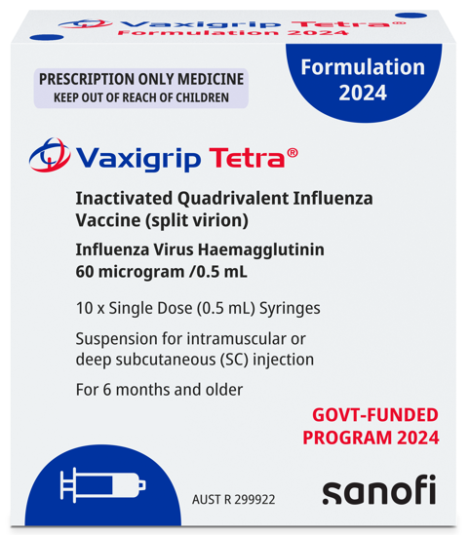
Fluarix® Tetra  0.5 mL (GSK)  - Do not split doses, give 0.5mL  - Latex free | 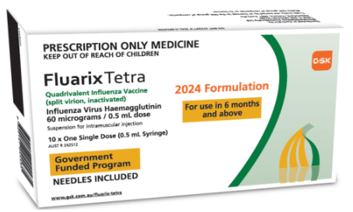
Children aged 6 months to less than 9 years receiving influenza vaccine for the first time need 2 doses given at least 4 weeks apart.

Aged 5 years to 64 years
Vaccine brand | Packaging
Flucelvax® Quad  0.5 mL (Seqirus)  - Do not split doses, give 0.5mL  - Latex free | 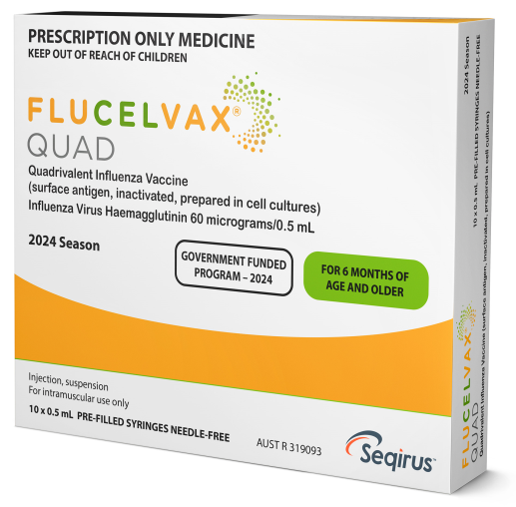
Vaxigrip Tetra® Fluarix® Tetra available for eligible people (below) aged 6 months to 64 years.
Aboriginal and Torres Strait Islander people, pregnant women, people with medical risk conditions

Aged 65 years and over
Vaccine brand | Packaging
Fluad® Quad  0.5mL (Seqirus)  - Milky white suspension  - Do not give to people ˂ 65 years | 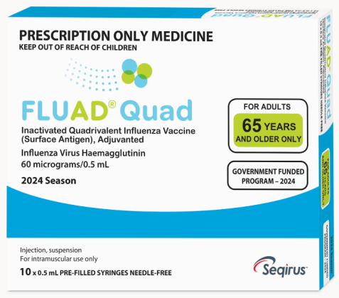
Preferred over other quadrivalent vaccines for people aged 65 years and older.

Appendix 3 - Influenza vaccine storage labels
2024 NIP influenza vaccine  Cohort - 6 months to <5years  Brand - Vaxigrip Tetra® | 2024 NIP influenza vaccine  Cohort - 6 months to <5years  Brand - Fluarix® Tetra
2024 NIP influenza vaccine  Cohort - 5 to 64 years at risk  Brand - Vaxigrip Tetra® | 2024 NIP influenza vaccine  Cohort – ≥65 years  Brand - Fluad® Quad
2024 NIP influenza vaccine  Cohort - 5 to 64 years at risk  Brand - Fluarix® Tetra | 2024 Influenza vaccine  PRIVATE STOCK
2024 NIP influenza vaccine  Cohort - 5 to 64 years at risk  Brand – Flucelvax® Quad | 2024 Influenza vaccine  PRIVATE STOCK

This document can be downloaded from the Seasonal Influenza vaccine webpage <https://www.health.vic.gov.au/immunisation/seasonal-influenza-vaccine>.
To receive this publication in an accessible email the Immunisation Unit <immunisation@health.vic.gov.au>
While the information contained in this resource has been researched, reviewed and presented with all due care, the content is for use by a doctor or qualified immunisation provider only.
All information contained in this publication is accurate at the time of publication. Authorised and published by the Victorian Government, 1 Treasury Place, Melbourne © State of Victoria, Department of Health, March 2024

