CDIS groups process
Victorian Maternal and Child Health (MCH) Child Development Information System (CDIS)
December 2020
Contents
Overview 1
Add a specific group to a group template 3
Add facilitators to a specific group 3
Option A: Add client (child) directly to a specific group 4
Option B: Three-step process 4
Step 1: Add client (child) to group template waitlist 4
Step 2: Viewing group template waitlist 4
Step 3: Move client (child) from group template waitlist to a specific group 5
Send SMS to a specific group 6
Update RSVP status 6
Edit a specific group: Change dates and times for sessions 7
Step 1: Return client to group template waitlist 7
Step 2: Make changes to group session dates and times 7
Step 3: Return clients to the group 7
Print a specific group list 8
Record attendance and outcomes 8
Important note 9

Overview
The initial group set-up (known in CDIS as ‘Creating a new group template’) is designed to be performed by specifically designated staff, such as MCH Coordinators, Team Leaders or Admin staff only.
If a group type (that is, template) that is required has not been created, contact your MCH Coordinator or Team Leader.
Only use group templates that have already been created to add groups.
Group templates are the basic structure of a group.
Group templates comprise:
- group type
- council group name
- target age
- recommended group size
- number of sessions
- session topics planned
A waitlist is available for use for every group template.
Specific groups are formed by Add new Group to that group template.
Note: Groups can be set up in advance if group dates are known or can be set up once there are enough clients on the group template waitlist to warrant a group.
A client (child) can be:
- added directly to the relevant specific group
- added to a group template waitlist and then added to a specific group.
For example, if a Council has 2 MCH Centres:
- Collins St centre – three sites or offices have planned groups, so they book clients directly into specific groups
- Bourke St centre – one site or office places clients onto the group template waitlist. Once there are enough clients on the group template waitlist to warrant a group, a group is added to the group template and the clients are moved from the waitlist to that group.
This is illustrated in Figure 1.
Figure 1: Adding to a group and adding to a waitlist
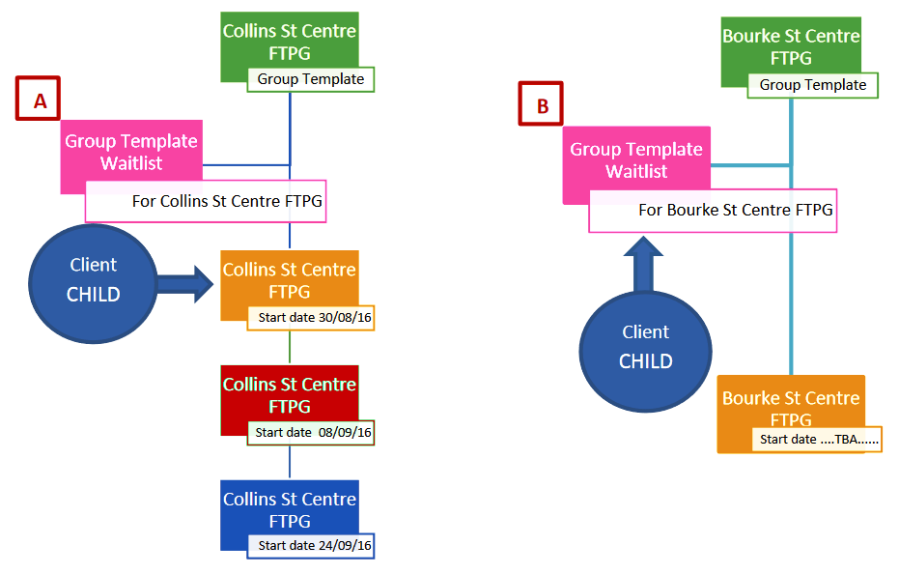

Add a specific group to a group template
That is, ‘Add a new date’.
- From the home (search) screen, go to ‘Schedule’, then ‘Groups ‘and then ‘Group Templates’
- Select the plus icon next to the name of the relevant group template
- Select the ‘Add new date’ button (under the name of the group template)
- In the ‘Add new start date for group’ pop-up box:
    - Complete required data fields
    - Select ‘Calculate Session Dates’ button
    - Edit session dates or times if required – use digits or arrows, or select desired date using calendar box
    - Untick the checkbox next to session, if wanting to skip a session (or day or week and so on).
Notes:
- Public holidays are not currently identified when adding session dates to a group
- Ensure dates are checked before adding sessions and remember to account for public holidays by adding an extra week or session to the group then unticking the public holiday date so it is not included in the group dates
- Additional session dates or times cannot be added after the group has started
- Session dates or times can only be edited if there are no clients already in that group – see Edit a specific group.

Add facilitators to a specific group
- From the home (search) screen, go to ‘Schedule’, then ‘Groups’ and then ‘Manage Groups’
- Select the relevant group template (this is the Council group name) from the ‘Group type’ look-up list
- Select ‘Search’
- Select the plus icon next to the start date of the relevant group
- Find facilitator by selecting from the look-up list
- Select the checkbox for external facilitator if needed and select type from the look-up list
- Select the ‘Confirm facilitator’ button.
Notes:
- Confirm facilitator must be selected to be displayed in ‘Group Attendance/Outcomes’
- Only the facilitator can enter ‘Group Attendance/Outcomes’.
- If a reliever is facilitating a group they can go through these steps to add themselves as the facilitator prior to marking attendance screen

Option A: Add client (child) directly to a specific group
- From the client history screen, go to ‘Clinical Activity’ then ‘Book Group’
- Select the relevant group template (this is the Council group name) from the ‘Group type’ look-up list
- Select ‘Search’
- Select the plus icon next to the name of the relevant group template
- In the ‘Group’ pop-up box:
    - Select (tick) ‘all future sessions’ or individual relevant sessions
    - Child is ticked by default – do not untick or tick anyone else
    - Select (tick) ‘Generate Reminders’ if relevant – Select ‘Primary Contact’ as recipient, Tick override default text if relevant (do not change text in brackets), do not use ‘send confirmation letter to batch print’
    - Select ‘offered’ – this is automatically recorded in the client (child) history or notes area
    - Select ‘Save’
Notes:
- Only add child as group attendee.

Option B: Three-step process

Step 1: Add client (child) to group template waitlist
- From the client history screen, go to ‘Clinical Activity’ then ‘Book Group’
- Select the relevant group template (this is the Council group name) from the ‘Group type’ look-up list
- Select ‘Add to Waitlist’ button
- Select ‘OK’ – ‘Client added to waitlist’ confirmation message
Notes:
- A client (child) can be added multiple times to a waitlist, but they are only displayed once
- This is not automatically recorded in the client (child) history and notes area
- Only add child to the group waitlist

Step 2: Viewing group template waitlist
- From the home (search) screen, go to ‘Schedule’, then ‘Groups ‘and then ‘Group Templates Waitlist’
- Select the plus icon next to the name of the relevant group template
- Select one of three options:
- Print group waitlist
- Send SMS
- Remove clients
Notes:
There is a fourth option, ‘Send letter’. Do not use this option.

Print group waitlist
- Select the ‘Print Group Waitlist’ button
- Open download
- Select ‘Print’ from the toolbar
Note: This printed group list does not display the group template name.

Send SMS
- Select the clients you wish to SMS by selecting the checkbox
- Select the ‘Send SMS’ button
- When asked ‘Send SMS?’, select ‘OK’
- In the ‘SMS’ pop-up box:
- Select recipients – all primary contacts only
- SMS template: Select ‘Group Waitlist’ from look-up list
- Add or edit text as required –do not alter text in brackets
- Select ‘Send SMS’
Notes:
- SMS is automatically recorded in client (child) history under ‘Letters/Reports – Correspondence History’
- Organisations may choose to send emails rather than SMS; however, currently there is no simple way of doing this – it currently requires accessing the email address from the client (child) primary caregiver history.

Remove clients
- When asked ‘Remove clients?’, select ‘OK’
Notes:
This is automatically recorded in the client (child) history and notes area as ‘removed [Group type], [start and end date of group] on [entry date]’.

Step 3: Move client (child) from group template waitlist to a specific group
- From the home (search) screen, go to ‘Schedule’, then ‘Groups’ and then ‘Manage Groups’
- Select the relevant group template (this is the Council group name) from the ‘Group type’ look-up list
- Select ‘Search’
- Select the plus icon next to the start date of the relevant group
- Select the ‘Add Client(s) from W/L’ button
- In the ‘Add from Waitlist’ pop up box
- Select clients to move to specific group using the checkbox
- Select the ‘Add to group’ button

- In the ‘Who is Attending’ pop-up box:
- Select ‘CHILD (self) ONLY’ checkbox
- Select ‘Add to group’
Notes:
- Only add child as the group attendee
- RSVP status is ‘accepted’ by default – this is automatically recorded in the client (child) history and notes area. This RSVP status can be changed to ‘offered’ by selecting the pencil icon next to the client (child) name on the ‘Client(s) attached to this group’ list – this is automatically recorded in the client (child) history and notes area.

Send SMS to a specific group
- From the home (search) screen, go to ‘Schedule’, then ‘Groups’ and then ‘Manage Groups’
- Select the relevant group template (this is the Council group name) from the ‘Group type’ look-up list
- Select ‘Search’
- Select the plus icon next to the start date of the relevant group
- Select the clients you wish to SMS by selecting the checkbox
- Select the ‘Send SMS’ button
- When asked ‘Send SMS?’, select ‘OK’
- In the ‘SMS’ pop-up box:
- Select recipients – all primary contacts only
- SMS template: Select ‘Group Waitlist’ from look-up list
- Add or edit text as required –do not alter text in brackets
- Select ‘Send SMS’
Notes:
- SMS is automatically recorded in client (child) history under ‘Letters/Reports – Correspondence History’
- Organisations may choose to send emails rather than SMS; however, currently there is no simple way of doing this – it currently requires accessing the email address from the client (child) primary caregiver history.

Update RSVP status
- From the home (search) screen, go to ‘Schedule’, then ‘Groups’ and then ‘Manage Groups’
- Select the relevant group template (this is the Council group name) from the ‘Group type’ look-up list
- Select ‘Search’
- Select the plus icon next to the start date of the relevant group
- Select the pencil icon next to the client (child) name to update once RSVPed

- In the ‘Edit Status’ pop-up box:
- Select either ‘offered’, ‘accepted’ or ‘declined’ – see following Notes
- Select ‘Save’
Notes:
- RSVP status is automatically recorded in the client (child) history and notes area
- If ‘declined’ is selected, the client (child) is removed from the specific group list
- The free text field can be used to add a reason. This is also automatically recorded in the client (child) history and notes area.

Edit a specific group: Change dates and times for sessions
Note: Session dates and times can only be made if there are no clients already allocated in that group.

Step 1: Return client to group template waitlist
Note: This is automatically recorded in the client (child) history and notes area as ‘removed [Group type], [start and end date of group] on [entry date]’.
- From the home (search) screen, go to ‘Schedule’, then ‘Groups’ and then ‘Manage Groups’
- Select the relevant group template from the ‘Group type’ look-up list
- Select ‘Search’
- Select the plus icon next to the start date of the relevant group
- Select all clients by ticking the checkbox
- Select the ‘Return to Waitlist’ button
- When asked ‘Return clients to Waitlist?’, select ‘OK’

Step 2: Make changes to group session dates and times
- From the home (search) screen, go to ‘Schedule’, then ‘Groups ‘and then ‘Group Templates’
- Select the plus icon next to the name of the relevant group template
- Select the greyed out start date of the relevant group
- In the ‘Edit Planned Dates for Group’ pop-up box, edit data fields as needed
- Select ‘Save’.

Step 3: Return clients to the group
Note: This is automatically recorded in the client (child) history and notes area as ‘accepted [Council group name], [start and end date of group] on [entry date]’.
- From the home (search) screen, go to ‘Schedule’, then ‘Groups’ and then ‘Manage Groups’
- Select the relevant group template from the ‘Group type’ look-up list
- Select ‘Search’
- Select the plus icon next to the start date of the relevant group
- Select the ‘Add Client(s) from W/L’ button

- In the ‘Add from Waitlist’ pop up box
    - Select clients to move back to specific group using the checkbox
    - Select the ‘Add to group’ button
- In the ‘Who is Attending’ pop-up box:
    - Select ‘CHILD (self) ONLY’ checkbox
    - Select ‘Add to group’

Print a specific group list
- From the home (search) screen, go to ‘Schedule’, then ‘Groups’ and then ‘Manage Groups’
- Select the relevant group template from the ‘Group type’ look-up list
- Select ‘Search’
- Select the plus icon next to the start date of the relevant group
- Select the ‘Print Clients in this group’ button
- Open download
- Select ‘Print’ from the toolbar
Notes:
- This printed group list does not display the group template name, the specific group session dates, times, location or facilitator, and any client alerts or flags.

Record attendance and outcomes
Note: Complete these steps in the order presented
- From the home (search) screen, go to ‘Schedule’, then ‘Groups’ and then ‘Group Attendance/Outcomes’
- The staff name is set in ‘View my groups’ by default
- Select the ‘Refresh’ button
- Select the plus icon next to the start date of the relevant group
- Record DNA:
- Select client (child) hyperlinked name
- In the pop-up box, select relevant session from look-up list
- Select the DNA checkbox and select reason from look-up list
- In free text field, type DNA – [reason] [comments]. For example: ‘DNA – cancelled. Mother phoned as client (child) unwell today’
- Select ‘Save’

- Write individual notes within group setting if relevant
- Select client (child) hyperlinked name
- In the pop-up box, select relevant session from look-up list
- If caregiver other than mother attends, document in ‘Child Individual Group Session Notes’. For example: ‘Child attended with father’
- In free text field, enter notes for that individual within group setting if relevant
- Select ‘Save’
- Select all attendees using the checkboxes
- Select ‘Notes’ to enter session notes
- Select group topics discussed from look-up list – select the plus icon after each to add
- Document in free text field, ‘All children attended with their mother today, unless otherwise stated.’
- Additionally, enter generic group comment in free text field if relevant
- Select ‘Save
Tip: If caregiver other than mother attends or you have forgotten to document in ‘Child Individual Group Session Notes’, add a ‘Progress Note’ in ‘Child History’ stating:’Child attended group today with [person such as father or grandmother]’ or other relevant individual notes from the group session
Notes:
- Recording attendance and outcomes must be completed in the specified way otherwise it will not be recorded.
- Facilitators can enter group attendance and outcomes
- Facilitators can be changed while the group is in progress (that is, not all sessions completed) but cannot be changed after the group has finished. It is recommended that ‘Relievers’ are edited as ‘Facilitator’ before the group session starts (as required), so that the Reliever can enter group attendance and outcomes.
- While the group template has an activity or topic assigned to each session, this is for planning purposes only. On completion of a group session, it is important to add the session topics actually covered in the ‘Record Session Outcome’ generic group notes, as it is from here that it is automatically recorded in the client (child) attendee’s history and notes.
- If an additional client arrives to attend a group that was not anticipated, their invitation to the group cannot be backdated. In this case, add a note in the client’s history and notes section that they attended and add them to the group for future dates. After this, they will be displayed in the ‘Attendance/Outcomes’ for future group sessions.
- A systems administrator can back date – enabling them to add client/s and add attendance in line with MCH service providers CDIS and practice policies.

Important note
If a client (child) does not have a ‘Pref Contact Name’ listed in the specific group list or the group template waitlist, go to client (child) history and ensure that ‘Relationship’ is linked with the primary caregiver and that the primary caregiver’s record is open.
To receive this publication in an accessible format phone 1300 650 172, using the National Relay Service 13 36 77 if required, or email Commissioning Performance and Improvement Aged and Community Based Health Care and Cancer Services <mch@dhhs.vic.gov.au>
Authorised and published by the Victorian Government, 1 Treasury Place, Melbourne.
© State of Victoria, Australia, Department of Health and Human Services June 2020.
ISBN 978-1-76096-023-0 (pdf/online/MS word)
Available at health.vic – Child Development Information System <https://www2.health.vic.gov.au/primary-and-community-health/maternal-child-health/child-development-information-system>

